Oliver Bird Information Engineering Assignment – The City Book Store
This assignment covers the design and implementation of a simple database and accompanying form and report system for a local bookstore. It allows for store workers to search through the database for their stock, their suppliers/publisher and their customers. It also allows the functionality for the user to input their new stock, and add any new suppliers, customers or publishers to the database.

- Contents
  - Code Overview
    - Table Creation
      - Suitable tables
      - Third Normal Form

    - Data input
  - User Guide
  - ERD
  - References

- Code Overview
  - Table Creation

    - Suitable Tables

When creating the tables and fields for this database, the end user functionality and use cases were considered. They need a database which can store all current stock, all current customer info, all orders, and also be able to have information regarding books they may not have in stock, but could potentially either buy in, or have sold previously. It also must allow the user to edit all of these tables.
The required tables to accomplish this are as follows:
- Address – This will hold all address related data for both customers and suppliers / publishers.
- Books – This will hold all data related to books. The associated publisher is only related to an ID in this table to allow for 3NF. Books marked as first editions use the ‘bit’ field type to flag them as either first or not first editions.
- Customers – This will hold all data related to customers.
- Orders – This holds all data relating to a given order. This has foreign keys to many other tables as it requires information held outside of the table itself.
- Stock - A simple table relating a stock ID to a given book.
- Staff – A table holding all information regarding their staff

Attached below are some examples of the SQL code which was used to generate the tables and the appropriate relationships. The queries had to be run in the order of the dependencies, for example only tables with no foreign keys could be created. The address table was created first, and the relational objects followed.

    - Address Create Query

CREATE TABLE Address (
Address_ID Int PRIMARY KEY,
House_Name varchar(30),
Street_Name varchar(30),
City varchar(20),
Postcode varchar (8)
)

    - Book Create Query

CREATE TABLE Book
(
Title varchar(50),
Book_ID int PRIMARY KEY,
Author varchar(50),
First_Edition BIT,
Publisher_ID Int,
Review int,
Cost CURRENCY,
FOREIGN KEY (Publisher_ID) REFERENCES Publisher(Publisher_ID)
);

    - Customer Create Query

CREATE TABLE Customer
(
Name varchar(50),
Email varchar(50),
Address_ID Int,
Customer_ID Int PRIMARY KEY,

Liked_Genre varchar(50),
FOREIGN KEY (Address_ID) REFERENCES Address(Address_ID));

    - Orders Create Query

CREATE TABLE Orders
(
Order_ID Int PRIMARY KEY,
Customer_ID Int,
Staff_Order_Member int,
Order_Date DATETIME,
Delivery_Date DATETIME,
Stock_ID Int,
FOREIGN KEY (Customer_ID) REFERENCES Customer(Customer_ID),
FOREIGN KEY (Staff_Order_Member) REFERENCES Staff(Employee_ID),
FOREIGN KEY (Stock_ID) REFERENCES Stock(Stock_ID));

    - Publisher Create Query

CREATE TABLE Publisher
(
Publisher_Name varchar(50),
Publisher_ID Int PRIMARY KEY,
Address_ID Int,
Tel Int,
FOREIGN KEY (Address_ID) REFERENCES Address(Address_ID)
)

    - Staff Create Table

CREATE TABLE Staff
(
Name varchar(50),
Employee_ID int PRIMARY KEY,
Role varchar(20)
)

    - Stock Create Table

CREATE TABLE Stock
(
Stock_ID int PRIMARY KEY,
Book_ID Int,
FOREIGN KEY (Book_ID) REFERENCES Book(Book_ID)
);

These queries create the appropriate tables and field types, alongside define the relationships between each table.
- Third Normal Form

The tables have been created in such a way that no duplicates can occur. There are no cases of two foreign keys being required to link two tables together, and all reference each other independently. Data belonging to a singular ‘object’ is only stored in the table belonging to that object and does not exist anywhere else within the database structure [1].

  - Data input

In some cases SQL was used to insert values into the tables. This was not suitable in all instances however. For both staff and the address tables, a random data generator was used [2].
Some examples of those scripts are listed below:
INSERT INTO Staff VALUES ("Thor Morton",2,'Sales')
INSERT INTO Staff VALUES ("Caldwell Bolton",3,'Sales')
INSERT INTO Staff VALUES ("Joshua Santos",4,'Manager’)
INSERT INTO Staff VALUES ("Samuel May",5,'Owner')
INSERT INTO Staff VALUES ("Camden Ball",6,'Manager’)
INSERT INTO Staff VALUES ("Jeremy Davenport",7,'Sales')
INSERT INTO Staff VALUES ("Jameson Hernandez",8,'Sales');

insert into Address (Address_Id, House_Name, Street_Name, City, Postcode, Country) values (1, 'Theodore', 'Johnson', 'Marston', 'ST20', 'United Kingdom');
insert into Address (Address_Id, House_Name, Street_Name, City, Postcode, Country) values (2, 'Hambribe', 'Butternut', 'Charlton', 'OX12', 'United Kingdom');
insert into Address (Address_Id, House_Name, Street_Name, City, Postcode, Country) values (3, 'Geram', 'Alpine', 'Wootton', 'NN4', 'United Kingdom');
insert into Address (Address_Id, House_Name, Street_Name, City, Postcode, Country) values (4, 'O'' Loughran', 'Harper', 'Denton', 'M34', 'United Kingdom');
insert into Address (Address_Id, House_Name, Street_Name, City, Postcode, Country) values (5, 'Fogden', 'Fallview', 'Newtown', 'RG20', 'United Kingdom');
insert into Address (Address_Id, House_Name, Street_Name, City, Postcode, Country) values (6, 'Ringe', 'Farmco', 'Tullich', 'AB55', 'United Kingdom');
insert into Address (Address_Id, House_Name, Street_Name, City, Postcode, Country) values (7, 'Sandeman', 'Nancy', 'London', 'SW1E', 'United Kingdom');
insert into Address (Address_Id, House_Name, Street_Name, City, Postcode, Country) values (8, 'Slyne', 'Moose', 'London', 'W1F', 'United Kingdom');
insert into Address (Address_Id, House_Name, Street_Name, City, Postcode, Country) values (9, 'Songer', 'Judy', 'Sutton', 'CT15', 'United Kingdom');
insert into Address (Address_Id, House_Name, Street_Name, City, Postcode, Country) values (10, 'Macallam', 'Hagan', 'Thorpe', 'BD23', 'United Kingdom');
insert into Address (Address_Id, House_Name, Street_Name, City, Postcode, Country) values (11, 'Graver', 'Mariners Cove', 'Hatton', 'CV35', 'United Kingdom');
insert into Address (Address_Id, House_Name, Street_Name, City, Postcode, Country) values (12, 'Stratley', 'Caliangt', 'Whitwell', 'DL10', 'United Kingdom');
insert into Address (Address_Id, House_Name, Street_Name, City, Postcode, Country) values (13, 'Kembry', 'Lake View', 'London', 'SW1E', 'United Kingdom');
insert into Address (Address_Id, House_Name, Street_Name, City, Postcode, Country) values (14, 'Northeast', 'Cordelia', 'London', 'EC1V', 'United Kingdom');
insert into Address (Address_Id, House_Name, Street_Name, City, Postcode, Country) values (15, 'Goalby', 'Montana', 'Aberdeen', 'AB39', 'United Kingdom');
insert into Address (Address_Id, House_Name, Street_Name, City, Postcode, Country) values (16, 'Bentke', 'Mccormick', 'Aberdeen', 'AB39', 'United Kingdom');
insert into Address (Address_Id, House_Name, Street_Name, City, Postcode, Country) values (17, 'Avent', 'Reinke', 'East End', 'BH21', 'United Kingdom');
insert into Address (Address_Id, House_Name, Street_Name, City, Postcode, Country) values (18, 'Golland', 'Barnett', 'Hatton', 'CV35', 'United Kingdom');
insert into Address (Address_Id, House_Name, Street_Name, City, Postcode, Country) values (19, 'McGebenay', 'Cherokee', 'Whitwell', 'DL10', 'United Kingdom');
insert into Address (Address_Id, House_Name, Street_Name, City, Postcode, Country) values (20, 'Tidgewell', 'Milwaukee', 'Eaton', 'DN22', 'United Kingdom');
insert into Address (Address_Id, House_Name, Street_Name, City, Postcode, Country) values (21, 'Rosenbloom', 'Holmberg', 'Seaton', 'LE15', 'United Kingdom');
insert into Address (Address_Id, House_Name, Street_Name, City, Postcode, Country) values (22, 'Rubel', 'Jay', 'Wirral', 'CH48', 'United Kingdom');
insert into Address (Address_Id, House_Name, Street_Name, City, Postcode, Country) values (23, 'Westwood', 'Lakeland', 'Stapleford', 'LN6', 'United Kingdom');

The rest of the database was populated manually.

- User Guide

When opening the database for the first time, the user is presented with a welcome page as shown below. This is the main form in which all actions using the database extend.

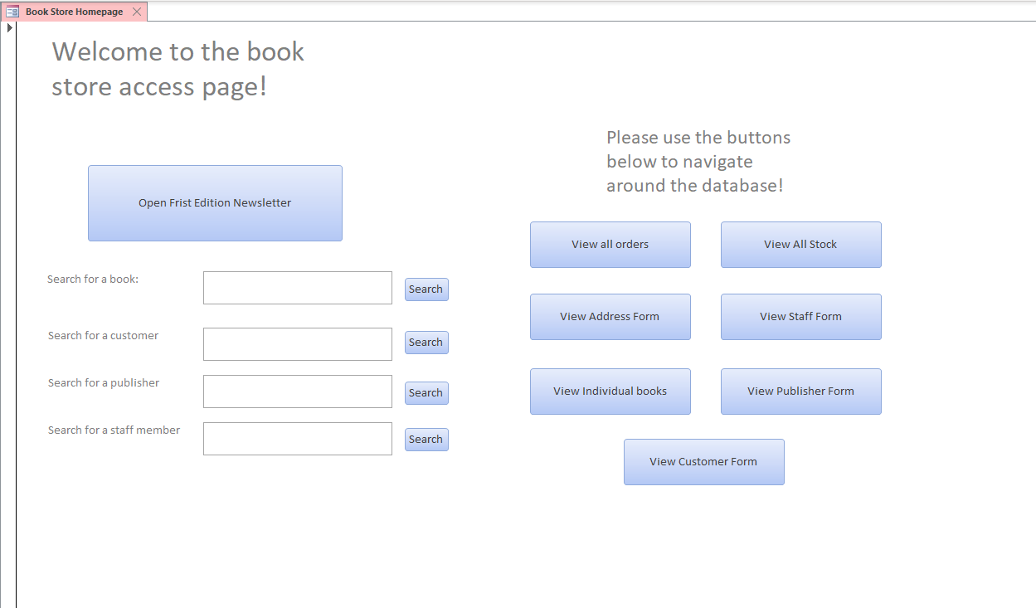

This form has button functionality to allow the user to navigate around the database, Open the tri monthly newsletter and search directly into various tables within the database structure using the search textbox.

To Open the newsletter, click the large blue button as shown below



This will take the user to the newsletter:

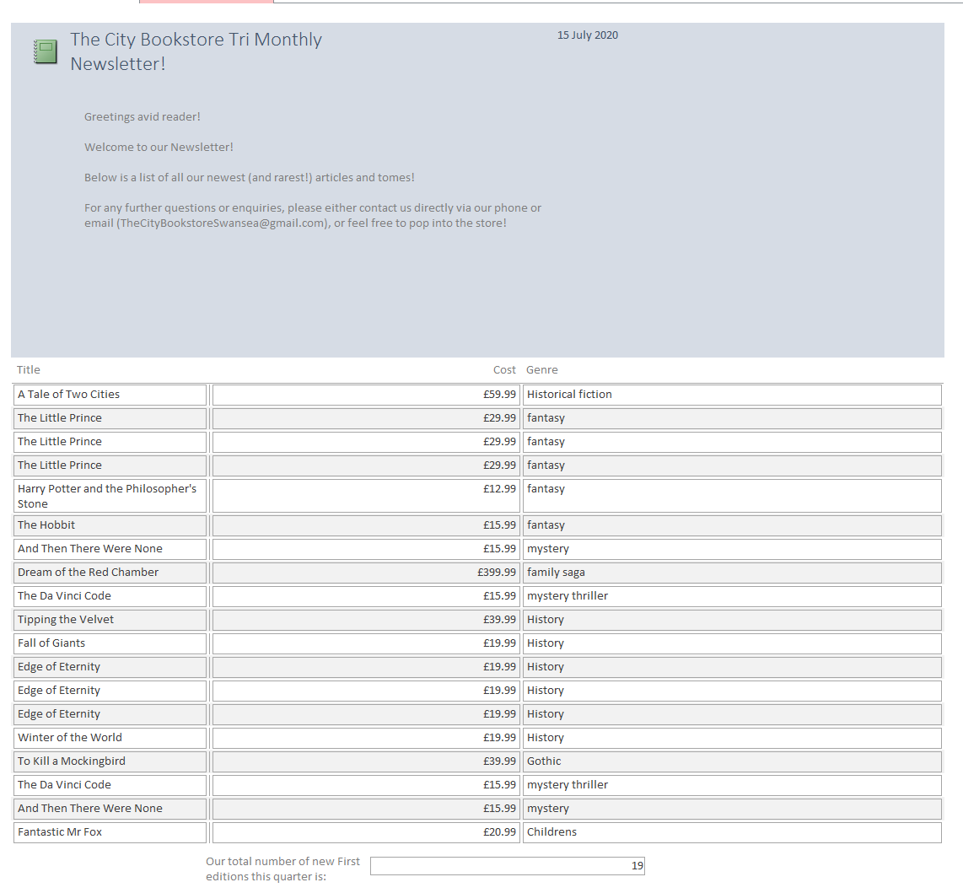
At the bottom of the report a calculation is done to display the total number of new first editions in the database.

To create this feature, a query has been made against the Book table with the additional criteria being that the value within the first edition column is ‘True’. This is the case as when the field type was defined In the table creation, the ‘bit’ type was used which allows for a simple Boolean field restriction to be used.

The search boxes shown below allow the user to use a wildcard search to lookup information from the described fields.
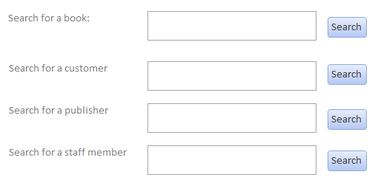
For example, if the user wishes to lookup a book, but isn’t sure of the name, the search will allow for this to some degree:

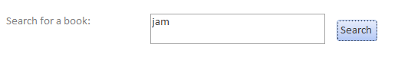
This search brings up a query with result:

The large buttons shown below allow the user to navigate across the other tables within the database as raw forms and queries.

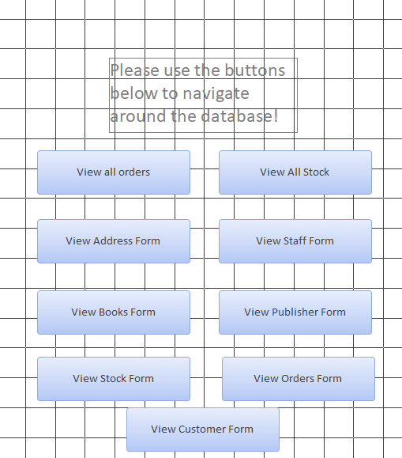

View all orders:
This button takes the user to a query result which shows all orders. Should they then wish to search further into the orders they can use the search bar at the bottom of the query. This has been bound to a macro to run the query.

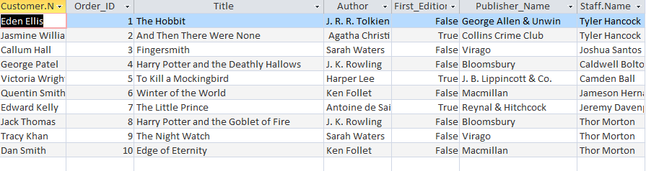
View all stock:
This button takes the user to a query which shows all current stock. They can search further into the results using the search box at the bottom.
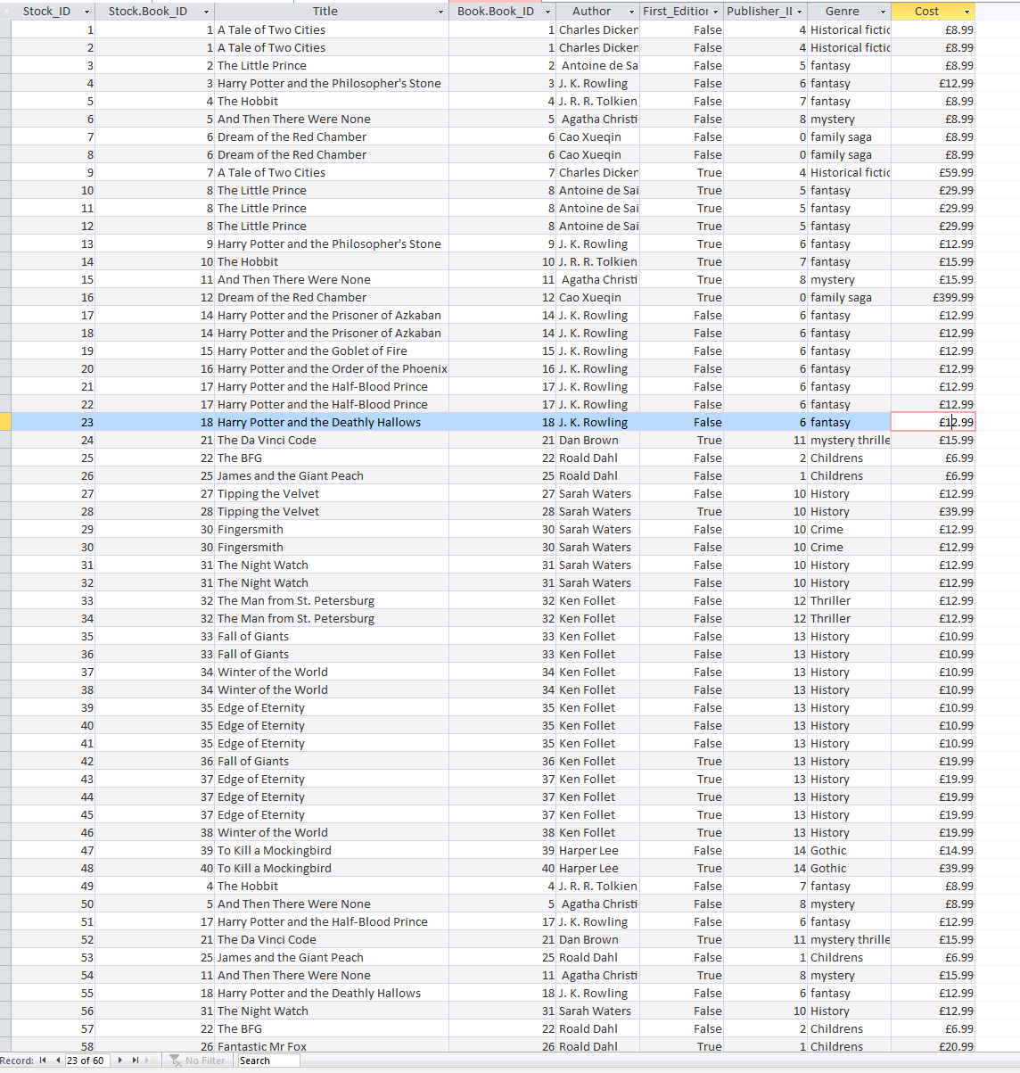

View Address Form:
This button takes the user to a form detailing all of the current addresses stored within the database. There are extra buttons on these forms to allow the user to navigate around the database and to modify the rows within:

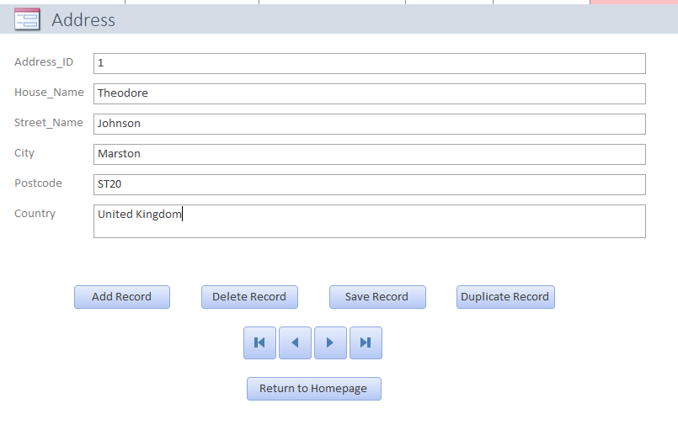
The add record button allows the user to input a new address.
The Save Record button allows the save the current record they are editing.
The Duplicate Record button allows the user to duplicate the currently selected record and assigns it a new ID.
The Delete Record button allows the user to remove the currently selected record.
The navigation buttons function as follows: The first takes the user to the first record, the second to the previous record, the third to the next record and the last to the final record.
The Return to homepage button takes the user back to the homepage form.

This functionality is exactly the same on all subsequent forms to allow the user to become easily adept to its use.

View Staff Form:

This button takes the user to a form detailing all their current staff members, and any associated orders they have placed.

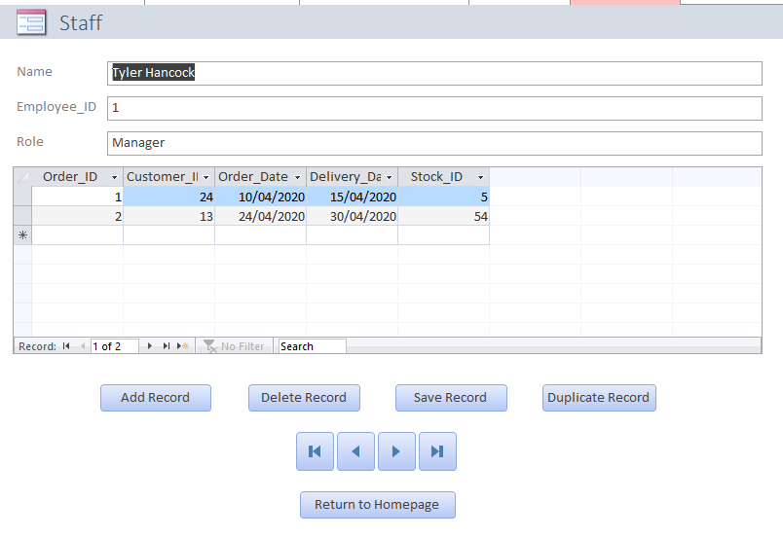

View Books Form:

This button takes the user to a form displaying all current books on the database. It also displays the stock associated with any of these results.

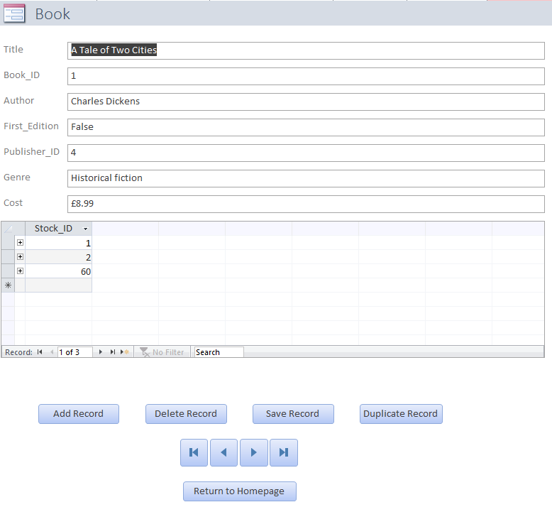

View Publisher Form:
This button takes the user to the publisher form, which displays all current publishers/suppliers. Some books do not necessarily have a publisher or is not applicable.

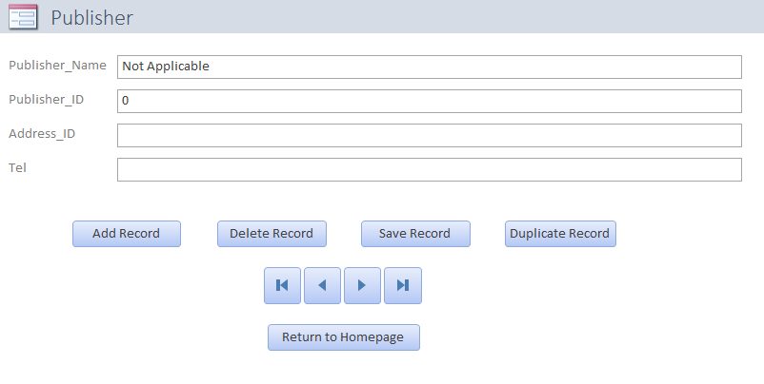

View Stock Form:
This button allows the user to view all current stock, and also displays a case In which an order was placed against that piece of stock.

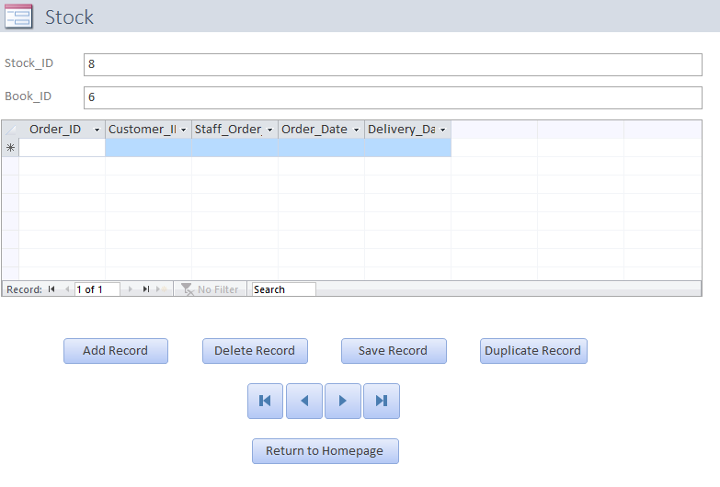
View Orders Form:
This button takes the user to a form displaying all current orders. They can freely create a new order using the provided buttons. The view all orders query has far more functionality in identifying current orders when compared to this individualised view

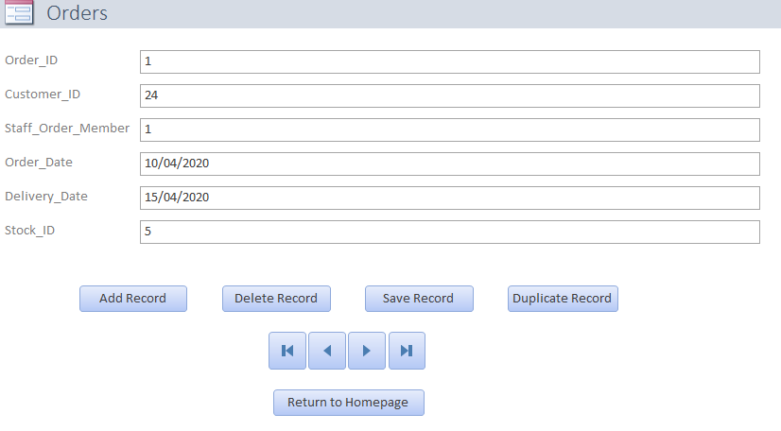
View Customer Form:
This button takes the user to a form detailing all current customers and allows the user to create new ones in the case of new business or interest.

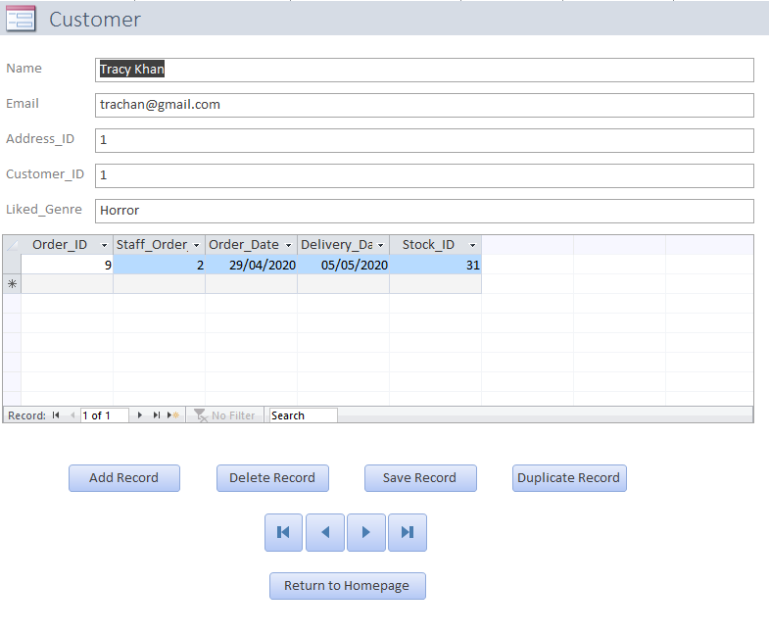

- Entity Relationship Diagram

Relationships were created in the initial setup of the tables using the previously noted SQL scripts. The results of those queries are shown firstly in the relationship model shown within the access database, and then displayed and explained using an entity relationship diagram from Microsoft Visio.

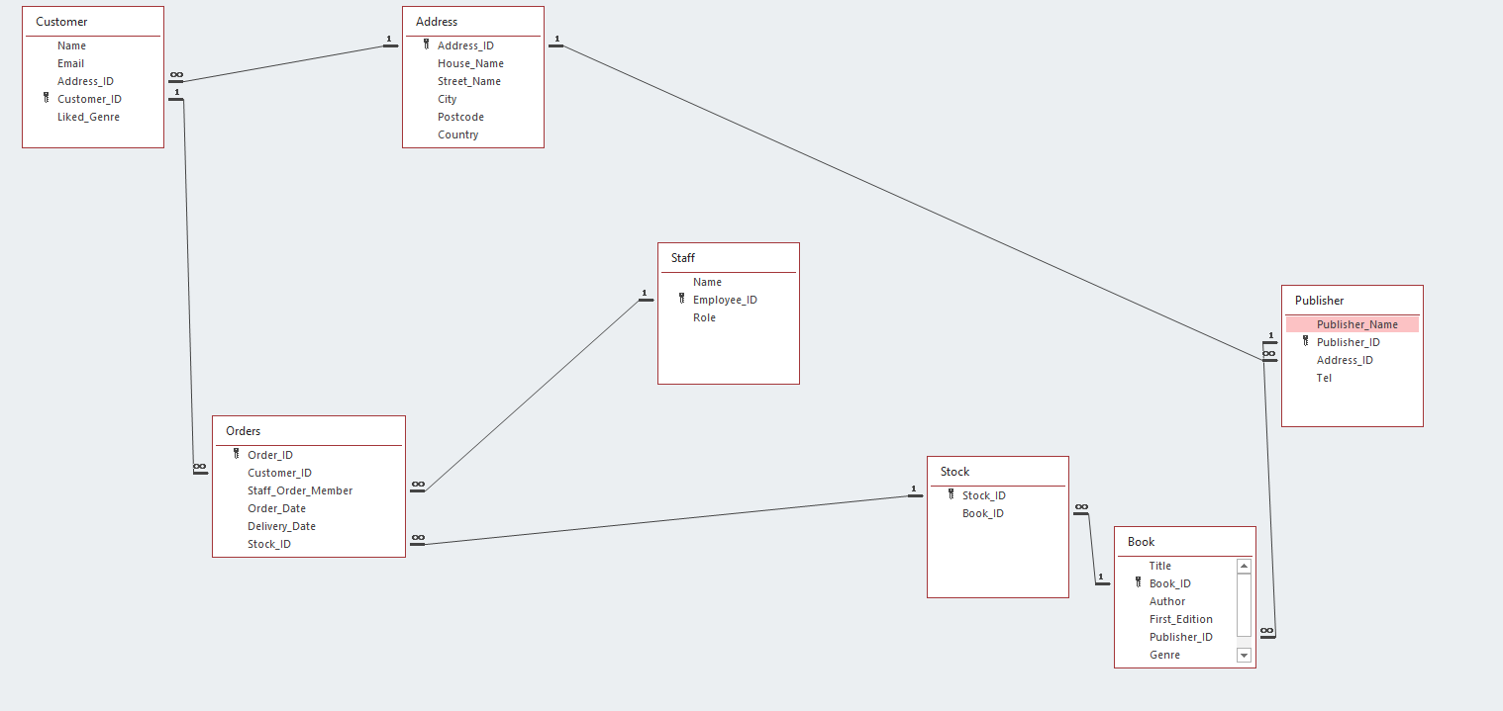
Figure 1. Relationship Diagram Created by SQL In Access

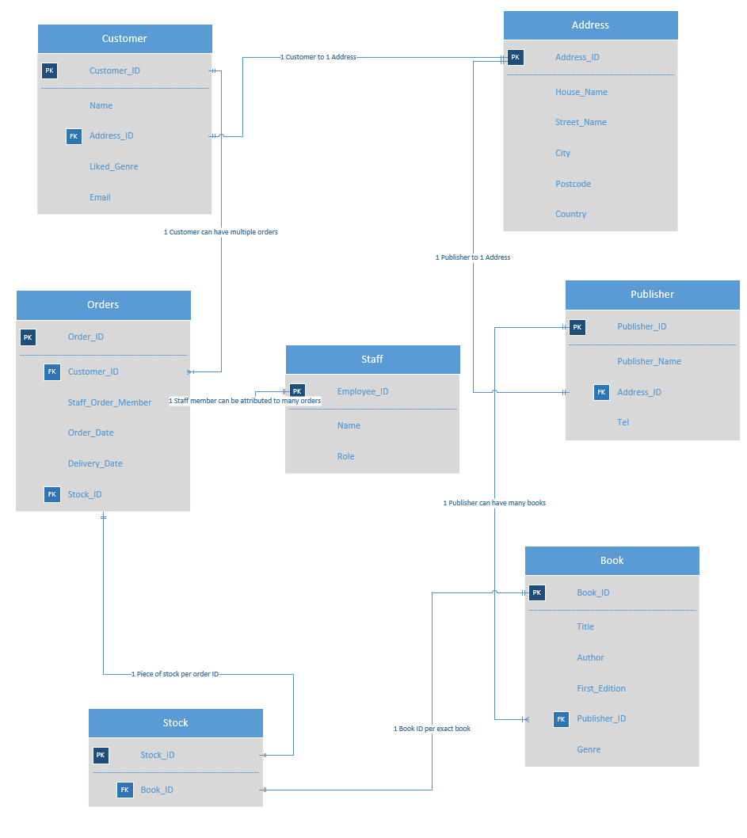
Figure 2. Entity Relationship Diagram Created Using Microsoft Visio

Visio allowed the correct degree of each relationship to be displayed and a brief description of why this was the case. For example between the ‘Customer’ and the ‘Address’ table, a 1 to 1 relationship is the correct type. For the moment it is not required for a customer to have multiple addresses, however this functionality could be added in the future. Between ‘Customer’ and ‘Orders’, it is a 1 to Many relationship as a single customer can have many orders placed.

References

[1] | Wikipedia, "Third normal form," 05 05 2020. [Online]. Available: https://en.wikipedia.org/wiki/Third_normal_form.
[2] | Mockaroo, "Mockaroo - Realistic Data Generator," [Online]. Available: https://www.mockaroo.com/.

