

Module Assignment Submission
Student Name: | Yavor Tanev
Student Number: | 2030046
Module No: | LCBB4004
Module Title: | Marketing Fundamentals
Lecturer: | Mohammad Rahman

Module Code: LCBB4004
Module Title: Marketing Fundamentals

“Blog on LEXUS UK”

Table of Contents
Introduction 3
Background history of LEXUS UK as a brand 4
LEXUS UK as a Competitive Brand 5
The strategy of LEXUS UK 6
Pricing strategy of LEXUS UK 8
Supply chain management of LEXUS UK 9
LEXUS UK marketing strategies for public representation 11
Conclusion 12
References 13

Introduction
Lexus is a premium car manufacturer that is part of the Toyota. Lexus was first developed in the USA in 1989. Lexus is now traded internationally. Eiji Toyoda established Lexus. Lexus is now decided to sell in over 70 countries and regions worldwide, and it is ranked as one of the top ten Japanese brands traded globally (Avila and Isabel, 2008). Lexus' corporate headquarters are in Nagoya, Japan. And the workable facilities are located in Luxembourg, Brussels, Torrance, California, and the United States. The Lexus company is regarded as a luxury product. Lexus has been a valuable business and is presently conducting well. More than 490,000 Lexus automobiles have been sold, with North America accounting for 60% of international sales.


Background history of LEXUS UK as a brand
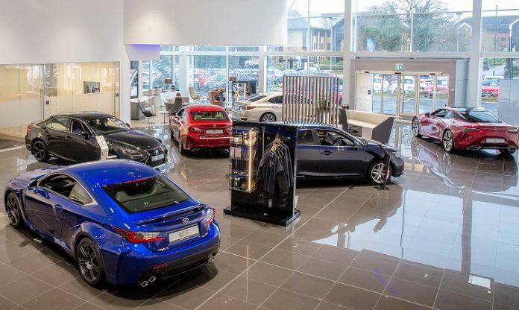
LEXUS is recognized as one of the leading automotive car manufacturing companies, with massive business impact, but LEXUS UK was not this good from the start. Toyota chairman Eiji Toyoda offered some advice to construct the greatest car on the market in 1983. This concern compelled Toyota to launch a highest programme called F1 ("Flagship One"). The F1 initiative, whose final product was the Lexus LS 400, goal of developing a centerpiece sedan which might broaden Toyota's production line by providing it a significant presence in the luxury market and providing an upscale commodity towards both longstanding and innovative consumers. Automakers' ability to outsource more expensive configurations grew in the 1980s as a result of mutual outsource restrictions imposed by the Japanese government and U.S. trade legislators, which limited traditional cars sold. Honda launched the Acura brand in the United States in 1986, influencing Toyota's luxurious cut suggestions; the initial Acura approach was a trade extension of the Honda Legend, which launched in Japan in 1985 as a rival companies to the Toyota.
The Lexus network in the United Kingdom is modeled after the brand's network in the United States, which began in 1989. Lexus models have traditionally been marketed across Toyota dealerships in Europe. Toyota, on the other hand, gave notice of termination to all 67 Lexus dealers in the United Kingdom in December 1997. Only half of the new Lexus distributors are anticipated to be new Lexus manufacturers. Lexus is taking its time granting businesses.
However, the UK is far ahead of other International markets in terms of establishing Lexus businesses. By the end of the year, it expects to have completed up to 30% of its new car companies. Lexus sales have increased faster in the United Kingdom than those in the rest of Europe. UK revenues have accounted for up to 60% of Lexus' total European quantity.

LEXUS UK as a Competitive Brand
LEXUS UK is acknowledged as one of the major and widest automobile industries during the year 2021, and it is classified as the nation's most prestigious company. LEXUS UK's greatest worthwhile asset is its fundamental principle, as well as the brand's adaptability and features, which has contributed to the company's long-term accomplishment. LEXUS UK is a manufacturer which does not presume in the quantity of their merchandise, but rather in the reliability of the service they generate, which they assume will be the distinguishing feature and brought people accomplishment (Long, 2021).
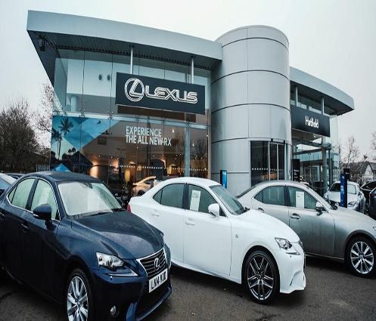
The beginning development of LEXUS UK is considered as low. LEXUS UK focuses on improvement and advancement, and they like to ensure that their rival companies do not have the importance that they might offer, which has made LEXUS UK one of the finest franchises with incredible opportunities in the industry.
LEXUS UK's profitability grows as a result of expenditure management, and they also emphasis on advancement and distinctions to ensure that the LEXUS UK business strategy supports both person's new existences and a luxury brand corporate structure at the same period (Lexus, 2021). And, most likely, LEXUS UK is a manufacturer that evolves trains to confirm that they are trend setters, but rather a product that evolves to the industry order to guarantee the brand's achievement. They have presented new merchandise to the economy, which has increased requirements for the brand because it now has an influence on society.

The strategy of LEXUS UK

The primary goal of LEXUS UK as a manufacturer is to confirm that consumers are pleased with the commodities they receive and that individuals perceive distinctive when acquiring from them. LEXUS UK is both creative and appreciative of the pleasure of any other company's advancement. LEXUS UK, as a product, likes to keep up with and embrace new market opportunities, which is why they are still flourishing in the marketplace.
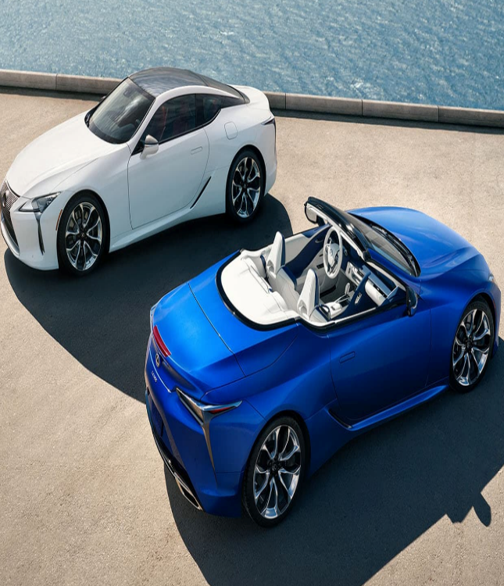
Individuals still have their technology advancement components, and they do coming up with creative attributes of a luxury brand, but ultimately, the reproduction of current trends is also a massive component of LEXUS UK's task. By ensuring that LEXUS UK works hard to develop unique products, the brand's segmentation has grown significantly. Which is why LEXUS UK is identified as one of the largest luxury items, and the desired market that LEXUS UK has prioritized is also into the revolutionary personal style who has the components of a brand (Long, 2016). The primary goal of LEXUS UK is to ensure that companies are unable to replicate the innovated parts that the company is pursuing in order to ensure their accomplishment. LEXUS UK has a large and accurate segment, but their intended audience is extremely narrow. They are aiming for individuals who are self-assured and want to stand out in the apparel world. LEXUS UK has taken the plunge and ensured that the market they are aiming is accurately selected by their components, marketplaces, and intended audience to make certain that the items are correctly prepared and inserted in the correct areas and marketplaces (Kapferer and Bastien, 2012). It really is one of the purposes why, despite reduced manufacturing and lesser merchandise segments, LEXUS UK continues to be one of the most important brands. They sell children's items. Several models were combined, and a luxurious pricing strategy was implemented.

Pricing strategy of LEXUS UK
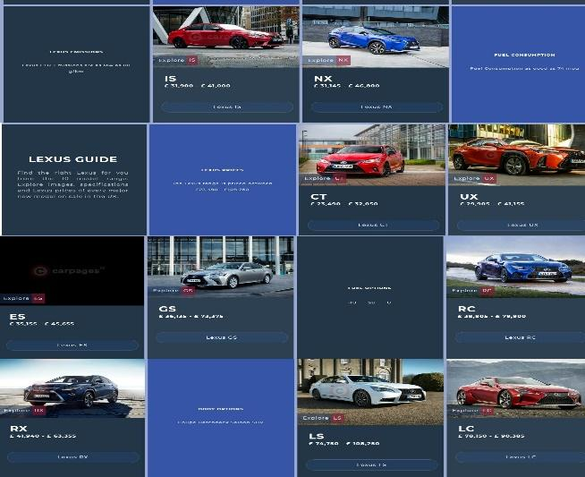
The pricing strategy used by LEXUS UK is the superb and primary mystery to their achievement as a car company or organization. LEXUS UK is a band with pleasant and distinctive merchandise to offer, and LEXUS UK is a corporation that has used premium pricing as their pricing structure, resulting in their minimum cost and maximum apparel element in the business. LEXUS UK has a higher pricing model than the majority of the car industry, but LEXUS UK has very important factors that have propelled them to the top (Car-buying-strategies, 2021).
To begin with, LEXUS UK's prestigious brand image and brand popularity have made their valuations less controversial. They provide high-quality products to their customers, so having a higher price range hasn't damaged the business. Also, while LEXUS UK's production is high, due to cost leadership, they are unable to keep their prices lower than the majority of the brands with which they compete (Kapferer and Bastien, 2012). Furthermore, LEXUS UK has advertising or expenses for raw material costs that will solely add up to the cost of the brand and cause the pricing of the brand to go up towards a competitive pricing strategy.
Subsequently, the cost of an LEXUS UK varies based on expenditure. Numerous manufacturers have adopted elevated pricing methods, but have ultimately realized that the market requires it and that the business has value to offer its consumers. This is why LEXUS UK employs a cost-based pricing strategy (Car-buying-strategies, 2021). Cost-based pricing is defined by the amount of money it costs a company to construct, production, and allocate a goods or services, as well as the profitability that the industry will endure beyond that expenses. The rationale for LEXUS UK's cost-based pricing strategy is to ensure that people who can afford luxury brands with highly competitive prices will be able to find good products with proper pricing strategy from LEXUS UK.

Supply chain management of LEXUS UK
LEXUS UK decided to invest consistently in contemporary IT systems to help supply chain management processes as innovation becomes an increasingly important feature of supply chain. It uses web-enabled sourcing technology from its desired network operator including e-auctions and digital requests for quotes/proposals.
The business is overly dependent on its supply chain's ability to deliver on time and without interruptions to LEXUS UK specifications. LEXUS UK devotes a significant amount of time and effort to recognising and managing potential weaknesses in its outward supply chain (Sanders, 2020).
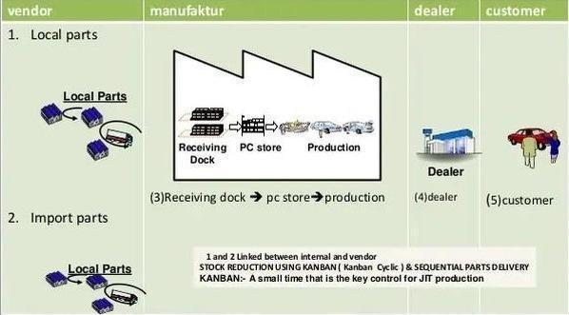
The supply of car portions is a critical component in the car manufacturing supply chain. Supply chain operations must also be effective and satisfy consumers. Differences in transportation items necessitate different formulations at all times.
This is due to each car owner's car model and configuration options. Important parts must also be obtainable for a long duration to automobiles. Several car manufacturers, for instance, sell initial automotive parts which are over old (Abdul Rehman, 2017).
Employees or technicians in each integrated resource must be aware of the specific machinery and aspects that must be installed in each car unit. Obviously, the manufacturing department has organized all background knowledge and required configuration guidelines. That not just, but employees must also understand anything connected to the use of methods to configure materials and determine the correct acceleration configurations per each separate screw that remains. Another of the recommended best places, with a variety of distribution centres available. There's many reasons why LEXUS UK should be regarded as an automobiles sector destination. Several of companions are business strategy points among the configurations of mass transit in order to accommodate the movement of products trans-shipment and the idea of an incorporated globe urban centre with a diverse range of viewpoints facilities. This will contribute to a performance of the business in generating its greatest merchandise (Lexus, 2021).
Ultimately, supply chain management and components are critical. Some automobile manufacturers frequently make the distinction. To be sure, all established factories are required to meet domestically and internationally storage regulations in order for the supply chain to function properly.

LEXUS UK marketing strategies for public representation
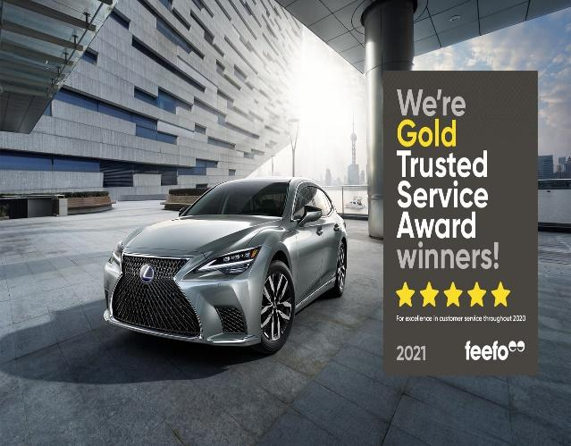
The marketing strategies employed by LEXUS UK are not dissimilar to those employed by other brands, but LEXUS UK has a unique approach to product marketing. LEXUS UK is a brand with a high marketing cost, and any advertisement about LEXUS UK as a brand is uncommon. They use various strategies such as sales and advertising for the brand, but word of mouth is the strategy that LEXUS UK prefers most of the time (Wei-chieh, 2015).

Furthermore, LEXUS UK has a large prospective industry with a large amount of consumers, which is why they do not require any promotional strategies, whether the advertisements of their commodity is done through consumers or through posters and magazines that are published, which is a high-cost bearing marketing itself. Besides which, LEXUS UK's consumer is rather appealing, which is why they must expend so much money on content advertising. Consumers engage in conversation and facilitate responses, and they are also aware of the new things that LEXUS UK is presenting to ensure that they do not miss out on any of LEXUS UK's great sales or products. There are several merchandise on the LEXUS UK webpage, and anyone can view the website and learn about LEXUS UK products at any moment (Wei-chieh, 2015). Social networking and webpages have also prompted the company to make advertising more attainable than ever.

Conclusion
LEXUS is widely considered as one of the world's largest companies, and their core audience and distribution network have helped them become far more popular and effective with each crossing period. The organization is primarily an automobile manufacturer, and have presented it as a trendsetter in order to impact the culture of individuals, particularly those who enjoy the style and would like to stand out in a crowd. The business's promotional methodologies have propelled it to this point.

References
Abdul Rehman, S. (2017). Reverse Logistics and Challenges: Supply Chain Management of Automobile Industry. Advances in Applied Sciences, 2(5), p.80.
Avila, S.I.M. and Isabel, S. (2008). Lexus: a premium brand. The Ritksumeikan Business Review, 47(2), pp.71-89.
Car-buying-strategies. (2021). 2021 Lexus Prices: MSRP, Invoice vs True Dealer Cost. [online] Available at: <https://www.car-buying-strategies.com/lexus-invoice-prices.html> [Accessed 16 December 2021].
Kapferer, J.N. and Bastien, V. (2012). The luxury strategy: Break the rules of marketing to build luxury brands. Kogan page publishers.
Lexus. (2021). [online] Available at: <https://www.lexus.co.uk/> [Accessed 16 December 2021].
Long, B., (2016). Lexus–The challenge to create the finest automobile. Veloce Publishing Ltd.
Sanders, N.R., (2020). Supply chain management: A global perspective. John Wiley & Sons.
Wei-chieh, T. (2015). A Research on Key Success Factors and Integrated Marketing Model of Luxury Brand-A case Study of LEXUS.

