University Of Wales Trinity Saint David
London Campus

Developing relationships and workplace achievement
BMSK5002
Luzidia Tangal - 1605821
Lecturer Name - Ze Zook


Table of Contents
Title | Page Number
Introduction | 3
Critically Asses the potential benefits to the organization and the individual of personally developing individuals in the workplace. | 5
Critically evaluate development vehicles available to an organization appropriate to the development needs of the individual | 8
Develop a plan to meet the identified development needs and expectations of an individual | 14
The process and activities required to implement the development plan | 17
Evidence of wide reading and research, encompassing the application of relevant academic theories and models | 18
Conclusion | 19

Introduction

Faced with so many changes, uncertainties and turbulences that define organizations in the current context, what remains for us is the challenge of survival of organizations that are aware that competitiveness, productivity and quality are not only results of investment in technologies, but investment in the people working in the organization.
The motivation of workers is an issue that has been widely explored in the human resources management. However, there is no way to address this issue without mentioning the satisfaction of the needs of the employees of a company as preponderant aspects to the quality of life of the professionals in the work environment. It is important to know, identify the needs and desires of people and thus contribute to the creation of conditions that motivate employees to participate in company decisions, facilitate personal development, provide means for positive feedback, provide challenges, design a system of rewards, granting benefits and salaries compatible with the function (Maslow, 1954).

Selected Organization – ALDI
In today’s business organizations are worried about their employee motivation and ALDI is not behind from that. It is the role of the HR department of ALDI to work for the wellbeing of staffs and offer better opportunity to them.
The history of ALDI begins 1913 with a family business in Essen, Germany. The name ALDI comes from the abbreviation of Albrecht Discount. Later, in 1961 the Albrecht brothers divided the company into two groups, giving rise to ALDI NORD and ALDI SUD. Currently, ALDI is one of the largest European food distribution companies with more than 30, 000 employees in the UK and Ireland (www.aldi.co.uk, 2019).
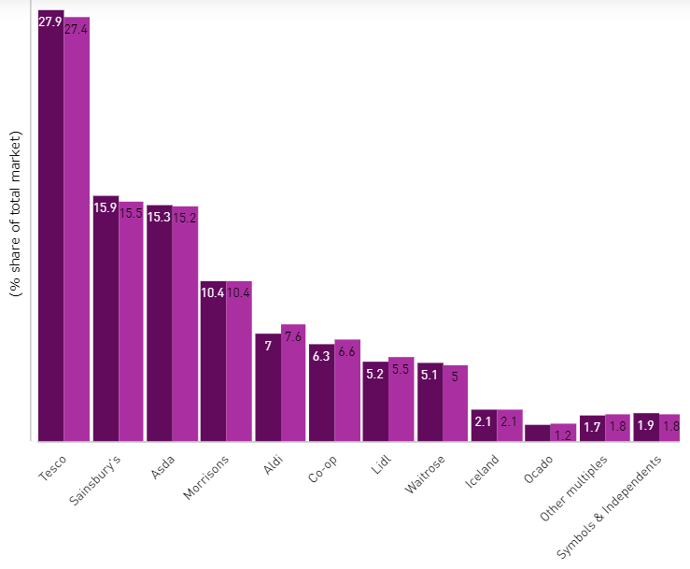
Fig 1 Source: www.retailgazette.co.uk Great Britain Grocery Market Share

ALDI maintained its position as the UK’s fastest growing grocer, to support its growth, ALDI works with employees that are well-trained, motivated and who are passionate with customer service. ALDI believes that it is very important to recruit motivated people and willing to grow within the organization. Therefore, the organization provides fantastic training courses and in this way, ensure that all employees find the personal development they are looking for.
Every individual of ALDI need to shape his construction according to the requirement. It is very urgent to start something when the starting is seem very comfortable, the person feels that he is on the right way and when will be success in the first step his confidence will grow bigger and bigger every day (Sheldrake, 2003). On the work place a person may face different challenges and if he can engage himself busy with the new deals and he can overcome the obstacles the various challenges are seem easy to him and he can make himself with full of variations. Its known to all that the quality of different types, talents and skill are very common to all but it’s very important to show it what the business which is doing by him requires to him. Different business sector run on the base different principle rule so all the employee of that institution should make himself according to the demand of that institution. All are different from each other in philosophy and ideal but when the employee of different minded works together they used to do same thing with each and every employee. And who are able to prove himself he is success in his own sector.

1 Critically Assessment of the potential benefits to the organization and the individual of personally developing individuals in the workplace.

The present condition of the world in business sector is becoming more difficult and competitive. And if a worker can prove his skill then the worker individually will be benefitted beside his company also will be developed. If a worker cannot develop his skill personally he cannot help to develop his company and has to improve himself in his on the base of individual thinking (Hansson, 2001).
Skill - According to ALDI, it is essential to recruit the employee who is skilled like a team mate, situation handling capabilities, to lead organization capabilities, to take ownership of the shop and ensuring safe and well maintained at all the time.
Policy - The organization of the world is changing their policy frequently to be settled down. As like as the organization the individual improvement of every worker is very much needed. The skilled workers are offered different job to join (Sheldrake, 2003).
Personal Development - To show any one capabilities the employees have to have communication skill, technology skill, leadership skill and customer service skill (Hansson, 2001). The employee have to think to participate to related course so that the employee can attain the goal, If the employee want to lead the organization the employee must have to prepare to accomplish the job.
Career - So every employee should increase his skill settle down with the modern world and can develop his career as well as for the development of the organization where he works (Sheldrake, 2003).
Sometimes it is seen that there is a lot of problem around the workers and they feel a lot of problem around but ultimately there is something positive behind worst scenario (Hansson, 2001). There is a lot of way to develop skill and proper utilization. And if one is unable to do that he has to be kicked out from the competitive world.

Benefits of Individuals
There are many ways to the benefits of individuals like teamwork, presentation skills, communication skills etc.
Team work – The individual sets the tone for the group, anticipates other’s needs, cares about other people’s happiness. Through involving team work one can gather different idea from the other team member. At present different educational institute provide a project not to an individual person rather they give it as team work because they want different idea about the work. By doing team work the person can share his idea with the other person who works the team mate (Sheldrake, 2003).
Presentation Skills: Presentation skill is very important for every employee of a company. An employee of a company presents his company and the products so he or she should have a clear concept over the things and has to focus on the things through presentation. Now a days different institution arranges presentation skill training course to improve the subjects and it’s also very effective achieve the knowledge how to develop the Skill (Hansson, 2001). If the employees have no presentation skill they cannot impress the clients by their products.
Communication skills - Communication skill plays the vital role to run a company universally. At present the world is becoming closer to closer and most of the company wants to enter into the international level where the communication skill is most important and who are individually good on communication skill they are very fast in company level. And if an employee has better communication skill his confidence increases rapidly. Beside to make international market its first step to communicate with the nonnative people and then the communication skill plays the important role.
Leading Others – The leading skill it is important since it conveys to the individual confidence, delegates appropriately, makes people feel good about their work and challenges other when they don’t live with ALDI values.
Benefits to organization
By personally developing the individual’s huge benefits are kept in an organization like:
Better Decision Making - A company may need changes any decision frequently so it’s very important to make any decision according to the company need and it also expected to all the employee of ALDI to make decision when it is necessary. An employee can achieve the decision making ability by developing individual skill.
Become More Ethical – It is the first condition for a company to have the ethical and full of morality employee if the company wants to be developed. A worker can be ethical by doing himself individual improvement (Chatfield, 2018). Ethically sound people can everything for his company’s reputation.
Problem solving method - As there is an organization there is problem. It’s very natural to think but it’s very essential to have problem solving employee in an organization. And all the company wants to get those people who are able to solve any difficulty the company faces (Maund 2018).
To get flexible worker - There are lot of people who are multi-talented can do any works which are required to him by the company. All the company always wants to get that type of employee who is able to do any job when it’s needed. And those employees are considered the assets for a company. So the personally developing individual can be helpful to get flexible worker (Sheldrake, 2003).
Get ahead of the competition - the business world is being changed frequently so the company should run with the running world and to do that every company should appoints those type of people who are able to adjust themselves with the changes. The employee should keep new idea and plan in their head as if they can use it when needed.
The ability to attract new talent - All the company always looks for the new talents to recruit. And they try to select the best one for the company. And the talent works effectively from the starting of the company. Beside the company should provide proper training to increase the talent and skill of the employees.
Having more effective staffs - Every employee are not equal skilled in business sector so who those are little behind from other can take lesson from by doing himself developed. And definitely it’s helpful for the person as well the organization.

2 Critically evaluate development vehicles available to your organization and explain the extent to which you think they are appropriate in meeting the development needs of the individual

For an employee the personal learning is the best way to improve in the office sector. The present time is passing with rapid changing so an employee need more personal learning if he wants to be used to in the multipurpose business sector. When an employee can get the right achievement which he tried more and more, then the organization also will be benefitted by the individual improvement of the employee (Hansson, 2001). If an employee wants to achieve success he has many ways to such as:
- Training / career development – It is very important to give proper training to make someone skilled and strong. To improve it ALDI created an Academy at Bolton Distribution Center in Manchester. And it should have some time frame when the training period will start and when will it complete.it must be effective to be success (www.aldi.co.uk, 2019).

- Conflict Resolution – To mitigate internal conflict of employees ALDI has efficient human resource guided plan and program. The conflict resolution plan helps to reduce internal conflict of employees and solve their own.
- Compensation (payroll and wages) – Compensation or benefit package are important for employee motivation. ALDI always tries to maintain employee motivation at highest level so they paid employee compensation time to time. In 2017 ALDI increased wages for the shop floor staff to £9.75 per hour in London and €11.50 per hour in Ireland.
- Recruitment – ALDI have an extensive way of recruitment process. They always tries to recruit effective and efficient human resources so that they will bring efficiency to the organization.
- Time management - In this stage the employee can divided the time which spend to complete any professional course in which time will start and when the course will finish. It also very important as the employee can use his time in proper utilization.so the employee should follow the rules.
- Conference and seminars – conference and seminar is an effective way to learn a lot. In a seminar a lot of participant participate to deliver and present their own feeling and emotions. So an employee also can exchange his feelings and emotions by delivering speech and can gather knowledge from the other and can use the experience in his practical life if he wants (Sheldrake, 2003). Conference or seminar is the place to express oneself and the platform to prove oneself.
- Social network – Social the best way to exchange the experience at the moment. By using the system one can gather vast knowledge and take the experience from other which they share on social network. In this way, an employee can achieve the knowledge how they can be success individually and can do something better in his career. Social network is the popular way to come closer from one corner to another of the world. And one can get the best idea of the people of different country easily can make the proper utilization of those.
- Performing individual - To work as a team work is helpful to learn but it is also very much needed to work individually where one can get the opportunity to take the challenge and overcome all the difficulty single handed.to gather knowledge from other is important but it is more important to use it in the personal life. When an employee can face the different situation in workplace he or she has to solve all the things by taking the challenges he or she must try to overcome the difficulty so they can take confidence that they are able to face any situation successfully (Sheldrake, 2003).
- Effective goal setting – all the works in workplace is not equally meaningful. So it’s important to select the effective one which can help an individual to reach in his or her goal.to set the effective and work according to it is more helpful to be success. In ALDI, the company have to select the goal how to satisfy the client and how to make good bonding with them and this idea may help an employee to get himself success in his working place.

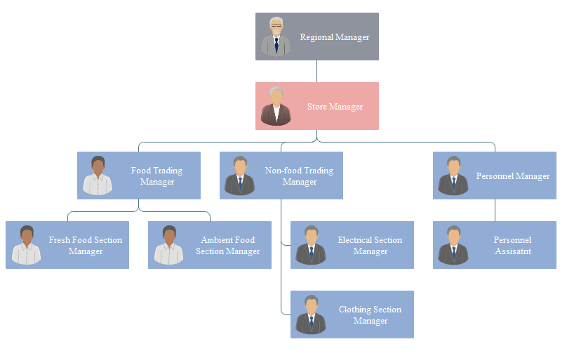
- Organisational structure / Company Hierarchy- organizational structure also known as corporate structure. Organization structure is designed to describe the hierarchical structure of the employees. The hierarchy structure of ALDI is more traditional.

Figure 2: Hierarchical organizational structure of ALDI (ALDI, 2018)

An employee can learn a lot of knowledge by developing himself personally which are very much effective in the workplace by the improvement the employee can be benefitted as well as the employee also can take advantage.
The above mention system and way can help an employee to be success in the workplace where he can show their talent and merit. Through the process like other can also be developed in his working sector fluently.
When the employee try to show their potentiality there need to judge their performance, and there are many ways to justify it among them SWOT is the best as considered. This process ensure the best way to evaluate the working strategy of one employee. Beside it is much needed to make some system like SWO to analysis the performance of the employs who works in a particular company. And it is a way to search out the strengths, weakness, opportunity, threat in the place of profession.
Under to SWOT policy there are arranged examination where the employee can participate to increase their ability to overcome all the fear and they can feel comfort to adjust with the idea. And it is also evaluated how an examinee make answer of the exam how can he face the situation. There are a lot of varieties in the term so that the employee can cope up the fact with his professional life.
The main focus of the SWOT is to make any employee strength and decorated who the office can condition in favor of them. Creating opportunities for the employee is also the target of SWOT. The employee also need to create place on it to evaluate his capability and responsibility (Sheldrake, 2003).
SMART, the most reliable way for any organization to confirm that the organization is going to successful or not, According to the present business situation all the organization should be Followed SMART

S – Specific
M – Measurable
A – Achievable
T – Time - Bound
The main goal of the company to hire the best performer who is able to properly utilize the opportunities and they should have the abilities to manage all the things well. According to ALDI is essential to recruit the employee who is skilled like a team mate, situation handling capabilities, to lead organization capabilities, to manage all the activities capabilities. ALDI suggests the below ideas.
- The prime feature is to increase the opportunities for the personal necessity.
- It is important to make the job for the individual in such way where they can bring their opportunities in their profession
- Rapid response if any customer feels any necessity
- Must should ensure the standard of the good of the organization
- Give priority and support to the employees
Kolb Learning Cycle
This is another way to evaluate the improvement of the individuals and how to be skilled. To learn something there should be some specific way, this process also helps to attain the goal. The Kolb learning cycle ensure the four steps which deals with the concept like
- Reflective Observation
- Concrete experience
- Abstract conceptualization and
- Active experimentation
Individual skills and capabilities against the ALDI objectives
The employees have achieved a lot of skill and developed themselves working in this company. They have attain the capabilities how to manage the customer, how to communicate with the clients, how to work with the group how to take challenge and handle it wisely and beside now they know how to sharpen the knowledge when it is necessary. But to gather all the knowledge and experience they had to take part some essential course which helps them to improve quality, retail savvy and also share their thinking in different seminar and convention (Sheldrake, 2003). Now the employees can do anything effective on the light of their professional experience.

Identify own development needs and the activities required to meet them
It is mentioned frequently that in this competitive age every company or organization want appoint the best performer as their employee .It is also same for the strategy of ALDI. The employees have shown communication skill, technology skill, Company leadership skill and so (Hansson, 2001). They are thinking to participate to related course so that they can attain their goals, If they want to lead the organization they must have to prepare themselves by doing the course successfully. The ALDI employees will trying their best level to get the chance to make them developed.
Personal strategy
We can learn something new reading any articles or thesis too. If we read the biography of the famous person who are successful in their own sector we can learn how they been reached on their target. We can follow the experimental book what are considered as the pioneer of business sector. Different business review is also may be useful to get some clear concept to gain business related knowledge. If we want to be success in this area and want to run my organization with lot of success it is necessary to follow the ideas.

Identify development opportunities to meet current and future defined need
My current and future needs are given below
Current needs: at the current situation WE am looking for a higher degree from a renowned institution. As we could not complete my academic life so WE want to continue it successfully. Hope if WE can complete the entire course with a good result it will help to do better in my professional life and also WE can research for something creative for my organization.
Future needs: Future needs indicate the official performance which WE can delivery for my organization to gain something positive in my work place. WE am trying to achieve my personal skill over different useful subject which are business related. Its little tough to trace which one is future need it can be found in different time according to necessity

3 Develop a plan to meet the identified development needs and expectations of an individual

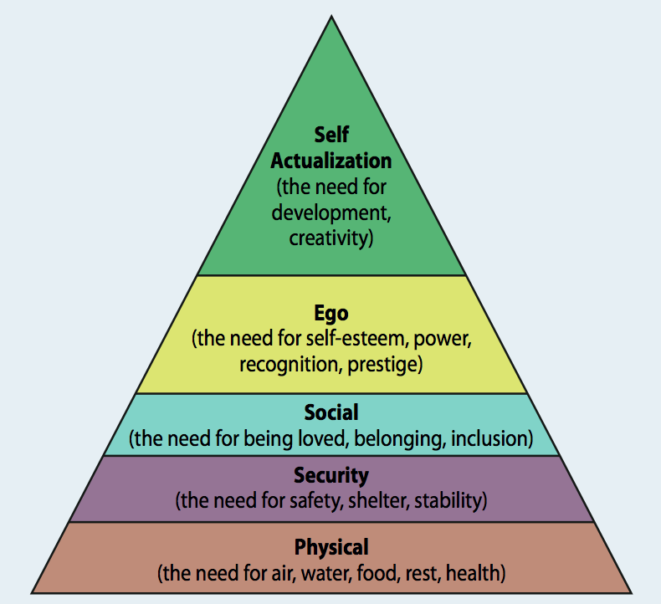
Figure3: Maslow Pyramid Needs
Physical needs are the first stage of the pyramid which ensures the individuals get all basic needs. Security is the second stage and ensures safety and security to the individuals. The social needs achieved when individuals get respect from other, when the individual feels that he is part of the group. The recognition on the employee’s better performance develops self-esteem of the individuals. Final stage takes to the self-actualization which makes the employees to share innovative and creative ideas to the organization.

Herzberg two factor theory
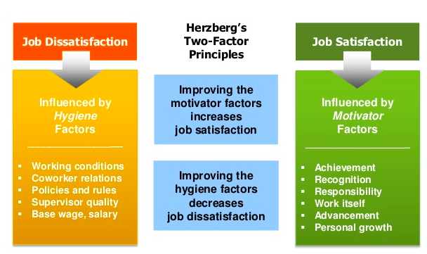
Figure 4: Herzberg two factor theory
The employee should set them which are needy for them and they should create a plan according to their necessity individually. Without making any specific plan no can go to the expected target at all. As it is difficult to point out the future need, it is wise to find out the possible need. As an individual employee need to skilled as the environment of the business world is changing by day because of the influence of globalization so it is much needed to be updated with the changing process. So it is very important to follow a specific process to adjust with the changing world (Hansson, 2001). Which process want to follow are given bellow:
The first duty of the candidate is to create effective curriculum vitae which help to get a good job. As the company first check CV of a candidate so to be considered as a candidate need to make an informative and effective curriculum vitae to get a job in an easy way to find.
It is also important for us to select the short time target which is related with the profession. First of all its important to complete our academic degree so that can get involve ourselves with the related research which will be very helpful for us and for organization
Long time plans mainly may be for five years means where should be placed and we will be happy to see ourselves in which position. It will depend on our engagement on professional life to work in a suitable place where we feel better to work actually.
SWOT evaluation – SWOT evaluation can help us to evaluate ourselves in which stage we are in. It will help to trace about our strength and weakness. So if we follow it we will tested sharply in our work place and can get opportunities to make right of our mistakes.
Defining the time frame – in this stage we can divided time which spend to complete any professional course in which time will start and when the course will finish. It also very important as we can use our time in proper utilization. So WE should follow the rules.
My learning plan – WE should fix learning plan that which will be the best way of learn
Consistent check the individual and working improvement policy

Personal and Professional Development Chart
Action | Resource | When
Further Studies | We will try our level best so that we can get opportunity to be admitted into a famous institution in U K | From June 2019 to January 2020
It Training | We want complete a course on it sector where there is available short courses | We Decided to complete the course very soon and compete it within six months
Time management skills, Decisional skills, and leadership skills | Different courses that are helpful to develop our working skills like decision making skill and others | Wish WE will complete it with in five months from now
Masters in Strategic management | It’s my wish to admit in an institution to take the gradation | We will finish it within one year
Joining the ALDI | Wish we will join the skilled discipline of ALDI by achieving degree | To join the course we should finish the course of masters in strategic management

The process and activities required to implement the development plan

It is very important to make a plan to be individual skilled. So the employee have also some specific plan to attain individual development like
Creating the target time structure - it is most significant to set time frame so that the work which has been done in right time and within preplanned time.
Learning Resources – The employee can make use different social media as our learning resources
Getting the feedback – to get feedback from any work is more pleasing to here and it influence one person to do the best work.
In the meantime it has been mentioned that if the employee read the biography of some famous persons who are related to business the employee can gather vast knowledge and experience through the books and the employee can use the idea in the practical life appropriately (Sheldrake, 2003). The employee can collect some famous. PEST also the best way to evaluate the performance it teach me how to manage different situation in working life.

Evidence of wide reading and research, encompassing the application of relevant academic theories and models
Undertake and document development activities as planned
The development process are planned on the base below activities. Appropriate Training – it is very important to give proper training to make someone skilled and strong. And it should have some time frame when the training period will start and when will it complete.it must be effective to be success
Accomplishment of education – to achieve the goal it’s very much important to complete the strategic management course with in a certain period. It must help to an individual to attain success in the best level.
As it has been explained about many strategic course of business related which my help an individual to improve his or her communication skill, Leadership skill, Management skill and the relationship skill with the customers. But the important thing is that all the courses should finish within a certain period.it may be finished within three months but always it is not possible to finish it in time. After completing the courses all individuals use the knowledge which they acquire from courses have to use in practical life, and then the employee can understand about his or her weakness and strength clearly.so it should be finished as soon as possible.

Conclusion
In the above explanation it can be mentioned that all the organization now want to appoint the employee who are very much talented and skilled in the field of new business concept as the environment of business is changing rapidly and it also show us that in which way an individual can improve his skill on different subject which are very much important to continue a company with success. So every employee should increase his or her skill settle down with the modern world and can develop his career as well as for the development of the organization where he works (Sheldrake, 2003). And if one cannot develop his skill in the workplace by learning in different ways he cannot work in the competitive world where there is always changing the concept of business to fight with the organization of different country. So it is very crucial to run the business without facing any difficulty. But if one can follow any effective plan he can survive.

References:
Alvesson, (2012) Understanding Organizational Culture, London: SAGE.
Engelbert, A. and Kubbe, (2017) Corruption and Norms: Why Informal Rules Matter, New York City: Springer.
Guo, (2015) Cross-Border Management: Theory, Method and Application, London: Springer.
Hansson, O. (2001) The Structure of Values and Norms, Cambridge: Cambridge University Press.
https://www.retailgazette.co.uk/blog/2018/08/aldi-retains-title-fastest-growing-uk-grocer-amid-record-summer/
Kessler, E.H. (2013) Encyclopedia of Management Theory, London: SAGE Publications.
Keyton, (2011) Communication and Organizational Culture: A Key to Understanding Work Experiences , London: SAGE.
Miles, J., (2012) Management and Organization Theory: A Jossey-Bass Reader, London: John Wiley & Sons.
Minkov, M. (2012) Cross-Cultural Analysis: The Science and Art of Comparing the World's Modern Societies and Their Cultures, London: SAGE.
Monin, (2004) Management Theory: A Critical and Reflexive Reading, London: Routledge.
Sheldrake, (2003) Management Theory, London: Cengage Learning EMEA.
Argyris, C., Schon, D. (2008), Organizational Learning: A Theory of Action Perspective, Addison-Wesley, Reading, MA.
Armstrong, M. (2007) ‘Human resource management: a case of the emperor’s new clothes?’,Personnel Management. Vol. 19, No. 8, pp.30-35
Bagshaw M (2004) “Is diversity divisive? A positive training approach”, Industrial and Commercial Training 36, 4, 153-157
Beer, M., Spector, B., Lawrence, P. R., Mills, D.Q., Walton, R. E. (2004), A Conceptual View of HRM. inManaging Human Assets. Free Press, New York Chap.2
Beardwell, I., Holden, L. and Claydon, T. (2004) Human Resource Management a Contemporary Approach, 4thedition, Harlow: Prentice Hall

