Introducing the Modern Workplace
LCBB4003
Student Name:Alexandru Baractaru
Student ID:2129397
Lecturer: Dr Hoang Dang Nguyen

Table of Contents
Introduction 3
Main Tasks 4
1. How the organization’s structure and culture related to its performances 4
2. How the employees are motivated at Barclays 7
Conclusion 9
References 10

Introduction
Organization requires a specific structure that can be explored through the establishment of appropriate organizational cultures. Their combination can affect the productivity and profitability of the business (Cox & Klinger, 2011). This report will consider the case of Barclays. Through the observation of this business, the required questions will be answered. Besides, this report will highlight the concept of motivating employees significantly through the utilization and implementation of motivation theories.

Main Tasks

1. How the organization’s structure and culture related to its performances
Organizational structure is one kind of formal system of task as well as authority relationships that support controlling how people cooperate and utilize resources to obtain the ultimate objectives of the business. An organizational chart is related to the organizational structure which is the visual description. Organizational structure in a business supports controlling coordination and motivation within the workplace (Buchanan & Huczynski, 2019). An effective and appropriate organizational structure can give an appropriate shape to the behavior of employees or staff in the business so that a calm and peaceful environment can be ensured. It is a response to contingencies involving environmental technology and human resources that evolve as organizational growth and differentiation. It can be managed and changed via an appropriate process, especially the procedure of the organizational design. It represents the process of developing an organizational performance that can be used for correcting the process of measuring organizational performance. In this case, the correct design of structure can bring sustainability as well as efficiency in the field of workplace and overall business operation. It is said that an efficient structure of a particular business can help drive the mindsets of employees toward the ultimate objectives of the business (Cole & Kelly, 2020). In this field, the characteristics of a good manager do not matter that can support the development of the organizational structure. Besides, this can also support developing the overall performance of employees and workers. It is the structure of a business that follows different approaches that can be either vertical or horizontal structure but the chain of command may vary according to the divergence of such organizational structure. This can also support coordinating different parts of the business and different fields of work. As a result, flexibility for responding to future demands and developments and adapting to the change in environmental influences can also support performing diligently. This can also ensure social satisfaction among members working in the business. This can support nourishing accountability across the workplace. Besides, it is tried that flexibility in the workplace can support responding to future demands and developments. In this field, the change in environmental impacts can also support performing diligently and this can also help ensure social satisfaction among the members working in the business.
Barclays has a distinct organizational structure and leadership that can support operating as two divisions including Barclays UK and Barclays International and both are supported by the service. The organizational structure of Barclays looks like this:
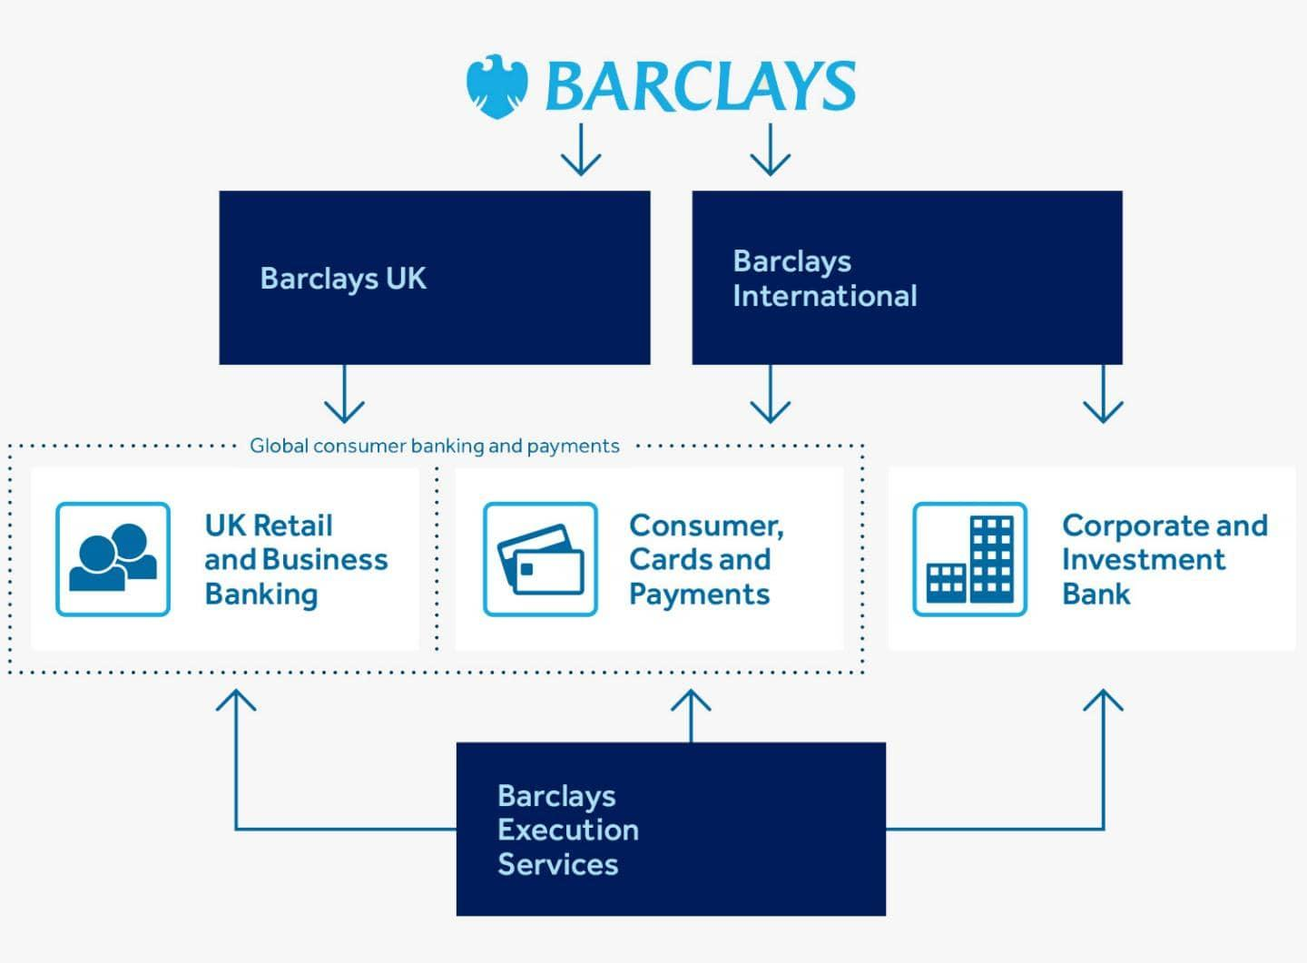
Figure 1: Organizational structure of Barclays
Source: (Barclays, 2023)
The entire branch has two significant parts. The first part always keeps exploring the concept of personal banking regarding the overall banking concept. The branch of Barclays in the UK indulges in offering retail solutions so that Barclay’s entire organizational structure can offer retail solutions. This part of Barclays always focuses on leading credit card providers, offering flexible borrowing, and payment solutions, especially when it is time to lead a customer experience (Barclays, 2023). But there is another branch that does not require any ring-fenced bank as well as subsidiaries. The international branch of Barclay’s considers diversity and inclusion to be highly promoted and encouraged where the main purpose of this kind of promotion and encouragement is to explore creativity and innovation across the business.
A business needs to have an effective organizational culture so that the entire business organization can explore the concept of dedication and its significance for obtaining the ultimate objectives that support exemplifying and amplifying (Kudaibergenov et al., 2023). It is proof that rituals, stories, and significant concepts regularly. That means it is actuated in an architecture of organizational practice and process that highly promotes the concept of effective performance and efficiencies in the field of entire business operations.
Overall, the organizational culture of Barclays is based on four major values. Firstly, respect in the workplace of Barclays always exists that highlighting the concept of recognition and proper treatment in the workplace. Besides, integrity is another value found in the workplace of Barclays. Excellence and stewardship are also part of the values in the workplace of Barclays.
Impacts of organizational structure and Culture on Performance: A positive work culture keeps promoting both productivity as well as engagement. Besides, the managers in the such workplace can ensure the continuous development of the employees’ experience. That means a positive and efficient organizational culture always supports obtaining the ultimate success and reaching the long-term vision of the business. On the other hand, a negative organizational culture always impacts productivity phases that support increasing turnover rates and employees in the workplace cannot concentrate appropriately which can help them increase the productivity and profitability of the business (Mullins, 2019). That means employees in the such workplace if Barclays experience this, will be discouraged which will keep demotivating them in terms of obtaining the ultimate objectives and goals of the business. Alternatively said their motivation, dedication, passion, and interests will keep lowering day by day. As a result, productivity levels will get affected. Employees do not find interest in working in that workplace and feel disconnected from their distinct work. That means an effective organizational structure supports developing operational efficiency by ensuring clarity among the employees at all phases of a business.

2. How the employees are motivated at Barclays
For any kind of business, motivation is an essential as well as crucial issue that specifies the reasons for which people behave in a particular way and do what they do. It represents the available needs and demands of the employees so that appropriate actions can be undertaken for motivating them. It also indicates the procedure that highlights the contributions of employees that need to be energized, directed, and sustained so that appropriate actions can be undertaken for motivating the employees. In the workplace, motivation is quite crucial that accelerating the performance of each employee and that is why this is the function of ability and motivation. Motivation theories may be less relevant across cultures that specify that behavioral modification can improve the performance of the business (Temminck et al., 2013). Positive impacts are always seen more than negative impacts that can support overcoming the nature and scope of obstacles through the appropriate implementation of motivational theories and techniques. This also plays a significant role in the field of business operation and the workplace of Barclays. There are divergent theories of motivation that are applied for accelerating the process of motivating the employees in the business.
Maslow’s hierarchy theory: Like other businesses, Barclays’ HRM focuses on psychological needs including air, water, food, etc. In the workplace, this can insist on providing proper payment, a friendly work environment, and perks. Then, safety needs to be ensured regarding employees’ health, employment, and security. As a result, safe working conditions, job benefits, and job security or satisfaction are the core issues in the field. On the other hand, social issues are also envisaged including love, affection, and a sense of connection (Mullins, 2019). Self-esteem in the workplace job title, high-status job, and feedback from the messenger is an essential issue because it envisages status, self-respect, and recognition across the business, like Barclays. Finally, self-actualization consists of growth, creativity, and advancement, and for this, HR needs to envisage some major organizational factors.
Herzberg’s two-factor theory: This theory insists on exploring two motivators and hygiene factors. Motivators always insist on exploring the concept of divergent but significant issues related to the business can be explored. This theory is also applied in the field of Herzberg’s two-factor theory which can help highlight the concept of motivating employees in the workplace (Kudaibergenov et al., 2023). On the other hand, hygiene factors also consider some major issues, like supervision, company policy, relationship with supervisor, efficient working conditions, and so on. The HR needs to play leadership roles so that they can explore the concept of motivators as well as hygiene factors that make someone extremely satisfied or dissatisfied but it is dependent on the concept of HR.
McClelland’s achievement motivation theory: According to this theory, four major around-based, and socially developed motives are essential in this field. This theory also requires achievement, power, affiliation, and avoidance motives. In this field, four major traits are found and they include average difficulty in exploring the tasks or activities (Temminck et al., 2013). On the other hand, personal responsibility for performance can highlight the need for unambiguous feedback on how well they are performing. Besides, more innovative as well as creative concepts within the workplace can be explored.
Vroom’s expectancy theory: According to this, employees require some particular behavioral aspects in the workplace of Barclays and they are allowed to select particular alternatives for maximizing pleasures or enjoyment as well as minimizing pain. Key elements of this theory include valance, instrumentality, and expectancy. It is an expectancy that is one kind of belief where the more effort needs to be expanded on a task, the greater the performance in the workplace. In this case, the value of a person is measured by attaching to a given reward and this can be an extrinsic or intrinsic reward (Stocki & Łapot, 2015). On the other hand, instrumentality requires the belief that employees in the workplace will perform well and for this, the entire business will receive a greater reward. In this field, the person’s confidence in being able to get the outcomes expected can also be measured. Finally, the value the managers at Barclays can place on the expected outcome of employees’ efforts. It supports measuring the extent to which an individual in Barclays believes that the manager or organization will deliver the rewards that were promised.
Equity theory of motivation: It helps focus on ensuring appropriate equity, especially if they have been treated while comparing with other treatments. A feeling of inequality causes several negative issues, especially regarding the concept of inequality. Equity at the workplace, like the workplace of Barclays, indicates the process that supports focusing on workers’ perception of the fairness of their outcomes and inputs. In this field, they strive to maintain ratios of their distinct rewards to contributions which are equal to others’ ratios (Kudaibergenov et al., 2023). The HR of Barclays considers two major issues, including inputs and outputs. In the case of inputs, time effort, ability, loyalty, etc. are considered, and outputs consider pay, bonus, perks, and benefits.

Conclusion
After completing this report, it was understood that an effective organizational structure and culture always impact the concept of productivity and profitability of the business. This report has highlighted this issue through the exploration of the impacts of organizational structure and culture. Then, different motivational theories have been discussed for showing how employees are motivated within the workplace at Barclays.

References
Barclays (2023) Barclays Group Structure and leadership, Barclays. Available at: https://home.barclays/who-we-are/structure-and-leadership/ (Accessed: April 17, 2023).
Buchanan, D.A. and Huczynski, A. (2019) Organizational behavior. 10th edn. Upper Saddle River: Pearson.
Cole, G.A. and Kelly, P. (2020) Management theory and practice. 9th edn. Andover, Hampshire: Cengage Learning.
Cox, W.M. and Klinger, E. (2011) “Systematic motivational counseling: From motivational assessment to motivational change,” Handbook of Motivational Counseling, pp. 273–302. Available at: https://doi.org/10.1002/9780470979952.ch11.
Kudaibergenov, Z.B. et al. (2023) “Analysis of the influence of motivation on career management using the two-factor theory of Herzberg,” Farabi Journal of Social Sciences, 143(1). Available at: https://doi.org/10.26577/be.2023.v143.i1.010.
Mullins, L.J. (2019) Organisational behavior in the Workplace. 12th edn. Harlow, England: Pearson.
Robbins, S.P. and Coulter, M.K. (2020) Management. 15th edn. Pearson (Global).
Stocki, R., and Łapot, A. (2015) “Vroom’s participation model as a foundation of Organisation Audit: A new approach to CSR,” New Perspectives on Corporate Social Responsibility, pp. 191–212. Available at: https://doi.org/10.1007/978-3-658-06794-6_10.
Temminck, E., Mearns, K. and Fruhen, L. (2013) “Motivating employees towards sustainable behavior,” Business Strategy and the Environment, 24(6), pp. 402–412. Available at: https://doi.org/10.1002/bse.1827.

