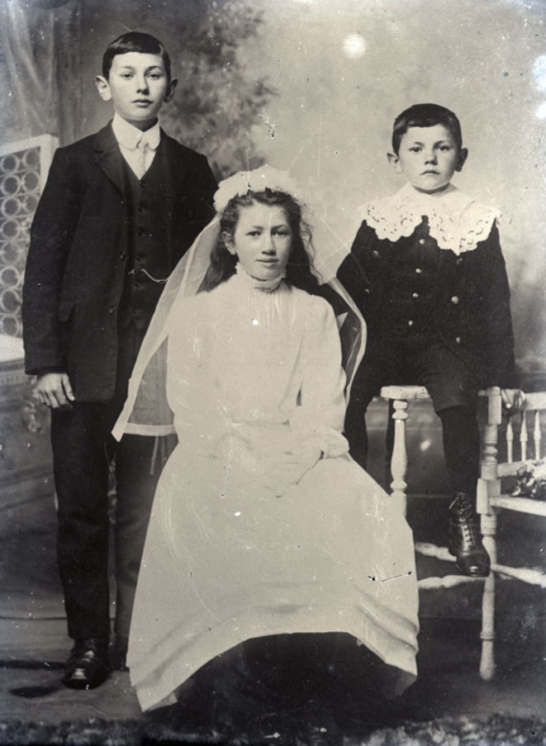
My brothers and I photographed in the drawing room, 1875

My name is Frances Edith Higgon. I was born on 25th June 1863, and I am 12 years old. My Papa is John Donald George Higgon and my Mama is Edith Emily Higgon, but most call her née. I have three brothers, John Arthur, who is ten years of age, Victor James, who is 7 years of age, and Archibald Belliers who is three years of age.
We live at Scolton Estate in Spittal, Pembrokeshire. Our family home replaced a former building, which had burned down in 1850. My Mama told me that our family has resided on the land since the 16th century. We have a good life here. There are acres of grounds for us to explore and we have stables with horses. My favorite is a mare called Folly who is all black with quite a temper! My Governess, Ms Anna, will not let me ride her no matter how much I plead with her. My brothers enjoy building dens in the woodland at the end of our paddock. They never let me join in with their games and how they tease me so!
My brothers attend Grammar School in Haverfordwest, but I must stay at home with my Governess and prepare for when I become a young lady. I learn to sew, cook, sing, and play the piano. Mama always tells me etiquette is important. I must make sure I keep my clothes clean and not creased, otherwise, Ms Anna will scold me. Mama has said now that I am twelve, I can soon begin accompanying her when she calls on other ladies which I very much look forward to. Papa is often out on business, but I do look forward to when he returns home. Especially when he brings me a gift. Last time he brought me an adorable doll whom I named Rosie. He often takes my brothers out hunting and last time they caught a pheasant!
When my brothers are older, they are going to join the Royal Artillery like Papa did. I will miss them dearly when that day comes. As for me, I will stay at home with Mama until Papa finds me a suitable husband once I come of age.

