
APPENDIX GA36a

LEVEL 4 ASSESSMENT SPECIFICATION

Student name: | George Butcher | Student ID number: | 2425267
Programme: | BEng OME
Module: | Physics
Module code: | ACDB4007 | Contribution to Overall Module Assessment (%): | 50
Lecturer: | Prof Kelvin Donne | Internal Verifier:
Assignment Title: | Computational modelling of ballistic impact | Word count (or equivalent): | 2000
Submission deadline: | Monday 19th May 2025 3pm | Return date of provisional marks & written feedback: | Monday 26th May 2025
Submission method: | All written assessments, where practical and possible, must be submitted via Turnitin unless otherwise instructed by the Lecturer. (Please DO NOT put this assessment specification into Turnitin or it will match many similarities with other students’ submissions.)  Alternative submission method (if applicable):  Late submission of the assessment will result in a late penalty mark:  Work which is submitted up to 1 week late will be capped at 40% for the first attempt and will be awarded a mark of 0% for re-assessment. Late submission penalties may be lifted only if there is an approved extenuating circumstances claim.  Work submitted more than 1 week late will be considered as a non-submission and will not be marked. The work may be considered as a submission for reassessment if offered by an Examining Board or if there is an approved extenuating circumstances claim.
Academic honesty / referencing: | Academic honesty is required. In the main body of your submission you must give credit to authors on whose research and ideas your work is based. Append to your submission a reference list that indicates the books, articles, etc. that you have used, cited or quoted in order to complete this assessment.

Table of Contents
Introduction 3
Abaqus Simulation 3
Results 4
First simulation – 1000m/s 4
Shear Stress. 8
Max Principle 10
Second simulation – 200m/s 12
Shear Stress. 15
Max principle 17
Discussion. 18
Conclusion 20
References 21

Introduction

For this assignment the learner is exploring the different stresses and strains of a high-speed ballistic impact onto a target plate. The simulation and results have all been produced on Abaqus. The learner was responsible for changing the materials of the projectile or the plate as well as creating a variable over two separate simulations so they could discuss the differences. After the simulation the leaner will have to investigate the direct and shear stresses of the projectile penetrating the plate, in order to understand the likely cause of plate failure.

Abaqus Simulation

Regarding the Abaqus simulation the student used a model file provided by the lecturer. Firstly, the student needed to decide on the materials used for the projectile and plate in the simulation. For the plate, the student used Aluminium. The behaviours of this material were found using Johnson Cook figures, provided by the lecturer, this can be seen in Table 1 below. For the projectile, the student used
Ti 6Al 4V (Grade 5) Titanium Alloy, this was found by the learner and the material properties of the Titanium Alloy can be seen in Table 2 below [1] [2].

Material Behaviour | Notation | Value
Mass Density |  | 2703
Shear Modulus |  | 26000000000
Reference Sound Speed | c0 | 5240
Slope of the Us-Up Curve | s | 1.4
Gruneisen Ratio | Gamma0 | 1.97
Yield Strength | A | 324100000
Strain Hardening Coefficient | B | 113800000
Strain Hardening Exponent | n | 0.42
Thermal Sensitivity Parameter | m | 1.34
Melting Temperature |  | 925
Transition Temperature |  | 293.2
Damage Constant 1 | D1 | -0.77
Damage Constant 2 | D2 | 1.45
Damage Constant 3 | D3 | 0.47
Damage Constant 4 | D4 | 0
Damage Constant 5 | D5 | 1.6
Reference Strain Rate |  | 1
Table 1 – Material behaviours of Aluminium.
Material Behaviour | Notation | Value
Mass Density |  | 4430
Young’s Modulus |  | 114500000000
Poisson’s Ratio |  | 0.345
Yield Strength | A | 862000000
Strain Hardening Coefficient | B | 331000000
Strain Hardening Exponent | n | 0.34
Thermal Sensitivity Parameter | m | 0.8
Melting Temperature |  | 1660
Transition Temperature |  | 1604
Damage Constant 1 | D1 | -0.09
Damage Constant 2 | D2 | 0.25
Damage Constant 3 | D3 | -0.5
Damage Constant 4 | D4 | 0.014
Damage Constant 5 | D5 | 3.87
Reference Strain Rate |  | 1
Table 2 – Material behaviours of Ti 6Al 4V.

After the materials were chosen for the projectile and plate the student decided to use the speed of the projectile as the variable to compare the different results. For the first simulation the learner had the projectile going at 1000m/s, for the second simulation the learner had the projectile travelling at 200m/s [3]. This provided the learner with totally different results to compare. The results from each simulation can be seen below.

Results

First simulation – 1000m/s

For the first Simulation the max principal values used can be seen below in Figure 1. The black values show high levels of compressive stress, this is a force that shortens or compresses a material, like when something is squeezed or pushed from opposite directions. The red and grey values shown below are high levels of tensile stress, this is a force where the material is resisting being pulled apart when it's being stretched or elongated.
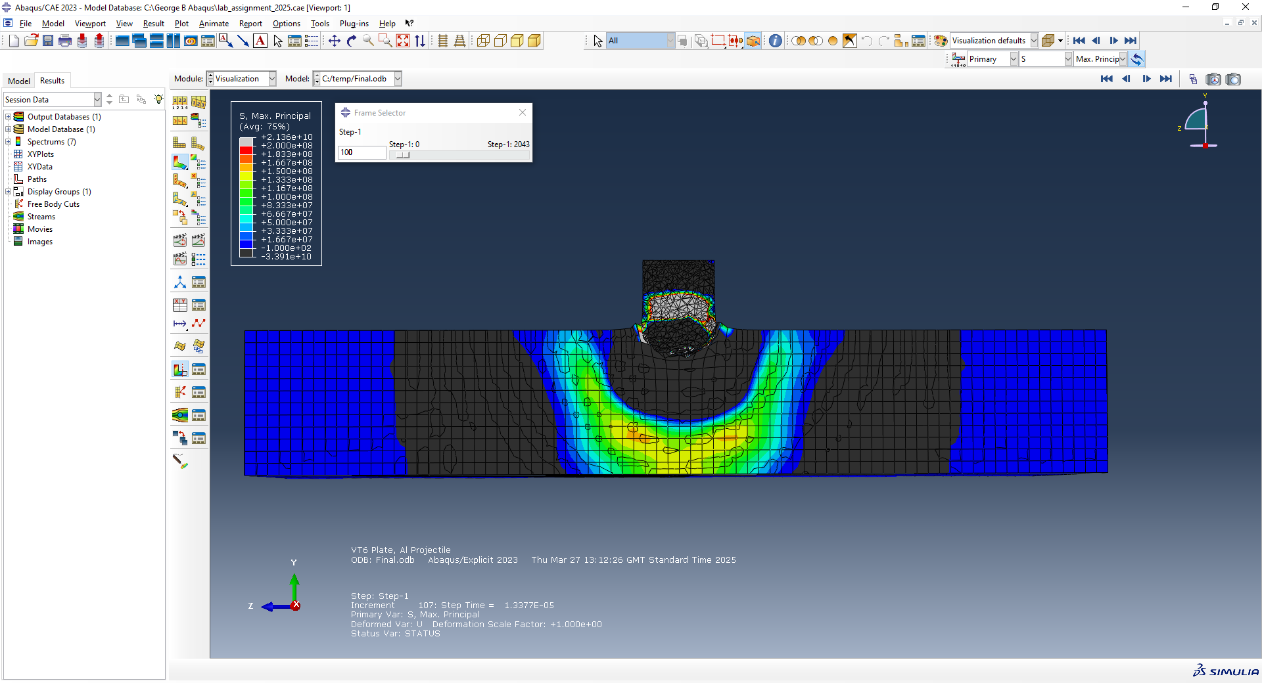
Figure 1 – Max principal values.
Firstly, in Figure 2 below, it shows the simulation before the projectile comes in contact with the plate. As it can be seen, there is no stresses or strain on either the projectile or the plate before contact is made. Both bodies are in equilibrium.

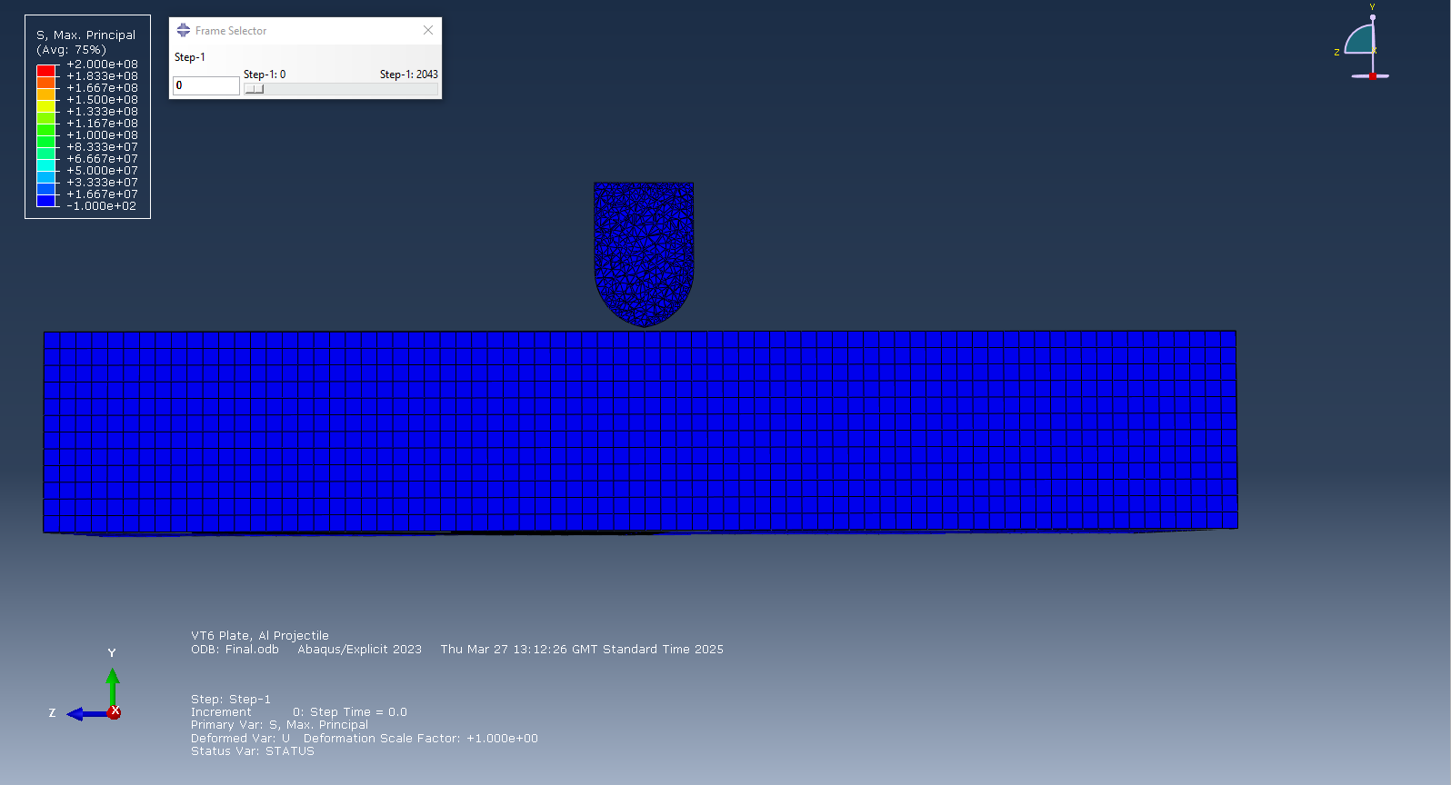
Figure 2 – Pre-impact condition.

Secondly, in Figure 3 below, this shows the initial impact of the projectile hitting the plate. The initial impact causes high levels of compressive stresses to the point of the projectile as well the impact point on the plate. It can also be seen that there are tensile stresses moving towards the back of the plate. This is because as the projectile strikes, compressive waves move forward while tensile waves propagate backward due to momentum transfer and boundary conditions.

Figure 3 – Initial impact.

Next, in Figure 4 and 5 below, it shows the projectile about half way through the plate. There is continued compressive forces at the front of the projectile as well as the impact point within the plate. However, the tensile stress on the plate have increased with the plate having the highest level of tensile forces at the bottom of the plate. This is due to the projectile continuing to displace material, causing shear and tensile forces to increase. The plate stretches and begins to fail due to ductile tearing.

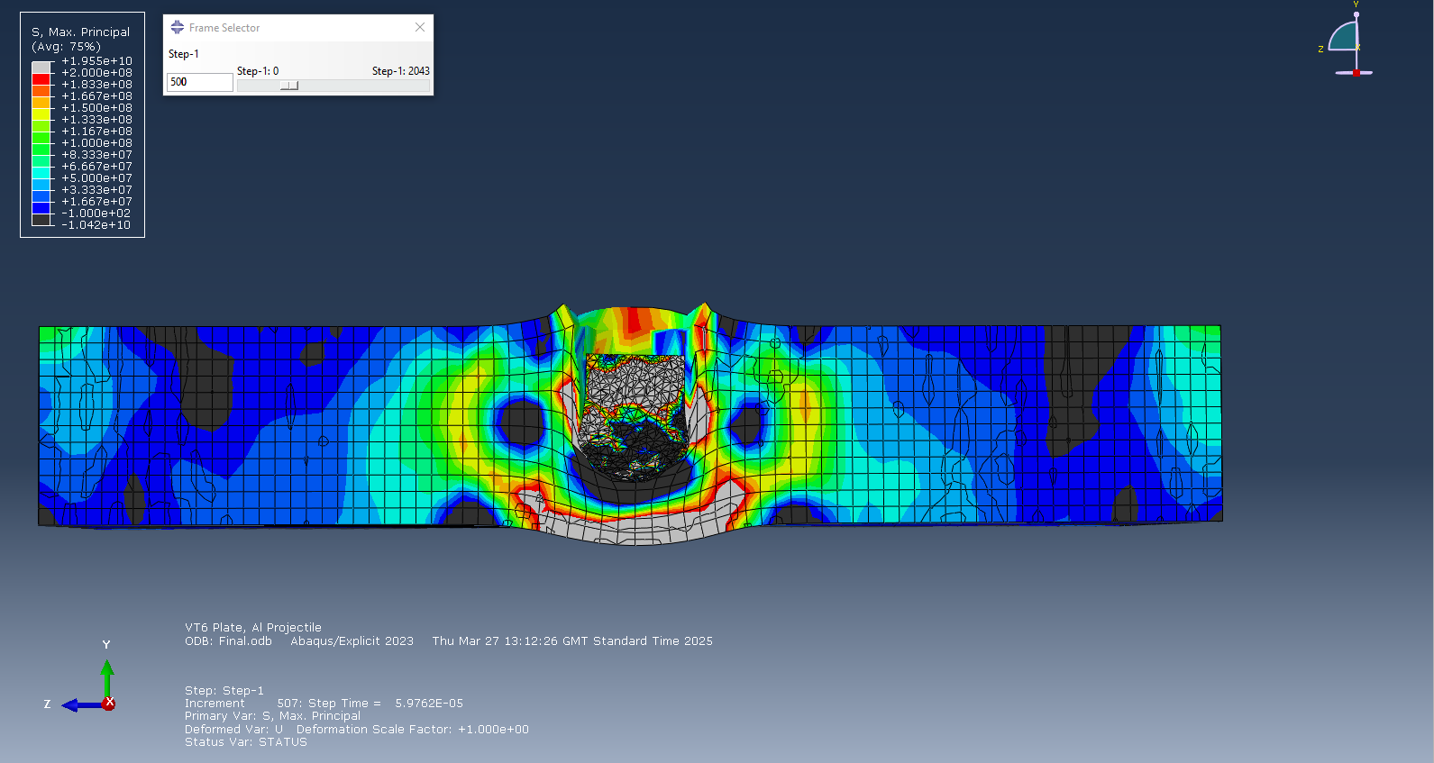
Figure 4 – Mid-Penetration
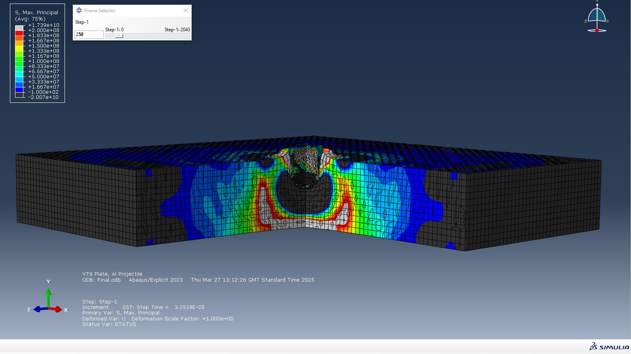
Figure 5 - Mid-Penetration

As shown in Figure 6 and 7 below, the projectile is nearly broken all the way through the plate. The compressive forces have dissipated, except in the tip of the projectile as the momentum is still causing compressive stress. The reduced compressive stress is due to less material in front of the projectile to resist motion. The tensile forces at the exit of the projectile have increased as the material is pulled apart to make space for the projectile. This is because as the projectile tears through the plate it leaves the surrounding area in a stretched, stressed condition.

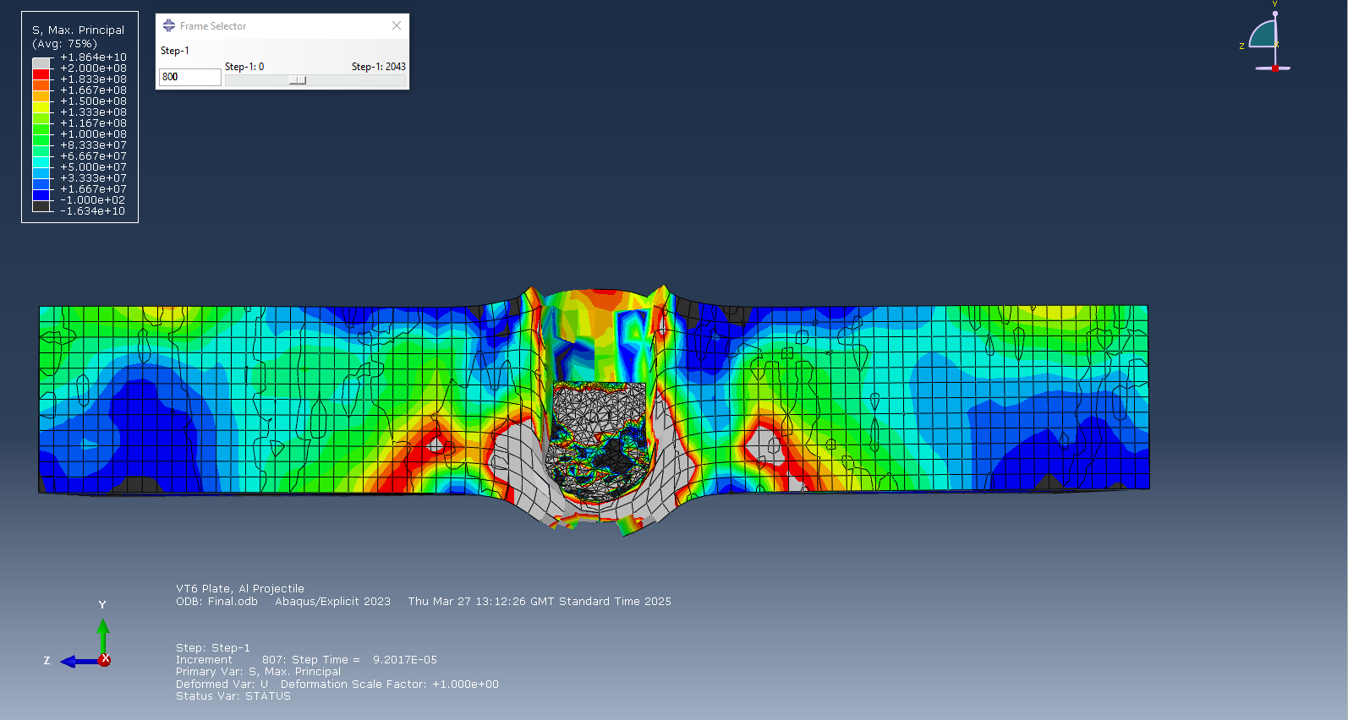
Figure 6 – Near-Complete Penetration.

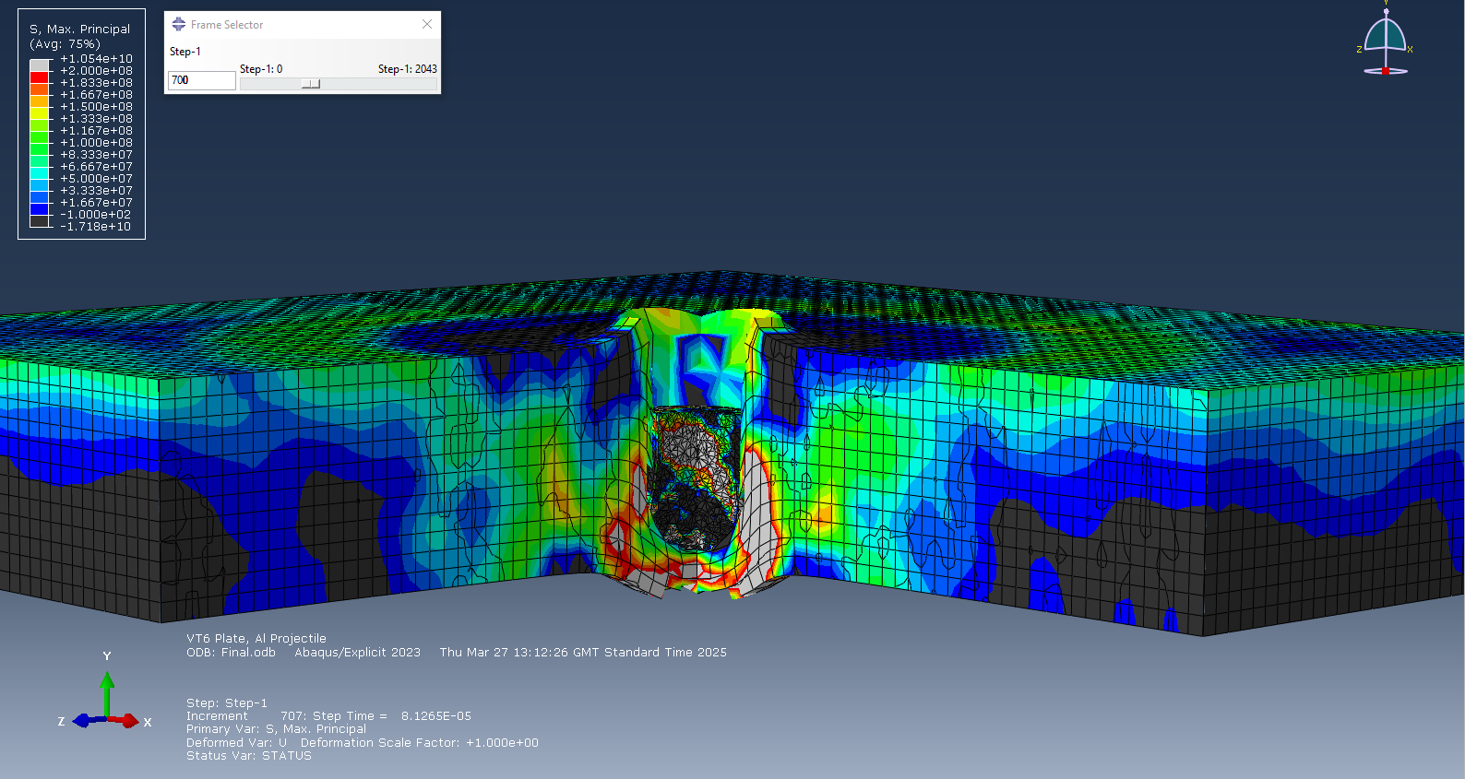
Figure 7 - Near-Complete Penetration.

Finally, as seen in Figure 8, the projectile penetrates the plate. Tensile forces surround the hole made from the projectile as the force has pulled apart the material, creating a residual tensile ring. High tensile forces can also be seen within the projectile as now there is no external forces pushing against it. Localised compression can be seen at the base of the plate, around the exit hole, this is due to the tensile forces around the hole pushing the material around it together.

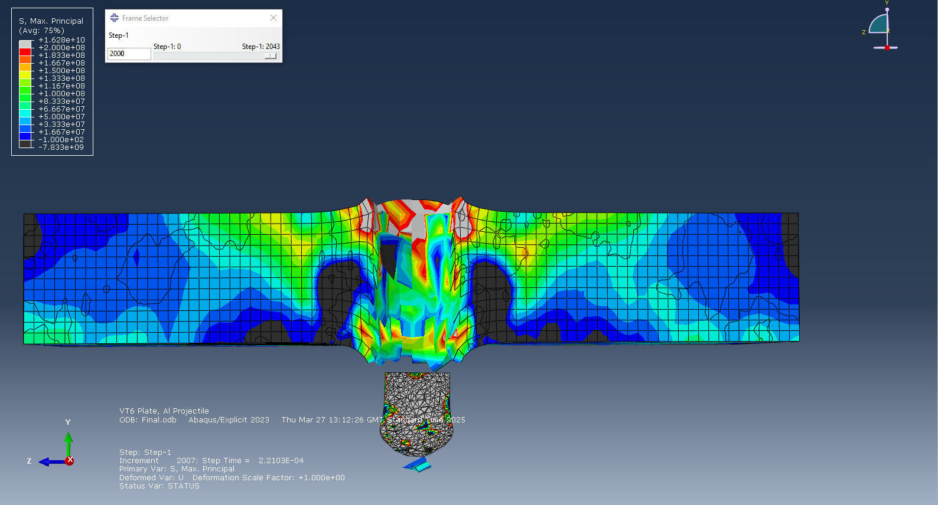
Figure 8 – Exit Phase.

Shear Stress.

For the next part of the results, I’m going to talk about the shear stresses of a single node within the simulation. For the first contact, as seen in Figure 9, the shear modulus was measured to be 2142.56 Pa. This shows minimal deformation initially.

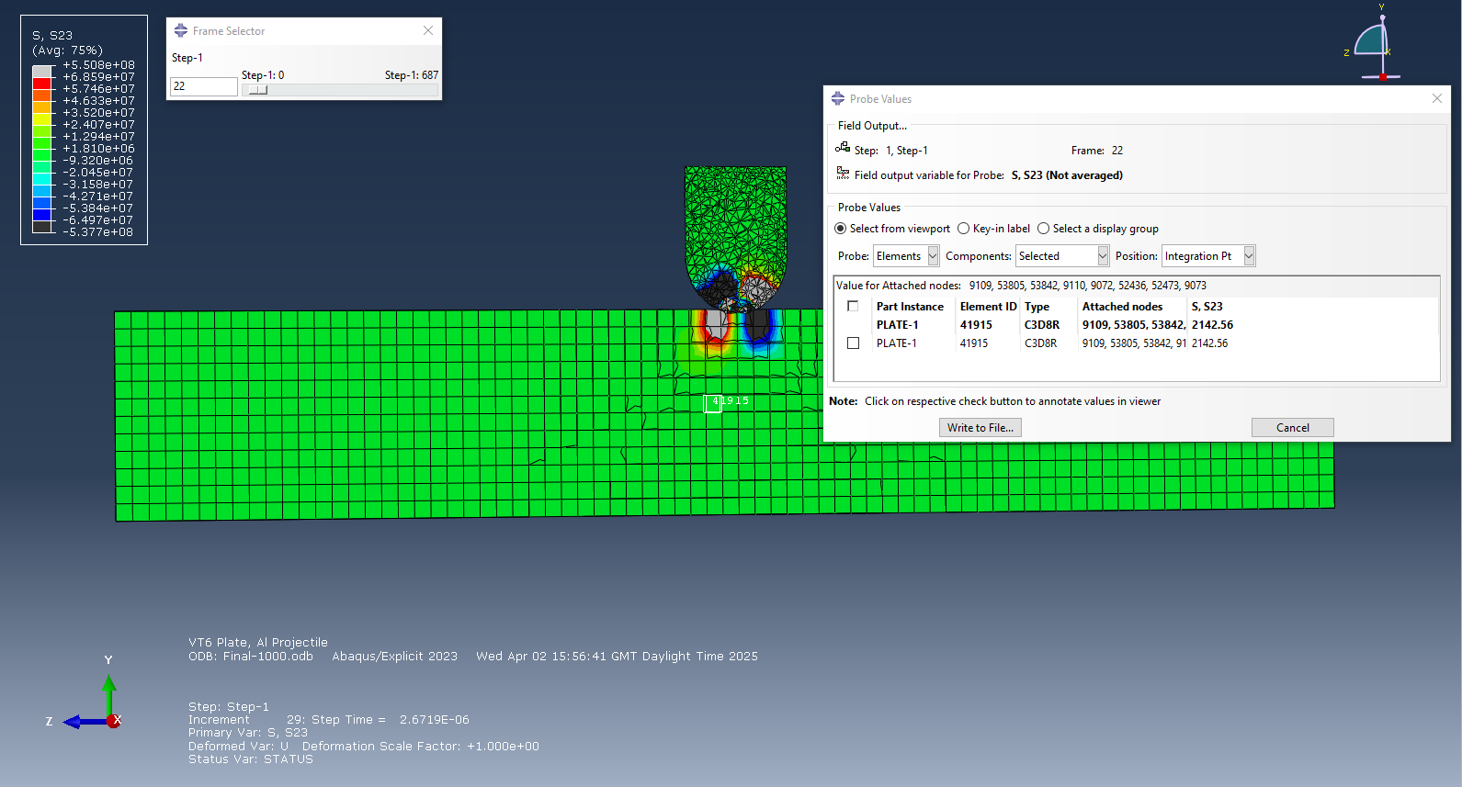
Figure 9

From figure 10 below, the shear stress equals 1.78674e+08 Pa. From this, we can determine that this node has been compressed due to the impact of the projectile.

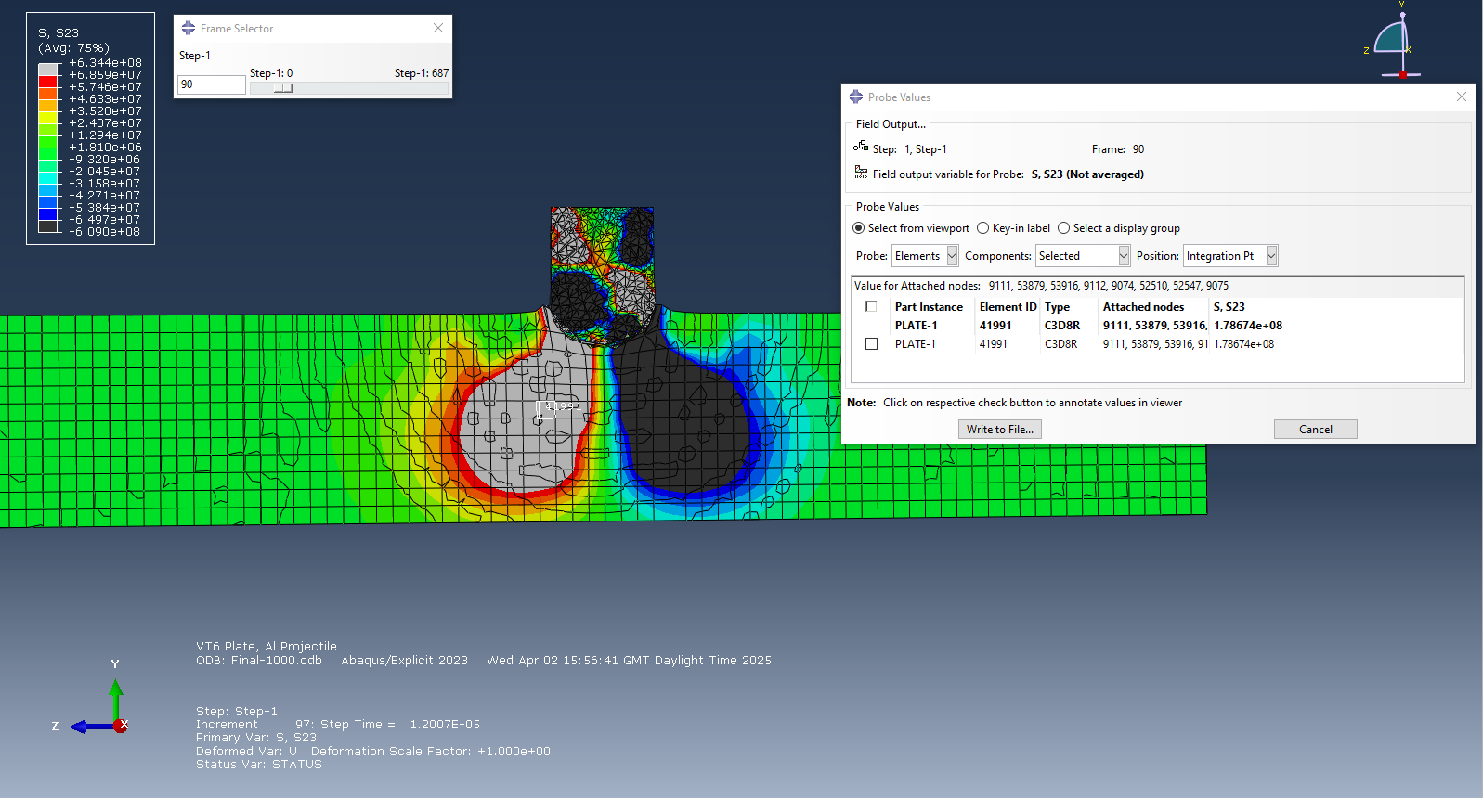
Figure 10

From figure 11 below, the shear stress equals 1.61863e+08 Pa. From this, there is a slight decrease in shear stress meaning the node has more tensile stresses as material is pulled apart.

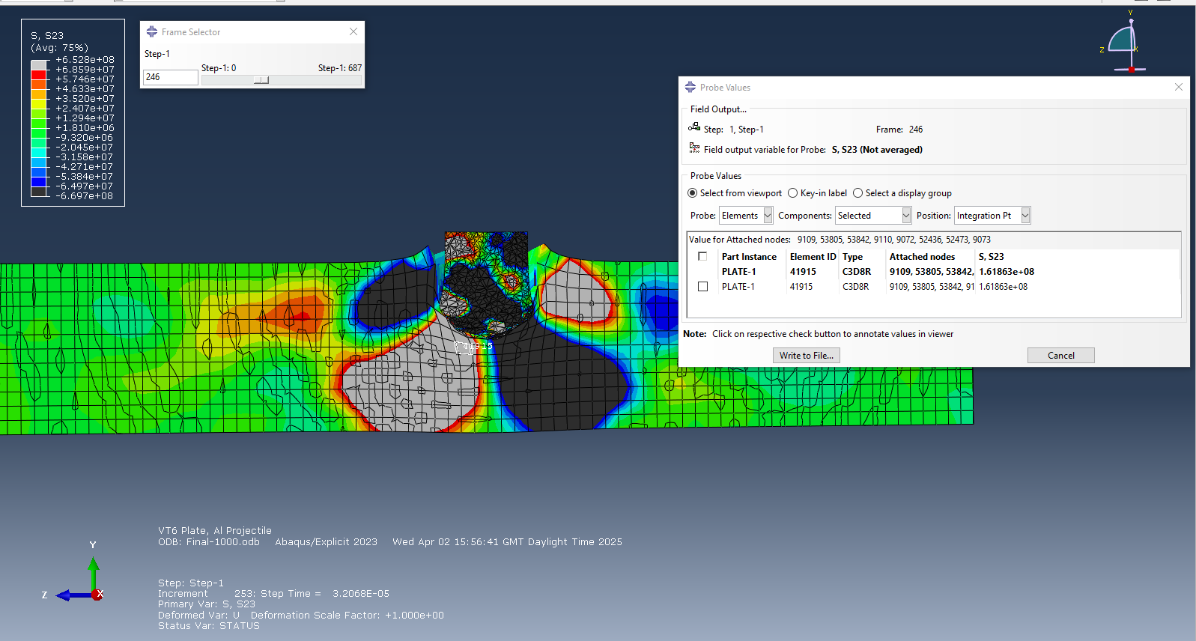
Figure 11

From figure 12 below, the shear stress equal 2.01753e+08 Pa. Thus, we can infer the shear stresses have increased causing compression as the projectile pushes further into the plate.

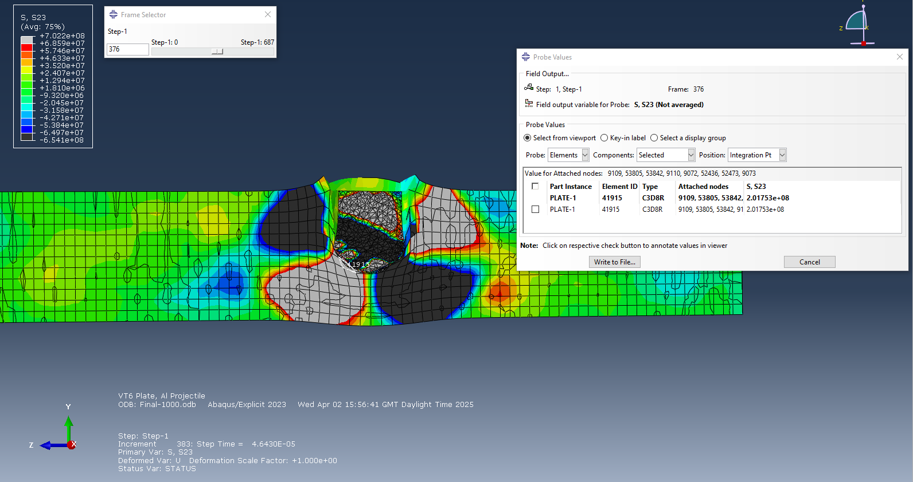
Figure 12

Max Principle.

For the next part of the results, I am going to talk about the max principal results on one particular node. For Figure 13, the max principal value is -3.1195e-07 Pa. This shows slight compressive forces as the projectile makes contact with the metal plate.

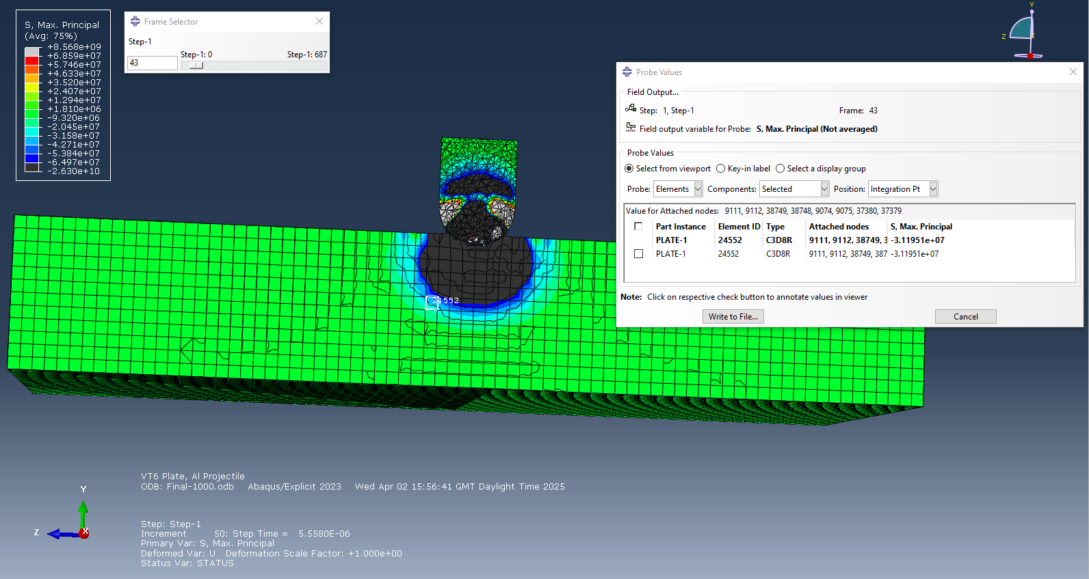
Figure 13

From Figure 14, the max principal value is -5.43805e+08 Pa. This high negative value shows high compressive forces acting upon the node.

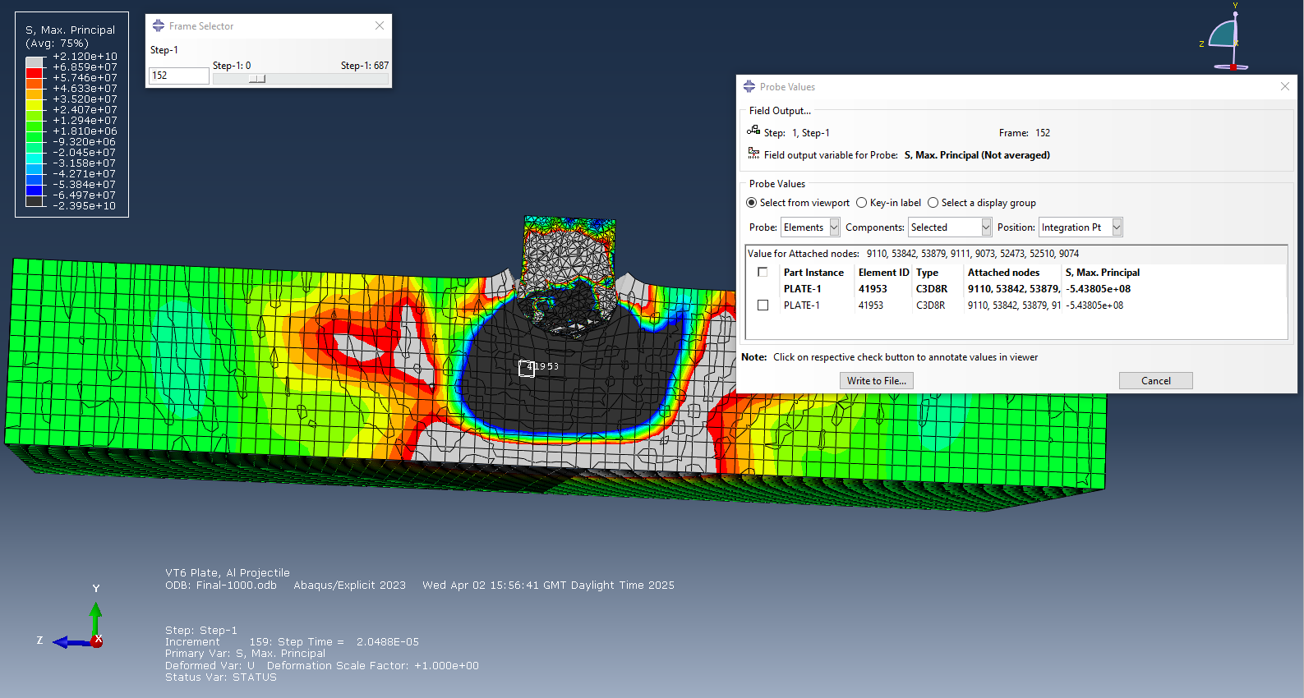
Figure 14

From Figure 15, the max principal value is -4.39853e+08 Pa. This has slightly reduced from the previous reading; this shows that the node has undertaken some tensile stress as the material starts to yield.

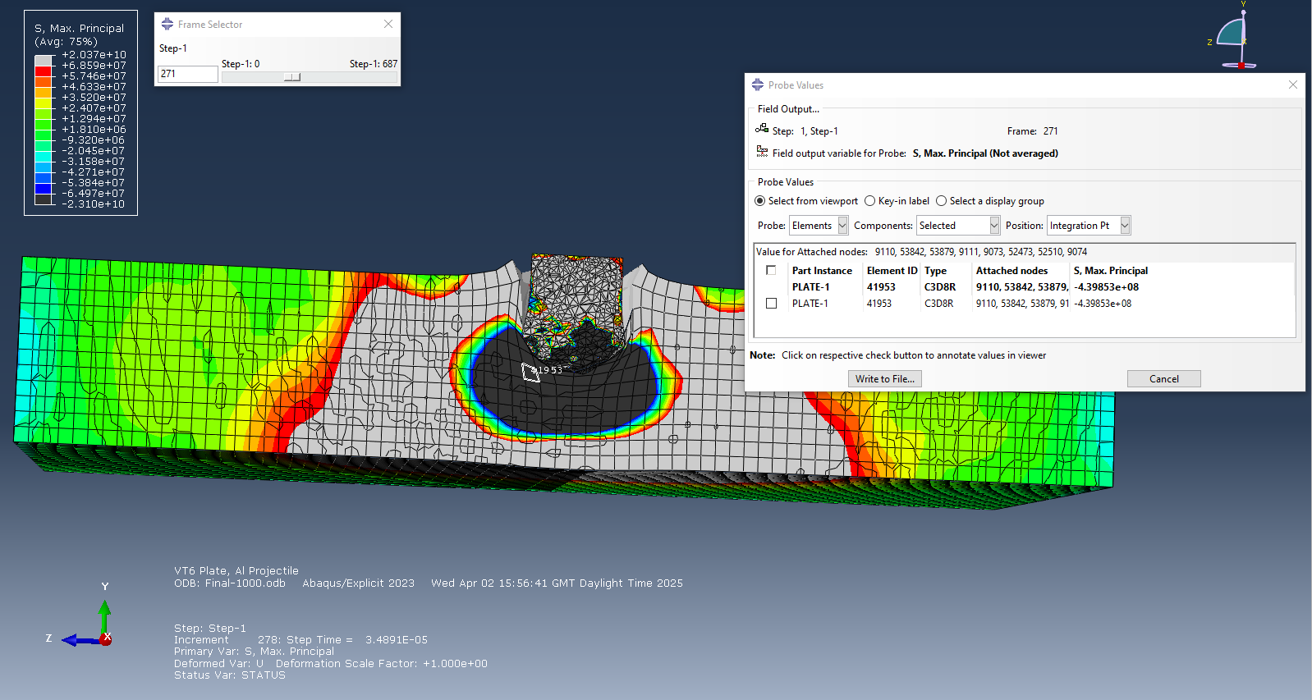
Figure 15

From Figure 16, the max principal value is -1.10168e+09 Pa. This is a significant spike, suggesting peak compressive stress before failure.

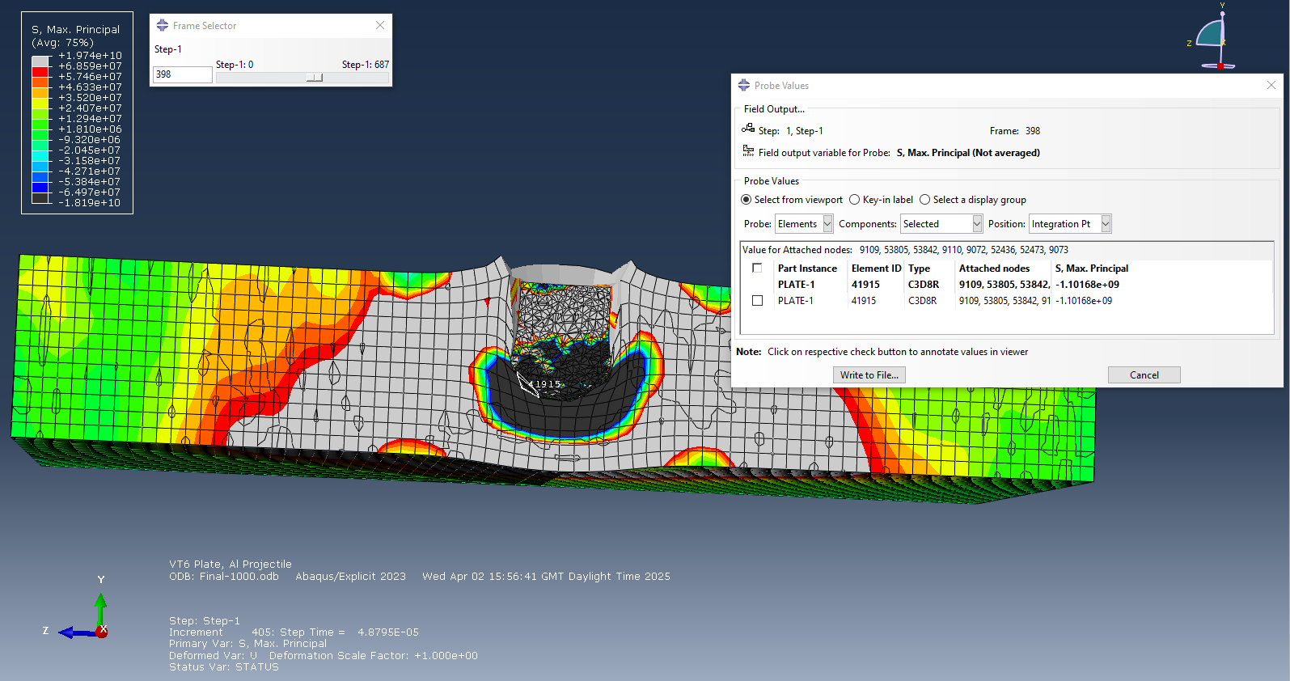
Figure 16

Second simulation – 200m/s

For the second simulation the max principal values used can be seen below in Figure 17. The black values show high levels of compressive stress. The red and grey values shown below are high levels of tensile stress.
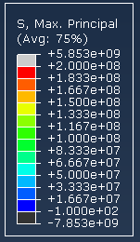
Figure 17

From looking at Figure 18 and Figure 19 below and comparing it to Figure 17 above we can see that the initial impact for the second simulation is similar to the first simulation, however the forces are lower. Initial impact shows compression at contact and early tension in the projectile tip.

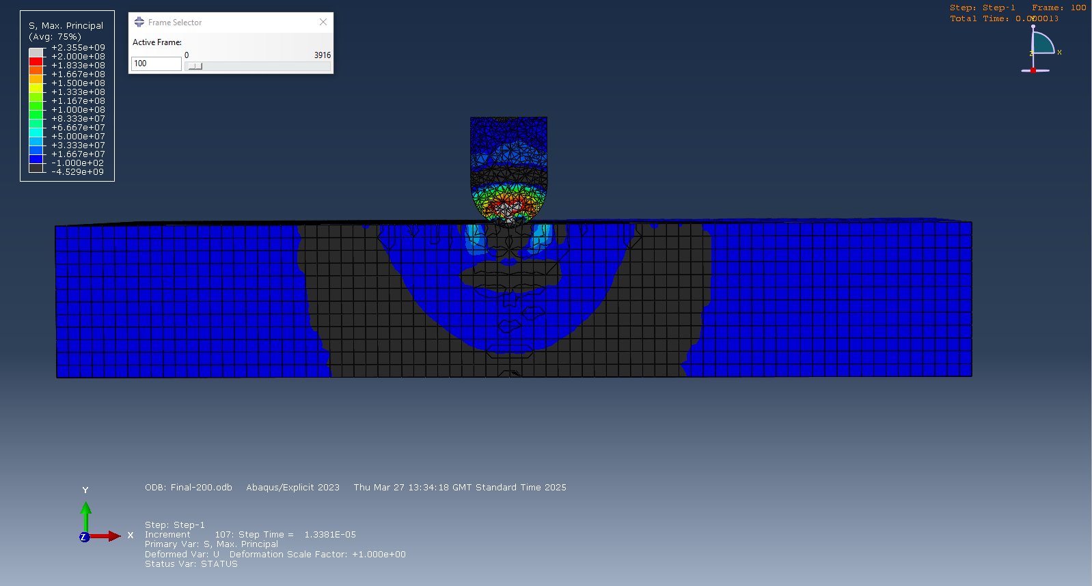
Figure 18 – Initial impact

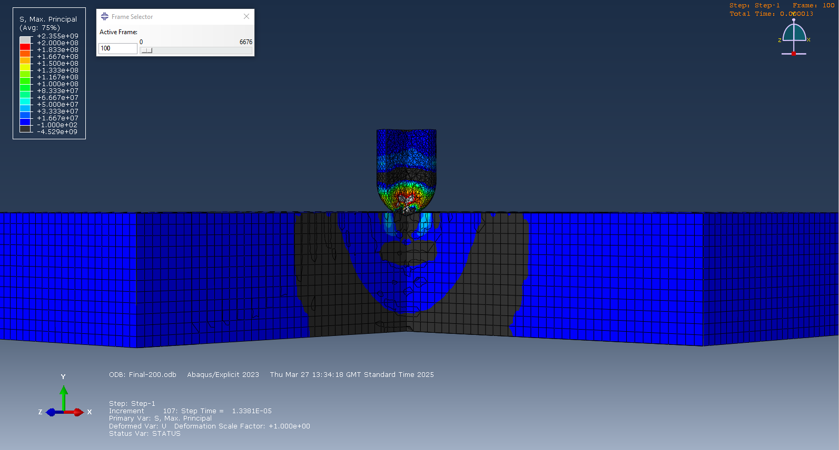
Figure 19

For the next part of the simulation, shown in Figure 20 and 21, we can see a localised compression point shown in black. We can also see high tensile stresses on the tip of the projectile, this is because the slower speed means the projectile deforms more and lacks the energy to cause full penetration.

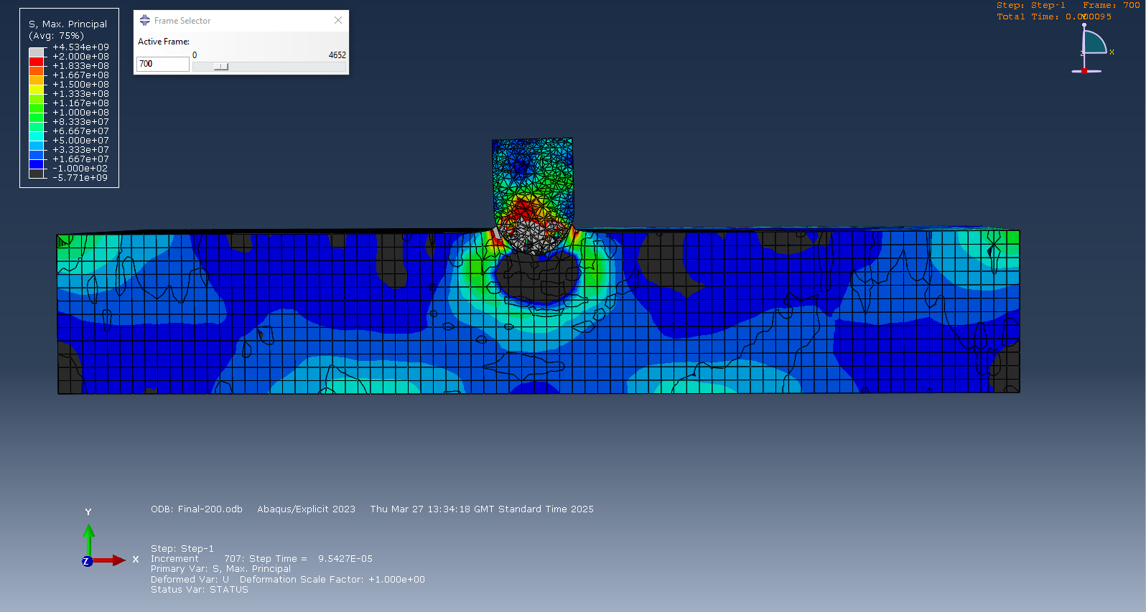
Figure 20

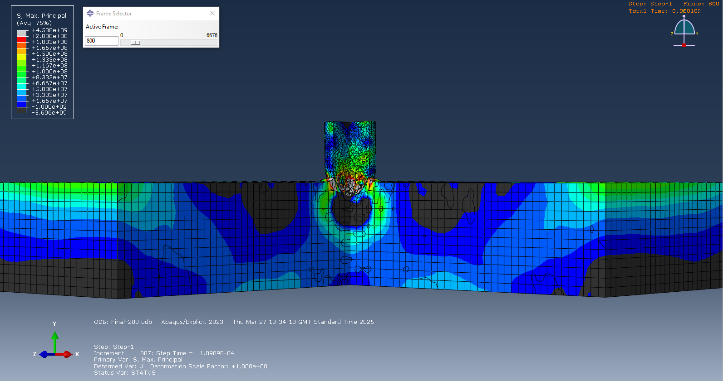
Figure 21

Finally, shown in Figure 22 and 23, we can see that the projectile has been rejected from the plate, showing that the lack in speed made it unable to go through. From these images we can see that the plate had high compressive forces on the back end and impact spot on the plate showing that the material had pushed together. We can also see high tensile forces around the initial impact point and the tip of the projectile showing that the material has been pulled apart.

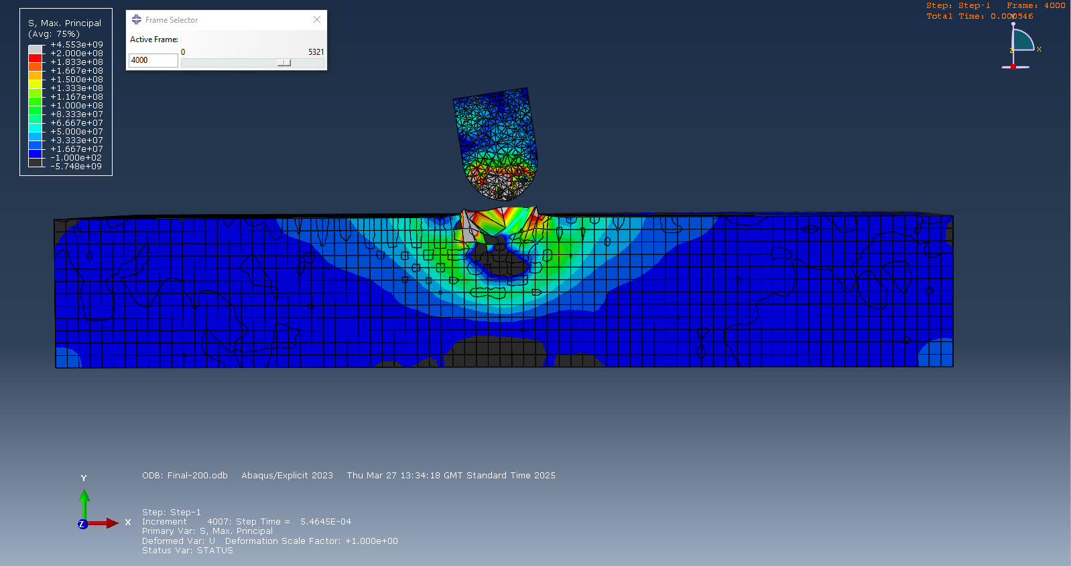
Figure 22

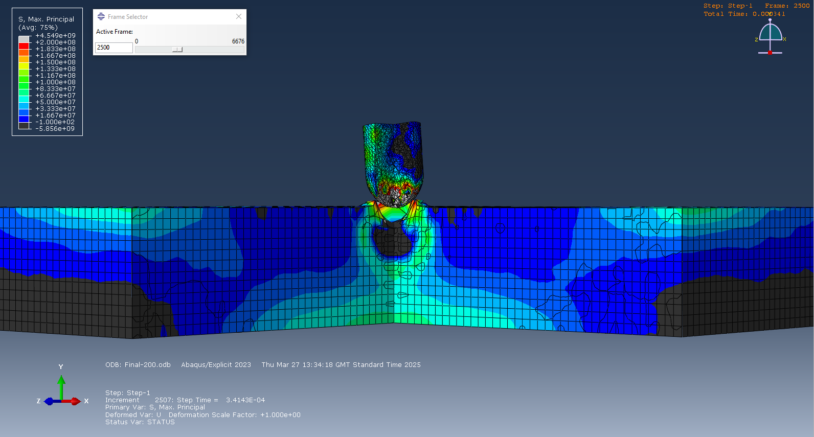
Figure 23

Shear Stress.

For the next part of the results, I’m going to talk about the shear stresses of a single node within the simulation. For the first contact, as seen in Figure 24 below, the shear modules equal 1.85445e+08 Pa. This shows high initial shear as projectile contact’s the plate.

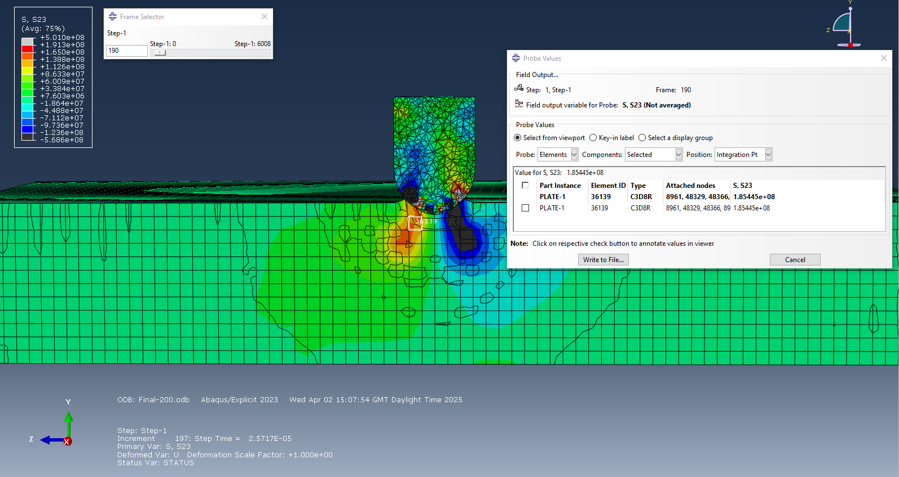
Figure 24

From figure 25 below, the shear modules equal 371181 Pa. This shows compressive forces reducing the shear stresses of the node.

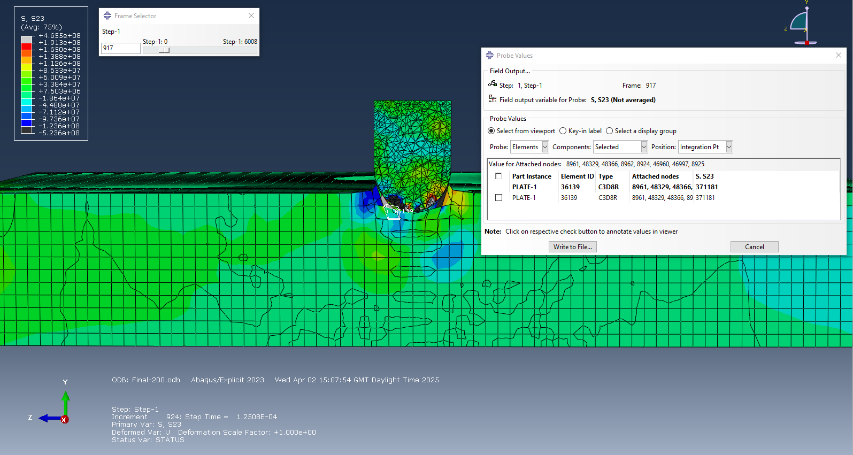
Figure 25

From Figure 26 below, the shear modules equal 3.74296e+07 Pa. This shows slight increase in shear stress as projectile is rejected from the plate, providing material relaxation after rebound.

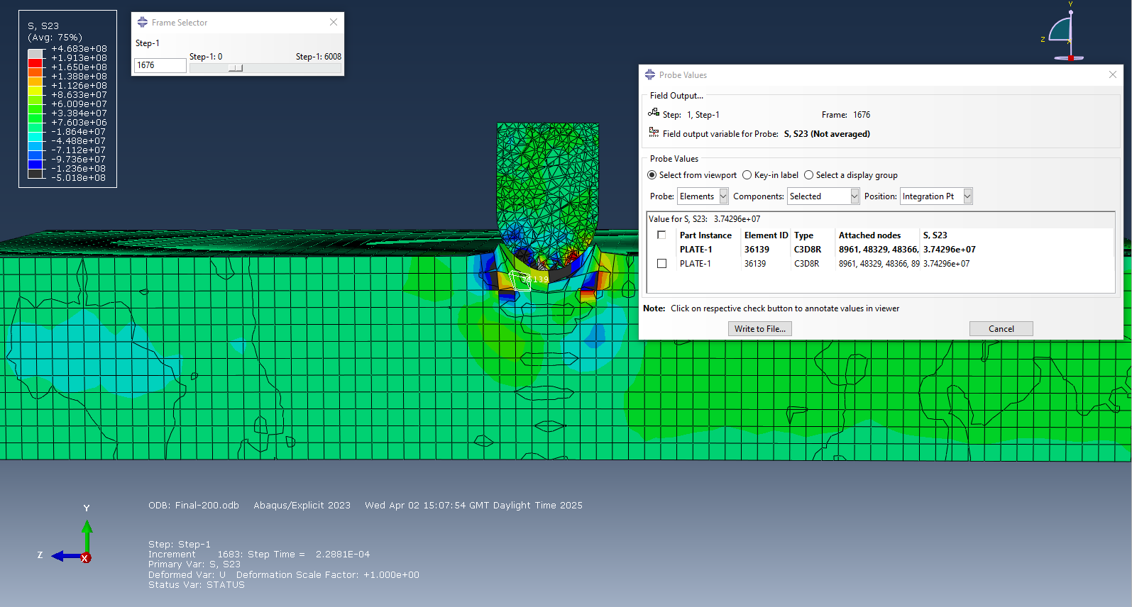
Figure 26

Max principle.

For the next part of the results, I am going to talk about the max principal results on one particular node. From Figure 27, the max principal value is 7.12108e+07 Pa. This shows high tensile stress is present, early material elongation due to the projectile hitting the plate.

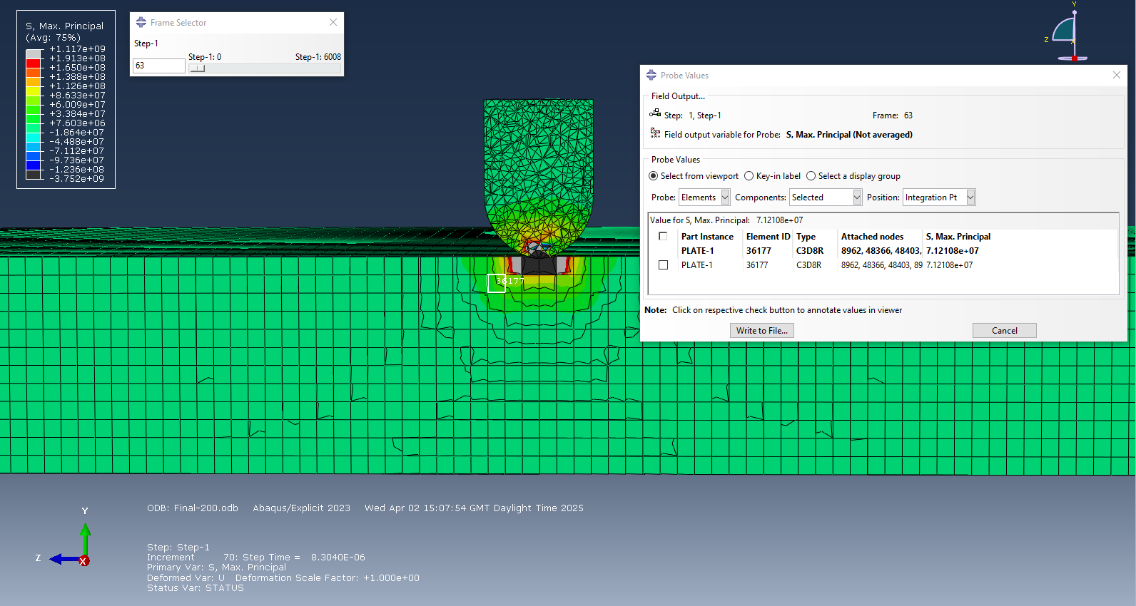
Figure 27

From Figure 28, the max principal value is -2.55553e+08 Pa. This shows huge increase of compressive stress as the projectile pushes down on the node due to momentum.

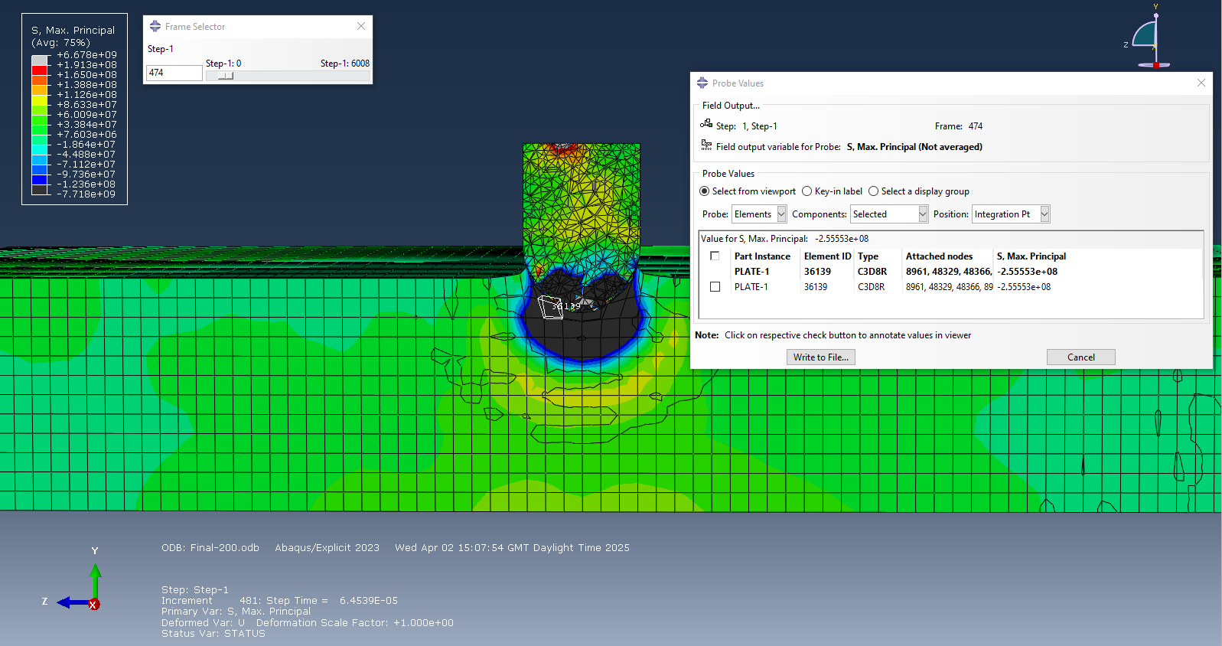
Figure 28

From Figure 29, the max principal value is -1.20037e+08 Pa. This shows a reduced compression stress on the node. The compressive forces on that single node will decrease as the projectile rebounds after losing momentum.

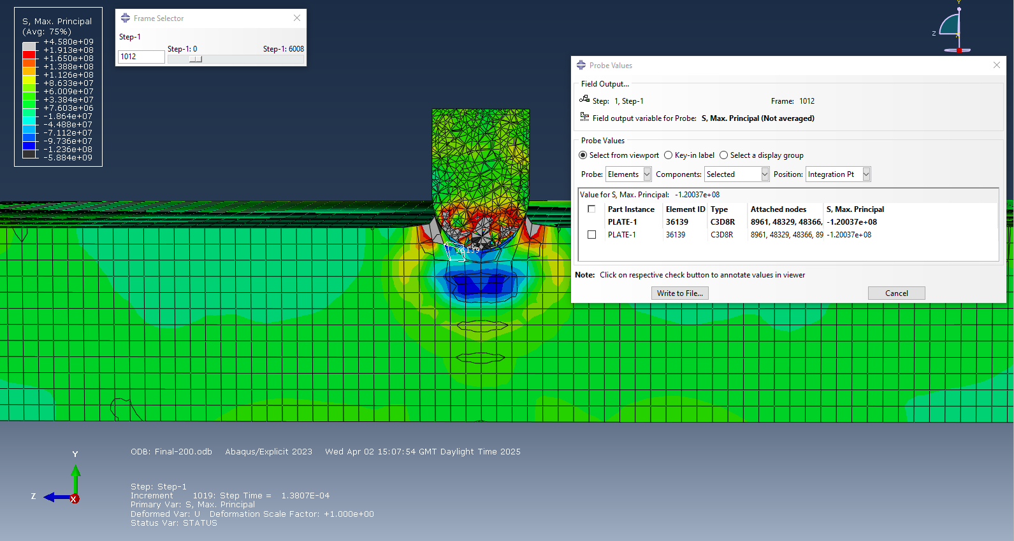

Discussion.

The simulations conducted above at two different velocities of 1000 m/s and 200 m/s highlight significant differences in deformation behaviour and stress. These findings are important for understanding how materials behave under high stress and strain environments.

Firstly, the fundamental difference between the two simulations lies in the projectile's initial kinetic energy. Kinetic Energy = 1/2 mv². Given that kinetic energy is proportional to the square of velocity, a projectile at 1000 m/s carries 25 times more energy than one at 200 m/s. This difference directly influences the forces that apply when the projectile hits the metal plate. Looking to the 1000 m/s simulation, the projectile successfully penetrates the plate, transferring enough energy to induce plastic deformation and complete failure through a combination of compressive and tensile stresses. Regarding the 200 m/s simulation, the energy is insufficient to overcome the yield and ultimate tensile strength of the plate, resulting in partial penetration and rebound of the projectile.
Secondly, at initial impact, both simulations display localised compressive stresses at the contact surface between the projectile tip and the plate. When observing the 1000 m/s case, the compressive wave travels through the material, followed by tensile waves as the plate stretches when the projectile moves through the material. The tensile forces eventually dominate at the rear of the plate, initiating ductile tearing as the projectile exits. In the 200 m/s case, the compressive wave pushes back due to insufficient force, and tensile zones form only near the impact site without causing full material failure. These results demonstrate the wave propagation dynamics typical of ballistic impacts (compressive shock fronts followed by tensile reflections). The transition from compressive to tensile failure is well-documented in materials science, particularly in metals with moderate ductility. [4]

Next, regarding the shear modulus values for a selected node in both simulations initially showed low values, this was followed by a sharp increase of compressive forces. Post-impact, fluctuations were observed showing changes between compressive and tensile deformation. In the 1000 m/s simulation, the shear stress peaked during mid-penetration, signifying material flow and plastic shear of this node. In contrast, the 200 m/s simulation showed less variation and a rapid return to low shear values, consistent with elastic rebound rather than material failure. Understanding shear behaviour is vital for predicting failure in a material, useful in armour panels or aircraft skins.

Next is the max principal stress, during the early stages of both impacts, compressive principal stresses were present. As the projectile progresses in the 1000 m/s case, tensile principal stresses increase, indicating stretching and material failure of the plate. The peak stress value (−1.10e+09 Pa) shows the expected material failure thresholds for aluminium. Turning to the 200 m/s simulation, the principal stress values show a temporary compressive peak followed by a rebound, affirming that the material did not reach its failure threshold. This information is essential in designing materials that can withstand high-velocity impacts without failure.

Finally, understanding when a material will fail is vital to both safety and performance in real life situations. Military body armour relies on material deformation and energy dissipation. In car crashes, knowing the energy absorption and stress characteristics helps design safer vehicles, particularly for crumple zones. Furthermore, these results validate the use of computer simulations, which significantly reduces the cost and time of physical testing. Similar approaches have been successfully applied to simulate dynamic responses and failure in complex structures, such as in concrete under impact loading [5]. Showing the wide range of uses for computer aided design.

Conclusion.

In conclusion, this report provides a comprehensive understanding of the stress and strain response of an aluminium plate under two ballistic conditions. At 1000 m/s, the projectile had sufficient energy to cause full penetration, resulting in high compressive stresses and high tensile stresses as the material failed via ductile tearing. In contrast, the 200 m/s simulation showed incomplete penetration, with the projectile being rejected and the plate mostly undergoing elastic deformation. These results confirm that projectile velocity plays a critical role in material failure. This can be used in real life examples like armour and vehicle safety systems. The use of computer simulations, significantly reduces the cost and time of physical testing.

References.

[1] J. Thomas, Kurtze Unterweisung Von Dem Innern Wort Gottes in Frag Und Antwort. Palala Press, 2016.

[2] K. SGS, “Ti 6Al 4V (Grade 5) Titanium Alloy Data Sheet,” Kyocera SGS Europe, 2024. https://kyocera-sgstool.co.uk/titanium-resources/titanium-information-everything-you-need-to-know/ti-6al-4v-grade-5-titanium-alloy-data-sheet/

[3] N. Thakur, P. Kumar, and R. Singh Bharj, “Effect of Variation of Johnson-Cook Parameters on Kinetic Energy and Simulation of 4340 Steel Projectile,” Materials Today: Proceedings, vol. 5, no. 14, pp. 27884–27892, Dec. 2018, doi: https://doi.org/10.1016/j.matpr.2018.10.027.

[4] Y. Zhu et al., “Ballistic impact wave and back bulge propagation mechanism and blunt trauma assessment of ceramic/UHMWPE composite body armor,” Journal of Materials Research and Technology, vol. 31, pp. 1483–1506, Jun. 2024, doi: https://doi.org/10.1016/j.jmrt.2024.06.101.

[5] G. Meschke, B. Pichler, and J. G. Rots, Computational Modelling of Concrete and Concrete Structures. CRC Press, 2022.

