Dissertation proposal

Throughout this piece of text, I shall be talking you through three key words that shall create a question for my third year dissertation. The three words I have chosen to explore in this essay are diversity, printmaking and style. I will be backing up the explanation of these key words by involving quotes from artists, designers and thinkers to further explain the words I have chosen. After I have explored my three key words I will be starting to think about how to involve them in my question for my third year dissertation. And creating a strategic action plan. Within this proposal I shall be discussing my aims and objectives as well as contrasting arguments of the definitions. I shall also be offering a debate in how the three key words chosen correlate accordingly well and in which will hopefully contribute to meaningful research.
The first key word that I will be exploring is ‘diversity’. The term as defined by (Barak, 2005) Diversity involves everyone, it is not something that is defined by race or gender. It extends to age, personal and corporate background, education, function and personality. It includes life- style, sexual preference, and geographic origin, tenure with the organizations… and management or non-management.” Furthermore, the term diversity in the 21st century is becoming more openly used to describe the diversification of individuals such as those involved within the LGBT community and those who play an active role within the feminist movement. An example of diversity can be cultural diversity which is the differences in a person’s personality, age, religion, sexual orientation, race and ethnicity. On top of the factors I have already discussed diversity could also be someone’s mental abilities such as skills someone possesses, someone’s mental abilities or even someone’s past experiences. A bad factor of diversity can be the stereotyping it can bring and the effect that could have on someone who is different such as someone bulling another individual because of their diverse characteristics. In the 21st century diversity has grown to be more feminist based, as Patricia Hill Collins, a sociologist, explains in an interview she had “I approach African-American women as facing a set of social problems that are constructed at the intersection of multiple systems of power.” This quote explains that African-American women are having a hard time coping in the modern world because of male superiority, this quote links to my key word because of the diversity between males and females, also it relates to the diversity between races. This key word relates to my dissertation question because clothing design can be quite varied in style and representation. This word would take up a large amount of my dissertation because of the amount of varied definitions surrounding this specific word. As individuals are more inclined to express themselves in different ways which has contributed to the assorted meanings and expressions around the area of the word ‘diversity’.
Further, the second key word that I will be using shall be ‘printmaking’. Printmaking as defined by (Edmunds, 2004) describes the process as “the formal definition of a print has been that of an image formed in ink, which has been transferred by pressure from a printing surface”. There are many different types of printmaking such as screen-printing where you expose an image into mesh stretched over a frame, then when it has been exposed you push water based inks through the areas where your image is and it should appear on the piece of paper placed below the screen. Another printmaking technique that is commonly used is linocut which is where you take a sheet of lino and draw your image onto it then use the carving tool to cut away the negative space, after this you role on some oil based ink covering all that isn’t cut away, then place it face down onto a sheet of paper then apply pressure on top of it then it should leave a print onto the paper placed below. Other printmaking techniques used include etching, woodcut, engraving and lithograph which are all pretty much the same process. Printmaking in the beginning was not considered an art form, it was more known as a medium of communication. It was not until the 18th century that produced printmaking pieces were considered as originals and not until the 19th century that artists began to produce limited edition prints. Such printmaking techniques as etching and woodcut go back all the way to the Stone Age where they produced a style called cave art on bones, cave walls and stones. European printmaking started with printing onto fabrics back as early as the 6th century, printing on paper came later when the arrival of paper technology arrived from the Far East. The first woodcut prints were produced in Germany at the beginning of the 15th century and they was used to make playing cards. Only slightly before this the first royal seals were produced in England and was of Henry the eighth. In recent history printmaking has come a long way with the introduction of digital software, such as programmes such as Adobe Photoshop and Adobe Illustrator where you can create your design on them then either print it off or get it etched onto a piece of lino or wood using a laze cutter. Also the invention of photo emulsion which allows you to expose a photo realistic image onto a screen for screen-printing instead of cutting out stencils. Famous artists and designers that are well known for using printmaking techniques are Andy Warhol, Jasper Johns, Robert Rauschenberg, Roy Lichtenstein and Mark Rothko. As you can see in this screen-print by Andy Warhol, he has used bright block colour, this is very common for the process of screen-printing especially in the 1960s where they didn’t have photo emulsion to get finer details on images. I chose the word ‘printmaking as one of my key words because it is how I produce a lot of my own work and I thoroughly enjoy it, the main printmaking technique I use is screen-printing because you can get outstanding outcomes from doing it. This word relates to my question because I want to relate the printmaking prints to current styles and images that are produced onto clothing for example printmaker Shepard Fairey has his own clothing brand which only has his own designed artwork printed onto them. This process is widely used in commercial industries such as; clothing, advertising, branding and a home furnishing pieces. This word will be especially interesting to conduct research upon as it is a worldwide known process which can be adapted across the globe with different styles of this practice.
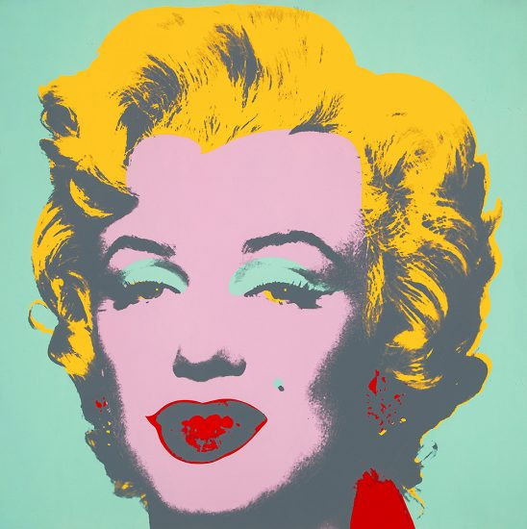

Andy Warhol, Marilyn Monroe (Marilyn), 1967
Finally, my last key word that I have chosen is style, this word can be referred to as “style is a replication of patterning, whether in human behaviour, that results from a series of choices made within some set of constraints” (Meyer, 1996). In addition to this the term style can also be argued as “Style as the constant of form, and sometimes in the constant elements, quality and expression of an individual or a group” (Whitley, 2001). The word style can be interpreted in many different ways, it can be a way that someone has dressed themselves, as in the colour or the fit of their outfit or it can be interpreted as in the way in which something is done, for example in art terms can be the way a brush stroke has been made. Style has drastically changed over the years, for example in the 20th century men’s fashion consisted of more formal attire such as suits and formal trousers. On the other hand, 21st century fashion is more graphic with the designs used and also is more outlandish as in its look is more relaxed and informal. With the artistic aspect of style again things have drastically enhanced over the years, for example brush stroke have become digitalised and are easier to apply as you can downloads thousands of different strokes to your computer, rather than creating them brush strokes yourself manually which takes much longer to do but it does give your art work more of a unique and also gives it more of an individuality look to it. As explained in this quote fashion styles influence one and other, “it is amazing to see how the different events in history have influenced and changed the way people have dressed throughout time. Some of the most popular fashions are classic, they can stand the test of time and hardly ever "go out of style", only experiencing minor changes to keep up with the trends.” This quote is interpreting that fashion has been influenced a lot by different circumstances in history and that no style goes out of fashion it just enhanced them garments to match modern day fashion. I chose to include this word because I have a keen interest in fashion and I think it will link well with my other two key words, it links well with my first key word, diversity because not everyone’s style is the same we all have different preferences on what we wear. Plus this key word also links with the printmaking key word as most prints on t-shirts, hoodies etc. are mostly either screen-printed on or lino- printed on. In this image it shows illustrator Shepard Fairey preparing a print for a piece of clothing.

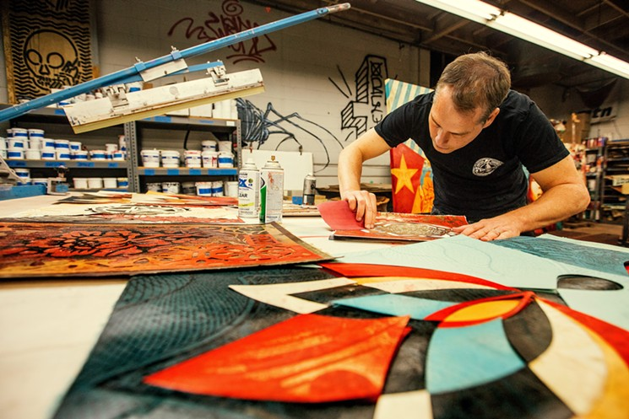

Shepard Fairey, 2017

As I have conducted a thorough investigation exploring the three key words as mentioned before these being; Diversity, Printmaking and Style. It has lead me to finalise my dissertation question. From the research that I have conveyed I believe the three key words coincide very well together, in which will contribute to a further in-depth research project that being my dissertation. These have furthered my knowledge and understanding of what I shall have to research and gather for my dissertation. The purpose of this proposal was for me to have an insight on the theories and arguments surrounding the three key areas, I have been able to identify critical compare and contrasting arguments in which will all contribute to the research process of my dissertation.
In order to form my dissertation I will need to have a range of purposeful aims and objectives in order to reach a sound conclusion and analysis.

Aims-
- My primary aim is that my dissertation will contribute as meaningful piece of research to the industry.
- Explore the way in which the word diversification is being used in modern society.
- To gain in-depth knowledge of expertise surrounding the three key words such as; contrasting arguments, theories, opinions and evidence.

Objectives-

- To consider a wide-range of opinions around the areas of my three key words from the use of books and journals
- To analyse and examine the environment surrounding the three key words, and how they have or have not influenced decisions within the industry / professionals
- To examine how the three key words have been defined by industry experts and the evidence and contrasting arguments surrounding those.

From exploring these three key words I have compiled a question to use for my dissertation which is “How diverse printmaking styles have influenced modern expression”. This can be interpreted into individual’s self-expression such as; clothing, body art, make-up and body positivity.
Further research (action plan)
To ensure that I successfully meet the purpose of the dissertation question I will need to create and follow a specific action plan that will allow me to always be up to date with common trends surrounding the environments of my three key words.
- Keep an up to date diary on recent trends which surround the areas of diversity, printmaking and style.
- Read a range of journals and reliable sourced materials that will contribute to a greater understanding of the areas I am investigating.
- Follow a range of influencers who promote their style online to a wide audience. This will be done by using the platforms; Facebook, Twitter, Instagram and YouTube.
- Investigate global trends surrounding the three areas.
- The power of online platforms to have influence on a worldwide market such as top professionals of self-expression like James Charles and The PAQ YouTube channel.
- Global news. Developing countries allowing their citizens to have more basic human rights which can contribute to the ways in which they express themselves in terms of style and self-perception.

References
- Amazon associates programme. 2018. History of Printmaking. [Online]. [4 May 2019]. Available from: https://the-artists.org/history_of_printmaking/
- The people history -- Steve Pearson. 2019. Thepeoplehistorycom. [Online]. [4 May 2019]. Available from: http://www.thepeoplehistory.com/fashions.html
- Leonard b Meyer (1996). Style and music. : University of Chicago Press.
- David s Whitley (2001). Handbook of rock art research. California: Altamira press.
- Mor- barak (2005). Managing Diversity: Toward a Globally Inclusive Workplace. India: Sage publications.
- Edmunds (2004). Three decades of American printmaking: The Brandywine workshop collection. (1st Ed.). New York: Hudson Hills press.

