

Module Name: Developing Relationships and Workplace Achievement
Module Number: BMSW5102_LON
Company Name: Google Inc.
Student Name: Linda-Ruth Makoutou-Ngondet
Student Number: 1807164
Lecturer Name: Dr. Ze Zook

Table of Contents
Abstract 3
Introduction 3
Google Background 3
Google Structure, Culture and its Values 4
Benefits that Google gives to employees within the organisation 5
Benefits that employees gives to Google 6
Motivation Theory - Maslow’s Hierarchy of Needs 6
How Google reinvented HR and powered people analytics success 7
Career Development 12
Talent Management 13
Apprenticeships 15
Personal Development Plan (PDP) 15
Recommendations 16
Conclusion 16
References 17
APPENDIX 20

Abstract
This report focuses on Google's motivational strategies that have been explored and contrasted with conventional methods of motivating employees. This was done to find the key to the success of Google in inspiring and attracting its employees as no other organisation has been able to do so far. Google's certainly great at inspiring the employees. What was also found is that Maslow's needs hierarchy still applies to employee motivation today.

Introduction
Work relationship have consistently been a piece of organisational theory and research. It is an indispensable piece of the study of management and organisational research and it depends on some fundamental studies of organisations and organisational life.
Work relationships structure the establishment of a variety of arranging forms: they clarify how staff deal with their professions and make work (and life outside of work) pleasant, how managers lead the staff, how staff arrange the work over their jobs, and how and why unions between associations succeed or fall flat.
Relationships clarify why workers remain in their employments and why they leave them. They clarify why groups produce astounding results and why they fail to meet expectations, why and how organisations can create and convey complex items and services and why and how they neglect to do as such.

Google Background
Google Inc. began in 1996 as the brainchild of Sergey Brin and Larry Page, two bright computer science grade students. They met back at Stanford University in 1995 where they did their PhDs, and came up with innovative ways to find and coordinate massive datasets. They also developed a technology called PageRank which allows them to analyse the relevance of a particular website. It occurred to them that a search engine based on the PageRank algorithm would be much more efficient than current search engines in achieving better and more reliable results(McFadden, 2018). Google.com was created on 15 September 1997 (O'Connell, 2018).
Google has always been a play on the word "googol" and is a mathematical concept for number 1 preceded by 100 zeros. It is rumoured that this represents the mission of the creators to organise an endless amount of online information (Bellis, 2020).

Fig. 1 Google Inc logo

Source: https://www.seroundtable.com/seos-impact-google-january-2020-core-update-28852.html

Google Structure, Culture and its Values
Organizations come in different shapes and dimensions. The workers shall be subject to the rules, regulations, principles and desired actions of the organisation. They can also be subject to scheduling structures inside the organisation. This decides their role in the organisation, and what influence they possess in their position of employment. Such structures are subject to constant analysis, adjustment and alteration procedures (Taylor, n.d.).
The organisational structure is the basis for monitoring relationships within an organisation. These relations may generally be diagrammed in the context of an organisation map. The organisation diagram may not necessarily represent real reporting or decision-making relationships within an organisation, so that the managers can distinguish in both the formal and the informal structure (Quangyen & Yezhuang, 2013).
Culture is a fascinating theory that influences nearly every part of human life, both positively and negatively. At a much more noticeable basis, human culture has an influence on the way people embrace one another, the customs they celebrate and the food they consume. Less apparent aspects of culture include people's beliefs, values and ideologies that affect the visible aspects of culture (MacLachlan, 2009).
Google's credo is that it is not about money, it is a lifestyle that brings creative supremacy over the competition. They portray themselves as a company which works through teamwork and creative engagement to change the world. Employees feel fortunate to be part of such a company and are incredibly pleased to be a part of the brand (Lashinsky, 2007).
Google provides a bend-functional hierarchical structure that is essentially a corporate matrix with a large degree of flatness. This flatness is a distinguishing structural characteristic that facilitates the development and productivity of the business (Smithson, 2019).

Benefits that Google gives to employees within the organisation
Google's work climate has led to the company's long-term success; it is characterised by chaotic workplace advantages that are rarely present in many businesses. However, Google's workplace encourages an employment-life balance by concentrating on key elements of a healthy work climate that enhances employee engagement and organisational identity. Such approaches include organisational culture, recruiting approaches, job growth, style of leadership and employee engagement (England, 2015).
Google has all that employees can expect in terms of market capitalization from one of the largest businesses in the United States: bikes and electric staff cars with which they go to meetings, gaming centres, natural gardens and environmentally friendly fittings. Google wants to make life easier for its workers and is constantly finding ways to improve their health, wellness and their values (Fechter, 2019).
When Google's employee dies, the employee's spouse or partner gets a pay-out of 50 per cent of the worker's salary per year for a ten-year period. Google also has a programme for a Global Learning Leave that allows staff to take leave of absence for further training. Google pays for all this research (Stabile, 2008).
The company is giving its workers one of the most creative working environment cultures. Google cares so much about creativity that it has laid out nine creativity standards. One of the values allows Google workers to invest 20% of their time exploring new ideas that they are excited about (Yang, 2017).
With such an impressive work culture, it is no surprise people worldwide are competing for Google vacancies. This puts Google in a good place to be able to pick and select only the best and brightest. In a summary, the great corporate culture draws top talent and contributes to satisfied workers. Happy workers lead to higher efficiency and lower turnover. Which eventually results in higher profits and greater overall performance for Google (Vozza, 2018).

Benefits that employees gives to Google
Google's work gives employees a sense of contributing to the worldwide. The applications and technology on which Google employees work has positively impact on society. Humans would benefit from these innovations; for instance, auto-driving cars would allow their occupants to relax during transporting. The level of incidents is low, with just a handful of injuries occurring in one million miles, all reported due to human mistake. Google employees are developing new medical innovation — contact lenses with sensors that can read the patient's blood glucose level, that is of great advantage to diabetics. That's another advantage worker is offering to google company and to the world.

Motivation Theory - Maslow’s Hierarchy of Needs
Motivation may be characterised as the driving force which accounts for the strength, direction and persistence of an individual's effort to achieve a goal. Since decades, social scientists have been examining motivation and trying to figure out what motivates an individual behaviour, how and why (Souders, 2020). Through the years, it has suggested hundreds of theories about motivation such as Hertzberg’s Two-Factor Theory, Maslow’s Hierarchy of Needs, Hawthorne Effect, Expectancy Theory and so on.
Maslow principle focused primarily on personal interests of the workers. Maslow put forward the hypothesis that there are five stages in a continuum of human needs that the workers need to fulfil at work: behavioural, safety, needs for belonging, esteem and self-actualisation. (Please see Appendix 1: Maslow’s Hierarchy of Entrepreneurial Needs).
All the requirements are organised into a hierarchy and a worker would be motivated by the desire to satisfy the next requirement in the hierarchy only when a lower level of need has been completely met. For e.g., an individual who is starving will be motivated to earn a decent income to buy food before contemplating having a better job offer or respecting others (Goyal, 2015). Every organisation will then have multiple benefits for workers to enable them in meeting the desire and strengthen the hierarchy. Managers will always recognise that not all employees are similarly motivated, so not all go on to the same degree of hierarchy. Therefore, they would have to have very specific compensation plan from one job to the next. Google can take care of the economic, health and social needs of its workers by leveraging multiple extrinsic motivators. Such extrinsic motivators are like several free cafeterias, with an outstanding salary that helps meet much of the emotional desires of their workers. Google protection for the employees is supported by personal health facilities (gyms, pools), childcare, Doctor’s office service and many more. Google provides several places where workers can relax and communicate with each other, allowing them to feel part of the community and fulfil their social needs. Since Google is a knowledge-based organization, meeting higher-level criteria is of tremendous significance to the business.
It is only when workers seek to meet their higher-order needs that they aim for creativity. By paying workers an annual tuition expense of up to $6000, Google motivates its staff to work to meet their higher-level self-actualisation and self-esteem needs. Working independently often gives employees a sense of obligation which boosts their self-esteem.

How Google reinvented HR and powered people analytics success
The department responsible for finding, assessing, recruiting and training work candidates as well as enforcing employee-benefit services is Human Resources or HR. Although businesses are reorganising to gain a strategic edge, HR plays a key role in helping corporations deal with a rapidly shifting environment and growing competition for high-quality employment (Heathfield, 2019 ).
John R. Commons, a pioneering economist, first coined the word "human resource" in his 1893 published book "The Distribution of Wealth." Nevertheless, it was not until the 19th century that the HR departments formed to address misunderstandings between workers and their employers.
A Human resources department is a significant, if not essential, part of every firm irrespective of the organization's scale. This focuses on maximising employees' productivity and protecting the company against any threats that may come from the workplace. HR responsibilities cover salaries and pensions, recruiting, dismissal and holding the company and its staff up-to-date with any regulations that may affect them (Itika, 2011).
The reinvention of Google's HR role around the human resources team has significantly impacted its corporate results. Because of the forward-thinking approach to HR and human intelligence, Google became one of the most successful businesses in the world by market capitalisation (Lochan, 2015)
A new kind of people management
The market performance of Google can be linked to what can only be defined as exceptional people-management strategies arising from the use of people analytics. "New path" companies dominate through continuous innovation generation. Because of that managers are starting to realise that continuous innovation can't happen unless a business makes a tactical step toward concentrating on handling people management. Concentrating carefully on people management is critical, since innovations come from individuals and the company can not maximise its innovations unless the company is able to recruit and retain innovative workers. But even then the organisation needs to give them exceptional executives and a positive climate (Shrivastava et al., 2018).
People's expenses frequently exceed 60 per cent of total business costs, so analytically speaking handling such a large cost element makes sense. Google's growth had to be largely attributed to its being the first data-driven HR service in the world. Google's market growth will persuade executives of any organisation that wishes to expand rapidly that they need to start at least embracing the data and the anallitacly based model used by Google. This strategy helped Google generating impressive effects in workplace efficiency that none can equal (on average, each employee produces approximately $1 million in sales and $200,000 in income per year) (Shrivastava et al., 2018).
Reinventing HR with people analytics
Google's HR is distinct from the hundreds of other HR operations that many businesses create. First, Google doesn't name it human resources; instead, it's called "people's operations." VP and president Laszlo Bock have learnt, with good justification, to expect data-based judgments everywhere. The powerful 'people analytics team' powers decision-making at Google (Shrivastava et al., 2018).
Two main statements from the team reflect their ambitions: "All decisions taken by people at Google are focused on data and analytics" and the objective is to ... "apply the same quality of rigour to decisions made by people as we do to decisions made by engineers." Google is replacing the subjective decision-making approach in HR from the 20th century. Though it calls the "people analytics" approach, it can be called alternate "data-based decision-making," "algorithm-based decision-making" or "fact or evidence-based decision-making" (Shrivastava et al., 2018).
How Google’s people analytics works
The people analytics department reports directly to the VP, and every big HR role has a leader of it. It creates numerous products including dashboards and non-anonymous workplace surveys. It also seeks to recognise insightful connections and give suggested acts. The goal is to replace the use of opinions with data and metrics. Everyone has learned of Google's free food, 20 percent time, and a wide variety of enjoyable events, but understand that each has been introduced and is kept dependent on data. Some of the people analytics methods Google uses are so rare and efficient that this can only described as "breathtaking"(Shrivastava et al., 2018).
Attributes of leadership and the role of managers in people anaytics department
The "project oxygen" study analysed internal data reams and concluded that for high success and retention great managers are necessary. The eight attributes of great leaders were also established. The results found that, rather than superior technical skills, frequent one-on-one counselling, including showing confidence in the employee and daily direct feedback, was ranked as the number one key to positive leadership. The managers are assessed on the eight criteria by their workers twice a year for their efficiency(Shrivastava et al., 2018).
The PiLab
The PiLab is a special subgroup no other organisation has at all. This performs practical research within Google to evaluate the most successful solutions to people management and to sustain a competitive atmosphere (including the sort of compensation that makes workers happiest). By relying on scientific data and tests (by simply reducing the size of the plates) the facility has increased workplace safety by lowering the calorie consumption of its staff at their dining establishments(Shrivastava et al., 2018).
A retention algorithm
A statistical algorithm has been developed to proactively and effectively determine which workers are most likely to become a retention problem. This strategy encourages managers to intervene until it is not too late and also requires the personalisation of retention strategies(Shrivastava et al., 2018).
Predictive modelling
Google is looking forward to people management. As a result, it builds predictive models and applies "what if" research to constantly strengthen the forecasts of upcoming problems and possibilities in managing people. This also uses analytics to create more efficient workplace training, which in a increasingly growing and evolving organisation is necessary(Shrivastava et al., 2018).

Improving diversity
Analytics is used to overcome discrimination issues as opposed to other businesses. As a result, the people analytics team undertook an investigation to identify the root causes of low diversity recruiting, retention and promotions (especially among women engineers). The findings were drastic and tangible for growth, advancement and promotion (Shrivastava et al., 2018).
Google is unique in its organized recruitment approach, as a group makes the hiring decisions to avoid employing individual managers for their own short-term needs. It built an equation for each large worker family under the Janus project that analysed unsuccessful applications to identify potential candidates that they may have missed. Since they realized that they had only a 1.5% failure rate, some of the revisited applicants were working as a result (Shrivastava et al., 2018).
Mentorship programme at Google tech
Mentoring is seen as a valuable method for professional advancement in various fields. Many corporate organisations use mentoring strategies as part of recruiting and staff development programmes. Interaction between business and academia is of tremendous importance for the development of a competitive labour market and for the training of highly qualified and versatile employees at national and European level. Nevertheless, this partnership often expresses some shortcomings and creates a certain disparity between business needs and the competencies and aspirations of young graduates (Ilieva, 2015).
The Company Mentoring programme would function as a forum for learning, exercising and improving professional and corporate management skills, critical analysis, rational decision taking, collaboration, organisational skills and social responsibility. The programme is highly flexible and can be used for solely teaching and learning purposes, for career development purposes, or both at a time. Company mentoring can often be confused with management consulting and company coaching, but in several aspects it is different (Ilieva, 2015).
As said by Ilieva in ‘The Importance of Mentoring Programs in Business’, Management consultancy is focused on the consultant's experience, understanding, skills set and technology. The consultant's expertise set focuses on building up their own internal tools to be used for the good of the client business.
Company coaching believes that the customer has the potential to do so and allows them to explore it for themselves.
Business mentoring aims at the professional advancement of individuals who are well versed in their basic technological skills but require additional assistance in certain fields of experience, expertise or knowledge.
She also said that there are some differences between different forms of supervision in the field of business in order to describe mentoring as such:
Guidance: the method of guiding a person or a group across the pathway from the current state to the desired state.
Coaching: encouraging others to develop their understanding, to set and accomplish goals to enhance their behavioural results.
Teaching: encouraging people or teams to improve thinking skills and abilities
Mentoring: helping to form the individual's views and values in a constructive way; sometimes a long-term professional partnership with someone who is done it before.
Counselling: helping a person enhance performance by fixing past situations
Mentoring is also frequently confused with "coaching" and there is a need to explain the distinction in order to prevent ambiguity between the two words (Please see Appendix 2).
The mentoring provides the person with a clearer career direction. This will shore up employee morale, build a supportive organisational atmosphere and increase company profitability.
Google Inc. is building strong mentoring programs, establishes roles and responsibilities, and engages in goal-setting discussions.
Google runs a Summer Technology mentoring programme every year. The curriculum is available to students from all over the world. The mentoring programme has students partnered with mentors who will help them to grow their talents and improve their computer abilities. Participants are eligible for stipends if they are willing to create code for open-source software projects. The model had more than 8,500 members from 100 different countries (together, 2019).
Fiona Yeung works as an UX Designer at Google, Material Design department. When asked what she things about the intern mentorship program in her department she replied: “I highly recommend the mentorship program! One of the greatest things about an internship Google is the mentorship they provide. Sure, you will receive mentorship from your host, but you should also be planning 1:1s with other Googlers so you can learn more. I scheduled 1:1s with different Googlers every day, along with weekly 1:1s with my mentor. You should try your best to take advantage of the resources and put in the time, effort, and commitment to scheduling these meetings. They can be as casual or serious as you like. Plus, it is nice to have input and mentorship from people outside of your time and sometimes not even in the same role. Overall, it will help you no matter what.”

Career Development
The word 'career' in the sense of the workplace can be seen more clearly as a set of work experience that a person can have over time. Work experience can include moving from one job to another, but also the evolving complexity of work inside a single job and the experience of working on several projects. Career movements of organisations are most much downwards rather than sideways, and can have cross-departmental, regional or organisational borders (CEDEFOP, 2007).
(Please see Appendix 3: Few aspects of 'career growth' from an adult perspective)
In order to navigate their own careers over time within a hiring company and in the work market more generally, people would typically need to participate in five main fields of thinking and practise.
In career preparation, people need to understand not just their own goals and ambitions, but also what sort of prospects 'someone like them' might have. Such benefits can come both inside and beyond their existing organisation. General career knowledge, even inside a specific organisation, would be of no use to people who do not realise how the people in their company see them and what sorts of occupations they could be deemed to be a legitimate candidate. Therefore, feedback from others is an essential contribution to self-knowledge (CEDEFOP, 2007).
Career preparation within an organisation also requires the use of consultations and guidance to guide a specific strategy or sense of direction. However, more conversations and compromises are also required in order to obtain approval from those within the company that have the ability to offer access to work or learning opportunities (CEDEFOP, 2007).
This intervention includes negotiating a variety of formal and informal procedures and receiving assistance from a wide range of individuals. Individuals require professional skills to do that, just as much as they do to frame their own job goals or decisions. Both these fields of thinking and practise can fairly be regarded to be part of 'career growth' for people in jobs. From the employer's point of view, promoting career development means helping people among all these aspects, not only in career thinking, but also in taking career action. Companies can only do so because they see career development as serving the interests of companies, not just the desires of workers (CEDEFOP, 2007).
Perhaps most interesting is the link between positive career development and the motivation of the workforce. Evidence of this is increasingly growing in the broad body of work on the correlation between HR activities and high-performing organisations (Purcell et al., 2003).

Talent Management
Analysis of the history of developed countries reveals that human capital has played a very important role in the growth processes in these nations. Human capital has become a significant element in sustainable economic growth. The degree and level of ability and professional labour, thus, decide the wage disparities between the number of workers. Managing human capital as well as resources has now been one of the most important problems and the biggest obstacle for decision makers in the areas of finance, research, technology and creativity. According to Ashton & Morton, (2005), a large number of human resource (HR) practitioners around the world have reported, in a variety of policy studies, that talent management is one of the most important human capital challenges facing the 21st century organisation (Baqutayan, 2014).
As Lewis & Heckman (2006) pointed out, "there is a troubling lack of clarification about the concept, reach and ultimate goals of talent management." This may be one explanation why professionals consider its recognition very difficult but still highly necessary for the success of the business. It is therefore important to create a concise and consistent concept of talent and talent management as a continuous guide to organisation (Baqutayan, 2014).
According to CIPD (2012), "Talent management is the systemic recruitment, recognition, growth, commitment, maintenance and delivery of those individuals who are of specific interest to an organisation, either because of their 'great potential' for the future or because they perform business / operation-critical positions (Baqutayan, 2014).
(Please see Appendix 4: The Importance of Talent Management)
Google is one such company that has proved to be a pioneer in recruiting and retention of staff by strategies developed by HRM and corporate management. The company understands the importance of talent management for continuity of business. "Information and talent are the only competitive benefit of the modern knowledge economy." In fact, Google has promoted this in the company. They also incorporated workforce engagement techniques in company culture, engaging extensively in the recruiting and development of human capital. Their new Talent Strategy Management System 'is focused on three foundations for full benefits: People, Principles and Process.' People represent people who are actively interested in managing talent. This covers staff, HR and executives. Principles include strategic management policy, goals, principles and priorities. System, outlines the systematic analysis and administration of HR. Nevertheless, in order to accomplish corporate goals and consistency, Google must establish and incorporate a comprehensive talent management strategy. A well-developed and executed talent management plan would allow Google to hire and attract the most talented and professional people in the business. Talented workers are expected to ensure that Google retains a competitive edge and achieves its goals (Ark, 2019).

Apprenticeships
Apprenticeship is a method for the workplace to help people relate to a job direction with several different professions. It is a work-based learning programme, often referred to as a 'know and receive' programme, where on - the-job teaching is paired with appropriate classroom instruction. The apprentice slowly acquires new abilities and applies these acquired skills to work under the guidance of a tutor. After completion of the programme, the apprentice gets awarded industry-recognized certification. Apprenticeships are one direction to fulfil the needs of employers in terms of expertise, thus enabling apprentices to start a strong career and growing their skills without taking on significant amounts of school debt. While apprenticeships have historically been related to building and business, apprenticeship programmes are now part of all sectors, including healthcare, Retail, advanced engineering, banking, insurance and transport, distribution and logistics (Kuczera and Field, 2018).
(Please see Appendix 5: The Benefits of Employing Apprentices)
Google not only embrace the difference, they welcome it, endorse it, and build on it for the good of their workers, their customers, and their cultures. Apprentices are part of the company's commitment to create better apps for any user, and their varied background helps ensure that google products are as varied as their customers. During the programme, apprentices are introduced to various places and departments at Google, while learning and improving their technical and professional skills (GOOGLE, 2020).

Personal Development Plan (PDP)
Businesses are becoming more conscious of the importance of engaging in their employees, and many have programmes and procedures in place that offer opportunities for preparation and development for their staff. But executives must take personal responsibilities in their professional lives to renew and develop their skills and knowledge. Professional growth is a continuous lifetime process in which talents and abilities are developed, formed and strengthened to ensure maximum efficiency and ongoing employment. Professional growth does not necessarily imply upward movement; instead, it is about inspiring people to enhance their results and reach their maximum potential at any stage in their careers. Professional development preparation is the practise of establishing short, medium or long-term performance goals and objectives; evaluating existing realities; choosing suitable learning practises to fulfil certain identified needs; defining expertise, abilities or competency criteria (McLaren, 2019).
(Please see Appendix 6: Personal Development Planning Cycle).
Google provides a "learning culture "an" environment that promotes interest and sharing of information, "promoting better business results. Through the Googler-to-Googler (G2G) programme, the company adopts a specific approach to career growth and continuous learning for its employees. Employees are teaching their colleagues new work skills throughout the programme. Volunteers (or "g2g'ers") come from various departments and can teach courses, take part in 1:1 mentoring, and develop learning content. Negotiations, leadership, and role-related skills such as sales training, Android training, and Python coding are among the most common classes (McLaren, 2019).
Google also uses the Career Guru programme to assist with career growth. Compared to a mentorship programme, Career Guru links workers with business members who give in-depth descriptions about what it's like to operate in various positions inside the organisation , this will help employees understand what positions are available and how they should apply (McLaren, 2019).
(Please see Appendix 7: Personal Development Plan-Technology Manager at Google Inc.)

Recommendations
Based on the research and because Google expands in shape and size, the company's challenge will be to retain the same degree of creative engagement and sense of empowerment among its employees. Google is having trouble finding the right talent in its other offices around the world. Employees must be motivated to operate in a more creative way and sufficient tools and finances must be provided for the same. Managing growth by keeping the same collegiate environment in the future will be essential to company’s success.

Conclusion
With unique benefits Google is inspiring its employees. Nearly all the advantages can be tracked back to one of five levels on Maslow's needs hierarchy. It is not a modern motivation theory, in any way. What is fresh is just how Google addresses the five-level needs of its employees. Google is not using any new or special motivational idea in any way or in any form. Many businesses can handle the various rates of needs of their own workers, even without the budget of Google. Although not all companies can afford their employees the benefits that Google can, Google also helps businesses to learn from this. First, businesses should know that Maslow's hierarchy is still powerful in employee motivation.

References
Adekiya A. A and Ibrahim F., 2016. Entrepreneurship intention among students. The antecedent role of culture and entrepreneurship training and development.. The International Journal of Management Education, 14(2), pp. 116-132.
Ali, S. A., 2018. The Fundamentals of Organisational Structure. [Online]
Available at: https://www.researchgate.net/publication/322854742_The_Fundamentals_of_Organisational_Structure
[Accessed 23 March 2020].
Ark, T. V., 2019. 10 Talent Tips From Google HR. [Online]
Available at: https://www.forbes.com/sites/tomvanderark/2019/03/06/10-talent-tips-from-google-hr/#72ae312e475a
[Accessed 30 March 2020].
Baqutayan, S. M. S., 2014. Is Talent Management Important? An Overview of Talent. Mediterranean Journal of Social Sciences, 5(23), p. 2290.
Bellis, M., 2020. The History of Google and How It Was Invented. [Online]
Available at: https://www.thoughtco.com/who-invented-google-1991852
[Accessed 23 March 2020].
CEDEFOP, 2007. Career development in employing organisations: practices and challenges from a UK perspective. Thessaloniki, Wendy Hirsh, Institute for Employment Studies, Brighton, UK and National Institute for Careers Education and Counselling, Cambridge, UK .
England, J. D. &. L., 2015. An Inside Look at Google's Best Employee Perks. [Online]
Available at: https://www.inc.com/business-insider/best-google-benefits.html
[Accessed 24 March 2020].
Fechter, J., 2019. Google Employee Benefits Review: Are Their Careers Worth It?. [Online]
Available at: https://futurefuel.io/employee-benefits/google-careers/
[Accessed 24 March 2020].
Field, M. K. a. S., 2018. Apprenticeship in England, United Kingdom. Paris : OECD .
GOOGLE, 2020. Apprenticeship Programs. [Online]
Available at: https://buildyourfuture.withgoogle.com/programs/apprenticeship-programs/
[Accessed 30 March 2020].
Goyal, P. K., 2015. Motivation: Concept, Theories and practical implications. International Research Journal of Commerce Arts and Science, 6(8).
Heathfield, S. M., 2019 . What Is a Human Resource?. [Online]
Available at: https://www.thebalancecareers.com/what-is-a-human-resource-1918144
[Accessed 2 May 2020].
Ilieva, D., 2015. THE IMPORTANCE OF MENTORING PROGRAMS IN BUSINESS. Rome, Proceedings of the 15th International Academic Conference, Rome.
Irwin L. Goldstein, K. F., 2001. Training in Organizations. 4 ed. s.l.:Cengage Learning.
Itika, J. S., 2011. Fundamentals of human resource management Emerging experiences from Africa. s.l.:African Studies Centre .
Lashinsky, A., 2007. Google is No. 1: Search and enjoy. [Online]
Available at: https://archive.fortune.com/2007/01/05/magazines/fortune/Search_and_enjoy.fortune/index.htm
[Accessed 18 March 2020].
Lochan, S. A. P. &. D. R., 2015. Training Comprehensiveness: Construct Development and Relation with Role Behaviour. European Journal of Training and Development, 39(7).
M., C. N. a. H., 2016. How strategic focus relates to the delivery of leadership training and development.. Human Resource Management , 55(4), pp. 541-565.
MacLachlan, M., 2009. What is Culture?. [Online]
Available at: https://www.communicaid.com/cross-cultural-training/blog/what-is-culture/
[Accessed 23 March 2020].
McFadden, C., 2018. Almost Everything You Need to Know About Google's History. [Online]
Available at: https://interestingengineering.com/almost-everything-you-need-to-know-about-googles-history
[Accessed 23 March 2020].
McLaren, S., 2019. Google’s Former Career Coach Recommends This Trick to Boost Employee Engagement. [Online]
Available at: https://business.linkedin.com/talent-solutions/blog/employee-retention/2019/google-career-coaching-boost-employee-engagement
[Accessed 5 May 2020].
Messina I, G. O. S. M. B. F. M. A. F. A. C. M. G. S. O. D., 2018. Trainees' self-evaluation of their development as psychotherapists: An Italian contribution to an international collaborative study on psychotherapy training. Clin Psychol Psychother, 25 December, 25(2), pp. 338-347.
N, A. M. B. a. L. R., 2018. Gamification of employee training and development. International Journal of Training and Development, 22(2), pp. 162-169.
O'Connell, B., 2018. History of Google: How It Began and What's Happening Beyond 2019. [Online]
Available at: https://www.thestreet.com/technology/history-of-google-14820930
[Accessed 23 March 2020].
Quangyen Tran, Y. T., 2013. Organizational Structure: Influencing Factors and Impact on a Firm. American Journal of Industrial and Business Management, Volume 3.
Seidle, B. F. S. a. P. J., 2016. Do leadership training and development make a diffderence in the public sector? A panel study.. Public Administration Review, 76(4), pp. 603-613.
Shweta Shrivastava, K. N. A. R., 2018. Redifining HR using people analytics: the case of Google. HUMAN RESOURCE MANAGEMENT INTERNATIONAL DIGEST, 26(2).
Smithson, N., 2019. Google’s Organizational Structure & Organizational Culture. [Online]
Available at: http://panmore.com/google-organizational-structure-organizational-culture
[Accessed 23 March 2020].
Souders, B., 2020. 20 Most Popular Theories of Motivation in Psychology. [Online]
Available at: https://positivepsychology.com/motivation-theories-psychology/
[Accessed 3 April 2020].
Stabile, S. J., 2008. Google Benefits or Google's Benefit?. Journal of Business & Technology Law, 3(1).
Taylor, S. P., n.d. Organisational Structure. International Journal of Housing and Human Settlement Planning, 5(2).
Thomas H. Davenport, J. H. J. S., 2010. Competing on Talent Analytics. [Online]
Available at: https://www.researchgate.net/profile/Thomas_Davenport2/publication/47369355_Competing_on_talent_analytics/links/53db93a40cf2a76fb667a588.pdf
[Accessed 20 March 2020].
together, 2019. Most Successful Mentoring Programs. [Online]
Available at: https://www.togetherplatform.com/blog/most-successful-mentoring-programs
[Accessed 30 March 2020].
Vozza, S., 2018. This is how Google motivates its employees. [Online]
Available at: https://www.fastcompany.com/90230655/how-google-motivates-its-employees
[Accessed 24 March 2020].
Yang, L., 2017. 13 incredible perks of working at Google, according to employees. [Online]
Available at: https://www.insider.com/coolest-perks-of-working-at-google-in-2017-2017-7
[Accessed 24 March 2020].
Zaitseva, N. L. A. M. I. Y. R. a. B. I. V., 2015. Foresight technologies usage in working out long term. Forecasts of service and tourism personnel training system development. Journal of Environmental Management & Tourism, 6(2), p. 410.

APPENDIX

APPENDIX 1: Maslow’s Hierarchy of Entrepreneurial Needs
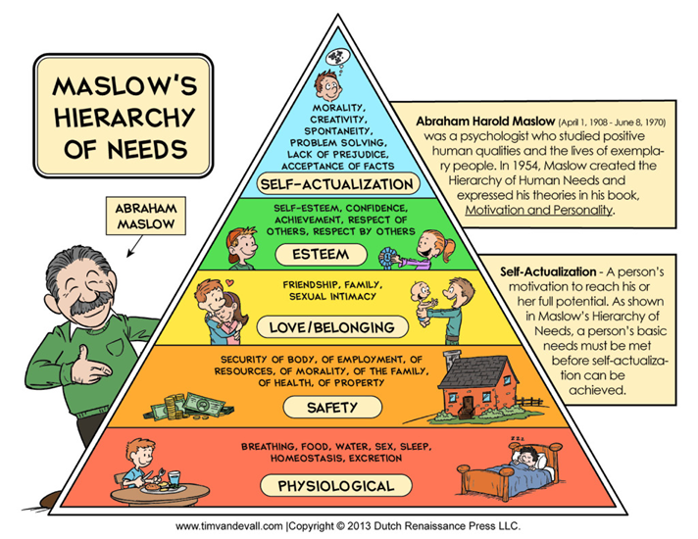

Source: https://www.danmartell.com/hierarchy-of-entrepreneurial-needs/

APPENDIX 2: Mentoring and Coaching content table
Mentoring | Coaching
Relationship oriented  Long term  Development driven  Requires a design phase  Self-selected  Strategy  Life | Task oriented  Short term  Performance driven  Does not requires design  Comes with a job  Skills  Task (job) - related
Source: (own figure based on research)

APPENDIX 3: Few aspects of 'career growth' from an adult perspective
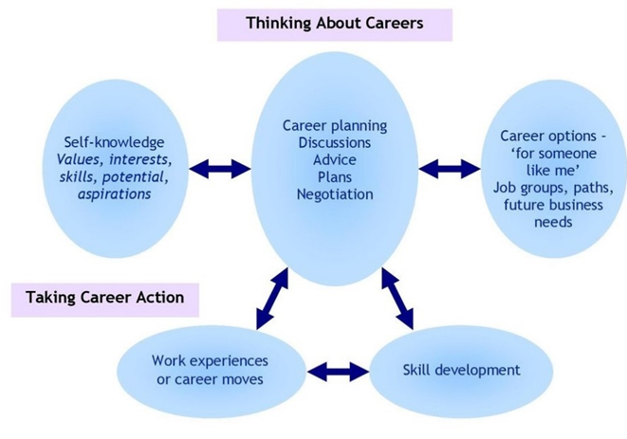

Source: http://ballyclaresecondary.co.uk/careers-downloads/
Appendix 4: The Importance of Talent Management
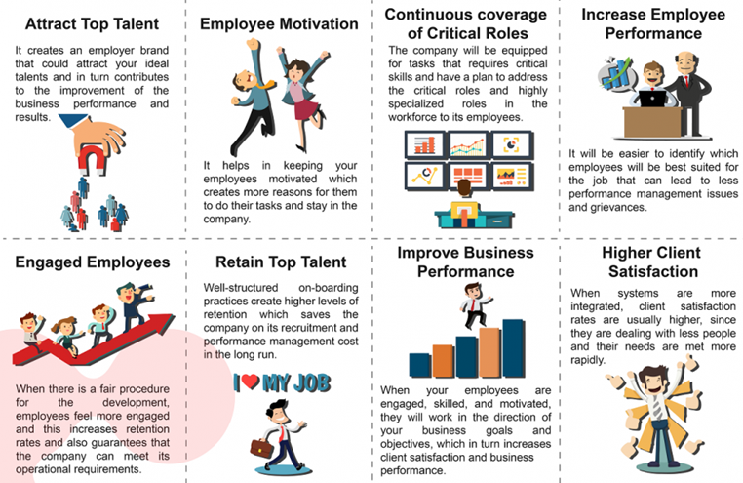
Source: http://www2.humanresourcesonline.net/the-importance-of-talent-management-and-why-companies-should-invest-in-it/

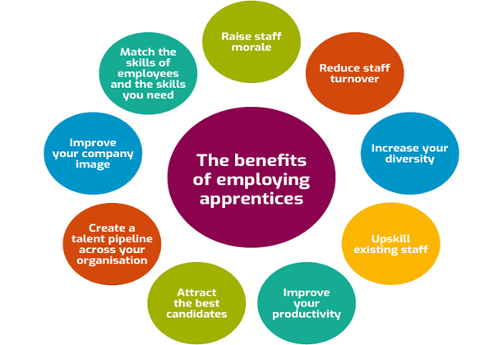
APPENDIX 5: The Benefits of Employing Apprentices

Source: https://www.northeastgrowthhub.co.uk/toolkits/apprenticeship-toolkit
APPENDIX 6: Personal Development Planning Cycle
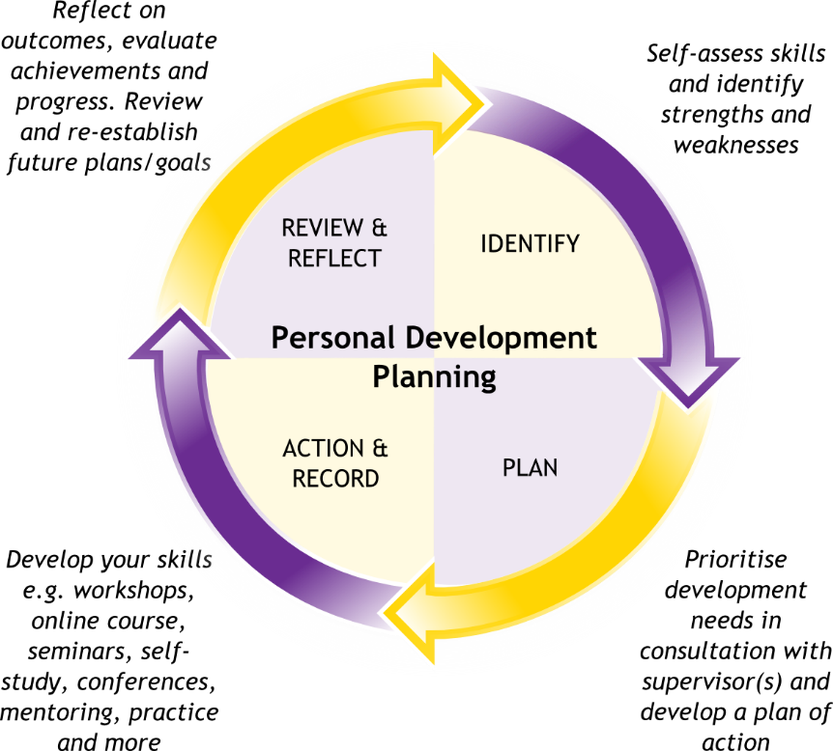
Source: http://mentorguru.info/a-powerful-personal-development-plan/

APPENDIX 7: Personal Development Plan Project Manager at Google
Long Term Goals
Improve skills to move on to managing diverse programmes and large-budget projects.
Short Term Goals
Certify as a skilled project planner and gain expertise in handling ever increasingly challenging tasks. Develop teamwork and public presentation expertise, as well as key communication strengths for programmes.
Goal | Objective | Resource required | Measurement | Target date
To be recognized as a professional project planner | Completion of project management preparation to obtain qualification | Training | Finishing training effectively | Q2
To be recognized as a professional project planner | Finishing the qualification process in project management | Documentation for qualification, references | Accredited qualification | Q3
Acquire knowledge in projects management | Effectively produce two big projects or two small ones | Assignment to project management duties. | Plan variability, budget variation, stakeholder input | Q4
Enhance the capacity to talk in public | Plan and produce a total of 5 presentations | Chances of project representation with stakeholders | Efficient completion of the presentations and feedback from participants | Q4
Source: (own table based on research)

