

Menu Engineering

Student Name : Iulian Gheorge Popa
Student ID : 2118661
Module Title : Food and Beverage Operations BMIH4002 LEVEL 4
Date : February 2023




Trinity Hotel
Valentine’s Day Menu
+44 1482222600
BOOK a RESERVATION
£70 Per Person excluding Drinks

Starters (Any two)

Cream of Mushroom Soup
Chive Crème Fraiche, Sauteed Mushrooms
34 Shrimp Cocktail
Avocado, Marie Rose Sauce
Grilled Fresh Asparagus
Fine Ratatouille, black olive croquette, and sweet pepper mayonnaise

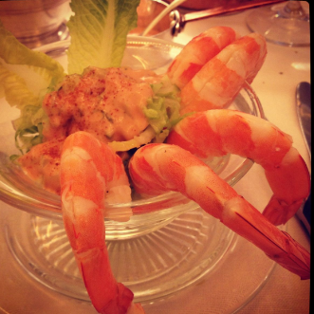

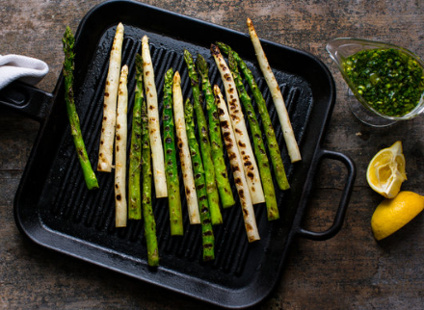

Main Course (Any two)

Prosciutto Wrapped Corn Fed Chicken
Garlic fondant potato, roasted vegetables & feta cabbage wrap, chicken jus
Baked Lasagna of Aubergines
Pomodoro sauce, Béchamel and aged Grana, Padano cheese, Spinach and Lentils orzotto
Chateaubriand
Root vegetable dauphinoise, tender-stem, roasted vine tomatoes and Diane sauce

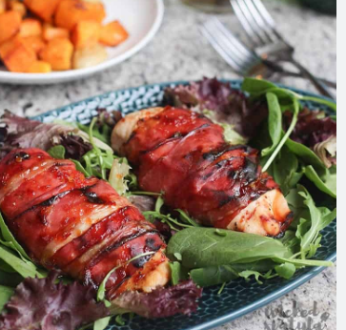

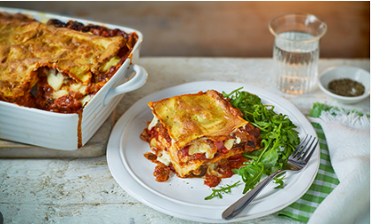

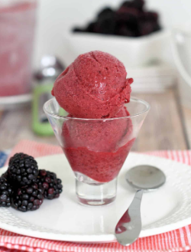
Cassic Meringue, blackberry sorbet
Chocolate Melting Bomb
Chocolate Nemessis (GF)
Salted caramel sauce, Fresh berries and Milk Ice Cream
Stone Manor Cheese Plate
Savoury biscuits, apple chutney
Dessert (Any two )sert



Drinks sert

White Whisky 125 ml
Ardmore Legacy £11.50
Glenmorangic Original £9.50
Brandy 125 ml
Courvoisier £12.90
Courvoisier VSOP £15.90
RUM 100 ml
Captain Morgan Spiced £8.90
Captain Morgan Dark £10.90
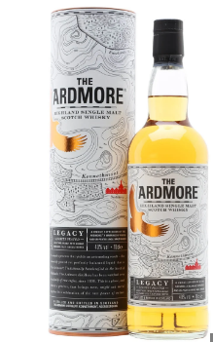

Please inform your server if you have any allergies regarding the menu. This will charge 20% extra in your bill.
References
Hogarths, 2023. Valentines Day. Available at https://hogarths.co.uk/stone-manor/whats-on/valentines-day/. [Accessed on 16th February 2023]
The Casa Hotel, 2022. The Casa Hotel. Available at: https://thecasahoteluk.com/documents/SH_Yateley_Menu.pdf> [Accessed 16th Feb. 2023].
Warner Leisure Hotels, 2022. Adult only Hotels & Breaks: Warner Leisure Hotels. Warner Hotels. Available at: https://www.warnerleisurehotels.co.uk/> [Accessed 16th Feb. 2023].
34-Restaurant, 2023. Available at https://34-restaurant.co.uk/wp-content/uploads/2023/01/01850_34-Mayfair_Menu_Updates_2023_ALC_.pdf. [Accessed 16th Feb. 2023].

