Developing workplace critical thinking
Module code: BMSW5101
Student name: Cristina Anton
Student ID: 2110293
Teacher name: Zahra Mohammadnazari
Word Count: 2132

Contents
Introduction 3
Organisational Overview 3
Theory of Management 4
McGregor`s X and Y Theory 5
Advantages and disadvantages of McGregor`s X and Y Theory 6
Conflict resolution 8
Examples of organisational conflict 8
Options to solve the conflict 8
Conclusion 10
References 10

Introduction
Management theories refer to ideas collected by managers to enhance their strategies into organisations for motivate and make employees do give their best in order to achieve organisational goals. The success of a business significantly depends on the employees' performance and their effectiveness to serve the customers. To enhance their performance and effectiveness, managers use different strategies to motivate them to follow organisational goals in order to make the company more successful and profitable. Not always employees are happy with management decision, or with other people behaviour and this create conflict inside organisation. However, it is management responsibilities to find a resolution, create a good relationship between teams and create a warm ambient.
The aim of this report is to discuss Management theories and apply one of them in organisational context which in this case is Tesco and the chosen theory is McGregor`s X and Y Theory. Also, will be analysed advantages and disadvantages which application of McGregor’s X and Y Theory bring to Tesco. At the end will be assessed how the company approach conflict resolution when employees disagree on organizational priorities and how managers should solve these conflicts.

Organisational Overview

Figure 1: Tesco Shop
(Source: Pinterest.com)
The selected organisation for this report is Tesco Plc; a UK based multinational company of general merchandise retailing and groceries. This company has it headquarter Welwyn Garden City in England. It has founded in 1919 and at present is considered to be the world 3rd largest company in the world for its gross revenue. Tesco is the world's largest retailer, employing 326,000 people and operating about 2300 supermarkets and convenience stores (Statista. 2022). Tesco's core business is mostly in the United Kingdom, where the company ranks as the largest private employer and food store in the "United States." Tesco has roughly 1900 locations. The company conducts its whole operations mostly through various format shops and online. Dotcom, one-stop, large, and tiny are among the formats and patterns stored by the company, which are characterised by the range and amount of items supplied (Corporate Watch, 2022).
Fresh food, groceries, baby products, frozen foods, beauty and health products, bakery, electrical goods, entertainment, home products, apparel, games, toys, garden, pets, and household appliances are among the non-food and food items offered by the company (Globaldata.com, 2022). Tesco's Bank of Tesco provides insurance and retail banking services in the United Kingdom.

Theory of Management
Theory of Management refer to ideas collected by managers to enhance their strategies into organisations for motivate and make employees do give their best in order to achieve organisational goals (Cole 2015).
Classical management theory emphasizes that workers have physical and economic needs and do not consider social needs (Tsoukatos, 2018, p 126). As a result, managers should emphasize worker needs and not just productivity.
The behavioural theory postulates that the performance of leaders or managers depends on their behaviour within the organization (Thompson and Glasø, 2018, p 15). managers should lead as an example to increase productivity and reduce turnover. Similarly, managers need to understand employee behaviours, including conflicts and expectations, for appropriate management strategies (Schedlitzki and Edwards, 2017, p 347).
Motivation theories are important to the company because they give insight into what motivates employees to perform better. Furthermore, it gives managers and leaders with a tool to encourage and inspire employees, as well as assist them in better understanding how people may be controlled and managed (Paais and Pattiruhu, 2020).
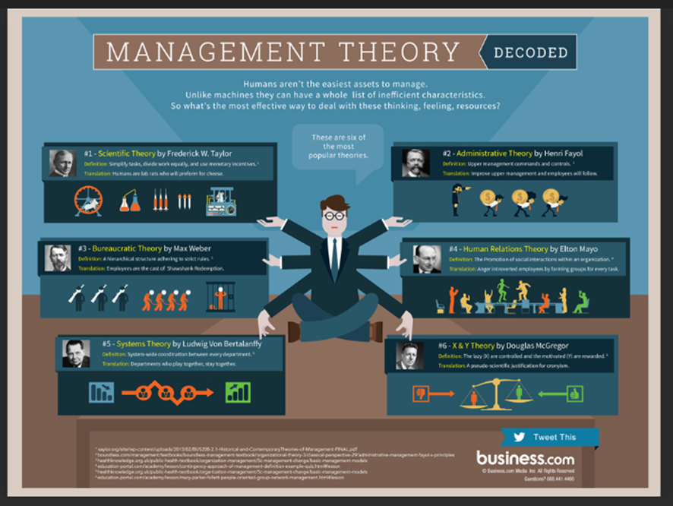
Figure 2: Management theory
(Source: Bennett Conlin, 2022)

McGregor`s X and Y Theory
McGregor`s X and Y Theory: This theory shows the two nature of human behaviour and the motivation method accordingly. Douglas McGregor develops this theory of human motivation and management in 1950 and further developed it in 1960.
McGregor's Theory X and Theory Y are two contrasting theories that explain how managers view employees. Here is a short description attached below to describe this theory considering Tesco Plc:
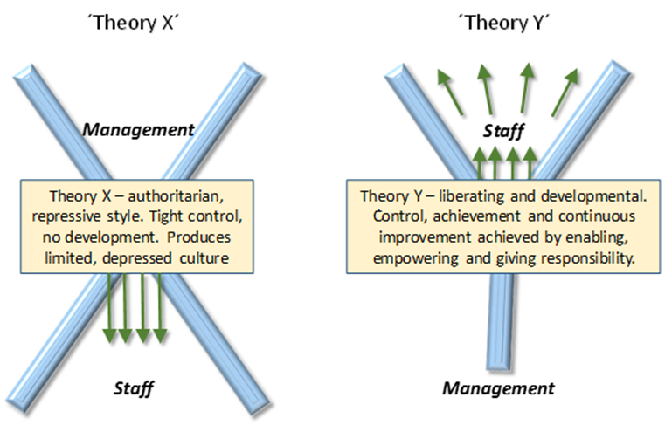
Figure3: McGregor`s X and Y Theory
Source: (Beck and Zlatkin-Troitschanskaia, 2018)
• Theory X: Theory X managers view employees as lazy and unmotivated. Here the employees of organisation are considered to be less interested to work. Employees tend to be lazy, tend to neglect their responsibilities and desire to avoid performing their job. They fear challenges, changes, lack motivation and excitement. That`s why they need to be kept under strict management control and need to be guided strictly (Bennett Conlin, 2022). By applying Theory X managers know that the company will benefit from a stabile target because they are keeping strict control over employees and do not allow them to be under target but also will have as disadvantage that employees are not happy and are working less if they are so much under control. The companies should not be too strict with employees because they are the backbone of any business organization. The proper functioning of the employees will ensure the steady growth of the organization (Kazancoglu and Ozkan-Ozen, 2018).
• Theory Y: Theory Y managers view employees as creative and resourceful. Team members of theory y are highly motivated and goal-oriented persons where they love to do their job, prefer to work with challenges, like to get responsibilities, like to be involved with creative and productive work with a free environment (Beck and Zlatkin-Troitschanskaia, 2018). This type of employees doesn’t necessarily need to be guided with close observation. They can do their job on their own with high motivation.
Tesco managers adopt a bit from both theories. In 2016, Matt Davies wants to develop culture of appreciation of staff to boost customer service (The Guardian, 2016). Matt Davies is chief executive of Tesco’s UK and Irish business. He encouraged managers to appreciate more employees and say to them appreciative words. Since he has to ask managers to be kind with workers it is clear that they are adopting Theory X. Most likely managers are thinking employees are lazy or are coming to work only for necessity. Tesco have more disadvantages by adopting Theory X because for sure employees are not happy and are unmotivated. This management style pushes them down and they do not have reason to exceed their competencies.
Theory Y is adopted by Tesco management and is demonstrated because they are constantly looking for new ways to motivate and inspire employees by offering them different bonuses awards, discounts and good hourly rate (Tesco career, 2022). This has led to a number of advantages for Tesco, including a more positive work environment and increased employee productivity. However, there are also some disadvantages to this approach, as it can lead to managers being too lenient with employees and not setting clear expectations (Tesco Careers, 2022). However, it is very good that Tesco think also at its employees and adopt Theory Y as well not only X, but they could also give employees more opportunity to learn more and develop a better position within organisation.

Advantages and disadvantages of McGregor`s X and Y Theory

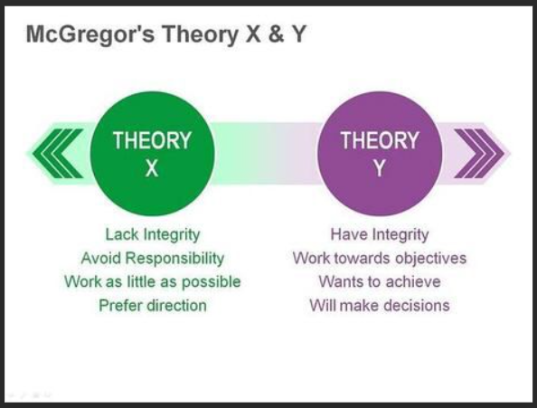
Figure4: McGregor`s X and Y Theory
Source: (Beck and Zlatkin-Troitschanskaia, 2018)
Advantages
The main advantage of McGregor's Theory Y is that it leads to a more positive work environment. This is because Theory Y managers view employees as creative and resourceful and are always looking for new ways to motivate and inspire them. This positive attitude towards employees results in a more positive work environment, where employees feel valued and appreciated (Tesco PLC, 2022). This, in turn, leads to increased employee productivity, as employees are more likely to be motivated to work hard when they feel valued but also some employees can lose time and not do their job seriously. Tesco managers must be very carefully how they give permission and trust to ensure that employees are following the common goal and so not understand wrong their attributions. Theory X bring advantage because being a large company some employees must be strictly observed how they are performing. With the time managers can increase their trust and offer them more opportunities.
Disadvantages
The main disadvantage of McGregor's Theory Y is that it can lead to managers being too lenient with employees. This is because Theory Y managers view employees as creative and resourceful and are always looking for new ways to motivate and inspire them. This can lead to managers not setting clear expectations, and employees may take advantage of this leniency. This can result in decreased productivity, as employees are not motivated to work hard if they do not feel that there are clear expectations (ARCHER and CAMERON, 2013).
Overall, Tesco adopt both McGregor's Theories. Theory Y is more advantageous than Theory X because it leads to a more positive work environment, increased employee productivity, and a better understanding of employee motivation (Tesco PLC, 2022) but also theory X bring advantages because our employees which do not work accordingly and must be observed to find solution to increase their performance. However, there are some disadvantages to this approach, and managers should be aware of these before implementing it. For example, from theory X, Tesco can create conflict between employees making them feel too much stressful and under pressure but also Theory Y can create conflict between them making them think that some employees are more appreciated than others. However, both of theories if not implemented well can lead to low productivity, negative culture and bad relationship inside organisation.

Conflict resolution
An organisational conflict can be defined as behaviour intended to obstruct the achievement of another person’s/department’s goals. According to Mullins (2005), *organisational conflict* is an essential part of improved organisational performance. Conflict resolution is essential professional skill (Indeed, 2021). Managers possess these skills in order to help organisations to build a good relationship between employees, a positive culture, and organisational success which arise when employees are happy, motivated and do not have problems.
Tesco's culture has a big influence on employee engagement, individual learning, impact communication, corporate values development, people decision-making, and resolving individual and team conflicts. Tesco's employees may enhance their relationships with their bosses and co-workers thanks to the company's culture. It also aids in the formation of pleasant and healthy working connections. Employees become more committed to their jobs and collaborate with co-workers to meet their goals. (Tesco Careers, 2022).

Examples of organisational conflict-
Disagreement over a task. Many employees may be annoyed by the way in which the tasks they have to do have been allocated. At Tesco, some employees review show that some workers with heavier tasks are unhappy and complain that they do not agree with how the management is doing inside the organization (Tesco employees review, 2022). The management task is to clearly talk to the team and explain to them that the heavier tasks must be fulfilled, but in order to remove the dissatisfaction of the workers, they can be rotated so that everyone is treated equally. Employees may misunderstand some rules, or policies and can interpret that management are acting under preferences. If this happens, management must discuss with them and ensure they understand the situation. Clarifying their mind and paying attention to them will increase their trust, will create better relationship because they feel that management can listen their voice and find a solution. In this way the company gain a positive culture where managers assist employees, a positive work environment with happy employees, and high performance because happy employees are performing well (Future of Working, 2022)
Employee not meeting expectations. Some hard-working workers may be unhappy with the fact that others do not give their interest as much as they do, but still have same salaries, benefits, and treatment (Tesco employees review, 2022). This creates conflict between employees affecting their relationship. Also, hard workers people can consider that it is managers fold because should give awards and benefits based on their performance. Managers should in this situation ensure that who is working harder receive incentives, award or bonuses. They should always encourage employees to perform better. If other people are not performing maybe managers can show that they have less opportunities, then people who work hard. If employees receive awards will not focus on what other are doing and will focus to get their bonus. Managers should also discuss with lazy employees and explain them that have priorities and responsibilities which if are not complete they can be punished. In this way people will be focused on their tasks, relationship will not be affected and company continue to be successful.

Conclusion
In conclusion Tesco is a multinational company of general merchandise retailing and groceries. Management involves setting strategies and policies necessary for accomplishing tasks and planning employees' working for better performance in their respective jobs. Managers at Tesco are responsible of employee’s motivation and behaviour. McGregor's Theory X and Theory Y are two contrasting theories that explain how managers view employees. Theory X managers view employees as lazy and unmotivated while Theory Y managers view employees as creative and resourceful. Tesco managers appear to adopt both of them. Overall, McGregor's Theory Y is more advantageous than Theory X for Tesco. This is because it leads to a more positive work environment, increased employee productivity, and a better understanding of employee motivation. There are a number of ways that Tesco can resolve conflict when employees disagree on organizational priorities. By communicating clearly and establishing common goals, the company can help to avoid misunderstandings and disagreements. In cases where conflict does arise, mediation and arbitration can be used to reach a resolution that is acceptable to all parties. Finally, disciplinary action may be necessary in some cases to address employees who persist in causing conflict or who are not able to work cooperatively with others.

References
Adams, D., (2018). Mastering theories of educational leadership and management. University of Malaya Press
ARCHER, D. and CAMERON, A. (2013) Collaborative Leadership; Building Relationships, Handling Conflict and Sharing Control. 2nd Ed. London: Routledge.
Beck, K. and Zlatkin-Troitschanskaia, O., (2018). From Diagnostics to Learning Success. Rotterdam: Sense.
Cole, K., (2015). Management Theory and Practice. Melbourne, VIC: Cengage Australia.
Conlin, B., (2022). Popular Management Theories Decoded. (Online). Available at: https://www.business.com/articles/popular-management-theories-decoded/ (Accessed on 18 November 2022)
Future of working, (2022). 12 Reasons Why Happy Employees are the Most Productive. (Online). Available at: https://futureofworking.com/12-reasons-why-happy-employees-are-the-most-productive (Accessed on 21 November 2022)
Indeed, (2021). 6 Workplace Conflict Examples With Useful Resolutions (Online), Available at: https://uk.indeed.com/career-advice/career-development/workplace-conflict-examples (Accessed on 11 November 2022)
Kazancoglu, Y. and Ozkan-Ozen, Y.D., (2018). Analyzing Workforce 4.0 in the Fourth Industrial Revolution and proposing a road map from an operations management perspective with fuzzy DEMATEL. Journal of Enterprise Information Management.
McGregor D., (1960). The Human Side of Enterprise, McGraw-Hill.
Nationwide (2022). Tesco Workers claim Pay Discrimination. (Online). Available at: https://natemplaw.co.uk/portfolio/tesco-workers-claim-pay-discrimination/#:~: (Accessed on 18 November 2022)
Paais, M. and Pattiruhu, J.R., (2020). Effect of motivation, leadership, and organizational culture on satisfaction and employee performance. The Journal of Asian Finance, Economics, and Business, 7(8), pp.577-588.
Schedlitzki, D. and Edwards, G., (2017). Studying leadership: Traditional and critical approaches. Sage.
Statista, (2022). Number of Tesco stores in the United Kingdom (UK) and the Republic of Ireland from financial year 2012 to 2022. (Online), Available at: https://www.statista.com/statistics/490947/tesco-group-stores-united-kingdom-uk/ (Accessed on 20 November 2022)
Tesco Careers, (2021). Our Culture. (Online). Available at: https://www.tesco-careers.com/explore-our-world/our-culture/ (Accessed on 8 November 2022)
Tesco Career, (2022). Benefits. (Online). Available at: https://www.tesco-careers.com/explore-our-world/benefits/ (Accessed on 16 November 2022)
Thompson, G. and Glasø, L., (2018). Situational leadership theory: a test from a leader-follower congruence approach. Leadership & Organization Development Journal.
The Guardian, (2016). Manners market management: Tesco bosses told to be nicer to staff. (Online). Available at: https://www.theguardian.com/business/2016/mar/16/tesco-managers-polite-new-initiative (Accessed on 20 November 2022)
Tsoukatos, E., (2018). Innovation and Capacity BuildingCross-disciplinary Management Theories for Practical Applications. Palgrave Macmillan.
Watch, C., (2022). Tesco Company Profile - Corporate Watch. (online). Available at: https://corporatewatch.org/tesco-company-profile/ [Accessed 10 November 2022].
Wong, K., (2020). Organizational Culture: Definition, Importance, and Development, [online] Available at: https://www.achievers.com/blog/organizational-culture-definition/ (Accessed 17 November 2022)

