Name: Ronakkumar Barad Student Number: 2527222 Module Code: LCHS7003
Module Title: COMMUNITY CARE AND MANAGEMENT LONGER-TERM CONDITIONS
Lecture Name – Muhammed Khan Assignment Title: Component 1 Information Booklet of
Longterm Condition Management – Arthritis




Rotherham Doncaster and
South Humber
NHS Foundation Trust

Arthritis Information Booklet

Adult Mental Health Services

Introduction
Arthritis is one of the most common chronic illnesses in the world today, with it being a major source of pain, disability, and decreased quality of life. Arthritis is a group of more than 100 joint disorders that include osteoarthritis and rheumatoid arthritis, amongst others. The incidence of arthritis is expected to increase due to ageing populations, obesity, and an inactive lifestyle in both the world at large and specifically in the UK. This study will analyse the definitions of arthritis, the prevalence rates, risk factors, impact and care agendas for the condition, before critically analysing the impact of arthritis on individuals and families.

Explanation and evaluation of the focused long-term condition

Definition
Arthritis can be described as a group of chronic musculoskeletal conditions that are characterised by inflammatory, degenerative, or damaging conditions of at least one joint that lead to pain, stiffness, swelling, and limited movement. Accordingly, there are over
100 types of arthritis, which include osteoarthritis (OA) and rheumatoid arthritis (RA), being the two most common types (ArthritisFoundation, 2022).

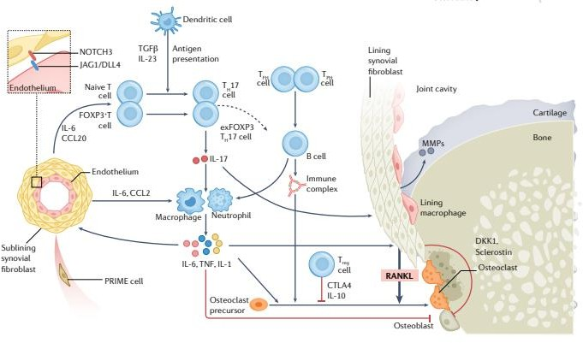

Figure 1: Bone erosion in arthritis
(Source: Komatsu and Takayanagi, 2022) OA is mainly caused by joint cartilage and tissue degeneration. On the other hand, RA is caused by joint inflammation due to an autoimmune response (Komatsu and Takayanagi, 2022). It should be mentioned that arthritis is a chronic condition that persists throughout the whole lifetime of patients.
Prevalence of the long-term condition Arthritis is a major public health problem on a global scale because of the growing number of people affected and its role in causing disabilities. In particular, about 595 million people in the world suffer from osteoarthritis (WHO, 2023). WHO considers musculoskeletal disorders to be the main cause of disability in the world, and arthritis is one of those conditions that contribute to the years lived with disability. In other words, the number of people suffering from arthritis has increased by over 13% since 1990, and it is mainly connected with ageing and obesity (PTI,

2025). There are fewer cases of rheumatoid arthritis compared with osteoarthritis. Only about 18 million people suffer from OA, but women are two to three times more likely to have the disease than men (WHO, 2023). Among the people of the UK, arthritis continues to be one of the most prevalent chronic diseases. It has been indicated that about 10 million people in the UK suffer from arthritis or other musculoskeletal diseases (ArthritisUK, 2025).
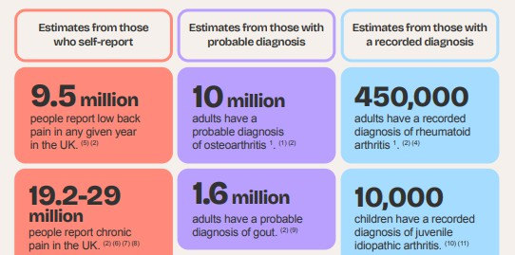

Figure 2: Arthritis prevalence in the UK
(Source: ArthritisUK, 2025)
There is an immense cost involved due to this disease. Approximately 5.4 million people in the UK are affected by osteoarthritis, whereas 450,000 people are affected by rheumatoid arthritis (NRAS, 2022). Arthritis accounts for a large number of cases in which people visit their general practitioners, attend outpatient visits, undergo operations at orthopaedic clinics, and incur costs for social care services. More than 100,000 joint replacements procedures of hip and knees take place
annually in the NHS, and arthritis is the main reason for joint replacements (NHS, 2024). Arthritis has therefore been prioritised under the NHS Long Term Plan, whose main goals include early detection, community-based rehabilitation, and multidisciplinary care.

Risk factors of the health condition
- The development of arthritis is multivariate and is related to the interplay between different risk factors.
- Age is the most important risk factor that predisposes to osteoarthritis, as joint cartilage wears off with age. Due to the growing life expectancy around the globe, the incidence of degenerative joint diseases is constantly increasing (Chen et al. 2026).
- Gender plays a role in disease susceptibility as well. Women are more susceptible to osteoarthritis and rheumatoid arthritis than men, especially at menopause.
- Obesity can be considered another major and modifiable risk factor for the disease. Being obese means having mechanical joint load as well as an increase in chronic inflammation due to adipose tissue (Sobieh et al. 2023). It is proven by numerous studies that being obese considerably increases the risk of knee osteoarthritis.

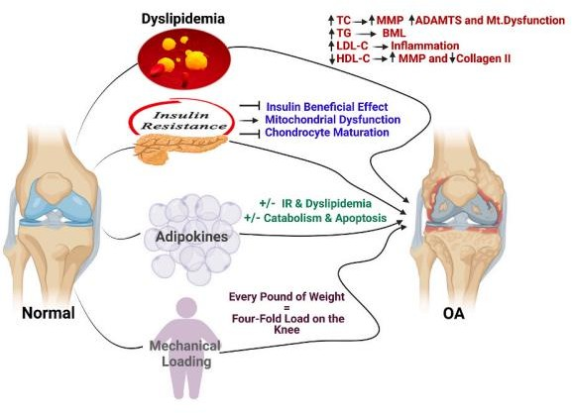

Figure 3: The interplay between obesity and OA
(Source: Sobieh et al. 2023)
Genetic predisposition leads to RA due to the inheritance of predisposing genes such as HLA-DRB1. Individuals who have a family background with RA have a higher possibility of developing rheumatoid arthritis throughout their life (Chen et al. 2024). The most well-known risk factor is smoking.

Age
Sedentar y life
Genes
Arthritis risk factors
Medical history
Obesity
Smoking

Figure 4: Arthritis risk factors
(Self-created)
Tobacco smoking leads to immune system dysfunction, resulting in an increased risk of
developing the disease. History of joint injuries, repetitive work tasks, and high-impact sports activities increase the likelihood of developing osteoarthritis due to faster destruction of the cartilage (Iacobescu et al. 2024). Work that includes frequent joint movement, such as kneeling and lifting objects, is connected with osteoarthritis. The other factors include a sedentary lifestyle, weak muscles, metabolic disorders such as diabetes, and chronic inflammation. Furthermore, being disadvantaged in terms of socioeconomic status may influence delayed detection and treatment of the disease.

Critical evaluation of the impact of the long-term condition

Physical, social and psychological implications
The impact of arthritis on an individual is not limited to physical symptoms; it encompasses various aspects of an individual’s life. Physiologically, pain, joint rigidity, immobility, fatigue, and muscle weakness make the execution of daily activities like walking and dressing oneself difficult. Joint destruction eventually results in disability and dependence, thus requiring the need for long-term care or joint replacement (Murphy et al. 2024). Psychologically, chronic pain and inability lead to anxiety, stress, and depression. People suffering from chronic arthritis have a higher prevalence of mental disorders compared to other individuals

(Giblon et al. 2025). The psychological instability is exacerbated even more by the fear of becoming increasingly ill and disabled. Social life is hampered by the disease as it prevents people from working, studying, enjoying themselves and interacting with other people.
People with arthritis are financially distressed as they cannot perform their jobs and may choose to retire at an early age. Even the family members of arthritis patient can act as carers, adding further distress. There are multiple healthcare professionals involved in the treatment of arthritis in the NHS, which include rheumatologist, general practitioner, physiotherapist, occupational therapist, psychologist and pain therapist (NHS, 2023). Treatments based on scientific evidence include patient education, exercises, weight control, analgesics, NSAIDs, disease-modifying antirheumatic drugs (DMARDS) in cases of rheumatoid arthritis, biological treatments, corticosteroids, and joint replacement surgery.

Wider implications for families
Arthritis impacts the whole family, since relatives tend to offer constant physical, psychological and practical assistance during the course of the condition. Caregiving duties due to arthritis tend to lead to greater emotional strain and lower quality of life among caregivers (Alemu et al. 2025). Family members normally assist patients in
undertaking their daily activities such as taking medication, doing household chores, and transportation to hospital appointments, which denies them time to engage in productive ventures. Over 10 million individuals experience arthritis or musculoskeletal disorders in the UK (ArthritisUK, 2025). Therefore, caring for a relative suffering from arthritis might lead to financial problems, burnout of caregivers and worsened well-being.


Figure 5: Prevalence of arthritis in the UK
(Source: ArthritisUK, 2025)
The broader impacts of arthritis on economic and social factors usually go beyond individual patients and affect the stability and dynamics

within households. Family involvement in the long-term care plan increases treatment compliance and decreases the burden of caregiving as well as psychological distress (Gaugler and Mitchell, 2022). The families of such patients may have lower incomes because of reduced working hours or early retirement of the patient. 1.2 million of unpaid carers suffer economically and 72% of them get hurt physically and psychologically from their work (Carers UK, 2023). Consequently, the health service needs to develop family-centred approaches through education and support for the carers.

Suitable available evidence-based treatments
The effective treatment of arthritis requires interventions based on evidence that alleviate pain, retain joint functionality, and improve quality of life. Exercise, weight control, and patient education are some of the key elements of an effective arthritis treatment strategy (Huffman et al. 2024). Most common treatments involve physiotherapy, occupational therapy, exercises and life style changes that help to improve mobility without losing their independence. Exercise and self-management therapy are the first options for treatment, as it helps to reduce pain and improves physical functioning (Practicebusiness, 2023). This approach involves the patient's active participation in
the process of treatment and decreases disability.
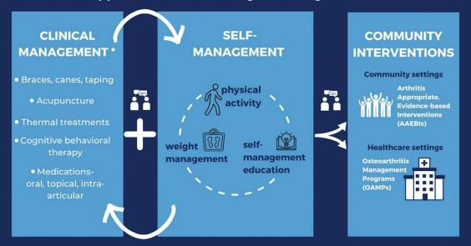
Figure 6: Public health approach to non-surgical management of arthritis (Source: Huffman et al. 2024)
Medications are used alongside rehabilitation to control inflammation, manage pain and prevent disease progression where relevant. Early use of disease-modifying anti-rheumatic drugs is extremely important to obtain better results for people suffering from rheumatoid arthritis (Giachi et al. 2022). Medication can be of different kinds, including non-steroidal anti-inflammatory drugs, corticosteroids and biologics, as well as conventional DMARDs, but joint replacement surgeries are used in case of significant joint destruction. A multidisciplinary approach involving medication, rehabilitation and other specialists is considered to be the most effective in arthritis treatment (NHS, 2023). Regular monitoring and therapy reviews help maintain therapy efficacy and safety.

Investigation of current theoretical perspectives

UK model for better patient outcomes
The NHS Comprehensive Model of Personalised Care is one of the top models that ensures better outcomes for people with arthritis in the UK.

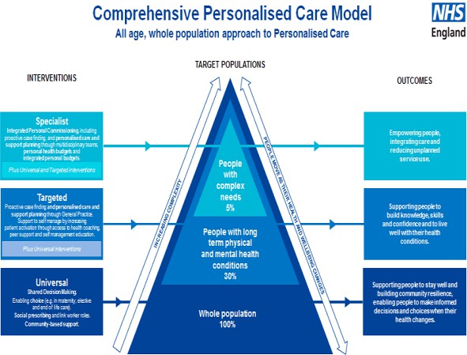

Figure 7: Comprehensive Personalised Care Model (CPCM)
(Source: Happyhealthylives, 2024)
- NHS’s CPCM encourages the provision of personalised care since it acknowledges the fact that each individual has various clinical, preference, and situational needs (Happyhealthylives, 2024).
- Personalised care requires healthcare providers to consult patients when making choices regarding treatment, rehabilitation, and long-term disease management. NHS England maintains that personalised care provides an opportunity for individuals to make decisions on their health and wellness.
- The NHS Long-Term Plan highlights that personalised care can benefit up to 2.5 million people (NHS England, 2022). This will ensure that patients play an active role in physiotherapy, taking medications, weight loss, and lifestyle changes to improve disease management and independence. Therefore, personalised care increases patient participation in arthritis management.
- The model further enhances multi-disciplinary collaboration between specialists in rheumatology, physiotherapists, occupational therapists, nurses and general practitioners in order to provide health care services. This collaboration will allow addressing physical, psychological and social needs of patients at the same time while eliminating fragmented care.
- Individualised care leads to greater patient activation, improved self-management and increased satisfaction among people living with long-term conditions (Aboumatar et al. 2022).
- Nevertheless, implementation is inconsistent due to the shortage of the workforce, regional disparities and growing demand for services that limit

opportunities for individualised care planning.

International model for improved patient outcomes
Wagner's CCM model is one of the well-known models internationally as an efficient tool for enhancing outcomes of people with chronic illnesses like arthritis.
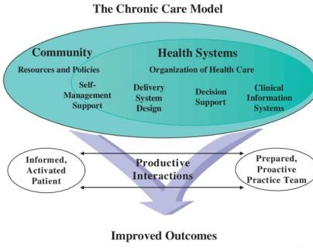

Figure 8: The Chronic Care Model (CCM)
(Source: Pomey et al. 2024)
According to Wagner’s CCM model, positive communication between educated patients and prepared health care providers results in improved treatment outcomes and better disease management (Pomey et al. 2024). There are six interrelated factors of this model, which include self-management support, decision support, delivery system design, clinical information systems, and organisation of health care and community resources. The process of chronic disease management presupposes the cooperation of
organised health care systems providing for educated patients and proactive professionals (Xu et al. 2026). In the case of arthritis, they contribute to continuous monitoring, education of patients, teamwork and prevention of the disease progression.
The Chronic Care Model also emphasises the need for integrating community resources into healthcare delivery for effective self-management and independence. Patients suffering from arthritis need ongoing rehabilitation, counselling, and community exercises to maintain mobility and social interactions. Chronic care models improve compliance to drug therapy, involvement of patients, and physical function in individuals with different chronic conditions (Kroenke et al. 2024). However, there are many challenges that may be encountered when adopting such a model since its implementation requires a huge investment in terms of resources, staff training, and technology development. Notwithstanding this drawback, the model is globally popular since it facilitates efficient arthritis management.
Both theories advocate for patient-centred management of arthritis and improve the well-being of patients through collaboration in healthcare provision and active involvement of the patients. Approximately 20%-40% of the UK population live with multiple long-term conditions for which the government has reformed its health and care system (Kings

Fund, 2025). NHS Model emphasises personalised care, while Wagner’s Model emphasises healthcare integration. Personalised care combined with the integration of chronic diseases leads to better patient experiences and outcomes (Raaijmakers et al. 2023). Thus, a combination of both models would result in more effective management of arthritis because of the empowerment and integration of healthcare delivery, among others.

Examination of social and health care agendas

Local care agendas
Arthritis care is delivered using the Integrated Care System (ICS), Integrated Care Board (ICB), and local government within the local context. Further, local authorities and community-based musculoskeletal (MSK) services collectively support integrated and person-centred care. The England MSK core capabilities framework in the NHS guides how GPs, physiotherapists, occupational therapists, pharmacists, and voluntary organisations collaborate to provide personalised management of arthritis (CSP, 2026). Additionally, the Health and Care Act 2022 policies strengthened integrated care systems by coordinating healthcare provision in local communities.

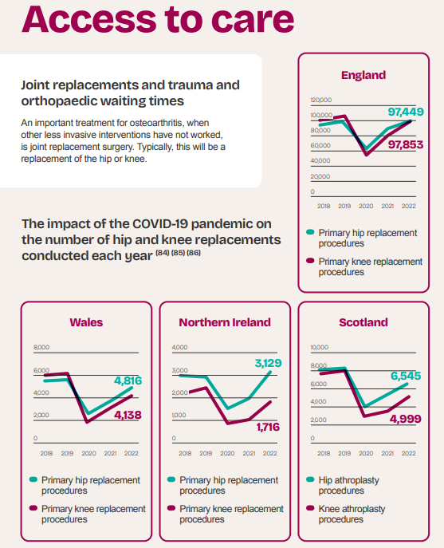
Figure 9: Care access to people with osteoarthritis in different local segments (Source: ArthritisUK, 2025)
Primary knee replacement procedures reached 4,138, 1,716 and 4,999 in Wales, Northern Ireland and Scotland, respectively, for arthritis management (ArthritisUK, 2025).

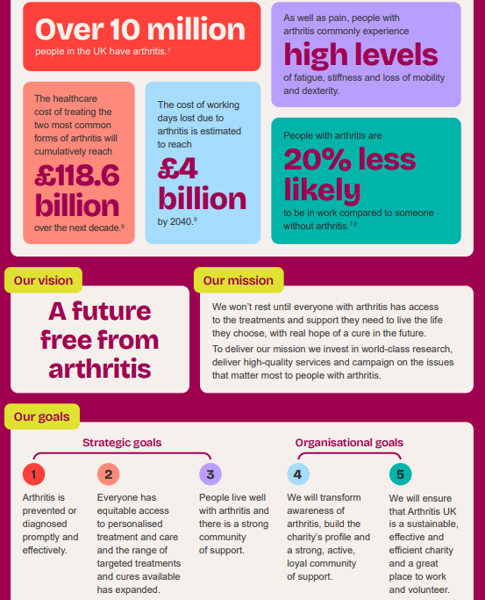

Figure 10: Local agendas to cure arthritis in the UK
(Source: Arthritis, 2026)
Evidence showed the requirement of demonstrating the need for locally coordinated interventions for addressing arthritis problems. Local goal agendas created to manage arthritis are community support, increasing awareness and proper diagnosis of the disease (Arthritis, 2026). However, implementation of the care policies is not consistent, as there are differences in the funding, workforce availability, and access to
MSK services among ICBs. The local political health and social care agenda includes implementing developmental projects through rehabilitation and early intervention for arthritis. However, inequalities in the provision of services hinder holistic treatment. Multidisciplinary rehabilitation, community physiotherapy and social prescribing in local UK areas benefit patients with arthritis (Hartford et al. 2022). Further investments in rehabilitation, workforce development, and self-management help maintain consistency in the process.

National political care agendas
Arthritis management has been influenced by the NHS Long Term Plan (2019) and the NICE Guideline NG226, and the Major Conditions Strategy evidence-based policy initiatives at a national level. Osteoarthritis in over 16s collectively support prevention, early diagnosis, multidisciplinary treatment, and self-management strategies of arthritis (NICE, 2022). The prescribed structured physical activity, weight control, and patient education by NICE help decrease pain and increase mobility in patients. The Health and Social Care Act 2012 has also contributed to the process of service commissioning and provision of healthcare services (Legislation, 2012). National implementation has been achieved through the use of first-contact physiotherapists and multidisciplinary MSK pathways in primary care. However, shortages

in the workforce and variations in waiting times create health and care access barriers to manage adverse arthritis (Ainsworth et al. 2025). These disparities in accessibility to rehabilitation services, hence making some policies ineffective.
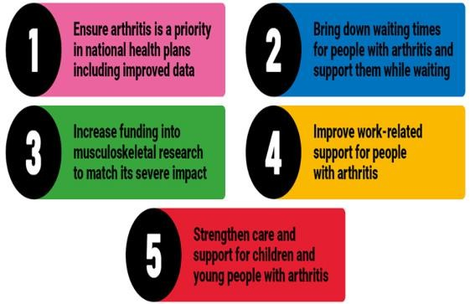

Figure 11: National government priorities for managing arthritis
(Source: Arthritis, 2026) Therefore, national political agendas provide a robust framework for developmental initiatives and integrated arthritis management. National political agendas aim to reduce waiting times, improve support, funding, and care (Arthritis, 2026). Further, stronger investment, equitable resource distribution and consistent implementation are required to achieve sustainable self-management and improved long-term patient outcomes. The international WHO Rehabilitation 2030 Initiative advocates for integrated rehabilitation and physical activity for chronic musculoskeletal disorders in older people (WHO, 2022). All these policies aim at assisting in strengthening their multidisciplinary approach in offering
rehabilitation, although implementation differs according to national, international, and local healthcare resources and policy priorities.

Recommendations for person-centred care improvement

Self-management
Extend personalised self-management education programmes: There is a need to extend the availability of self-management programmes which include arthritis education, physical activity, pain management, and lifestyle advice. Personalised education and self-management programmes help people gain confidence, enhance adherence to medication and allow informed decision-making to manage arthritis (Wang et al. 2023). The use of these programs will make sure that whole person-centred care is provided by taking into consideration physical, psychological and social aspects of the condition.
Improved multi-disciplinary team contribution: This team must include general practitioners (GPs), rheumatologists, physiotherapists, and occupational therapists within ICSs. The integrated process makes coordination easier and inspires patients to observe their symptoms, stay active, and take arthritis medication themselves (Primdahl et al. 2024). Digital technology named NHS apps, virtual consultations and remote symptom

management, can be used along with routine care to improve self-management.
Increase accessibility to community rehabilitation and social prescribing: The local authorities need to invest more in community-based exercises, peer support groups and social prescriptions. Health inequalities will be reduced by connecting patients to various voluntary organisations and promoting healthy behaviour. Access to rehabilitation services consistently across all care areas decreases health inequalities and increases patient independence (Lane et al. 2023). This recommendation allows a personalised self-management plan that increases quality of life and decreases unnecessary admissions due to arthritis.

End-of-life care
Incorporate advance care planning: Arthritis rarely leads to death, yet advanced arthritis together with frailty and other chronic illnesses might lead to palliative care. Advance care planning should be introduced early during end-of-life care to discuss treatment, preferences, and symptom management of individuals (Gibbs et al. 2022). This contributed to patient-centred management of arthritic diseases and considering patients' preferences.
Palliative care integration into multidisciplinary provision of services: Patients with advanced cases of arthritis coupled with other diseases should have their
care delivered by a team of professionals. Care integration aimed at addressing pain, mobility challenges, psychological aspects, and family involvement (Feddersen et al. 2022). It will improve the quality of life since the holistic approach meets physical, emotional, and social needs throughout disease progression. Multi-disciplinary team input: It is recommended that the multi-disciplinary team focus on optimising comfort and managing symptoms of arthritis patients. An integrated care plan motivates patients to remain active and use medications for arthritis on their own (Kianian et al. 2025). Collaboration between health, social, and voluntary organisations can make health care provision more continuous and enable patients to have a dignified experience at the end of life. These recommendations ensure better care through a person-centred and holistic approach to patients.

Conclusion
It has been examined that arthritis is a persistent health problem associated with age, obesity, and lifestyle. Osteoarthritis has considered the most common type worldwide and in the United Kingdom. Arthritis has led to physical disabilities, psychological distress and socio-economic problems among patients and their families despite the availability of multidisciplinary and rehabilitative intervention approaches in treating the condition. Both the NHS model of personalised

care and Wagner’s chronic care model have the ability to engage patients in better coordinated care. Local and national care agendas have highlighted the need for equitable service delivery. Further, stronger
self-management support and integrated end-of-life care recommendations helped to improve long-term outcomes.

Reference list
Aboumatar, H., Pitts, S., Sharma, R., Das, A., Smith, B.M., Day, J., Holzhauer, K., Yang, S., Bass,
E.B. and Bennett, W.L., (2022). Patient engagement strategies for adults with chronic conditions: an evidence map. Systematic reviews, 11(1), p.39. https://doi.org/10.1186/s13643-021-01873-5
Ainsworth, J., Bolic, M., Ismail, I., Mohammadpour, Z. and Wood, J., (2025). Sociodemographic and economic barriers to initial specialist care for patients with rheumatoid arthritis: a scoping review. BMC rheumatology, 9(1), p.76. https://doi.org/10.1186/s41927-025-00501-2
Alemu, N.L., Das, N., Watts, J.J., Robinson, S., Chen, G. and Gao, L., (2025). The Burden of Informal Caregiving for Adults with Musculoskeletal Conditions: A Systematic Review: NL Alemu et al. PharmacoEconomics, 43(10), pp.1179-1204. https://doi.org/10.1007/s40273-025-01523-x
Arthritis, (2025). The State of Musculoskeletal Health 2025. Available at: https://www.arthritis-uk.org/media/n4xaxcas/auk_state-of-msk-health-report_updated.pdf [Accessed on 10.07.2026].
Arthritis, (2026). Our 5 priorities for government. Available at: https://www.arthritis-uk.org/get-involved/campaigning/our-campaigns/our-5-priorities-for-government/ [Accessed on 10.07.2026].
Arthritis, (2026). Our Strategy 2023 to 2028. Available at: https://www.arthritis-uk.org/media/g3tp4rze/j16-auk-organisational-strategy_final.pdf [Accessed on 10.07.2026].
ArthritisFoundation, (2022). Types of Arthritis Pain. Available at: https://www.arthritis.org/health-wellness/healthy-living/managing-pain/understanding-pain/sources-of-arthritis-pain [Accessed on 13.07.2026].
ArthritisUK, (2025). Arthritis and other musculoskeletal conditions in numbers. Available at: https://www.arthritis-uk.org/media/flpbvm2m/arthritisuk_state_of_msk_health_-report_2025.pdf [Accessed on 13.07.2026].
Carers UK, (2023). Key facts and figures. Available at: https://www.carersuk.org/policy-and-research/key-facts-and-figures/ [Accessed on 13.07.2026].
Chen, L., Wu, B., Mo, L., Chen, H., Zhao, Y., Tan, T., Chen, L., Li, Y., Yao, P. and Tang, Y., (2024). Associations between biological ageing and the risk of, genetic susceptibility to, and life expectancy associated with rheumatoid arthritis: a secondary analysis of two

observational studies. The Lancet Healthy Longevity, 5(1), pp.e45-e55. https://doi.org/10.1016/
Chen, M., Chen, S., Xie, C., Li, F., Tao, C., Gong, W., Qu, M., Lin, S., Shao, Z. and Xiao, G., (2026). Global prevalence, incidence, and years lived with disability (YLDs) of osteoarthritis: trends from 1990 to 2021 and projections to 2050. Journal of Orthopaedic Translation, p.101029. https://doi.org/10.1016/j.jot.2025.11.005
CSP, (2026). Musculoskeletal core capabilities framework for first point of contact practitioners. Available at: https://www.csp.org.uk/system/files/musculoskeletal_framework2.pdf [Accessed on 10.07.2026].
Feddersen, H., Søndergaard, J., Andersen, L., Munksgaard, B. and Primdahl, J., (2022). Barriers and facilitators for coherent rehabilitation among people with inflammatory arthritis–a qualitative interview study. BMC health services research, 22(1), p.1347. https://doi.org/10.1186/s12913-022-08773-x
Gaugler, J.E. and Mitchell, L.L., (2022). Reimagining family involvement in residential long-term care. Journal of the American Medical Directors Association, 23(2), pp.235-240. https://doi.org/10.1016/j.jamda.2021.12.022
Giachi, A., Cugno, M. and Gualtierotti, R., (2022). Disease-modifying anti-rheumatic drugs improve the cardiovascular profile in patients with rheumatoid arthritis. Frontiers in Cardiovascular Medicine, 9, p.1012661. https://doi.org/10.3389/fcvm.2022.1012661 Gibbs, A.J., Wallis, J.A., Taylor, N.F., Kemp, J.L. and Barton, C.J., (2022). Osteoarthritis management care pathways are complex and inefficient: a qualitative study of physiotherapist perspectives from specialised osteoarthritis services. Musculoskeletal Care, 20(4), pp.860-872. https://doi.org/10.1002/msc.1638
Giblon, R.E., Achenbach, S.J., Myasoedova, E., Davis III, J.M., Kronzer, V.L., Bobo, W.V. and Crowson, C.S., (2025). Trends in anxiety and depression among individuals with rheumatoid arthritis: a population-based study. The Journal of rheumatology, 52(3), pp.210-218. doi:10.3899/jrheum.2024-0165.
Happyhealthylives, (2024). What is Personalised Care? The Comprehensive Model and the Six Components - Happy Healthy Lives. Available at: https://www.happyhealthylives.uk/integrated-care-board/resources-and-services/personalising-care-for-our-people/what-is-personalised-care-the-comprehensive-model-and-the-six-components/ [Accessed on 13.07.2026].

Hartford, W., Backman, C.L., Li, L.C., McQuitty, S., McKinnon, A., Kherani, R. and Nimmon, L., (2022). Networks of care: a social network perspective of distributed multidisciplinary care for people with inflammatory arthritis. ACR Open Rheumatology, 4(1), pp.40-56. https://doi.org/10.1002/acr2.11349
Huffman, K.F., Ambrose, K.R., Nelson, A.E., Allen, K.D., Golightly, Y.M. and Callahan, L.F., (2024). The critical role of physical activity and weight management in knee and hip osteoarthritis: a narrative review. The Journal of rheumatology, 51(3), pp.224-233. https://doi.org/10.3899/jrheum.2023-0819
Iacobescu, G.L., Iacobescu, L., Popa, M.I.G., Covache-Busuioc, R.A., Corlatescu, A.D. and Cirstoiu, C., (2024). Genomic determinants of knee joint biomechanics: An exploration into the molecular basis of locomotor function, a narrative review. Current Issues in Molecular Biology, 46(2), pp.1237-1258. https://doi.org/10.3390/cimb46020079
Kianian, T., Gholamnejad, H., Rassouli, M., Farzadnia, F., Kheibar, N. and Moosavi, S., (2025). Quality Indicators for Evaluating Home Healthcare Services: A Scoping Review. Advances in Nursing & Midwifery, 34(1), pp.8-22. DOI: 10.22037/anm.v34i1.48362
Kings Fund, (2025). Improving Clinical Coordination Of Multiple Long-Term Conditions | The King’s Fund. Available at: https://www.kingsfund.org.uk/insight-and-analysis/long-reads/improving-clinical-coordination-multiple-long-term-conditions [Accessed on 13.07.2026].
Komatsu, N. and Takayanagi, H., (2022). Mechanisms of joint destruction in rheumatoid arthritis—immune cell–fibroblast–bone interactions. Nature Reviews Rheumatology, 18(7), pp.415-429. https://doi.org/10.1038/s41584-022-00793-5 Kroenke, K., Corrigan, J.D., Ralston, R.K., Zafonte, R., Brunner, R.C., Giacino, J.T., Hoffman, J.M., Esterov, D., Cifu, D.X., Mellick, D.C. and Bell, K., (2024). Effectiveness of care models for chronic disease management: A scoping review of systematic reviews. PM&R, 16(2), pp.174-189. https://doi.org/10.1002/pmrj.13027
Lane, C.Y., Lo, D., Thoma, L.M., Zhang, T., Varma, H., Dalal, D.S., Baker, T.A. and Shireman, T.I., (2023). Sociocultural and economic disparities in physical therapy utilization among insured older adults with rheumatoid arthritis. The Journal of Rheumatology, 50(11), pp.1414-1421. DOI: https://doi.org/10.3899/jrheum.2023-0103
Legislation, (2012). Health and Social Care Act 2012. Available at: https://www.legislation.gov.uk/ukpga/2012/7/contents [Accessed on 10.07.2026].

Murphy, J., Pak, S., Shteynman, L., Winkeler, I., Jin, Z., Kaczocha, M. and Bergese, S.D., (2024). Mechanisms and preventative strategies for persistent pain following knee and hip joint replacement surgery: a narrative review. International Journal of Molecular Sciences, 25(9), p.4722. https://doi.org/10.3390/ijms25094722
NHS England, (2022). Personalised Care. Available at: https://www.england.nhs.uk/personalisedcare/ [Accessed on 13.07.2026].
NHS, (2023). Rheumatology :: East Lancashire Hospitals NHS Trust. Available at: https://elht.nhs.uk/services/rheumatology [Accessed on 13.07.2026].
NHS, (2023). Treatment - osteoarthritis. Available at: https://www.nhs.uk/conditions/osteoarthritis/treatment/ [Accessed on 13.07.2026].
NHS, (2024). CMICB_Clin084 -Hip and knee replacement surgery. Available at: https://www.cheshireandmerseyside.nhs.uk/media/smrhlppb/pol-clin084-hipkneereplace-v1-final.pdf [Accessed on 13.07.2026].
NICE, (2022). Osteoarthritis in over 16s: diagnosis and management. Available at: https://www.nice.org.uk/guidance/ng226/chapter/Recommendations [Accessed on 10.07.2026].
NRAS, (2022). What is RA?: Rheumatoid arthritis explained. Available at: https://nras.org.uk/resource/what-is-ra/ [Accessed on 13.07.2026].
Pomey, M.P., Schaad, B., Lasserre-Moutet, A., Böhme, P. and Jackson, M., (2024). Towards a new integrated model for taking into account the experiential knowledge of people with chronic diseases, integrating mediation, therapeutic education and partnership: the expanded chronic care patient–professional partnership model. Health Expectations, 27(5), p.e70054. https://doi.org/10.1111/hex.70054
Practicebusiness, (2023). Osteoarthritis: Key takeaways from the new NICE guidelines | Practice Business. Available at: https://practicebusiness.co.uk/osteoarthritis-key-takeaways-from-the-new-nice-guidelines [Accessed on 13.07.2026].
Primdahl, J., Bremander, A., Hendricks, O., Østergaard, M., Latocha, K.M., Andersen, L., Jensen, K.V. and Esbensen, B.A., (2024). Development of a complex Interdisciplinary Nurse-coordinated SELf-MAnagement (INSELMA) intervention for patients with inflammatory arthritis. BMC Health Services Research, 24(1), p.87. https://doi.org/10.1186/s12913-023-10463-1
PTI, (2025). Study indicates incidence of rheumatoid arthritis increased 13% since 1990. Available at: https://www.thehindu.com/sci-tech/health/study-indicates-incidence-of-

rheumatoid-arthritis-increased-13-pc-since-1990/article69700849.ece [Accessed on 13.07.2026].
Raaijmakers, L.H., Schermer, T.R., Wijnen, M., van Bommel, H.E., Michielsen, L., Boone, F., Vercoulen, J.H. and Bischoff, E.W., (2023). Development of a person-centred integrated care approach for chronic disease management in Dutch primary care: a mixed-method study. International journal of environmental research and public health, 20(5), p.3824. https://doi.org/10.3390/ijerph20053824
Sobieh, B.H., El-Mesallamy, H.O. and Kassem, D.H., (2023). Beyond mechanical loading: the metabolic contribution of obesity in osteoarthritis unveils novel therapeutic targets. Heliyon, 9(5). https://doi.org/10.1016/j.heliyon.2023.e15700
Wang, E., Rodrigues, I.B. and Li, L.C., (2025). Effectiveness of Tailored Self-Management Interventions for People with Chronic Musculoskeletal Conditions: A Systematic Review and Meta-Analysis. Physiotherapy Canada, 77(2), pp.148-161. https://doi.org/10.3138/ptc-2023-0050
WHO, (2022). Musculoskeletal health. Available at: https://www.who.int/news-room/fact-sheets/detail/musculoskeletal-conditions [Accessed on 10.07.2026].
WHO, (2023). Osteoarthritis. Available at: https://www.who.int/news-room/fact-sheets/detail/osteoarthritis [Accessed on 13.07.2026].
Xu, X., Chen, Y., Zhang, Y. and Lu, L., (2026). Clinical Practice of the Proactive Health Concept in Chronic Disease Management: A Qualitative Study from the Perspective of Neurology Medical Staff. Risk Management and Healthcare Policy, p.607825. https://doi.org/10.2147/RMHP.S607825

