Business Plan

Audra Arundel
1905286
3rd July 2020

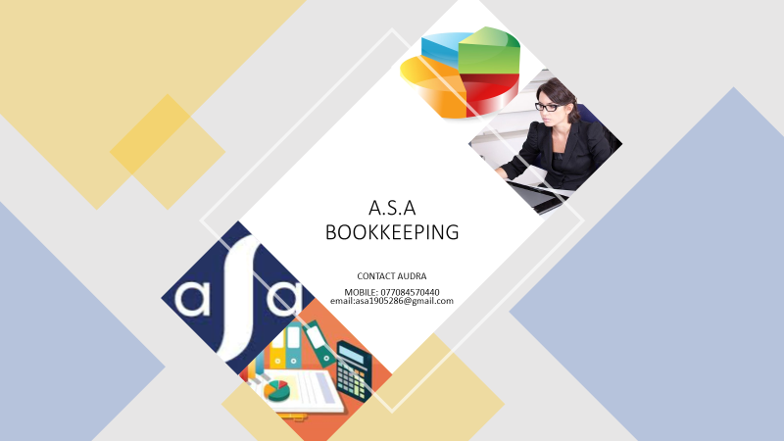

Table of Contents
1.0 Company description page 2
1.1 Proposed business plan page 2
1.2 Aim of the business page 2
1.3 Mission statement page 2
1.4 Products & Services page 3
1.5 Why bookkeeping? page 4
1.6 PEST analysis page 5
2.0 Marketing page 6
2.1 How the business will be advertised pages 6-7
2.2 Marketing my business page 7
2.3 Who is my target market? pages 7-8
2.4 Marketing questionnaire analysis page 9
3.0 Physical resources page 10
3.1 Business expenses pages 10-11
4.0 Financial resources page 12
4.1 Cashflow projection page 13
5.0 Human resources page 14
5.1 Recruitment page 14
5.2 Job Description pages 15-16
6.0 Analysis page 17
6.1 SMART analysis page 18
6.2 SWOT analysis page 18
7.0 The future of the business page 19
8.0 Appendices page 20
8.1 Marketing questionnaire pages 20-24
8.2 Cashflow projection page 25
9.0 References pages 26-28

1.0 Company description
1.1 Proposed business plan
My proposed business plan is of a bookkeeping business based predominantly in my local area of Swansea and serving small local businesses. The business will be run from my home in the Treboeth area of Swansea and will be referred to by my initials A.S.A BOOKKEEPING with S.A also applying to Swansea’s postal code. There is no legal requirement to have any formal qualifications to be a bookkeeper, however they are welcomed as attracting clients would be easier and allow a higher rate of pay to be achieved. By the launch of my business I will have the Association of Accounting Technicians(AAT) qualification, a recognised bookkeeping qualification in the U.K.
The business will be a sole trader meaning that the business will be run solely by myself, Audra Arundel with its success or failure being my full responsibility along with any financial implications. As a sole trader I will inform HMRC and register as self-employed by filling in an online form, self-assessments will be submitted once I have earnt more than £1000 from 6th April to 5th April(Companybug,2020).
I will have unlimited liability and be personally liable for the firm’s debts and may have to pay for losses made by the business(BBC Bitesize,2020).The advantages of being a sole trader are that I will be my own boss, keep any profits made, easy to set the business up with lower costs, however it does come with disadvantages, the risk to being a sole trader is that personal finances are not protected with unlimited liability, may not be tax efficient, no one to share decision making and making it harder to take time off.
A Fixed monthly fees will start at around £250 for basic bookkeeping services, with extra for additional services such as payroll and VAT. A 10% discount will be given to the first 10 new clients with a 10% discount offered to my surrounding businesses.

1.2 Aim of the Business
to provide a home run bookkeeping business serving the small businesses in the local area. Providing businesses with the tools to make decisions based on the financial health of the business with honest, understandable advice. Adhering to guidelines issued by the International Accounting Standards(IAS) allowing clients to take care of their businesses knowing their accounts are being handled professionally.

1.3 Our Mission Statement
“To aid small businesses in achieving their financial objectives by providing a personal, quality prompt serviced in a professional manner”.

1.4 Products and Services

The business would provide.
•Data entry into accounting software
•Filing invoices
•Paying suppliers
•Making business payments
•Customer and supplier reconciliations
•VAT returns
•Prepare wage payments
•Prepare company books ready for end of year accountant.

The business unique selling point would be that it is based in SA5, with numerous small businesses in my surrounding streets varying from decorating businesses & nail bars to cake shops & florists all of whom would be offered discounts and incentives to help growth and development within the local community. With local businesses I am more likely to know the business owners personally and be able to understand what the needs and the requirements of their business are.

1.5 Why bookkeeping?


This Photo by Unknown Author is licensed under CC BY-SA

A bookkeeping business has been chosen for 2 reasons.
1) My love of numbers along with facts and figures and the desire to have a career that I will enjoy
2) By the beginning of 2019 there were 2.4 million more businesses than at the beginning of 2000(Merchantsavvy,2020), Suggesting that the need for bookkeeping would be in demand, to support entrepreneurs in understanding the financial aspects of their business, especially for small businesses as 95% of businesses in the United Kingdom(U.K) employ fewer than 10 people(Merchantsavvy,2020).
Bookkeeping is a £2bn industry in the U.K providing a vital service to Britain’s small and medium sized businesses, Scott(2016)was a useful source of information. There are 23 bookkeepers covering the whole of the area across Swansea according to yell.com business directory with Swansea city having around 1,500 small businesses.
These facts considered I believe there is a place in the market for my bookkeeping business to develop and grow.

1.6 PEST Analysis
PEST is an acronym for political, economic, social, and technological. A way of understanding the impact external elements have on your business and a strategy for reviewing the business.

POLITICAL | •Brexit could lead to uncertainty in legislation  •Possible changes to small business funding  •Changes to tax policies  •Increase in minimum wage laws
ECONOMICAL | •Uncertainty of business security due to changes in European Union trade and law  •Economic growth decline due to recession  •Unemployment trends  •Incomes of local businesses
SOCIAL | •Support for local businesses increases local reputation but could restrict growth from larger businesses  •A recession will make people less likely to take the risk of running their own business
TECHNOLOGICAL | •The development of online bookkeeping systems may deter business clients  •Speed of internet connection

2.0 Marketing

Marketing is the process of teaching consumers why they should choose one product over another, it identifies who is likely to buy your product and how to promote it, Lake (2019) was a useful source of information. The business will use the 7p’s of marketing which is a strategy tool devised by E. Jerome McCarthy published in 1960. It will be used to identify the business requirements and competitive strategies; Product, Promotion, Price and Place which are the core 4p’s with the addition of People, Process and Physical evidence, these will define key issues that will affect the marketing of the business and its products and services(Smart Insights,2019).The core 4p’s will identify,
•Products/services-what customer needs does the business satisfy?
•Promotion-how can I communicate the benefits of using my business to gain more customers?
•Prices- how much is the customer willing to pay for the service? how can I alter the pricing model?

•Place-where will the business be based? how will clients access the business?
This Photo by Unknown Author is licensed under CC BY-NC

2.1 How the business will be advertised & promoted

The business will promote the fact that customers will be able to get on with the day to day running of their business without worrying about balancing their books. Marketing of the business would include networking with potential clients and accountants, advertising the business on platforms that are free of charge such as social media, Facebook. LinkedIn, Gumtree and, advertising leaflets door to door to my target market along with communicating to local businesses through e-mails. I will also introduce myself to the local businesses if they do not already know me so they can get a personal sense of myself and the business. Google My Business also offers a free business listing service. As a small business it would not be cost effective to cover a wide area when advertising so I will concentrate on my target market of local businesses. There are many advantages to advertising on social media apart from being cost effective, it allows customers to identify with my brand and allows me to engage with my customers and attract new ones. Advertising my business on social platforms where people are sharing opinions and showing what they like can only benefit the promotion of my business. Direct communication between customers and the business will enable customers to get the personal service they deserve and the invaluable feedback through reviews they can give the business to help it develop.
Flyers will be distributed to local and surrounding businesses, they are a quick way of advertising a simple message, covering a chosen location or target market advertising discounts available and is a cost-effective way of promoting my business. Prontaprint in Swansea offer a service of providing 500 flyers for a payment of £30.
2.2 Marketing my business I will advertise the
•Service the client will receive a service which will be personal and of good quality in a professional manner. The challenge facing the business is to ensure the customer receives a higher quality service than our competitors offer.
•Promotions refer to a set of activities that communicate the service to make people aware and attract customers to your product (m.economictimes,2020).Our promotions will include reductions in costs for businesses based within the local area and discounts for first 10 new clients.
•Prices would be competitive with a fixed price in advance for smaller businesses so they can budget their costs in advance and 10% discounts for local businesses in my surrounding area and 10% off the annual fee for first 10 clients. Fixed monthly fees will start at £250 for basic bookkeeping services, with extra for additional services such as payroll and VAT.
•Place my place of business will be internet based at my home address with client one to one’s available where required.
2.3 Who is my target market?



Marketing segmentation is a commonly applied marketing strategy, helping to prioritise and engage with different audiences, determining the target market of your product/services(SmartInsights,2019). Segmentation divides the business market into categories where different types of customers can be identified to target your marketing to a specific type of customer such as ages, gender, social backgrounds. locations etc. The target market is who I will sell my services to, which would be small local businesses, my position within the marketplace would be based on cost leadership where the business will provide a competitive quality service at a competitive price. Clients will expect a no-frills basic product to meet their basic needs. The alternative to a cost leadership marketed business would be a differentiation marketing strategy where customers pay a premium for a unique service. When making marketing choices for my business from promotional flyers to emails I will look at my business from the customers perspective before deciding how I will market the business and consider the marketing of the business as an investment into its success.

Marketing flyer

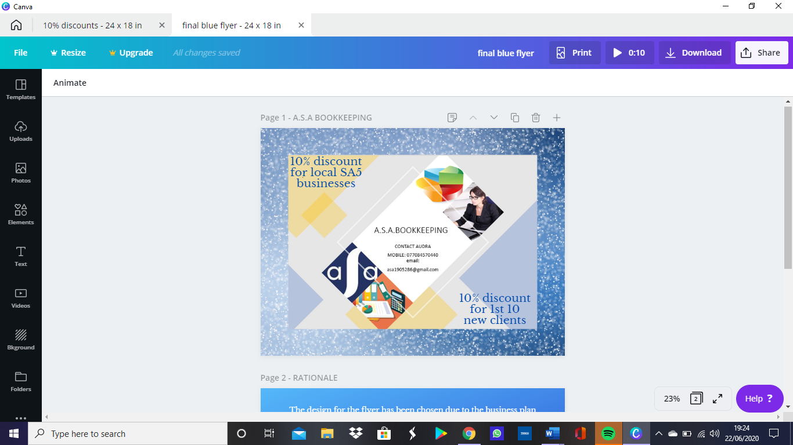

2.4 Marketing questionnaire analysis
A marketing questionnaire has been undertaken to identify if my business would be required and the best ways to advertise the business (see appendix 1).
Due to my concerns over the name of the business and whether the name would deter clients from using my business this was one of the questions asked. 30% of respondents said it either may or it would deter them, which would suggest that it may be beneficial for me to consider a change of business name to attract a wider market.
100% of those questioned agreed that they do support local businesses wherever possible reinforcing my decision to base my business targeting local business owners.
My advertising strategy is to use social media platforms alongside business flyers, the results show that my target market would be reached using these forms of advertising. It would be advisable to increase any social media presence as half of those questioned said that social media was the advertising, they were most attracted by.
The questionnaire identified that over 90% of those questioned would use a bookkeeper rather than to do their own using an online facility. A concern to starting the business is that clients would choose an online facility, but the results identify that only 10% would do so, adding to my belief that there is a market for my bookkeeping business.
60% of respondents said that they either run their own business or that they were likely to do so in the future. With the continuing growth throughout the U.K of smaller businesses, it suggests that a bookkeeping business would be beneficial providing a service to small business owners.


This Photo by Unknown Author is licensed under CC BY-NC-ND

3.0 Physical resources
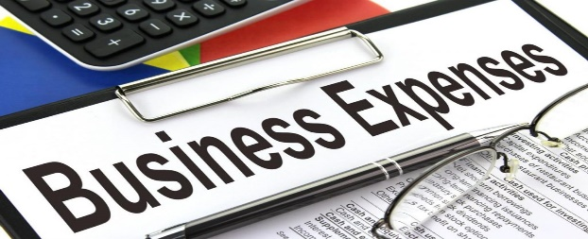
This Photo by Unknown Author is licensed under CC BY-SA
The business will be a clicks business run from my home address in Treboeth, Swansea. The physical resources the business will require are a computer, printer, internet, desk, business mobile, business cards, website hosting & maintenance, data protection fee, bookkeeper’s insurance, bookkeeping software, branding, and sundries including stationery, ink etc.
3.1 Business expenses per annum
Salaries 51,547
National Insurance 3,449
Pension contribution 3% 646
Data protection fee 60
2x Computer 958
Business computer security (Curry’s) 40
Microsoft business (Curry’s) 249
Brother Printer (Argos) 199
Electrical testing 150
2x Office desk(Argos) 330
Business cards x500 (Prontaprint) 36
Software (sage £30 per month + vat) 432
Bookkeepers insurance (policybe.co.uk) 162
Employers liability insurance (Simply business) 81
Business mobile (Tesco £38.49 month ) 462
Wi-Fi (Virgin) 336
3x 500 Promotional flyers (Prontaprint) 87
2x Calculator (Argos) 30
Stationery, printer paper, ink & sundries 250
=£59,504

A Money Laundering Licence also known as Anti Money Laundering (AML) registration with the industry regulator, International Association of Bookkeepers(IAB) is required to run a business within the financial sector(GOV.UK ,2020). As a sole trader that will have access to clients personal information, I will be required to pay a data protection fee of between £40-£60 to the Information Commissioner’s Office(ICO) to ensure I am compliant with the General Data Protection Regulation(GDPR). With this all clients will be reassured that all personal detail is held securely and will not be shared, all information that is no longer required will be destroyed regularly in a secure manner(ICO,2020).
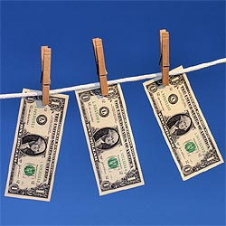
This Photo by Unknown Author is licensed under CC BY

A bookkeeper’s insurance is a Professional Indemnity insurance offering protection for bookkeepers who could be liable to a legal claim if a client believes the services, they received have caused a financial loss to their company. Hart(2016)was a useful source of information.

4.0 Financial resources


This Photo by Unknown Author is licensed under CC BY-SA
Financial resources will be provided by owner’s capital, an indication of how committed I am to the success of the business. Savings of £50,000 along with an investment of £50,000 off a family member through the profits of a property sale will be used as capital. A legal contract will be drawn up outlining the amount of money that has been invested and that I have sole ownership of the business.
•£50,000 savings
•£50,000 family investment
•£100,000 Total Investment available
This Photo by Unknown Author is licensed under CC BY-SA-NC
A government backed start up loan, which is an unsecured personal loan would be available if additional finance is required. A business support grant from the Welsh Government would be available, this grant is dependent on where in Wales your business is situated with Swansea based businesses being eligible for a Business Support Grant of up to 50% of project costs ranging from between £250-£1000(Startups,2020).

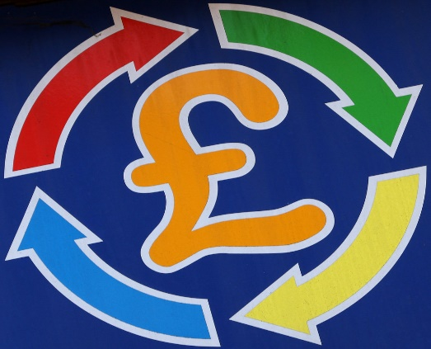
This Photo by Unknown Author is licensed under CC BY-SA-NC

4.1 Cashflow projection
(see appendix 2)
Bookkeeping as a business doesn’t require a huge amount of infrastructure to get started . An initial amount of £40,000 will be used to start the business, extra funds of up to £60,000 are available if required. There is limited outgoing expenditure for the business with just basic start-up items required from computers, desks, software to data protection fees. During the first 6 months of the business I will draw a lower wage of £2000 per month to assist the business during the development period and give the business every chance to survive its first year of trading. The projected figures consider the fact that a 10% discount will be offered in the surrounding area where I am targeting my business any other income received that doesn’t include the 10% would be a bonus. 20 clients have been approached and agreed to use the business this has been used for projected sales with a target of doubling the client base to 40.Captital costs such as computers, desks & printers will be paid in full when opening the businesses other fixed costs that can be spread over the year on a monthly basis will be paid in instalments such as mobile phone and insurances. The projected figures show an annual profit of over £17,000 during the first-year trading period. The business will need to continue to expand its client base during its second trading year continuing to support the local community possibly by investing in sponsorship of local events e.g. advertising through football/rugby teams or local events, community fayres etc.

5.0 Human resources


This Photo by Unknown Author is licensed under CC BY
Bookkeepers have no legal requirement to have any formal qualifications, I have 15 years of bookkeeping experience and have recently completed the Association of Accounting Technicians (AAT) qualification ,a recognised bookkeeping qualification In the U.K. As a sole trader I will be responsible for Human resources, Marketing and Financial operations.
Fire safety must be adhered to with risk assessments and all legislation applied.
Health and safety legislation applied.
Employer’s liability insurance will be obtained from an authorised insurer covering the business for at least £5 million, a monthly cost of £6.75 is a quote for this cover from Simplybusiness.
5.1 Recruitment
The company will employ 1 member of staff to establish the business with a salary based on 37.5 hours working week with a recommended £11.05 an hour rate of pay (payscale,2020). Advertising the vacancy I will use local press, social media, and the company website. Once candidates are chosen, they will be checked to establish their right to work in the UK with guidance from GOV.UK. Candidates will be interviewed by a panel of at least 3 people, which is recommended to ensure impartiality. The equality act 2010 must be applied to ensure there is no discrimination.
The successful candidate will have a Disclosure and Barring Service (DBS) check carried out due to their access to financial information. This service helps employers to make safer recruitment choices(GOV.UK,2020).
A statement of employment is required so both the employer and employee are aware of what is required of both parties, this will include information such as rate of pay, hours of work, salary, holiday entitlement and a job description . The business must then register with HMRC to be able to pay tax and national insurance. Enrolment in to a company pension is a legal requirement with the employer obliged to pay 3% of the employees’ salary into a pension scheme(GOV.UK,2020). Employees must have full training on fire evacuation and legal requirements for Fire Safety along with all Health and Safety guidance.

5.2 JOB DESCRIPTION


This Photo by Unknown Author is licensed under CC BY-SA

To maintain financial records, preparing tax returns and looking after the financial health of the company preparing end of year statements for the company accountant.
Duties would include:
•recording all financial transactions
•handling accounts
•paying regular bills for the company
•completing tax forms
•maintaining financial legers
•client invoices
•coding receipts ready for the accountant
•invoicing and paying for goods and services
•filing all necessary documents

•cash handling and bank deposits
•clerical support where needed
•Level 2 or 3 IT skills essential

The job specification would be:
•Excellent communication skills
•Knowledge of accounting software
•Teamwork and communication
•Bookkeeping experience
•Honesty
•Flexibility

Annual salary of £21,547 would be paid on a pro rata basis
benefits would include 28 days paid holiday pro rata & statutory bank holidays
Salary is based on 37.5 hours working week with a recommended £11.05 an hour rate of pay (payscale,2020).

6.0 Analysis
6.1 Smart Objectives of the Business

Aim is to have an operating bookkeeping
business by September 2020
To survive the first year of trading
Increase in clients from a target of 20 to start the business with an aim of 40 by the end of the year
Specific
:

Business start-up date has been set with monthly reviews of progress
Attract new clients each month
Measurable:

The business will be run from home limiting the amount of investment needed into the business
Any employees will be involved and work towards achieving the end goal

Achievable:

A start-up capital of £100,000 is available for equipment & salaries will aid in starting the business and becoming operative.
Target is achievable with market conditions and the available resources

Realistic:

The business will achieve a profit in the 1st year of operation increasing to a target of 40 clients
Timebound:

6.2 SWOT ANALYSIS

STRENGTHS  •Ability to support businesses in the local community  •Home run business with lower overheads  •Competitive rates  •Professional skilled staff providing excellent service | WEAKNESSES  •No client bases  •No reputation  •No one to share responsibility with  •Competitors offer similar service  •USP only covers local area
OPPORTUNITIES  •Support local businesses  •Opportunity to develop and grow the business  •Growth of client bases  •Investment could be found from forming a partnership  •Increase in entrepreneurship leading to more clients | THREATS  •Uncertain economy due to Brexit  •Possible changes to legislation  •Competition  •Increase in online bookkeeping services  •Possibility of recession  •Financial risks with unlimited liability

7.0 The future of the business

This Photo by Unknown Author is licensed under CC BY-SA-NC
With a successful business operating as a sole trader it will be easier to expand my business allowing me to be openminded about which direction to continue to develop and adapt to its changing needs. If the business starts to see an increase in income and more employees it may be more tax efficient to run the business as a limited company, a company structure will protect my personal assets when the company grows. A partnership will have the benefits of shared responsibilities, profits and would make it easier to raise finance to develop the business, both partners would have full liability. My future plans for the business are to expand into a business premises increasing the number of staff I employ with the possibility of diversifying into accountancy either through a partnership or by employing an accountant to be able to offer our clients a complete service and reaching a wider market.
To be able to survive the first year of trading the business will need to increase the number of its clients from the first month target of 20 clients giving a monthly income of £4500 to a target of 40 by the end of the first year giving a monthly income of £9000. This is taking into consideration a discounted offer of 10% being applied to all clients. The first year of trading will allow me to build a strong position developing a good reputation for providing a quality service at an affordable price, allowing me to continue to grow and expand the client base. The business could widen its target area once a reputation has been gained and compete with other competitors through offering a variety of discounts.
The economy is facing uncertain times with the threat of a recession, many businesses will be looking to lower their costs, with the threat of cheaper online systems being utilised a concern for the business, our business needs to find a way of increasing our turnover through working with businesses towards developing their knowledge and understanding of these systems.

8.0 Appendices
8.1 Marketing questionnaire
https://docs.google.com/forms/d/e/1FAIpQLSf7CMWCMLkK6v7Gie7afF1Wpo4wS4xdZkPrsDoNeRWKp6L2kw/viewform?usp=sf_link

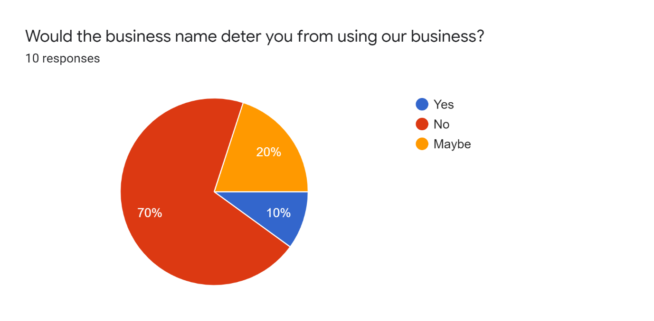
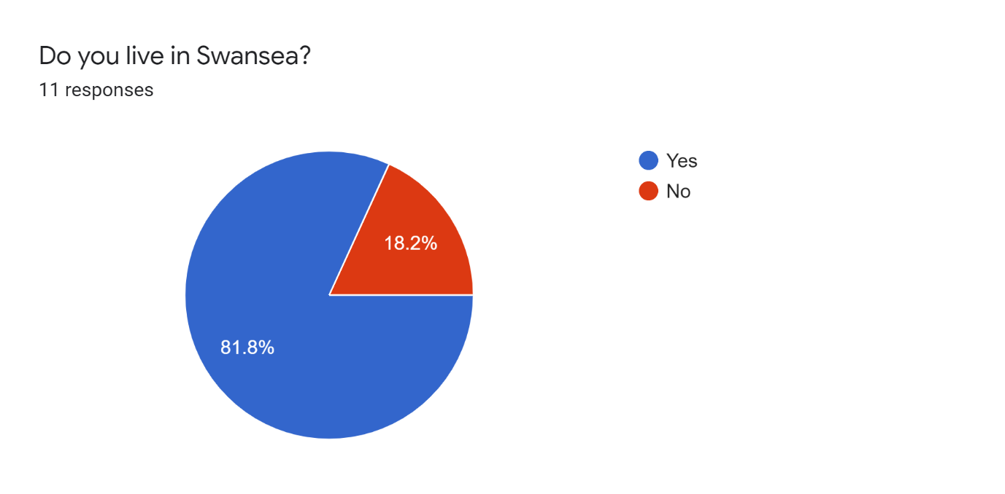
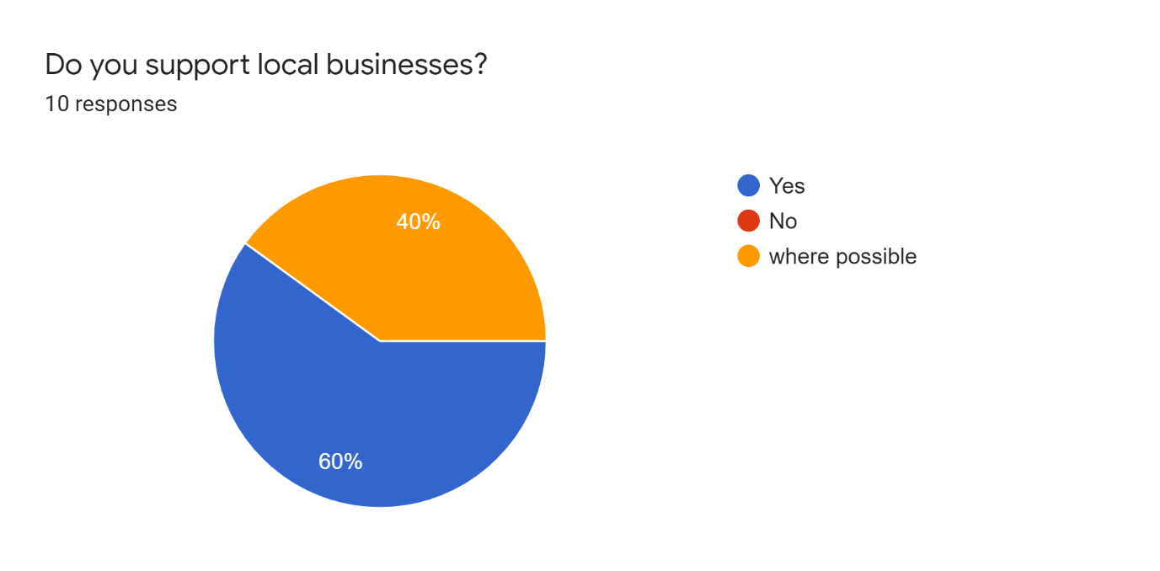

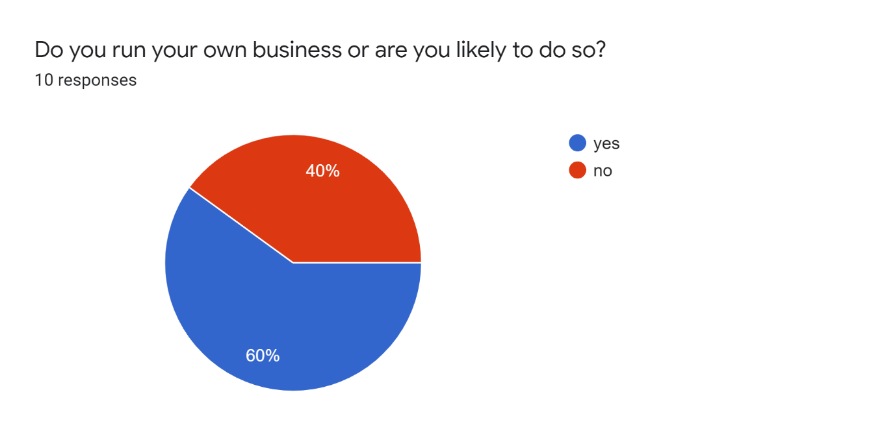

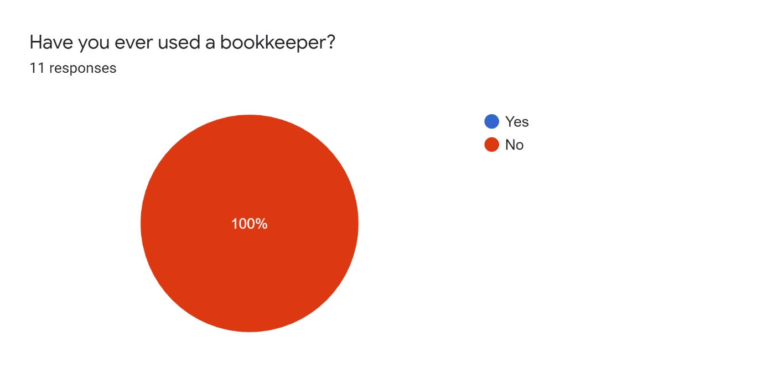

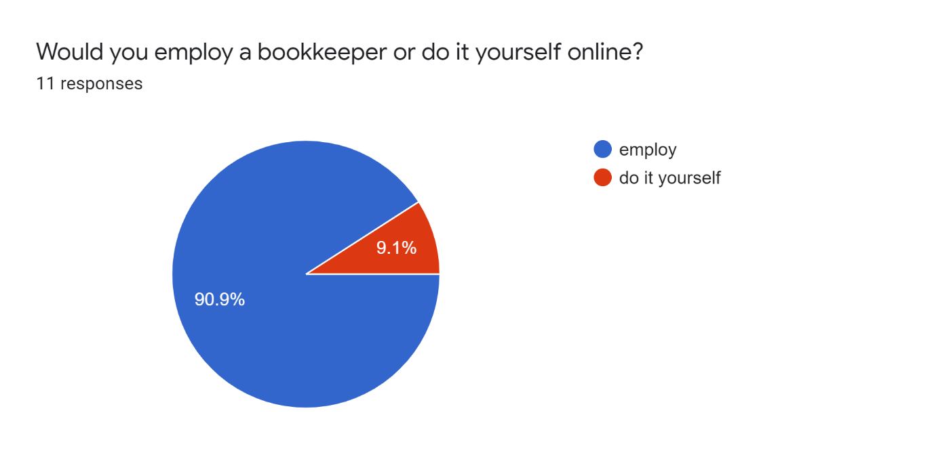
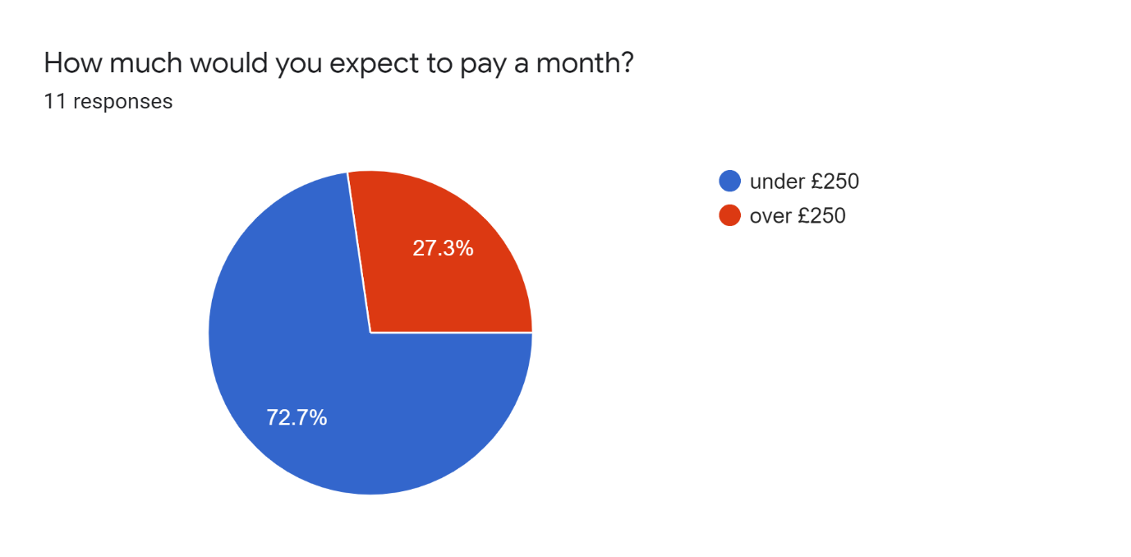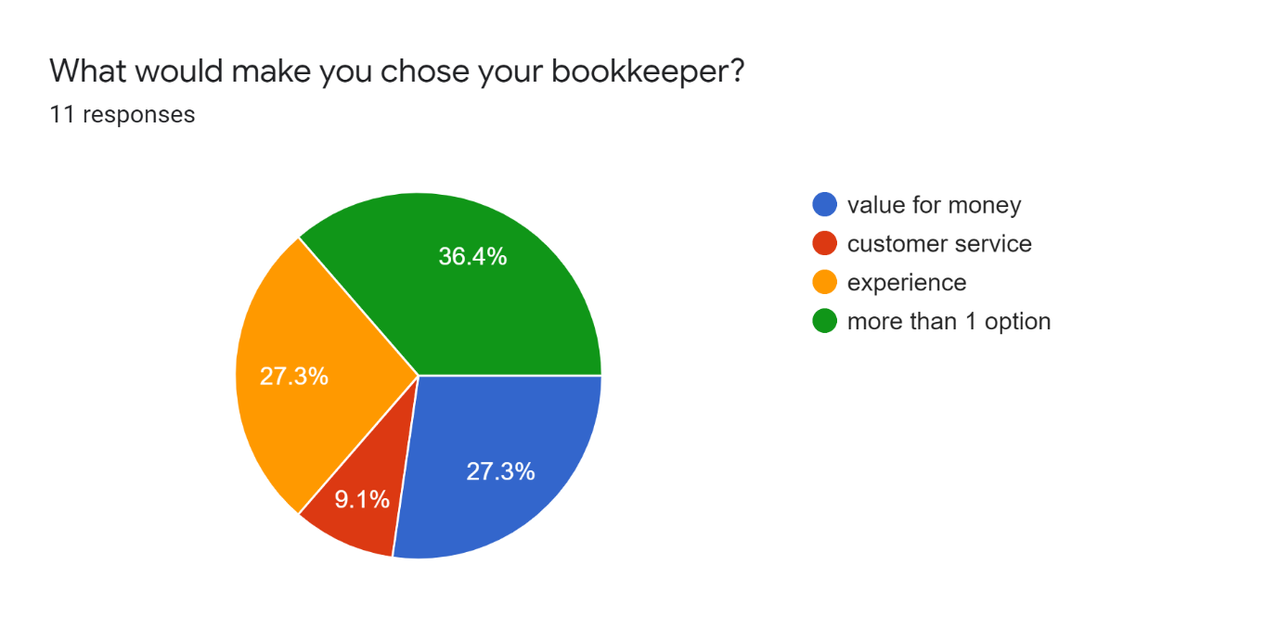
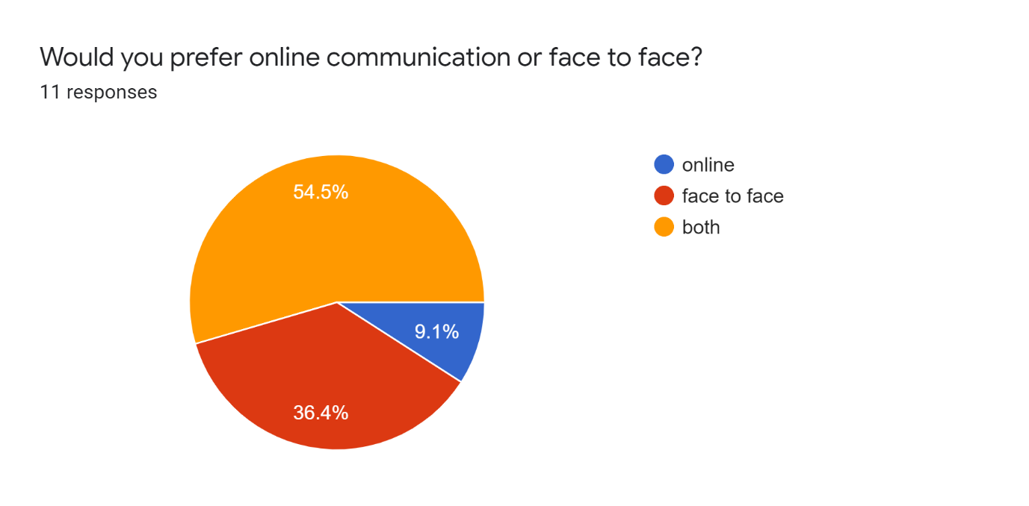
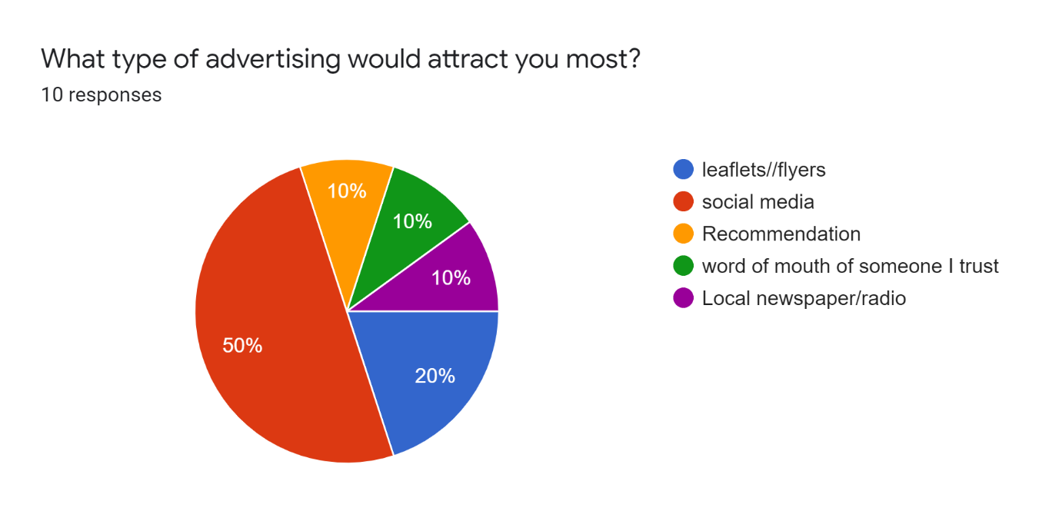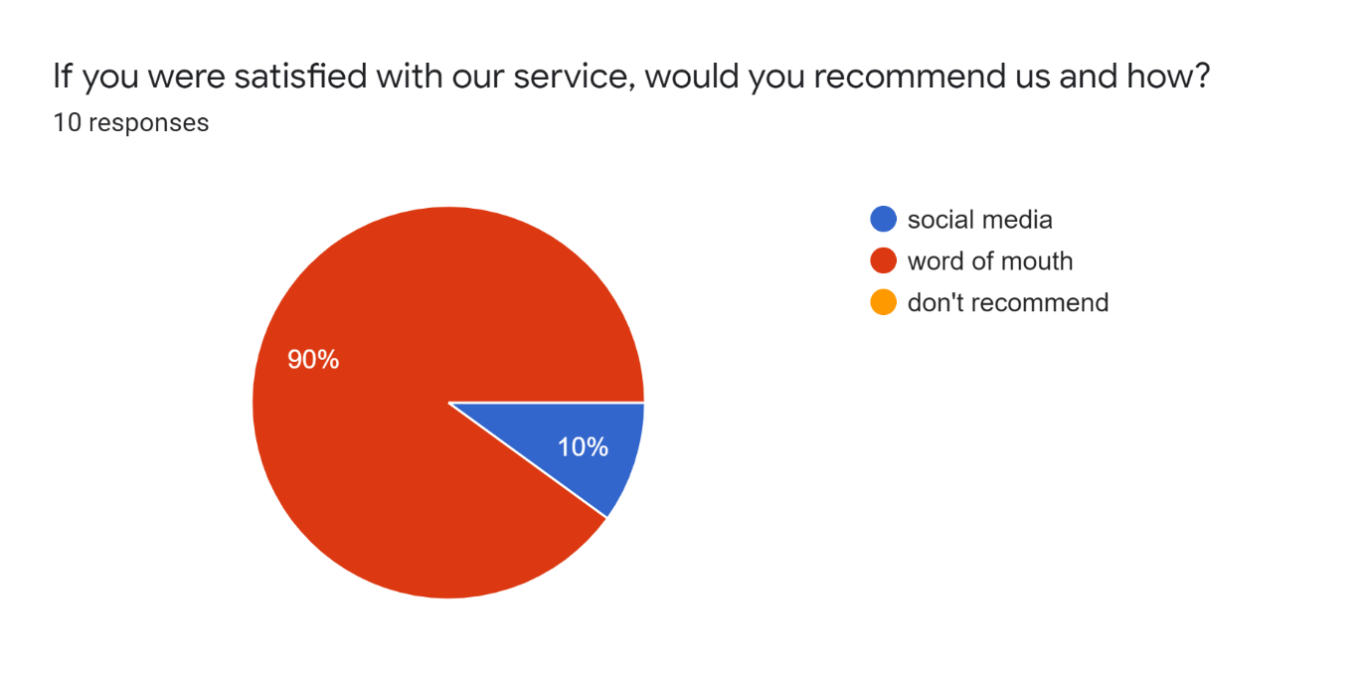

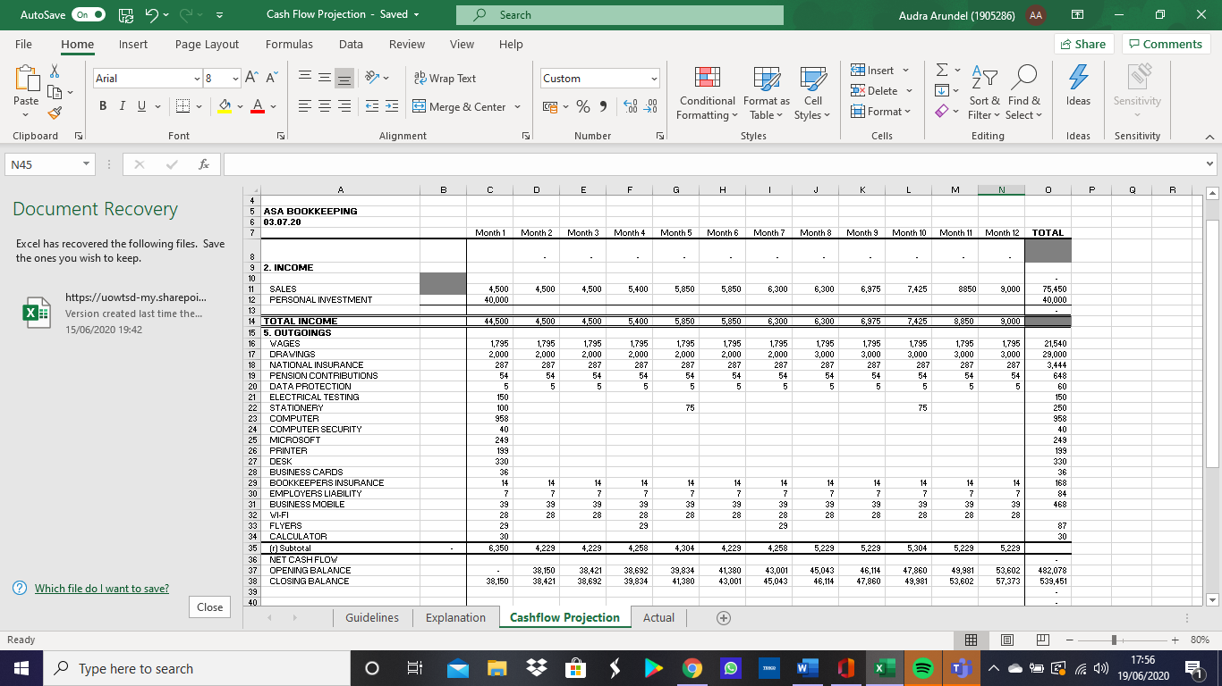
8.2 Cashflow projection
9.0 References
Bookkeeper insurance, Available at:https://www.policybee.co.uk/bookkeepers-insurance.(Accessed:16th June 2020).
Business cards, Available at: https://swansea.prontaprint.com/special-offers/.(Accessed: 16th June 2020).
Business security,Availableat:https://www.currys.co.uk/gbuk/computing-accessories/software/internet-security-and-antivirus/mcafee-small-business-security-2019-1-year-for-5-devices-10184683-pdt.html. (Accessed:16th June 2020).
Calculator, Available at: https://www.argos.co.uk/product/9183409 (Accessed: 16th June 2020).
Computer, Available at: https://www.currys.co.uk/gbuk/computing/desktop-pcs/desktop-pcs/lenovo-ideacentre-a340-23-8-all-in-one-pc-intel-core-i3-128-gb-ssd-black-10203295-pdt.html. (Accessed:16th June 2020).
Computer desk, Available at:https://www.argos.co.uk/search/office-desk/?clickOrigin=searchbar:home:term:office+desk(Accessed: 16th June 2020).
Flyers, Available at: https://swansea.prontaprint.com/special-offers/ (Accessed :16th June 2020).
Printer, Available at: https://www.argos.co.uk/search/printers/category:33016389/opt/sort:customer-rating/(Accessed: 16th June 2020).
Samsung galaxy s20, Available at: https://www.tescomobile.com/shop/samsung/galaxy-s20-5g(Accessed:16th June 2020)
Microsoft office business, Available at: https://www.currys.co.uk/gbuk/search-keywords/xx_xx_xx_xx_xx/office%2Bbusiness/1_20/relevance-desc/xx-criteria.html (Accessed:16th June 2020).
Wi-Fi, Available at: virginmedia.com/shop/broadband/deals?buspart=uk_ps_acq_cable_GOOGLE_Brand_IntelligentWiFi_Exact_Brand_IntelligentWiFi_WiFi_Exact_virgin+wifi&CMP=DFA&medium=PPC&gclid=CjwKCAjw26H3BRB2EiwAy32zhUqqWBI29djZMPdcXn3gJKqKVgLXA-was7UxkF1lgJYTuF_cx6VNaRoCJOkQAvD_BwE&gclsrc=aw.ds
(Accessed: 6th June 2020).

BBC Bitesize(2020)’GCSE Business Revision’. Available at:http://www.bbc.co.uk/bitesize/guides/z4br87h/revision/1/(Accessed:5th June 2020).
COMPANYBUG(2020)’The advantages and disadvantages of being a sole trader’. Available at:http://www.companybug.com/advantages-and-disadvantages-of-a-sole-trader/ (Accessed: 6th June 2020).
GOV.UK(2020)’About Us-Disclosure and Barring Service-GOV.UK’ .Available at :http://www.gov.uk/government/organisations/disclosure-and-barring-service/(Accessed: 23rd May 2020).
GOV.UK(2020)’Anti-money laundering registration’. Available at: http://www.gov.uk/anti-money-laundering-registration/(Accessed:16th May 2020).
GOV.UK(2020)’Workplace pensions: What you, your employer and the government pay’ .Available at:http://www.gov.uk/workplace-pensions/what-you-your-employer-and-the government-pay/ (Accessed:23 May 2020).
Hart, J.(2016)’How professional indemnity insurance protects bookkeepers’ .Available at: http//www.aatcomment.org.uk/run-your-business/how-professional-indemnity-insurance-protects-bookkeepers/(Accessed:23 May 2020).
ICO(2020)’Data protection fee’. Available at:http://www.ico.org.uk/for-organisations/data-protection-fee/(Accessed:16 May 2020).
Lake, L.(2019)’Learn what Marketing Is and How It Is Used’ .Available at: http://www.thebalancesmb.com/what- is -marketing-2296057/ (Accessed :22 May 2020).
m.economictimes(2020)’what is promotions/Definition of Promotions, Promotions meaning-The Economic Times’. Available at: http://www.m.economictimes.com/definition/promotions/amp/ (Accessed: 22 May 2020)
Merchant Savvy(2020) ‘UK SME Data statistics &Charts’. Available at :http://www.merchantsavvy.co.uk/uk-sme-data-stats-charts/(Accessed:16 May 2020).
PayScale(2020) ‘bookkeeper’s hourly rate’. Available at: http://www.payscale.com/research/UK/job=bookkeeper/hourly-rate/ (Accessed: 23 May 2020).
Post, J.(2018)’What is a PEST Analysis?’ Available at: http://www.businessnewsdaily.com/5512-pest-analyss-definition-examples-tenplates/ (Accessed:21 May 2020).
Scott, M.(2016)’The market most bookkeepers are overlooking’ Available at:http://www,aatcomment.org.uk/run-your-own-business/the-market-most-bookkeepers-are-overlooking/ (Accessed:22 May 2020).
Smart Insights(2019)’How to use the 7Ps Marketing Mix?’. Available at:http://www.smartinsights.com/marketing-planning/marketing-models/how-to-use-the-7ps-marketing-mix/ (Accessed:16 May 2020).
Smart Insights(2019)’The Segmentation, Targeting and Positioning model’. Available at: http://www.smartinsights.com/digital-marketing-strategy/customer-segmentation-targeting-and-positioning/amp/( Accessed: 16 May 2020).
Startups(2020)’Business grants in Wales 2019’.Available at: http://www.startups.co.uk/business-grants-wales/ (Accessed:16 May 2020).

