PRACTICAL ASSESSMENT 2019/2020 Answer Sheet

SCHOOL OF ENGINEERING

NAME OF COURSE/PROGRAMME: | BEng Motorcycle Engineering
YEAR OR LEVEL: | Year 1
NAME OF MODULE/UNIT/ASSESSMENT PAPER: | Motorcycle Technology
MODULE NO: | M4X00392
DATE OF ASSESSMENT: | 28th April 2020
START TIME: | 09.00
FINISH TIME: | 11.30
TIME ALLOWED: | 2.5 hours

INSTRUCTIONS TO CANDIDATES:

Answer all questions.

Use the data set provided to answer all questions.

You can use screen shots of the data to help with your answers.

QUESTION ONE

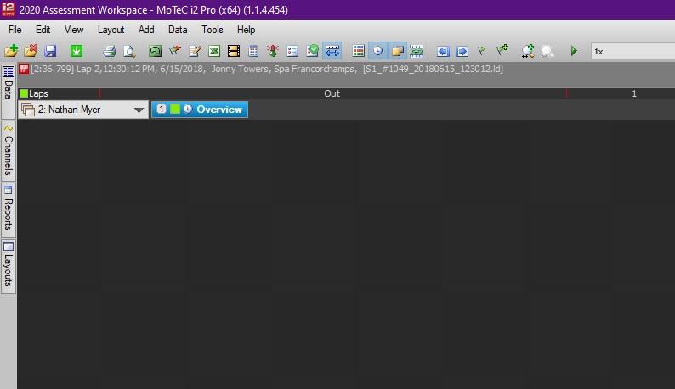

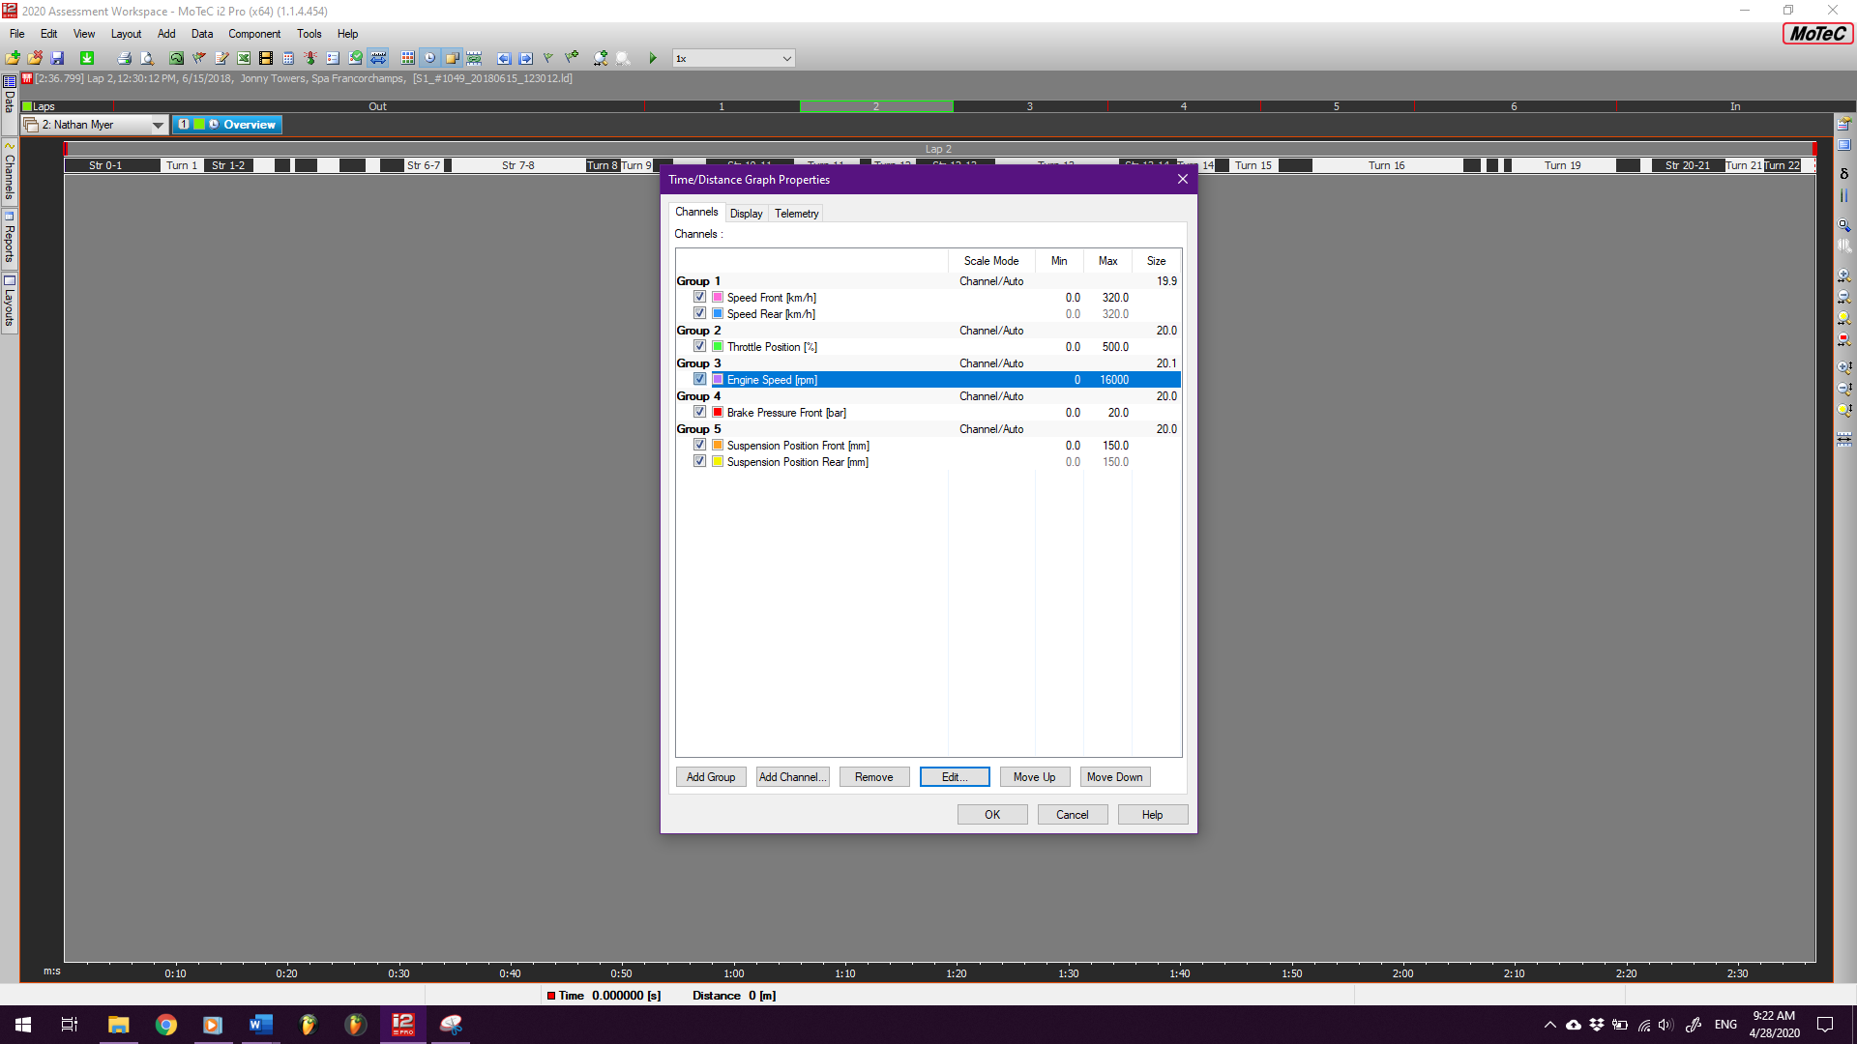
B)

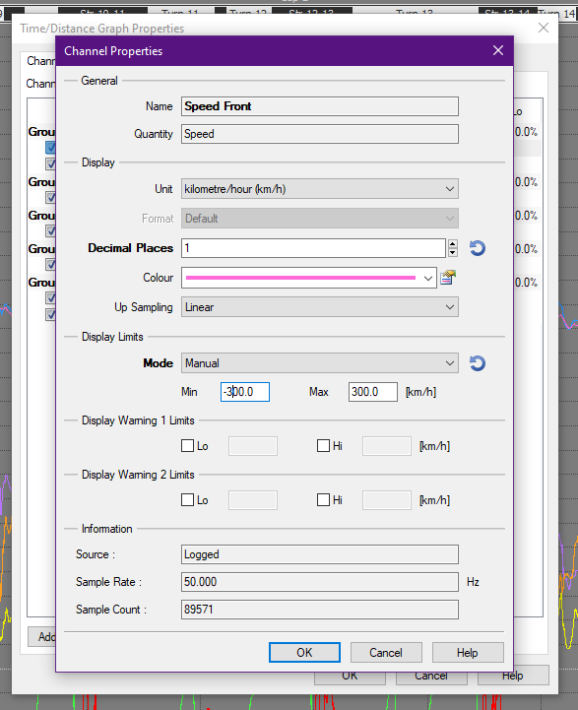
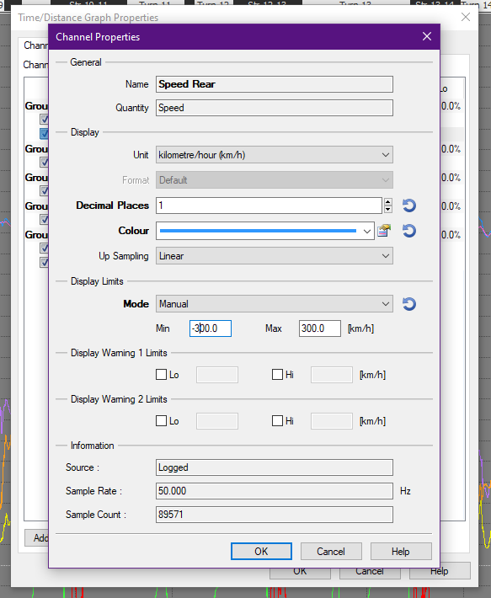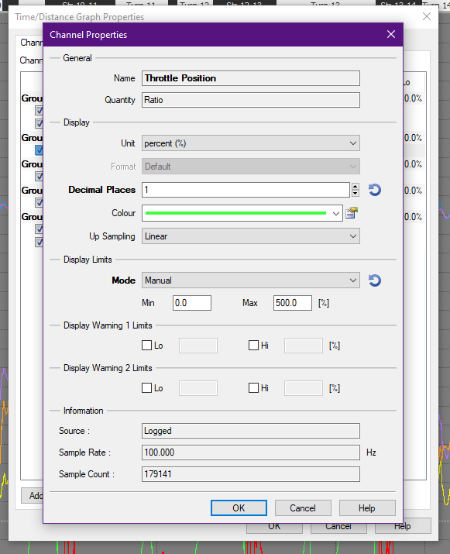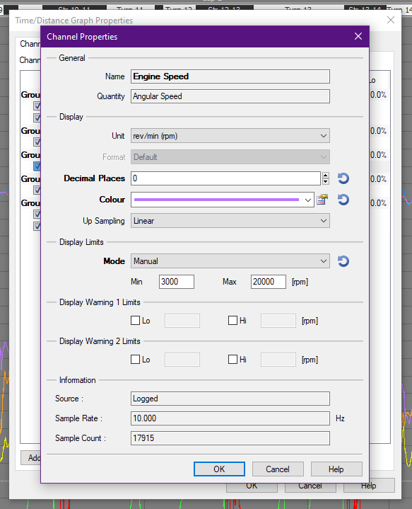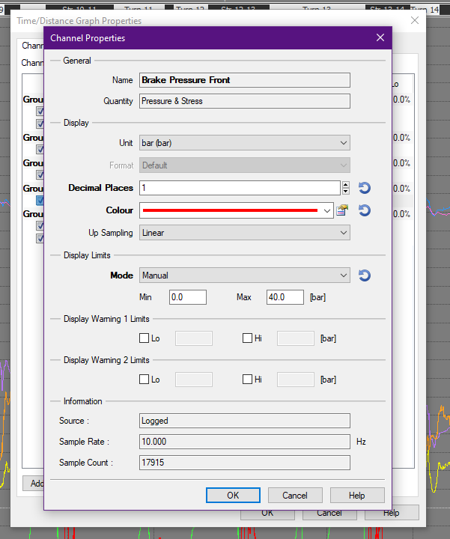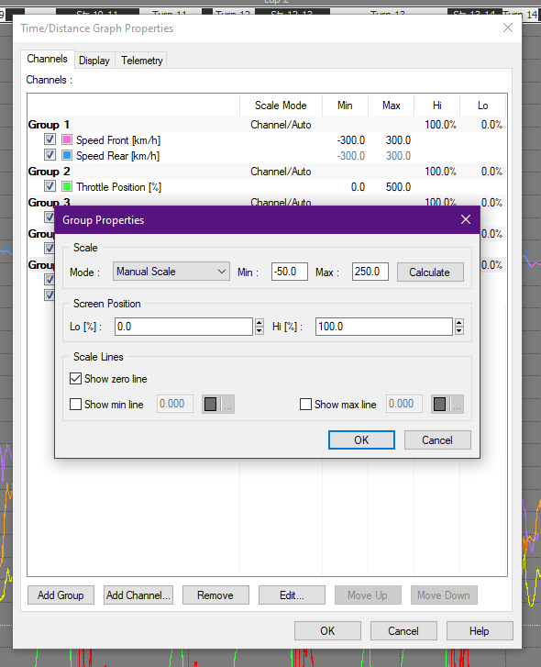
Final product with limits separating the traces out:
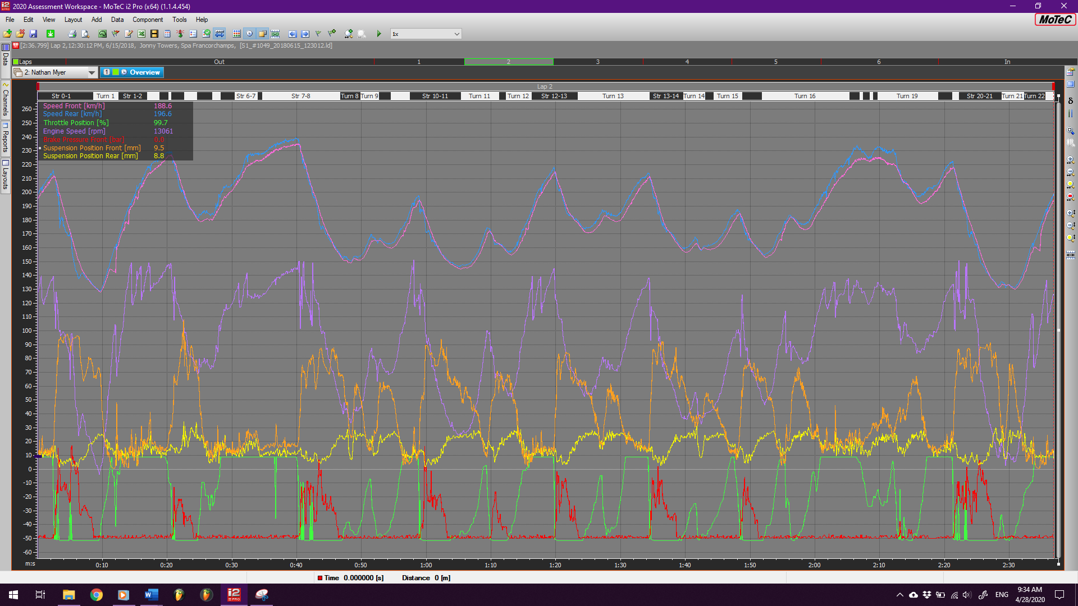

C)
Setting the sections using evenly spaced quarters for ease of use and to average out speeds over individual turns and straights:
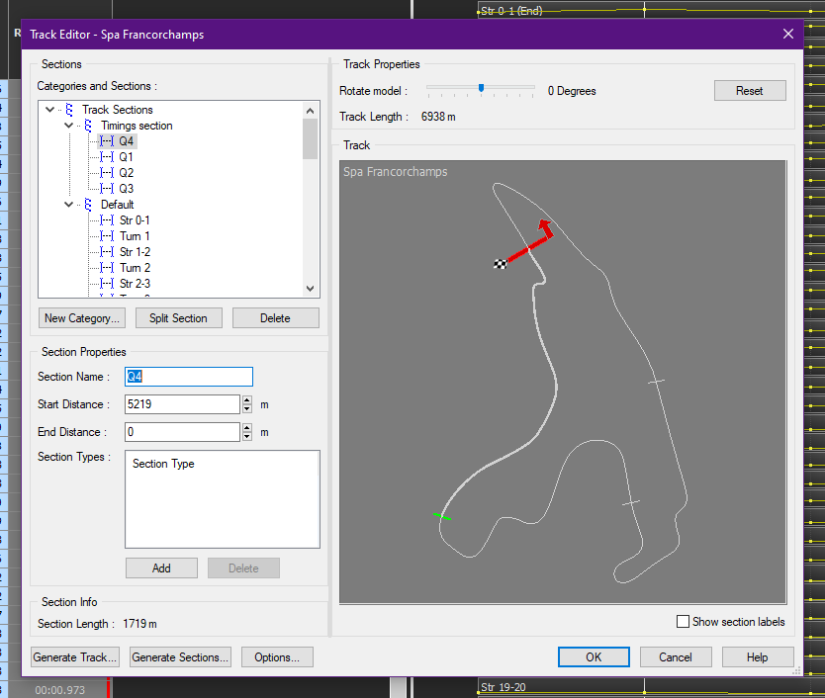

The finished product:
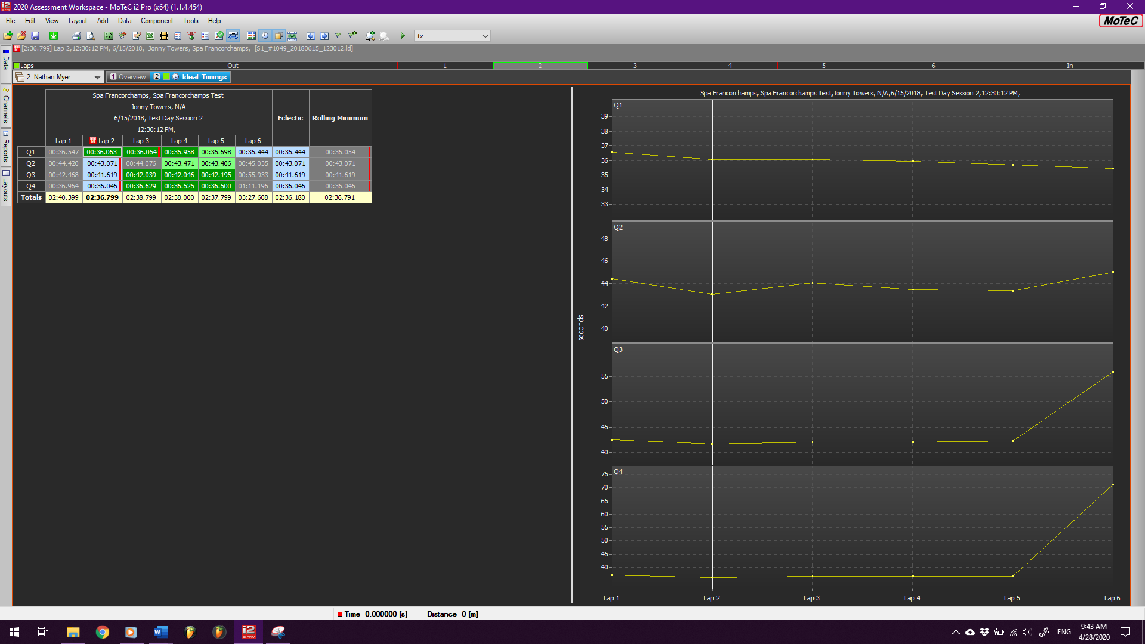

QUESTION TWO
Damper velocity histograms (pink::front, orange::rear). These show the frequency that the damper moves in a certain velocity over the selected data range, center is 0mm/s. Can be used to check that the damping is behaving correctly and also gives concrete datapoints that can be used to adjust the ‘stiffness’ of the suspension.
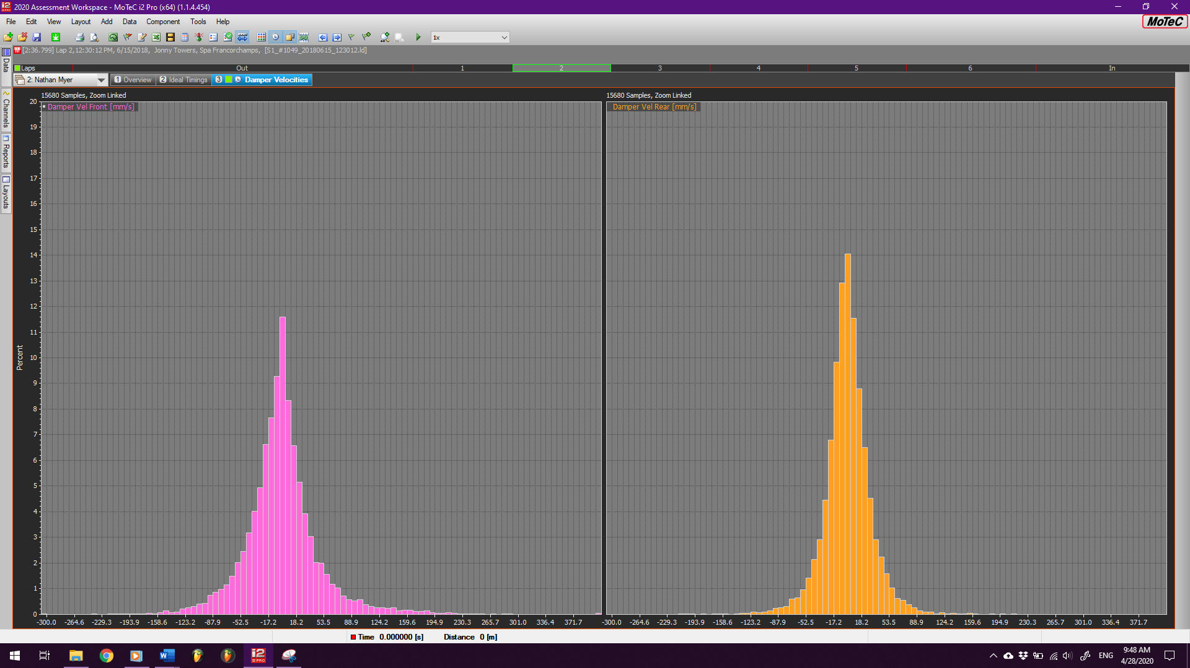
In both cases, rebound (left side) seems to be slightly faster than compression (right side). Should ask rider if suspension feels too stiff or not, perhaps try softening and see what effect that has on times.

Configuring channel report: (assuming regular weather, so minimum coolant temp not included). Channel report is used to check calibration of instruments as well as see that no components are exhibiting dangerous behavior, e.g. that the suspension is not bottoming out or overextending and that the coolant stays at an appropriate temperature and doesn’t spike too high.
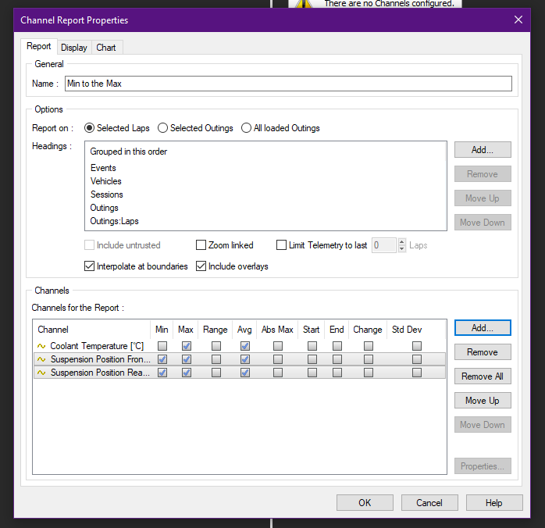
The resulting table:
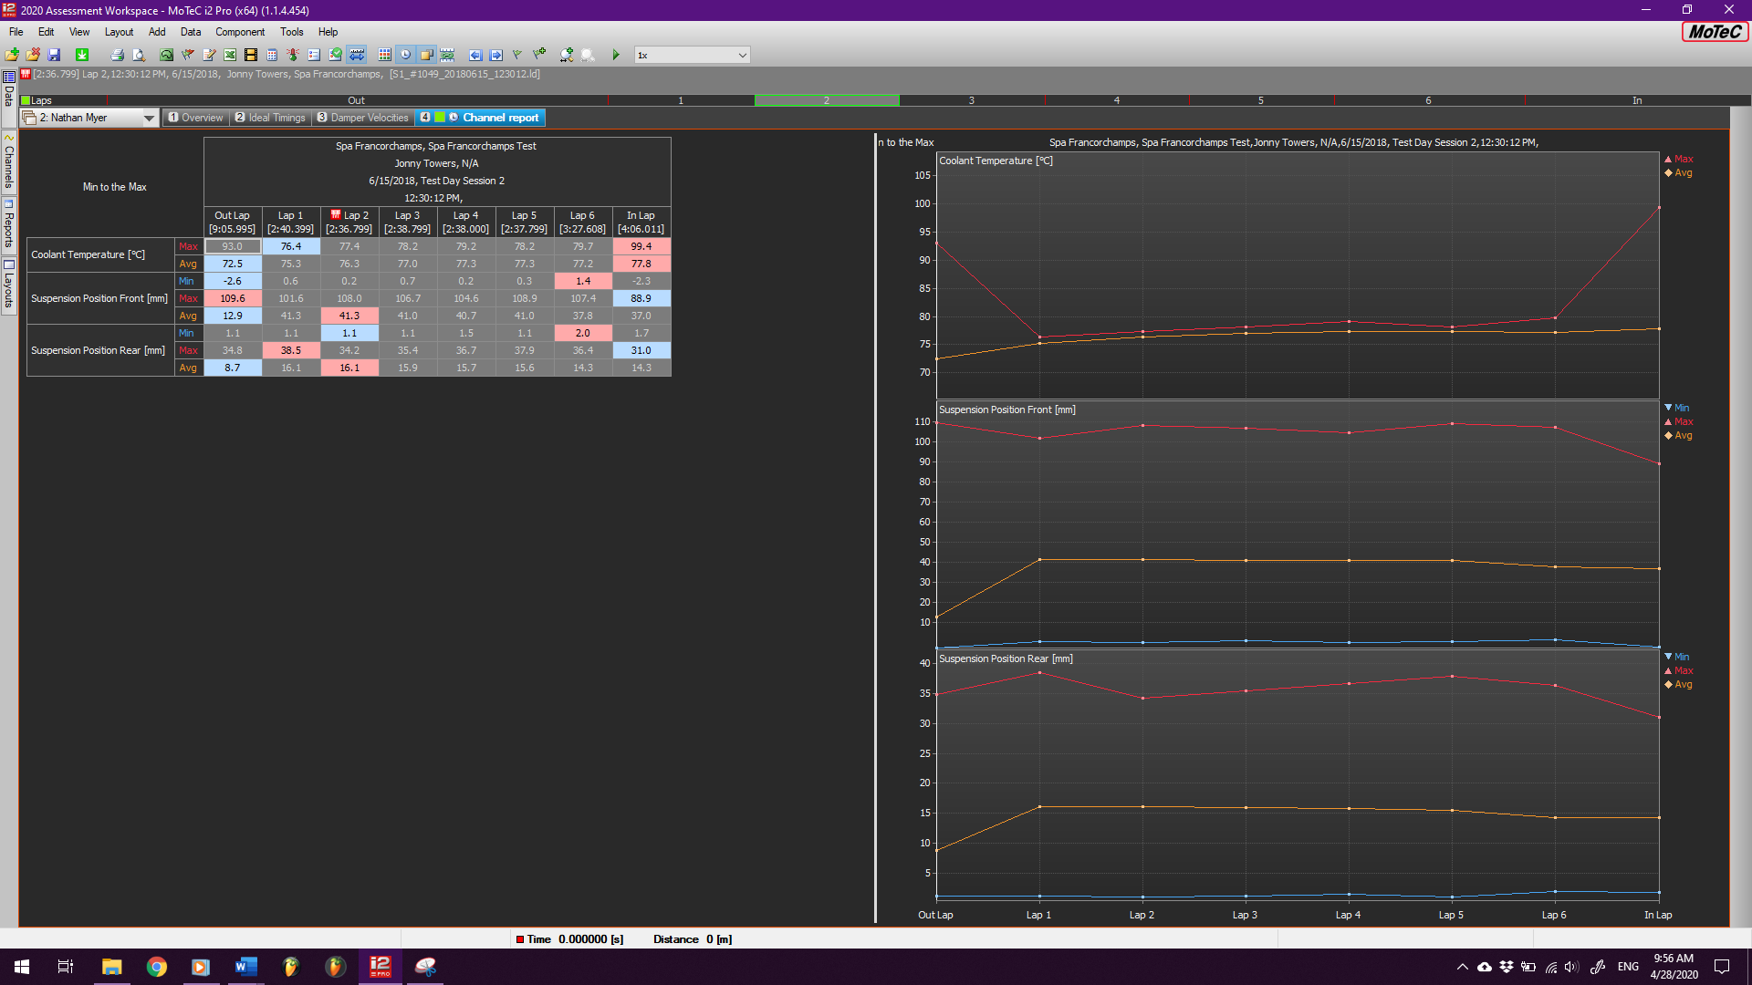
Average coolant temp looks good, rear suspension out of calibration by 1 or 1.5 mm? fairly high max as well. Front suspension seems okay.

Setting up the track report. Track report can be used with a gearing calculator and other data to check that the rider and bike have enough driving force at the slowest point of turns, and that they are not hitting the bike’s mechanical maximum velocity in straights (i.e. the rider isn’t being slowed down by improper gearing)
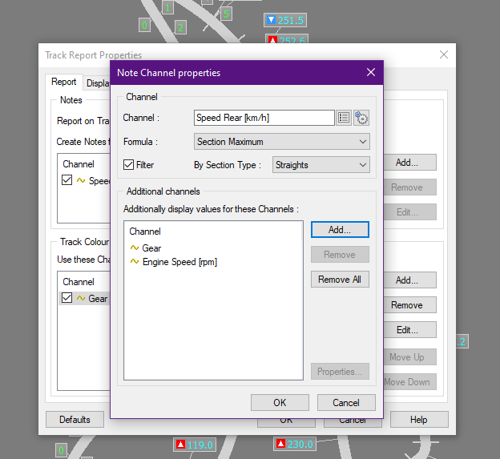
The result:
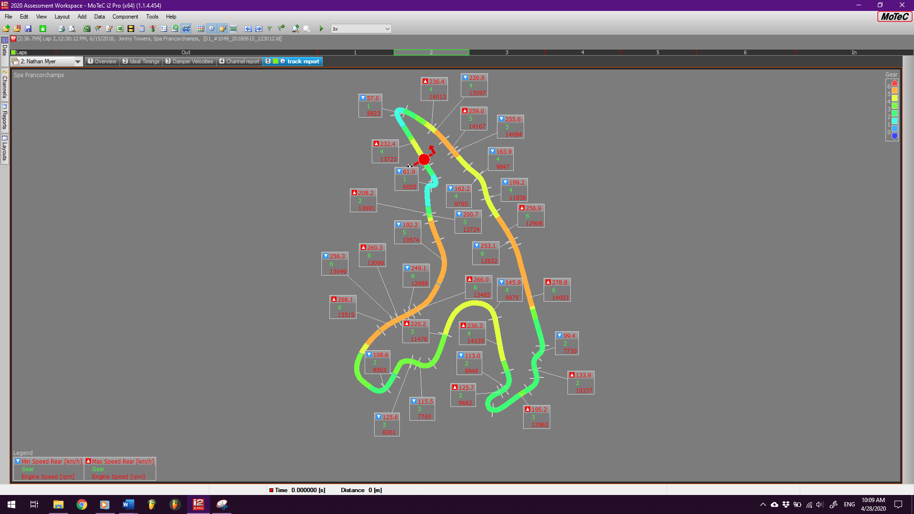

QUESTION THREE
A)
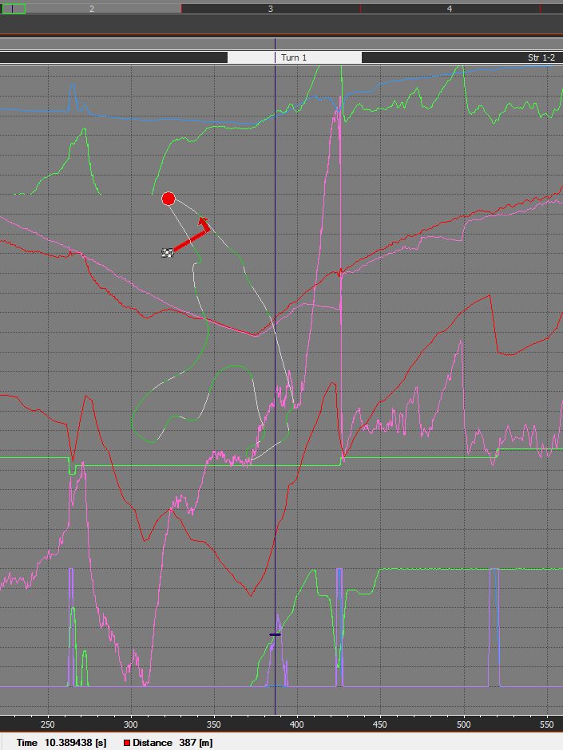
Coming out of the first turn, the ignition retard (purple trace at the bottom) activates as the rider is rolling on the throttle, suggesting that the bike is controlling rear wheel spin when the rider goes on the throttle a bit too quickly. Interestingly, the ignition retard also triggers with the ignition cut during upshifts (the two spikes seen to the right), which means this bike has a quickshift system installed.
B)
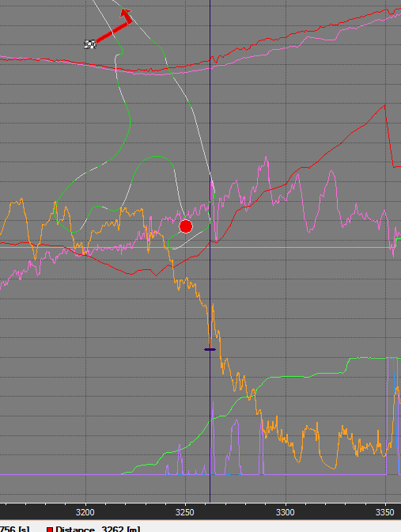
The ignition retard here (purple trace) coinciding particularly with the sudden extension(s) of the front suspension (orange trace) demonstrate the bike retarding ignition to control wheelies.
C)
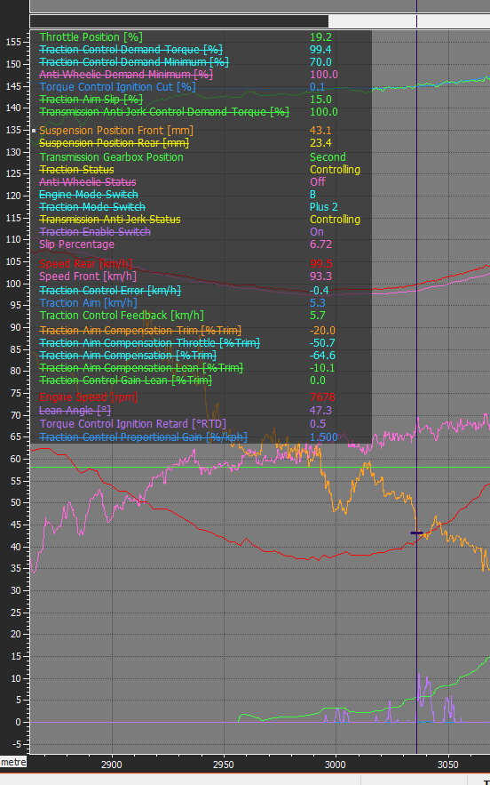
The traction control seems to come on universally at about 6.5 to 7 percent slip, as is seen here.

QUESTION FOUR
Over the first straight, lap five was faster than the fastest lap (lap 2) by about 0.4 seconds, as seen below:
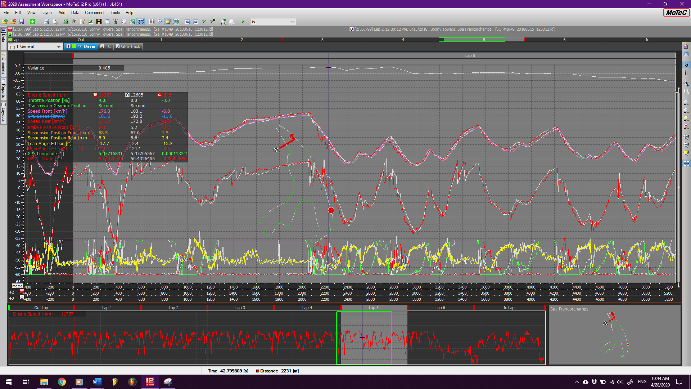
This is because at the first corner, the rider had trouble with the throttle on lap two, rolling off briefly and hence losing speed over the entire ensuing straightaway.
Note the throttle positions here at the turn: lap five is steady at full but lap two dips down to 1/3rd throttle. Oof.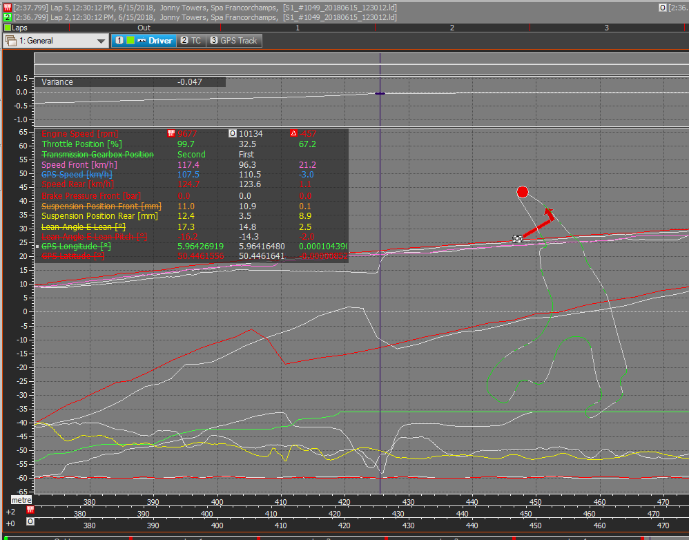

QUESTION FIVE
- The sprockets that fit the given tire, swingarm size, and number of links are 15 front and 44 rear. This also fits with the motec data: in second gear at 13,900 RPM rear wheel speed should be 181kph according to the calculator. In the data, it’s around 178-180kph, shown below.
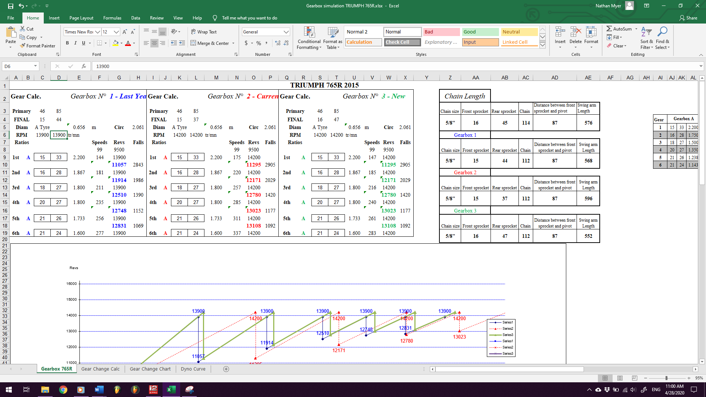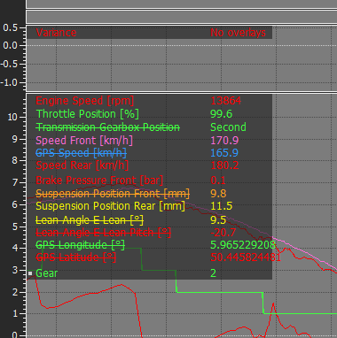

- The driving force appears to be at its maximum in first gear at 10,000RPM, as seen here:
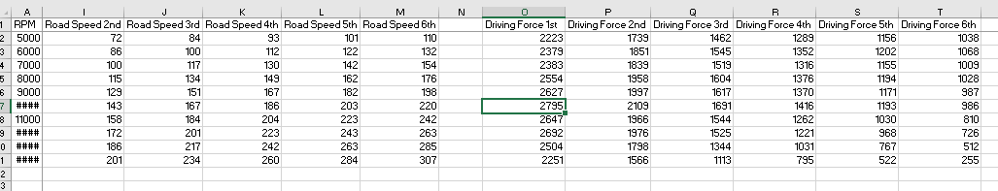
This conclusion is backed up firstly by the shift point chart, which shows first gear having the most driving force of all the ratios:

And is secondly supported by the dyno curve, which shows peak torque at around 10,000RPM:

