An Academic report on “An Individual Employee’s Career Plan”

Prepared by
Yawar Abrar Hossain (1916654)

Module: Developing Relationships and Workplace Achievements
Module Code: BMSW5102
Lecturer: Modak Koushik
Submission Date: 7th of May 2021

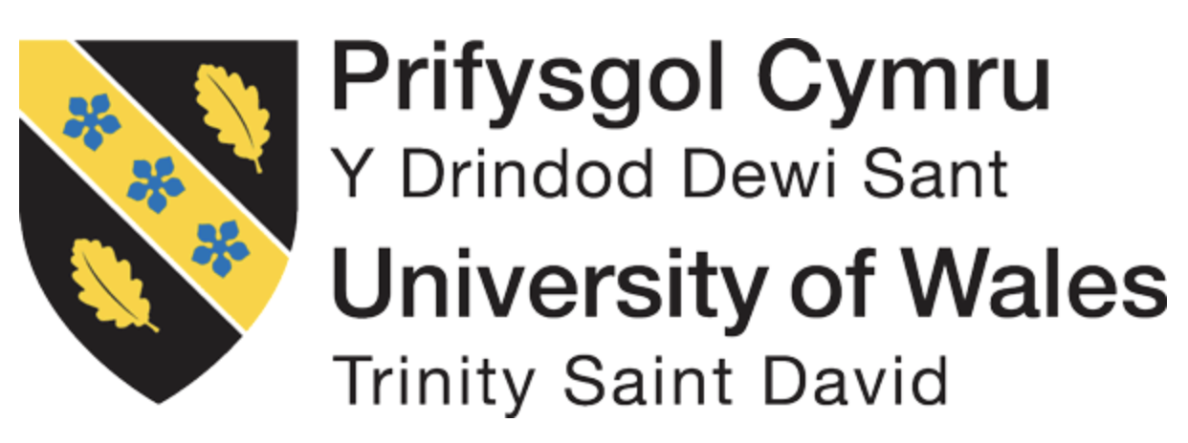

Contents:

Page
- Introduction ................................................................................... 3
- Background ................................................................................... 4
- Learning and Development ........................................................... 4
- Career Planning ............................................................................ 5
- Human Resource Management Theories and Models ........................... 6
- Employee – Knowledge, Skills and Competence .......................... 9
- Development Needs and Expectations ........................................ 10
- Conclusion .................................................................................... 20
- References ................................................................................... 21

Introduction

The basic motivation behind learning and development is to enhance both individual and organisational performances. There has been a massive change in last two decades due to globalisation and technological advances. It has also transformed people lives in various ways, importance of different jobs and learning new skills. “Learning is generally defined in terms of the acquisition of knowledge that leads to a relatively permanent change in behaviour which results from experience” (Mullins and McLean, 2019). Development can be defined as “the process in which someone or something grows or changes and becomes more advanced” (Cambridge Dictionary, 2019). Learning and Development is a process in which it creates an atmosphere of ongoing journey of learning and development through strategies that empower associations to continually create and develop (CIPD, n.d.). Learning can be a purposeful and formal interaction or an inadvertent result of standard development or progression. It is basic to perceive according to what individuals learn and grow their understanding and capacities to adjust adequately to the astounding and alternating solicitations of the organisation. Consideration should be given management of learning inside affiliations (Mullins and McLean, 2019).

The case study will be based on my current employment with Mitchells and Butlers (M&B) plc. I have been working with M&B since 2016 as a General Manager and then transferred to the Human Resource (HR) Officer, Learning and Development (L&D) role in 2020. In this role, I am required to create a plan based on company’s training and development and explain to what extent it meets and identify the potential development needs of an individual.

The main purpose of this report to create a development plan applying relevant academic theories, models and methods, identifying potential needs and expectations of individual employees in the current workplace. Furthermore, will critically evaluate the organisations development means, which are effective and efficient for the development of an individual.

Moreover, will be discussing employee’s personal development plan, appraisal, performance management, succession planning, evaluate and record feedback and career development strategies. Above list is not limited to it but will include further discussions on techniques and methods used by the company to provide guidelines on career pathways, structured, guided learning styles for training and development.

Background

M&B is the second largest pub company in the UK, currently it operates 15 brands across 1660 sites across the country. It employs over 42,500 in the hospitality industry (Mitchells and Butlers Annual Report, 2020; Statista, 2019).
To ensure the company increases the productivity and individual performances of the 42,500 employees, it needs to have a solid L&D team to focus on implementing company policies on training and development. L&D team runs separately than HR team but most of the L&D employees are HR trained. It is vital that the company retains the good employees and reduces the employee turnover. UK hospitality industry has the highest turnover rate at 30%
(Birkin, 2019).

Learning and Development

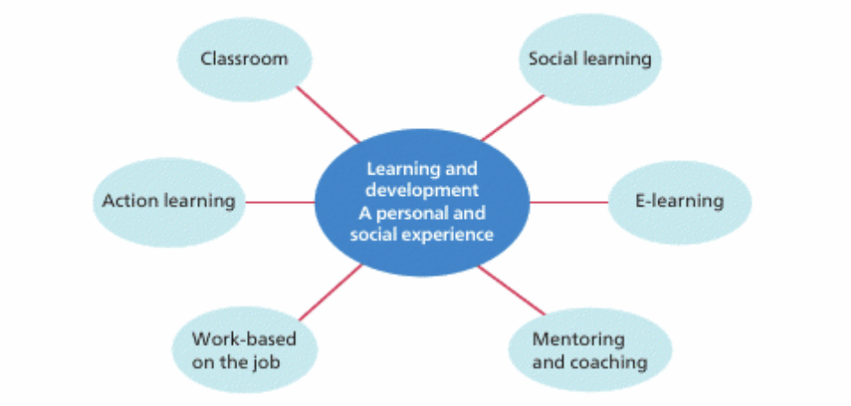

Figure 1: Types of Learning and Development
Source: Mullins and Mclean 2019, p.170

Figure 1 shows different ways an individual can learn and develop in his or her lifetime. M&B uses different options for learning and development. The company uses L&D strategies to set organisations goals by encouraging and helping individuals to learn and grow (Armstrong and Taylor, 2020). L&D strategies are set by HR and it is implemented by L&D team in M&B. The objectives set out by L&D is to create an organisational culture on learning, training and development, e-learning, work based on job learning and apprenticeship. On top of that the HR focuses on performance related issues by encouraging the line managers to use relevant tools, such as appraisals, personal development plan (PDP), annual review, performance management for career development. According to Reynolds (2004), “learning culture as a ‘growth medium’, in which ‘employees will commit to a range of positive discretionary behaviours, including learning.’ He suggested that to create a learning culture is necessary to develop organisational practices that give employees a sense of purpose in the workplace, grant employees opportunities to act upon their commitment, and offer practical support to learning.”
M&B uses four steps to learning and development, analyse, plan, implement and evaluate. The process starts with analysing learning and development requirements, planning various steps to meet the requirements, either using self-learning, formal and informal learning, workshop and digital learning, implement the learning and development and final part is to evaluate the process (Armstrong and Taylor, 2020).
Knowledge, skills and competence are needed for an individual’s learning. Learning outcome states that a learner should be able to perform after finishing the learning process and acquired knowledge, skills and competence. Learner should have relevant knowledge and understands, have skills and able to demonstrate and have competence what learner is ready to do. There are five steps to learning, participation, repetition, relevance, transference and feedback.

Career Planning

Career management is a major part of talent management. The main provision of this to ensure development of individuals in order to establish flow of talent in the organisation for its needs and employee’s own desire.
Career planning is an important part of career management, which helps an individual to progress in an organisation as per evaluation of organisational requirements, in according with employee’s performances, potential and successes (Armstrong, 2010). According to Mäkelä and Suutari (2009), “success is measured in terms of psychologically meaningful work and career progression that comes from inter-company self-development rather than hierarchical advancement within one company.”
The best way to plan career is to identify potential goals, assess own attributes, determine how to reach goals by acquiring further information about goal and distinguish between individual measures and professional needs, move toward objectives through guides and other relational guides and personal development project and regularly assess objectives and work toward objectives.
The purpose of career planning is to ensure the employees are having a desired career path to achieve career goals. It reduces employee turnover by promoting and developing existing individuals, developing potential employees to their future role, creates internal progression and improves motivation, covers skill gap and focus on the skills so can improve, helps the line manager to shuffle employees between the jobs and also able to identify true skills.
Succession planning is a process where an individual talent is identified to meet potential needs in the future to cover the management opportunity (Armstrong, 2010). The succession plan is followed in many organisations, to ensure the transition period of a manager leaving and the talent can take the position straightaway (McDonnell and Collings, 2011). To be successful in this competitive era, succession planning in a business creates successful and productive labour force by ensuring skills need to be sourced, nurtured, developed and retained now. Succession plan should be done according to company objectives, culture and long-term strategy. This plan does not only help the company to retain talent but also helps management to train and development, so he/she could move forward to the next role (Mullins and McLean, 2019).

Human Resource Management (HRM) Theories and Models

Human Resources Management (HRM) can be defined as strategic approach which effectively manages employees in a business to such an extent that assisted the business to reach result. It is intended to expand worker execution in assistance of a business' essential targets (Armstrong and Taylor, 2020).

According to Guest (1987, p.505), HRM tend to bend more towards “theories of commitment and motivation and other ideas derived from the field of organisational behaviour.” The important theories are, AMO, contingency, human capital, motivation, social exchange and stakeholder.

AMO – AMO stands for Ability, Motivation and Opportunity, these three independent components swap forms for individual characteristics to bring success in the organisation (Boxall and Purcell, 2003).

Contingency – It states that HRM practices are reliant upon the association's current circumstance and conditions. Paauwe (2004, p.36) mentioned HRM policies and performances differs in accordance to influences, for example company, size, age, technology, etc.

Human Capital – It explains how employees in a business providing knowledge, skills and abilities improving authoritative ability and with the importance of contribution. Human capital resources are said to have unique nature within the organisation potentially generating upper hand (Nyberg et.al., 2014).

Motivation - Hypothesis explains the factors that impact target facilitated direct. It as such effects the the methodologies utilised in HRM to improve commitment, reward individuals and oversee execution.

Social Exchange – It explains that human beings will contribute to loyalty, commitment and discretionary effort, if they have been treated fairly and well in the organisation. The organisation must adhere to policies which mutually benefits both employer and employees, also known as ‘mutual gains’ (Kochan and Osterman, 1994).

Stakeholder – There are number of people who are stakeholders in an organisation, they are shareholders, employees, customers, government, etc. (Freeman, 1984), without them the business will cease to operate. The company HR must take into consideration before formulating and implementing strategies and policies (Armstrong and Taylor, 2020).

There are many different models of HRM, they are, Michigan framework, Harvard framework, Contextual model, 5-P model and European model.

Michigan framework – “HR frameworks and the association construction ought to be overseen in a manner that is harmonious with hierarchical methodology. The basic administration task is to adjust the conventional design and human asset frameworks, so they drive the essential goals of the association” (Fombrun et.al., 1984, p.37).

Harvard framework – “It states HRM includes all administration choices and activities that influence the idea of the connection between the company and workers. Line managers acknowledge greater obligation regarding guaranteeing the arrangement of driven strategies and HR policies, HR has policies in place to ensure that oversee how HR activities are created and executed in manners that make them even more developing” (Beer et.al., 1984).

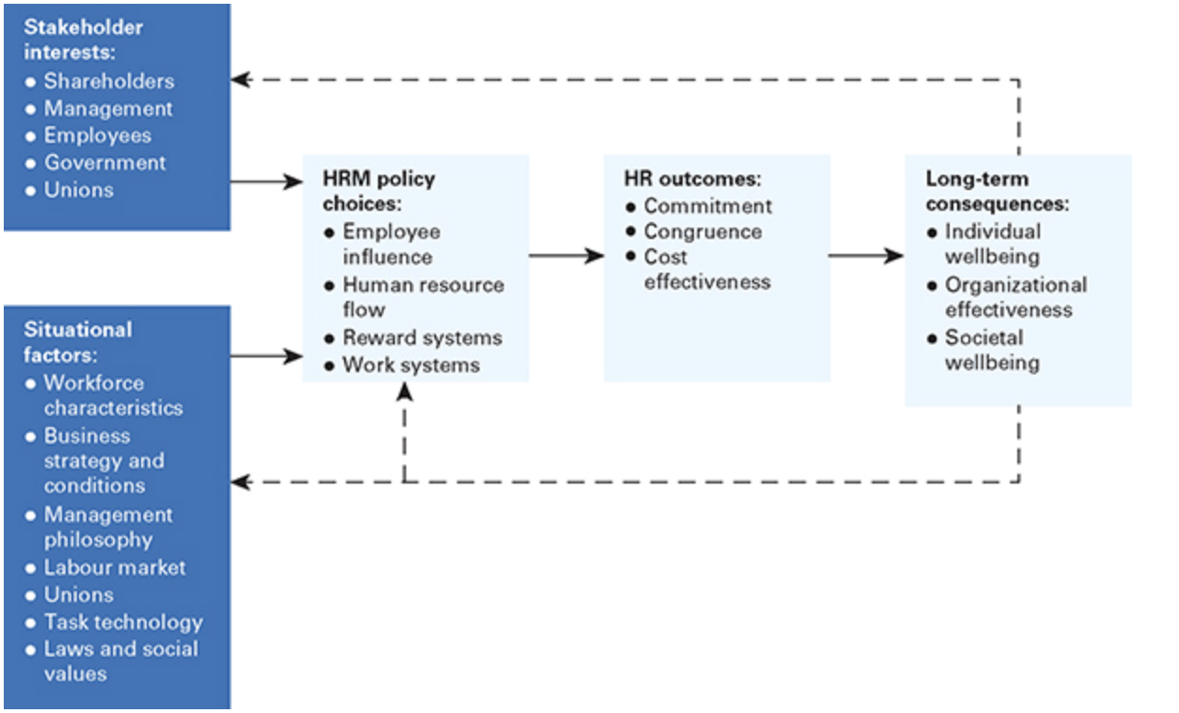
Figure 2: The Harvard HRM framework
Source: Beer et.al. (1984)

Contextual model – This model indicates the significance of environmental factor which is underestimated in other models. The relevant model supports incorporating the HRM framework in the environment in which it is created. A more extensive arrangement of partners is engaged with the detailing and execution of human resource methodologies. These stakeholders could be both internal and external can influence and are influenced by strategic decisions (Schuler and Jackson, 2000, p.229).

5-P model – It is developed by Schuler in 1992, which is a model of HRM and operated under five constitutional aspects, HR philosophy, policies, programmes, practices and processes. “Reason as the association's vision, mission, and essential destinations, standards are characterised as operational conventions set to prompt accomplishing a reason, processes incorporate association engineering, frameworks, and techniques for activity, individuals are the essential HR asset performing assignments in accordance with the designated standards and cycles, execution, eventually, is an outcome that can be estimated by the proper guidelines” (Schuler, 1992).

European model – European model was developed by Brewster in 1993. They are as follows:
Environment – set up legitimate system.
Objectives – organisational objectives and social concern – individuals as a distinct advantage.
Focus– cost/advantages and environment investigation.
Relationship with employees – association and non-association.
Relationship with line managers – subject matter expert/line contact.
Role of HR specialist – expert managers: vagueness, resistance, adaptability.
The fundamental differentiation between this model and what Brewster alluded to as 'the endorsed model' was that the last includes liberation (no lawful system), no worker's guilds and an emphasis on hierarchical goals however not on friendly concern (Brewster, 1993)

The theories and models have its own advantages and disadvantages. In this report, will be using human capital and social exchange theories and Harvard framework due to how it has been developed. Learning desired skills and knowledge will produce human capital, both party benefits from social exchange theory and the Harvard framework explains that HR functions are managed effectively through commitment, congruence, competence and effectiveness.
“The mutual gains model suggests that HRM should benefit both individuals and organizations. However, the dominant models within HRM theory and research continue to focus largely on ways to improve performance, with employee concerns very much a secondary consideration” (Guest, 2017, p.22)

Employee – Knowledge, Skills and Competence

Knowledge best defined as what individuals comprehend about things, ideas, thoughts, speculations, methods and practices; skills defined as the capacity to apply information and use skill to finish jobs and resolve issues; competence can be defined as the demonstrated capacity to utilise information, abilities and individual, social or potentially “methodological capacities, in work or study circumstances and in expert and self-awareness” (Armstrong and Taylor, 2020).
It is important that employee understands where the gap is, it will help to identify the gap and work on the opportunity by making self-development plan. The plan will help to compare gap between the skills individual have and the ones need to work on, it will help to build up the skills and perform better. Mentors who are part of L&D individuals, who could help employees to provide mentoring, including advice, learning programme, acquire necessary knowledge, problems faced by employee in early stages, coach in specific skills, help with projects, etc. (Armstrong and Taylor, 2020). According to the famous microbiologist Louis Pasteur, “Fortune favours the prepared mind.” (goodreads.com,n.d.). There are three stages of training, assessment stage, training stage and evaluation stage (Goldstein and Ford, 2002).
As discussed earlier, there are many other ways to build knowledge, skills and competencies in an organisation. In M&B the L&D team will provide support for management team to upskill and improving performances, the learning and training are based on e-learning, on job, workshop, courses in a training institution, classroom based, practical, etc. The support is available through the line manager.

Development needs and Expectations

M&B uses different tools and techniques to develop their team at workplace. The business usually set aside budget for learning, training and development. The tools M&B uses are, personal development plan (pdp), appraisals or annual review, job chats, succession planning, performance assessment plan, performance management for poor performances, these plans should be made according to SMART (Specific, Measurable, Achievable, Realistic and Time-bound) goals and objective to ensure it can be measured.

PDP – Personal Development Planning (PDP) is a form of independent learning, by taking help from the line manager, guidance from others and encouragement based on performance reviews. There are four steps to it which are, break down current circumstance and improvement needs, put forward objectives, get ready activity plan, implement (Armstrong and Taylor, 2020).

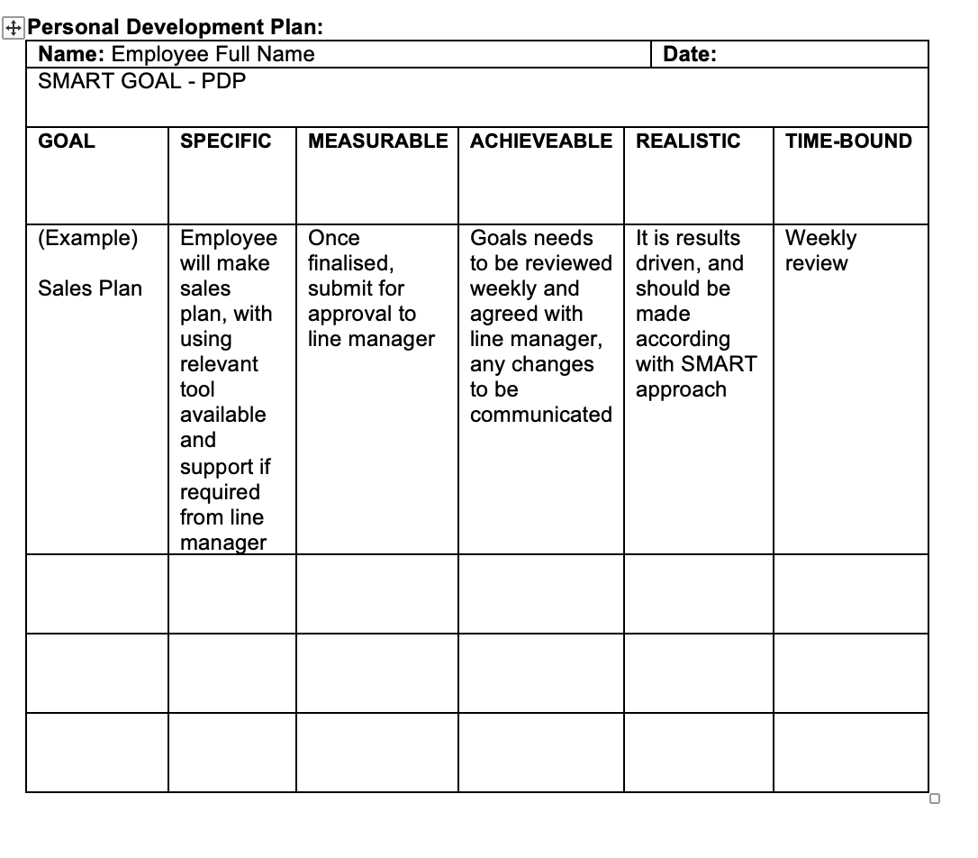
Figure 3: Personal Development Plan
Source: Hossain (2021)

Appraisals or Annual Review – It is either quarterly or half yearly or annual review based on performances, which allows individual’s performance to be reviewed. Reviewer generally the line manager of individual. Peter Reilly (2015) said, managers need to carry out a wide range of reviews on the performances and by using different tools. Should include key competencies, line managers comments, review, etc. (Armstrong and Taylor, 2020).

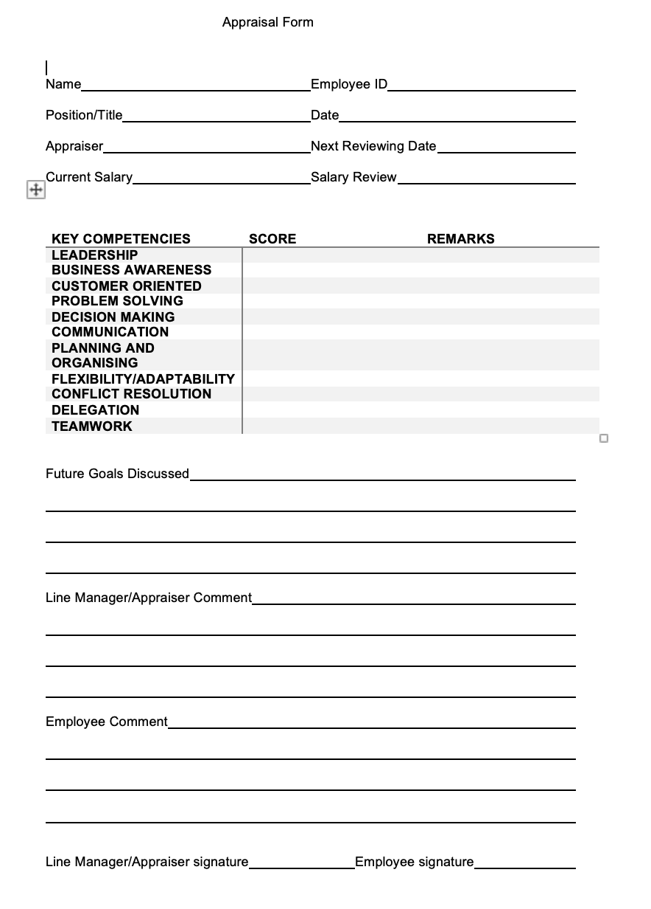
Figure 4: Appraisal Form
Source: Hossain (2021)

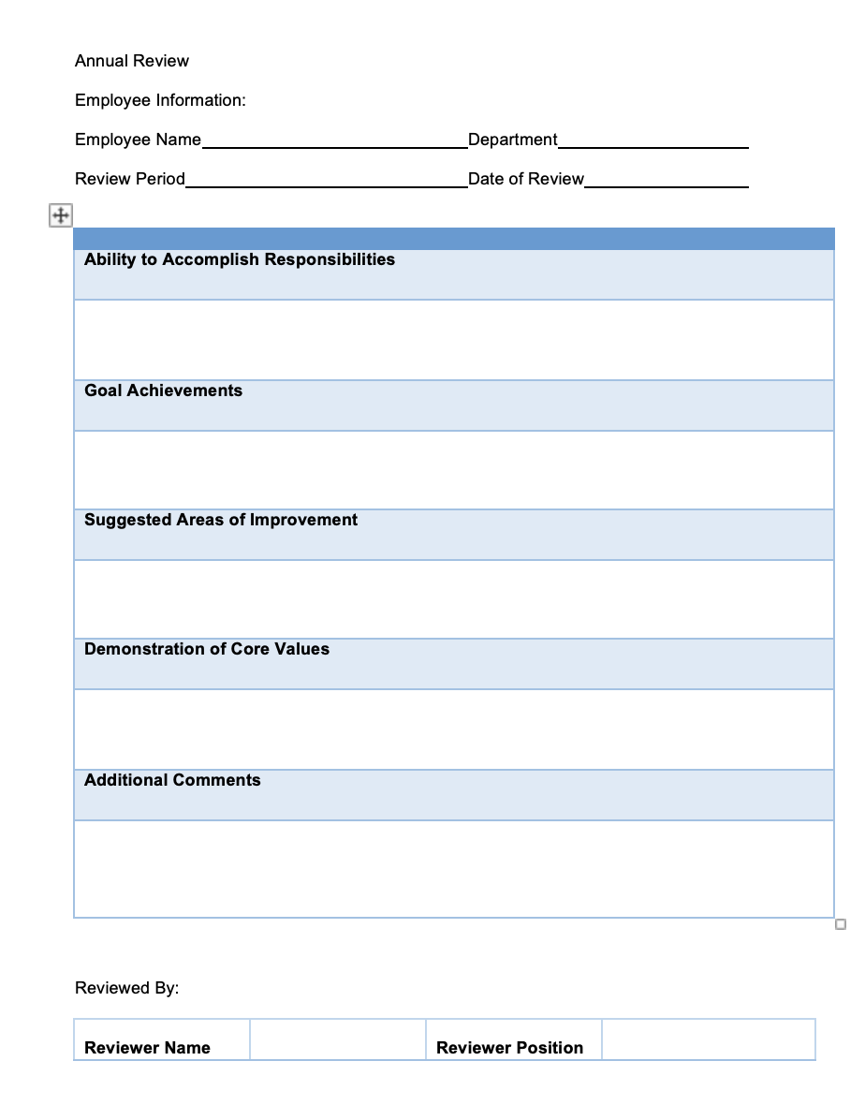
Figure 5: Annual Review
Source: Hossain (2021)

Job Chat – Job Chat is a formal document, which reviews new employees’ performances, it is done every 4 weeks up to 12 weeks. It also helps to see individual passes the probationary period. The probationary period is 12 weeks in M&B.
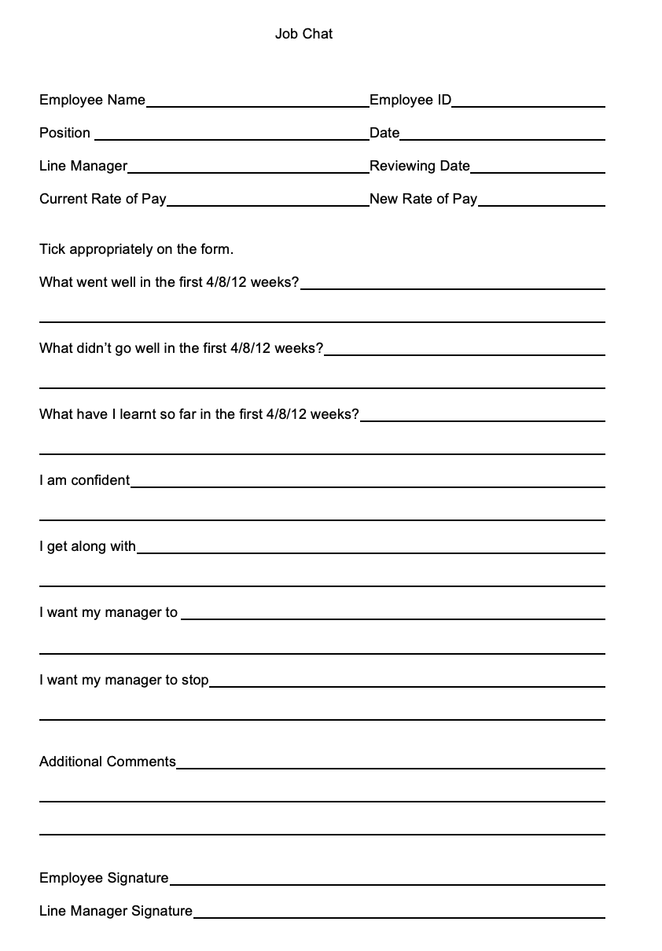
Figure 5: Job Chat Source: Hossain (2021)
Succession Planning – Succession Planning is important in any businesses; it helps to reduce staff turnover and able to keep the talent within the company. So, the company and the talent grow together. The succession plan consists of key competencies, strengths, weaknesses, development needs and plan.

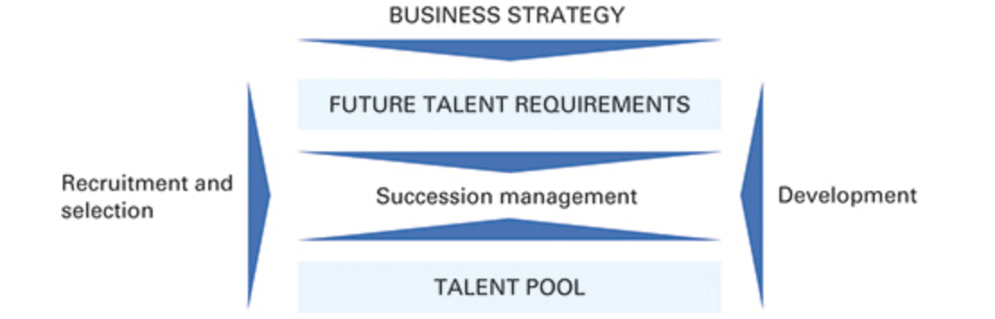
Figure 6: Cemex Ltd. Talent Management
Source: Armstrong and Taylor (2020)

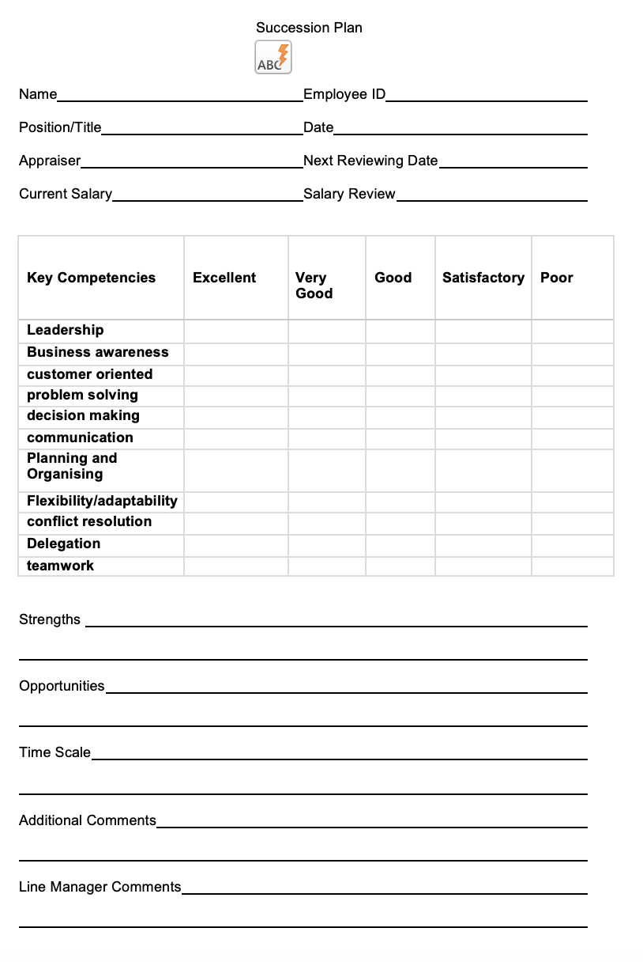
Figure 7: Succession Plan
Source: Hossain (2021)

Personal Assessment Plan – This plan is similar to PDP, which is carried out by one own self, but personal assessment plan is carried out by line manager to assess the performances between starting range 0 to 3 months, mid-range 3 to 6 and long range 6 to 12 months.
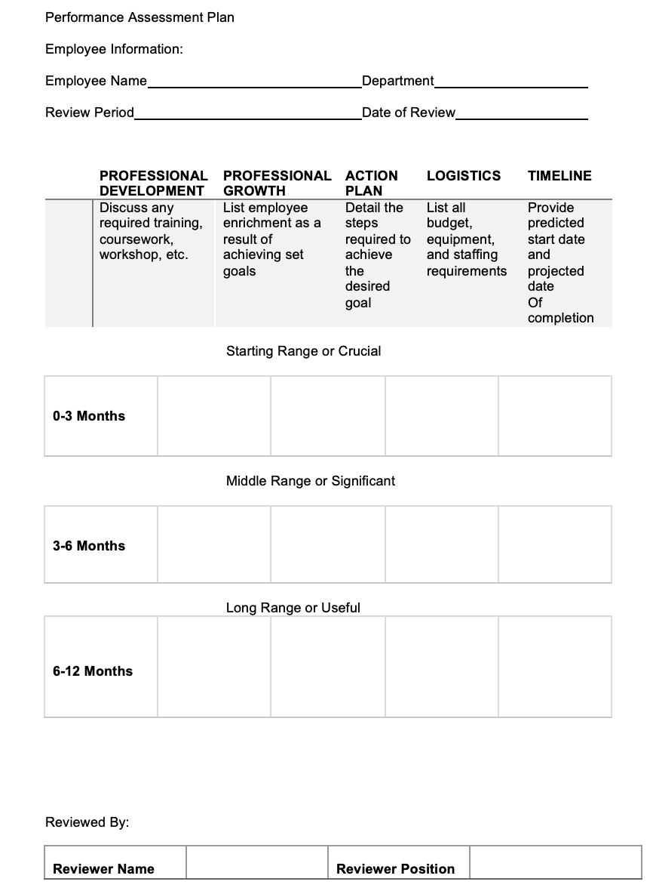

Figure 8: Personal Assessment Plan Source: Hossain (2021)
Performance Management – Performance Management is also known as Opportunity to Improve form. It is used to manage poor performances of an employee, it is a formal document which is agreed with the poor performing employee to improve their performances, not improving their performances would lead to disciplinary action being taken against them. Three steps for performance management, define role, set performance objectives, agree development plan.

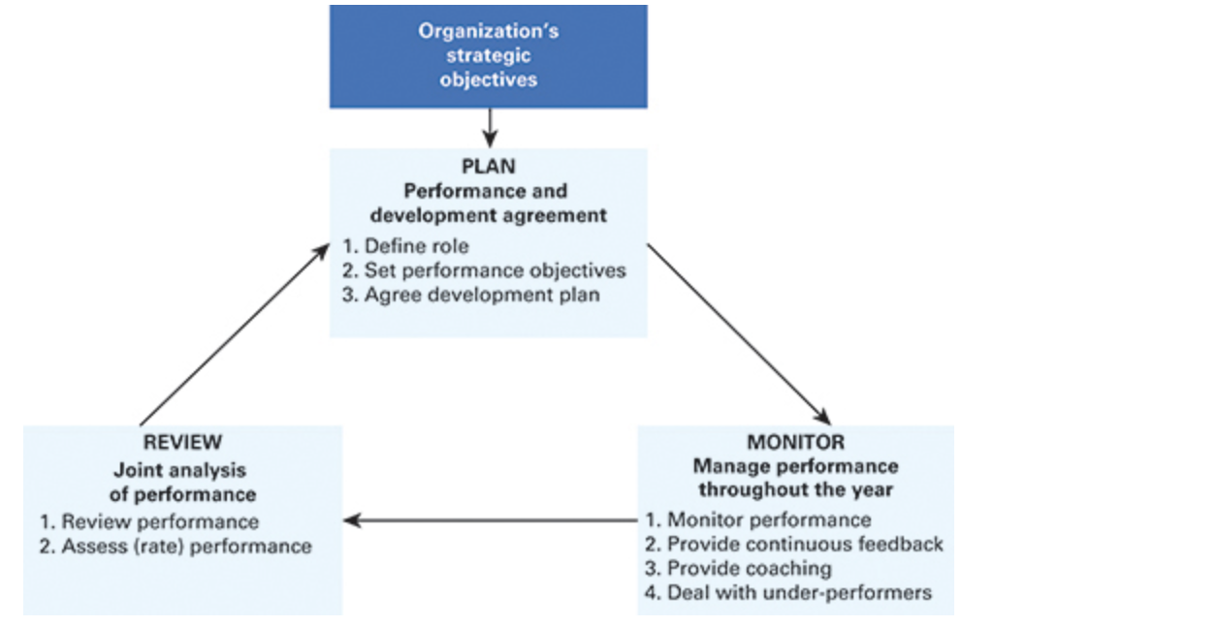
Figure 9: Performance Management System in Astra Zeneca
Source: Armstrong and Taylor (2020)

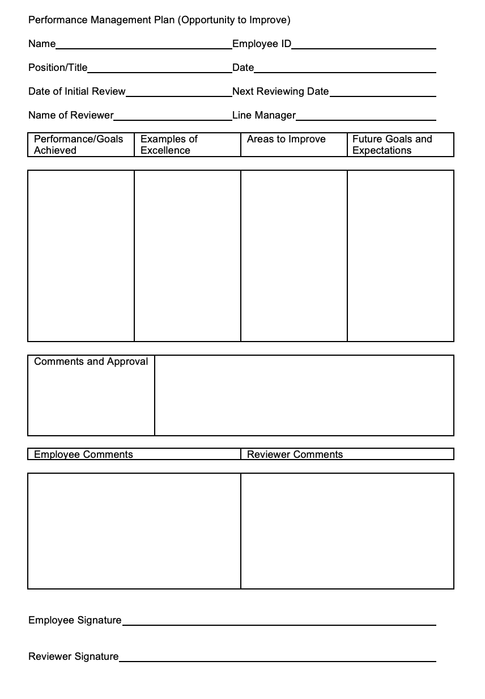
Figure: Performance Management Plan
Source: Hossain (2021)

The career plan is designed to provide guidelines to retain employees, improve performances, identifying talents, etc. There are different tools available for every different business, the above tools are there to help M&B to keep vast number of employees decrease turnover and increase performances. These effective methods are designed by HR to help the business grow.

Conclusion:

Training and development allow the employees to be trained on certain skills or job role. The knowledge is not limited, according to the famous philosopher “Knowledge is Power” (Knowledge is Power, 1849).
Career Development plan are there to ensure the employees have progression plan in place, prepare with learning activities and experiences. According to the earlier discussion, I have applied human capital and social exchange theories to this case study; as I believe education and training improves productivity by increasing knowledge and skills, social exchange shows that employees are loyal if they are looked after. Harvard model is the powerful utilisation of HR in an association through the administration of individuals related exercises. These theories and model both apply to my current work organisation. Other tools have been used to satisfy the needs for the development, training and learning of the employees. Some of the tools are only available in my organisation and some are universal. This career development tool could be used to develop individuals or improve their performances, it will help to reduce turnover and also help them to move to talent pool through succession planning.

References:
Armstrong, M. (2010). Armstrong’s essential human resource management practice: a guide to people management. [online] London; Philadelphia: Kogan Page. Available at: https://r1.vlereader.com/Reader?ean=9780749459901 [Accessed on 5 May 2021].
Armstrong, M. and Taylor, S. (2020). Armstrong’s handbook of human resource management practice. 15th ed. [online] London, United Kingdom ; New York, Ny: Kogan Page. Available at: https://bibliu.com/app/#/view/books/9780749498283/epub/content/52_chapter35.html#page_673 [Accessed on 5 May 2021].
Beer, M., Spector, B., Lawrence, P., Quinn Mills, D., and Walton, R. (1984) Managing Human Assets, New York, The Free Press
‌Birkin, H. (2019). Retaining staff - UKHospitality. [online] Ukhospitality.org.uk. Available at: https://www.ukhospitality.org.uk/blogpost/1721400/325437/Retaining-Staff [Accessed on 5 May 2021].
Boxall, P. F. and Purcell, J. (2003) Strategy and Human Resource Management, Basingstoke, Palgrave Macmillan
Brewster, C. (1993). ‘Developing a “European” model of human resource management.’ The International Journal of Human Resource Management, [online] 4(4), pp.765–784. Available at: https://doi.org/10.1080/09585199300000057 [Accessed on 5 May 2021].
Cambridge Dictionary (2019). DEVELOPMENT | meaning in the Cambridge English Dictionary. [online] Cambridge.org. Available at: https://dictionary.cambridge.org/dictionary/english/development [Accessed on 5 May 2021].
CIPD. (n.d.). Learning and development roles. [online] Available at: https://www.cipd.co.uk/careers/career-options/learning-development-roles#gref [Accessed on 5 May 2021].
Fombrun, C.J., Tichy, N.M. and Devanna, M.A. (1984) Strategic Human Resource Management, New York, Wiley
Goldstein, I.L. and Ford, K. (2002). Training in Organizations: Needs Assessment, Development, and Evaluation. Belmont, Ca: Wadsworth, Cop.
goodreads.com. (n.d.). A quote by Louis Pasteur. [online] Available at: https://www.goodreads.com/quotes/384173-fortune-favors-the-prepared-mind [Accessed on 5 May 2021].
Guest, D.E. (1987). ‘Human resource management and industrial relations.’ Journal of Management Studies, [online] 24(5), pp.503–521. Available at: http://dx.doi.org/10.1111/j.1467-6486.1987.tb00460.x. [Accessed on 5 May 2021].
Guest, D.E. (2017). ‘Human resource management and employee well-being: towards a new analytic framework.’ Human Resource Management Journal, [online] 27(1), pp.22–38. Available at: https://doi.org/10.1111/1748-8583.12139 [Accessed on 5 May 2021].
Hossain, Y. (2021). Personal Development Plan.
Hossain, Y. (2021). Appraisal Form.
Hossain, Y. (2021). Annual Review.
Hossain, Y. (2021). Job Chat.
Hossain, Y. (2021). Succession Plan.
Hossain, Y. (2021). Personal Assessment Plan.
Hossain, Y. (2021). Performance Management Plan.
Knowledge is Power. (1849). Scientific American, [online] 4(44), pp.350–350. Available at: https://www.jstor.org/stable/24930683 [Accessed 5 May 2021].
Kochan, T A and Osterman, P (1994) The Mutual Gains Enterprise: Forging a winning partnership among labor, management and government, Boston, MA, Harvard University Business Press
Mäkelä, K. and Suutari, V. (2009). ‘Global careers: a social capital paradox.’ The International Journal of Human Resource Management, [online] 20(5), pp.992–1008. Available at: https://doi.org/10.1080/09585190902850216 [Accessed on 5 May 2021].
McDonnell, A and Collings, D G (2011) ‘Identification and evaluation of talent in MNEs, in H Scullion and D G Collings (eds)’ Global Talent Management, London, Routledge, pp 56–73

Mitchells and Butlers Annual Report (2020). Mitchells & Butlers plc Annual Report and Accounts 2020. [online]. Available at: https://www.mbplc.com/pdf/2020/reports/MAB_Annual_Report_2020.pdf [Accessed on 5 May 2021].
Mullins, L.J. and Mclean, J.E. (2019). Organisational Behaviour in the Workplace. 12th ed. [online] Harlow, England: Pearson. Available at: https://ebookcentral.proquest.com/lib/trinity/reader.action?docID=5830196 [Accessed on 5 May 2021].

Nyberg, A.J., Moliterno, T.P., Hale, D. and Lepak, D.P. (2012). Resource-Based Perspectives on Unit-Level Human Capital. Journal of Management, [online] 40(1), pp.316–346. Available at: https://doi.org/10.1177/0149206312458703 [Accessed on 5 May 2021].
Paauwe, J (2004) HRM and Performance: Achieving long-term viability, Oxford University Press, Oxford
Reilly, P (2015) Performance Management: Improving the delivery/improving the performance in practice, Brighton, IES

‌Reynolds, J. (2004). Helping people learn: strategies for moving from training to learning: research report. London: Chartered Institute of Personnel and Development (CIPD).
Schuler, R.S. (1992). ‘Strategic human resources management: Linking the people with the strategic needs of the business.’ Organizational Dynamics, [online] 21(1), pp.18–32. Available at: https://www.academia.edu/1982998/Strategic_human_resources_management_Linking_the_people_with_the_strategic_needs_of_the_business [Accessed on 5 May 2021].
Schuler, R. S. and Jackson, S. E. (2000) Strategic Human Resource Management, Oxford, Blackwell

Statista. (2019). UK: biggest pub chains 2017 | Statista. [online] Available at: https://www.statista.com/statistics/310844/ten-leading-independent-pub-companies-in-the-united-kingdom-uk-by-number-of-pubs-owned/ [Accessed on 5 May 2021].
‌

‌

