Name: Angharad Ahmed
Student number: 2520180
Module: Awe and Wonder: Mathematics, Science and the Outdoors (ECEY5005)
Declaration of AI and digital image use: Artificial intelligence (AI) was used solely to support research for this assignment. Google image tools were used to create the visual poster from my own original photographs in order to illustrate different aspects of mathematical and scientific learning that can be explored within a natural environment. The photographs used in this assignment are my own work and were taken at Pembrey Country Park on 6 September 2026.

Outdoor Mathematical and Scientific Learning
  - Photograph, learning story, risk-benefit assessment and critical discussion
This assignment examines how a photographed woodland environment can support mathematical and scientific learning for children aged four to five. Part One presents my photograph from Pembrey Country Park and identifies features that may prompt inquiry, including trees, ferns, filtered light, uneven ground, a hanging balance and a collection of natural loose parts. Part Two develops a constructed learning story to show how children might compare mass and size, count meaningful quantities, investigate patterns and properties, observe plants, measure growth and ask questions about light, water and seasonal change. The story is used as a form of pedagogical documentation rather than evidence that the fictional events actually occurred.
Part Three provides a risk-benefit assessment. It distinguishes hazards that require removal from manageable challenges through which children can learn to judge space, coordinate movement, make decisions and develop confidence. It also considers safeguarding, weather, clothing, sunscreen, hygiene, allergies, consent and individual needs. Part Four critically compares Piaget, Vygotsky, Bruner, Froebel, Reggio Emilia and Forest School, supported by early mathematics and science research and Curriculum for Wales. The main argument is that outdoor resources do not teach by themselves. Learning depends on an adult who knows what to observe, why a concept matters, when to scaffold and when to step back. Inclusive practice is therefore central: children with additional learning needs and children learning English or Welsh as an additional language may require reasonable adjustments, multimodal communication and different routes into the same ambitious inquiry. Across all four parts, the adult’s role is to create a safe-enough, accessible environment in which children’s ideas are trusted, challenged through evidence and extended without adult ownership replacing child-led play.

Part One My Photograph
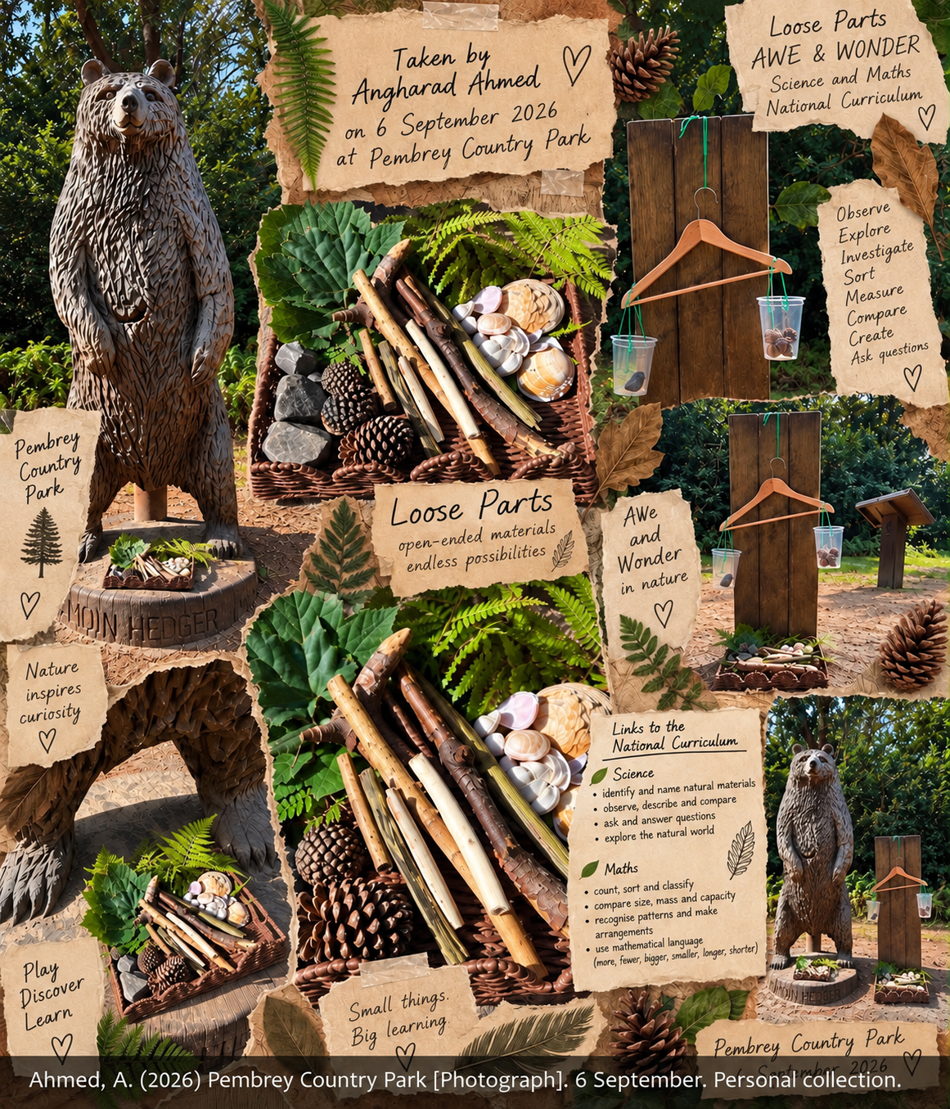  Figure 1. Visual poster developed from my own photographs of the Pembrey Country Park learning environment. | 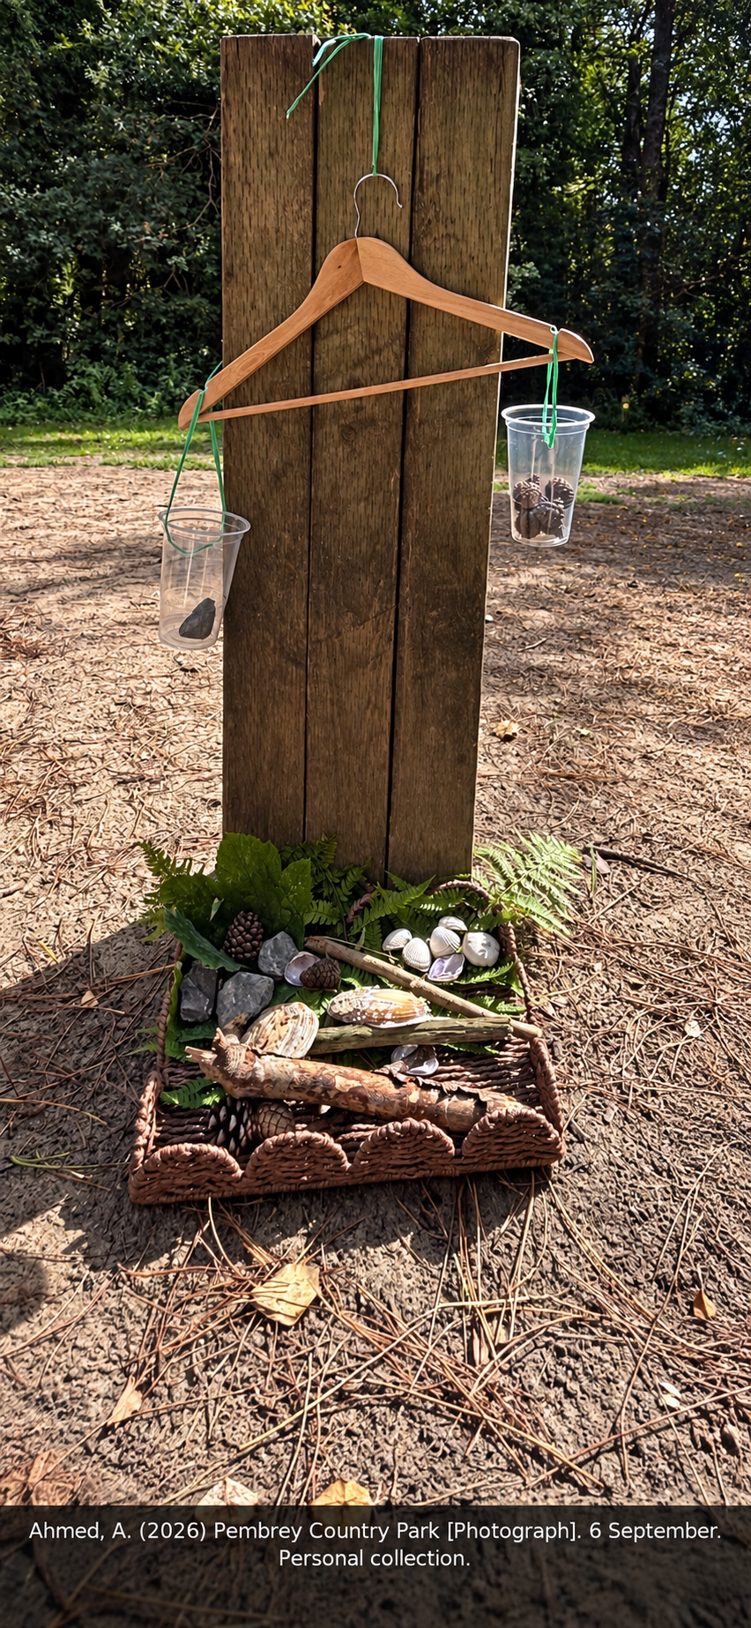  Figure 2. Hanging balance and natural loose-parts collection.
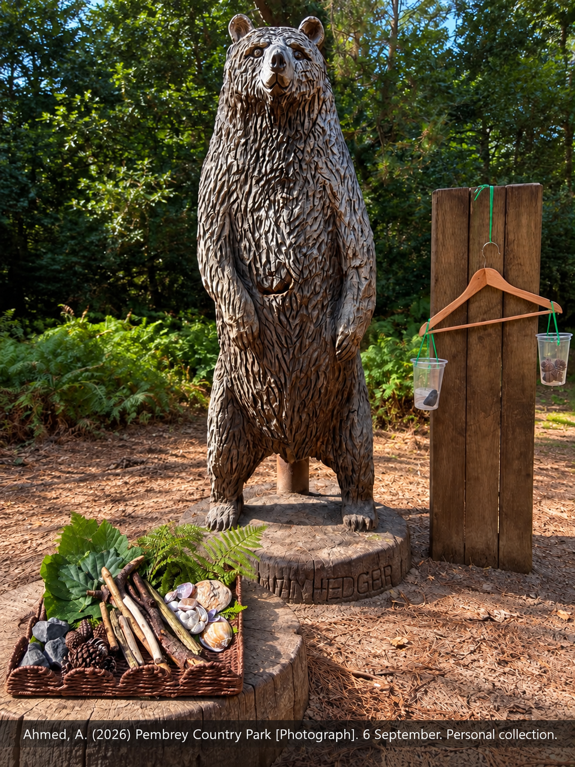  Figure 3. Woodland balance beside the carved bear and loose-parts collection. | 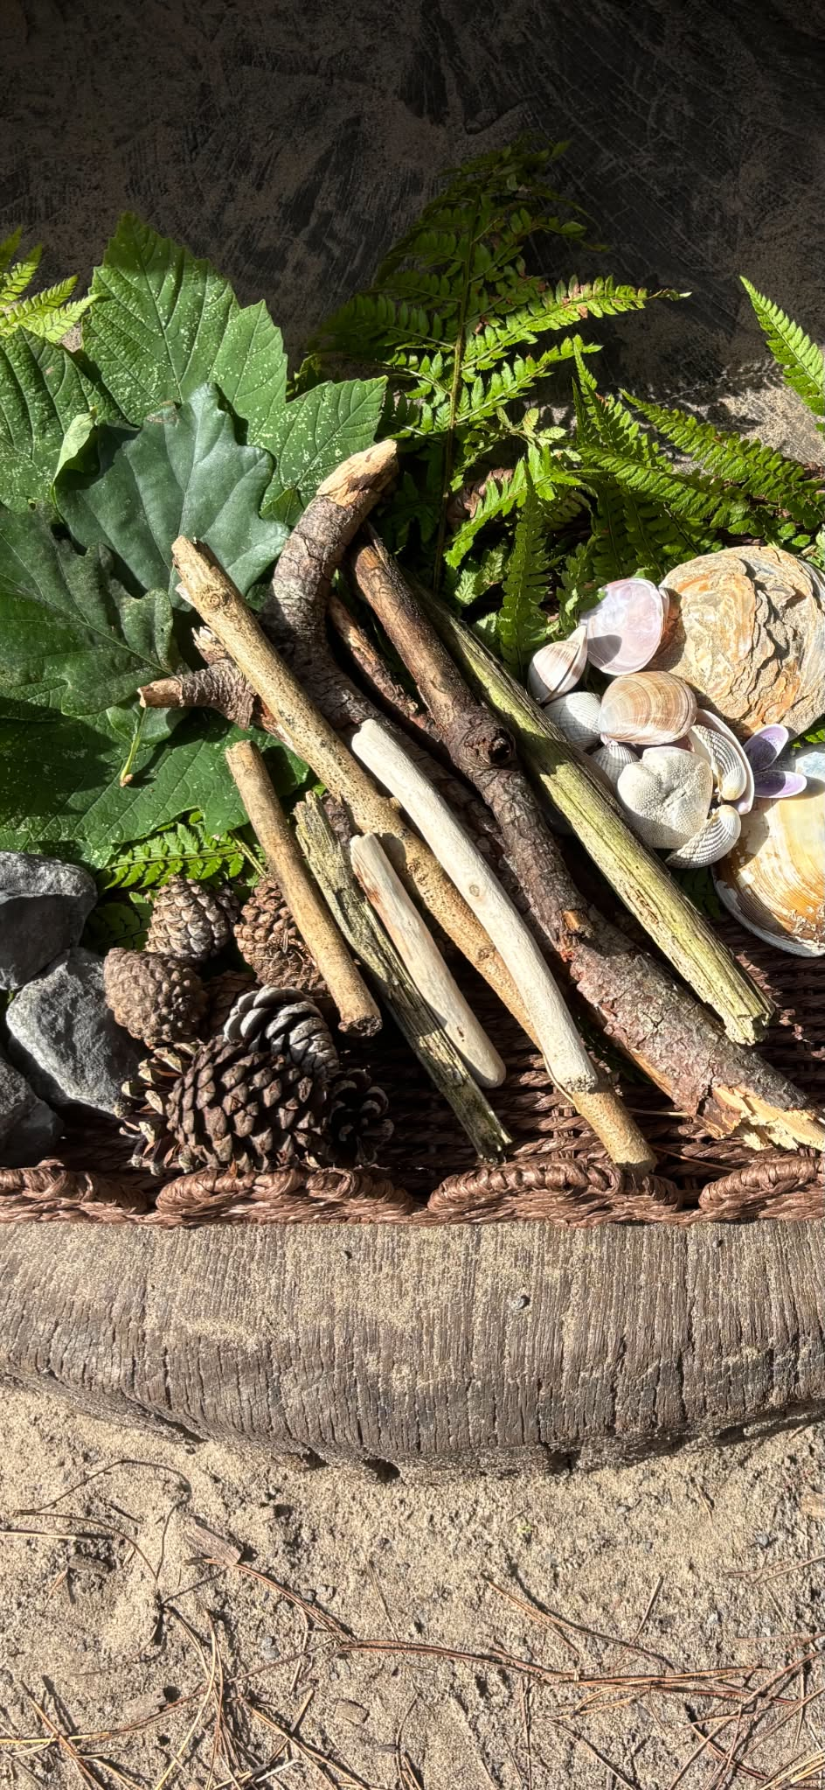  Figure 4. Natural loose parts including sticks, stones, pinecones, shells, leaves and ferns.
Photograph credit for Figures 1–4: Ahmed, A. (2026) Pembrey Country Park [Photographs]. 6 September. Personal collection.
The photograph was taken by me at Pembrey Country Park on 6 September 2026. It shows mature trees and filtered sunlight, ferns, broad leaves, bark, exposed roots, leaf litter and uneven ground. Beside a carved wooden bear is a simple balance made from a coat hanger, string and two transparent containers. A low basket contains sticks of different lengths and thicknesses, stones, pinecones, shells, bark and leaves. These visible features offer authentic opportunities to investigate living things, seasonal change, light and shadow, growth, texture, pattern, number, length, mass and balance.

Part Two Learning Story

Learning Story: Exploring and Investigating the Woodland
This constructed learning story uses the photograph of Pembrey Country Park as the starting point for outdoor learning with three children aged four to five. The woodland contains mature trees, ferns, leaf litter, exposed roots, stones, pinecones, shells, sticks and a hanging balance. These features create an authentic context for Mathematics and Numeracy and Science and Technology within Curriculum for Wales. This reflects Enabling Learning guidance, which presents enabling adults, engaging experiences and effective environments as interdependent and emphasises play, being outdoors, observation, and authentic and purposeful learning (Welsh Government, 2023a). The purpose is not to turn the woodland into an outdoor worksheet, but to show how an enabling adult can recognise curriculum learning within child-led play, make careful interventions and return to children’s ideas over time.
Before entering, I checked the site, established visible boundaries and revisited rules for sticks, living things and the recall signal. Mia looked at sunlight moving through the branches, Harri walked around the carved bear and Elin crouched beside the natural materials. I said, ‘Show me what interests you.’ Their choices revealed starting points while I remained close enough to safeguard them without allocating identical tasks.

Observation One: Which Side Will Go Down?
Mia selected the largest pinecone and said, ‘This one will be heaviest because it is biggest.’ Harri chose a smaller stone, while Elin suggested placing both objects in the hanging containers. When the stone side moved down, the children stopped and looked closely. Rather than correcting Mia, I asked, ‘What did you notice?’ and ‘How could we find out whether bigger always means heavier?’ The children tested other combinations. They counted pinecones into one container, estimated how many might balance one stone, and used higher, lower, heavier, lighter, nearly level and equal as they described the movement.
As the investigation continued, I noticed that Mia touched each pinecone while counting but counted one twice when it rolled. I asked, ‘How could we arrange them so that we know each one has been counted once?’ She placed the pinecones in a line and counted again. Harri then moved one pinecone from the line into the container for each number word. This showed developing one-to-one correspondence and also demonstrated peer scaffolding. When the two sides were almost level, Elin said, ‘It needs a tiny one.’ I restated her idea using more precise language: ‘You think a lighter object might make a smaller change.’ Her prediction showed that she was beginning to consider the size of an effect rather than only whether the balance moved.
The mathematical learning involved cardinality because the final number counted represented the total quantity in the container. It also included estimation, comparison, early equivalence and the language of mass. Scientifically, the children made a prediction, observed a physical effect, changed the materials and revised an explanation. This inquiry reflects Curriculum for Wales Science and Technology, in which curiosity, questioning, observation and evidence contribute to developing and refining explanations (Welsh Government, 2023c). Mia’s initial assumption that the larger pinecone would be heavier was therefore treated as a theory to investigate rather than an error to correct. Mathematics and Numeracy was used for a meaningful purpose: number and comparison became tools for answering the children’s own question (Welsh Government, 2023b).
My role was responsive rather than directive. I introduced vocabulary after the children had noticed the phenomenon, supported stable counting and selected contrasting objects without demonstrating a correct combination. A large, light pinecone and a small, dense stone challenged the assumption that size determines mass. This intervention acted as temporary scaffolding: it kept the intellectual problem with the children while making the underlying concept more visible. I recorded brief comments and photographs rather than interrupting the play with a worksheet. Possible next steps were to test two objects of similar size, order several objects by predicted mass before using the balance and compare the children’s predictions with the results.

Observation Two: What Is Growing Around Us?
Elin moved towards the ferns and broad leaves surrounding the tree stumps. ‘These leaves are not the same,’ she said. Harri noticed that ferns grew in a patch beneath the trees, while Mia placed a broad fallen leaf beside a fern frond. I asked, ‘What is the same and what is different?’ and wondered aloud why some plants were growing in brighter places and others beneath the trees. The children described colour, shape, edges, veins, size and texture. They counted sections of the fern, ordered three fallen leaves by length and used sticks as non-standard measuring units. They also compared living green growth with dry brown leaves on the ground.
Their conversation developed into questions about growth and change. The children wondered where new leaves came from, why some had fallen and whether plants needed the same amounts of water and light. I helped them distinguish between what could be observed during the visit and what would require evidence collected over time. They chose one small shoot, drew its shape and placed a stick nearby as a reference point without touching the plant. Harri suggested photographing it, while Mia predicted that it would be taller when we returned. Elin thought it might have more leaves. I explained that scientists often revisit the same place and compare records before reaching a conclusion.
This observation integrated classification, pattern, counting, non-standard measurement, comparison and time. The scientific emphasis was on living things, variation, growth, seasonal change and the need for repeated observation. A tablet camera and drawings allowed children to represent evidence in different ways, connecting technology to a genuine purpose rather than using it as a distraction from sensory experience. Enabling Learning guidance identifies outdoor environments as places that can stimulate curiosity about the living and non-living world and support exploration and problem-solving (Welsh Government, 2023a). Here, Science and Technology and Mathematics and Numeracy worked together as children quantified and communicated changes in the natural world (Welsh Government, 2023b; Welsh Government, 2023c). Care for the shoot also supported ethical and holistic learning because the plant remained in its habitat rather than being picked for an adult-planned display.

Observation Three: Looking for Woodland Minibeasts
Harri noticed movement beneath a loose piece of bark lying on the ground and called the others to look. Before anyone lifted it, I asked, ‘What might be living underneath, and why might it choose this place?’ Mia predicted that small creatures would prefer the dark because the soil felt damp. With adult support, the children carefully lifted the bark and observed a woodlouse, a small spider and several worms. They used a magnifier to examine visible features without removing the creatures from the habitat. Elin commented that the woodlouse had ‘lots of legs’, while Harri noticed that the worm had no legs. The bark was then returned gently to its original position.
The children began to classify the creatures according to observable features such as legs, body shape, colour and movement. I avoided giving them a formal identification key immediately and asked, ‘How could you make groups so another person understands your rule?’ They represented their observations with marks on a clipboard and compared the damp, shaded location with a drier patch nearby. Because only a small number of creatures was seen, I did not present the result as proof that all minibeasts prefer damp places. Instead, I said, ‘That is what we found today. Where else could we look safely, and what would we need to keep the same if we compared the places?’ This introduced fair comparison and the provisional nature of evidence in an age-appropriate form.
Mathematical learning included counting meaningful quantities, comparing more and fewer, sorting by a chosen rule, describing position and beginning to represent data. Scientific learning included habitats, the needs of living things, similarities and differences, prediction, observation and evidence. Positional vocabulary such as under, beside, between and behind arose naturally as the children described where creatures were found. Photographs could later support a simple pictogram showing the different locations or types observed. The activity therefore connected curriculum knowledge with curiosity while maintaining respect for biodiversity. It also showed why adult subject knowledge matters: the practitioner must recognise classification, data and fair comparison within play rather than seeing only an exciting encounter with a worm.
The enabling adult also held responsibility for safety. I checked before bark or stones were lifted, reminded the children not to touch unfamiliar fungi or put hands near their mouths, monitored allergies and bites, and ensured handwashing afterwards. These precautions reflect the practitioner’s continuing duty to safeguard children while enabling meaningful exploration and should be implemented in accordance with the setting’s safeguarding, health and safety, allergy and individual healthcare procedures (Welsh Government, 2022). The controls did not remove all challenge: children learned to approach living things slowly, judge where to place their hands and restore the habitat. Visual rules, gestures and peer modelling would support children learning English or Welsh as an additional language, while photographs or model minibeasts could offer a lower-sensory route into the same ideas. Inclusion meant providing different ways to investigate and communicate, not giving every child a separate simplified task.

Assessment, Children’s Voice and Possible Next Steps
Across the three observations, assessment was embedded in attentive observation. I noticed Mia’s changing understanding of size and mass, Elin’s comparison of plants and living things, and Harri’s use of classification and recording. I read selected comments back to the children and asked whether I had understood them correctly. Each child then chose one idea to revisit: Mia wanted to find a large object lighter than a small one, Elin wanted to check whether the shoot had changed, and Harri wanted to compare minibeasts in two locations. Involving them in interpretation respected their right to express a view and prevented the learning story from becoming only the adult’s account.
Additional resources could include magnifiers, a ruler, number cards, a camera, drawing boards and objects contrasting in size and mass. Loose parts remained open-ended, but their selection was intentional. A large light object, a small dense object or noticeably different stick lengths could expose useful variation. Resources should extend existing questions, while occasional prompts such as ‘What changed?’ make reasoning visible without interrupting sustained attention.

Returning the Learning to the Classroom
Back in the classroom, the children’s photographs, drawings, counts and spoken predictions would be revisited in a floor book or shared display. The woodland balance could be recreated with safe classroom materials so the children could test new contrasts and explain whether their ideas had changed. Photographs of the marked shoot could be ordered over several weeks, with children measuring visible change and discussing whether the evidence supported their predictions. Records from the minibeast search could become a pictogram, followed by discussion about what the small sample could and could not show. A book such as Dr Seuss’s The Lorax could prompt questions about trees, habitats and responsibility, but children’s interpretations should be discussed rather than replaced by an adult moral.
This continuation turns the visit into progression rather than an isolated experience. The adult can compare later explanations with the original comments and plan further visits from children’s questions. Curriculum and subject knowledge guide timely scaffolding, while children retain ownership. Mathematics and science remain holistic through their connections with language, movement, collaboration, well-being and environmental care.

Part Three Risk-Benefit Assessment
The following risk-benefit assessment considers both the developmental benefits of outdoor exploration and foreseeable hazards in the woodland environment. Risk management should be proportionate: significant hazards require appropriate control, while manageable challenge can support children’s judgement, confidence and physical competence (Health and Safety Executive, 2012). Enabling Learning similarly recognises the value of opportunities for appropriate risk and challenge (Welsh Government, 2023a). Where provision is regulated childcare, the assessment should also be read alongside the National Minimum Standards, including the expectations for safeguarding and safety in Standards 20 and 24 (Welsh Government, 2026). Controls must be adapted to the setting’s own procedures and to individual children’s medical, sensory, communication and mobility needs.
Experience or space | Benefits retained | Hazard and associated risk | Who is at risk | Precautions and adult action | Residual risk
Bounded woodland exploration | Independent exploration, confidence and orientation within a known space. | Boundaries, nearby roads or separation; risk of a child becoming lost or entering an unsafe area. | Children; supervising adults. | Agree visible boundaries, meeting point and recall signal; check gates; purposeful staff positioning; frequent headcounts; visual boundary cues and rehearsed rules. | Low
Walking over natural ground | Balance, coordination, spatial judgement and physical confidence. | Roots, mud, stumps, uneven ground or unstable branches; slips, trips, falls or impact injury. | Children and adults, especially those with mobility, visual, sensory or fatigue needs. | Pre-visit site check; remove hidden sharp items; avoid unstable trees or areas; suitable footwear; clear an accessible route; provide proportionate support. | Medium
Moving beneath low branches | Scanning, judging height, ducking and moving with awareness. | Dead, sharp or low branches and dense vegetation; scratches, eye or head injury. | Children and adults; increased risk for visual, mobility, attention or processing needs. | Remove or avoid dead and unstable branches; point out sound low branches; model looking ahead and ducking; allow spacing; add contrast cues or adult proximity when needed. | Low
Outdoor learning in changing weather | First-hand learning about weather, light, shadow and seasonal change. | Sun, heat, cold, rain or wind; sunburn, dehydration, chilling or reduced concentration. | All participants; children with relevant health needs. | Check forecast; shade, water, hats, warm layers and waterproofs; follow sunscreen policy; shorten, relocate or cancel if unsafe; check individual health plans. | Low
Using balance and natural loose parts | Mass, length, balance, classification, coordination and responsible risk-taking. | Sticks, stones, splinters, hanging string or damaged containers; cuts, impact, entanglement or eye injury. | Children and nearby adults. | Inspect equipment; use short secure cords and child-sized resources; carry stones; keep long sticks low and spaced from faces; stop use if damaged; supervise to need. | Medium
Observing plants fungi and minibeasts | Biodiversity, life cycles, properties, wonder and environmental responsibility. | Sap, berries, fungi, bites or stings; irritation, poisoning or allergic reaction. | Children, especially those with known allergies; adults. | Identify known high-risk species; no tasting; ask before touching; observe wildlife gently; cover cuts; keep allergy plans and authorised medication accessible. | Medium
Exploring soil leaf litter and damp habitats | Sensory inquiry, habitat observation and evidence gathering. | Animal faeces, contaminated water, litter or hand-to-mouth contact; infection or cuts. | Children and adults. | Check area; avoid contamination; remove litter safely; wash hands after exploration and before food; prevent hand-to-mouth use of objects. | Low
Using tools and collecting materials | Agency, practical competence and ethical scientific inquiry. | Misuse of tools or damage to living things; injury or habitat damage. | Children, adults and wildlife. | Use assessed child-sized tools with direct teaching and agreed zones; collect fallen material; return minibeasts; avoid stripping plants; intervene when harm is likely. | Medium
Managing medical or safeguarding concerns | Inclusive participation in purposeful off-site learning. | Medical incident, incomplete consent information or safeguarding disclosure; delayed care or inappropriate response. | Children; practitioners with duty of care. | Current contacts and medical details; consent and visit procedures; trained first aider and kit; record/report incidents; follow the designated safeguarding route; never investigate a disclosure. | Low
Safeguarding considerations. Risk-benefit assessment does not replace safeguarding responsibilities. Practitioners remain responsible for supervision, agreed boundaries, children’s individual medical and additional learning needs, emergency procedures and appropriate responses to concerns. A disclosure or concern should be managed through the setting’s established safeguarding procedure and referred through the designated route rather than investigated by the practitioner (Welsh Government, 2022).

Child-Friendly Golden Rules
Stay where you can see the agreed adult or boundary marker; stop and listen to the recall signal; carry stones and keep long sticks low; ask before touching unfamiliar plants or fungi; use tools only in the agreed place; be gentle with living things; wash hands after exploring and before eating. The adult explains, models and revisits these rules rather than assuming that spoken instructions alone are accessible.

Risk-Benefit Rationale
The assessment does not attempt to remove every uncertainty from the woodland. It considers likelihood and possible severity, then selects controls that are proportionate to the child, place and activity. For example, an unstable or dead branch is an unacceptable hazard and the area should be avoided. A sound low branch presents a manageable challenge: after checking it, I can point it out, model looking ahead and allow children to practise ducking. Uneven ground can similarly remain when children have suitable footwear and supervision. Through these encounters they learn to scan, slow down, judge height, coordinate their bodies and communicate hazards to others. Risk is therefore assessed dynamically rather than through a form completed once before the session.
Before the visit I would check the route, boundaries, forecast, emergency access, mobile signal where relevant, toilets or handwashing arrangements, staffing, first-aid provision and the condition of the balance and loose parts. I would confirm consent, collection arrangements, contacts, allergies, medication and individual healthcare or learning plans. Families would receive clear information about waterproofs, warm layers, footwear, hats, drinking water and the setting’s sunscreen procedure. Spare clothing can prevent family income or an unexpected weather change from excluding a child. During the session, adults would position themselves so that the balance, boundary and wider movement area remain visible, while avoiding unnecessary hovering that restricts play.

Part Four Critical Discussion

The Role of the Adult in Inclusive Outdoor Mathematics and Science

Adult Role, Curriculum and Holistic Learning
Outdoor provision can make early mathematics and science tangible: mass is seen when the balance tilts, number has purpose when children add pinecones, and plant growth becomes a phenomenon that can be revisited. However, an environment is not educational simply because it is natural. Curriculum for Wales identifies enabling adults, engaging experiences and effective environments as interdependent and emphasises play, being outdoors, observation, and authentic and purposeful learning (Welsh Government, 2023a). The adult role should therefore not be reduced to a choice between directing children and withdrawing. Practitioners need professional judgement about when to observe, scaffold, model, question or protect uninterrupted exploration.

Observation, Scaffolding and Co-construction
Piagetian constructivism explains why first-hand action matters. A child who predicts that a large pinecone will outweigh a small stone meets evidence that unsettles the existing idea and can reconstruct understanding (Piaget, 1952). This protects children from receiving science as disconnected facts. Yet Piaget’s emphasis on individual construction can underplay language, culture and unequal access. A child may manipulate the balance without acquiring the comparative vocabulary or shared reasoning needed to explain the result. Therefore the adult should allow physical exploration but not assume discovery alone guarantees conceptual development.
Vygotsky offers a stronger account of socially mediated learning. Within the Zone of Proximal Development, an adult or capable peer can help a child connect “that side went down” with heavier, lighter, quantity and prediction (Vygotsky, 1978). Bruner’s account of scaffolding similarly supports temporary, contingent help (Wood, Bruner and Ross, 1976). The practitioner might hold the container steady, model one word, gesture to the level or ask, “What could you change?” before reducing support. Compared with unguided discovery, this can make important concepts accessible; compared with direct instruction, it preserves agency. Its weakness is practical: scaffolding can become disguised control if the adult has a preferred answer and leads the child through it.

Nature Play and the Enabling Environment
Froebel’s emphasis on unity, nature, play and self-activity complements constructivism but gives the outdoor context greater ethical and holistic significance (Tovey, 2017). Plants, stones and sticks support intellectual, physical, social and aesthetic learning together. The adult prepares a rich environment and observes the child’s self-chosen activity. However, a romantic reading of ‘natural development’ can obscure the need for explicit inclusion, subject knowledge and safeguarding. Froebelian freedom is meaningful only if the practitioner ensures that every child can reach, interpret and use the materials and if natural objects are encountered respectfully rather than treated as unlimited resources.
Reggio Emilia-informed practice shifts attention towards listening, documentation and the environment as a participant in learning (Edwards, Gandini and Forman, 2012). The photograph can become a provocation: transparent containers make comparison visible, while ferns, leaves and filtered light invite multiple forms of representation through talk, movement, drawing, counting and photography. Documentation helps adults revisit children’s theories instead of reducing assessment to correct answers. In contrast with a tightly sequenced Brunerian scaffold, Reggio practice is more willing to let the direction emerge through dialogue. Yet importing Reggio as an attractive display style is superficial. Its value lies in careful listening and collaborative interpretation, both of which require time, staffing and critical reflection.
Forest School also values learner-led exploration, relationships, repeated contact with nature and supported risk. It should not, however, be used as a label for any one-off activity among trees. Earlier British case studies associated repeated woodland participation with confidence, independence and social development (O’Brien and Murray, 2007). More recent systematic-review evidence identifies potential benefits for preschool children across physical and motor development, nature connectedness and aspects of health and wellbeing, but also reports methodological limitations and a need for stronger empirical evidence (Sella et al., 2023). Positive outcomes should therefore not be attributed uncritically to the Forest School model itself. Reggio foregrounds collective meaning-making and documentation, whereas Forest School more explicitly foregrounds long-term relationship with place, autonomy and risk competence. Neither removes the practitioner’s responsibility to plan, observe and intervene when access or safety requires it.

Risk Competence, Safeguarding and Well-being
The distinction between hazard and beneficial risk is especially important in woodland practice. A dead branch likely to fall requires avoidance or removal, but a sound low branch can invite a child to notice, judge height and duck. Uneven ground can develop balance, and a manageable stick can teach spatial awareness. The adult’s risk-benefit assessment asks what harm is foreseeable, how serious it could be, which controls are proportionate and what learning would be lost through complete removal. Children also participate in dynamic assessment by naming hazards, agreeing boundaries and explaining safe choices. This does not transfer the duty of care to them; it treats safety as knowledge and judgement that can be developed with support (Health and Safety Executive, 2012).

Mathematics, Science and Sustained Inquiry
Specific mathematics research strengthens these broad theories. Clements and Sarama (2021) argue for teaching that responds to developmental learning trajectories. In the photographed environment, the adult should notice whether counting is stable and one-to-one, whether the child understands that the last number represents the total, and whether comparison is based on number, length or mass. A closed question such as “How many?” may check recall, while “How many more might make it level?” connects cardinality, estimation and equivalence. The adult intentionally varies materials and models terms such as heavier, equal, longer and fewer, but avoids turning every object into compulsory counting.
Early science research supports inquiry that begins with children’s curiosity while recognising the adult’s pedagogical contribution (Eshach and Fried, 2005). Ramanathan, Carter and Wenner (2022) likewise identify children’s curiosity, wonder and interests as starting points for preschool scientific inquiry and emphasise the teacher’s role in facilitating sustained investigation. Observing leaves, predicting which side will fall, testing objects and revisiting a marked shoot involve observation, classification, prediction, evidence and change over time. Adults should distinguish a productive misconception from failure. If a child says that smooth objects are lighter, the practitioner can value the theory and offer contrasting evidence rather than immediately announcing a rule. Scientific understanding grows through repeated comparisons and explanation, not through an isolated exciting activity. Curriculum for Wales similarly emphasises curiosity, exploration, communication and developing explanations (Welsh Government, 2023c).
Dewey’s experiential view adds a useful caution: experience becomes educative when it connects with later inquiry rather than existing as an isolated event (Dewey, 1938). The adult therefore returns to photographs, drawings, measurements and earlier predictions. Digital technology can support this continuity when children photograph the marked shoot, record a short oral prediction, use a simple magnifier camera or compare images over several weeks. Technology should reveal change or support communication, not distract from direct sensory attention. A book such as Dr Seuss’s The Lorax can also provoke discussion about trees, resources and responsibility, but the adult should not impose its moral as the correct conclusion. Children can compare the fictional landscape with the photographed woodland, ask what living things need and decide how collections of natural materials can avoid damaging the site (Seuss, 1971).
Open-ended conversation is central but must be used critically. Questions such as “What do you notice?”, “Why do you think that?” and “How could we find out?” can reveal reasoning and support sustained shared thinking (Siraj-Blatchford et al., 2002). However, a stream of adult questions can feel like interrogation and interrupt deep involvement. The skilled adult alternates between observing, wondering aloud, modelling vocabulary, demonstrating safe use, adding a carefully chosen resource and remaining silent. Their subject knowledge matters because they must recognise less obvious mathematics and science, including equivalence, non-standard measurement, repeating pattern, material properties, seasonal change and fair comparison.

Inclusion, Rights and Participation
Inclusion changes both environment and interaction. A child with additional learning needs may require an accessible route, stable seating, larger containers, adapted grips, reduced sensory load, a predictable sequence, extra processing time or one-step instructions. Visual rules, object cues and now-and-next boards can reduce dependence on spoken language. For an EAL learner, the adult can pair words with objects, gestures, photographs and peer modelling, repeat useful comparative vocabulary in context and welcome home-language explanations rather than treating silence as lack of understanding. Multiple modes of response—pointing, sorting, moving, drawing, signing, photographing and speaking—reflect a Reggio-inspired respect for many ways of meaning-making.
Vygotsky’s more knowledgeable other need not always be the adult. A peer may demonstrate how to steady the balance, continue a pattern or find a route beneath a branch. Mixed-competence collaboration can expand participation, provided the adult watches that one confident child does not control the apparatus or speak for everyone. Brunerian scaffolding can then include environmental supports—picture sequences, contrasting objects, a stable tray, number cards or a talking button—rather than constant verbal prompting. This comparison matters for inclusion: a narrow interpretation of scaffolding may create adult dependence, whereas thoughtfully designed resources allow children to act with increasing autonomy.
Inclusion is not achieved by giving every child the same task. Equality of access may require different tools, adult proximity, routes or ways of communicating while the intellectual purpose remains ambitious. The UNCRC establishes rights including non-discrimination (Article 2), the child’s best interests (Article 3), participation (Article 12), education (Articles 28 and 29) and play (Article 31) (United Nations, 1989). Within Wales, the Rights of Children and Young Persons (Wales) Measure 2011 places a duty on Welsh Ministers to have due regard to the UNCRC when exercising relevant functions (Welsh Government, 2024a). For practitioners, a rights-respecting approach means identifying barriers, listening to children’s ideas and enabling meaningful choices and participation. Consultation with families and relevant professionals, individual healthcare or learning plans, spare clothing, accessible routes, visual communication and a quiet retreat are therefore pedagogical and rights-respecting decisions as well as welfare measures.
Trusting children’s competence does not mean assuming that they already possess the knowledge needed to remain safe or interpret phenomena. It means treating their predictions, languages and strategies as worthy of attention. The adult can say, “You think the biggest object will be heaviest; let us keep that idea while we test it,” thereby separating respect for the child from automatic agreement with the claim. This stance connects Reggio listening with scientific fallibility and Vygotskian dialogue. It also supports a growth-oriented view of learning: an unexpected result is evidence to reason with, not a failure to hide.

Planning, Assessment and Progression
Planning should identify the what, the why and the possible adult response. The ‘what’ may include cardinal number, mass, non-standard length, repeating pattern, habitats, plant properties, light and growth. The ‘why’ is that these ideas help children quantify, describe, predict and explain their world. The adult response remains flexible: observe a strategy, model one term, introduce a contrasting object, record a theory, support safe tool use or revisit the place. This long-term, preventative and participatory approach is consistent with the Well-being of Future Generations (Wales) Act 2015 and its concern for social, cultural, economic and environmental well-being, while the curriculum experience encourages responsibility towards living things and shared places (Welsh Government, 2024b).
Assessment in this model is formative and narrative. A learning story records context, action, language, dispositions and possible next steps; it can show curiosity, persistence, collaboration and conceptual development that a numerical checklist misses. However, narrative assessment is interpretive and may privilege what the adult expects to see. Practitioners should separate description from interpretation, include children’s words and representations, invite families’ knowledge and revisit tentative conclusions. Curriculum links should illuminate learning rather than being retrofitted to every action. A child carrying three sticks is not automatically demonstrating secure cardinality; the adult needs evidence from repeated, varied participation.

Conclusion
Overall, no single approach supplies a complete method. Piaget protects active construction but insufficiently explains guided participation; Vygotsky and Bruner clarify social support but can be misused to justify adult direction; Froebel values nature and holistic play but needs a contemporary inclusion lens; Reggio Emilia strengthens listening and documentation but is resource-intensive; Forest School foregrounds sustained relationship and risk competence but should not be reduced to occasional woodland activities. The most defensible adult role is responsive co-construction. The practitioner prepares an inclusive and safe-enough environment, observes before intervening, identifies the mathematics and science within play, listens to children’s theories, models precise language, asks occasional generative questions, enables peer collaboration, documents learning and revisits ideas over time. Expertise is shown not by dominating the inquiry or disappearing from it, but by making well-timed decisions that preserve curiosity while extending every child’s capacity to participate, reason and wonder.

References
Clements, D.H. and Sarama, J. (2021) Learning and Teaching Early Math: The Learning Trajectories Approach. 3rd edn. New York: Routledge.
Dewey, J. (1938) Experience and Education. New York: Macmillan.
Edwards, C., Gandini, L. and Forman, G. (eds.) (2012) The Hundred Languages of Children: The Reggio Emilia Experience in Transformation. 3rd edn. Santa Barbara, CA: Praeger.
Eshach, H. and Fried, M.N. (2005) ‘Should science be taught in early childhood?’, Journal of Science Education and Technology, 14, pp. 315–336. doi: 10.1007/s10956-005-7198-9.
Health and Safety Executive (2012) Children’s Play and Leisure: Promoting a Balanced Approach. Available at: https://www.hse.gov.uk/entertainment/childs-play-statement.htm (Accessed: 21 September 2026).
O’Brien, L. and Murray, R. (2007) ‘Forest School and its impacts on young children: Case studies in Britain’, Urban Forestry & Urban Greening, 6(4), pp. 249–265. doi: 10.1016/j.ufug.2007.03.006.
Piaget, J. (1952) The Origins of Intelligence in Children. New York: International Universities Press.
Ramanathan, G., Carter, D. and Wenner, J. (2022) ‘A framework for scientific inquiry in preschool’, Early Childhood Education Journal, 50, pp. 1263–1277. doi: 10.1007/s10643-021-01259-1.
Sella, E., Bolognesi, M., Bergamini, E., Mason, L. and Pazzaglia, F. (2023) ‘Psychological benefits of attending Forest School for preschool children: a systematic review’, Educational Psychology Review, 35, article 29. doi: 10.1007/s10648-023-09750-4.
Seuss, Dr (1971) The Lorax. New York: Random House.
Siraj-Blatchford, I., Sylva, K., Muttock, S., Gilden, R. and Bell, D. (2002) Researching Effective Pedagogy in the Early Years. Research Report 356. London: DfES.
Tovey, H. (2017) Bringing the Froebel Approach to Your Early Years Practice. 2nd edn. Abingdon: Routledge.
United Nations (1989) Convention on the Rights of the Child. United Nations Treaty Series, 1577, pp. 3–178.
Vygotsky, L.S. (1978) Mind in Society. Cambridge, MA: Harvard University Press.
Welsh Government (2022) Keeping learners safe. Available at: https://www.gov.wales/keeping-learners-safe (Accessed: 21 September 2026).
Welsh Government (2023a) Enabling learning. Curriculum for Wales. Available at: https://hwb.gov.wales/curriculum-for-wales/designing-your-curriculum/enabling-learning (Accessed: 21 September 2026).
Welsh Government (2023b) Mathematics and Numeracy: Designing your curriculum. Curriculum for Wales. Available at: https://hwb.gov.wales/curriculum-for-wales/mathematics-and-numeracy/designing-your-curriculum (Accessed: 21 September 2026).
Welsh Government (2023c) Science and Technology: Descriptions of learning. Curriculum for Wales. Available at: https://hwb.gov.wales/curriculum-for-wales/science-and-technology/descriptions-of-learning (Accessed: 21 September 2026).
Welsh Government (2024a) Rights of Children and Young Persons (Wales) Measure 2011. Available at: https://law.gov.wales/rights-children-and-young-persons-wales-measure-2011 (Accessed: 21 September 2026).
Welsh Government (2024b) Well-being of Future Generations (Wales) Act 2015: The essentials. Available at: https://www.gov.wales/well-being-future-generations-act-essentials-html (Accessed: 21 September 2026).
Welsh Government (2026) National Minimum Standards for Regulated Childcare for Children up to the Age of 12 Years. Available at: https://www.gov.wales/national-minimum-standards-regulated-childcare-children-age-12-years-statutory-guidance (Accessed: 21 September 2026).
Wood, D., Bruner, J.S. and Ross, G. (1976) ‘The role of tutoring in problem solving’, Journal of Child Psychology and Psychiatry, 17(2), pp. 89–100. doi: 10.1111/j.1469-7610.1976.tb00381.x.

