Student name: Rebeka Sultana Student Number:2013537
Module:BMIH4002 Date:25.02.2023
__________________________________________________________________________________

Hotel Trinity
London Central
Christmas Menu
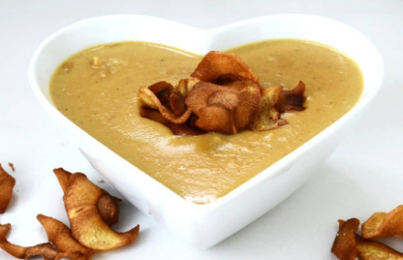
Starters – choice one from:
Parsnip and honey soup
- with bruschetta
Prawn cocktail
- with gems lettuce, baby tomatoes, Marie rose sauce
Chicken and liver parfait
- on rye bread

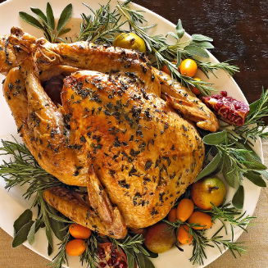
Mains courses – choice of one from:
Traditional roast turkey
- with all the trimmings
Beef filet mignon
- with sautéed mushrooms, long stem broccoli and carrot puree
Grilled sea-bass
- with squashed garlic potatoes and chive beurre blanc
Mediterranean vegetable risotto
- root vegetables and butternut squash

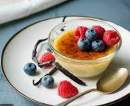
Desserts – choice of one from:
Crème Brulee
- Caramel and apricot
Brownie
- cinnamon, caramel and chocolate, with scoop of ice crème
Sundae
- with choice of 3 toppings (chocolate, white chocolate or strawberry)
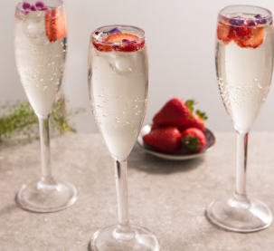
Drinks
Choice of one Glass of wine (175 ml) :
Red, white or prosecco.

Xmas drinks offers
Champagne package
1x
- Moet chardonnay
(750ml)
£145
Wine package
6x bottles
- House red wine
- House white wine
- Rose
(750ml)
£110
Bottle beers
6x
- Carlsberg
- Budweiser
- Becks
(300ml)

£35

£105
Per person

Call to Book and reserve:
0121 12345678
References:
- All images from google.com

