Academic and Employability Skills
Minhazur Rahman - 1706274

Contents
Analysing of relevant employability skills 1
Needs to develop in the future to gain credibility: 5
Employment opportunities: 6
Perspective of an employer trying to recruit 7
Conclusion 10
Reference: 11

Introduction
In today’s business world it is very competitive for the new employees. Most of the organisation needs to skillful and experience employees to perform in their organisation. Academic and employability skill is very essential for the employees. Academic skills is very essential for searching new jobs and keeping jobs that provide a steady income, benefits and opportunities for advancement. The employability skills are those skills that necessary for getting, keeping and being successful in a job. There are different types of skills such as communication, teamwork, problem solving, initiative and enterprise, planning and organizing, self-management, learning and technology skills are very effective for the job seekers. Aldi is the selected organization in this report. The aim of this report is to hire a retail assistant according to the required skills of Aldi (aldicareers, 2017).

Analysing of relevant employability skills:
Employability skill is very essential for the employees to develop their experience. The organisation requires to different types of skills for their operation. In the present business strategy, most of the business organisation wants to skillful employees to operate their business (Taylor, 2016). The employees need some skills for competitive job markets such as teamwork, planning & organizing, time management, communication, commercial awareness, leadership, IT skills, self-awareness, decision-making, innovation & creativity, management, interpersonal skills etc. these skills are very effective for the employees to take the opportunities from the organization. In this below, analyzing of relevant employability skills that helps to the employees in working places:

Teamwork skills: Teamwork skills help to work confidently within a group. It is very effective skills for the employees. In this way, the leader or a manager can perform well in a team. Team based work helps to achieve the business goals and objectives. Teamwork skills help to the employees to protect different types of problems in working area (Taylor, 2016).

Planning & organizing skills: Planning and organizing skills is very effective for employees in the management operation. Planning and organizing helps to make the proper solution in business operation. In this way, the management of organization makes short-term and long-term plan that effect in the development of business action.

Time management skills: Time management is the coordination of action and activities to maximize the effectiveness of an individual’s efforts. Time management skill is very essential for all types of employees in working place. The aim of time management is enabling employees to get more and better work done in less time (Whetten and Cameron, 2014).

Communication skills: Communication skills make the relationship between the employees and customer in business operation. There are different types of communication process such as verbal communication, written communication, face to face communication are effectively for business organization (Scott, et al, 2017).

Commercial awareness skills: Commercial awareness skill is the ability to understand what makes a business or organization successful by either buying or selling products. It is very essential for the employee who works as a marketing officer in organization (Taylor, 2016).

Leadership skills: A good leader is very effective for any business organization. The leader leads the employees and solves the problems in working places. A good leader also improved the ability to succeed under pressure, increased emotional intelligence, growth of confident in team, improved the productivity of the workforce, increased the awareness of diversity in the working place, improved listening and communicating skills etc.

IT skills: IT skill is an important factor for the present business world. IT skills are essential in order to utilize computers and related technology efficiency. Different IT skills help to improve the employees and they include to their curriculum vitae. For example, the employees in production must need to the skills of operating machines. On the other side, the employees in HRM, they need to the skills of IT for calculating and observing the process (Scott, et al, 2017).

Self-awareness skills: Self-awareness skills help an individual to tune into their feelings as like as to the behaviors and the feelings of others. It is very effective for the employees in working places. It increases the employee’s motivation and working spread in organization (Engmann, etal, 2017). For example, the employees understand what to do in the critical situation according to self-awareness skills.

Decision-making skills: Decision-making skill is very effective for business operation. There are five factors that influence in decision-making process such as past experience, a variety of cognitive biases, an escalation of commitment and sunken outcomes, individual differences, including age and socioeconomic status and a belief in personal relevance Engmann, etal, 2017). The employees need to decision-making skills for solving the different problems in working places. In this way, the employees improved their others skills and take advantage from the organization. Decision-making skills help to deciding which modules to take next year and targeting proper customers in a sales job (Taylor, 2016).

Innovation & creativity skills: Innovation skill is the ability to produce a new and unique ideas and innovation is the implementation of creativity. Innovation & creativity skills have become critical skills for achieving the success of new business on the last decades. For example, the innovative employees help to make the new ideas about services, products and plan in organisation. This innovation and creativity skills influences in organisational development.

Management skills: The management skills help to achieving the business goals in organization. The Management skill is the practice of understanding, developing, and deploying the employees. In this way, the employees contribute to the development of organisation and design a development plan for achieving business goals (Whetten and Cameron, 2014).

Interpersonal skills: Interpersonal skills are the life based skills that the people are use in every time to communicate and interact with other with people. This skill is very essential for the people in their personal and professional development. The employees need to interpersonal skills for improving their professional development in organization. Most of the business organisation requires interpersonal skills based employees for their business operation (Scott, et al, 2017).

Problem solving skills: This skill is very essential for all types of employees in the working place. The employee’s faces different types of problems in working environment such as labor retention, operation problems, less production, less profits etc. Problem solving skills help to the employees to solve the problems in business operation and achieving the business goals (Taylor, 2016).

Needs to develop in the future to gain credibility:

The credibility is very effective factors for the employees to make relation with others in organization. It helps to improve the employee’s position in future. According to different skills, the employees can develop their relationship in working environment and adapting in working places Engmann, etal, 2017). For example, as a retail assistant, the employees need some credibility skills such as loyalty, trust, respect, education, honesty, accountability, focused, actions, competence etc.
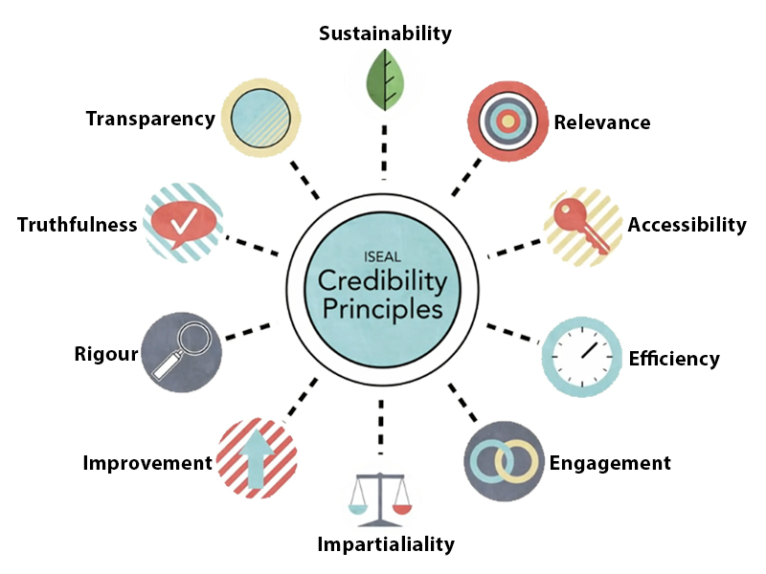
Figure: Credibility Principle
Source: (White, 2016).

The credibility of loyalty is very important for the development of employees in future. As a retail assistant, the employee must maintain the loyalty in working place. Loyalty from the good leader helps to others employees and motivates to work in the future to gain credibility. The ability of employees trust is very effective factors that help to developing the credibility in future Engmann, etal, 2017). Working with the subordinate employees, new staffs, with team members increases the respect in working places by the employees. For example, the new employees respect to their leaders and managers that improve their credibility in working places. Education is the vital factors for developing the credibility in the organization. The well-educated people are concerns about their responsibilities and duties in every situation (Scott, et al, 2017).

The reputation of honesty is very essential for developing credibility in future. Improving a reputation for providing honest and truthful information that can be verified if necessary goes a long way forwards for achieving employees respect and establishing credibility. Proper accountability helps to complete the required goals and objectives for employees. According to accountability, the employees prepare the work effectively that develops the credibility in future in working places. For example, a leader leads the team or groups following to the credibility. In this way, the leader achieves the loyalty from the team members and the supervisor gives proper rewards for outstanding work with efficiency (White, 2016).

Employment opportunities:
The organisation helps to the employees to develop in the future to gain credibility that influences in employment opportunities. The employees search the job with extra opportunities in the business organization Engmann, et al., 2017). there are different types of opportunities such as continuous education courses, tuition reimbursement, career development, counseling services, skills training, promotion for outstanding works, mentoring in working places, develop the leadership skills that provides the employees opportunities in organisation.
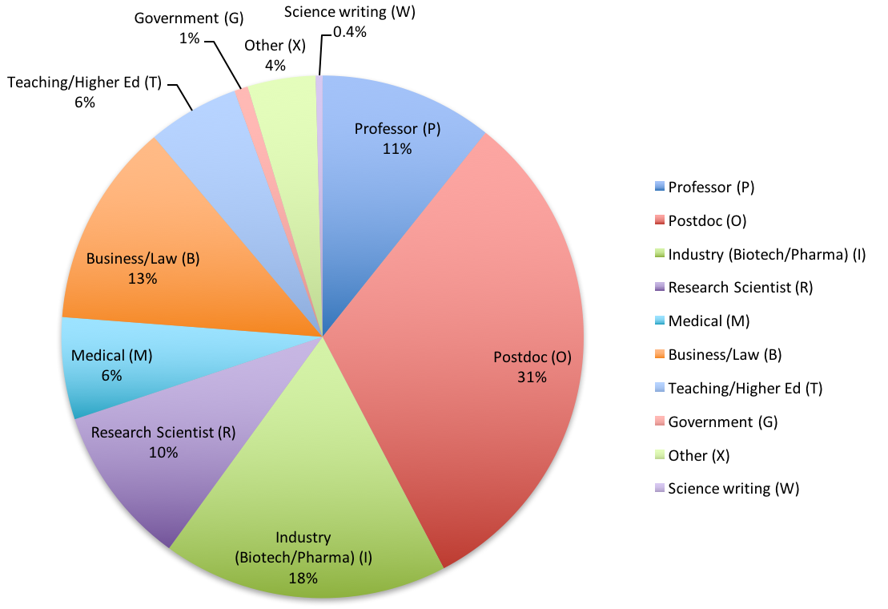

Figure: Career opportunities and resources
Source: (Taylor, 2016).

The organisation announces the different opportunities for the employees in working place. The employees can achieve this opportunities according to follow the rules and responsibilities in organisation. The promotion process of employees depends on their working performance. The supervisor monitored the working performance of employees in working places. If their performance is better from the previous performance then they promoted to the higher level of organization. If their working level is decreases then the supervisor suggests them to take proper training for working and improve the working skills (Gravells, 2010).

Perspective of an employer trying to recruit:

The organisation requires recruiting the employees for developing the business operation. There are different types of department in organization such as management, finance, accounting, marketing, operating etc. The employees need specific skills for particular post. The organization needs specific skills people for recruiting new employees. For example, ALDI Careers recruits a new retail assistant for developing the working performance in organization.
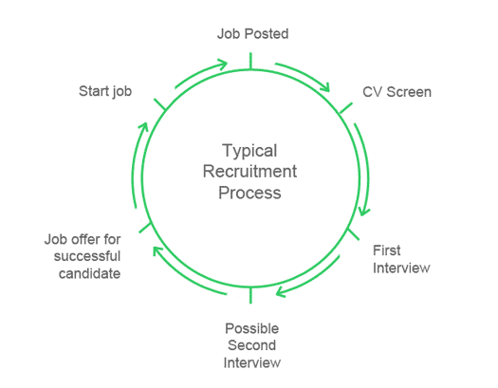

Figure: Recruiting process
Source: (Adams and Hershey, 2000).

ALDI Careers requires some responsibilities for retail assistant such as
- Maintain the outstanding store condition and visual merchandising standards
- Ensuring the high levels of customer satisfaction by excellence sales service\
- Helping to the Retail Manager
- Ascertain customer’s needs and demands
- Follows the rules and regulation in organization
- Keep up to date with product information
- Welcome and greet the customers
- Actively works with the working place and involve in the receiving process

As a retail assistant, the employees needs some skills for ALDI Careers such as good teamwork, Flexibility to do different tasks, ability to be friendly and polite, good communication skills, hard work, time management skills, problem solving skills etc.

Good teamwork: Team based work is very effective for the employees. This skill effects on the employees working development. The retail assistant improves his or her working performance by good teamwork skills (aldicareers, 2017).

Flexibility to do different tasks: The retail assistant needs the skills of the flexibility to do different tasks. Retail assistant plays different types tasks of in working place such as helping to the Retail Manager, ascertain customer’s needs and demands, follows the rules and regulation in organization etc (Hind and Moss, 2011).

Ability to be friendly and polite: The employees need to the ability to be friendly and polite as retail assistant. The retail assistant maintains the customer satisfaction. So, it is very essential to provide the friendly and polite attitude for retail assistant.

Good communication skills: Good communication skills help to communicate with the customer with employees. Communication sills make the relationship between customers and employees in working places (Hind and Moss, 2011).

Hard work: The retail assistant needs to hard work skills in working places. There are different types of work are performed by the retail assistant in the organization (aldicareers, 2017).

Time management skills: The retail assistant need to time management skills. Time management skill is very essential for preparing the task properly in working place. As a retail assistant needs to early morning starts (Whetten and Cameron, 2014).

Problem solving skills: The retail assistant needs to problem solving skills in work place. It is very effective for the employees in organization to find the problems and solve it with proper way. The retail assistant faces different types of problems in working place. So, retail assistant needs to the skills of problems solving (Whetten and Cameron, 2014).

Conclusion: Academic and employability skills are very important for the employees in different working places. Today’s business world is very competitive in getting new job for the employees. Different types of skills are very helpful for the employees to get the specific job. These skills help to the employees to build up a good future career and promoted higher level in organization.

Reference:
Adams, S. and Hershey, M. (2000). The recruiting process. Milwaukee: Peanut Butter Pub.
aldicareers (2017). ALDI Careers - Retail Assistant. [online] Aldicareers.com.au. Available at: https://www.aldicareers.com.au/Careers/In-Store/Retail-Assistant [Accessed 13 Dec. 2017].
Engmann, M., Rao, A. and Adamson, B., (2017). Principles of Successful Skills Development Models. In Bridging the Skills Gap (pp. 123-141). New York; Springer International Publishing.
Gravells, A. (2010). Delivering Employability Skills in the Lifelong Learning Sector. Exeter: Learning Matters Ltd.
Hind, D. and Moss, S. (2011). Employability skills. Sunderland: Business Education.
Scott, F.J., Connell, P., Thomson, L.A. and Willison, D., (2017). Empowering students by enhancing their employability skills. Journal of Further and Higher Education, pp.1-16.
Taylor, L., (2016). What is employability and what does it mean for you? How to Develop Your Healthcare Career: A Guide to Employability and Professional Development, pp.1-20.
Whetten, D. and Cameron, K., (2014). Developing Management Skills: Global Edition. London; Pearson Higher Ed.
White, L.M., (2016). An Applied International Equine Experience Benefits Employability Skills in Undergraduate Students 1. NACTA Journal, 60(1a), p.7.

