A critical perspective of ASDA in relation to its CRM, Ethics, Sustainability and Quality Policies and Operations

STUDENT NAME | Sadia Anjum
STUDENT NUMBER | 1708775
MODULE NUMBER | BMSW5003
MODULE TITLE | Understanding and Engaging in the Customer Experience
LECTURER | DR Vajira Balasuriya

Executive summery
This report is an investigation of how Asda deals with their customer experience and customer relationship management based on their ethical and sustainability policies. A comparison of Asda’s ethical stance with other competitive supermarkets, such as: Tesco, Sainsbury, Morrison, Aldi and Iceland is also included. Part of the report has attempted to critically discuss some quality models and theories, such as: Deming’s Quality Cycle, Juran’s Quality Trilogy and Cosby’s cost of quality and how they might assist Asda to improve their customer relationship management. The link between the concept of quality and measuring or improving their Customer Relationship Management has also been discussed here. This report has found that Asda is practising ethic and sustainability in their marketing operations but there is always room for improvement. Some recommendations has been suggested as a conclusion of the report to improve Asda’s Customer Relationship Management.

Table of contents

List of Tables 4
List of Figures 5
1. Introduction: 6
1.1 Asda history 7
2. Ethical and sustainable customer experience in relation to CRM: 8
2.1 Customer Relationship Management (CRM): 9
2.2 Customer Experience Management (CEM) 10
2.3 Ethics 11
2.3.1 Business ethics 11
2.3.2 Critiques on business ethics: 12
2.3.3 Examples of marketing ethics: 12
2.4 Sustainability 13
2.4.1 Marketing Sustainability 13
2.4.2 Critiques of sustainability 14
2.4.3 Examples of marketing sustainability 15
2.5 Some ethical and sustainability issues of ASDA 16
3. Quality models and their relevance to organisations 20
3.1Deming’s cycle 21
3.1.1 Plan 22
3.1.2 Do 22
3.1.3 Check 22
3.1.4 Act 22
3.2 Juran’s Quality Trilogy 24
4. Conclusion: 27
4.1 Ethics and sustainability conclusion 27
4.2 Ethics and sustainability suggestions and recommendations 27
4.3 Quality models conclusion 27
4.4 Quality models suggestions and recommendations 27
Reference list: 28

List of Tables
Table 1: comparison of popular supermarket on ethical and sustainable issues

List of Figures
- Figure 1: Food Waste scorecard in Supermarkets
- Figure 2: Deming’s Quality Cycle
- Figure 3: Juran’s Quality Triology

1. Introduction:
This report investigates how Asda deals with their customer experience and customer relationship management based on their ethical and sustainability policies and compare them with other competitive supermarkets. It also includes a critical discussion of some quality models and theories that may assist Asda to improve their customer relationship management. It also attempts to link the concept of quality and to measuring or improving their Customer Relationship Management. This report is concluded with some recommendations to improve Asda’s Customer Relationship Management.

Asda history
ASDA is one of the leading supermarkets in the UK. Asda stands for Associated Dairies. In 1949, chain butchers’ shops owner Asquith family and the Associated Dairies Company joined together in Yorkshire and founded Asda. It expanded into the south of England during the 1970s and 1980s and now according to a statistics in January 2017, there are a total of 631 stores all over the UK including 339 superstores (UK: number of Asda stores 2017-2019 | Statista, 2020). There are more than 145,000 Asda employees and more than 18 million customers who shop in Asda stores weekly (Our History, 2020). Asda sells everything from groceries, clothing, electronics and even fuel. They even provide online services; delivery to customers’ doorstep and click and collect.

2. Ethical and sustainable customer experience in relation to CRM:

The practice of ethics and sustainability is a vital issue in businesses and organisations. Any individual will appreciate and expect honest and fair treatment from another individual. However it is even more important for a business organisation to maintain those ethical values for its customers, employees and even the management to build a great relationship and reputation for itself in the market.
Business organisations must achieve sustainability through practicing their ethical values and having a clear, consistent mission and belief. Sustainability has become the core belief of a company these days. In recent years, considerable media coverage has kept the public agenda ongoing regarding ethical and sustainable factors. The public and consumers are now more alert and demanding of brands and retailers to produce and sell goods and products responsibly and ecologically. Another ethical issue British consumers are particularly concerned about is Animal welfare. A Mintel research shows that 74% of adults in the UK listed “cruelty free” or “against animal testing” as the principle significant factor of what makes a company ethical (UK Ethical Consumer Markets Report | Ethical Consumer, 2020). An ethical positioning has helped businesses to achieve their sales momentum. Businesses use Ethical factors as USP (Unique Selling Point) to create brands so that they can set themselves apart from others. However, now-a-days the expectations are growing for all businesses to apply ethic and sustainability. Supermarkets are also part of it. To improve customer relationship management supermarkets are investigating customer experience based on ethical and sustainable issues.

2.1 Customer Relationship Management (CRM):
Organisations apply Customer Relationship Management (CRM) as a policy that focuses on analysing the customer data for tactical and strategical purposes and aims to win and keep profitable customers (Ellis, 2011). It is known as an operational management, where Automation (the process of automating sales and customer service functions) becomes a key part of service delivery or sales force management (Buttle, 2004). In the simplest way, CRM can be defined as a technique that companies use to Find, Get and Keep their customers. The adoption of CRM systems can provide businesses with the necessary information that can give customers a reason to choose them rather than their competitors (Reynolds, 2002).
CRM is an acronym for……
- Continuous Relationship Marketing
- Customer Relationship Marketing
- Customer Relationship Management (Armstrong et al, 2017)
Customer Relationship Management (CRM) makes it easier for the companies to implement Customer Experience Management (CEM).

2.2 Customer Experience Management (CEM)
Customer Experience Management (CEM) concept is to focus on customers and not on marketing. It concentrates on processing rather than the outcome. The aim of CEM is to strategically manage customers’ experience with a specific product or a company. Customer experience data capture customers’ perspective about a particular company (Schmitt, 2003).
In other words, customer experience is a multidimensional construct which focuses on the customer’s cognitive, emotional, behavioural, sensorial, and social responses to the offerings of the business throughout the customer’s entire purchase journey (Lemon and Verhoef, 2016).
Customer experience depends a lot on individuals, their emotional state, the situation they are in and a variety of other factors (Palmer, 2010). The experience of a customer in a particular company in the context of a specific circumstances on a specific time affects value creation of that business (Prahalad and Ramaswamy, 2003).

2.3 Ethics
Ethics is a set of ideas and principles that enable us to differentiate between right and wrong and to determine what behaviour is beneficial or detrimental to others. According to bioethicist Larry Churchill, “Ethics, understood as the capacity to think critically about moral values and direct our actions in terms of such values, is a generic human capacity” (Churchill, 1999). Ethics is not to be confused with behaving only in accordance with social norms, religious practices and the law of the country. It’s a stand-alone concept which can be used to describe an individual’s unique belief system, habits or actions (Paul & Elder, 2006), (Tanguay, 2014).

2.3.1 Business ethics
Every business organisation has some values and goals to operate effectively and efficiently in the market and also not to harm any individual while doing so. An individual or a group who has interest or concern in a business or company are known as the stakeholder such as, investor, supplier, customer and employee. The stakeholders can either affect the business or most likely be affected or harmed by it. In order to build or maintain an efficient relationship between the business and its stakeholders it is vital that the applications of business ethics are administered most appropriately. It must exist in order to mitigate potential risks a stakeholder faces. The preconditions for setting up and maintaining ethical dealings between business and its stakeholders should be in accordance with both the business goal and the ethics mission, but at the same time not go against social norms and laws of the country. Without exploiting the power a business has over its stakeholders, both parties must continue to have freedom of choice. the power of the business or weakness of stakeholders must not be exploited.

2.3.2 Critiques on business ethics:
Business ethics is an important topic for both scholars and practitioners. It is often established in terms of professional codes of conduct i.e. comprehensive sets of rules or guidelines stating how an employee should behave in the workplace. Corporate ethics requires establishing and maintaining minimum standards of responsibility and behaviour that companies should follow or developing a system of accountability through which a company can exercise its ethical role.
Marketing ethics addresses principles and standards that describe suitable conduct in the marketplace. It refers to Marketers’ standards of conduct and moral values. According to
CIM (2016) marketing ethics is not about a definite goal or fixed set of principles, rather it’s an ongoing, ever-changing concept. Unethical marketing activities in an organization usually develop from the pressure to meet performance goals. One example of obvious ethical issues in marketing would be attempts to delude or take advantage of a situation.
Many companies create ethics programmes to train employees to act ethically.
Employees’ personal values sometimes conflict with employers’ ethical standards.

2.3.3 Examples of marketing ethics:
Ethics in Marketing Research:
- Research studies must be valid and reliable
- Customer confidentiality and privacy must be respected
- Sales should not be in disguise of research
- Online security and privacy should be protected

Ethics in Product and Package Strategy
- Packaging should be accurate to actual size
- All the information on products should be adequate
- Packaging should be environmentally friendly wherever possible
- No animal testing and product testing should clarify safety concerns

Ethics in Pricing
Some unethical and illegal practice of pricing
- Deceptive Pricing: Where businesses influence their customers to buy higher-priced goods.
- Unfair Pricing: When company lowers the price and when the competitors are driven away raises price back to their former level.
- Price Discrimination: if different buyers are charged different prices for the same product.
- Price fixing: If all the businesses in an industry agree to set the prices at an unfairly higher level.
(Lee et al, 2012)

2.4 Sustainability
Sustainability means to use resources to meet human needs in a way that the ability of future generations to meet their own needs will not be compromised, it includes natural, social and economic resources. Natural sustainability can be defined as meeting people’s requirement without compromising the health of the ecosystems (Callocot & Mumford, 1997). Environmental sustainability can refer to the ability to maintain things or qualities that are valued in the physical environment (Sutton, 2004).
Sustainability can be divided into three sections:
- Environment
- Economy
- Society

2.4.1 Marketing Sustainability
Sustainable marketing are the activities which aim to meet consumers’ needs and do not endanger possibilities for the future generation. Ethical marketing conduct ensures achievement of long term consumer and business welfare of sustainable marketing. Therefore, ethical marketing act like the cornerstone of sustainable marketing (Kotler, et al, 2017).

2.4.2 Critiques of sustainability
The second set is typified by McCann-Erickson’s (2007) definition that: Sustainability is a collective term for everything to do with responsibility for the world in which we live. It is an economic, social and environmental issue. It is about consuming differently and consuming efficiently. It also means sharing between the rich and the poor and protecting the global environment while not jeopardizing the needs of future generations. Sustainable marketing which has been defined by Charter et al. (2006) as “creating, producing and delivering sustainable solutions with higher net sustainable value whilst continuously satisfying customers and other stakeholders”.

2.4.3 Examples of marketing sustainability
Climate change
- One of operational hazard that impacts the environment is the usage of energy in lighting, heating and cooling stores
- Reduce landfill waste can help the environment
Waste
- Practice the 5 R's of Carbon footprint: refuse, reduce, reuse, rot, recycle
- Food donation can help to proceed towards Zero waste
Supply chain
- The practice of collaboration — such as reducing energy waste by ensuring that vehicles are loaded fully before they are sent out and the same vehicle makes deliveries in the same area
- Invest in alternative modes of transportation — companies can reduce the cost and the environmental impact of their deliveries by using variety modes of transportation depending on the size of the delivery such as use of canals, motorbikes, ships and airships.

2.5 Some ethical and sustainability issues of ASDA
Zero waste: Asda conducts a zero waste policy. Their aim is to reduce, reuse, recycle and redistribute as much as possible so that there is no waste to landfill. They have managed to divert 100% of their waste from landfill. 86% of their operational waste is distributed among charities, recycled or sent for anaerobic digestion. Their broken or unwanted equipment and trolleys are either repaired or used for parts. All their cardboard and plastic is recycled, they even recycle the cooking oil used in their restaurants to make biofuels. They donate surplus food as well as other surplus products such as: clothing, cleaning and other household goods (Asda.com - Online Food Shopping, George, & more, 2020) (Asda releases food waste data, 2020).
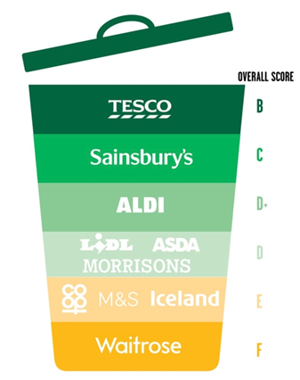(Source: resource.co)
Figure 1: Food Waste Scorecard in Supermarkets

Energy: Asda teams work hard to reduce impact of lighting, heating and cooling their stores have on the environment. Since 2005, their estate has increased 200% but they have managed to keep the usage of the amount of electricity almost the same (Babbs, 2020).
Carbon footprint: In simple words, carbon footprint defines the amount of carbon dioxide being released in the atmosphere as a result of the activities of the company. For any businesses, one of the greatest opportunities to find efficiencies lies in their supply chain. The Asda team works closely with their suppliers to reduce carbon footprint on earth and recently they have organised their biggest ever Sustainability Conference where over 900 suppliers and Asda colleagues gathered together to share ideas and solutions regarding how to tackle climate change and reduce food waste (Asda’s carbon footprint, 2018).
Healthier choices for customers: Asda claims to be passionate about clear labelling and they have started to put traffic light labelling in 2007 on their Own Brand product packaging to help customers understand the nutritional values of everything that they choose. Even their online shopping enables the customers to filter products by their dietary needs, including ‘Free From’, low fat, sugar and salt or contain a higher source of fibre.
Fair trade: Fair trade will make a significant positive impact in the world. It is about trading and paying fairly between companies in the developed countries who sell products and goods to customers or final consumers and producers or farmers in the developing countries who produce or make the goods. Fair trade includes better pricing, providing decent working conditions and local sustainability. According to an Asda spokesperson, sales of some branded Fairtrade lines such as Clipper tea, Divine chocolate and Fruit Passion orange juice have risen by 47% over the last year, while their own-label Fairtrade bananas have risen by 112%.

Fair pay: Fair pay also signifies fair trade where the producers, farmers or workers should be paid fairly. Most of the time workers from a developing country are at disadvantage where they are paid much less than a labour in a developed country. In recent years, Tesco, Aldi and Asda have come under fire for exploiting workers in Bangladesh to produce cheap clothing and not paying fair pay (Hickman, 2006).
An investigation by the Sunday Mail alleged that all three supermarkets paid low wages to workers in Bangladeshi factories, leaving them unable to support their families. The investigation found that Aldi has paid “poverty wages” of 25p an hour for producing Aldi polo shirts which resulted in many women unable to send their own children to school (garments worker, 2011).
Similarly it was found in the Sunday investigation that Babylon Complex, which produces school shirts for Asda’s clothing range George, paid some of its workers under 26p an hour.
“Asda cares about the welfare of the people who work to produce the products we sell. We expect our suppliers to treat their workers with respect and dignity, and we take allegations regarding mistreatment of workers seriously,” said an Asda spokeswoman (Chamberlain, 2015).
Gender equality: Asda welcomes individuals from any background to work for them as they believe that an inclusive workplace, where colleagues can flourish regardless of their gender or race, is the best way possible to be a successful business in the market and to serve their customers satisfactorily.
Working condition: Employee involvement is a big part of Asda Stores’ operational philosophy – and that can include a visit to the Dragons’ Den, says Tom Washington. There aren’t many jobs where making suggestions to your boss results in you pitching your idea to the formidable Dragons’ Den star Peter Jones (Washington, 2010).
At supermarket chain Asda Stores, they respect their employees’ opinion and ideas and those are highly valued. They believe that appreciating and encouraging the employees to come forward and share their opinion and giving them a freedom of conduct is the best way to have a healthy working condition.

Table 1: comparison of popular supermarket on ethical and sustainable issues

Issues | Asda | Waitrose | Tesco | Sainsbury | Morrison | Cooperative
Food waste prevention | 4th | 6th | 1st | 2nd | 4th | 5th
Fair trade banana | 10% | 100% | 10% | 100% |  | 100%
Unfair pay/ child labour | Yes |  | Yes | yes
Air pollution by transport | Minimised |  | Minimised
Animal welfare | 4th | 1st | 2nd | 2nd | 2nd | 2nd
Sustainable seafood | 38% | 67% | 48% | 76% | 4% | 61%
(Dickinson, 2018),
(Clayton, 2010),
(Garments worker, 2011),
(Change. org, n.d.)

3. Quality models and their relevance to organisations
There are several quality models and theories developed by scholars which often businesses adopt to enable employees to focus on quality rather than quantity and strive hard to excel in whatever they do. This part of the report critically investigates a few of these quality models and theories and discusses how they might assist an organisation to improve its customer relationship management.
Some of them are:
- Deming’s Cycle
- Juran’s Quality Trilogy
- Crosby’s cost of Quality
- Kaoru Ishikawa’s Control Quality Circle
- Kaizen

3.1Deming’s cycle
The Plan-Do-Check-Act (PDCA) is a cycle created for continual process improvement (CPI). It teaches organisations to outline their objectives and actions, that’s the planning phase. Then, they need to do the actions to implement the process improvements. Next, they need to check quality to ensure improvement against the original. Finally take actions based on the result from stage “check” to determine if the changes were successful and where changes need to occur for continued improvement before returning to the plan phase.
The PDCA cycle is known as the Shewhart Cycle and as the Deming’s Cycle. In 1939, Walter A. Shewhar mentioned this theory first in his book, Statistical Methods from the Viewpoint of Quality Control. According to Shewhart, the structure of the cycle is drawn from the concept that the key to the evolution of a successful enterprise is to constantly evaluate the management practises and to be willing to adapt and to discard unsupported ideas. W. Edward Deming was the first person to make this a popular concept and he changed the name from Shewhart’s Cycle to PDCA Cycle. He also referred the PDCA Cycle for the PDSA Cycle, where the S stands for study (Johnson, 2002).

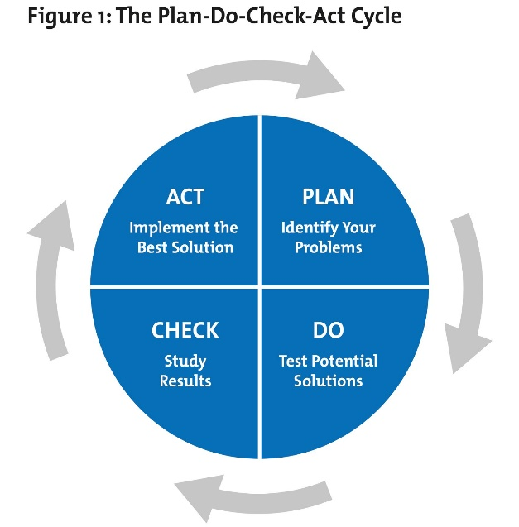(Source: Shimula.com)
Figure 2: Deming’s Quality Cycle

3.1.1 Plan
There are two parts of this stage, identifying the problem and determining the expected result. After the problem is identified, the expectations need to be established. Then it can be decided if the implementation of PDCA in the short and long term. It is important that expectations are established clearly and in a way that concrete steps can be taken towards realizing each one, instead of aiming for vague, abstractly defined goals.
The planning phase must also take any previous PDCA iterations into account, ensuring that the same mistakes are not repeated as last time. This makes it important to have proper data collection systems in place, although it depends on the specific organizations and how they do it.

3.1.2 Do
The next stage is to develop a solution, a plan of action to solve the problem. This step is relatively straightforward as long as the plans are designed with attention to detail and with enough flexibility to account for possible last-minute changes if requires. When the plan of action is decided then organisations should follow it through, step by step.

3.1.3 Check
Evaluate the result and see if the desired goal was achieved. It is crucial that the results of the PDCA cycle are verified according to the initial expectations outlined in the plan, as well as old data gathered from previous cycles if appropriate. You can also verify your findings against third-party data sets, if you have access to those, although this is a highly individual factor and depends on the industry you are working in. But if you have access to additional data sets that can help you make a more informed decision, it is definitely something you should use in the Check phase.
Make sure to get as much input as possible from all levels of the company at this stage, not just from high-level executives or people from those circles. All employees will likely have some valuable input to provide about the current iteration of the PDCA cycle, and ignoring the additional information you can obtain in this manner is one of the fastest ways to kill progress in your company completely.

3.1.4 Act
Standardise the solution. Now that you have gone through the first three steps of the PDCA cycle and you have collected some data about the way it was realized, it is time to make appropriate changes to the whole organization in preparation for the next PDCA run. This is why it is so important to collect as much data as possible during the Do phase, and to put it through a thorough enough analysis in the Check phase. Failing to do either of those will leave you in a situation where you have far too little information to make an informed decision in the Act phase, and that can make the whole PDCA process unnecessary.
Keep in mind that some of the actions you take here may need to be reverted later on, depending on how they impact the whole organization. Just because a certain change in the company structure makes sense on a local level when running the current project, this does not mean that you will get good results across the board from implementing it.

3.2 Juran’s Quality Trilogy
While on the other hand Juran's model just takes the "fitness for use" as the basic criteria of the quality improvement and the individual units should perform in such a way in accordance with the specification and the direction so as to achieve that fitness for the use. The Joran's model accepts the majority of the quality management problems are due to the poor management rather than the poor work of its lower or middle level management. Juran's model provides an analytical approach to manage for the quality and focuses on how to handle the quality functions on the basis of that. The production process is defined as a relationship between the customer research, suppliers, design, materials, production, assembly, and the inspection according to the Joran's model. The Juran's model is more practical minded suggesting the highly practical and the feasible answers. Juran made the focus on the product improvement and the conformances in the service by reducing the uncertainty and the manufacturing process variations.
Juran believed there were ten steps to quality improvement. These steps are:
- An awareness of the opportunities and needs for improvement must be created
- Improvement goals must be determined
- Organization is required for reaching the goals
- Training needs to be provided
- Initialize projects
- Monitor progress
- Recognize performance
- Report on results
- Track achievement of improvements
- Repeat

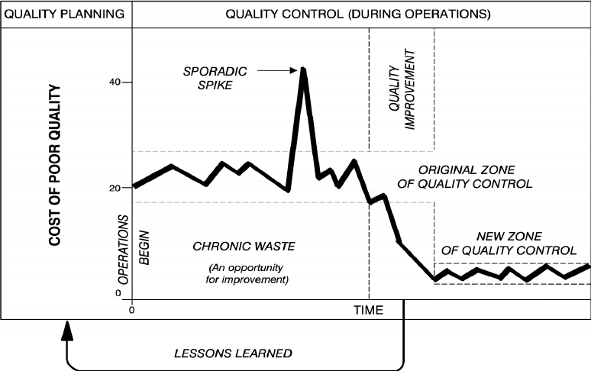

Figure 3: Juran’s Quality Triology

4. Conclusion:
The findings of this report is as bellow, some recommendations and suggestions are included in this conclusion.

4.1 Ethics and sustainability conclusion
After investigating the ethics and sustainability policies of Asda and how they influence their customer experience it is certain that Asda is working towards taking a strong ethical and sustainable stand in the industry. They value their customer experience and constantly working hard to improve their CRM.

4.2 Ethics and sustainability suggestions and recommendations

4.3 Quality models conclusion

4.4 Quality models suggestions and recommendations

Reference list:

- Asda’s carbon footprint 2018. [online] Available at: <http://s7d2.scene7.com/is/content/asdagroceries/Asda.com/7.%20Sites/Environment/8102_ASDAs_Carbon_Footprint_2018.pdf> [Accessed 13 March 2020].
- Asda.com. 2020. Asda.Com - Online Food Shopping, George, & More. [online] Available at: <https://www.asda.com/creating-change-for-better/better-planet/operations> [Accessed 13 March 2020].
- Babbs, L., 2020. Asda's Commitments To Tackle Climate Change. [online] Corporate - ASDA. Available at: <https://corporate.asda.com/blog/2020/01/31/asdas-commitments-to-tackle-climate-change> [Accessed 13 March 2020].
- Callicott, J.B. and Mumford, K. (1997), “Ecological sustainability as a conservation concept”, Conservation Biology, Vol. 11 No. 1, pp. 32-40.
- Chamberlain, G. (2015). Tesco and Sainsbury school uniforms made by workers paid 25p an hour. [online] mirror. Available at: https://www.mirror.co.uk/news/uk-news/tesco-sainsbury-school-uniforms-made-6432539 [Accessed 13 Mar. 2020].
- Change.org. (n.d.). Sign the Petition. [online] Available at: https://www.change.org/p/asda-and-tesco-protect-the-poorest-farmers-and-workers-from-the-uk-s-banana-price-wars-by-going-fairtrade-gofairtrade [Accessed 13 Mar. 2020].
- Churchill, Larry (1999). "Are We Professionals? A Critical Look at the Social Role of Bioethicists". Daedalus. pp. 253–274.
- Corporate - ASDA. 2020. Asda Releases Food Waste Data. [online] Available at: <https://corporate.asda.com/newsroom/2019/09/25/asda-releases-food-waste-data> [Accessed 13 March 2020].
- Corporate - ASDA. 2020. Our History. [online] Available at: <https://corporate.asda.com/our-story/our-history> [Accessed 11 March 2020].
- David, Tanguay (2014). "Buddha and Socrates share Common ground". Soul of Wit. Archived from the original on July 22, 2014. Retrieved July 22, 2014.
- Ducker, P., 1981. What is Business Ethics?. The Public Interest, 63(18).
- Ethical Consumer. 2020. UK Ethical Consumer Markets Report | Ethical Consumer. [online] Available at: <https://www.ethicalconsumer.org/research-hub/uk-ethical-consumer-markets-report> [Accessed 12 March 2020].
- Garments worker. (2011). [online] Available at: https://www.actionaid.org.uk/sites/default/files/doc_lib/the_real_asda_price.pdf [Accessed 13 Mar. 2020].
- Hickman, M. (2006). The real price of cheap clothes: Bangladeshi sweatshop labourers paid. [online] Available at: https://www.independent.co.uk/news/uk/this-britain/the-real-price-of-cheap-clothes-bangladeshi-sweatshop-labourers-paid-just-3p-an-hour-427589.html [Accessed 13 Mar. 2020].
- Johnson, C.N. (2002). The benefits of PDCA. Quality Process, 35(5), p.120
- McCann-Erickson (2007), “Can sustainability sell?”, available at: www.unep.fr/pc/sustain/ reports/advertising/can-sustainability-Sell%20.pdf
- Palmer, A., 2010. Customer experience management: a critical review of an emerging idea. Journal of Services Marketing, 24(3), pp.196-208.
- Paul, Richard; Elder, Linda (2006). The Miniature Guide to Understanding the Foundations of Ethical Reasoning. United States: Foundation for Critical Thinking Free Press. p. NP. ISBN 978-0-944583-17-3.
- Prahalad, C.K. and Ramaswamy, V. (2003), “The new frontier of experience innovation”, MIT Sloan Management Review, Vol. 44 No. 4, pp. 12-19.
- Reynolds, J., 2002. A Practical Guide To CRM. 1st ed. New York: CRC Press, pp.1-2.
- Schmitt, B., 2003. Customer Experience Management. New Jersey: John Wiley & Sons, Inc., pp 20-21
- Shmula. (2018). How Should an Organization Apply the PDCA Cycle? |. [online] Available at: https://www.shmula.com/how-should-an-organization-apply-the-pdca-cycle/24984/ [Accessed 13 Mar. 2020].
- Statista. 2020. UK: Number Of Asda Stores 2017-2019 | Statista. [online] Available at: <https://www.statista.com/statistics/300543/asda-number-of-stores-in-the-united-kingdom-uk/> [Accessed 11 March 2020].
- Sutton, P. (2004), “A perspective on environmental sustainability”, available at: www.ces.vic.gov. au/ces/wcmn301.nsf/obj/cesplan/$file/A þ Perspective þ on þ environmental þ sustainability.pdf
- Washington, T., 2020. Employer Profile: Asda - Employee Benefits. [online] Employee Benefits. Available at: <https://employeebenefits.co.uk/issues/november-2009/employer-profile-asda/> [Accessed 13 March 2020].
- "What is sustainability". www.globalfootprints.org. Retrieved 2 May 2018.
- Wright, N. S. and Bennett, H. (2011) “Business ethics, CSR, sustainability and the MBA,” Journal of Management & Organization. Cambridge University Press, 17(5), pp. 641–655. doi: 10.1017/S1833367200001309.

