
I confirm that I have not presented any AI generated materials as my own work.
I confirm that I have copies of my drafts, notes, and other resources I used, which I may be asked to
provide in evidence.

Internal verifier: Arpu Kumar
Independent Project BMSW6009
Name: Rasa Vilimaite
Student number: 2020471
Lecturer: Scott James

Table of Contents
1. Introduction 2
1.1. Background 3
2. Literature review 5
3. Methodology 8
3.2 Research Philosophy 8
3.3 Research Method 9
3.3.1 Methodological Design 9
3.3.2 Instrumentation and Data Collection 9
3.4 Ethical Considerations 9
3.5 Reflection on the Method 9
3.5.1 Justification 9
3.5.2 Limitations 10
3.8 Conclusion 10
4. Results 11
4.1 Respondent Demographics 11
4.2 Pre-Pandemic Digitisation 12
4.3 Acceleration of Technology Adoption During COVID-19 13
4.4 Operational Improvements Post-Pandemic 16
4.5 Digital Engagement and Marketing Strategies 18
4.6 Long-Term Perceptions and Adaptability 19
4.5 Digitisation Outcomes 21
5. Discussion 22
5.1 Digital Transformation as a Result of COVID-19 22
5.2 The Effect of Technology on Efficiency and Customer Satisfaction 25
6. Conclusion 27
7. References 29

How has the COVID-19 pandemic reshaped the role of technology in enhancing customer engagement and streamlining corporate operations within retail businesses?

Introduction
The purpose of this dissertation is to investigate how the retail industry reacted and adapted its use of technology during and after the COVID-19 pandemic, as well as the effect that this use of technology has had in improving efficiency and finding new ways to engage with customers without relying on traditional, in-person interaction. It will argue that COVID-19 accelerated the growth of digitisation within the retail industry and that the effects of digitisation have significantly increased operational efficiency, becoming essential for competitiveness in the post-pandemic landscape.
To explore these developments, primary research will be conducted. This dissertation will adopt a questionnaire-based methodology to gather data from individuals working within the retail industry, including both frontline employees and those in corporate or managerial roles. The aim is to assess the extent to which technology was used before, during, and after the pandemic, and to evaluate the impact of this usage in terms of customer engagement, satisfaction, and the streamlining of internal operations.
While the primary methodology is quantitative, the importance of recognising the value of qualitative insights cannot be overlooked. As Cohen, Manion, and Morrison (2017) point out, the integration of both quantitative and qualitative approaches can enrich the research process, especially in complex social environments such as retail, where behaviours, beliefs, and perceptions are pivotal. Though structured questionnaires often aim to produce quantifiable data, they can also include open-ended elements that yield qualitative responses, allowing participants to articulate their experiences in their own words.
In this context, qualitative data plays a crucial role in deepening the understanding of how individuals perceive and respond to technological change. Gibbs (2018) argues that qualitative analysis enables researchers to explore meanings, motivations, and interpretations, offering insight into the ways people make sense of transformation within their work environments. Such perspectives are especially valuable in examining the human impact of rapid digitisation, which cannot be fully understood through numerical data alone.
Aubrey and Riley (2017) further support this view by emphasising the relevance of theoretical and contextual understanding when examining behavioural change in response to challenging situations, such as those brought on by the pandemic. They argue that effective analysis must go beyond surface-level observations to consider the underlying factors that drive individual and organisational adaptation.
Therefore, while this dissertation is primarily grounded in quantitative data collection, it also acknowledges the interpretive value of qualitative data as part of a broader mixed-methods perspective. Open-ended responses within the questionnaire will be analysed thematically to capture the subjective dimensions of digital transformation, supporting a more nuanced and holistic account of the changes experienced within the retail sector during this period.

1.1. Background
The COVID-19 pandemic disrupted the global retail landscape, prompting an accelerated shift toward digital technologies as retailers faced new challenges, such as restrictive government lockdowns that brought in-store traffic to a standstill. What had previously been a gradual shift toward digitisation became a rapid transformation. Retailers embraced technological innovations to maintain business continuity, engage with customers in new ways, and optimize internal operations (Calvino, Criscuolo & Ughi, 2024; Andruetto et al., 2021).
Prior to the pandemic, the retail sector had already begun to adopt technology, albeit at a gradual pace. Many companies have established e-commerce platforms and inventory tracking solutions. However, the overarching strategy for many businesses still revolved around physical in-store experiences. Digitisation was seen as supplemental rather than a core component of retail operations. This changed dramatically as the pandemic unfolded. With physical storefronts forced to close for extended periods, businesses faced immediate pressure to find alternative ways to serve their customers. This marked a turning point where digital channels took centre stage. Retailers had no choice but to invest in technologies such as remote work platforms and increase their investments in technologies such as e-commerce platforms. This shift not only enabled companies to survive but also improved their efficiency of operation post-pandemic, making adequate digitisation essential to remain competitive.
Contactless transactions, once considered a convenience, quickly became a necessity. Digital wallets and contactless payment systems such as Apple Pay, Google Pay, and QR code-based solutions saw a rapid uptick in usage. In-store environments were modified to reduce physical contact, and many retailers introduced curbside pickup and “buy online, pick up in store” services, highlighting the new importance of safe, socially distant transactions.
E-commerce platforms experienced explosive growth during the pandemic. Retailers who had previously treated online sales as secondary suddenly found themselves dependent on these platforms to stay afloat. Businesses with pre-existing partnerships with platforms like Amazon, Shopify, and Alibaba saw an influx of third-party sellers, indicating a broader ecosystem shift (UNCTAD, 2021; WARC/Ascential, 2022)..
The supply chain, a backbone of retail operations, also underwent a significant overhaul. Traditional supply chain models, often rigid and linear, struggled to adapt to the unpredictability caused by COVID-19. Delays and shortages exposed critical vulnerabilities. To address these issues, many retailers turned to new inventory management or data analysis software in order to respond to disruptions in real-time. Automation in warehouses and distribution centres also increased through the use of robots, reducing reliance on manual labour and ensuring business continuity amid workforce shortages.
From a strategic perspective, the ability to pivot quickly, adopt new business models, and meet customers where they are has become the new benchmark for resilience and competitiveness. Retailers that had already laid the groundwork for digital transformation found themselves at a distinct advantage, while those reliant on more traditional strategies or those without the resources to quickly catch up (McKinsey, 2022; Preprints.org, 2024).

2. Literature review
Before the pandemic, the retail industry displayed varied levels of digitisation. While online sales channels had been growing, brick-and-mortar stores remained central to the retail experience (Pantano et al., 2020). Technologies such as point-of-sale systems, inventory tracking, and basic e-commerce platforms were widespread, yet the integration of advanced technology was often limited to larger or more innovative retailers. McKinsey & Company (2022) observed that e-commerce capabilities were frequently developed as separate, poorly integrated systems alongside legacy store and supply chain architectures.
Carvalho et al. (2020) observed that while social media marketing was becoming mainstream, few retailers had sophisticated strategies for multi-channel engagement. Similarly, Madamidola et al. (2024) noted the adoption of inventory management systems based on barcode scanning and RFID technologies; however, many small and mid-sized retailers still rely on manual processes. This technological lag left many retailers ill-prepared for the sudden disruptions brought by COVID-19. (Robertson et al., 2023)
The onset of the pandemic forced a sudden shift in consumer behaviour and operational capabilities. Government-mandated lockdowns led to the closure of physical stores, causing a sharp decline in revenue. The luxury sector in particular saw a projected 30–40% drop in sales (Editorial Team, 2023). Several well-established brands, including Debenhams and Topshop, entered administration due to their over-reliance on physical storefronts and delayed adoption of digital strategies (Dornbrack, 2024).
Toole et al. (2020) reported that COVID-19 accelerated the digitisation of customer and supply-chain interactions by three to four years. Organisations that had previously approached digital transformation cautiously were now compelled to implement changes rapidly. Shankar et al. (2021) emphasise that the crisis marked a tipping point, with digital transformation no longer being a strategic option but a survival necessity.
The deployment of technology such as Zoom, Microsoft Teams, and Slack facilitated remote collaboration among corporate teams (McKinsey, 2021). Meanwhile, in-store retail staff, who could not work remotely, faced reduced hours or job loss (Mutebi & Hobbs, 2022). Remote work, previously uncommon in retail outside of corporate roles, became a widespread necessity. Data from Mutebi and Hobbs (2022) shows that while only 12% of UK workers worked from home at least once a week in 2019, this figure rose to 22% by September 2022. Hybrid work, combining in-office and remote models, became the default in many corporate retail settings.
Retailers began investing in cloud-based platforms to support remote work, including enterprise resource planning (ERP) systems (Pezzini, 2022), cloud POS systems (Grand View Research, 2023), and collaboration tools. These platforms enabled functions such as HR, payroll, and customer service to continue with minimal disruption (Soolis, 2021). According to OECD (2019), small and medium-sized enterprises (SMEs) were slow to adopt cloud technologies due to perceived complexity and cost. However, the pandemic forced even the most hesitant organisations to migrate essential functions online.
However, the shift to remote access introduced new challenges. Cybersecurity became a critical concern, particularly as sensitive customer and financial data were accessed from home networks. According to KPMG (2021), many organisations had to overhaul their security policies, introducing multi-factor authentication and stricter access controls.
The inability to engage customers in person prompted a rapid shift toward digital engagement strategies. Retailers increased their use of social media, personalised email marketing, and mobile applications to maintain consumer relationships (Mason et al., 2021). Luxury brands, in particular, faced challenges adapting their high-touch customer experience to digital formats (Hoang et al., 2023).
Carvalho et al. (2020) and Jiang & Stylos (2021) argue that the pandemic accelerated the redefinition of customer engagement from physical presence to interactive digital touchpoints. Features such as AI chatbots, virtual try-ons, and augmented reality experiences gained traction, particularly in fashion retail. These tools provided consumers with a semblance of an in-store experience, helping sustain engagement during lockdowns.
Retailers also leveraged data analytics to personalise offerings and anticipate consumer demand. Gilmore (2019) highlights that businesses using robust data synthesis techniques were better equipped to respond to shifting customer preferences and stock availability challenges.
The crisis catalysed the adoption of automation technologies in areas such as logistics, customer service, and supply chain management. AI-driven tools like chatbots reduced the need for human customer service agents and handled increased online inquiries during peak periods (Soolis, 2021).
Grewal et al. (2021) and Verhoef et al. (2021) discuss the growing role of robotics in retail, including autonomous delivery systems and warehouse automation. Although such technologies existed before the pandemic, they saw broader implementation post-2020. Delivery drones and in-store robots addressed safety concerns by reducing human interaction, especially during the height of the health crisis.
Although they had been in use longer than other technologies before the COVID-19 pandemic, inventory management also benefited from increased automation. (Lam et al., 2022) Real-time tracking systems using IoT and RFID technologies helped mitigate supply disruptions by offering precise data on stock levels (Madamidola et al., 2024). These systems also allowed retailers to respond quickly to fluctuating demand patterns caused by panic buying or unexpected product shortages.
Global supply chains faced massive disruption during COVID-19 due to travel restrictions, factory shutdowns, and labour shortages. Retailers were forced to adapt by sourcing locally, diversifying suppliers, or integrating vertically (Chopra, 2019). Deloitte (2022) outlines several case studies of retailers that redesigned their supply chains using digital twins and predictive analytics to improve resilience.
The digitisation of supply chains allowed for greater visibility, enabling faster decision-making during periods of volatility. Technologies like blockchain and AI-powered forecasting tools began to see increased interest, although widespread adoption remains nascent (Fernie & Sparks, 2019; Shankar et al., 2021).
The operational changes triggered by COVID-19 required a strategic reorientation for many retailers. O’Toole et al. (2020) observe that many businesses undertook in months what would have taken years under normal conditions.
Richelieu (2021) notes that businesses had to pivot not only technologically but also culturally, adopting flatter organisational structures, fostering cross-functional collaboration, and investing in employee digital skills. These changes are likely to have long-lasting effects on how retail businesses are structured and managed.
As restrictions eased, a hybrid model of operations emerged, combining digital and physical elements. While e-commerce has maintained its elevated share of overall retail sales (IMD, 2020), there is also renewed interest in experiential retail, using digital elements to create a unique experience. (Deloitte Digital, 2024) Luxury and lifestyle brands have embraced immersive technologies to enhance this demand: for example, Valentino Beauty’s use of smart mirrors and Shiseido’s VR pods in physical spaces have increased engagement and sales (McDowell, 2024), while LEGO and Nike stores now include AR-driven interactive features and personalized digital storytelling within their physical locations (Ecommerce Age, 2023).

3. Methodology
This chapter outlines the methodology employed to explore the research question: How has the COVID-19 pandemic reshaped the role of technology in enhancing customer engagement and streamlining corporate operations within retail businesses? This study aims to assess the extent to which digitisation and the development of technology have influenced retail practices in response to pandemic-induced disruptions. To achieve this, the chapter adopts the layered structure of Saunders et al.’s (2019) Research Onion, which provides a comprehensive framework for understanding and justifying methodological choices. This chapter explains the philosophical stance underpinning the research, details the primary research methods used, discusses ethical considerations, and reflects on the chosen approach's strengths and limitations.

3.2 Research Philosophy
The research is grounded in a positivist philosophical perspective. Positivism assumes that reality is objective and can be measured through observable phenomena. This aligns with the study's aim of identifying patterns in technology adoption in retail during and after the COVID-19 pandemic. A positivist approach supports the use of quantitative methods, as it prioritises numerical data and empirical validation over subjective interpretation. The rationale for this stance lies in the need to identify measurable trends across a wide population of retail professionals. Rather than focusing on individual experiences or narratives, this research aims to detect more general patterns and relationships. This choice ensures that findings are derived from evidence that is replicable and statistically valid, in keeping with the requirements of academic research (Saunders et al., 2019).

3.3 Research Method

3.3.1 Methodological Design
The study employs a quantitative research method, utilising a closed-ended questionnaire as the primary data collection tool. This approach enables the collection of standardised responses from a large group of retail professionals, which facilitates statistical analysis. While qualitative methods could provide deeper insights into individual experiences, the quantitative approach was deemed more appropriate given the research's focus on breadth.

3.3.2 Instrumentation and Data Collection
The primary data for this study were collected through a Google Forms questionnaire. This questionnaire was designed to be completed in under 10 minutes to minimise participant fatigue and increase response rates (Galesic and Bosnjak, 2009). Questions included multiple-choice options to capture attitudes toward technological changes, frequency of tool usage, and perceptions of impact on customer experience and internal operations. The questionnaire was distributed online. This was decided upon to maximise reach among professionals in various roles within the retail industry. By using digital platforms, the study could target respondents familiar with technological tools and active in digitally enabled environments.

3.4 Ethical Considerations
The questionnaire was developed to ensure it was non-invasive, avoiding any questions related to personal identity, income, gender, or ethnicity. Participants were informed about the study's aims, data handling procedures, and the voluntary nature of their participation. Informed consent was obtained implicitly, as participants were advised that completing the questionnaire would constitute agreement to participate. Furthermore, the short duration of the questionnaire respected the participants’ time.

3.5 Reflection on the Method

3.5.1 Justification
The decision to use a quantitative approach is justified by the nature of the research question, which seeks to identify industry-wide patterns and correlations in technology use and customer engagement during a major global event. Quantitative methods are well-suited to testing hypotheses and identifying trends across a wide population. This method allows for generalisability and objectivity, enabling researchers to draw reliable conclusions that are less likely to be influenced by personal bias. In the context of a positivist philosophy, structured questionnaires offer a practical and efficient means of gathering data that can be analysed to answer the research question. (Saunders et al., 2019)

3.5.2 Limitations
Despite its strengths, the research design does involve certain limitations. One notable limitation is the lack of qualitative data, which might have provided valuable insights into personal experiences of technological change, particularly in areas such as the impact that increased use of technology has had. While the use of closed-ended questions simplifies analysis, it may also restrict respondents’ ability to express nuanced views. For example, some participants may feel that none of the available answer options fully reflect their experiences or opinions. Including at least one open-ended question might have addressed this limitation; however, it would have increased the amount of time that participants would have had to spend on the questionnaire, and as mentioned earlier in this chapter, this negates some of the positive
Additionally, the sampling method introduces potential bias, as more of the participants are likely to be employees, since there are more employees available online. Finally, the cross-sectional nature of the study captures only a snapshot in time. It does not account for the evolving nature of retail technology post-pandemic, nor does it allow for longitudinal comparisons that might reveal more about whether trends were long-lasting.

3.8 Conclusion
In conclusion, guided by a positivist philosophy and structured according to the Research Onion framework, the study adopted a quantitative methodology using a closed-question online questionnaire. Ethical principles were adhered to throughout, and the chosen methods are appropriate for uncovering generalisable patterns in technology adoption within the retail sector during the COVID-19 pandemic. While limitations such as the exclusion of qualitative data and potential sampling bias have been acknowledged, the methodology remains appropriate for achieving the study’s objectives. The findings derived from this approach will be presented and analysed in the subsequent chapters.

4. Results
This chapter presents the primary data collected from a survey of 42 respondents working within the UK retail sector. This research aimed to investigate how the COVID-19 pandemic influenced digitisation across retail businesses, with a specific focus on the adoption of new technologies, operational efficiency, and customer engagement strategies.
The findings are organised thematically to reflect key areas of investigation: pre-pandemic digitisation, the acceleration of technology adoption during the pandemic, improvements in operational efficiency, types of technologies implemented, evolving customer engagement methods, and the long-term impact of these changes. The quantitative insights drawn from closed-ended survey questions are laid out following these themes.

4.1 Respondent Demographics
Figure 1 shows that the majority of respondents (66.7%) identified as store employees, indicating that most of the feedback comes from frontline staff who are directly involved in day-to-day operations. Managers accounted for 19% of responses, offering a perspective on team leadership and store oversight. IT/Tech staff made up 11.9%, suggesting a modest representation of those involved in the technical infrastructure of retail operations. Executives were the least represented, with only around 2.4% of respondents, highlighting a limited input from those in strategic decision-making roles. Overall, the data leans heavily toward operational viewpoints, with fewer insights from the leadership responsible for making the decisions to integrate more tech into the retail industry.
Figure 1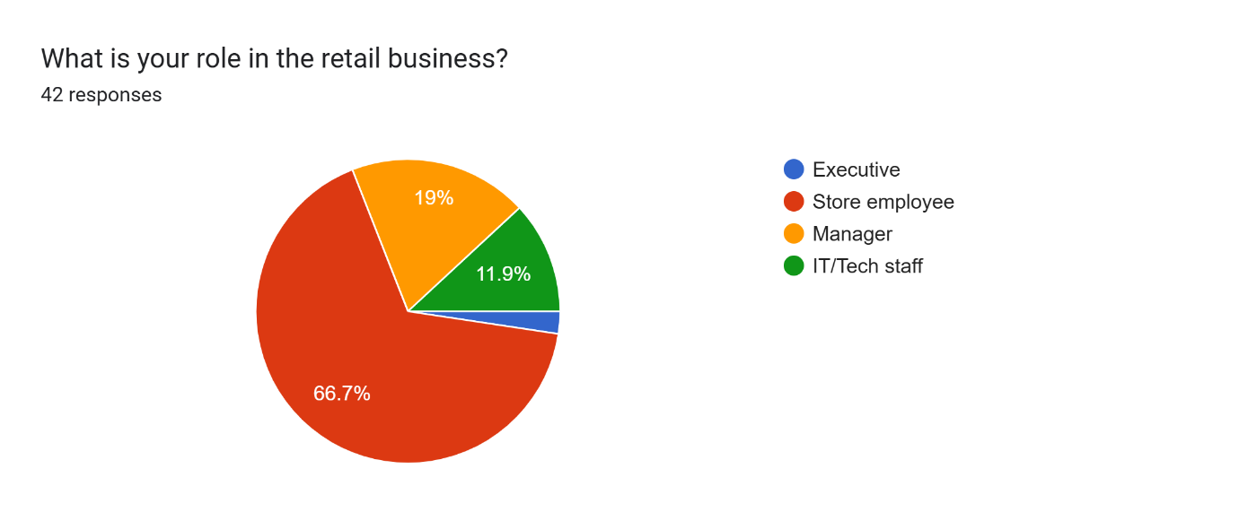

4.2 Pre-Pandemic Digitisation
Figure 2 illustrates the level of digital integration pre-pandemic. The largest proportion, 33.3%, rated their digital integration as low, indicating that many businesses had limited adoption of technology before the crisis. This was followed by moderate integration at 23.8% and very low integration at 21.4%, further emphasizing that a majority of businesses were operating with minimal digital infrastructure. Only 19% reported a high level of digital integration, while a mere 2.4% indicated very high digital preparedness.
Figure 2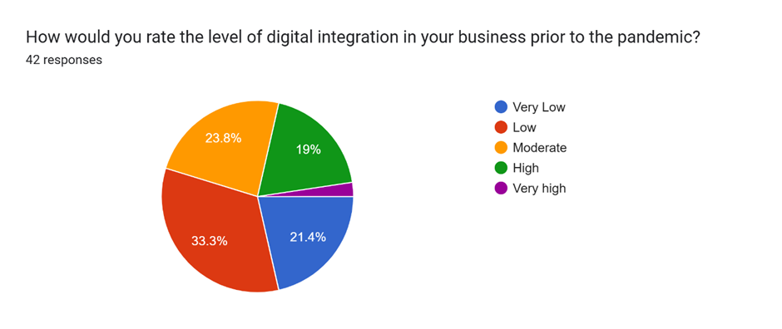

Figure 3 further supports this assessment, showing that before the COVID-19 pandemic, the most frequently utilized technology was inventory management software, reported by 40.5% of respondents. Point-of-Sale (POS) systems and e-commerce platforms were each used by 26.2% of participants, reflecting moderate integration of both physical and online sales technology. Customer Relationship Management (CRM) systems followed closely at 23.8%, suggesting some businesses were beginning to focus on customer data and engagement. Mobile apps were used by 14.3% of respondents, while mobile payment systems and digital marketing tools had minimal adoption, at just 4.8% and 2.4% respectively. Overall, the data suggests that, before the pandemic, most retailers had basic operational technologies in place but lacked broader technology.
Figure 3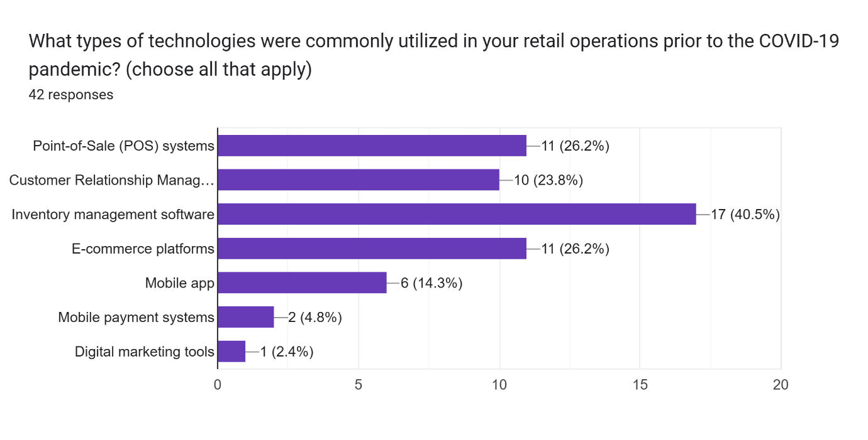

4.3 Acceleration of Technology Adoption During COVID-19
The pandemic acted as a significant catalyst for digital transformation. According to Figure 4, the overwhelming majority (88.1%) indicated that their organization did adopt new technologies during this period. The remaining 11.9% responded with "Maybe", indicating some uncertainty, possibly due to the high proportion of employee participants, who may not be fully aware of the technology implemented (See Figure 1). Notably, no respondents selected "No", emphasizing a near-universal trend toward the adoption of new technologies.
These findings correlate with the data in Figure 5, in which a significant majority, 83.3%, indicated that their business adopted automation tools, suggesting a widespread shift toward automation in response to the pandemic. Of the remaining 16.7%, the next most common response was ‘planning to’ (7.1%).
Figure 4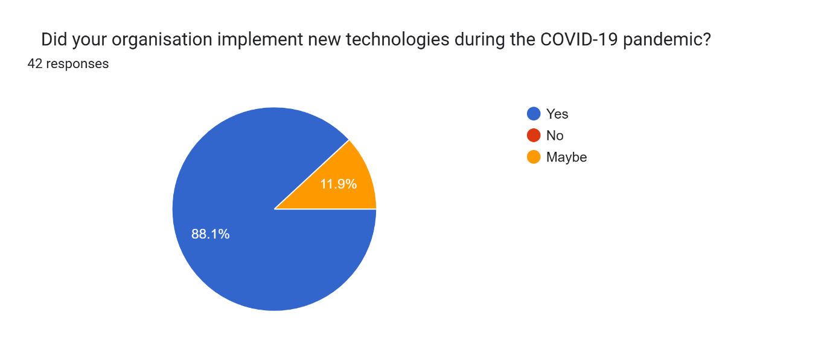

Figure 5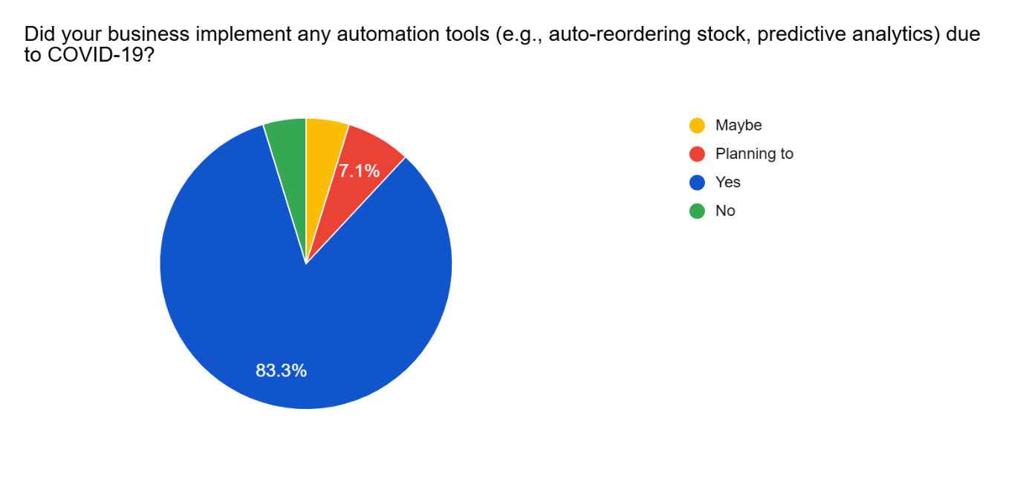

Figure 6 illustrates the key factors that influenced businesses to adopt new technologies during the COVID-19 pandemic. The most commonly cited driver was government restrictions and lockdowns, chosen by 50% of respondents. Decline in in-store traffic and competitor innovation were each selected by 33.3%, indicating both reactive and proactive motivations—responding to reduced footfall and staying competitive. Similarly, the need to maintain customer engagement was a significant factor for 31% (13), showing that customer connection remained a priority. 16.7% of respondents cited pressure to improve operational efficiency, suggesting it was a secondary concern compared to external pressures. Overall, the data shows that external disruptions played the most substantial role in accelerating technological adoption, while internal strategic motives like efficiency improvements were less prominent during the crisis.
Figure 6 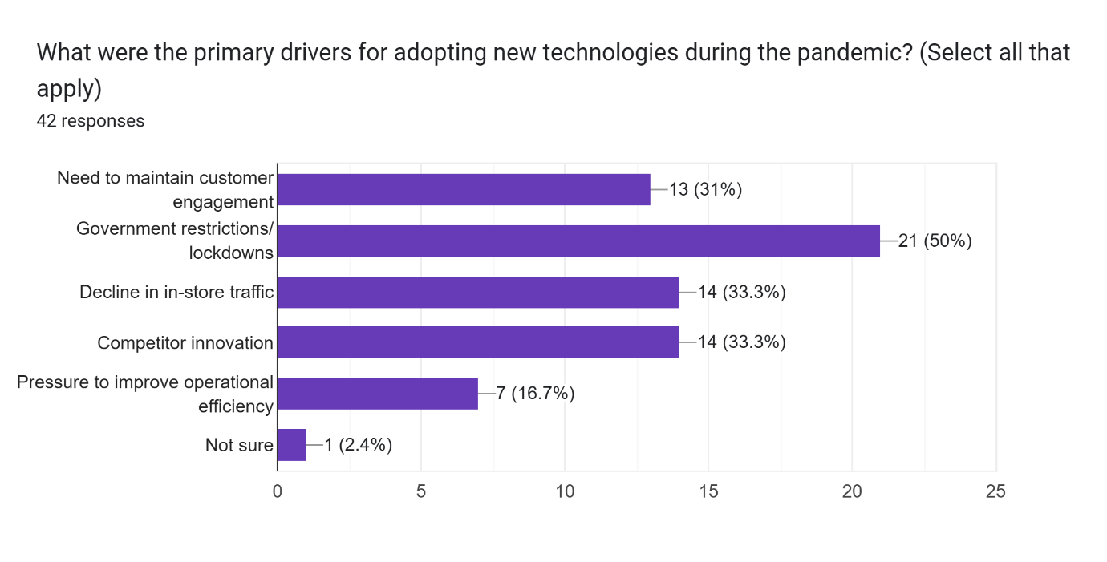

The types of technologies adopted or expanded during this period were diverse. As shown in Figure 7, the most frequently adopted technology was contactless payment systems, selected by 52.4% of respondents, indicating a shift toward safer transaction methods that complied with government restrictions. Similarly, 50% of respondents indicated that e-commerce platforms were adopted or expanded during the pandemic.
CRM chatbots or AI customer service tools were also utilised, with 45.2% of participants reporting their adoption, suggesting an increased focus on automating customer support during periods of reduced in-person interaction. 40.5% of respondents indicated that mobile apps were adopted or expanded. Additionally, inventory management systems (38.1%) and remote working tools (38.1%) saw notable increases.
Figure 7 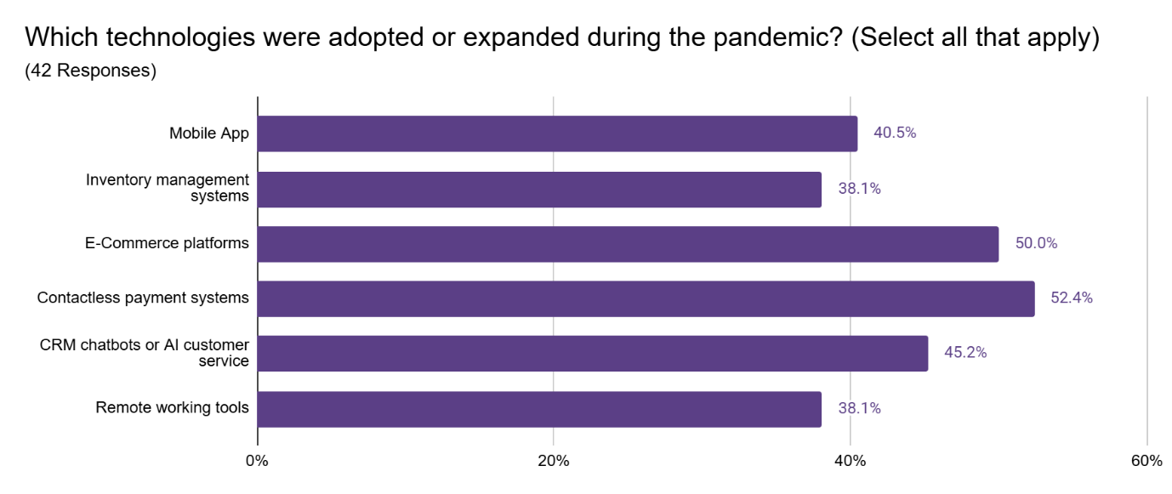

4.4 Operational Improvements Post-Pandemic
The rapid deployment of digital technologies during the pandemic led to improvements in operational efficiency. Figure 8 shows survey results evaluating operational efficiency post-pandemic on a scale from 1 to 5, where 1 indicates less efficiency and 5 indicates greater efficiency. 59.5% of respondents rated their operations at 5, suggesting that a majority of businesses now consider themselves significantly more efficient than they were before the pandemic. An additional 19% rated their efficiency at 4, and 21.4% chose 3. Notably, no respondents selected 1 or 2, indicating that none felt their efficiency had declined since the pandemic. This data strongly suggests that the technological and operational changes made during COVID-19 had a lasting and positive impact on business efficiency.
Figure 8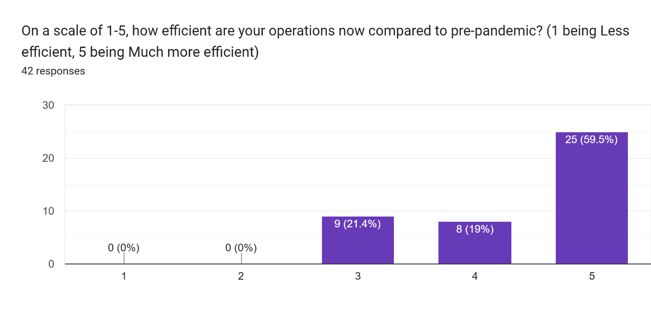

Figure 9 illustrates the internal operations that benefited the most from technology during the COVID-19 pandemic. The two most frequently cited areas were data analytics/reporting (73.8%) and supply chain coordination (69%), indicating that businesses heavily relied on technology to enhance data-driven decision-making and improve logistical efficiency in response to pandemic disruptions. Customer service also saw significant improvement, with 50% of respondents identifying it as a key beneficiary of technological adoption.
Other areas that benefited include staff scheduling or remote collaboration (38.1%), reflecting the shift to remote work and the necessity for efficient team coordination. Meanwhile, inventory management was cited by 28.6% of respondents, suggesting that although important, it was less central compared to analytics and supply chain issues during the crisis.
Figure 9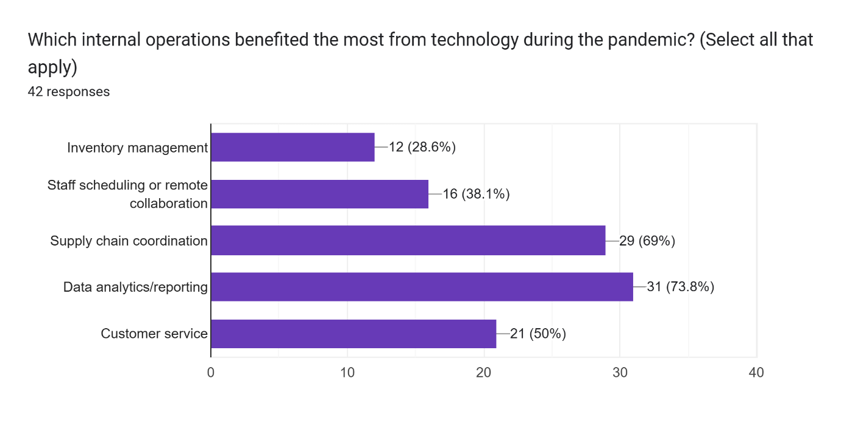

4.5 Digital Engagement and Marketing Strategies
Figure 10 presents data on which digital customer engagement strategies were perceived as most effective during the pandemic. Social media marketing emerged as the leading strategy, selected by 57.1% of respondents. Live chat/support (45.2%) and virtual consultations (42.9%) followed closely, indicating that real-time communication and personalized digital services were highly valued by customers during the pandemic.
Other strategies, such as email campaigns, loyalty/rewards apps, and online promotions and events, were each selected by 33.3% of participants, showing they remained relevant and useful but were not considered as impactful as the other three options.
Figure 10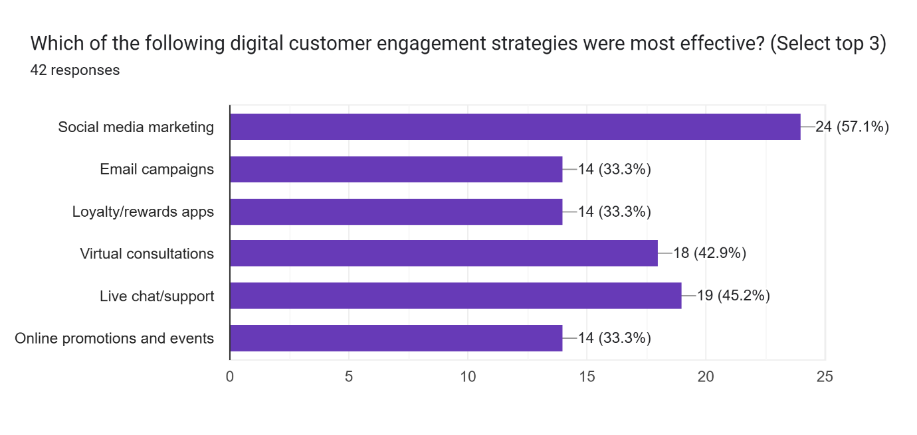

4.6 Long-Term Perceptions and Adaptability
As Figure 11 indicates, A significant majority of respondents (92.9%) believe that the technological changes made during the pandemic will be permanent, suggesting a strong consensus that the digital adaptations adopted during the crisis have become essential components of modern retail operations. 7.1% of respondents believe these changes will be partially permanent, indicating limited scepticism about the long-term sustainability of all implemented technologies.
Interestingly, no respondents selected "No" or "Maybe," emphasising the almost unanimous belief that the technological development made during COVID-19 will last.
Figure 11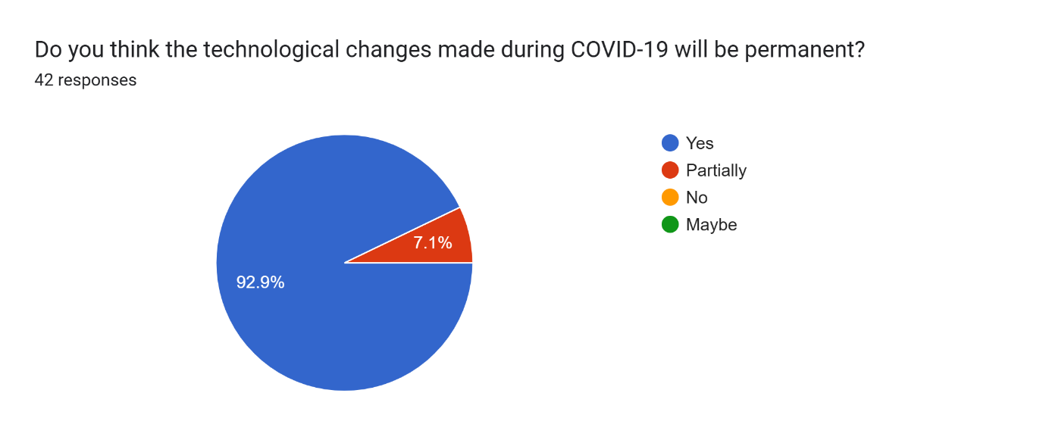

Figure 12 supports this narrative, with the majority (42.9%) indicating that the pandemic accelerated their adoption of technology and platforms. Meanwhile, 23.8% of respondents noted that staff adapted quickly to the newly introduced technologies. 16.7% reported that the technologies adopted were easy to implement. A smaller share (9.5%) believed they received adequate support in the form of training or resources for digital adoption, pointing to a potential gap in businesses’ support structures, and following from that, only 7.1% felt their business was technologically well-prepared before the pandemic.
Figure 12
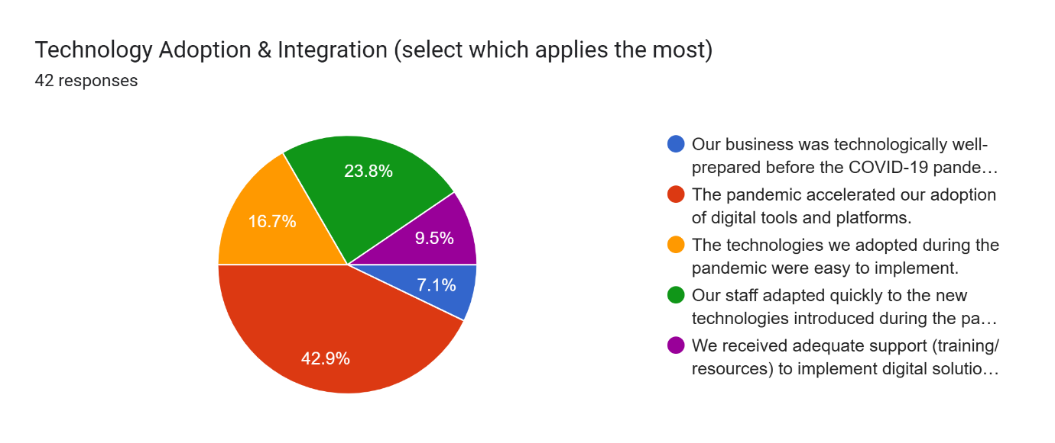

4.5 Digitisation Outcomes
Despite significant investment in technology, customer engagement outcomes were mixed. According to Figure 13, 50% of respondents indicated that their organisations experienced decreased customer satisfaction despite high technology use. 26.2% stated that social media and mobile apps became more central to their marketing strategies, highlighting a pivot to digital communication channels. Additionally, 23.8% reported increased customer satisfaction due to technology, reflecting successful integration and utilisation in some cases.
Smaller proportions of respondents acknowledged that technology helped maintain customer engagement (14.3%) and that technology enabled more personalised customer experiences (14.3%), pointing to benefits in customer relationship management where digital solutions were effectively leveraged.
Only 4.8% reported further emphasis on social media and mobile apps beyond what had already been central, suggesting either saturation or limited impact from increased usage.

Figure 13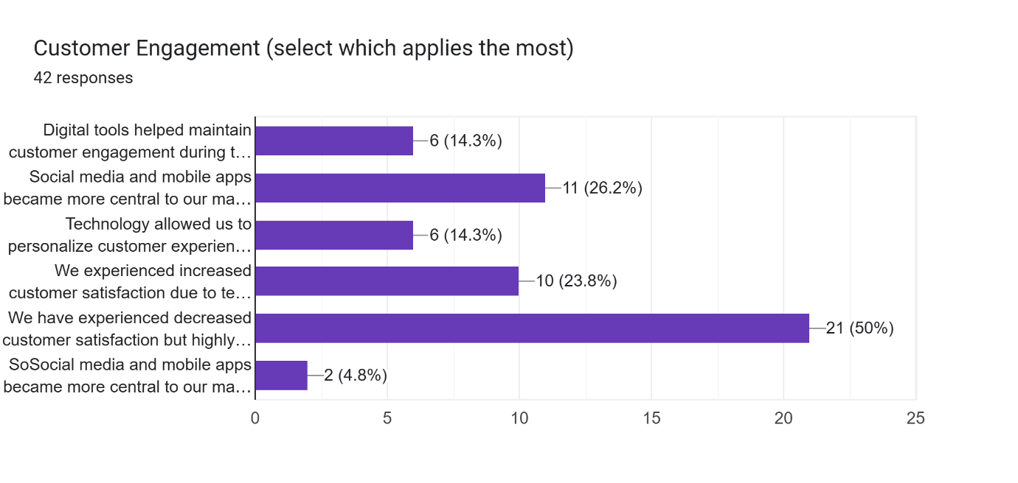

The data reveals that the COVID-19 pandemic significantly accelerated digital transformation across the retail sector, with notable improvements in efficiency, data analytics, and supply chain coordination. However, the findings also highlight challenges in translating technological investment into improved customer satisfaction, particularly given the limited strategic preparedness. These results offer valuable insights, which will be discussed in comparison to the literature in Chapter 5.

5. Discussion
The purpose of the quantitative research was to assess which retail businesses adopted new technological systems following the COVID-19 pandemic, and to determine whether any new developments had improved the efficiency of company operations and customer satisfaction. This chapter will discuss the findings of the quantitative research as well as the broader conclusions of the literature in regard to technology used and adopted, customer satisfaction, and the impact of remote work.

5.1 Digital Transformation as a Result of COVID-19
The first section of this discussion examines how the COVID-19 pandemic accelerated digital transformation in the retail sector. This is explored mostly through a comparative analysis of the quantitative data in Figures 2 and 7, which highlight the contrast between technologies used before the pandemic and those adopted or expanded during it.
Inventory management software was the technology most often used before the pandemic, with 40.5% of respondents indicating its use in their retail operations before COVID!9 (Figure 2). This aligns with Madamidola et al. (2024), which highlights the benefits of a sufficient inventory management system, stating that as early as the post-World War II period, companies like Toyota began to develop methods of inventory management. Many retailers had already adopted basic forms of inventory tracking or enterprise resource planning (ERP) solutions before the COVID-19 pandemic, because these tools delivered tangible benefits in terms of real-time stock visibility and cost reduction (Fernie & Sparks, 2019; Chopra, 2019).
Furthermore, technology such as POS systems also saw a moderate amount of use before the pandemic (Figure 2). POS systems make it quicker and easier for in-store employees to do their jobs, thus improving efficiency and ease of training for roles such as cashiers. (Hussein et al., 2020) However, it should be noted that of the participants in the primary questionnaire, 66.7% were in-store employees. Thus, a potential limitation of this study arises – an overrepresentation of lower-level employees could bias the results in favour of technology like POS systems since this group of staff may be more aware of it in comparison to, for example, digital marketing tools. The early uptake of these technologies, in particular, reflects the prioritisation of operational control, that is, the use of technology before COVID-19 primarily focused on increasing profit margins and improving efficiency behind the scenes.
In comparison, there was a relatively limited uptake of other digital technologies, such as mobile payment systems or digital marketing tools, before the pandemic (Figure 2). This may be explained by a lack of urgency. For small and medium-sized enterprises (SMEs) in particular, such investments were often deprioritised due to resource constraints, for example, the increased cybersecurity measures needed, as well as the high costs associated with setting up these platforms (OECD, 2019). It could be said, then, that before the pandemic, businesses utilised only the technologies that would streamline their in-person operations.
After the pandemic, as shown in Figure 7, there was a substantial increase in the use of all technologies included in the questionnaire, which represents a shift toward digitisation. Contactless payment systems emerged as the most adopted technology (52.4%). Although common among larger businesses that already had the resources to invest in them for efficiency’s sake pre-pandemic, post-pandemic, this technology sees far more use within SMEs. SumUp, a company that offers contactless payment machines for individuals, reported hitting the milestone of 1 billion transactions in the year 2024 (SumUp, 2024), in addition to consistent growth during the first half of the decade. This move toward contactless across many sizes of businesses could be a result of stringent social distancing measures, which created an urgent need to reduce points of contact during transactions in order to maintain hygiene. This finding is consistent with Jiang and Stylos (2021) research, whose research notes that engagement with technology intensified in response to increased risk aversion. Tools such as contactless payment machines offer a solution to this concern.
Not only does the literature indicate that the use of pre-existing technology increased during the COVID-19 pandemic, but it also demonstrates that new technologies were rapidly developed. For instance, Toole et al. (2020) report that some organisations were able to launch curbside pickup services in as little as two days, much faster than the typical 18-month deployment period observed before the crisis. This rapid acceleration in technological innovation reflects a broader shift in consumer engagement, as the global share of digital customer interactions increased from approximately 36% in December 2019 to nearly 58% by July 2020 (Toole et al. 2020) This trend is mirrored in the primary research data presented in Figure 4, wherein 88.1% of respondents indicated that their organisations implemented new technologies during the pandemic. This corresponds with findings from Pantano et al. (2020), which observed that during the pandemic, digital channels became the primary medium for interaction and transaction. This, in turn, correlates with the finding in Figure 7 that 50% of respondents noted an increase in the use of e-commerce post-pandemic. It is clear that the restriction of in-person transactions as a result of lockdowns strained retail businesses, and therefore, they resorted to the increased use of digital technology to survive. This evidence further confirms the acceleration of digital integration in retail business during and after the COVID-19 pandemic.
The data presented in Figure 6 provides insight into the primary drivers that influenced the adoption of new technologies during the COVID-19 pandemic. 50% of respondents identified government-imposed restrictions and lockdowns as the main reason for the increase in digitisation. A further 33.3% of respondents cited the decline in in-store foot traffic as a critical motivator. However, the lack of in-store foot traffic is likely a direct result of the aforementioned lockdowns, so both data points align with the consensus that the conditions brought on by the pandemic were the primary driver of technological integration during this period. (Holl, Rama, and Hammond, 2024; Toole et al., 2022; Evanschitzky et al., 2020)
Furthermore, 33.3% of respondents indicated competitor innovation as a motivator (Figure 6), showing that organisations were not only reacting to the external environment but were also responding to competitor actions to avoid falling behind. This is backed by the findings of Verhoef et al. (2021), who argue that digital transformation during COVID-19 was as much about gaining a strategic advantage as it was about short-term survival. In highly competitive sectors such as retail, the implementation of new technologies served as both a reactive and proactive measure.
Additionally, 31% of respondents highlighted the need to maintain customer engagement as a key motivator, reflecting a recognition that traditional modes of relationship management were insufficient under pandemic conditions. The deployment of CRM systems, AI chatbots, and digital communication tools became central to sustaining brand loyalty in a context devoid of face-to-face interaction (Shankar, 2020). Fewer respondents (16.7%) cited operational efficiency as a motivator, which could potentially link with the findings in Figure 2 that technology aimed at improving operational efficiency, such as inventory management systems, was already widely in use before the pandemic. Nevertheless, this supports the argument that streamlining through the use of automation was increasingly valued as retail businesses struggled through the crisis.
Therefore, both the primary research undertaken and the wider literature support the conclusion that the COVID-19 pandemic acted as a powerful accelerant in the development and deployment of technology within the retail sector.

5.2 The Effect of Technology on Efficiency and Customer Satisfaction
The second section of this discussion explores the relationship between the increased use of technology within retail and efficiency of operation, as well as assessing its impact on customer satisfaction.
According to Figure 8, the majority (59%) of respondents agreed that the digitisation accelerated by the COVID-19 pandemic had a markedly positive effect on business efficiency. This aligns with studies by Verhoef et al. (2021), who note that technology streamlines operations and improves communication between different locations within a business.
Of the variety of technologies listed in Figure 10, social media marketing was identified as the most effective strategy for improving efficiency by 57.1% of respondents. Mason et al. (2021) emphasise the increasing strategic value of social media marketing in the wake of the COVID-19 pandemic, arguing that the crisis significantly heightened the reliance on social media platforms as a primary mode of customer engagement. Social media’s ability to target specific demographics made it particularly well-suited to the changing retail environment brought on by lockdowns and social distancing regulations. Moreover, the cost-efficiency and scalability of platforms like Instagram, Facebook, and Twitter enabled retailers to maintain visibility and continuity even when physical operations were suspended. (Deloitte, 2020) Retailers, particularly SMEs, were able to capitalise on these dynamics by leveraging organic reach and user-generated content to boost their customer engagement. (Saura, JR. Palacios‐Marqués, D. and Soriano, DR. 2023).
Additionally, analytics embedded within social media platforms provide immediate and actionable insights on consumer preferences. Marketers can track engagement, click-through rates, demographic data, and conversion metrics in real time, allowing for data-driven adjustments to campaigns (Carvalho et al., 2017). Therefore, it can be argued that an increased reliance on technology helped to improve customer engagement.
Another example of an adaptation that has improved customer engagement is the adoption of AI-powered customer service solutions, such as chatbots. In Figure 7, 45.2% of respondents indicated that CRM systems and AI chatbots were expanded during the pandemic. As Soolis (2021) highlights, the surge in chatbot implementation during the pandemic allowed businesses to maintain high levels of customer engagement even when human workforces were constrained by lockdowns. These AI tools offered 24/7, instant service and dramatically reduced the load on customer service departments.
In the literature, remote work was often cited as one of the main forces responsible for the increase in efficiency, particularly in corporate and administrative functions. As noted by Mutebi and Hobbs (2022), remote and hybrid working arrangements have led to improved productivity, reduced overhead costs, and enhanced employee well-being. In the retail industry, these benefits have been most pronounced among head office staff, that is, staff who were able to transition smoothly to remote setups during and after the COVID-19 pandemic through the use of online collaboration platforms such as Zoom and Slack. Moreover, technological investments in collaborative platforms and cloud-based systems, driven by the remote work transition, further streamlined communication and project management. However, store-based staff were not able to make this transition so easily. This could explain why, in Figure 10, fewer respondents cited remote work as a primary driver of efficiency, since the majority of respondents were themselves store-based staff.
Mutebi and Hobbs (2022) also found that although after the lockdown measures were lifted, the proportion of UK workers in remote jobs decreased from 49% to only 22%, this still represents a higher proportion than in the years before the pandemic. In addition to the data in Figure 11, which shows that 92% of respondents felt that the changes brought on by the COVID-19 pandemic would be permanent, the argument could be made that although businesses were forced to adapt to a more digital strategy during COVID-19, the increase in efficiency of operation caused many businesses to adhere to this strategy even without the pressure of an ongoing global crisis.
However, despite the fact that many businesses found great success through the use of technology, many other businesses failed to adapt, often with severe consequences. Dornbrack (2024) outlines several high-profile corporate collapses during the pandemic, pointing to a lack of digital infrastructure as a critical failure point. This correlates with the data in Figure 12, where only 7.1% of respondents indicated that their business was not sufficiently technologically prepared going into the pandemic. Businesses that relied heavily on in-person transactions or outdated systems struggled to pivot quickly enough.
Furthermore, Editorial Team (2023) found that businesses that shifted to digital platforms often struggled to replicate the nuanced, human aspects of in-person interactions, particularly in regard to the luxury sector. While CRM systems enabled companies to track preferences to automate and personalise communications, these systems may lack the responsiveness and empathy required to fully satisfy customer needs. Editorial Team (2023) also notes that many companies, particularly smaller retailers, adopted technology reactively rather than strategically, leading to inconsistent service experiences that eroded trust and loyalty. This reflects the findings in Figure 13, wherein 50% of respondents indicated a decrease in customer satisfaction post-pandemic. It could be argued that the sudden influx of digital interactions led to customers becoming fatigued with standardised communications, overly frequent marketing emails, and generic chatbot responses that replaced the tailored service customers had come to expect pre-pandemic. Instead, many businesses prioritised efficiency over experience, and as a result, customer satisfaction suffered.
Therefore, it could be concluded that much of the digitisation that followed the COVID-19 pandemic is likely to persist in some capacity due to its positive impact on operational efficiency. For example, the adoption of remote work practices has enabled organisations to reduce overheads while maintaining productivity (Mutebi and Hobbs, 2022), and the use of social media and user-generated advertising has enhanced marketing reach and engagement at a lower cost (Mason et al., 2021). However, an overreliance on technology or the rushed adoption of it, particularly in customer-facing roles, risks undermining the personalised service and human interaction that many consumers continue to value, therefore negatively impacting customer engagement.

6. Conclusion
The COVID-19 pandemic has been a defining moment in the evolution of technology within the retail sector. This dissertation aimed to explore the utilisation of technology by retail businesses, and to assess the prospects for its continued utilisation in a post pandemic environment. Through the primary research undertaken as well as a review of the existing literature, this dissertation has demonstrated that the COVID-19 pandemic caused the use of technology within retail to increase significantly, and that from this growth in technology the efficiency of operation within retail has grown. However, its impact on customer engagement has been more nuanced. The retail sector must balance maintaining operational efficiency and restoring the quality of customer experience following this shift.
Before the pandemic, digitisation across the retail industry was generally low; most businesses relied primarily on basic technologies such as inventory management software and POS systems. More sophisticated tools such as mobile apps and digital marketing platforms have seen only limited adoption. This meant that many businesses were forced into a reactive scramble for solutions once lockdowns and restrictions were introduced.
In response to this urgent need for continuity, retail businesses across the board adopted a wide array of technology. Many organisations adopted new technologies during the pandemic. These included contactless payment systems, e-commerce platforms, AI-powered customer service tools such as chatbots, and the use of social media platforms for low marketing, all of which reflect a broader trend towards facilitating remote and low-contact retail experiences, to accommodate the regulations imposed by governments during the height of the COVID-19 pandemic.
One consistent finding across both primary data and literature is the positive impact of these technologies on operational efficiency. This trend demonstrates the role of automation in streamlining operations. Tools such as cloud-based project platforms and digital scheduling applications enabled businesses to rely more on remote work, and pre-existing automation systems were developed further in order to reduce overhead and labour costs. However, while technological transformation was broadly successful in enhancing operational efficiency, its effect on customer satisfaction has been far less consistent: while businesses became more efficient, they did not always maintain customer engagement.
Several factors contributed to this divergence. First, many businesses adopted CRM systems and AI chatbots without adequate attention to user experience. While these tools provided functional benefits, such as 24/7 availability and quick query resolution, they often fell short of replicating the empathy and personalised interactions that defined pre-pandemic customer service, especially in the luxury retail sector. This, to a certain extent, caused many businesses to struggle. Moreover, the sudden influx of digital communications led to customers becoming weary of online points of contact, such as repetitive marketing emails or social media posts.
These shortcomings were not merely technological but strategic. The research suggests that digitisation efforts were largely reactive rather than customer-focused. The pandemic forced businesses to digitise, but in doing so, many prioritised survival over service quality, an understandable yet consequential trade-off. Furthermore, the disparity in outcomes also reflects uneven levels of preparedness and support. Few respondents felt their business provided adequate training and support for digital tool adoption. This lack of investment in change management likely contributed to inconsistent implementation and undermined the effectiveness of technology.
Looking forward, the retail industry can take several lessons from the technological growth that resulted from the pandemic. First, digital transformation should be viewed not merely as a means of increasing efficiency but as a strategy for customer-centric innovation. While automation and remote systems have proven their worth in operational terms, future investment must prioritise user experience, particularly in CRM and customer service technologies. As indicated previously, digitisation without a human touch risks undermining brand loyalty and diminishing customer satisfaction. Therefore, the employees themselves should not be deprioritised, especially when it comes to customer-facing roles.
In conclusion, the COVID-19 pandemic dramatically reshaped the technological landscape of the retail sector. It accelerated the adoption of technology that streamlined operations, but also exposed the limitations of impersonal, reactive strategies in customer engagement. Moving forward, retail businesses must adopt a balanced approach: one that leverages the strengths of technology while preserving the relational aspects of service that customers continue to value.

7. References

‌

