Assignment 2
Marketing Fundamentals

COVID 19 IMPACT ON NIKE

Module Name: Marketing Fundamentals
Module code: LCBB4004

Student: Marius Scorcea (1921886)
Lecturer: Md Sadeque Imam Shaikh

Contents
Introduction 3
The process and Stages of Marketing 3
A Successful Strategic Marketing Process: Key Steps 4
Role of Marketing and Situational Analysis Models 5
Situation analysis importance 5
NIKE overview 5
SWOT Analysis for NIKE 6
PESTEL Analysis for NIKE 11
NIKE’s Five Porter’s model analysis 14
4p’s Marketing Mix and Segmentation, targeting and positioning 15
4 p’s Marketing Mix 16
Segmentation, targeting, positioning in the Marketing strategy of NIKE 18
Conclusion 20
REFERENCES 21

Introduction

The impact of Corona Virus called Covid 19 as well was enormous and affected peoples life, starting with they basics needs up to the most complex ones. There were mainly negative effects but also few positive aspects in this pandemic, people, companies, governments came together in order to overcome this challenge and once again, humankind prevailed and showed that has unlimited resources.
This report will provide a critical analysis and evaluation of how NIKE approach all this from marketing point of view, how they adapt and improve their strategies in order to keep up not only with people’s needs but also with the governments new rules and regulation. It is a big responsibility for a company like NIKE to maintain his position as one of the best seller brands from the world of athletic apparel companies.
The report will introduce the Macro and Mirco Environment as part of the NIKE’s situational analysis, what Marketing Mix are they using and where they position themselves on the market after all the challenges they have been through.

The process and Stages of Marketing

,Marketing is not the art of finding clever ways to dispose of what you make. It is the art of creating genuine customer value’.
Philip Kotler
According to CIM (2015), marketing is the management procedure that enables recognizing, foreseeing and meet the client expectations.
Due to its focus on the most crucial facets of the market, the marketing process is essential to the success of businesses of all sizes. Understanding the competitive market can help you capitalize on major trends and reach customers with the ideal product at the ideal time, place, and price.
It's crucial to use a straightforward marketing framework. It helps you to schedule your actions in advance, evaluate what is successful, and repeat them when and where they are most efficient.
Marketing is emphasizing the main tasks that every business must complete, such as finding clients, learning about their wants and requirements, examining the variables that affect their purchasing choices, and persuading them to purchase goods and services from you rather than a rival.
That is why the companies needs a strategy that is coordinated, thoughtful, and practical in order to utilize resources in the best way as possible. (CIM, 2015)

A Successful Strategic Marketing Process: Key Steps

The marketing strategy consists of five steps. Each one is meant to help the company to achieve the business goals. (Wizard or Sales, 2022).
- Mission.
- Situation Analysis.
- Marketing Plan.
- Developing Marketing Mix Decisions.
- Implementation and Control.

Role of Marketing and Situational Analysis Models

A marketing environment is made up of a variety of internal and external elements that can have an impact on a variety of marketing operations, including campaigns and product launches. These elements are crucial because they can promote business growth and innovation. Marketing personnel can create, advertise, and sell the company's goods and services more effectively by having a better understanding of the environment and its many elements. This information can be used to educate professionals, create clever marketing efforts, create well-liked items, and enhance sales. (Indeed, 2021).

Situation analysis importance

A situational analysis uses a variety of techniques to determine a company's capabilities, potential clients, and the business environment. Following that, business owners can develop a suitable marketing strategy to use for their organization based on the anticipated effects from the aforementioned aspects.
Three approaches—the PESTLE Analysis, the SWOT Analysis, and the Porter Five Forces Analysis—are frequently employed to conduct a situational analysis. SWOT analysis is the approach that many businesses choose to use most frequently among them. (Vanessa, 2022).

NIKE overview

Nike, Inc. is an American multinational corporation. Beaverton, Oregon, in the USA, is home to Nike's headquarters. In the year 1964, Bill Bowerman and Phil Knight discovered it. The business focuses on athletic wear and offers footwear, clothes, gear, and accessories.
Nike's main objective is to provide athletes with outstanding wearables and products that improve their athletic performance. But as a result of its popularity, Nike has expanded to offer tracksuit clothing as well. At the moment, Mark Parker leads Nike as CEO. (Business Strategic Hub, 2022)

SWOT Analysis for NIKE

STRENGHTS
Strong Brand Awareness and Brand Value - Nike is one of the most well-known brands in the world. Everyone is familiar with its swoosh logo.

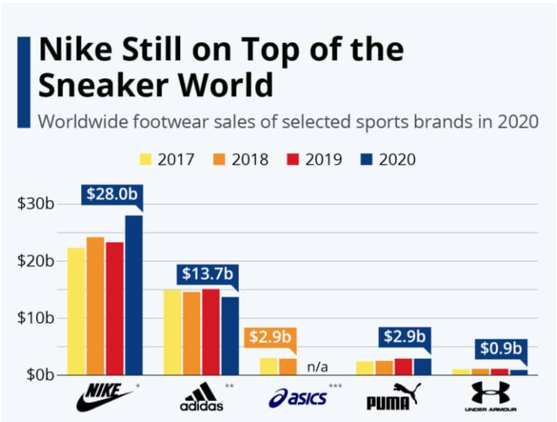
Huge Consumer Base - Nike has millions of customers who follow close Nike's trends, take part in Nike events, and even offer customer feedback.
Aiming for Sustainability - Mark Parker, the CEO of Nike, has stated that the company would continue to identify environmental problems in local communities.
Stars associations - Nike has benefited from its long-standing association with Michael Jordan in terms of sales. "Air Jordan 1 Shoes" are the result of their partnership.
Low Manufacturing Costs - The majority of Nike's footwear is made abroad.
Strong marketing expertise - Social media and marketing initiatives have been used effectively by the brand to reach more consumers.
WEAKNESSES
Poor Working Conditions Abroad - For the over twenty years, Nike has been the object of constant criticism for forced labor, child labor, low pay are some of these problems.
Suits- A former employee recently accused Nike of discriminating against him because of his Croatian ancestry.
In August 2018, four formerly employed women claimed that Nike has a terrible workplace atmosphere for women. The women launched a lawsuit against the sportswear manufacturer, alleging that it had broken the Equal Pay Act. The women claimed that the corporation consistently paid men more than women for doing the same amount of tasks.
Contradictory Approaches: Under the "Move to Zero" initiative, Nike committed to switching all of its facilities to 100% renewable energy with net-zero carbon emissions. Although the approach is excellent and welcomed, it goes against Nike's approach, which prioritizes innovation over sustainability. This gives the impression that Nike is not serious about combating climate change and that its pledge is merely a publicity trick.
Sexual Harassment: Several female employees noted that sexual misconduct and harassment were widespread in the business.
OPPORTUNITIES
Developing Markets: Despite the fact that Nike is currently present in many international nations, there are still many prospects for the company. This is due to the fact that developing economies like Brazil, China, and India are steadily thriving.
Innovative Things - Nike has created a lot of products, but there is still much room for innovation. Nike has expanded its technological capabilities in relation to fitness and wellness.
Effective Integration - Independent manufacturers are necessary for the manufacturing and supply of Nike's goods.
Nike has made the decision to sever its ties with some of the largest multi-brand retailers in order to improve customer experience and product positioning.
Acquisition of artificial intelligence Startup - To increase its online sales skills and forecast customers' purchasing patterns, it just bought the predictive analytics platform Celect.
Joins the Metaverse - Nike just purchased digital shoe manufacturer RTFKT. The company creates footwear for the virtual stratosphere. RTFKT asserted that it collaborated with FEWOCIOUS (a young artist) to sell genuine shoes in addition to their digital counterparts. Nike is counting on the Metaverse, where users can use their Metamask wallets to buy various kinds of in-game merchandise, as a platform to promote their digital shoes.
Online sales will account for 38.7% of the Nike brand's income in the fiscal year 2021. It is obvious that the pandemic is changing how Nike engages with its customers.
THREATS
Products of Fake Origin - Fake goods have a big impact on Nike's sales and reputation. A number of merchandisers and shops sell knockoff Nike goods for less money. This could damage Nike's reputation since consumers may think the company has started making low-quality goods.
Increased competitive pressure - Despite Nike's dominance in the athletic sector, the corporation nevertheless faces pressures from rival brands and new, emerging ones. Nike has to spend more money on marketing and advertising due to the increased level of competition.
Currency Foreign Exchange Risks: Due to the brand's global operations, it is impacted by changing exchange rates. In terms of financial results, Nike uses US dollars. Due to the U.S. dollar's exposure to volatility when compared to other financial currencies, this has an impact on its revenue.
Patent litigation - Whether a corporation is in the right or wrong, patent battles are vigorously disputed in the public eye. In U.S. and German courts, Nike and Adidas have been embroiled in a bitter patent dispute over Primeknit and Flyknit shoes.
Economic Uncertainty - All businesses are vulnerable to the adverse consequences of a global recession, regardless of their industry. Nike's sales have already decreased by 38% in Q2 2020, and if the recession is as severe as analysts forecast, they may plummet even more in the future.
Trade Tensions: Nike's dependence on various international markets is evident from the recent rise in its stock price, which was fueled by an increase in revenue in China.
Risk to the Population of Kangaroos - Nike has been charged with endangering the existence of the Australian kangaroo population. The top athletic brand creates leather football shoes using kangaroo skin.

PESTEL Analysis for NIKE

PESTEL business analysis is a methodology that aids business owners and entrepreneurs in comprehending how macro environmental issues affect their enterprise.
Political, Economic, Social, Technological, Environmental, and Legal factors are all abbreviated as PESTEL.
POLITICAL factors
The largest markets for the apparel sector globally are the US, China, and Japan. As a result, the US will always be a major participant in the athletic goods and clothing industries. Despite the fact that the US has a stable political climate, it has free trade agreements with a number of nations, and it is a member of NATO, the Trans-Pacific Partnership, and NAFTA. But if the current US-China trade spat continues, it might have a big effect on the sector's exports of completed goods and purchases of raw materials.
China, India, and Vietnam are examples of growing markets with significant levels of corruption that could be problematic for business. High degrees of corruption also result in higher amounts of bureaucracy. This could be a barrier for businesses trying to grow their business in these nations.
ECONOMIC factors
Most of the world's economies are returning to pre-pandemic levels of economic growth. With an annual turnover of USD 54 billion, the United States is the biggest consumer market in the worldwide athletic goods business. Key economic indicators, which are already showing signs of recovery from the COVID-caused declines, are crucial to the sporting equipment and apparel industries alike. United States sports equipment industry has grown by 5.9 percent between 2017 and 2022, which is another encouraging economic development for the sports sector.
Overall, the economic situation is relatively positive, with the exception of the persistent supply chain problems and associated financial losses.
SOCIAL factors
When it comes to demographics of the world's population, millennials and members of Generation Z make up the majority. Fitness, working out, and healthy living are becoming more popular among this generation. The demand for fitness equipment and accessories is increasing due to changing lifestyles, which is a positive statistic for the athletics, apparel, and footwear industries.
In order to attract more clients, businesses in the sneakers, apparel, accessories, and sporting goods sectors need to develop an effective e-commerce platforms.
The sector has a lot of room for sustainability, and buyers want companies of clothing, footwear, and accessories to support them in their efforts to protect the environment.
Top businesses in the sector are increasingly switching to environmentally friendly packaging. These developments will have a significant impact on the entire sector, and in the coming years, more people will adopt these sustainable advancements.
TECHNOLOGICAL factors
The leading nations influencing significant improvements in the global technology infrastructure, including the US, China, Germany, Russia, Israel, the UK, and Switzerland, are doing so in order to foster technological innovation in all sectors of the economy. The amount spent globally on research & development has surpassed USD 1.7 trillion and is growing quickly. Additionally, most nations have pledged to dramatically increase their R&D spending by 2030. IoT sensors, wearable technology, influencer marketing, digital marketing, SEO methods, artificial intelligence, augmented reality, and other cutting-edge technologies are also used in the sporting goods sector.
People can use their smartwatches to track their steps when wearing these sneakers. Such technologies will force industry paradigm shifts and force all major firms to adopt them as soon as possible in order to gain new clients.
ENVIRONMENTAL factors
Industry-wide problems include greenhouse gas emissions, water waste, water contamination, and packaging. The goal of sustainability is to develop carbon-neutral industries, better energy sources, and environmentally friendly clothing, accessories, and athletic items. The majority of states are currently enacting stronger environmental regulations for the sector that also support the promises made under the Paris Agreement and COP26.
LEGAL factors
The standards linked to anti-competitive behavior, employment and labor laws, workplace safety regulations, minimum wage regulations, and other laws that govern the industry are tightly regulated in the apparel, footwear, and sporting goods sector. The industry is required to abide by a number of consumer protection regulations and product safety standards. (Miller, 2022)

NIKE’s Five Porter’s model analysis

Harvard Business School professor Michael E. Porter created and developed this model in 1979. A business organization's competitive position and strength are evaluated and analysed using the framework. The threat of substitute products, the threat of new entrants, competitive rivalry, the bargaining power of suppliers, and the negotiating power of customers make up Porter's five forces. (The Writing Zone, 2020)
Bargaining power of customers
The customer has a modest purchasing power. Customers need footwear and clothing to function. There are no equivalent goods available. However, some buyers are sensitive to pricing and favor less expensive products. Customers generally have a moderate amount of power.
Bargaining power of suppliers
The manufacturers are the primary suppliers in this sector. Companies in this sector are working with manufacturers in developing nations to lower labor and material costs. As an illustration, Nike has outsourcing agreements with vendors in emerging nations including China, Mexico, and India. Due to the abundance of substitute suppliers available globally, the suppliers are not required to bargain power with the firms. The influence of suppliers is often mediocre.
Threats of new entrants
New businesses face relatively little barriers to entry. For a new sports apparel and footwear business to get off the ground, supplies must be sourced and a location must be located. However, it is challenging for the new stores to survive. Price competition poses the biggest challenge. Brand reputations pose a second concern.
Most clients find it challenging to quickly recognize new businesses.There is a very significant threat from new competitors.
Threat of substitute products
For Nike, the risk of substitute products is both very low and moderate. This is due to the fact that other rival companies, including Adidas and Under Armour, produce comparable goods. In comparison to Nike, there are other local and international brands that produce cheaper athletic shoes. Substitute items provide a modest threat.
Competitive Rivalry
There is fierce competition in the sports sector. Puma, Under Armour, and Adidas are some of Nike's main rivals. The sports market has become oversaturated, and the current companies are engaged in fierce competition to gain a bigger portion of the market and penetrate it more deeply. Because there are few top players and direct rivals, the competition is tougher. In general, there is little competition in the sports sector.

4p’s Marketing Mix and Segmentation, targeting and positioning

4 p’s Marketing Mix

The profitability and expansion of the athletic footwear, apparel, and equipment industries are governed by Nike Inc.'s marketing mix. The methods and tactics used to carry out the marketing plan with an emphasis on products, place, promotion, and price are referred to as a company's marketing mix (the 4Ps). (Gregory, 2022)
Nike Inc. improves its capacity to defend its enterprise from the fierce force of competition through its marketing mix. The business competes with other companies in the footwear, apparel, and athletic equipment marketplaces using its 4Ps.
Product Mix
Currently, the marketing mix of the athletic goods company encompasses a wide range of product categories and brands. However, broadly speaking, Nike's product mix can be divided into the following categories: clothing, footwear, apparel, and accessories.
In order to meet the needs of its target audiences and market sectors, Nike diversifies its product offering.
Place and Distribution in the Marketing Mix of Nike
The locations where the sporting goods company's items are sold, purchased, or distributed are described in this component of the marketing mix. Nike's market reach is optimized using this 4P variable.
According to their importance to the marketing strategy and results of the company, the following locations or venues make up Nike's distribution strategy in this context of the marketing mix:
- retail outlets
- Nike Store Online
- retail stores in Niketown (company-owned)
Promotional Mix
Promotional strategies are used in this component of the sporting goods company's marketing mix to inform clients about the products and persuade them to buy. The following are Nike's marketing initiatives, listed in order of importance to the company's marketing plans:
- Advertising
- individual selling
- direct selling
- sales incentives
In addition, the marketing mix includes public relations, whereby the business sponsors and donates money to groups like community-based networks to advertise its athletic shoes, clothing, and equipment.
Price Mix
This part of the marketing mix determines the prices that will provide the greatest profits while luring the targeted proportion of the global market for athletic and recreational goods. Nike makes technology expenditures in order to use premium pricing methods in its marketing. Nike Inc. uses the following pricing methods in its business based on these factors for this 4P variable:
Value-based pricing strategy
Premium pricing strategy
Nike Inc. effectively employs pricing techniques in this component of the marketing mix to maximize revenues while highlighting high value in promoting its goods and brands.

Segmentation, targeting, positioning in the Marketing strategy of NIKE

Segmentation
Market segmentation, in its most basic sense, is the division of a company's target market into segments that are feasible and reachable. Based on demands, demographics, priorities, shared interests, behavioural, and psychographic standards, Nike divides its market into sub-segments.
Targeting
In this phase of the marketing strategy, the segments that will result in the most effective and practical means of achieving the firm's objectives are methodically chosen. Nike divides their target demographic into three categories: men, women, and children.
Positioning
The main goal of positioning is to integrate the company's brand with those of its rivals. Nike has actively positioned its brand as the industry leader in sporting goods with cutting-edge, high-end technology. Customers were persuaded that Nike is a successful and ambitious brand by the swoosh emblem, the "Just Do It" slogan, and its advertising efforts to link to the outstanding accomplishments of famous athletes.
The above-mentioned points will be best supported by the Nike market segmentation, targeting, and positioning. The three components of Nike's marketing strategies are briefly illustrated in the table below.
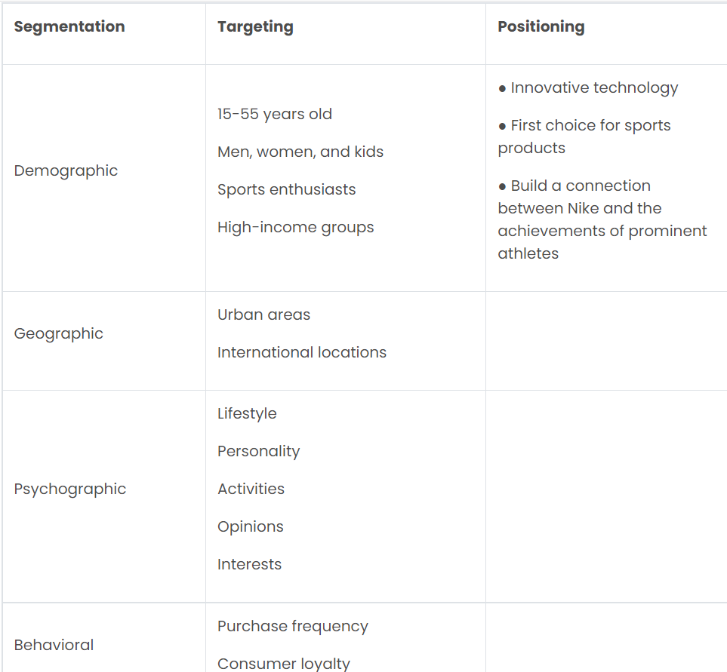

Conclusion

Following the COVID-19 setback, global economic indices are improving, and emerging markets are quickly catching up to modern lifestyles. The leading businesses will profit from this positive development in terms of their expansion in these nations. Additionally, the availability of inexpensive labour in Asian nations is a big plus for the sector. However, these nations' high levels of corruption and poorly regulated supply chains can be a problem. The sector must also adapt to the tighter legal and environmental standards being established on a worldwide scale.
Despite the epidemic, Nike had a successful fiscal year in 2021. The company is still in deficit, but the coming years seem hopeful. In the previous ten years, Nike's growth has been exponential.
It is a remarkable accomplishment only to introduce new product lines, create new brands, outsource, and grow a global presence.

REFERENCES

Business Strategy Hub, (2022), Nike Swot 2022|SWOT Analysis of NIKE, Available at: https://bstrategyhub.com/swot-analysis-of-nike-nike-swot-analysis/, (Accessed: 15th August 2022)
CIM, (2015), 7 p’s, A brief summary of Marketing and how it works, Available at: https://www.cim.co.uk/media/4772/7ps.pdf, (Accessed: 13th August 2022)
Gregory, L. (2022), Nike’s Marketing Mix (4Ps/Product, Place, Promotion, Price) – An Analysis, Available at: https://panmore.com/nike-inc-marketing-mix-4ps-product-place-promotion-price-analysis, (Accessed: 16th August 2022)
Indeed Editorial Team, (2021), What is a Marketing Environment? (A helpful guide), Available at: https://uk.indeed.com/career-advice/career-development/marketing-environment, (Accessed: 13th August 2022)
Miller, K. (2022), An Intelligible and Illustrative PESTLE Analysis of NIKE, Available at: https://crowjack.com/pestle-analysis/nike, (Accessed: 15th August 2022)
Study Lecture Notes, (n.d), Marketing Process Definition & Steps, Available at: http://studylecturenotes.com/marketing-process-definition-steps/, (Accessed: 10th August 2022)
The Writing Zone, (2020), Nike, Inc. Porter’s Five Forces Analysis, Available at: https://writer7.medium.com/nike-inc-porters-five-forces-analysis-a2031a7ed9c2, (Accessed: 15th August 2022)
Vanessa, (2022), A Situational Analysis of a Strategic Marketing Plan, Available at: https://www.mageplaza.com/blog/a-situational-analysis-of-a-strategic-marketing-plan.html#definition-classification-and-function, (Accessed: 15th August 2022)
Wizard of Sales, (2021),The 5 Steps Of A Marketing Process, Available at: https://sellingrevolution.com/blog/the-5-steps-of-a-marketing-process/, (Accessed: 13th August 2022)
Wondershare Edraw Mind, (n.d), Nike Market Segmentation, Targeting, and Positioning, Available at: https://www.edrawmind.com/article/nike-market-segmentation-targeting-and-positioning.html, (Accessed: 16th August 2022)

