Daniels Zelinskis (2104718)
Computer Networks and Cybersecurity
Network Operating Systems and Services (ACCA5023)
Nitheesh Murugan Kaliyamurthy
University of Wales Trinity Saint David

Contents

1. Introduction 3
2. Part 1: Practical Work – Teamwork 5
3. Part 2: Observational Tasks/ Work – Individual Task 36
3.1. Virtual LAN 36
3.2. Hypervisor Management Software 37
3.3. Network Directory Service 38
4. Conclusion 38
References 39

1. Introduction

In recent centuries, at least single new technology appeared. The 18th century was the era of mechanical systems, then steam machines appeared. As early as the 20th century, the key technology was the collection, processing, and distribution of information, telephone networks, television, radio, and much more, including the Internet, began to appear around the world, but at once it was possible to perform a large number of separate actions by interconnected computer networks.

If two or more computers can exchange information means they are interconnected, it is called computer networking and the connections between them can be completely different from using cables, fiber optics, or even wireless signals. There are also different types of computer networks such as PAN, LAN, MAN, WAN, which can differ in size and value, they can be considered as general-purpose networks, from sending files to access to the Internet, however, there are other networks with completely different purposes, such as SAN, EPN, VPN.
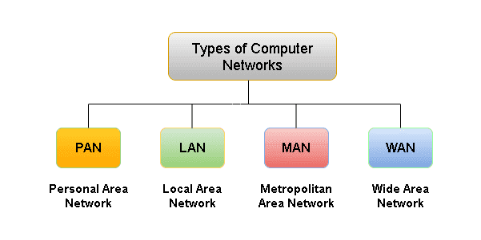
Adapted from www.tutorialsmate.com

Computer networks also have their own components, clients, servers, interface devices and network operating system (NOS), although clients and servers are the most important elements of a computer network.

In network world recognizes two architectures: Peer to Peer (P2P) and Client/ Server. The P2P architecture consists of nodes where roles can be switched from client to server and vice versa, while the Client/ Server architecture has roles, some of which are clients and others are servers. While all hosts can be nodes, not every node can act as a host.

It is through all of this that we live in a connected world where we can easily share any information around the world.

2. Part 1: Practical Work – Teamwork

Name of the Team: Team NOS
Team Members
Student Name | Student ID
Alexander Tzafos | 2104846
James FREW | 2108660
Josh naylor | 2114259
daniels zelinskis | 2104718

Team Evaluation (Self Evaluate your Team)
 | Student 1 | Student 2 |  | Student 3 |  | Student 4 |  | Student 5
Student 1 | 4 |  | 5 |  | 3 |  | 3
Student 2 | 5 |  | 5 |  | 3 |  | 3
Student 3 | 5 |  | 5 |  | 3 |  | 3
Student 4 | 5 |  | 5 |  | 3 |  | 3
Student 5
Rate your Teams Contribution with a scale of 1 to 5 (1 No Contribution and 5 Excellent Contribution)
Add your comments on Team Evaluation: (Justify your evaluation)
Student 4: I gave good ideas and did my job, also found few mistakes in our work.
Student 2: James was the head of our team; he coordinated us and made the final decisions.
Student 3: Josh has been helping to establish a good atmosphere in our team and done his job.
Student 1: Alex did a great job and worked on the design of our final work.

Student 5:
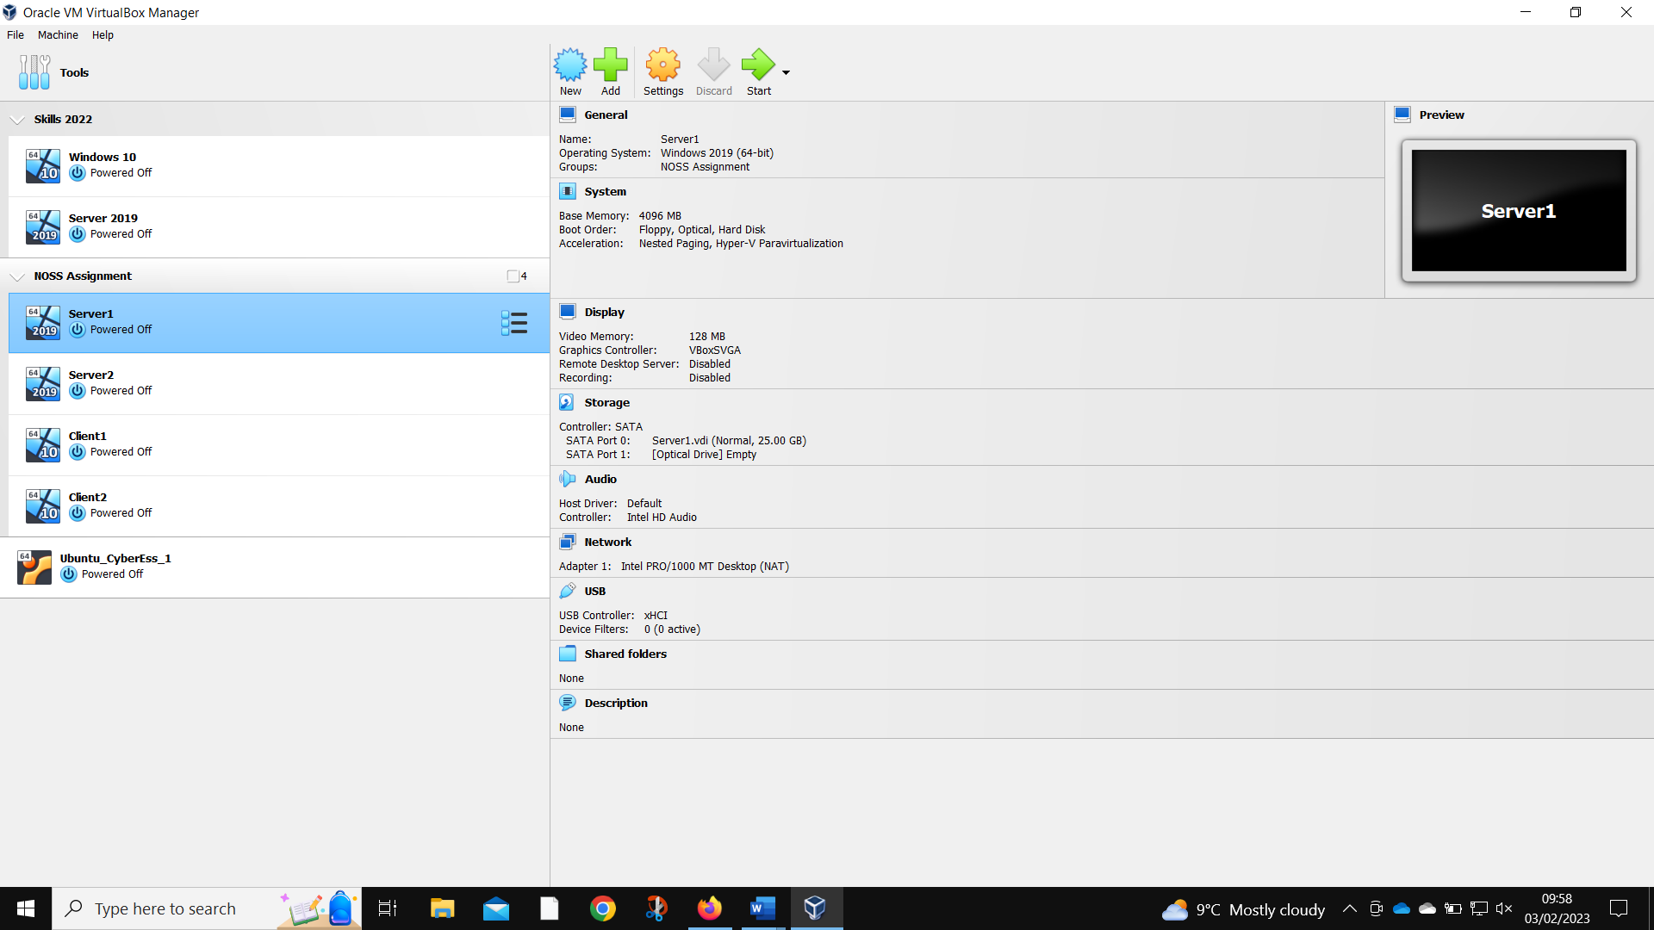
Server 1 created.
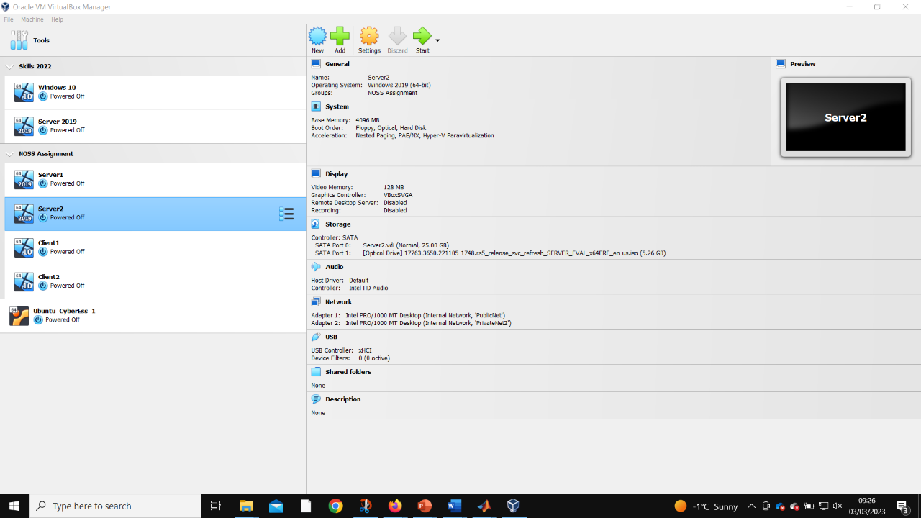
Server 2 created.
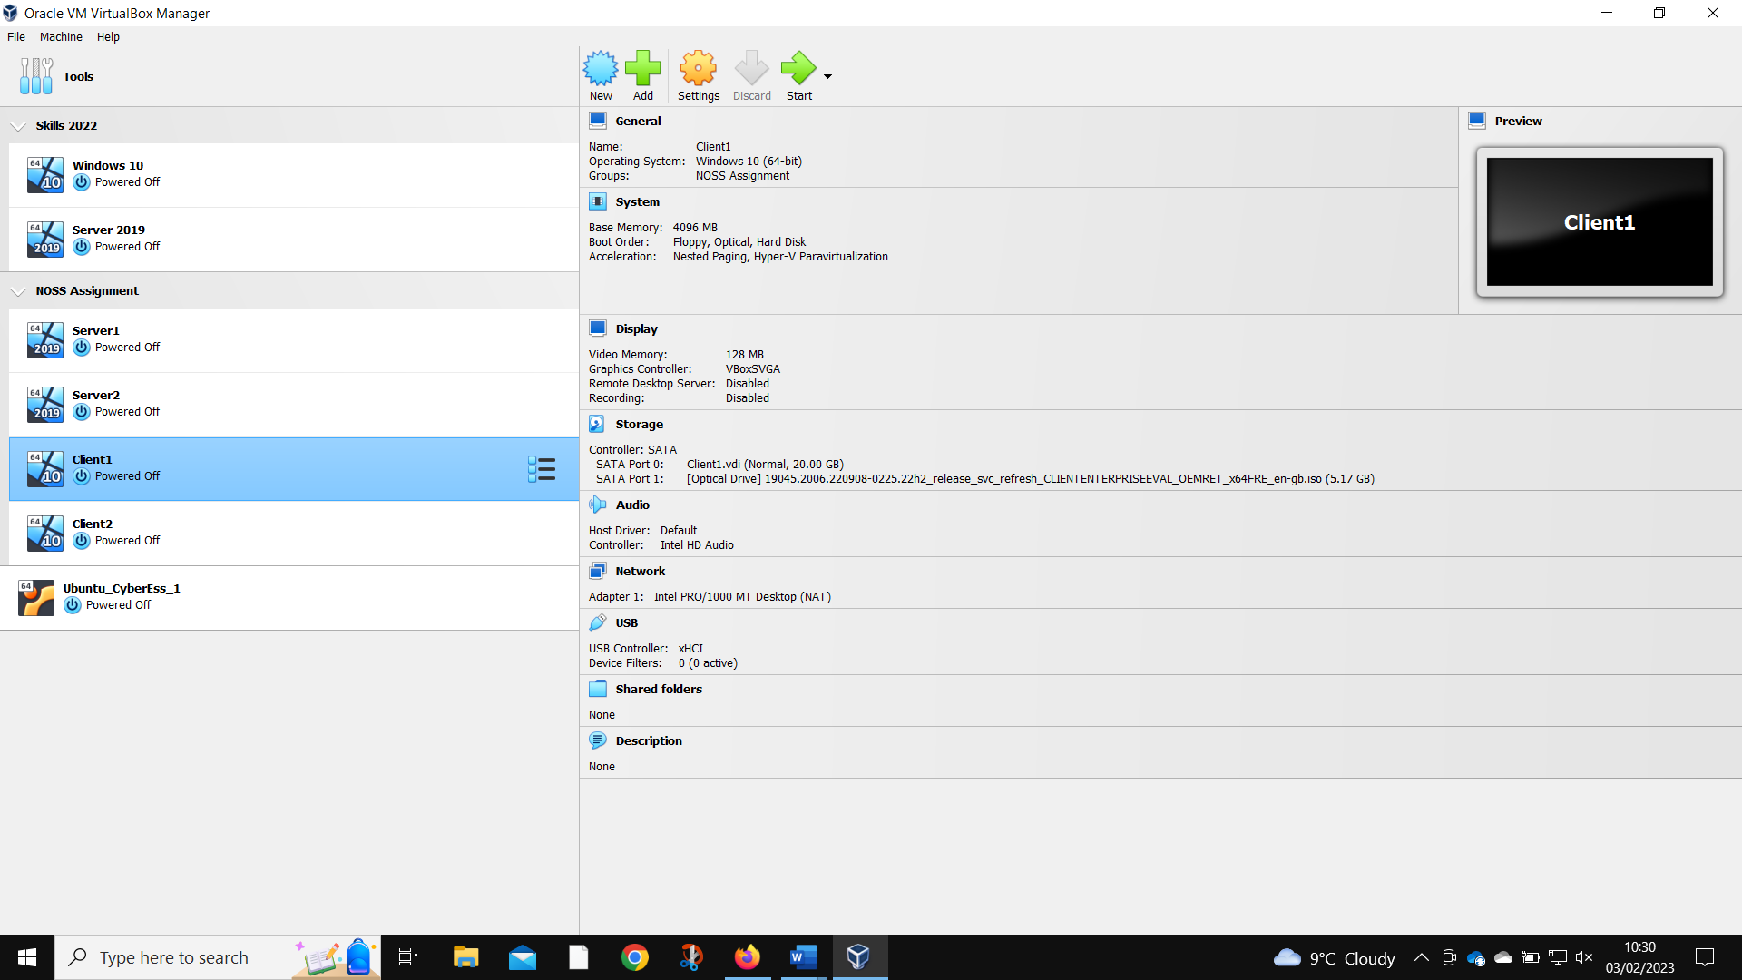
Client 1 created.
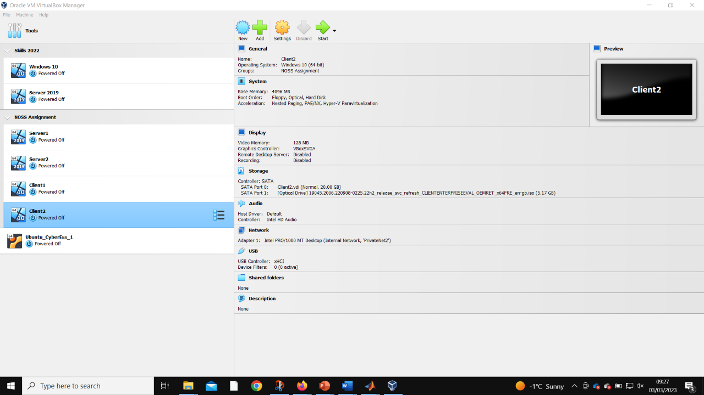
Client 2 created.
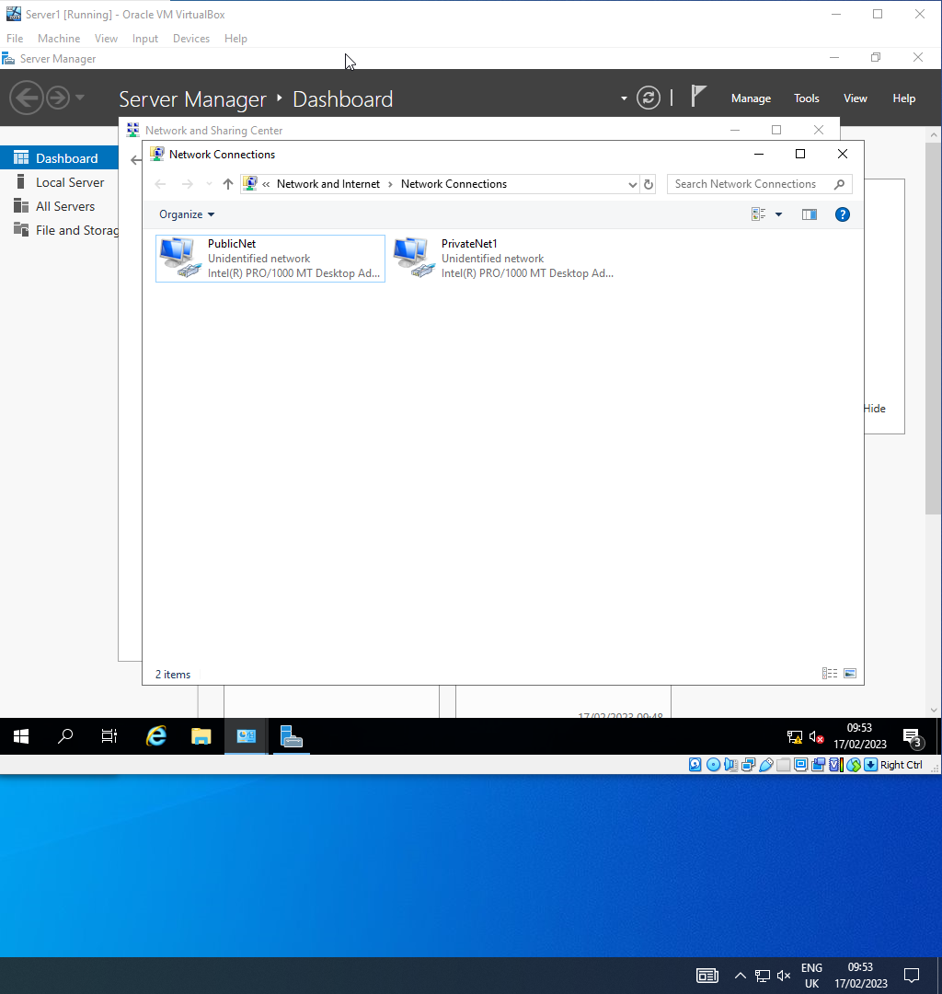
Server 1 networks named.
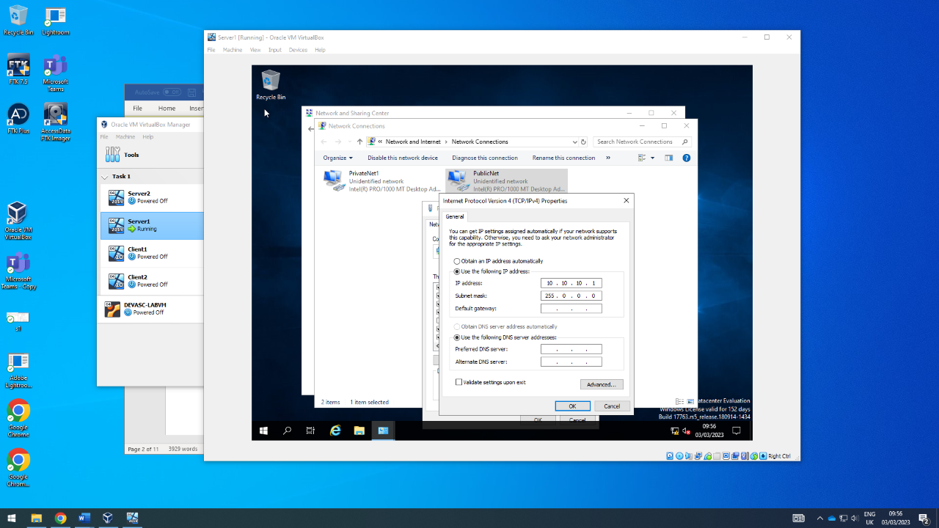
Server 1 PublicNet IP set.
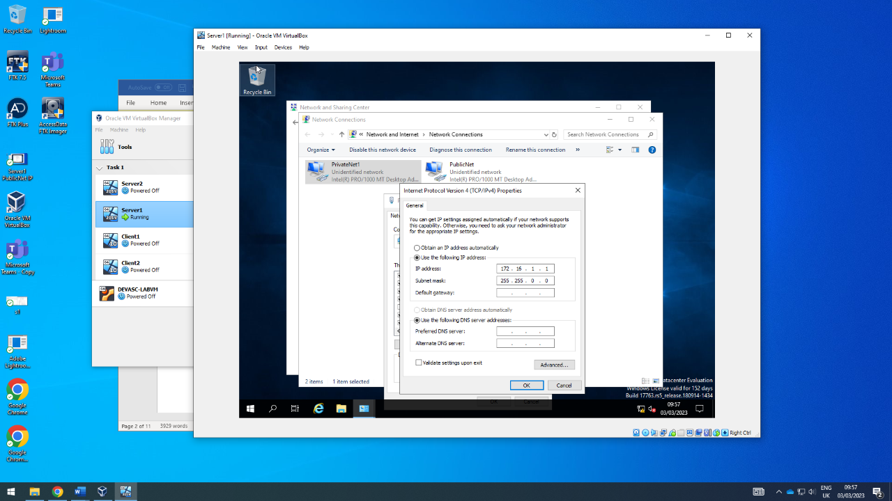
Server 1 PrivateNet1 IP set.
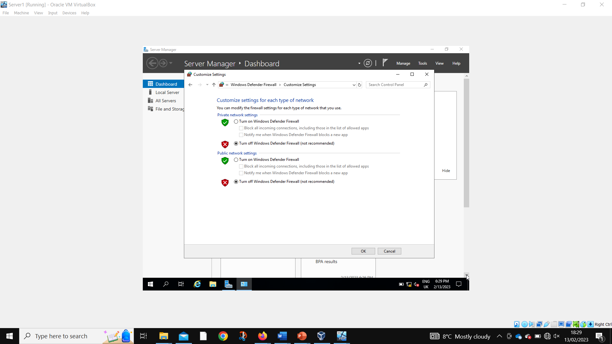
Disabling fire walls Server 1.

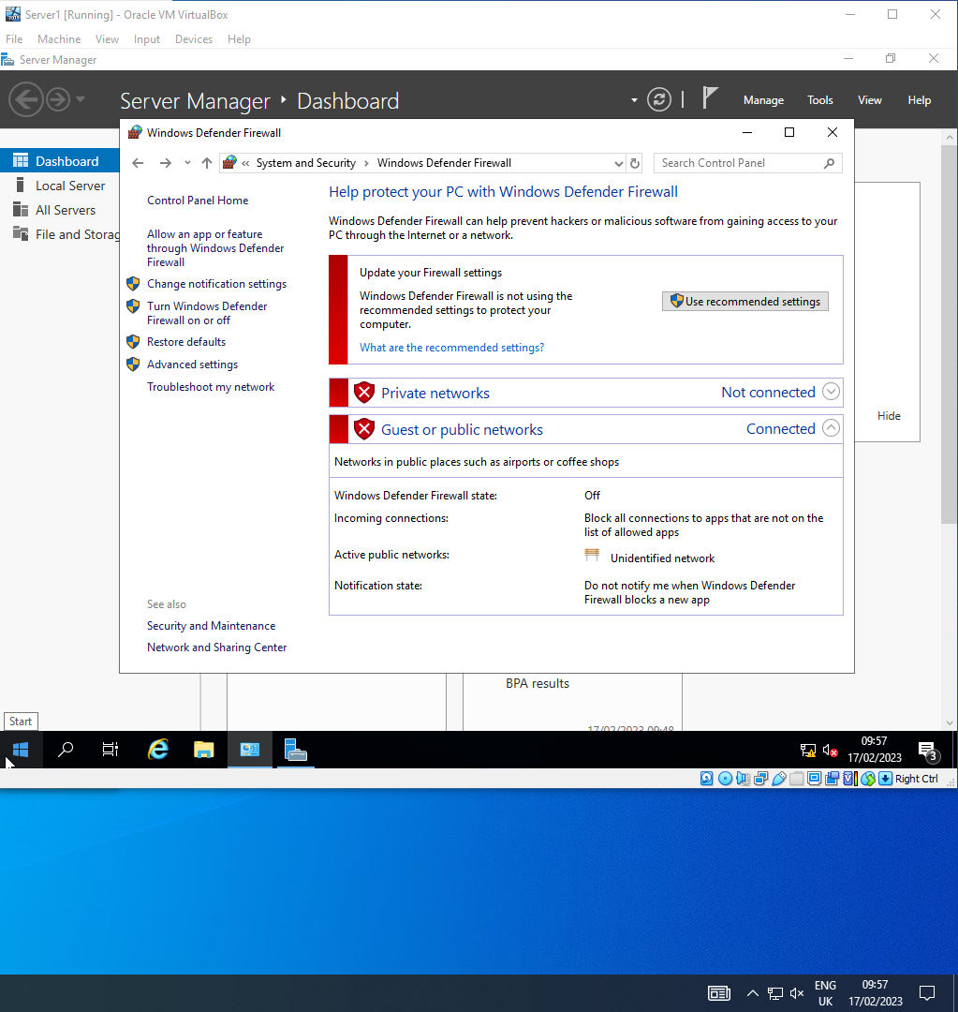
Fire walls disabled Server 1.

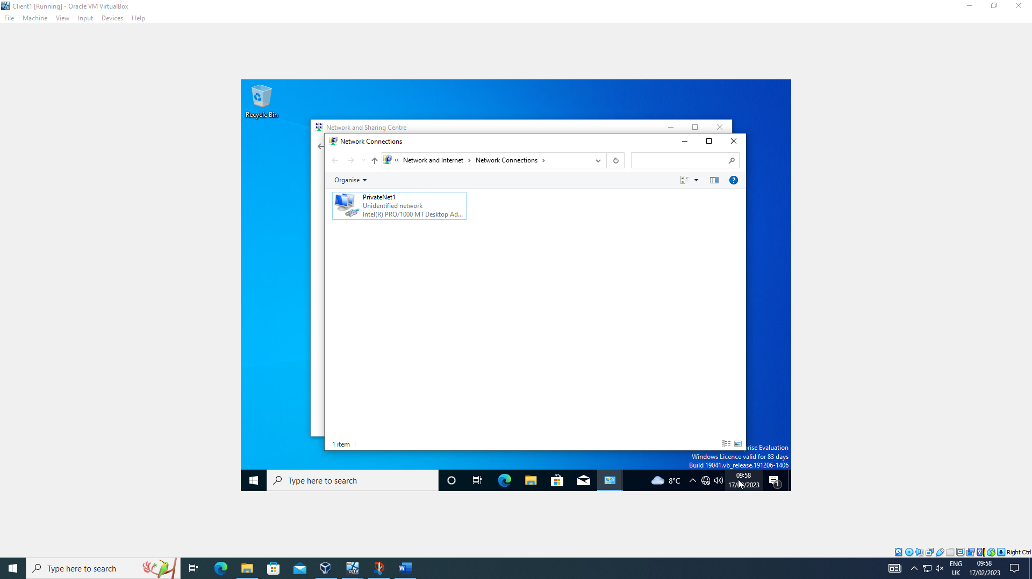
Client 1 network named.
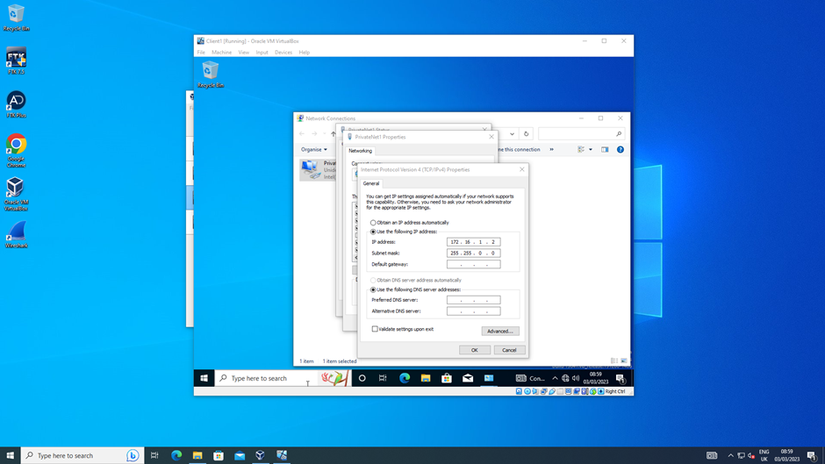
Client 1 PrivateNet1 IP set.
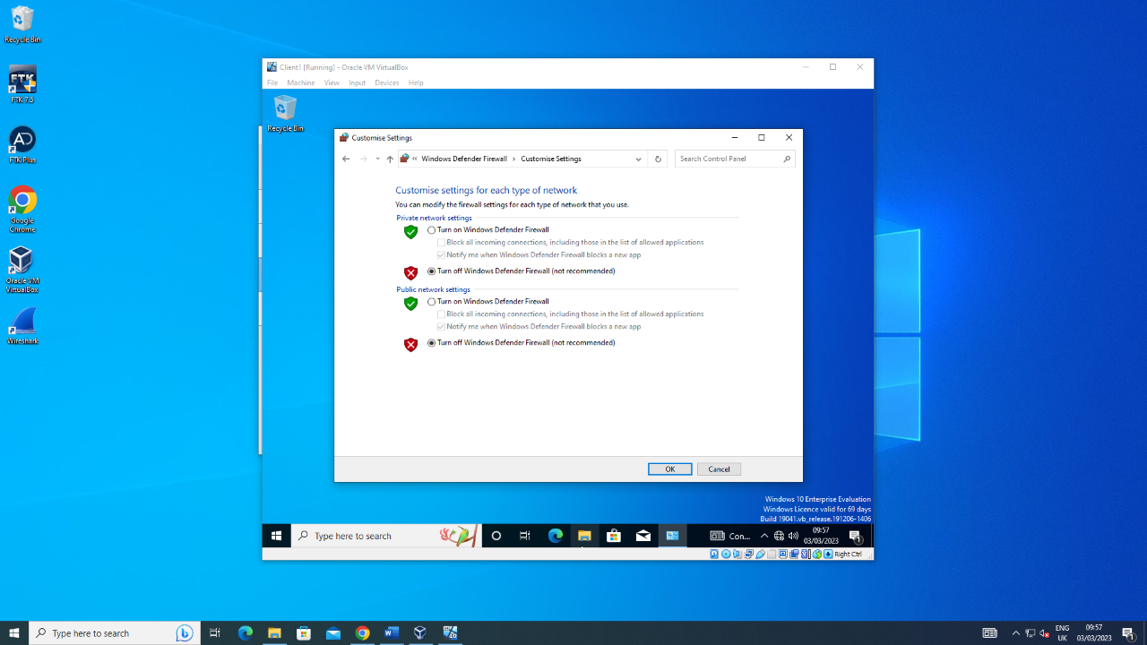
Client 1 firewalls being disabled.
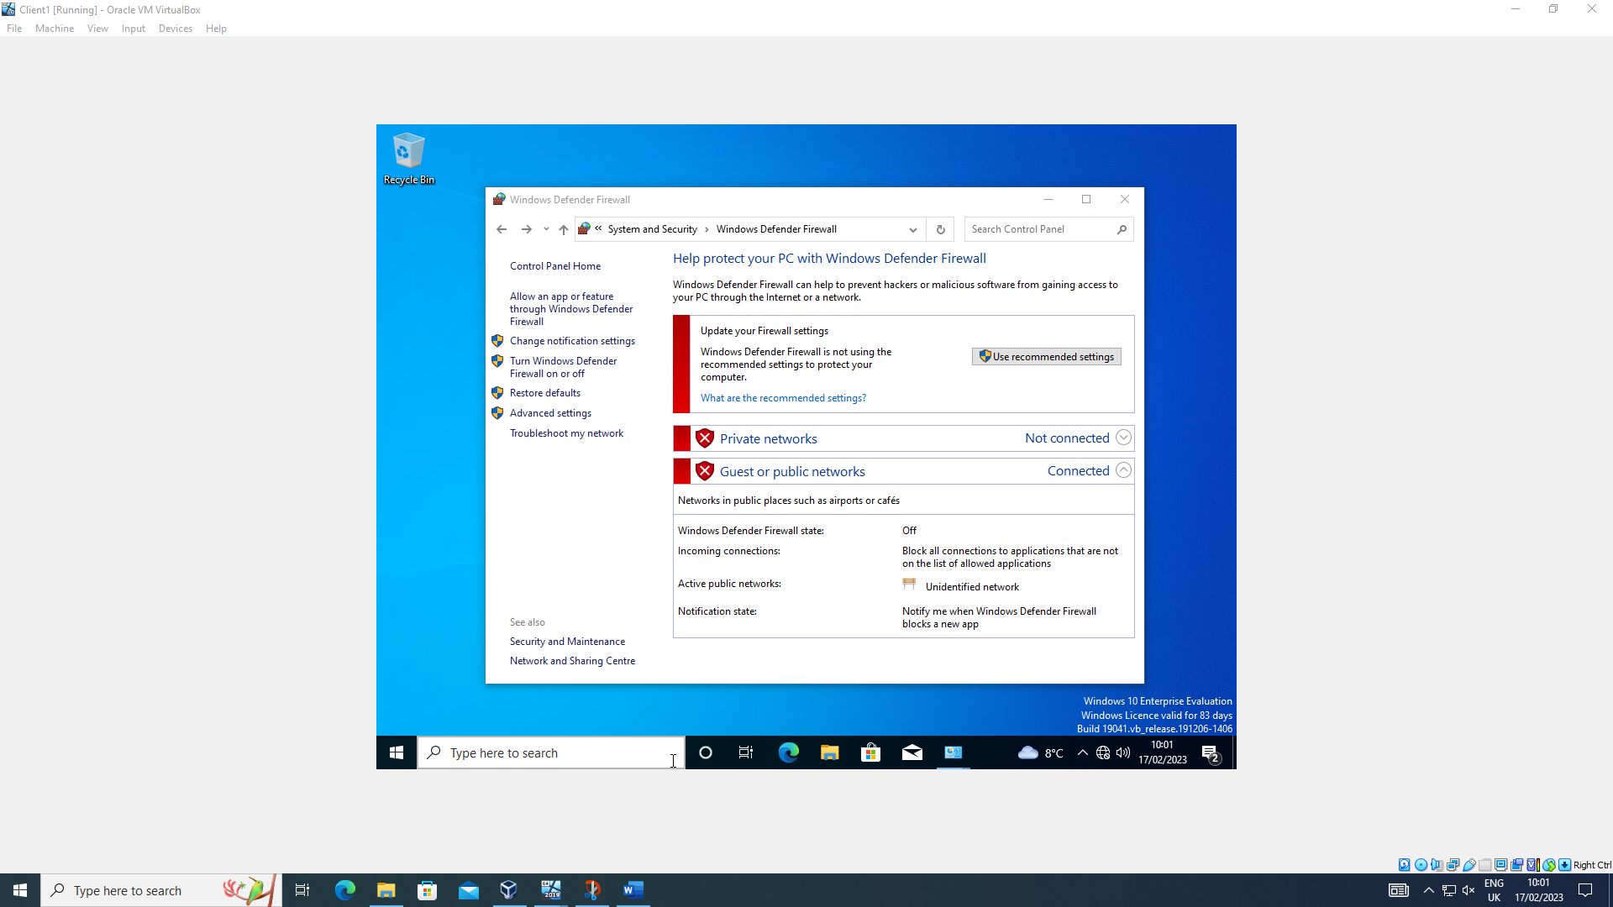
Client 1 firewalls disabled.
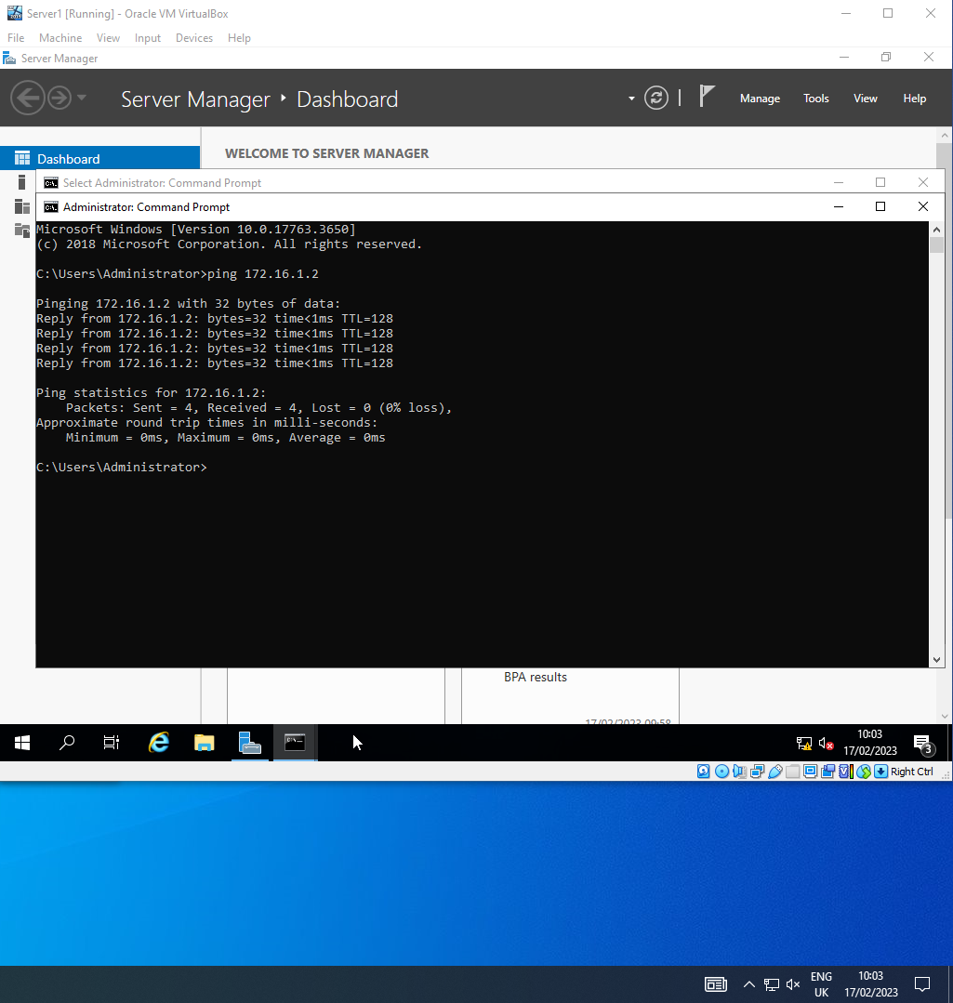
Server 1 successfully pinging client 1.
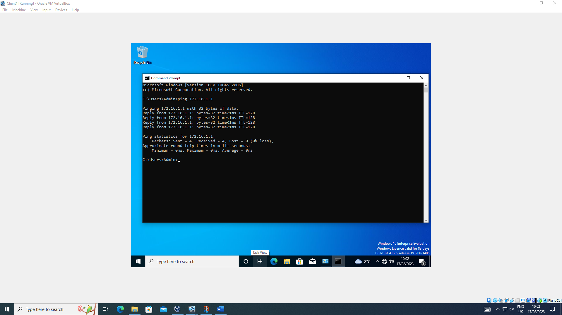
Client 1 successfully pinging server 1.
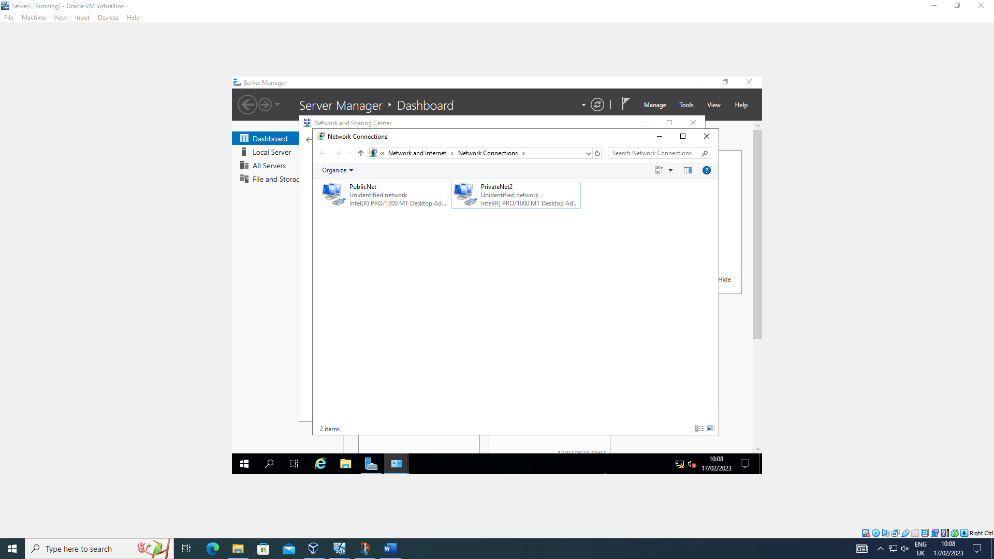
Server 2 networks named.
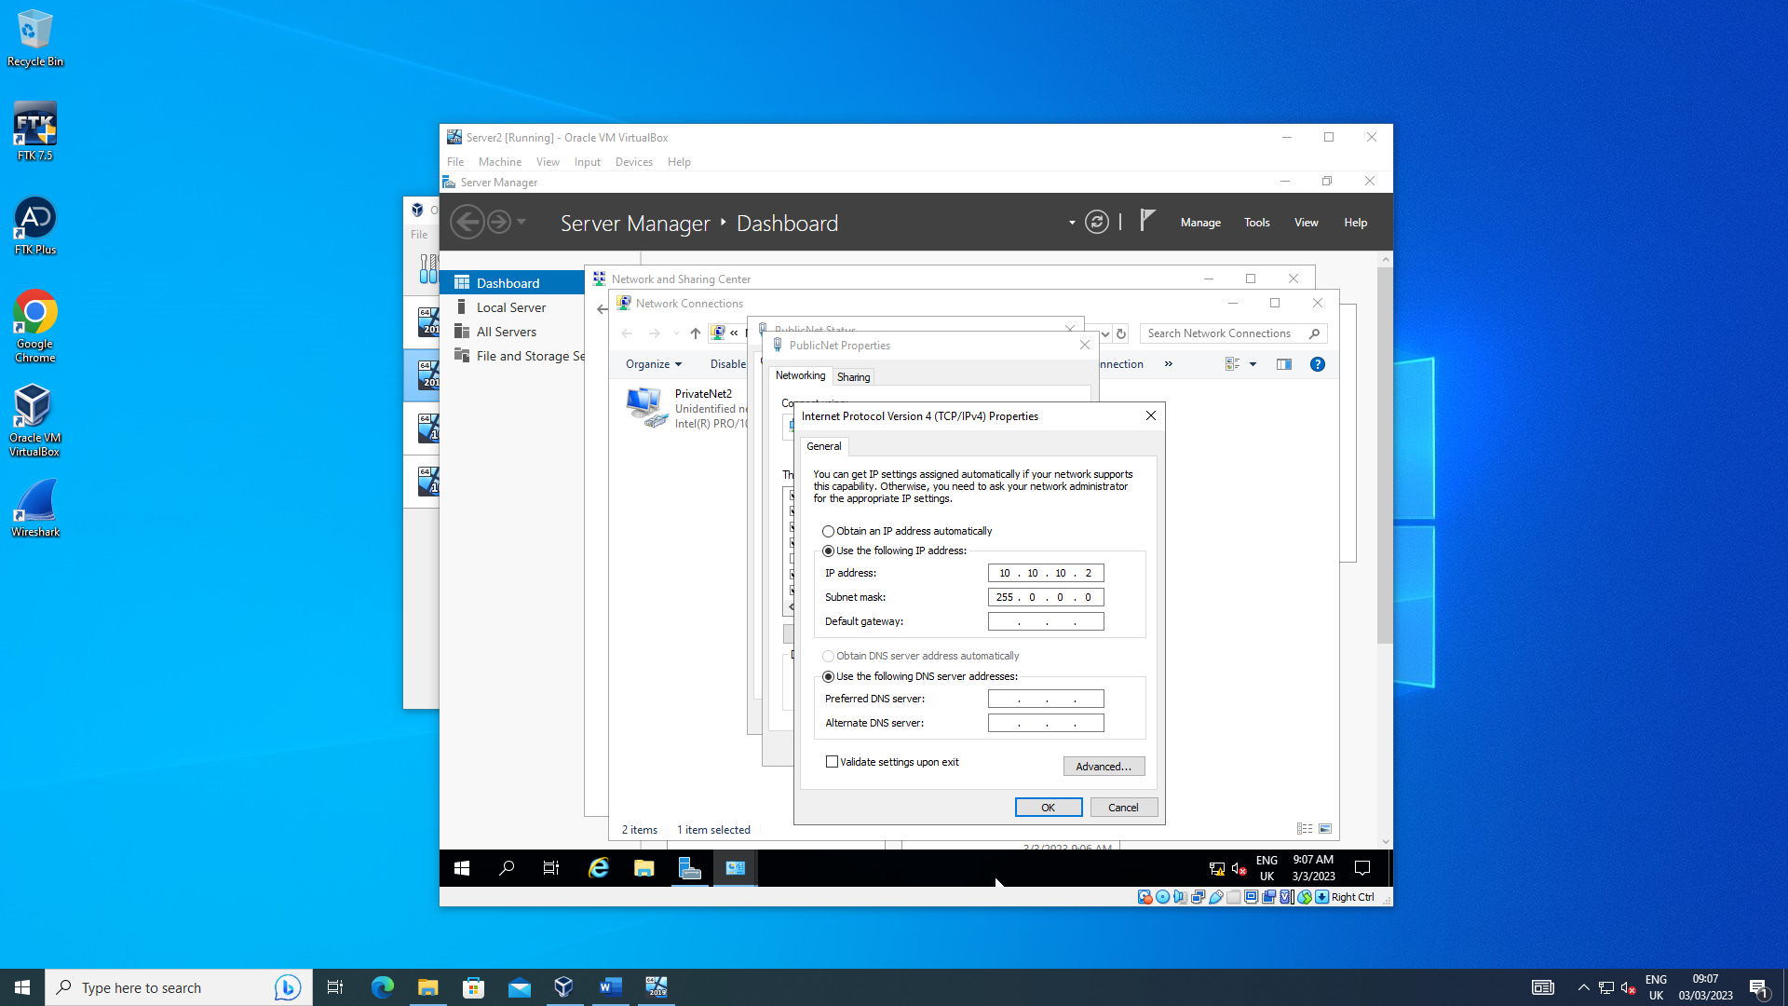
Server 2 PublicNet IP set.
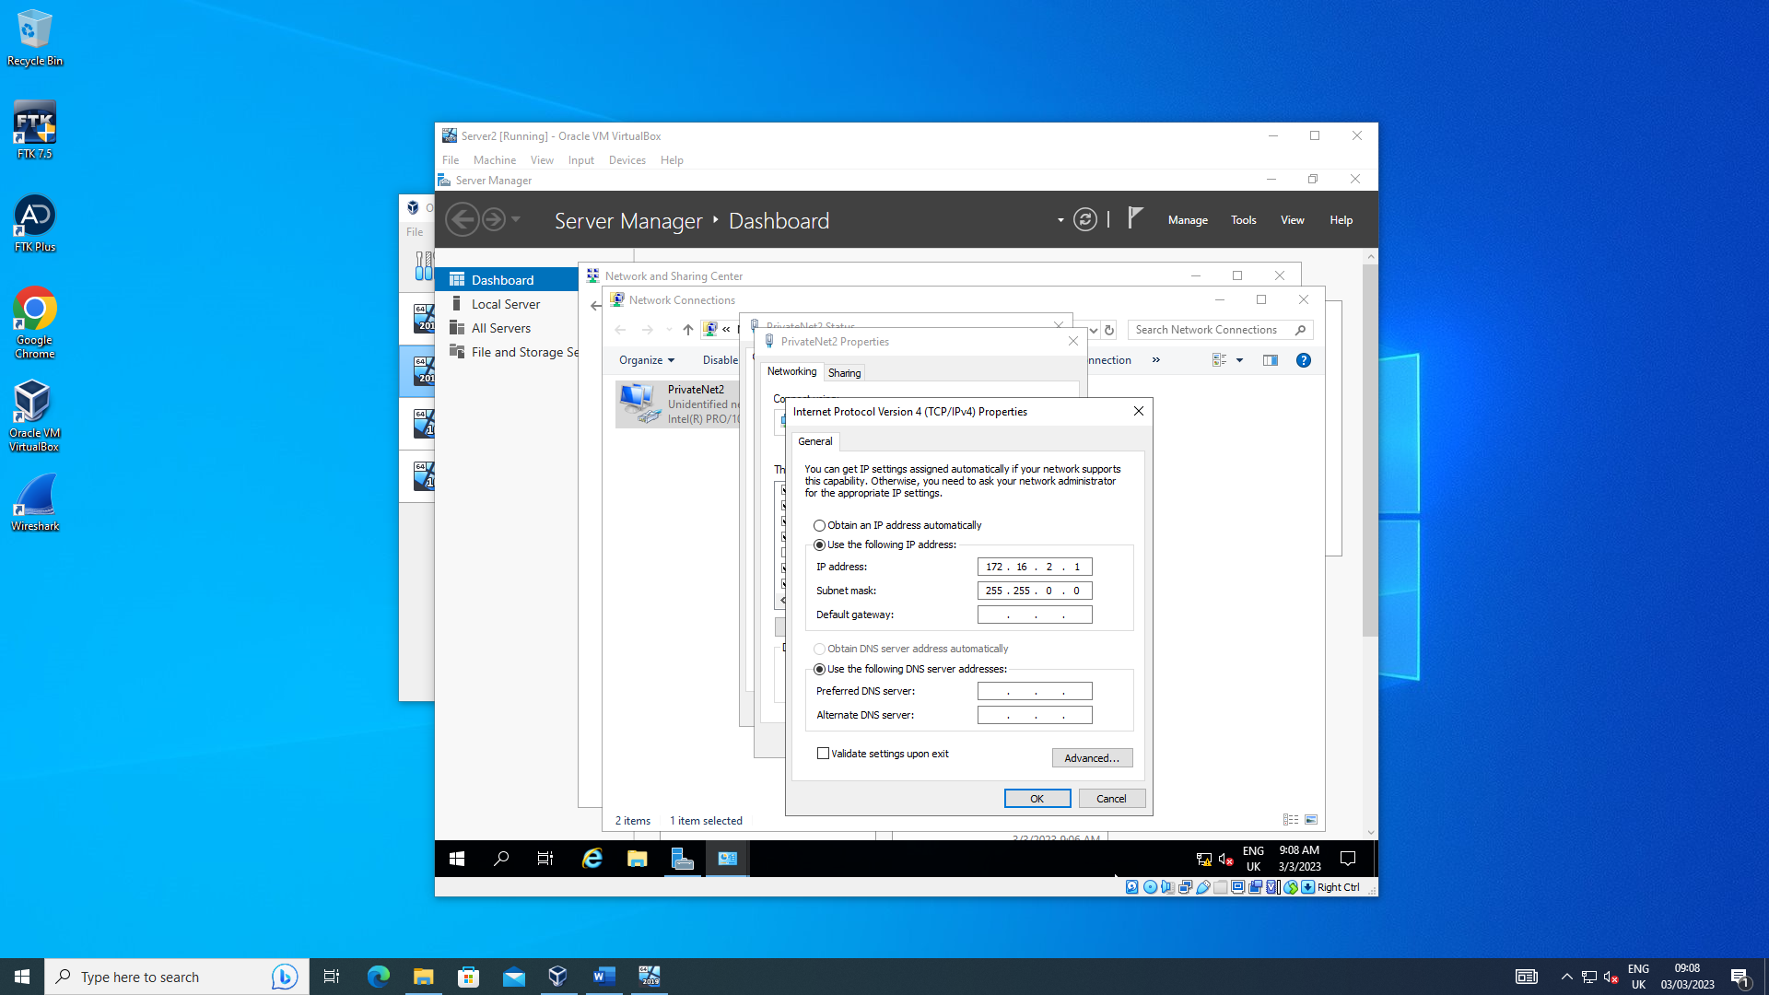
Server 2 PrivateNet2 IP set.
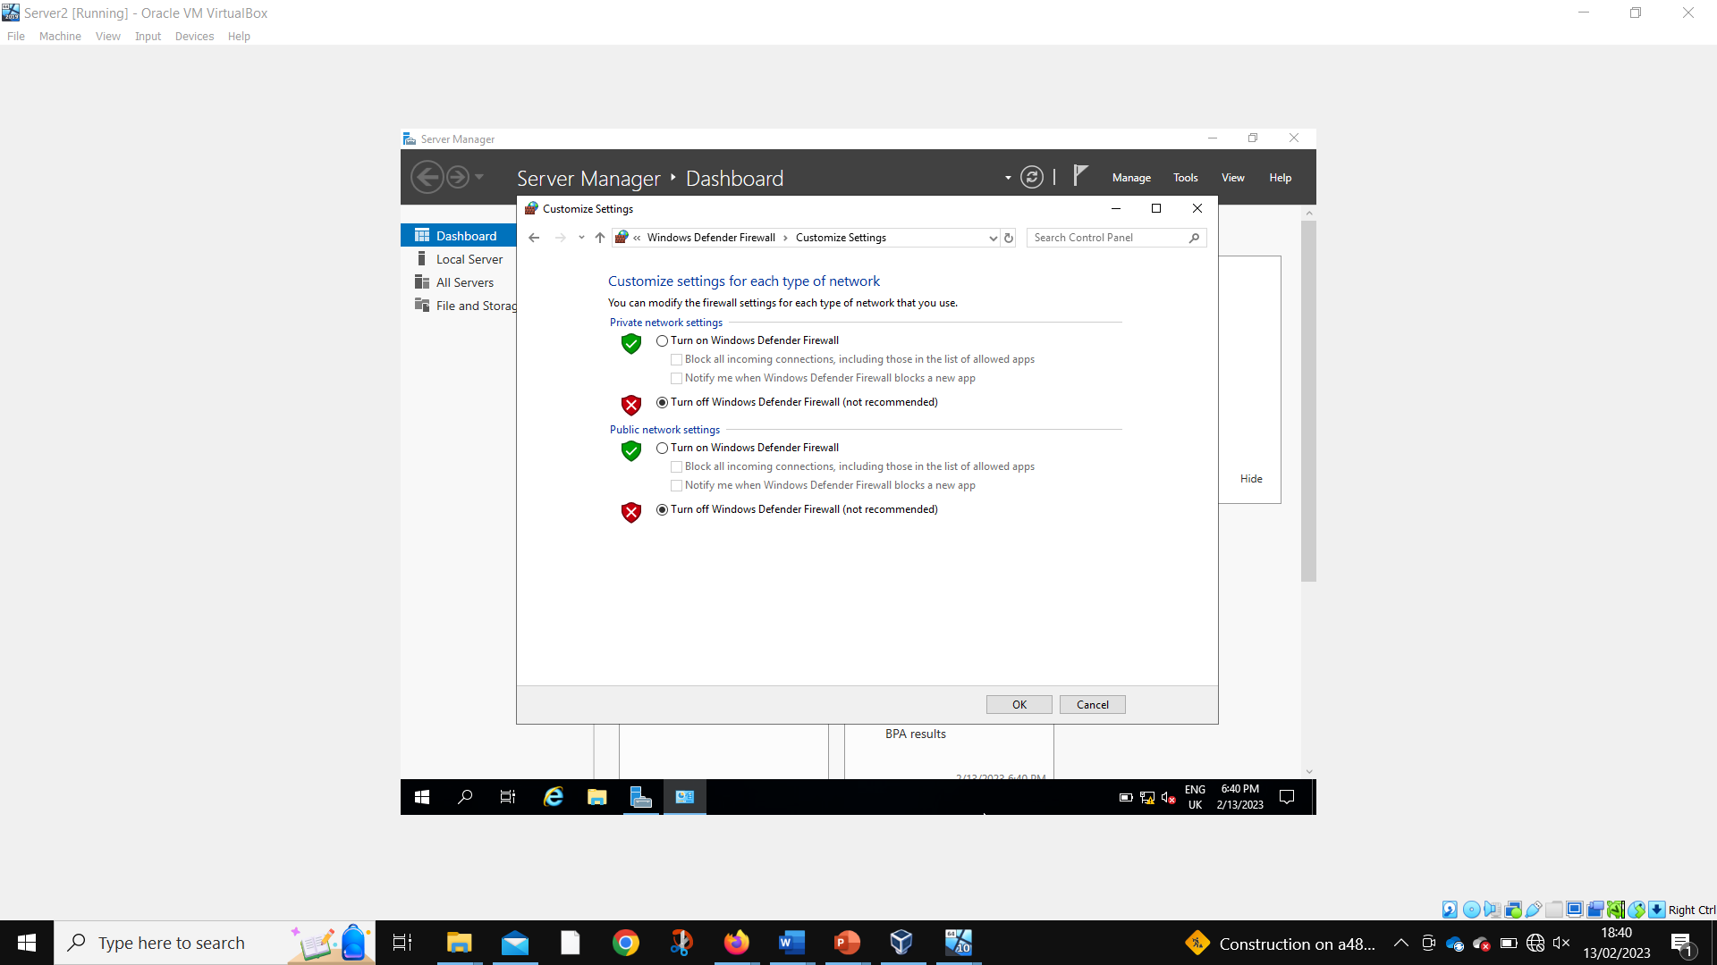
Server 2 disabling firewalls.
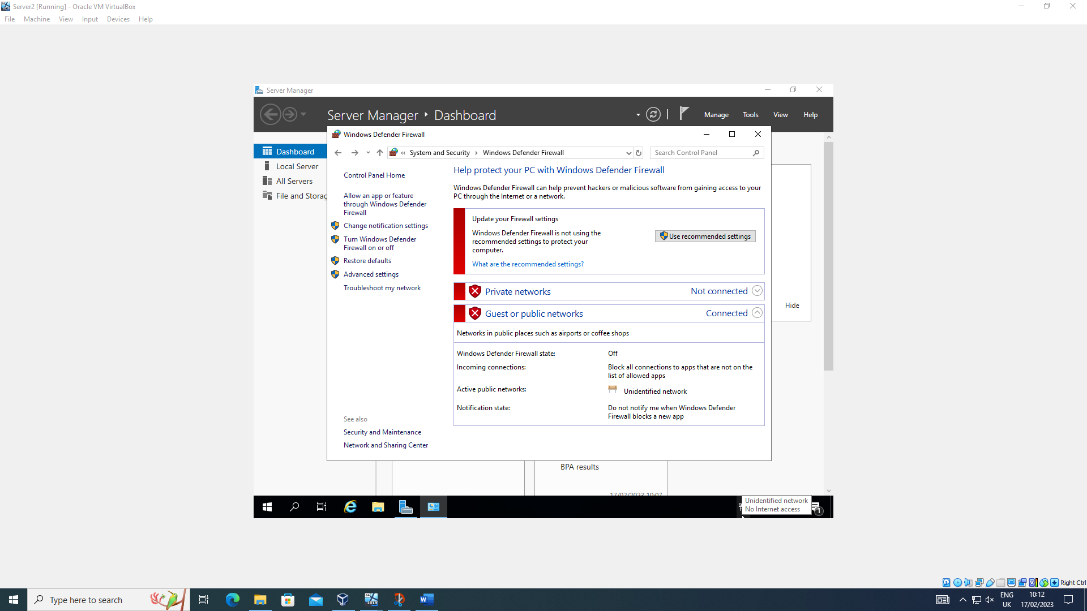
Server 2 firewalls disabled.
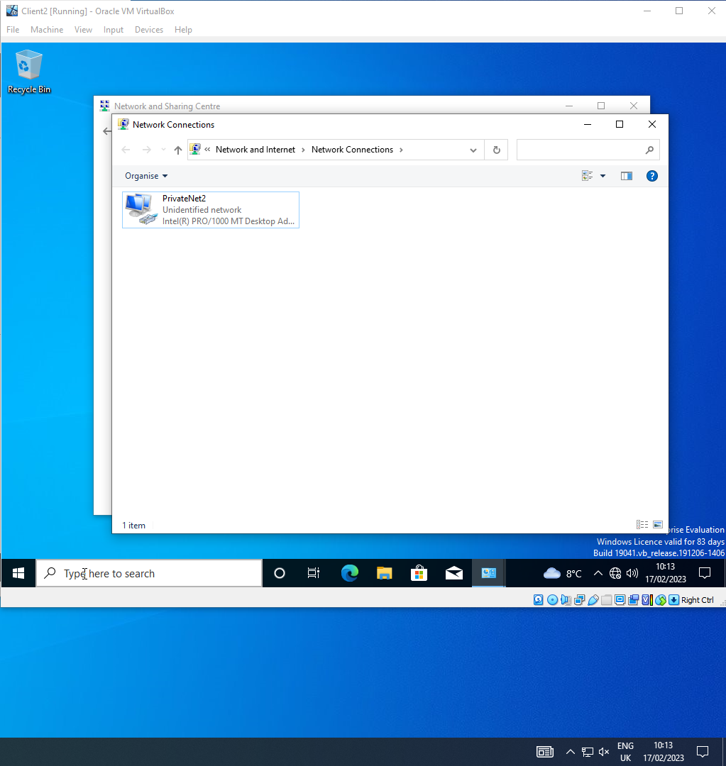
Client 2 network named.
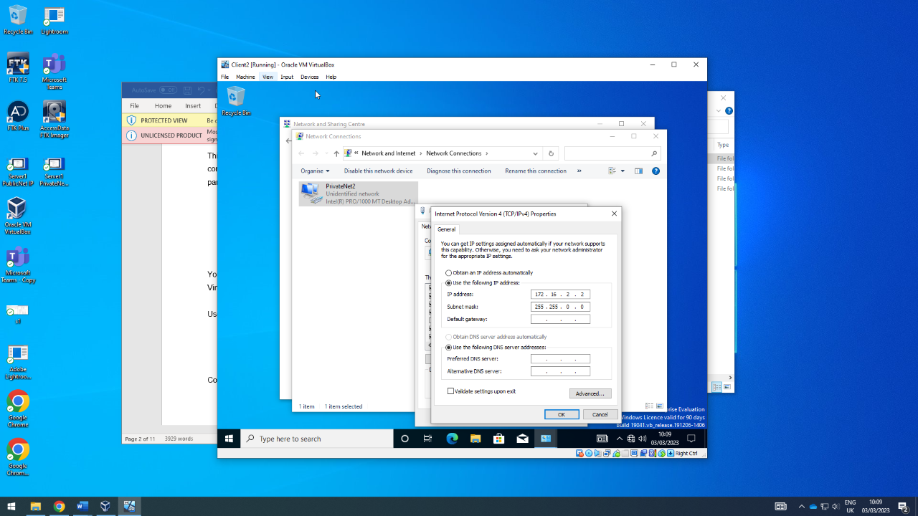
Client 2 PrivateNet2 IP set.
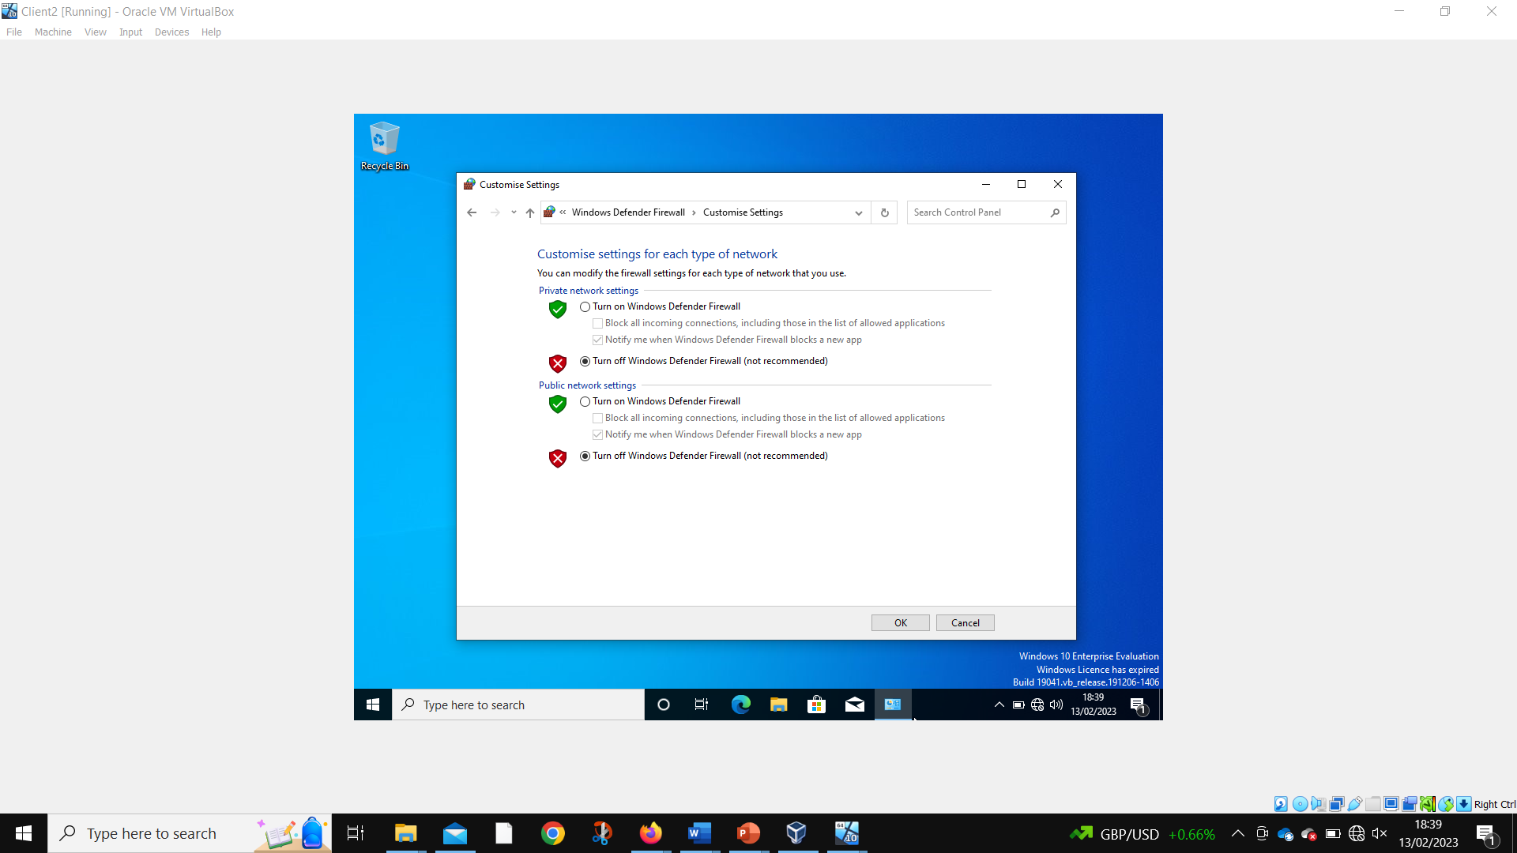
Client 2 disabling firewalls.
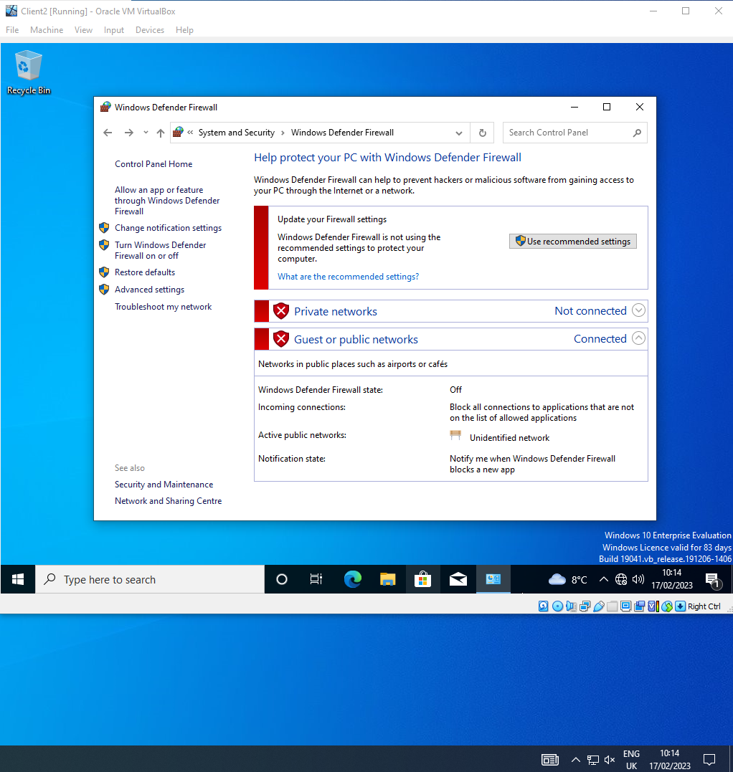
Client 2 firewalls disabled.
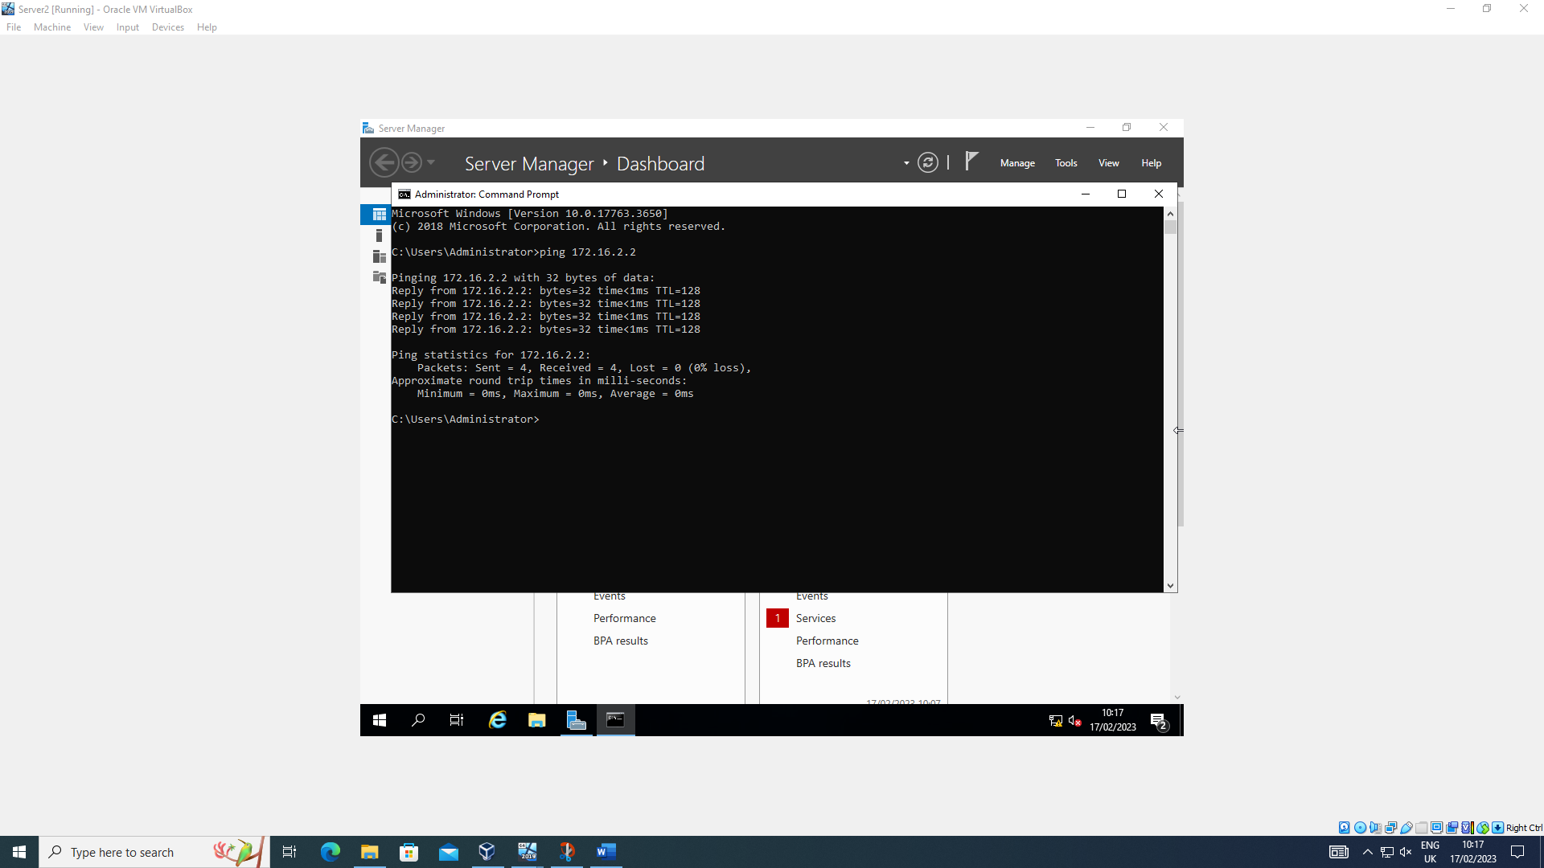
Server 2 successfully pinging Client 2.
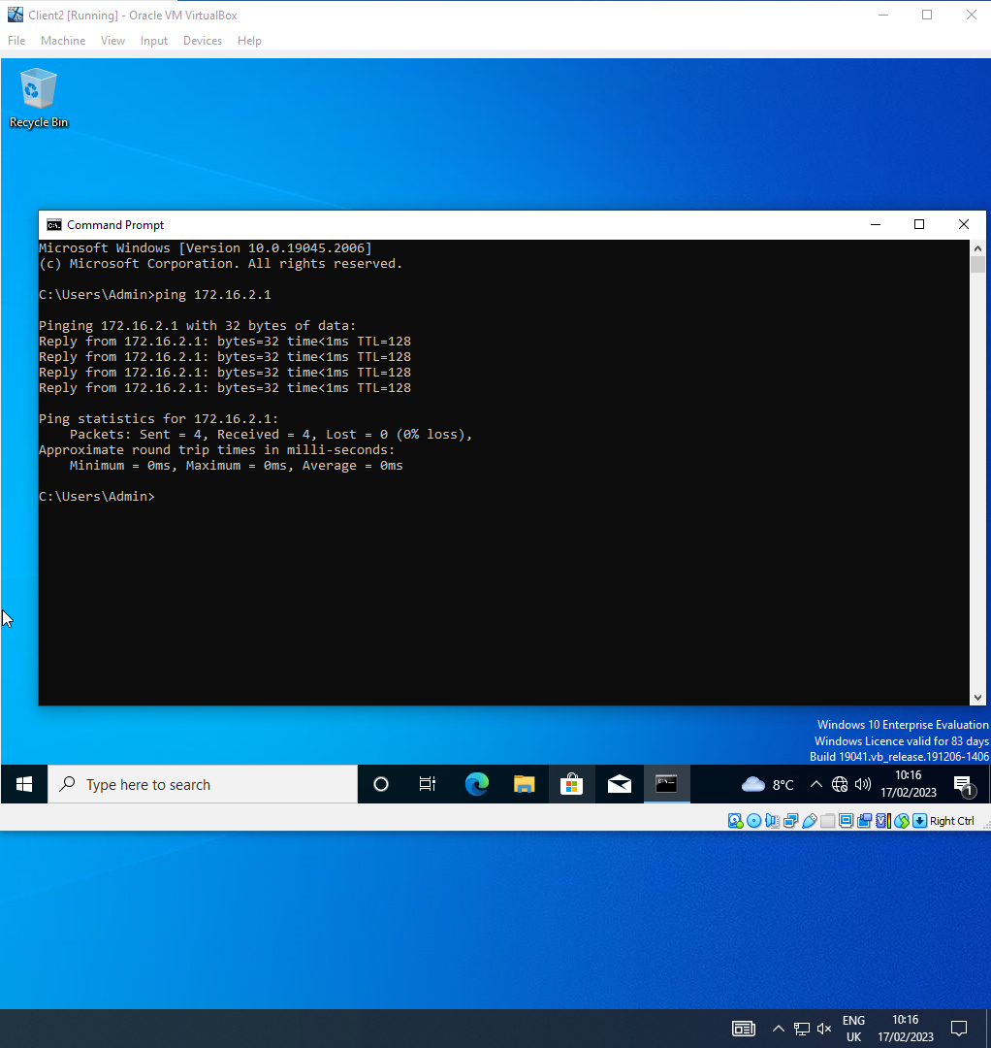
Client 2 successfully pinging server 2.

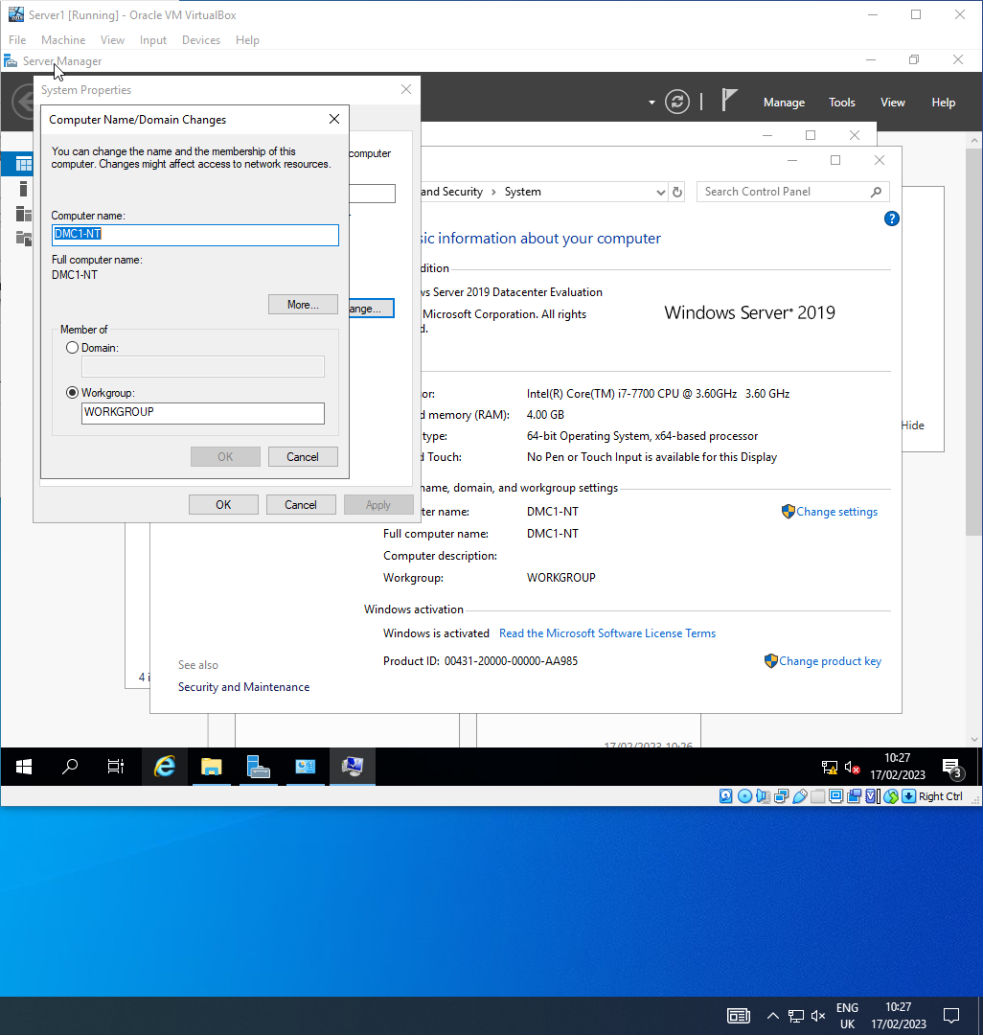
Changing Server1 computer name.
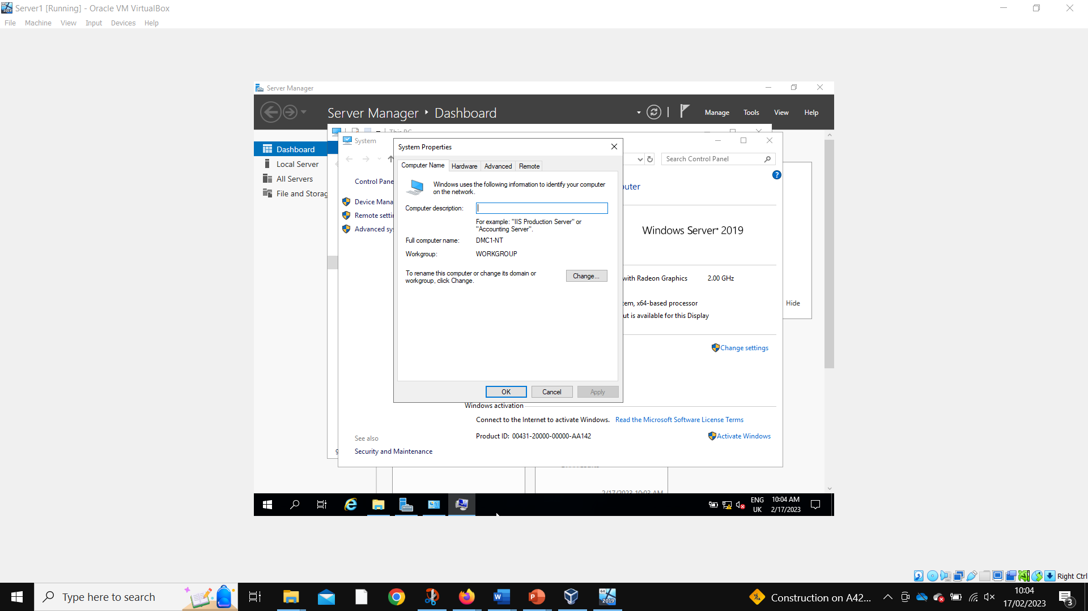
Server 1 computer name successfully changed.
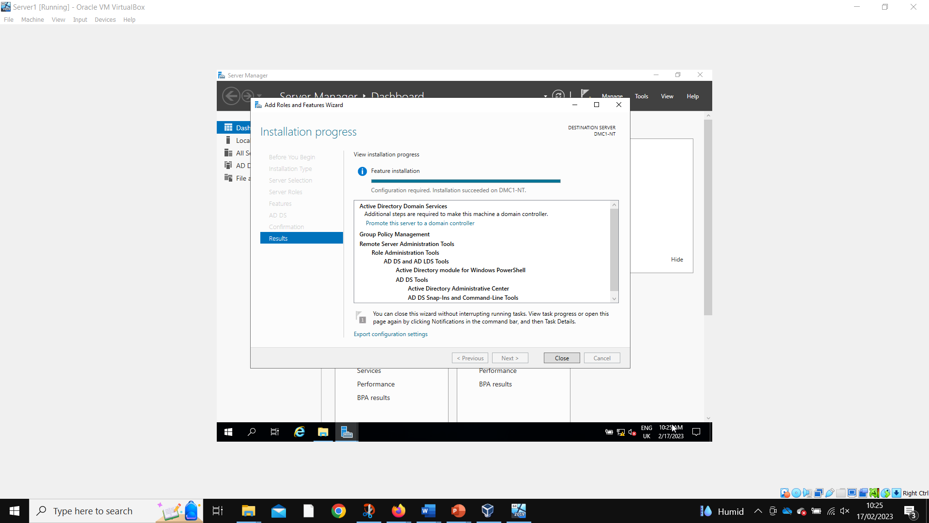
Server 1 adding active directory domain services.
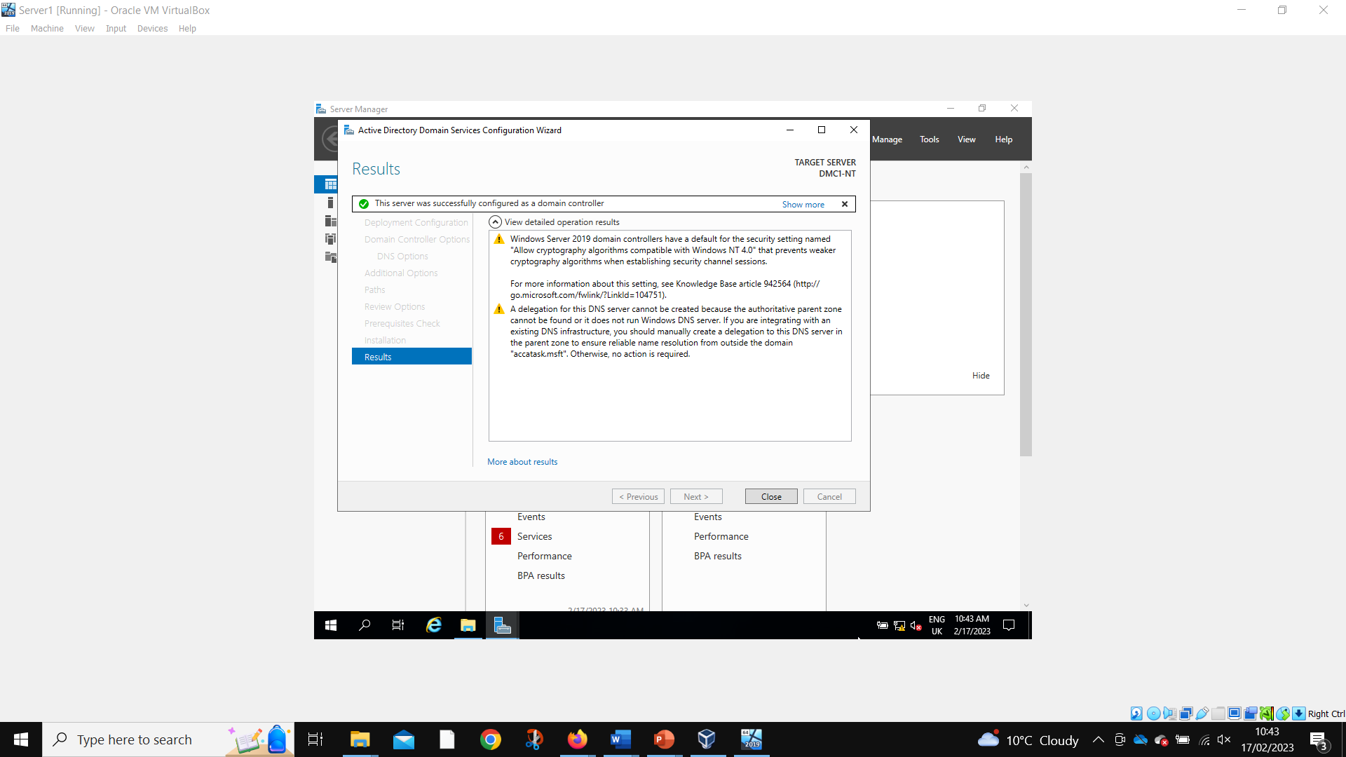
Server 1 active directory domain services successfully installed.
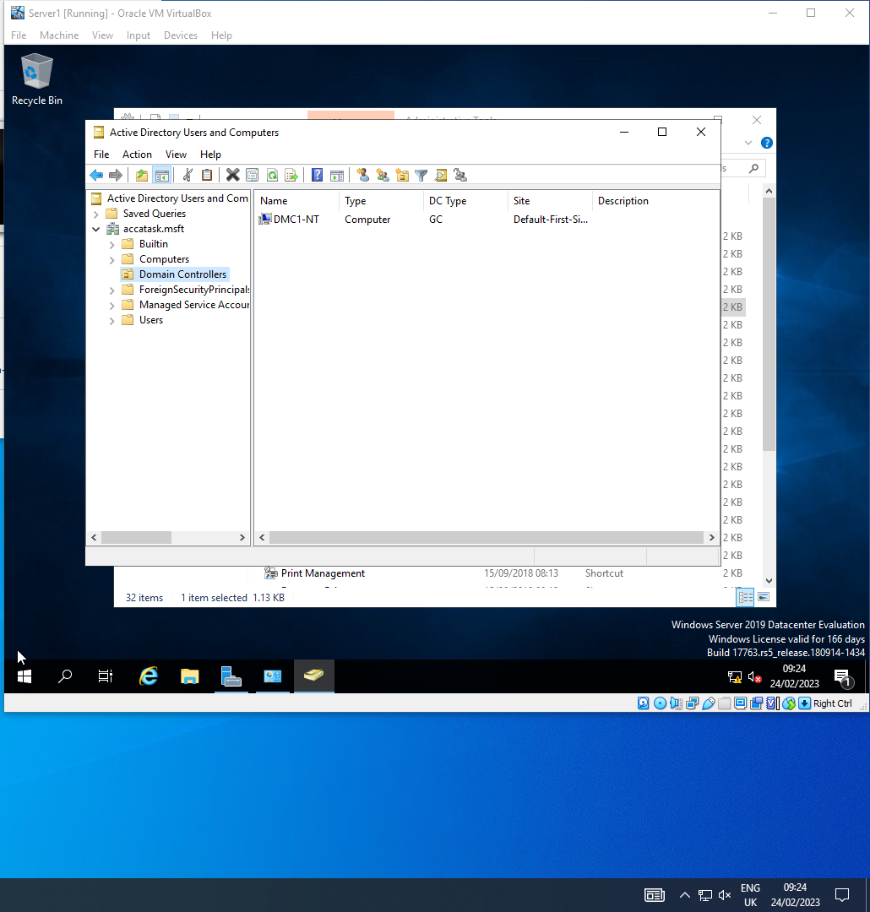
Server 1 DMC1-NT present in domain controllers.
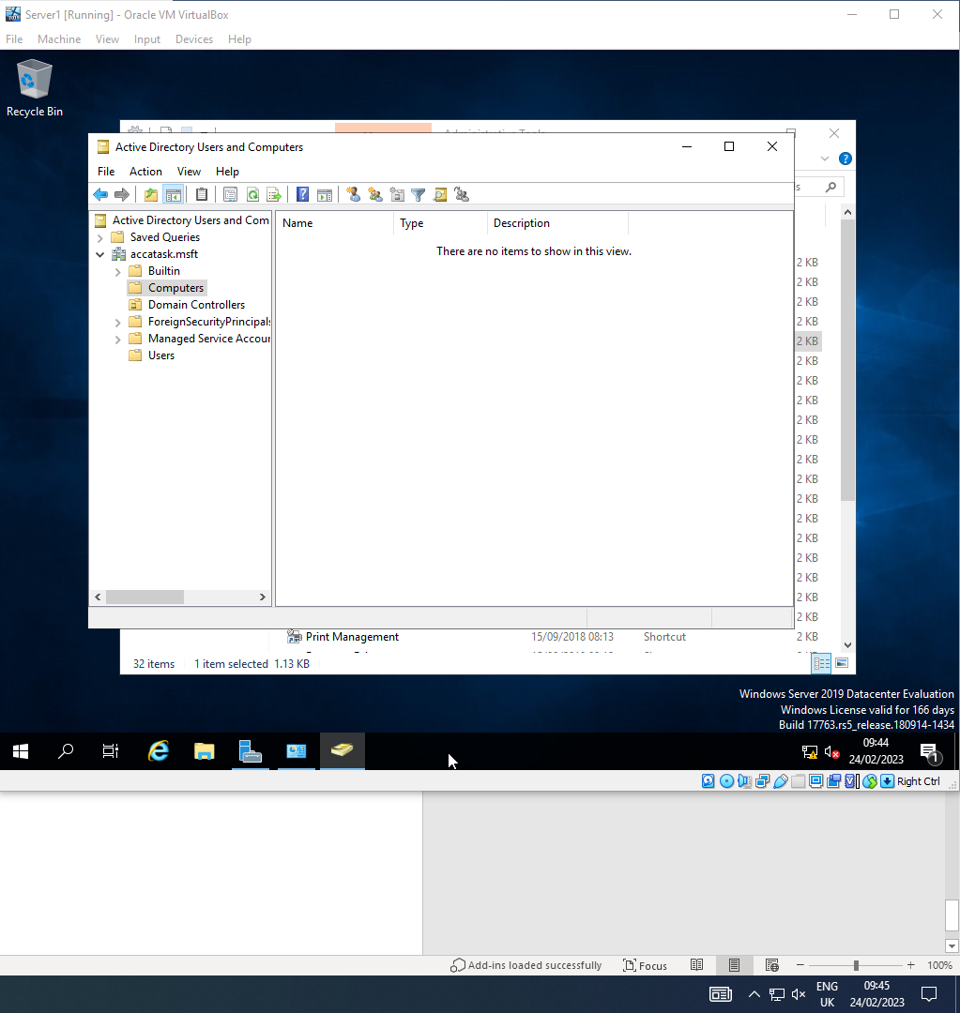
Computers folder empty.
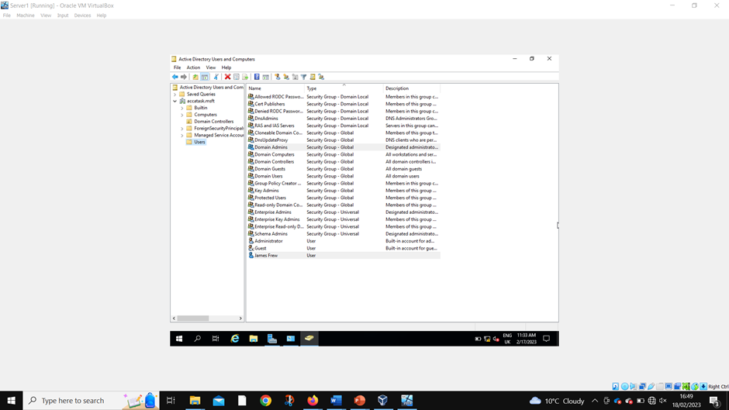
Admin account created.
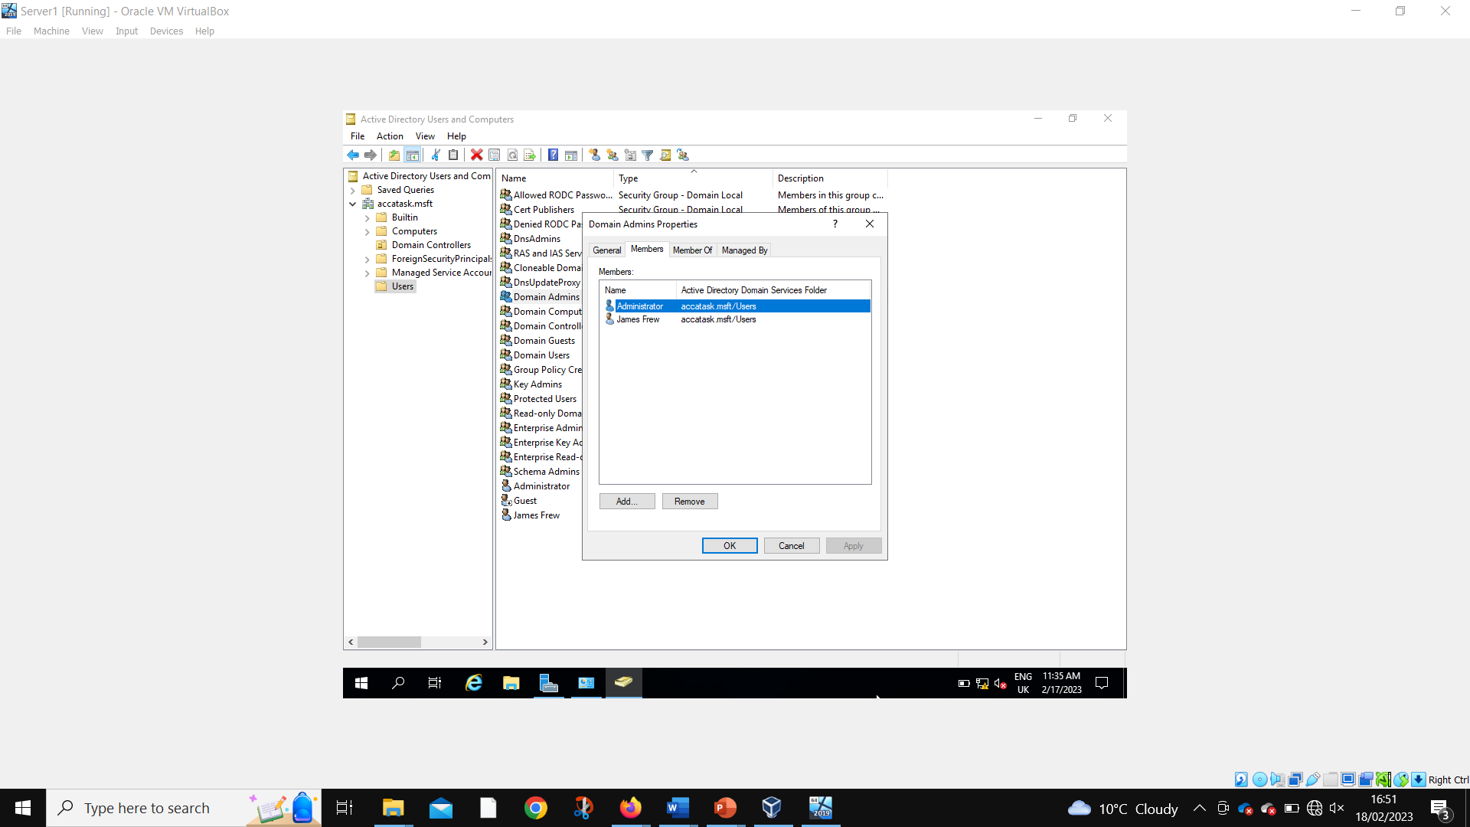
Admin account added to admin group.
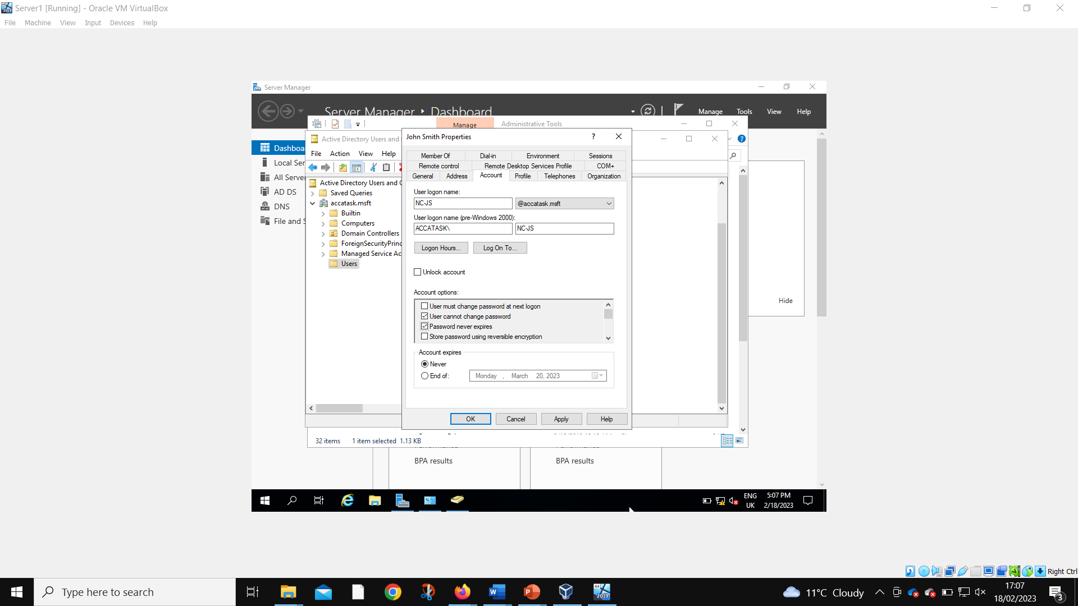
User account created.
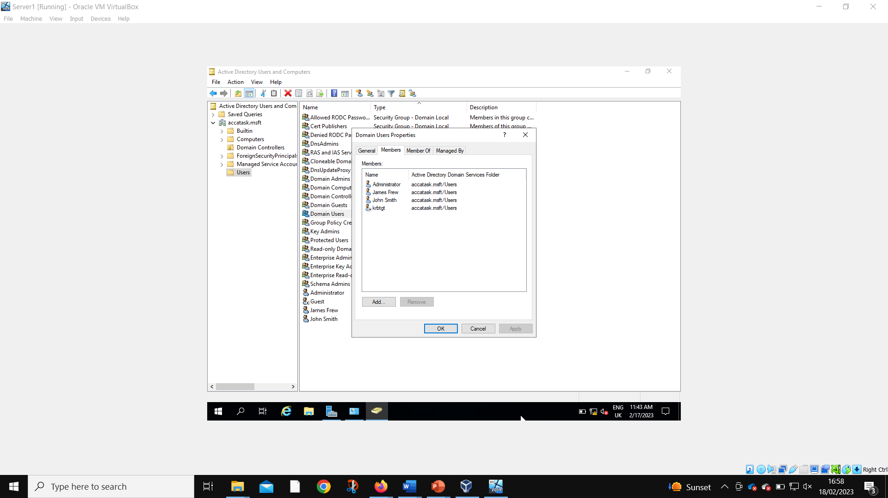
User account added to user group.
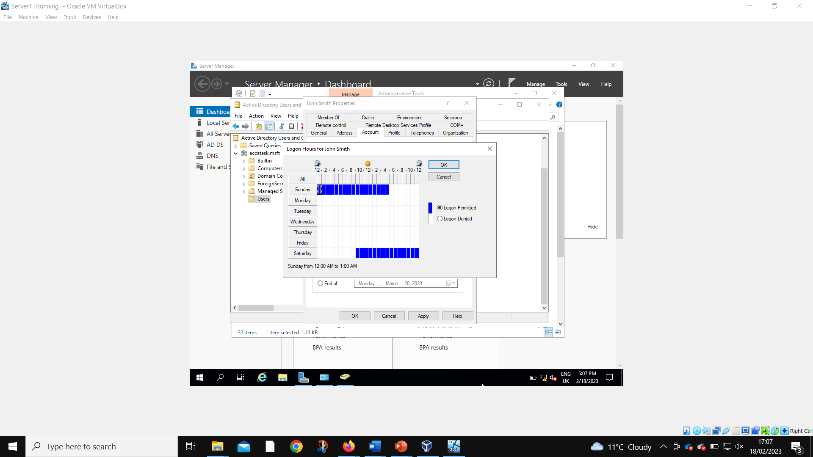
Access time restricted for user account.
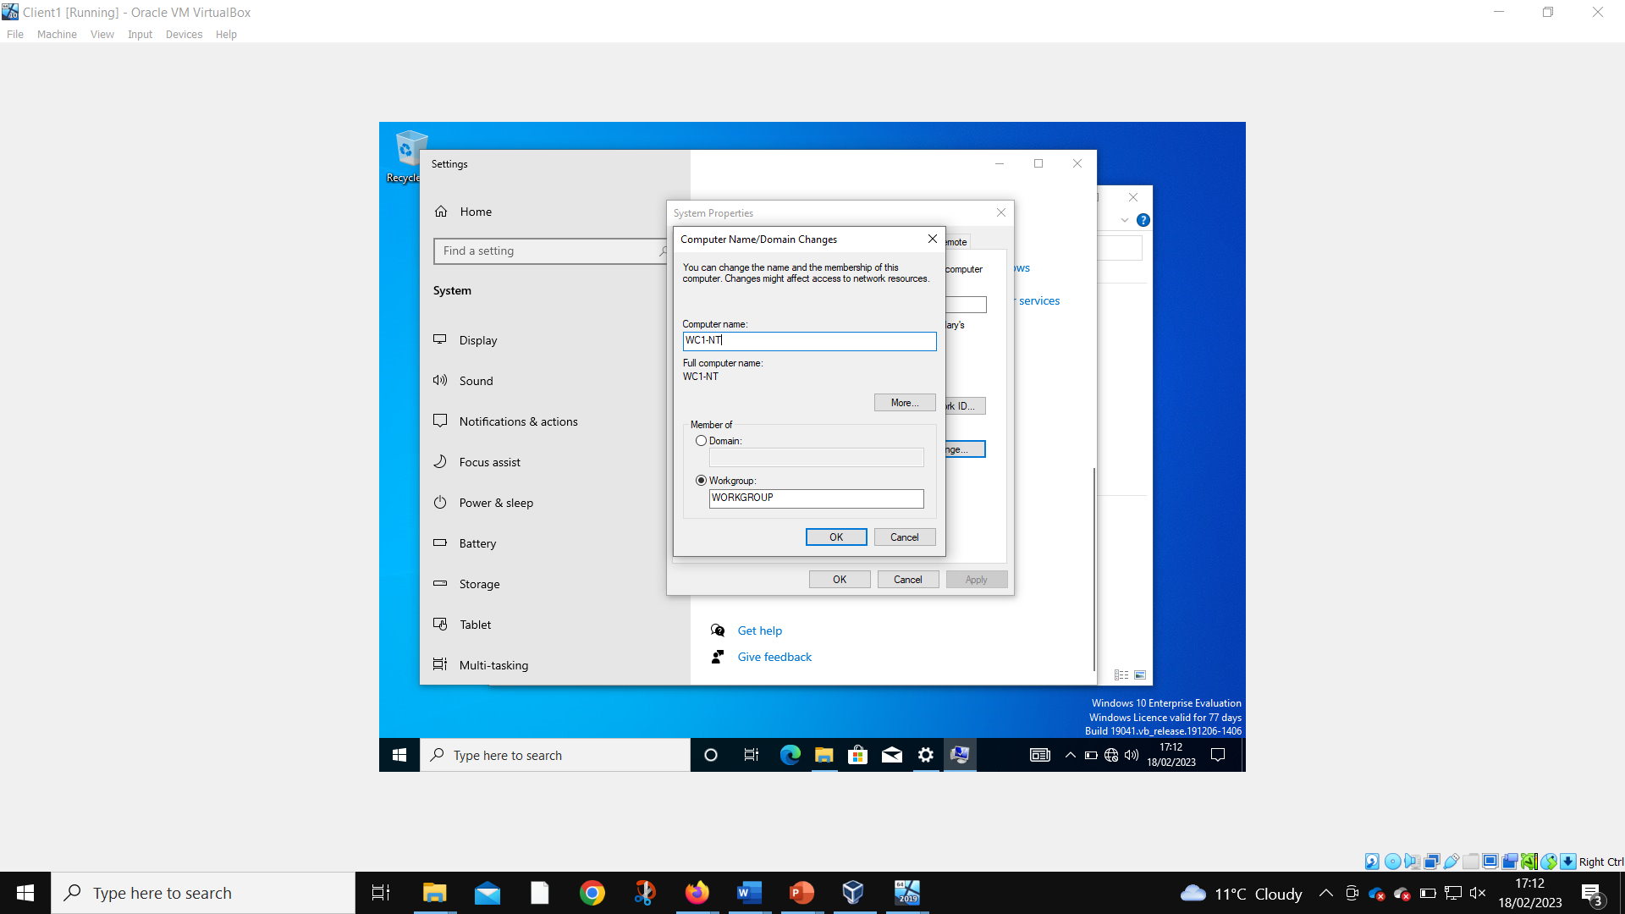
Client 1 computer name changed.
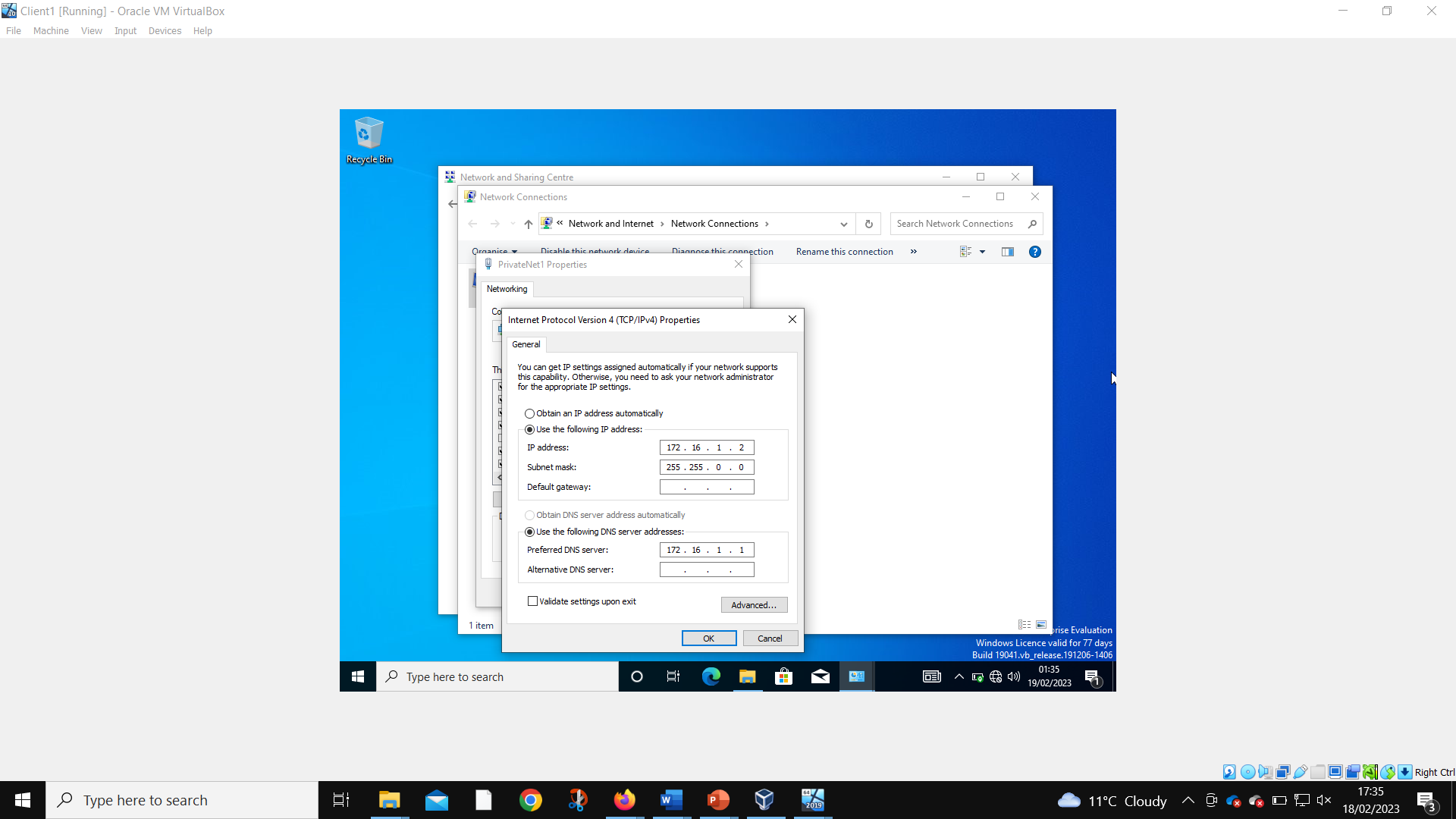
DNS IP assigned as 172.16.1.1. Instructions were to assign 10.10.10.1, but this is the address of the public network, and therefore wouldn’t work for the local DNS server connection.
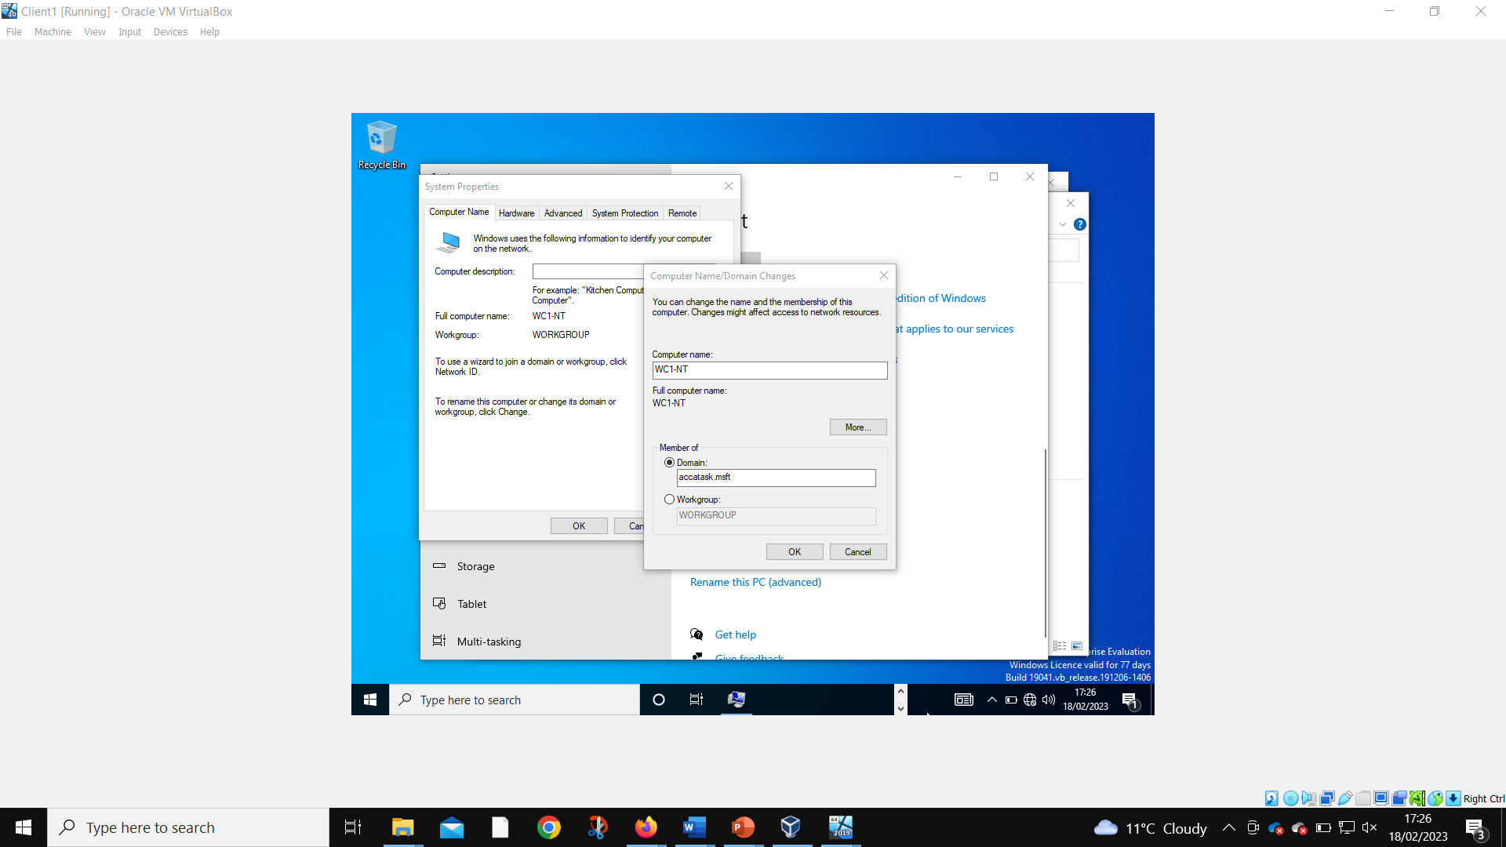
Client 1 member of domain changed.
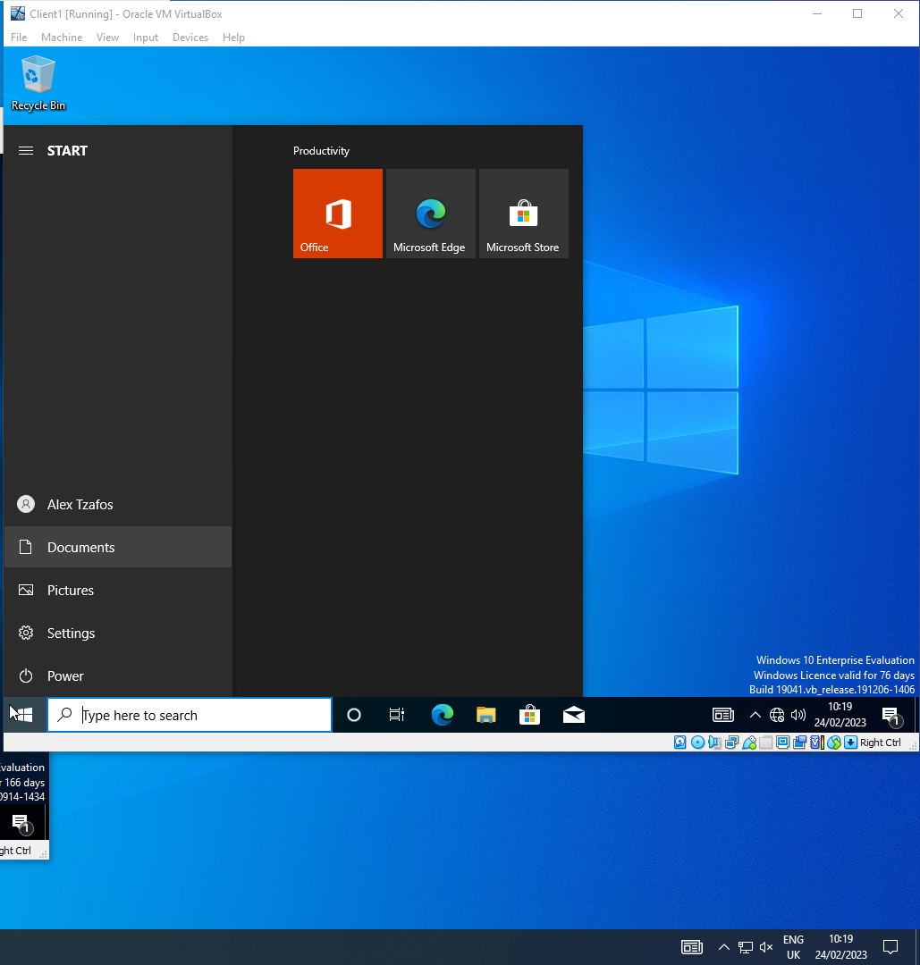
Admin account successfully logged into to Client 1.
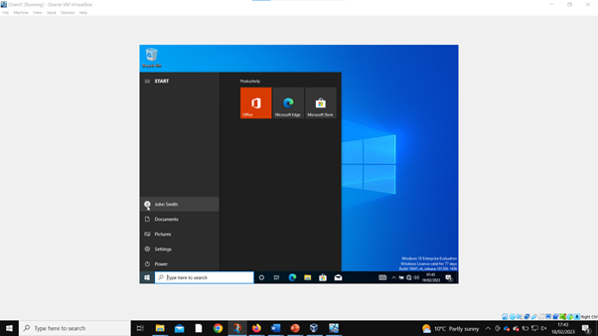
User account successfully logged into Client 1.
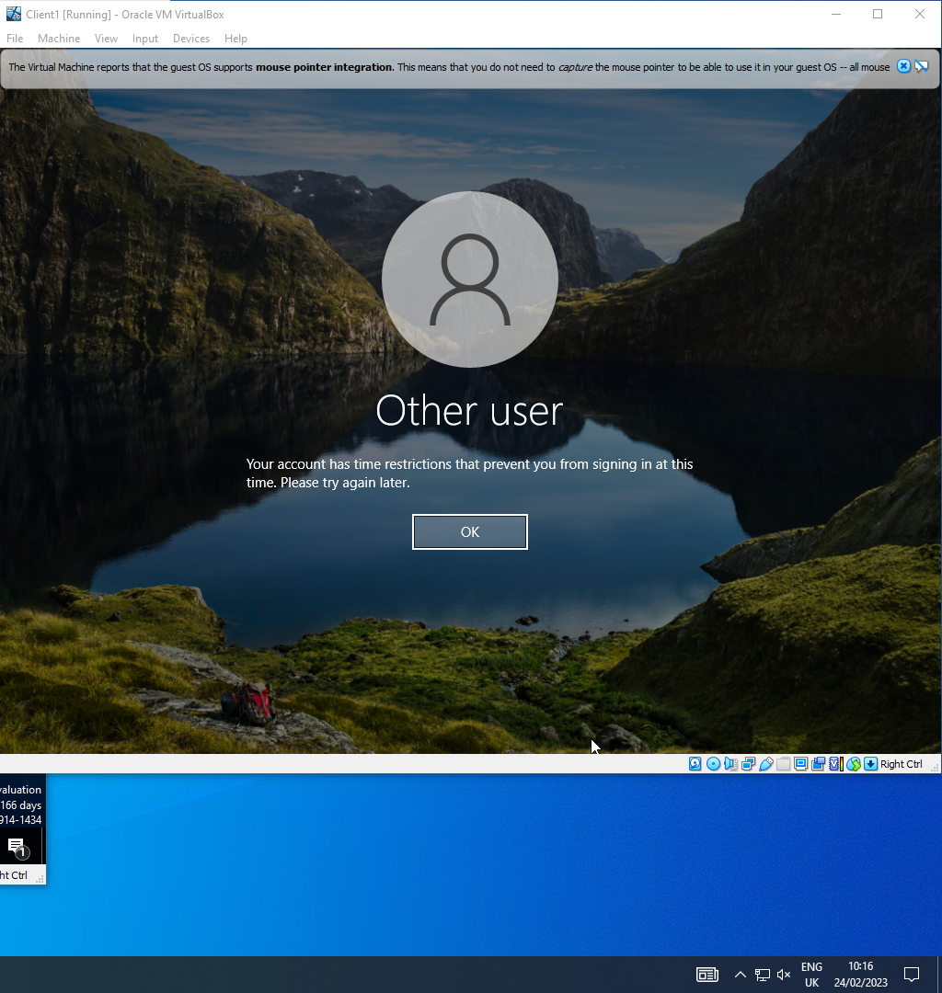
User account unable to log in to Client 1 due to time restrictions.
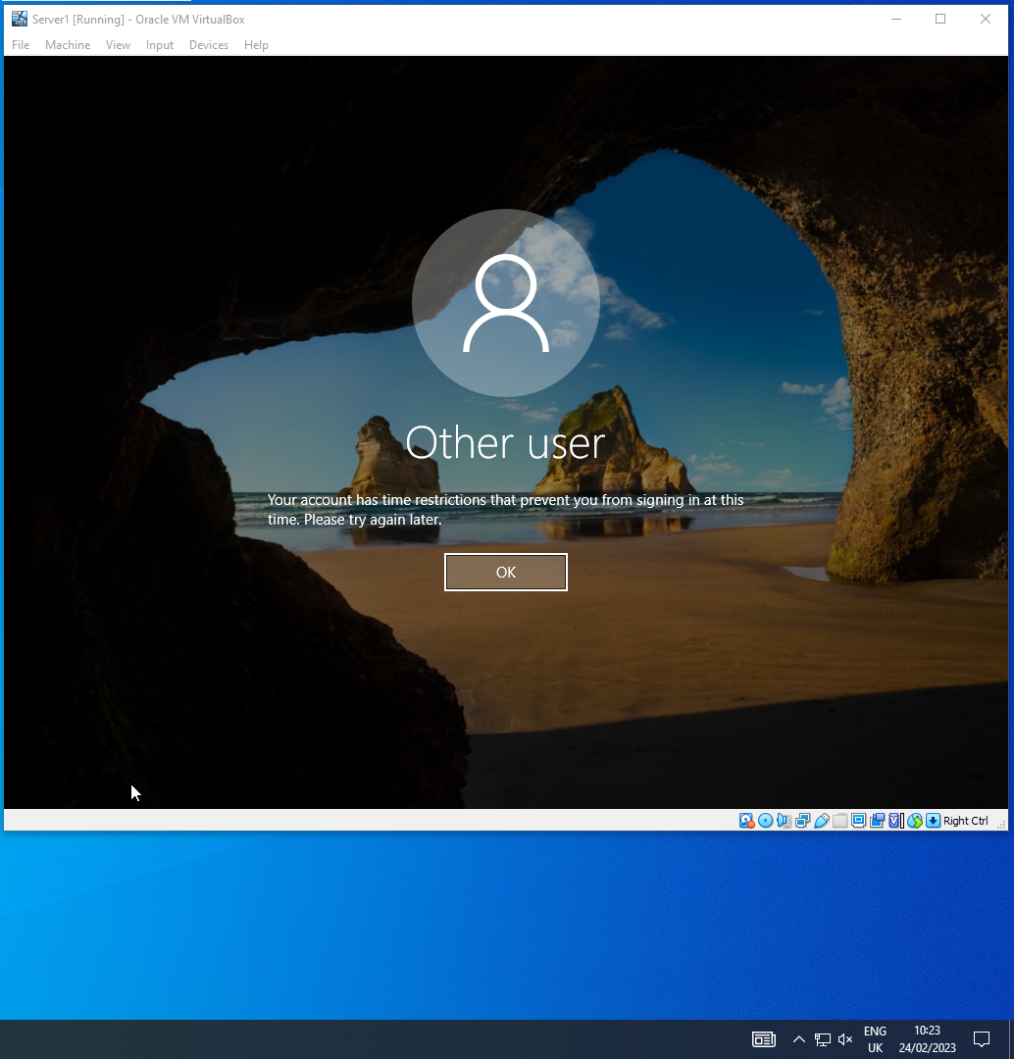
User account prevent from accessing/logging into Server 1.

3. Part 2: Observational Tasks/ Work – Individual Task

3.1. Virtual LAN

VLAN is a logical overlay network which is created from local area networks. It allows to get one logical network from devices available in multiple networks. In simple words, a LAN is a local network of computers and other devices for sharing resources and applications that are connected to the network in some place, such as a university, home, or office. Whereas VLAN stand for Virtual Local Area Network, which has many advantages, such as:
- Effective strategy for less investment than costly LAN.
- Reduces the size of broadcast domains.
- Allows to add an additional layer of security.
- Allows to experiment without worrying.
- Higher performance and reduce latency.
There are also shortcomings that can lead to the virus infection of the entire network as well as their leakage. In summary the primary advantage of VLAN is that it reduces the size of broadcast domains and convenient to use when you have lots of devices on your LAN.

3.2. Hypervisor Management Software
Hypervisor (VMM) is a hardware virtualization software that allows multiple operating systems to share a single hardware host. The Hypervisor acts as a manager, also called virtualization interface, managing the processor, memory, and host resources in the operating system to ensure that everything works properly and that nothing can disturb each other.
There are two types of hypervisors:
- Type 1 Hypervisor: A “Bare metal” or “Native Hypervisor” The Hypervisor runs directly on the system hardware (host system).
- Type 2 Hypervisor: A “Hosted Hypervisor” The Hypervisors run on a host operating system that provides virtualization services.
Type 1 Hypervisors include VMware ESX and ESXi, Microsoft Hyper-V, Citrix XenServer.
Type 2 Hypervisors such as VMware Workstation/Fusion/Player, VMware Server, Microsoft Virtual PC and Oracle VM VirtualBox that was used to perform the task above.
As mentioned previously, VirtualBox is a virtualization product that is used exclusively on Inter and AMD processors already on an existing computer running Windows, Mac, and Linux operating systems. And there is a lot of useful features namely:
- VirtualBox allows run multiple operating systems simultaneously at a time.
- Testing and recovery.
- VirtualBox runs on 32-bit and 64bit host OS.
- VirtualBox can present up to 32 virtual CPUs to each virtual machine.
- ACPI and iSCSI support.

3.3. Network Directory Service
Directory Service is a database for storing and maintaining user and asset information such as usernames, passwords, user devices and more. It is used to ensure that the user has access rights to the attachment and secure and organized organizations to keep their network safe without having to use IT resources. Catalog services are responsible elements for the security of the file. Up to now, Microsoft Active Directory (AD) is the most popular directory service.

4. Conclusion
In general, the procedures for installing a powerful and secure network will be effective for certain individuals or organizing the preparation of accurate work. Based on the completed work and the knowledge gained, it is certain that soon improved versions and possible new tools for work in the field of operating systems and services will be invented.

References

Different Types of Computer Networks: LAN, MAN, WAN. (2023). Retrieved from tutorialsmate: https://www.tutorialsmate.com/2020/05/types-of-computer-networks.html
Digital Millennium, D. (1998). Hypervisor Management Software. Retrieved from theintactone: https://theintactone.com/2022/01/23/hypervisor-management-software/
Intermedia, T. (2022, March 10). What is Active Directory and why is it so important? Retrieved from intermedia: https://www.intermedia.com/blog/what-is-active-directory-and-why-is-it-so-important/
Ltd., C. S. (2023). Directory Services. Retrieved from cyberark: https://www.cyberark.com/what-is/directory-services/
NETWORKS, C. (2010). ANDREW S. TANENBAUM FIFTH EDITION. DAVID J. WETHERALL.
Pedamkar, P. (n.d.). Difference Between VLAN vs LAN. Retrieved from educba: https://www.educba.com/vlan-vs-lan/
User Manual. (2004-2017). Retrieved from virtualbox: http://www.virtualbox.org
VapourApps. (2016, May 13). What is Hypervisor and what types of hypervisors are there. Retrieved from vapour-apps: https://vapour-apps.com/what-is-hypervisor/
What are clients, servers, hosts, and nodes? (n.d.). Retrieved from packtpub: https://subscription.packtpub.com/book/cloud-and-networking/9781788990868/1/ch01lvl1sec16/what-are-clients-servers-hosts-and-nodes
Williams, L. (2022, 12 31). What is VLAN? Types, Advantages, Example. Retrieved from guru99: https://www.guru99.com/vlan-definition-types-advantages.html
Yasar, K. (2023, March). Network operating system (NOS) . Retrieved from techtarget: https://www.techtarget.com/searchnetworking/definition/network-operating-system
Zandbergen, P. (n.d.). Types of Networks: LAN, WAN, WLAN, MAN, SAN, PAN, EPN & VPN. Retrieved from study: https://study.com/academy/lesson/types-of-networks-lan-wan-wlan-man-san-pan-epn-vpn.html

