

Student name: Jiawei Xu
Student ID number: 2105968

Research Proposal & supporting evidence
Psychological Mask

1. Introduction
In the study of the facial mask of Peking Opera in my master's period, the evolution of the facial mask of Peking Opera can be divided into the beginning period, the formation period, the development period and the maturity period depending on the period. During the early stages, the facial mask is mostly thick with eyebrows and beards and looks more realistic. In the formative period, face painting placed more emphasis on skin colour and uses exaggerated techniques for paintability, and there was a complete facial mask of styles at this time. The developmental period saw a wider variety of facial mask painting styles. These styles were also inextricably linked to the popularity of Peking opera at the end of the Qing Dynasty, with more emphasis on the five senses. In its mature stage, the facial mask became more vivid, enriching the facial expressions and incorporating emotions into the facial mask those days, the creators were more interested in incorporating abstract information into the mask through the study of expressions, particularly the five senses. This time my research wanted to look at masks as a direction, to see if we could find a design language that would allow masks to communicate with each other. So the first step in the research is to define the mask now.
What is a mask?
According to the Oxford Dictionary, masks can be divided into three interpretation:
1. Something that you wear over your face to hide it, or to frighten or entertain other people.
2. Something that you wear over part or all of your face in order to protect it.
3. A manner or an expression that hides your true character or feelings.
These three interpretation all express the keyword 'hide'.
The question of what form the hidden mask takes is by far the most interesting to me. So, what is the first interpretation when one hears the word mask? Do masks have more possibilities for the present or the future? For example, if the purpose is to hide, can I define the hands that cover the face as a mask, the VR glasses with the head, or when we are using online chat tools, are these chat tools or the phone itself our mask, for example, if it is clear that we are not very happy, but still reply back with an emoji with a smile, is the emoji our mask at this moment? How can masks change in the context of the information age?

2. Research Findings
I intend to divide the study of the mask into three directions, virtual masks (the development of masks in the context of information technology), psychological masks (focusing on the Persona by Jung), and physical masks (masks that we can see and touch). The first direction is examined and presented as the psychological mask in this essay.
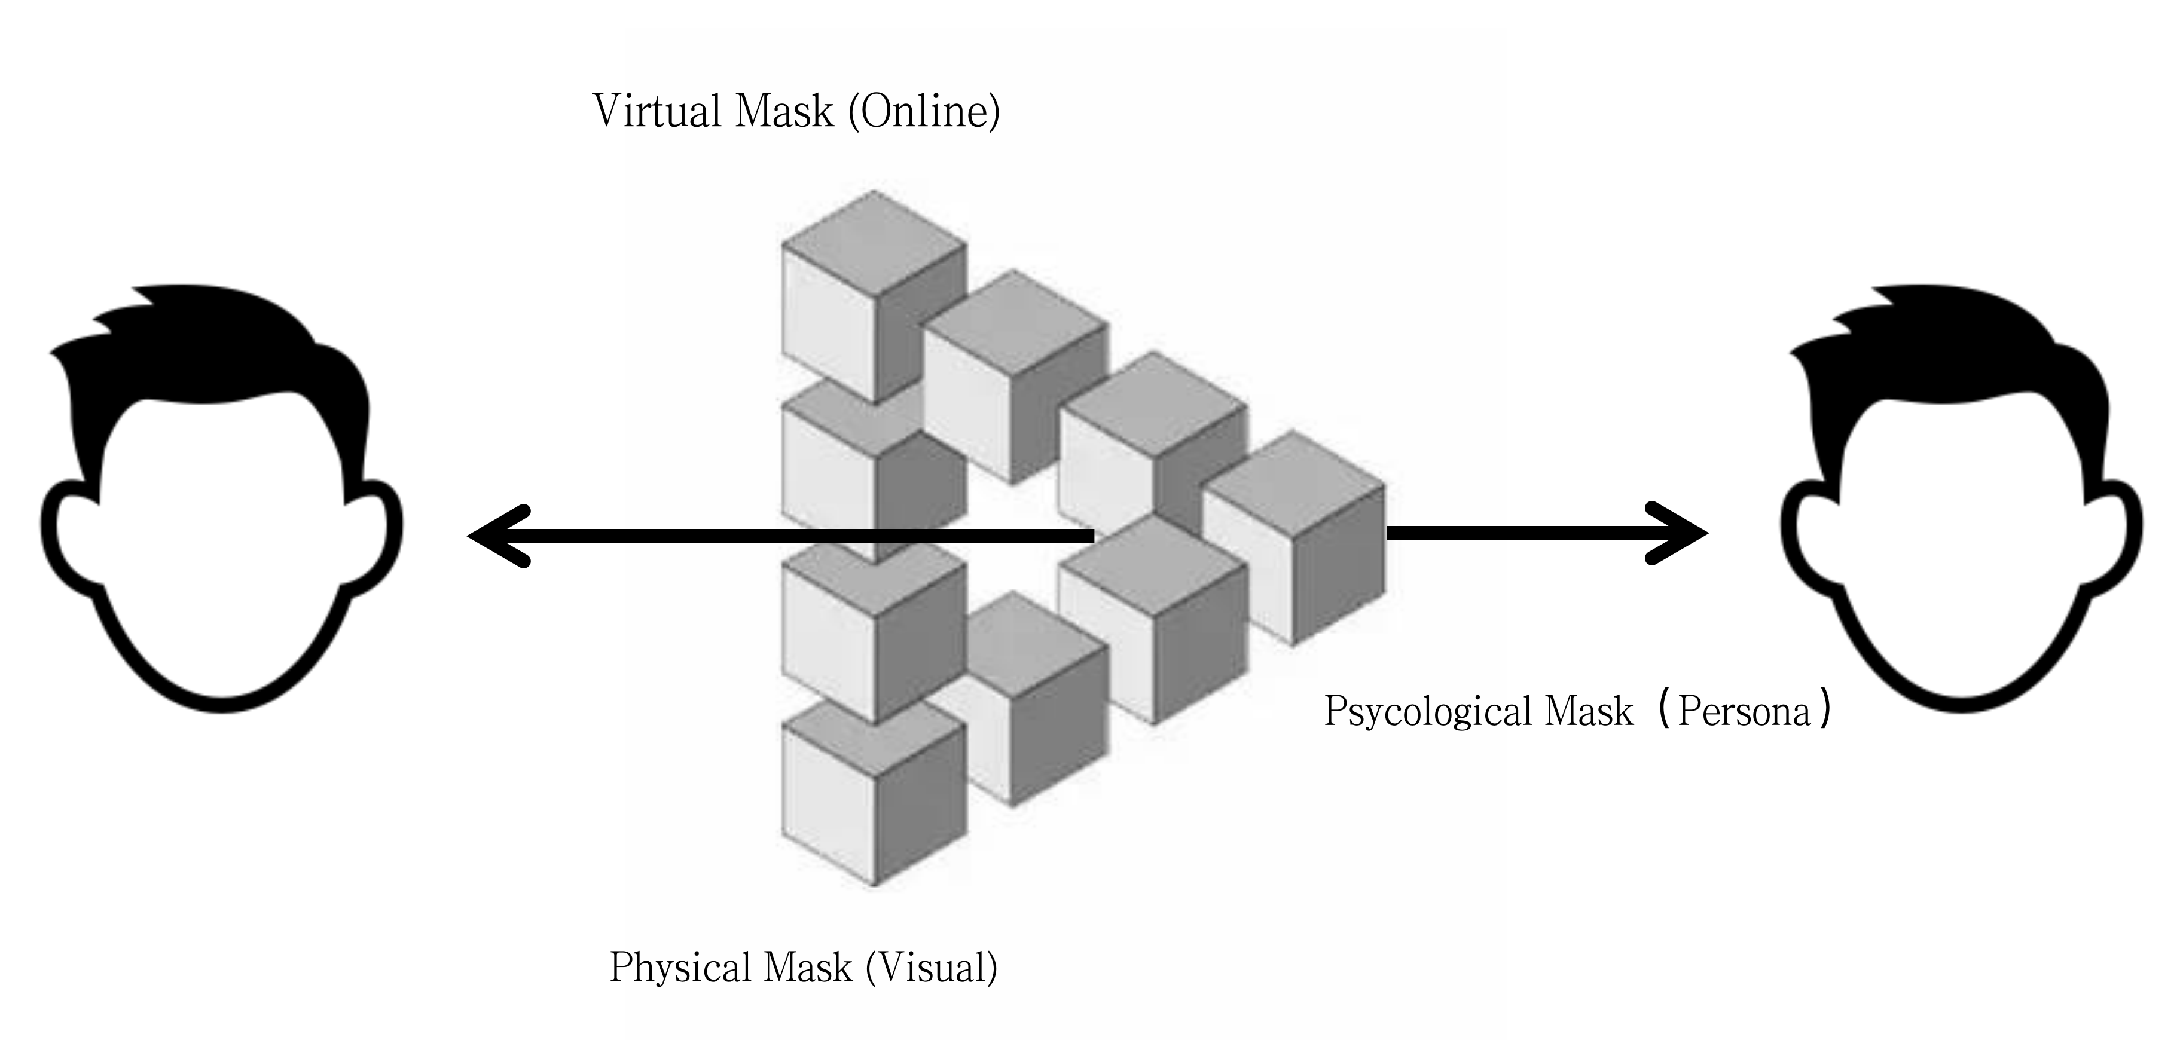
2.1 What is the psychological mask?
The definition of a psychological mask is closer to the explanation of the mask mentioned earlier, a manner or an expression that hides your true character or feelings. The mask hides the inner self on both the psychological and mask of understanding. For this aspect, I intend to base my research on the field of Persona in Jungian psychology. The Persona is, that the fact that the same person behaves differently in different situations means that he is made up of different parts of his inner being. (Huang, 2016)

2.1.1 Persona
Jung divided human mental activity into the conscious, the individual unconscious and the collective unconscious. The collective unconscious is the sum total of the mental activity of the family, the race, and even all of humanity, or human nature. It consists of many archetypes (Figure 1), the main ones being the ego and self, the anima and animus, the persona, and the shadow. Of these, the shadow is relative to the animal nature of man, and the personality mask is the social nature of man. (Huang, 2016)
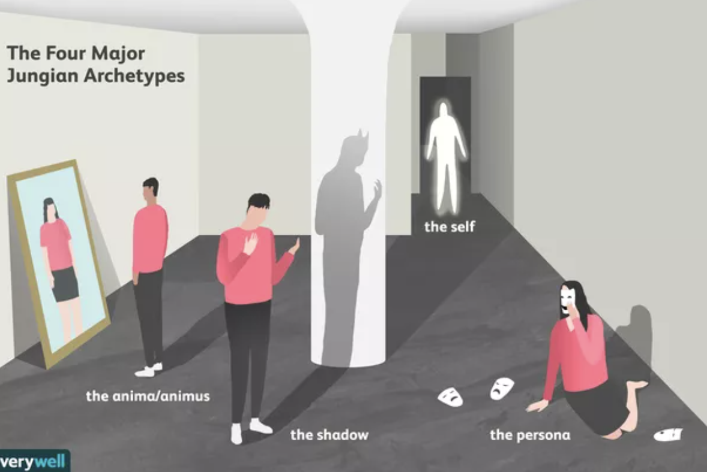
Figure 1. Hugo Lin, The Four Major Jungian Archetypes

Before understanding personality masks, it is important to understand Jung's basic concepts of consciousness and unconsciousness.
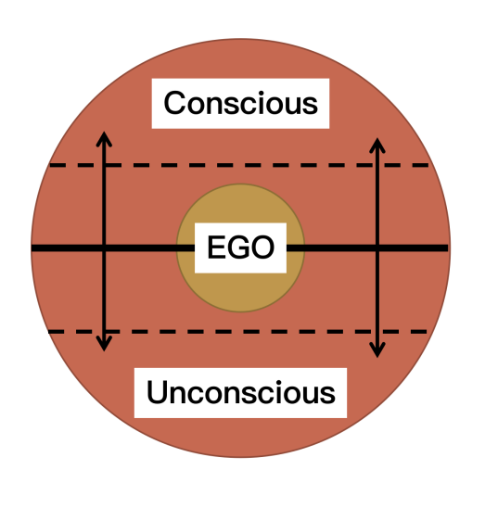
Figure 2.
Regarding Jung's concept of consciousness and unconsciousness, it is also a process of our internal or mental change, of which there are conscious and unconscious aspects. Processes. According to Jung, the inner world is simply a "functional complex confined within certain limits", which we can also understand as the inner personality, while the psyche is closer to all the elements and processes of figure 2, consisting of the conscious and the unconscious, which are opposed and complementary to each other, while our ego is integrated in this process. And the degree of differentiation or over-divisiveness of consciousness influences the personality mask. Jung referred to the general way in which a person reacts psychologically to the external environment as a personality mask. (Jacobi, 1980)
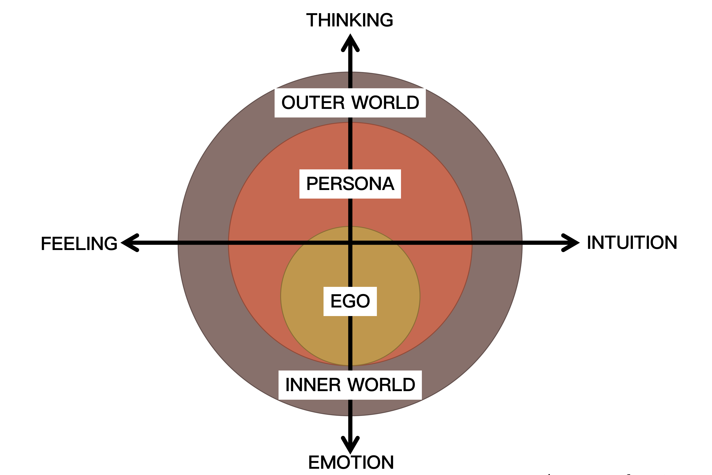
Figure 3. Ego and Persona four types of function
As can be seen in Figure 3, the person is in contact with the outside world through a system of psychological relations which at the same time acts as an "envelope" that wraps around the ego and separates it from the outside world. This "envelope" is the Persona, which controls the ego almost completely. The first function, thinking, as the dominant function, controls the personality mask almost completely. The two secondary functions of intuition and feeling influence the personality mask to a lesser extent, while the fourth function of emotion has little or no influence. (Jacobi, 1980)
Jung defined it this way, The Persona is a functional complex whose function is to allow for enhanced adaptation and the necessary comfort, but it is not consistent with personality; it is concerned only with external relations, i.e., the relationship between the individual and the object. The mask with which one presents oneself, and on which an agreement is reached between the individual and the collective, is the Persona. (Jacobi, 1980, p. 35) That is, in the external environment (e.g. social environment, cultural It is also the mask of personality that one displays as one adapts to the demands of the external environment (e.g. social, cultural, educational and physical). The Persona is therefore dynamic and grows.
They include not only psychological traits but also all our manners and gestures, such as the way we move our hands, the way we smile and the way we wear our hair and clothes. (Jacobi, 1980) This played a decisive role in my subsequent data collection.
The understanding of Persona can be understood in relation to role-playing or personas, which are formed by people constructing their own conscious identity in a social environment. For example, how you behave at home may be very different from how you behave in a formal setting. Or you may present yourself differently when you meet your best friend than you do when you meet your boss. This is when we put on a personality mask and play different roles in various situations.
2.1.2 Persona and Shadow
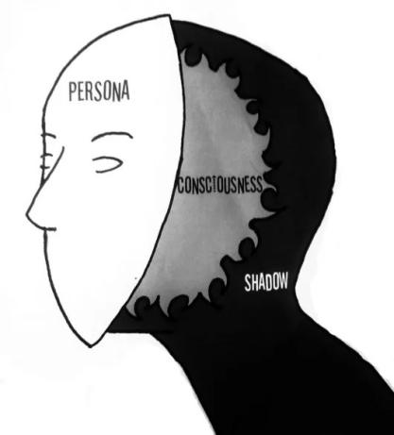
Figure 4. Source: Pinterest
The connection between shadows and personality masks is consciousness and unconsciousness. Shadows cover all the so-called unconscious contents. Shadows and personality masks have opposites. The Persona and the shadow are like the obverse and reverse sides of a coin, imperceptible when not activated, yet essential in their composition forming our complete personality.
Everyone carries a shadow with him, and the more sparingly this shadow manifests itself in the conscious life of the individual, the darker and more dense it becomes. (Jacobi, 1980) As the shadow exists in the unconscious, when the shadow is activated it is emotionally loaded and possesses autonomy, outside the control of the conscious self. The shadow can be seen as a repository of all one's unacceptable or aversive consciousness. Although in most cases the shadows are negative, it is imperative that we must face and perceive our own shadows and integrate them before we can become whole. If repressed excessively, or if we resist the shadows, it can cause us to change without realising it, and produce bad results.
But shadows are not always negative, just as there is no perfect person, and where there are shadows there are also places where light shines. So one needs to find ways in which the mask of personality can coexist with the shadows; unilateral repression will not serve any purpose.
2.1.3 Classification of Persona
We all wear Persona all the time. In most cases, people unconsciously avoid or deny wearing masks (Persona), which will come out later in the chapter on interviews. It is not clear when the mask was afflicted with this stereotype. From a psychological point of view, the mask or personality mask is an embodiment of an activity whose function, in addition to the mask itself of hiding one's conscious thoughts and emotions, is also to reveal an external side through adaptation to the environment, when the personality side has a relatively high degree of autonomy and is not entirely under the control of the ego.
If the Persona is to work, three factors must be considered: (Huang, 2016)
1. the ideal image of the self that everyone has in their mind and to which they would like to conform in their behaviour
2. the image of the person designed by the environment to suit his or her tastes and ideals
3. the psychological and physical limitations that limit the realisation of both the ideal of the self and the ideal of the external environment.
As long as one or two of these three factors are not taken into account, the personality mask will not be able to do its job. As a result, it will not only fail to promote the development of the character, it will become an obstacle in the way. For example, when dealing with one's children, one puts on the personality mask of 'father' / 'mother'. This personality mask needs to reflect the expectations and demands of the social environment, as well as one's own vision of the mask, in order to create this mask. When the mask is worn, it is constantly maintained and improved based on changes in the wearer's psychological and physical state.
The following is a table based on Huang's classification of personality masks.
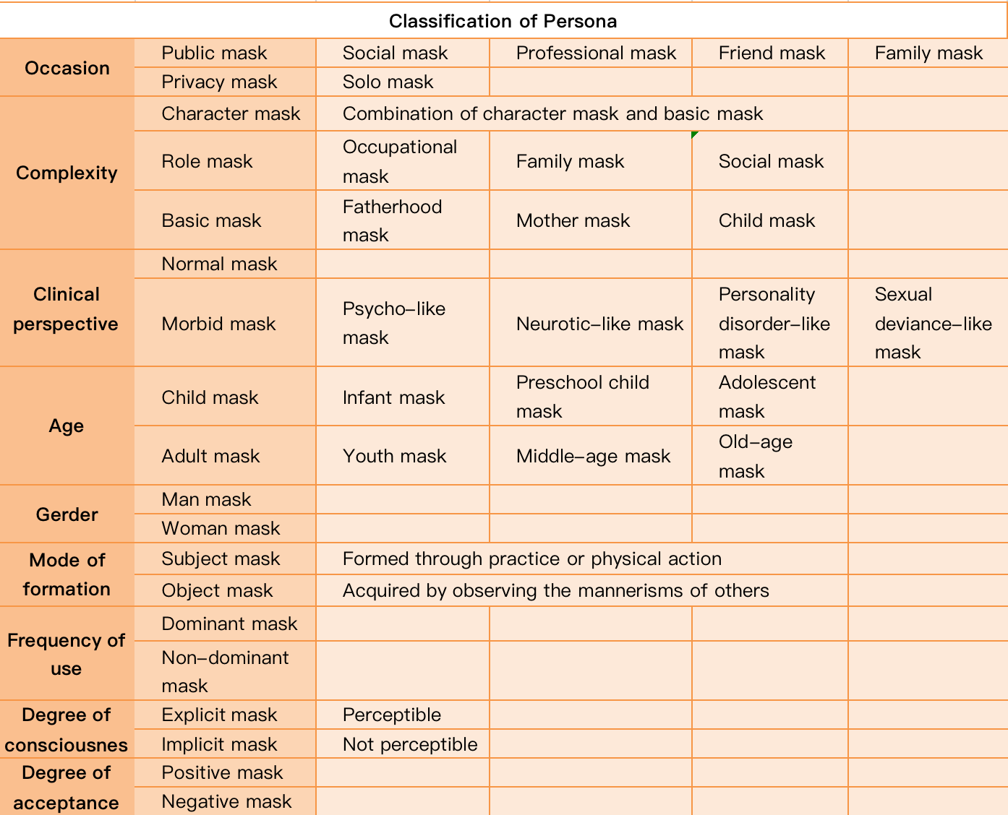
2.1.4 the “true and false” of Psychological mask
A psychological mask is either true or false, it is only public, private, and solitary. (Huang, 2016) From the above overview, it can be understood that the process of Persona is created by people's interaction with the external environment, without which certain personalities and groups would not be compatible. Rather, stereotypes of the psychological mask are created by the compromises people make with society. For example, in order to make a positive impression in an interview, a person must work hard to present a positive side. Incorporating negative emotions into the psychological mask is often seen as a forced compromise made by the individual in response to outside pressure. This is often when it is required by society. When it is in opposition to the mask of one's subject, one subconsciously perceives it as a 'false mask'.
In addition, people have a defence mechanism that protects them from the outside world, especially in the face of strangers or in group situations. When you hear someone say that you are wearing a mask, it is natural to protect your hidden self.
The stereotype of the mask also arises from human intuition. In today's society, individualism and the pursuit of individuality are prevalent, especially among the younger generation, who seek to "be themselves" in social interactions. It is our innate psychological traits that prevent us from accepting the concept of personality masks.
From the classification of masks in the previous section. In the classification based on the frequency of use, there are dominant masks and non-dominant masks. Dominant masks are often used as masks. A person's personality is mainly determined by the dominant mask, the so-called "true self". There can be only one dominant mask or several. Most of the so-called negative masks, called "false masks", are usually personality masks that do not agree with the dominant mask.
Psychological mask is a product of interpersonal interaction and we cannot deny the existence of Persona or psychological masks. This was the basis for my subsequent research.
2.1.5 Persona and situation
The definition of situation is a part of symbolic interaction theory. It is a concept used in the analysis of interpersonal interaction processes. It refers to the internal process of interpretation of external stimuli by people in any context. In order to decide how to behave, one has to assign a meaning to the interaction situation. (Yang and Hao, 2016, p. 552) Context, on the other hand, is defined as the combination of individual interpretations, implicit and unique understandings, along with culturally shared, explicit and common understandings of the surrounding environment that shape and constrain human behaviour. (Yang, Read and Miller, 2009, p. 3)
Persona have an impact on the formation and emergence of Persona in different contexts. For example, depending on the definition of Persona as corresponding to a specific person, it can be someone in real life, such as a parent or sibling; someone who has never met the person, such as a celebrity, the Queen of England; or even someone who does not exist at all, such as a cartoon character or a character in a fictional story. These characters have many Persona of their own and behave differently in different contexts. Therefore, character masks are not pure and are composite or combined masks that can be subdivided into the more pure role masks or basic masks. In other words, a character mask is a combination of a role mask and a basic mask. In contrast to character masks, role masks are purer, they correspond to the character and are only applicable to specific occasions. They are generally divided into occupational masks, family masks and social masks. Social masks are role masks other than occupational masks and family masks, such as customer masks, friend masks, hero masks and thief masks.
Contexts are motivating for Persona. This is because Persona are formed in specific situations. In different situations, one's speech and behaviour are internalised and different Persona are formed. Then, when one encounters a certain situation, a certain mask is triggered to be processed. Persona is motivated by the situation. Awareness invokes Persona according to the situation, it is just that one is not aware of it. (Huang, 2016)
Contexts consist of many details. Some details have a greater and some lesser effect on the arousal of the Persona. The Persona is revealed when all the details are present. Depending on the importance of the details themselves, the Persona may or may not be revealed if only some of the details are present. It is common for different situations to have the same or similar details, which is the biggest reason for the misuse of the mask.
2.1.6 Summery
For what is a psychological mask? The current process of investigation focuses on Persona in Jung. There are of course similar concepts to Persona in the history of psychoanalysis, defence mechanism, ego identification, false self. But I will not expand on the analysis here for the moment; the definition of psychological masks is first based on Jung's Persona. Later, Jung's Persona will be compared with the relevant concepts discussed above.

2.2 How is the research conducted?
Persona is a product of human interaction, and everyone has a Persona. How to collect information on Persona, and from what angles or ways to observe people in order to discover Persona. The theory of Jungian psychology can be applied to therapeutic situations. However, this aspect is quite specialised and it is difficult for me, as a visual designer, to gather information about different people's personalities in the way described above. To address this difficulty, I intend to carry out qualitative research methods.
Qualitative research is not the kind of research that takes place in a professional research environment, such as a laboratory, but aims to explore the world 'out there, by analysing the experiences of individuals or teams, analysing ongoing interactions and communications, analysing documents (text, graphics, film or music) or similar traces of experience or interaction, and so on. "Understanding, describing and explaining social phenomena 'from the inside', in the same way, that a quick portrait of a suspect can be drawn from the descriptions of various victims, is an attempt to understand or parse how people construct the world around them, what they are doing or experiencing, all of which is meaningful to the subject of study and rich in insights. (Flick, 2022, p. V) In order to better understand, describe and explain the subject of psychological masks, I will conduct an exploratory study of this subject through the methods associated with qualitative research.
2.2.1 Interview
One of the first things I wanted to try for psychological, which comes from human interaction, was the method of interviewing. When we want to study something, talking is a helpful way to understand that world and that life. The conversation is a fundamental component of interpersonal interaction. The hope of this interview was to capture a creative, sensitive and powerful way of capturing the experience and meaning of the interviewee's everyday life. To enable the interviewees to speak to others about their own exit from their own perspective and in their own words. Through this interview, an attempt is made to second and react to what Persona or mental masks mean to people. Also, the questions will be predetermined in advance, but this interview maintains an open attitude and does not incorporate inherent interpretations.

The first approach: the interview
Identifying the topic: Building on the research in the previous chapter, to understand the current understanding of psychological masks.
Design: planned interviews with 10 people of different ages and occupations (five of each sex)
Interviews: each interview lasts approximately 15 minutes and record
Analysis: To construct a picture of the variability in people's definitions of psychological masks based on their different understandings of psychological masks. and develop a more in-depth research study.
Content and questions:
- Year of birth
- Work
- Education level
- Sense of difference before and after wearing a mask? Give an example, e.g. feeling safe
- How often do you wear a mask in a week because of the epidemic?
- How do you feel when wearing a mask?
- How do you feel when you interact with people with a mask on?
- Do you feel a sense of security after wearing a mask?
- What exactly does it mean?
- Do you think there are other faces other than the mask?
- What are they?
- In which situations do they appear?
- What similar experiences have you had?
- What are your inner feelings during the experience?
Points 1-3 are to gather people's background, points 4-9 are to buffer the negative image of the 'mask', and points 10-14 focus on the questions you want to understand.
The interview process: Before the interview begins, the person is given a general introduction to the content and approximate length of the interview, and is informed that the interview will be recorded in a way that protects the person's privacy and that the recording will not be used for public purposes. Interview questions will not be strictly based on those set out in advance, but will be flexible based on the answers given. Finally, the interview ends.
During this interview, the following phenomena emerged.
- no matter how guided the questions were asked, the interviewees would deny the mental mask, especially in relation to whether or not they were wearing one.
- Among those who denied the existence of a mask, the concept of a mask was rationalised.
- The majority of the interviewees had a negative opinion about psychological masks.
- A small proportion of respondents were unable to understand or could be interpreted as rejecting psychological masks.
The above situations arise more from human defence mechanisms and instinctive protection of the self. This is especially when the trust between the interviewer and the interviewee has not yet been established. In addition, the stereotype of the mask, which was discussed in the previous section on the "truth or falsity" of the mask, was also mentioned. So with this first attempt, I will change my approach to the research and investigate psychological masks from a third perspective.
2.2.2 Observation
In the modern context, the question of how to define the concept of psychological masks is not only understood through psychology and other related theories but also, in the previous subsection, an attempt to find answers through interviews, in terms of the life experiences of the interviewees, etc. How can one define or quantify psychological masks in a way that overcomes human nature? Probably the biggest problem I am experiencing right now. For a field of research where there are problems but no explanations (or solutions), the rooted theory is the best approach.This approach is also ideal for a certain field that has not been much researched and theorised. (Flick, 2022, p. 15) It also tries to combine Autoethnography with a social life observation and engagement with itself, using different perspectives to construct a narrative line that evokes an understanding of the psychological mask.
Getting started.
Step 1: Observation
Second research attempt: observation
Initial questions:
- how to collect data?
- where to observe?
- How to observe?
The first question, how do you collect abstract data?
In conducting data collection through rooted theory, which begins with observation and ethnography in rooted theory research, the main questions in conducting sampling are how to identify scenarios and situations where observations can begin and where to find relevant events that will contribute to class and theory generation. Spardley's suggestions can be used as a guide for these questions: space, actor, activity, object, action, event, time, target, and sensation. (Spradley, 1980, p. 78) So, first of all, it is a question of which space to choose.
Second question, place of observation?
The above section sets out the basic concept of the psychological mask, before mentioning the definition of context. The origin of the word 'persona' is mentioned here. This comes from the Latin word for mask and refers to the theatrical mask worn by actors to indicate the role they are playing. Erikson also refers to theories of persona, self-identity and role marriage theory. The study of social roles specifically, such as gender roles, role expectations, and role conflict, is a part of social psychology. There are also theories of roles within social psychology, which developed from the theory of symbolic interaction.
Usually, our perception of roles comes from things like plays, TV shows, films, etc., which are of a performative nature. The concept of performance is often derived more from the concept of the stage. Whereas, Professor Charlie Schechner sees human performative performance as performance in everyday life. This includes people giving speeches, drinking coffee in a coffee shop, or people talking to people, etc. (Schechner, 2010, p.3)
Performance often takes place in eight different and intersecting contexts: (Schechner, 2010, p. 5)
- activities of everyday life (e.g. cooking, talking, etc.)
- art
- sports and other popular entertainment
- commerce and industry
- technology (e.g. the operation of cars and computers)
- sex
- secular and religious rituals
- games
Based on the above-mentioned contexts in which performative acts often take place, I will choose to observe them in a café. In the context of a café, there are many details that can stimulate different people. For example, when we face situations such as interactions with waiters, interactions with other customers, interactions with peers, etc.
The third question, is how do I observe?
According to Spradley's recommendations, observation is now beginning to be made of the actor, the action and the object. In the previous survey, the concept of Persona included not only psychological characteristics but also all our mannerisms and grooming, such as the way we move our hands, the way we smile, the way we wear our hair, etc. All belong to Persona.
Self-presentation is the desire to present an image of approval to both our external audience (others) and our internal audience (ourselves). We are committed to managing the image we create. We bolster our self-esteem and test our self-image through prevarication, justification and apologies (Schlenker & Weigold, 1992).
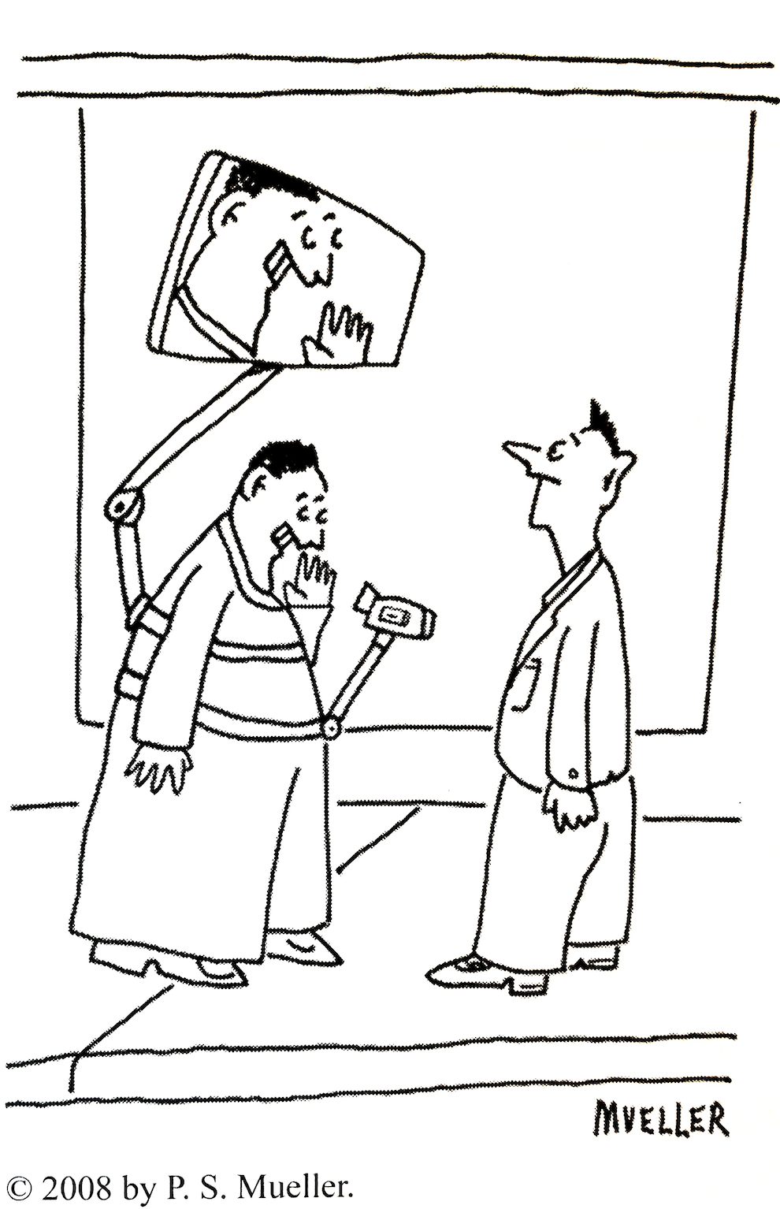
Figure 5.
As shown above, for most people, conscious self-expression is probably a way of life. They are constantly adapting their behaviour and paying attention to their social behaviour. All the time they present themselves as if they were photographed by a camera in front of them.
Actor: Café patron
Action: Behaviour in the café
Object: Appearance
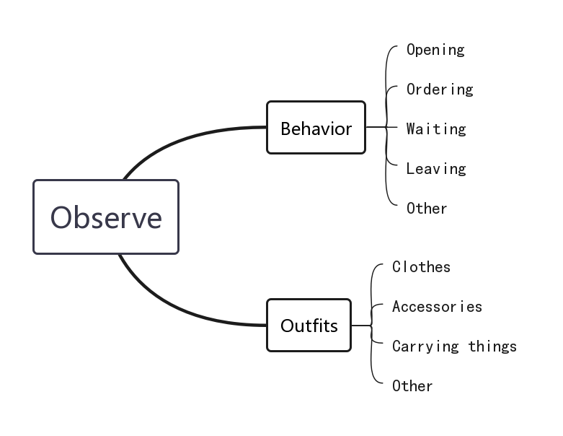
Figure 6.
As shown in Figure 6, people's behaviour and appearance are observed and documented. In behaviour, the main actions, such as opening the door, placing an order, waiting, etc., are recorded, starting with the person opening the door and ending with them leaving. In appearance, this is recorded by taking notes on clothes, jewellery, what they are holding, etc. Combining these two latitudes leads to the possibility of finding abstract data that can be quantified.
So far, my research is in the observation stage. I hope that through observation I will be able to find the main focal points and make focused observations to narrow the research perspective. Then selective observations will be made to find more arguments and examples.

- Critically Analyse 3 Research Methodologies

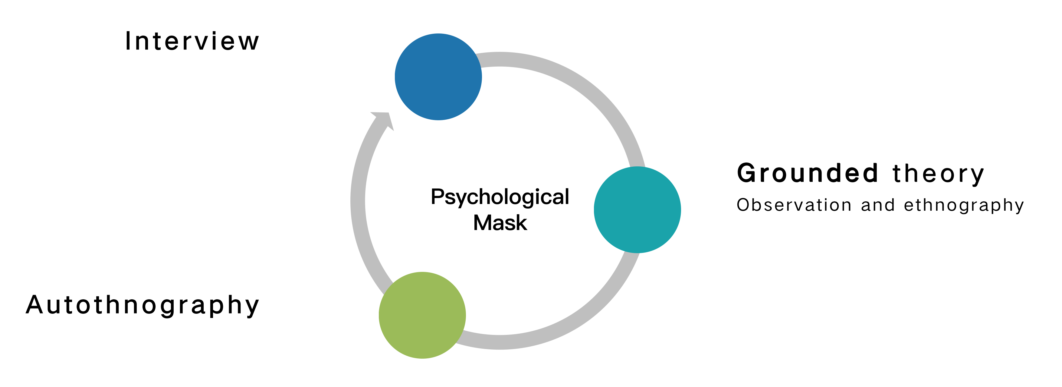
My Research Process
For this research, I used three methodological approaches: interviews, Grounded theory and Autoethnography. In line with qualitative research's focus on gaining experience, interaction and documentation in natural contexts and remaining open to finding research answers. In addition, the researchers themselves are an invaluable part of the research process. This is both in terms of their personal presence as researchers and in terms of their experience in the given field. In addition, these experiences give context to the role they play. For data transformation and analysis, there are also advantages for complex situations.
As my topic, the psychological mask does not have a clearly defined concept, so it is difficult to formulate a hypothesis to test, so qualitative research is required. This is gradually developed and refined in the course of the study. In order to examine the understanding of different people in relation to the psychological mask, the interview method was used at the beginning of the study.
3.1 Interview
3.1.1 What is Interview
Qualitative research interviews seek to understand the world from the perspective of the interviewee. This is done by discovering the lifeworld of the interviewee and revealing the meaning of their experiences before making scientific interpretations. (Svend and Steiner, 2020) Interviews are special forms of dialogue that generate knowledge through the interaction between the researcher and the interviewee.
3.1.2 Critical reflections on the interviews and my research
Based on my research process, seven of the twelve aspects that make up the interview format from a phenomenological perspective (Svend and Steiner, 2020, p. 12) are analysed along with their strengths and weaknesses in the context of my interview experience.
1. The world of life
The subject of the qualitative interviews is the everyday world of the interviewees. Unique, perceptive and powerful interviews are used to capture the experience and meaning of the interviewee's everyday life. It allows the interviewee to speak to others about their own circumstances from their own perspective and in their own words.
However, in contrast, when speaking from their own perspective, interviewees tend to incorporate their own biases into the conversation, which can easily influence judgement. It can also be influenced by the security of the interview session and the interviewee's expression of his or her own inner self. In the initial interviews with the psychological masks, most of the interviewees were biased towards the psychological masks and perceived them as a negative image. This affects the sustainability of the interview.
2. Meaning
Interviews aim to understand the meaning of the interviewee's core themes. What the interviewee says and how he or she expresses it are recorded and interpreted by the interviewer. The interviewer should observe and interpret the interviewee's occurrences, facial expressions, and body gestures, as well as understand the subject of the interview. Conversations on a daily basis are usually factual.
In addition to gathering information on the factual level, the interviewer would prefer to gather information on the meaning level. However, it is relatively difficult to do so, and the meaning level can be more abstract. It also relies on the clarity of the description of the interviewee's words and also how well the interviewer understands the deeper meaning. The interviewer may try to convey the meaning of the interviewee's words and 'feed' it back to the interviewee for immediate confirmation or denial. At this level, however, the interviewer often incorporates his or her own subjective ideas into the interviewee's interpretation of what the interviewer is saying. When he or she determines this with the interviewee, the interviewee subconsciously nods his or her head thinking that this is the answer the interviewer wants. This often results in a lack of clarity about what the interviewer is really thinking. For example, if I am asked "Do you feel that there are mental masks that are negative?" Most respondents would answer "yes", but when I continued to ask, some respondents would change their answers, making it difficult for the interviewer to determine what the respondent was really thinking.
3. Descriptive
Interviewers encouraged respondents to describe their experiences, feelings and behaviours as accurately as possible. The emphasis was on describing the diversity, variation and change of the phenomenon in detail, rather than shackling it to a fixed categorisation. In contrast, when it comes to the more difficult to understand questions when the interviewees themselves are unwilling to answer the question, it is clear that they want to end the interview as soon as possible. In my interviews, when asked about how they felt when they were wearing a psychological mask, respondents often subconsciously indicated that they were not wearing any mask.
4. Specificity
In an interview, the interviewer expects the interviewee to be able to explain the problem in terms of specifics and behaviour, rather than general observations. The more specific the description, the more concrete information the interviewer can obtain and, of course, sometimes general observations can be useful. However, it is difficult for the interviewer to guide the interviewee to describe the problem in concrete terms. For example, when I read through the question "What is your opinion about psychological masking?" most of the respondents did not respond to this question by describing specific situations or behaviours. Most of the respondents saw the question as an evaluation of someone else's behaviour, which made the respondents' answers defensive.
5. Openness
An interview's most significant characteristic is its openness, especially the interviewer's openness to new and unexpected phenomena. The interviewer's own solidified thinking is eliminated. The openness of the interview requires that the subject of the interview not be overly pre-determined. Don't cling to questions and frameworks that are set in advance. The interviewer conducts the interview with a critical view of his or her own preconceptions. However, multiple degrees of openness may lead to a shift in the subject matter of the interview. This requires the interviewer to have control over the subject matter of the interview and control the interviewee's overly pervasive responses. Sometimes it is difficult to move the interview questions along if the interviewee is too reserved. For example, in my pre-set interview questions above, by the tenth question, the interviewees often indicated that they did not understand or could not proceed, and often they began to deny the existence of the psychological mask.
6. Sensitivity
Different interviewers' sensitivities and knowledge backgrounds about the interview topic may lead to different narratives even if the interview questions and plans are pre-determined in advance. For example, an interviewer without a musical background would find it difficult to obtain a more detailed description of the interviewee's answers to relevant questions. This is especially true when wanting to explore in depth. In order to control the availability of data, consistency of approach and standardisation of interview format are required. This is with the goal of keeping the understanding of interview themes within a certain range or within the same range. However, the control of the depth of the interview topic can lead to implications for the level of detail of the information that the interviewee can provide. For example, I have no background in psychology at all, and when I conduct an interview with a psychological mask as the interview topic, it is almost impossible to gather useful information when the interviewee also has no background in psychology.
7. Interpersonal contextuality
Interviewing is a process of communication between the interviewer and the interviewee, and the construction of knowledge through communication between the two parties. The interplay between the two, while both parties work together to construct an interview space through which to communicate and interact with the interview subject of said research. This space, or context, is unique in that if another interviewer were to change the space might be constructed differently resulting in different knowledge being produced. However, it may depend on the level of interaction between the interviewer and the interviewee, or be personality specific. For example, if you encounter a more introverted interviewee who is less likely to express their own views, this requires a high level of interviewer facilitation. For example, in my interview cases, there are interviewees I would say are familiar, less familiar and completely unfamiliar. This is because the subject matter of my interviews is psychological. I show that the more unfamiliar the interviewee, the more he or she hides his or her views on the subject matter.
3.1.3 Summery
From the analysis of the characteristics of the interviews, it can be concluded that the requirements for the interviewer are not only to keep an open mind but also to have a professional understanding of the subject matter of the interview. It is also helpful to have preconceptions about the interview but also to be critical of them. If you think of the interview as a scale, the interviewer and the interviewee are the two ends of the scale. The interviewee may more or less deliberately say what the interviewer wants to hear in an asymmetrical interview. Further, to advance my research on psychological masks as a result of the specificity of my topic. Because of my topic, the interviewees become defensive. Therefore, I will use a new methodology, namely grounded theory.
3.2 Grounded Theory
3.2.1 What is Grounded Theory?
The term grounded theory appeared in a book by Glaser and Strauss (1967), where it was identified as a distinctive research method.
In recent years, the Grounded theory has been outlined as having four qualities: (Flick, 2022)
- few preconceptions about the problem domain
- Simultaneous processing of data collection and analysis
- Different interpretations of the data
- Research findings point to meso-theoretical constructs

3.2.2 When to use Grounded theory?
Grounded theory as a research method is ideal for areas of research where there are problems but no explanations (or solutions). It is also ideal for a field that has been too much researched and theorised, as this context provides room for new insights and perspectives to be generated. (Flick, 2022) According to my research theme, there are similar concepts for interpreting mental masks, from Jung's Persona to defence mechanisms, ego identification, and false self. I would like to build on the existing concepts and use Grounded theory to experiment with psychological masks in the context of the current times, in search of other possibilities.
3.2.3 Based on the Grounded theory process combined with my research analysis and its critical analysis
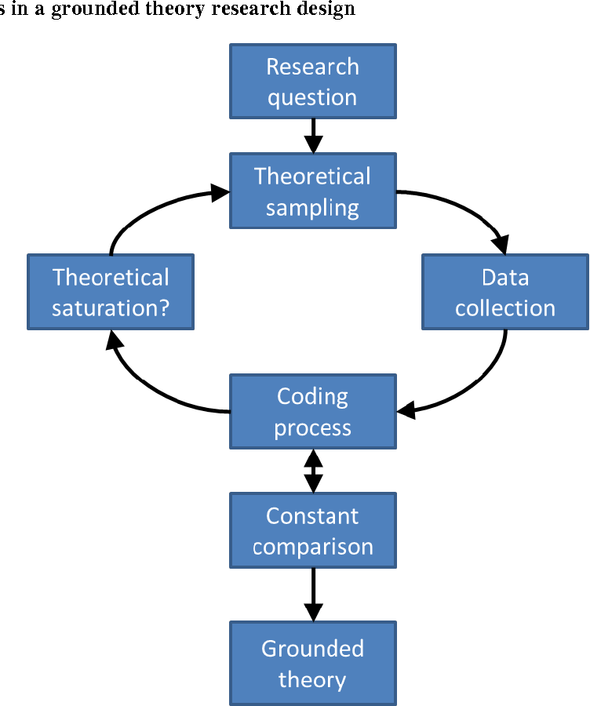
Figure 8. Key steps in a grounded theory research design
At the moment my research process is still at the data collection step of Grounded theory. In line with the principle of openness of Grounded Theory, the research perspective or research questions may change over time.
The first step is the initial hypothesis. One of the key questions about this hypothesis is whether it is a discovery or a construction. There are many possible starting points for conducting a Grounded Theory study. As a first step, the researcher's curiosity leads him or her to choose a research question. Secondly, personal experience, and the experiences of those around them, can also contribute to the establishment of a research question. The third is to fill a gap in the field of scientific research. The fourth is the emergence of a new phenomenon or the discovery of a new problem that leads to a research question. (Flick, 2022, p.23) The initial hypothesis for the research question began with my curiosity about what people now understand about mental masks. Determining the purpose of the research perspective, whether to discover the problem or to construct it, determines which aspect of the initial research question will be planned afterwards. By using different findings in the subsequent research process, we can change the research question or change the direction of the study, depending on the features of Grounded Theory. Because of the overly open-ended nature, this would have led me to remain sceptical about the research perspective and the relevant research questions in the early stages of the study, as it is qualitative research and without concrete evidence, it would have been difficult to develop the research.
Secondly, Grounded theory emphasises the need to maintain research value neutrality. (Feng and Su, 2020, p. 50) But often, between studies, the researcher will incorporate their own value judgments into the research topic.
The second step is that of data collection. The biggest problem encountered in the initial study of psychological masks based on the use of interviews was the inability to collect real data. Therefore, the observation method of Grounded theory was used for the exploration of the research topic. In this case, in Grounded theory, participant observation is divided into three stages: descriptive observation to gain a sense of reality in the research field and to further form research questions, focused observation to contract the perspective that limits the relevant thesis and selective observation to find more evidence and examples. (Spradley, 1980) What I have carried out so far is the descriptive observation phase, by making observations of people's behaviour and dress.
However, the process of observation is a process in which the observer is presented with facts or pictures that are not objective in philosophical terms, but are the result of intentional composition. (Feng and Su, 2020, p. 53) may emerge in my non-active, non-conscious potential state, for example, due to the fact that my field of study, visual communication design, unconsciously influences the perspective from which I observe things. In order to construct more rationally, it is necessary to use other methodologies, for example, while observing in the third person, I add the method of interviewing people in the situation I am observing, for example, waiters, to implement interviews in a reflective way. A degree of objectivity was achieved through the collection of data from different perspectives. While observing and interviewing, data collection was carried out. The first thing I did was literature collection, focusing on Jung's Persona. For Grounded theory, the use of documentation is an important form of data. (Flick, 2020, p. 47) From the data collected in the field, the observations and the documentation, preliminary theories are continually being constructed. Currently my research is still at the data collection stage, after which data analysis is achieved by coding and generalising the information. (Tian, 2016) Different forms of coding are applied, moving from open-ended coding in the beginning stages to more structured, focused or selective forms of coding (Figure 9).
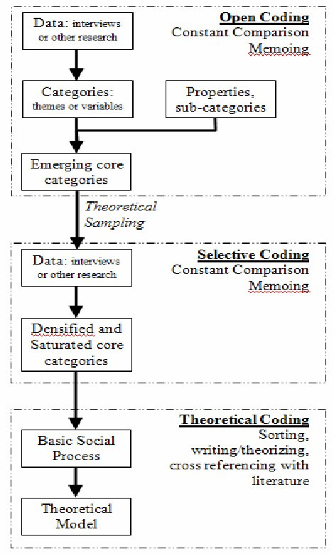
Figure 9. The process of Grounded Theory
Writing the memo is an intermediate relief between the coding and the completion of the preliminary analysis. The process of entering the field site, the work done in the field site, the generation and definition of material categories, and the generation of the theory are recorded. (Flick, 2020) If the initial analysis is not completed or the construct changes, the steps from data collection to theory construction will be repeated. For Grounded theory, the construction of a completed theory needs to be based on data, and a large amount of data collection leads to a longer research time and requires the researcher to have a high sensitivity to the point of convergence, especially for the field of mental masks, where the psyche itself is a more difficult content to measure and define, so it is difficult to complete.
The above two methodologies are the main ones I have used in this research, from interviews to observations, and from one-to-one perspectives to third perspectives in an attempt to develop a study of psychological masks. I will then briefly review Autoethnography, and through Autoethnography's daily observations, take a first look at how I record observations and then briefly discuss Autoethnography. In fact, this is similar to Grounded theory, which uses participant observation in which the researcher is also a participant and our perspectives are recorded at the same time as the objective facts are recorded.
3.3 Autoethnography
For the use of Autoethnography, I would like to use its writing to describe and systematically analyse my own research process.
Autoethnography is based on fieldwork, anthropology, phenomenology, and existentialist philosophy, and is an observation of everyday, incorporating observation into writing. It is a method of research and writing that aims to describe and systematically analyse personal experiences in order to understand cultural experiences. (Ellis, Adams and Bochner, 2010) It is also related to conformist interactionism, dialogue theory and narrative theory (storytelling), so it is good for documenting and describing processes. Autoethnography is acutely observant and participation-driven in human social life and aims to use the resources of participation, observation, introspection, dialogue and storytelling to construct a narrative line that evokes the lived reality of human beings. (Christopher, 2021) allows the researcher to write retrospectively and selectively about epiphanies that may be called part of the research. In undertaking Autoethnography, we can act as observers, participants or theorists to understand the richness, layers, nuances, depths and mysteries of human social life from different perspectives. The strength of autoethnography is to understand human social life as a human experience. (Christopher, 2021)
Of course, autoethnography also has certain disadvantages. Being fieldwork in nature, when we make observations we incorporate our own intellectual background and it is difficult to sight absolute objectivity.
In Autoethnography, writing is used as the main method of enquiry. The researcher is reflective and systematically introspective: reflecting on participation and observation of everyday life, writing notes to reflect, returning to the field, meeting to reflect, systematically reflecting, collating all experiences (as many as possible). (Christopher, 2021) Based on this characteristic combined with my research topic, mental masks, the biggest challenge, as mentioned before, is to authentically record information about people's mental activities. However, through Autothnography, it is possible to record one's inner activity in its entirety and try to reflect it in the Conference paper.

- Conclusion
Combining three methodological approaches, three different perspectives are used to construct an understanding of psychological masks. Interviews allow for an in-depth exploration of the research topic, the Grounded theory allows for the collection and analysis of abstract data, the combination of different sources to construct a preliminary theory, the combination of Autoethnography to complement the research topic from an intrinsic perspective, and the understanding and analysis of various methodologies, using the strengths of each and combining them with each other to gain a deeper understanding of the research questions. The information on psychological masks is still relatively poorly researched, and this aspect will be added to later.

Reference
Huang, G. (2016) Hidden Personality. Beijing United Publishing Co.,Ltd.
Jacobi, J. (2018) The psychology of C. G. Jung. SDXJ Publishing Co.,Ltd.
Lin, H. The five Major Jungian Archetypes [Figure]. Available at: https://www.verywellmind.com/what-are-jungs-4-major-archetypes-2795439 (Accessed 16 June 2022)
Yang, Z. and Hao, X. (2016) Dictionary of Psychology. Shanghai Dictionary Press
Yang, Y. Read, S.J. and Miller, L.C. (2009) The Concept of Situations. Social and Personality Psychology Compass.
Flick, U. (2022) Doing grounded theory. Shanghai People’s Press.
Schechner, R. (2010) Performance Studies: Essays of Richard Schnchner. Culture and Art Publishing House.
Flick, U. (2022) Doing Grounded Theory. Shanghai People’s Press.
Spradley, J. P, (1980) Participant Observation. New York: Rinehart and Winston.
Svend, B. and Steiner, K. (2020) Doing Interview. Shanghai People’s Press.
Glaser, B.G. and Strauss, A.L. (1970) The Discovery of Grounded Theory: Strategies for Qualitative Research, Chicago: Aldine.
Feng, L. and Su, Q. (2020) Criticism on the Phenomenological Method of Grounded Theory. Journal of Hunan Radio and Television University, 2020(3), pp. 50-54
Tian, L. (2016) Commentary and its practical application of Grounded theory, Availiable at: http://www.360doc.com/content/16/0628/05/25875037_571278513.shtml (Accessed: 23 June 2022).
Ellis, C. Adams, T.E. and Bochner, A.P. (2010) Autoethnography: An Overview [40 paragraphs]. Forum Qualitative Sozialforschung / Forum: Qualitative Social Research, 12(1), Art. 10, http://nbn-resolving.de/urn:nbn:de:0114-fqs1101108.
Christopher, N.P. (2021) Essentials of Autoethnography [video]. Available at: https://www.youtube.com/watch?v=Mp2g89DbCj4 (Accessed: 24 June 2022).

