Exploring the role of HRM in business growth: the case study on Morrison retail supermarket in UK

Table of Contents
1.0 Introduction 4
2.0 Literature Review 7
3.0 Research methodology 12
Reference List 15

1.0 Introduction
Human Resource Management (HRM) is a process which manages employees of an organisation. In this section the aim, objectives along with rationale will be highlighted to analyse the different roles played by HRM of Morrison to maintain the business growth. In this context Morrison retail supermarket is taken which was established in 1899 by Ken Morrison, headquartered in Bradford, UK. It is one of the 4th largest supermarket chains in UK.
1.1 Background of the research
For continuous business growth effective contribution of HRM is a must for any organisation. Role of HRM includes selection, training, development of the employees working for the organisation. According to Glaister et al. (2018), there is a close interrelation between HRM, team management and firm performance. Hence, HRM plays a crucial role for business growth. In addition, as commented by Heffernan et al. (2016), HRM is the key mediator to create a favourable environment in the workplace, hence improving their productivity and business growth. As stated by Jamali (2015), HRM also plays a pivotal role to address the issues which are being faced by the organisation, as organisations cannot grow if they are having issues related to employees and their wellbeing. Hences, HRM needs to address as early as possible in order to restore the work environment in work workplace.
1.2 Aim and Objectives
Aim
The aim of the research is to explore the role of HRM in business growth: the case study on Morrison retail supermarket in UK
Objectives
- To explore different roles of HRM for Morrison
- To analyse the factors affecting the role of HRM in context of Morrison
- To evaluate the issues associated with HRM affecting the business of Morrison
- To provide suggestions for mitigating the identified issues
1.3 Research question
- What is the role HRM plays in the business growth of a company like Morrison retail Supermarket UK?
1.4 Rationale
In 2016 Morrison came in the news as one of their IT employees named, Andrew Skelton leaked personal data of the employees online (Theguardian.com, 2018). As an immediate effect, employees of Morrison appealed to the High Court against Morrison for compensation against violation of Data Protection Act 1998 (Legislation.gov.uk, 2019). Hence, HRM department has been facing employee grievance issue.
This data leaking is a major issue because Andrew Skelton stole data of nearly 10,000 employees including their personal information and bank details and posted them online. It shows the vulnerability of the security of Morrison is as it puts up question on HRM regarding the employee security.
This issue is still hunting Morrison as they are yet to make full compensation which causes another lawsuit on their name affecting their brand value (Hrreview.co.uk, 2017). It causes a concern over the customers as they are thinking of company cannot secure their employees data how they will secure such a huge number of customers’ data.
It is the only incident in UK of such kind in the retail industry; hence the study will look into the situation, revealing the hidden consequences.
1.5 significance of the study
This study explores the different roles of HRM evaluating different circumstances, in order to improve the organisation’s working environment. The main aim is to improve business and growth of the company by improving the HRM operation thereby enhancing their performance. It has been witnessed that previous researches do not show proper evaluation of such data breach issues as it is the first incident of the kind. Hence, there exist many issues and queries related to the incident. This unexplored side of HRM role will be discussed in depth to aware everyone about the processing, remedy of the situation.
1.6 Structure of the dissertation
Figure 1: Structure of the Dissertation

2.0 Literature Review
2.1 Concept of HRM
Human Resource Management is a process of employing people to work, developing them so that they can emerge as a valuable asset of the company. HRM consists of following up basic amenities, analysing various aspects, providing training for the new as well as old staffs to make them updated. Role of HRM also includes managing wages, incentives with other benefits like health, performance evaluation and promote them further also comes under HRM role.
According to Brewster (2017), it has been witnessed that for developing a business, leading it to success requires an important role of HRM. It helps the organisation to maintain the employees in it tactfully. For any organisation their employees are considered to be more valuable than the products as quality of employees cannot be replaced by any means. For any ambitious organisation, there is always a pressure on the employees to reach the target set by the top officials, hence HRM needs to look after their employees’ basic needs and facilities so that they stay motivated in work. By any chance, if any uncertain situation arises HRM must solve them as early as possible.
2.2 Factors influencing the role of HRM
There are a number of factors such as technological advancements, training and development, government regulations which effect role of HRM.
Technological Advancements: According to Evans (2017), technology has both positive and negative effect on organisations that helps in reducing human errors, producing more efficiency and speed. On the contrary it has also increased unemployment situation along with vulnerability of security causes data breach.
Government Regulations: Laws are always helpful for companies in doing their business with transparency. It helps companies to have a clear vision of what to do or not. On the other side any sudden change in government policies creates haphazard situation as the companies are forced to change their existing system in order to follow the guidelines.
Training and Development: As stated by Imna (2015), training and development are very much helpful for any organisation so that they can mould newcomers with their work culture and process. However, it adds more expenditure to their balance sheet as productivity and manpower ratio decreases.
2.3 Theory model for role of HRM
The Ulrich Model
Various roles of HRM can be discussed on the basis of The Ulrich Model. According to Boroughs and Palmer (2016), it explains the HRM roles into 4 different segments such as, strategic partner, change agent, administrative expert and employee champion.
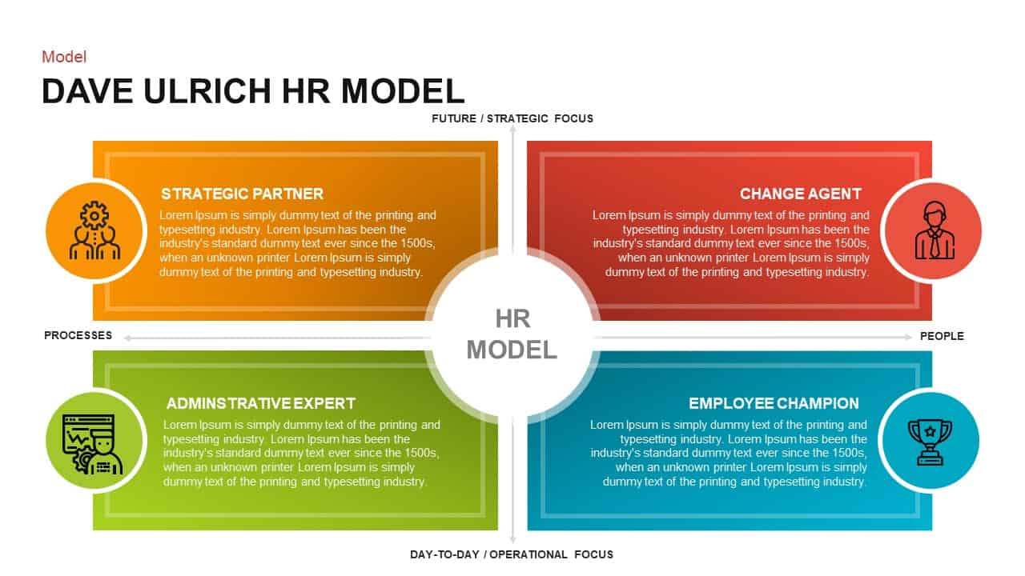
Figure 2: The Ulrich Model
(Source: Boroughs and Palmer, 2016)
Strategic partner is about connecting HRM functionalities with the business strategy. Change agent is about helping the organisation in its transition period providing manpower. Role of Administrative expert changes with time, now it focuses on improving the quality of product with minimum production cost prior to that it only focused on the quality of the product. Employee champion role of HRM helps the organisation to provide sufficient supply of man power when in need and also their responsibility to motivate and protect during transition.
Maslow’s Hierarchy of Needs
Maslow’s Hierarchy of Needs deals with employees’ motivation and basic needs. As commented by Shih et al. (2019), in order to get maximum output from the employees motivation plays a major role motivated employee can do better than a de-motivated one. There are five levels,
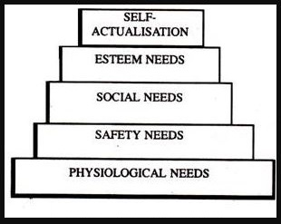
Figure 3: Maslow’s Hierarchy of Needs
(Source: Shih et al. 2019)
Physiological needs such as food, water, proper shelter, Safety needs include physical security of the employees. Social need consists of association with friends and family. Esteem deals with recognition promotion in the workplace, increment, incentives and Self-actualisation is the will to achieve something, it comes from others improvement, promotion. All the above mentioned factors are equally important to keep the employees motivated, for instance, if the social need is taken care of properly the employee will feel motivated as he does not need to worry further similar case for other situations.
2.4 Impact on the role of HRM on the basis of business growth
Business growth has a close connection with the role and functionalities of HRM for an organisation. HRM of a company recruits more new people to the workplace if there is a significant amount of growth, as more growth turns out to increase the business. On the other side, poor business growth leads to employees axing causing unemployment scenario. HRM can invest more for their youth program, training purpose as well as internship offerings. This helps the company to expand and improve their variety and quality with diversity. However, poor growth can lead to shutting down of such programs. Time when the company is earning a decent profit HRM can increase their employees benefit by providing incentives, rewards to motivate them more. On contrary downfall in market leads to less motivation in work environment, hence HRM this becomes strict as the outcome of the company is not up to the mark.
2.5 Literature gap
All the previous works were done explaining various roles how they impact in the operation of organisations. From the aforementioned three studies, it is witnessed that there is a huge flaw regarding the security of the employees. Introduction of internet and technology has opened up a segment with a new set of security issues. No other previous study or research has ever covered this factor in detail. All the other research discussed about their relationship with other departments, employee’s needs, facilities. However, cyber security also important as others is. In depth analysis of such factor will clarify the drawbacks which are still in existence, providing a new scope to improve hence providing better employee satisfaction. All together it will work for the benefit of the company.

2.6 Conceptual framework

Role of HRM

Business Growth

Concept of HRM
Factors influencing the role of HRM
Theory model for role of HRM
Impact on the role of HRM on the basis of business growth

Figure 4: Structure of the Dissertation

3.0 Research methodology
3.1 Research philosophy
Research philosophy is of four types such as positivism, realism, interpretivism and pragmatism. Interpretivism is based on journals (research-methodology.net, 2019). Hence it has limited data samples to consider however it is qualitative as it exploration based. The researcher will choose here positivism philosophy for evaluating the roles of HRM of Morrison. Positivism method is extremely secured, a vast sample of data can be collected, hence it a strong method to consider. In addition it is meaningful and logical philosophy.
3.2 Research approach
Research approach is of three types such as deductive research approach, inductive research approach and adductive research approach (Research-Methodology, 2019). For this research purpose the researcher will opt for deductive research approach as it is time saving, hence it can explain many aspects of HRM role in less time and it is also to the point method whereas other approaches are time consuming. Thematic analysis will be done by developing three themes for the research purpose on Morrison.
3.3 Research design
There are three types of research design currently in practice; they are exploratory, explanatory and descriptive. The researcher will choose the descriptive design for the research purpose as it is not based on any hypothesis rather it develops the concept while analysing the collected data. It uses a number of qualitative and quantitative methods to find out the outcome.
3.4 Data collection
Data collection methods are of two types such as primary data collection and secondary data collection method (research-methodology.net, 2019). In this study the researchers will consider both quantitative and qualitative methods for primary data collection. For this purpose researchers will select 30 employees from the organisation. This will come under quantitative data collection and for qualitative data collection 2 HR officials of Morrison will be chosen for interview purpose. All the participants will be given questionnaires for data collection. In addition, secondary data will be collected from books and journals.
3.5 Data analysis technique
After collection the quantitative data will be transformed readable format using Microsoft word, excel. Hence, they will be further analysed through graphs, tables. On the other hand Spiggle et al (1994) will be used to interpret the qualitative data.
Population and Sampling
The research is based on the HRM role changes due to business growth; therefore the researcher will consider employees as the population of the research. There will 30 different employees from the Morrison. Both probability and non-probability sampling technique will be applied here
3.6 Ethical consideration
This research deals with participants’ personal data and morality. As per Data Protection Act, 2018 participants’ personal data will be kept secret and will not be used for any unethical purpose (Legislation.gov.uk, 2019). In addition it will not be retained after the requirement is over. As per Equality Act, 2010 every participant will be treated equally irrespective of their gender, caste, colour (Gov.uk, 2015). The researcher will abide by the laws to study in ethical way, also UWTSD ethical 2 form guide and regulations will be used and taken into consideration in this research.
3.7 Limitation
There are a few limitations associated with this research work. First and foremost the budget is limited, hence, the researcher will not be able to access all related paper form online as most of them are paid. In addition, time constraint is another major barrier in this research. Hence, more employees cannot be approached. More number of data will lead to better analysis.

3.8 Timeline
Activity | Start Date | Duration | End Date
Selection of the research topic | 9/27/2019 | 1 | 9/28/2019
Deciding Aim and Objective | 9/28/2019 | 3 | 10/1/2019
Conducting literature review | 10/1/2019 | 2 | 10/3/2019
Selection of methodology | 10/3/2019 | 1 | 10/4/2019
Collection of primary and secondary data | 10/4/2019 | 6 | 10/6/2019
Analysis of collected data | 10/6/2019 | 2 | 10/7/2019
Finalising end result and recommendation | 10/7/2019 | 2 | 10/8/2019
Paperwork | 10/8/2019 | 2 | 10/10/2019
Final submission of research work | 10/10/2019 | 1 | 10/11/2019
Table 1: Work Breakdown structure

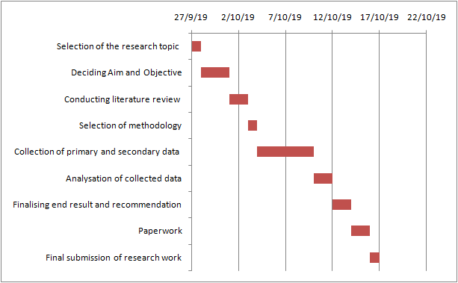
Figure 5: Gantt chart

Reference List

Boroughs, A. and Palmer, L., 2016. HR transformation technology: delivering systems to support the new HR model. Routledge.
Brewster, C., 2017. The integration of human resource management and corporate strategy. In Policy and practice in European human resource management (pp. 22-35). Routledge.
Evans, S., 2017. HRM and front line managers: the influence of role stress. The International Journal of Human Resource Management, 28(22), pp.3128-3148.
Glaister, A.J., Karacay, G., Demirbag, M. and Tatoglu, E., 2018. HRM and performance—The role of talent management as a transmission mechanism in an emerging market context. Human Resource Management Journal, 28(1), pp.148-166.
Gov.uk 2015. Equality Act 2010: guidance. [online] Available at: https://www.gov.uk/guidance/equality-act-2010-guidance [Accessed 27 Sep. 2019].
Heffernan, M., Harney, B., Cafferkey, K. and Dundon, T., 2016. Exploring the HRM-performance relationship: the role of creativity climate and strategy. Employee Relations, 38(3), pp.438-462.
Hrreview.co.uk 2017. Thousands of Morrisons workers due compensation after staff details breach. [online] HRreview. Available at: https://www.hrreview.co.uk/hr-news/thousands-morrisons-workers-due-compensation-staff-details-breach/109250 [Accessed 27 Sep. 2019].
Imna, M. and Hassan, Z., 2015. Influence of human resource management practices on employee retention in Maldives retail industry. International Journal of Accounting, Business and Management, 1(1), pp.1-28.
Jamali, D.R., El Dirani, A.M. and Harwood, I.A., 2015. Exploring human resource management roles in corporate social responsibility: the CSR‐HRM co‐creation model. Business Ethics: A European Review, 24(2), pp.125-143.
Legislation.gov.uk 2019. Data Protection Act 1998. [online] Available at: http://www.legislation.gov.uk/ukpga/1998/29/contents [Accessed 27 Sep. 2019].
Legislation.gov.uk 2019. Data Protection Act 2018. [online] Available at: http://www.legislation.gov.uk/ukpga/2018/12/contents/enacted [Accessed 27 Sep. 2019].

Research-Methodology 2019. Research Approach - Research-Methodology. [online] Available at: https://research-methodology.net/research-methodology/research-approach/ [Accessed 27 Sep. 2019].

Research-Methodology. (2019). Data Collection Methods - Research-Methodology. [online] Available at: https://research-methodology.net/research-methods/data-collection/ [Accessed 27 Sep. 2019].

research-methodology.net 2019. Research Philosophy - Research Methodology. [online] Available at: https://research-methodology.net/research-philosophy/ [Accessed 27 Sep. 2019].
Salleh, K.M., Sulaiman, N.L., Mohamad, M.M. and Sern, L.C., 2015. Academia and practitioner perspectives on competencies required for technical and vocational education students in Malaysia: A comparison with the ASTD WLP competency model. Procedia-Social and Behavioral Sciences, 186, pp.20-27.
Shih, C.Y., Huang, C.Y., Huang, M.L., Chen, C.M., Lin, C.C. and Tang, F.I., 2019. The association of sociodemographic factors and needs of haemodialysis patients according to Maslow's hierarchy of needs. Journal of clinical nursing, 28(1-2), pp.270-278.
Spiggle, S. 1994. Analysis and Interpretations of qualitative data in consumer research. Journal of Consumer Research 21: 491-503.
Theguardian.com 2018. Staff in line for payouts after Morrisons loses data leak appeal. [online] the Guardian. Available at: https://www.theguardian.com/business/2018/oct/22/staff-in-line-for-payouts-after-morrisons-loses-data-leak-appeal [Accessed 27 Sep. 2019].

