
An analysis and critical review of Marks & Spencer and its Change Process.
Halima Miah - 1712451


Executive Summary
February 18, 2021
University of Wales Trinity Saint David

This report will critically analyse the strengths and weaknesses during the change process which was planned and implemented within Marks & Spencer. An operational change was a necessity for M&S to survive, M&S joint venture with Ocado and shared their online platform and home delivery service to increase market share and profit.
Firstly, research demonstrates during the planning stage, M&S had appointed 4 external food directors who acted as change agents that successfully helped plan the change. The external food directors were appointed from Tesco, Sainsburys and supply chains thus resulting in having the expert knowledge which was needed during the planning of the change. This then helped drive the planning and implementation successfully as the external change agents were experts in their field.
Secondly, research suggests that M&S has a strong culture which helped implement the change successfully. M&S allow employees to work under their own initiatives, be involved in decision making and communicate changes to their employees. M&S have effective values within the organisation which help keep employees engaged and appreciated. Therefore, research suggest M&S’s strong culture helped implement the change successfully.
Further research demonstrates that during the planning and implementation stage the leadership within M&S hindered the change process as they used an ‘Autocratic’ leadership style and did not involve or communicate the change to their share/stakeholders resulting in share/stakeholders feeling completely withdrawn and becoming resistors of the change. This then resulted in share/stakeholders becoming a ‘complex area’ and incubators/apathetic.
After analysing the research that was compiled, the main recommendations drawn and aided for M&S to improve for future development in change is:
- M&S should utilise the external change agents (4 food directors) to train and transfer expert knowledge to the internal change agents/employees thus resulting in having the internal expertise internally for future use.
- Leadership should consider enrolling on an online course or university to enhance and broaden their approach on leadership styles, thus resulting in following a ‘Democratic’ leadership approach for future change. This will then allow share/stakeholders to be involved and communicated effectively which would result in successful future planning and implementation.

Table of Contents

1.0 Introduction 3
2.0 Findings 4
2.1 Introduction to Organisation 4
SWOT/PESTLE Analysis 5
2.2 Change Model 6
Kotter’s 8 stage model 7
2.3 Leadership 8
2.4 Change agents 9
Force Field Analysis 10
The Change Curve Model 11
2.5 Culture 11
The Schein Model 12
3.0 Conclusion 13
4.0 Recommendations 15
5.0 Appendices
References

Introduction
This report was requested for the Chief Executive of Marks & Spencer on the date of 26th March 2021. The report will analyse change with the organisation that incorporates the use of Change models, Leadership, change agents and Culture and its effectiveness to drive or hinder the change process.
The report was compiled by Halima Miah Marketing analyst, by using a variety of secondary resources such as textbooks, journals, articles and websites.

Findings

2.1 – Introduction to Organisation
Marks & Spencer (M&S) was founded by Michael Marks in 1884 in Leeds, the company went into partnership with Thomas Spencer in 1894 and this is when the organisation really started to take its shape. M&S started off as a penny bazar (Stall) in Leeds and now is a large British leading organisation with 8,500 employees working throughout 1,038 stores in the UK and 481 stores worldwide. M&S offer a large variety of products and services online and instore for its consumers. Clothing, homeware and furniture is available for delivery online through the M&S website and instore. Food products, banking services via HSBC and charities. (Marks and Spencer plc, 2021)
According to The BBC (2020) M&S has currently made a loss of £87.6m this year, their biggest downfall throughout their history. Losses of 40.5% decrease in clothing and home sales. Similarly, Wood, (2019) emphasises, M&S’s sales have fell over the last 8 years as organisation struggles to keep up with cheaper competitors such as Primark and online shopping. Evidenced in articles by McKinsey & Co, Roesler, (2018) identifies new research reveals that more consumers are shopping online for everyday items. This demonstrates consumer shopping trends have changed, and consumers are now become relevant on online shopping, food deliveries and same day deliveries. According to Schaverien, (2019) M&S experimented with online food service in 2017, however the organisation could not keep up with its competitors such as Asda, Tesco and Aldi. Therefore, evidence suggests that M&S are struggling to keep up in the current market share and an operational change must be implemented for the organisation to increase their market shares and for survival.
According to Terrell, (2015) operational change involves the way in which organisations work and lead the changes in systems, processes or both. Similarly, Juneja, (2015) agrees and states, operational change becomes a requirement or the need when an organisation is faced with competitive pressures and will focus on improvements in services and demands of customer.
Many authors suggest an operational change is vital in many organisations today and the constant need for adaptation to survive. Stated by Wassmer (2016) businesses today adapt at frantic paces as they are constantly being introduced to new technology and competitors. Operational transformation becomes vital as organisations evolve to stay competitive in today’s business environment. Likewise, Kotter, (2012) agrees and adds, the globalised economy is being driven by powerful technology which is creating more opportunities for everyone, forcing businesses to make dramatic changes and improvements to compete and survive. Therefore, evidence demonstrates that an operational change is vital for organisations to stay competitive and to survive.
Wassmer (2016) also highlight that the key element of operational survival is not just about money, technology and processes, “all successful companies revolve around people”. Likewise, Fok-Yow et al, (2013) agrees and states operational change is not just a matter of cost reduction and quality, it’s about how you handle people and resources. This demonstrates human resources is the key element to operational survival and without people operations will fail.
Evidence suggests M&S is currently behind in their market shares and financially struggling, due to this the organisation had to make a significant change to boost and increase their market share.
Schvarien (2019) illustrates, the online space is a growing market and it makes sense for M&S to be a part of that. Likewise, Archie Norman, Chief Executive of M&S adds ‘bringing the companies food department to scratch and helping M&S come out of their current financial difficulties is our priority’. This demonstrates, for M&S to survive in the current market, an operational change had to be put into place.
An excellent example of operational change implemented within an organisation is the recent partnership between Next and Tesco. Tesco are now selling their FF clothing range in Next stores and on their website. The operational change has been successful and has benefitted consumers from being able to shop confidently and conveniently online or in Next stores, also benefitting the partnership as it now offers consumers more reasons to visit Next stores to buy FF clothing resulting in increased market share, profits and customer satisfaction. According to Tugby, (2019) A Tesco spokeswoman explained “We want to offer our customers the best possible choice and convenience when they shop with us. This demonstrates that an operational change for Tesco and Next has allowed them to thrive.
According to Marks and Spencer plc (2020) Stuart Machin, M&S’s Food managing director states the organisation’s most recent driver is the food hall/department. M&S has become more innovated and has created an app called the HUB, the app allows employees to connect with customers by tracking emerging trends and insights, allowing the team to build a bigger better food range. The goal is to drive food transformation. This demonstrates that the food department within M&S is the main driver.

SWOT/PESTLE Analysis
For any change to be successful in the VUCA world organisations must plan out External and Internal risk factors and work to mitigate any issues that could arise. The author has drawn a SWOT and a PESTLE analysis to discuss the internal/external factors that could influence the change. (See Appendices for SWOT & PESTLE)
Drawing a conclusion from the internal factors from the SWOT analysis, the biggest opportunity for M&S to increase their market share and finances was to join the new venture and partnership with experienced online organisation such as Ocado and gain knowledge (Knowledge Transfer) and Ocado’s online network. M&S added 6000 food product and over 1600 clothes lines to Ocado’s network, this will then allow M&S; like its competitors to now sell food and offer home delivery and be more competitive. The strengths of the SWOT are M&S has a good reputation, loyal customers and a strong leadership and culture within the organisation. The weaknesses and the threat of the change can be a risk as M&S has many cheaper competitors who already have an online platform, however M&S’s new partnership with Ocado would help mitigate this risk. Another threat and weaknesses that the organisation face.
M&S do not have the expertise internally to plan and implement the change thus resulting in appointing external human resources. However, this can be seen as another opportunity for the organisation as they now have the external expert knowledge available to train employees for any future change(s). The biggest threat M&S is faced with is that the partnership cost a hefty £750 Million, resulting in share/stakeholders not being satisfied with the cost of the partnership.
Share/stakeholders can question ‘will M&S guarantee the success of the new venture’. The risk of this change could lead to share/stakeholders abandoning M&S at any time. The external factors which are presented from the PESTLE indicate, that the new venture could experience risks such as Brexit, Covid-19 and social aspects. The risks show that will M&S guarantee that they will be able to get stock from suppliers due to the United Kingdom leaving Europe (Brexit), another risk that can work in M&S’s favour being, the shopping culture has changed and customers are more reliant on online shopping, also COVID-19 has impacted and benefitted, due to lockdown and restrictions more consumers are now shopping online.
M&S’s venture with Ocado is a major driver as evidence suggests that for organisations to survive with the competitive world today, they must have an online platform. Schaverien, (2019) expresses, M&S for years has languished behind its competitors in setting up an online grocery delivery service. Shoppers today have completely become relevant on online shopping. M&S could not miss out on this opportunity. This demonstrates that an operational change for M&S is a major driver and the results from the SWOT and PESTLE highlight that M&S needed to partnership with Ocado to increase their market share.

2.2 - Change model
The world today is constantly adapting and changing due to competition, technology and improvements within organisations. According to Marks, (2020) Mark Cubans states in the Guardian, (2020) ‘every business, no matter who runs it, faces ongoing change. The only constant of business is change’. Therefore, organisations must carefully plan and implement changes for the best results.
Connelly, (2021) emphasises change models are used in many organisations today to help identify and reduce potential resistance and risks before the change process starts, an effective change model also can benefit the organisation as it helps the vision of the change be communicated effectively. Similarly, Kotter, (2008) illustrates change models supports a smooth transition from the old to the new and gives organisations and employees a template to follow to adapt to the change.
DR John Kotter created a change model in 1995 called, ‘Kotter’s 8 stage change model’, he believed ‘implementing change powerfully and successfully’, his model is an easy framework that provides a clear description and guidance on the entire process of change and implementation. (Mindtools, 2020)
According to Calegari, et al (2015) Kotter’s 8 stage change model is an excellent model which provides clear and concise activities which is focused on successfully managing and sustaining organisational change. However, Juneja, (2015) criticises, the model is a step-by-step model, missing a single step could lead to serious problems.
M&S can be seen to be using Kotter’s 8 stage change model during the planning and implementation of their operational change.

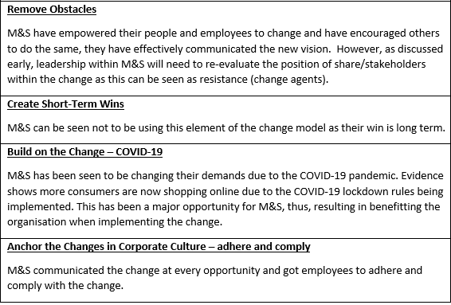
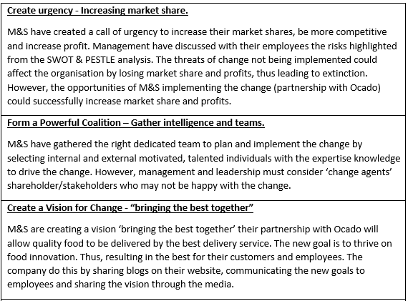
Kotter’s 8 stage model

Although Kotter’s model of change is an effective model, M&S can be seen not to be using every element of the model. Kotter’s 8 stage change model refers to short term wins, however M&S has set the change to a long-term vision. Therefore, this element of the model did not fit in with M&S’s long-term vision.
Another helpful model used during change in organisations is the ADKAR model. The ADKAR model was identified by Jeff Hiatt in 2003. The Model is an effective tool for planning change, equipping leaders in facilitating change, and supporting employees throughout the change. (PROSCI INC, 2021)
The model is very similar to Kotter’s change model however the model is more tailored to managing people during change, while Kotter’s model can be seen to be emphasised more on the processes during the change (AGS, 2021). The ADKAR model has a sequence which allows leaders to transition their employees during the change successfully. According to Hiatt, (2006) employees who have awareness of any change align themselves with the direction of the organisation and influence the change rather than those who are just told. ‘communicate the business need for change, and explain why the change is necessary. Emphasize the risks of not changing’ (Hiatt, 2006). Similarly, Quirke, (2008) agrees, organisation’s energy and enthusiasm comes from its people and the communication of both needs to point in the same direction. However, according to Kotter and Schlesinger (2008) some leaders will argue and state employees do not need to know the reason for every change, they just must simply follow through. Research demonstrates communicating changes effectively to employees helps implement the changes within the organisations.

2.3 Leadership
Research suggests that Leadership can be seen as a crucial aspect of any team or organisation during change management. A strong leadership enhances how an individual inspires and motivates others to successfully implement the change. Tang, (2019) sheds light upon Zenger and Folkman’s (2012) view, successful leaders must obtain the numerous soft skills qualities to drive successful change management. Mullins (2008) illustrates, leadership is a relationship between an individual and their team, and how the individual influences the behaviour and actions of their team by getting them to perform. Likewise, Sirkin, et al (2005) adds, successful change within an organisation must have the key elements of leadership, culture and motivation, as without these, employees will lack engagement, motivation and enthusiasm resulting in failure. Therefore, evidence suggests Leadership is key to influencing individuals to perform to reach the organisations and individuals’ visions and goals.
Research demonstrates during the planning stage of the new venture M&S had appointed 4 new external food directors to help plan for the upcoming change. The individuals appointed had specific expertise in their fields to provide benefits to the planning of the new venture. As stated by management professor Yukl, G A, expert power is more important than reward-based or coercive power in leading effectively. (Emerald Works Limited, 2021)
Stated by Jahnshan, (2019) Tesco strategy director Pav Anand had been appointed as head of food strategy & special products within M&S. Sainsbury’s head of technical Lisa Raschia had been appointed head of produce and horticulture and Danish Crown supply chain director David Stokes had been appointed head of sourcing, and PwC’s Laurissa Kuligowski will step into the role of commercial strategy and operations director at M&S. This indicates a wide variety of external expert leaders were selected within M&S’s food department to help plan the new operational change.
Furthermore, illustrated by Marks & Spencer, (2021) to help implement the change within, M&S has dedicated teams and leaders who have been working behind the scenes in preparation for go-live, developing new products, preparing supply chain processes and providing thousands of data fields and photos for the website. Therefore, research demonstrates leader’s involvement within the implementation of the change guided and prepared teams, and suppliers for the implementation.
Stuart Machin, M&S Food Managing Director adds, ‘I am immensely proud of the team’. This demonstrates effective leadership was carried out during the implementation stage, thus resulting in helping the change become successful. (Marks & Spencer, 2021)
However, deeper research demonstrates although leadership helped the planning and implementation of the change the organisation was also faced with many complex areas.
Firstly, as mentioned early, during the planning stage M&S appointed 4 new external food directors to help with planning. However, although this was beneficial, this can also be demonstrated as a complex area which had to be overseen by leaders. This complex area highlights the weakness and threat for the change as M&S lacked internal expert knowledge and had to appoint external human resources to help plan the change as the organisation did not have the expertise internally. Ward, et al, (2020) asserts, internal expertise enables efficiency in processes, advantages in problem solving and cost efficient.
Secondly, Share/stakeholders can be seen to be acting as a complex area as they were not 100% satisfied with the new venture and questioned the price and the guaranteed success of the change. As stated by Moore, (2019) the shares of investors had reduced because the investment cost £750M and M&S were asking not only £600M from their shareholders/investors but also a 40% cut on their share holds. This demonstrates that leadership has hindered the current situation between share/stakeholders of the organisation as the leadership has asked for a significant investment which can return profit in the long term but not short term. Quoted by CEO Rowe, ‘this is not about the short term, this is about the transformation of Marks & Spencer’. (Neate, 2019) research also demonstrates that the leadership within M&S at this point are using an ‘Autocratic’ leadership approach as the decisions are made and finalised without any input from share/stakeholders. According to Muenjohn et al, (2017) Autocratic leaders have a strong desire to establish and maintain order, they are task focused and will seek in behaviours they believe is right for their followers.
According to Bass (2008) Leadership is often regarded as the single to most important factor in the success or the failure within an organisation. As mentioned earlier, Leadership plays an essential role in the success or failure within change management in an organisation and in particular complex areas such as the variety of departments involved in the change, human resources, and the culture. Leaders either enhance or hinder change depending on their leadership approach. Many leaders can be either ‘Autocratic, Democratic or Laissez-Faire however research demonstrates an effective leader that drives success has a mixed approach of leadership. As stated by Insights Success, (2020) successful leaders adopt a combination of multiple Leadership style.

2.4 Change agents
According to Lunenburg, (2010) A change agent is a an individual or a team who has the skills and power to stimulate, facilitate, and coordinate the change process. Change agents may be either external or internal.
Research suggests change agents are vital in the change process within an organisation as they help improve, transform and develop the change using the specific expert skills. Change agents provide support to teams and leaders throughout the change process using technical ‘know-how’ knowledge to get the job done. As stated by Hammer, (2017) change agents are among the most important in any change management transformation. Similarly, Dunphy, et al (2003) illustrates change agents are the key element of operational survival as they have the specific skills to follow the change through. Therefore, research suggests change agents (human resources) are the key element of operational change to survive as they have the expert knowledge to guide and develop the team through change.
Stated by Quast, (2012) ‘change has an interesting way of affecting people that can often result in resistance. Change is disliked by many and it is inevitable. Resistance occurs when individuals do not understand the necessity of change, they fear the change due to the unknown or lack of communication from above. CIPD, (2020) illustrates resistors fear the loss of job security or control and in general many individuals are content in their current situation and feel they do not benefit from any change.
Resistance in change management can be seen as a positive or negative outcome and to identify and highlight these forces many organisations use Lewin’s force-field analysis to analyse the driving and restraining forces of the change. Lewin’s 1951 force-field analysis is a simple tool used to identify the positives and negatives of a change decision. (ASQ, 2021)
To identify the resistors of the change within M&S a force-field analysis has been drawn.

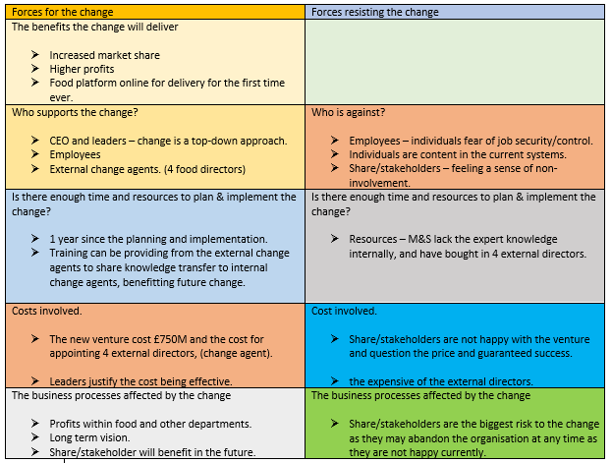
Force Field Analysis

Analysing the results from the force-field analysis; the main resistors of the change within M&S are share/stakeholder. As stated previously share/stakeholder are resisting the change due to their lack of involvement from leadership. Leadership followed an Autocratic leadership approach during communicating the change to share/stakeholders, thus resulting in resistance to the change and share/stakeholders become apathetic and incubators.
Furthermore, M&S have appointed 4 external food directors who have acted as external change agents to help overcome and plan the change. The external change agents have the expert knowledge to oversee the success of the planning which has been beneficial. However, the internal change agents (employees) within M&S do not have the specific skills, and expert knowledge to drive this change through, thus resulting in internal resistance, therefore to overcome this training would be need from the external change agents to transfer the expert knowledge internally, thus benefiting future change.
Research suggests individuals process change in different ways. However, it is important for leaders to help and guide employees through change. According to Mindtools, (2021) only when people have made their own personal transitions can an organisation truly reap the benefits of change. This demonstrates for successful change to be implemented your employees (change agents/resistors) need to adapt and accept the change.

The Change Curve Model
An excellent model that can be used by leaders to overcome change is the Change curve model. It was created by Elisabeth Kubler-Ross, and is a popular and powerful model used to understand the stages of personal transition and describes the four stages most people go through as they adjust to change. (Mindtools, 2021)
When applying the model to the change agents and resistor of the change within M&S, it can be seen that the Apathetic (share/stakeholders) are resisting the change and are stuck at the Denial stage, as they believe this change has nothing to do with them and does not affect them. However, some Incubators (Share/stakeholders) may have transitioned into the anger stage and are upset and angry as the change was implemented without their involvement. Also, the change affected them as their shares were cut. Another change agent that has transitioned throughout the change curve is the external directors who were appointed during the planning stage. Theses change agents are advocates, they are drivers of the change and have transitioned from the beginning straight to acceptance.
However, although currently the Apathetic and the Incubators are stuck on denial and anger, leadership are working to transition them through the stages, as the CEO of M&S explained the change implemented is a long-term vision, Incubators and Apathetic will see success and benefits in the future. Stated by Neate, (2019) the CEO of M&S illustrates the venture would ‘drive long term growth & successes.

2.5 Culture
Research suggests organisational culture is a key aspect that can lead an organisation either to success or failure. A thriving culture shapes the success of the organisation and its people and is a major enabler within an organisation during change management. According to CIPD, (2016) for businesses to succeed a strong thriving culture must exist.
In an article by Corporate Marks and Spencer (2018) leadership express that changes had to be made for M&S to thrive again, and the underperforming organisation was not due to its people resisting, in fact leadership claim that the employees in M&S are ‘great and passionate’ and the culture accelerates that. According to M&S Careers, (2018) the organisational culture within M&S is thriving, M&S have strong bonded teams who enjoy working for M&S and respect one another. Nick Foods section coordinator emphasizes “Everyone is so close here, more than friends than employees”. This demonstrates a M&S is operating a strong culture.
However, to recognise and make culture visible within an organisation, leaders can be seen to be using the Edgar Schein model which was developed in 1980. (Mullins, 2016) The Edgar Schein model highlights the 3 levels of culture within an organisation.
To highlight the 3 levels of the current culture within M&S the Schein model has been applied.

The Schein Model
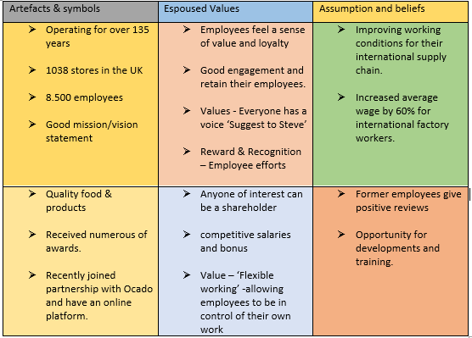
Analysing the results from the Schein model research suggests M&S have a strong culture within the organisation as the 3 levels demonstrate this.
Artefacts and symbols – M&S have been operating for more than 135 years, have many stores in the UK and worldwide and have more than 8,500 employees. The organisation has a strong reputation and loyal customers and has received numerous awards for their services and products.
Espoused Values – M&S have set strong values within the organisation which encourages employee voice, engagement and involvement. ‘(Suggest to Steve’) also another value ‘Smarter way’ encourages employees to take responsibility and control of their own work. The organisation reward and recognise employees for their hard work and pay competitive salaries which motivates and retains employees. As Cottrell S, (2003, p.9) puts it “You will need clear motivation to keep yourself going even through tough times”. Overall employees in M&S feel appreciated and loyal.

Assumptions & beliefs – M&S have created a good culture by improving working conditions for international employees and suppliers by paying them 60% above minimum wage and also by improving the working conditions in the factories. (The Guardian, 2016) The organisation can also be seen to have set a strong reputation as former employees have left positive reviews on Glass Door (2020) and have expressed the opportunities to grow and develop within M&S. therefore, research demonstrates that M&S are operating a strong thriving culture.
However, further research demonstrates that although M&S are operating a strong culture, the current operational change that has been implemented has causes raised for concerns as share/stakeholders are not supporting the change and are resisting. The share/stakeholders feel a sense of loss, lack of involvement and appreciation, thus resulting in feeling neglected and not communicated and listened to. Therefore, this is going against M&S values ‘suggest to Steve’ as it is not allowing communication and share/stakeholder voice. This is demonstrating poor culture and engagement towards the share/stakeholders as their voice and concerns did not get accounted for, leaving them feeling unappreciated and abandon. According to Mullins, L J (2016, p225) engagement with your people is vital as individuals feel a sense of connection with the organisation.
Therefore, Organisational culture will either enable or hinder the change, stated by Tharp, (ND) culture is considered the “glue” that holds an organisation together and for others, the “compass” that provides directions. This demonstrates culture is a key element in change within an organisation. Similarly, Belias, D and Koustelios, A (2014) states, ‘an organisation with the best strategy in the world, but a culture that won’t allow the strategy to happen, is doomed from the beginning.’ Therefore, research demonstrates that without an effective organisational culture change will failure.

3.0 Conclusion
To conclude, a vast variety of research has demonstrated M&S identifying an operational change had to be implemented to increase market share and profits for the organisation to survive. The new operational change resulted in partnership with delivery online service Ocado joining a new venture of food platform online.
Research suggests M&S have had many areas of success within the change process.
Firstly identified, M&S had an affective team of internal and external change agents which helped the planning and the implementation of the change. M&S appointed 4 new food directors with the expert knowledge to drive the planning of the change. The 4 directors acted as external change agents and had the expertise and were bought in from Tesco, Sainsbury and supply chains. This has provided M&S with the advantage of ‘Expert Knowledge’ needed to drive the change successfully.
Secondly, M&S selected dedicated teams and experts to drive implementation successfully, leaders of the food department guided and supported the dedicated teams to work behind the scenes in preparation for the implementation start date. M&S have also demonstrated they have a strong leadership and a thriving culture within the organisation which has helped make the change successful.
Furthermore, research demonstrates although the current Pandemic was not planned for, it has certainly benefited the change process. The current lockdown restrictions have helped enable the change to be successful as evidence suggests consumers have changed the way they shop and are completely reliant on online shopping, thus resulting in profit and increase market share for M&S.
Finally, M&S and external specialists believe the organisations absence from the fast-growing online market has long held them back for too long. The CEO of M&S expressed the tie up with online Ocado has resulted in very strong results such as profit in food rising by 19% and had been very profitable. Therefore, this demonstrates that the change has been successfully planned and implemented.
However, although M&S planned and implemented many positive outcomes to overcome the change, there were some barriers which would need developing for future planning,
Firstly, one of the major resistors that was identified during the implementation of the change was share/stakeholder. Share/stakeholders acted as ‘complex areas’ during the change, they became resistors to the change and incubators/apathetic. Share/stakeholders were not happy as they felt completely withdrawn to the change, not involved or communicated, furthermore resulting in funding the new venture and having their dividends cut by 40%. This is suggesting that M&S created a poor culture between themselves and their share/stakeholders as they did not follow their values, also if the change is not successful the risk of share/stakeholders abandoning the organisation.
Another barrier which hindered the resistance towards share/stakeholders was the leadership style implemented from above. The Autocratic leadership style which was used during funding the change was not communicated towards to the share/stakeholders resulting in resistance. This is demonstrating poor leadership from management. However, the CEO would argue that this change is not a short-term vision, it is a long-term transformational vision. Therefore, demonstrating share/stakeholder will see results and benefits in the future.
Adding to this research demonstrates during the planning stage M&S was seen to be using the Kotter’s 8 stage model which, although the models flowed well with the change, one element did not align which was the ‘create short term wins’ as M&S’s change is a long-term win. Therefore, to overcome this for future development M&S could use a different model such as the ADKAR model, which also considers the human elements to change not just the processes like the Kotter model.
Finally, a second ‘complex area’ which was highlighted was the external change agents that were appointed (4 food directors). This became a complex area as M&S lacked the expert knowledge internally thus resulting in buying in external expert knowledge. To overcome this for future change, M&S should use the external expertise to transfer knowledge to the internal change agents. This will then allow M&S to have their own expertise internally for future change.
Overall, research has demonstrated that M&S have successfully planned and implemented an operational change which is increasing their market shares and profits. With slight room for improvements for the future of change within the organisation.

4.0 Recommendations
After analysing the results from the conclusion, a set of recommendations have been aided to develop M&S for any future planning and implementation of change.
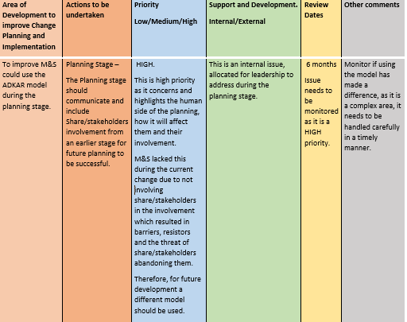

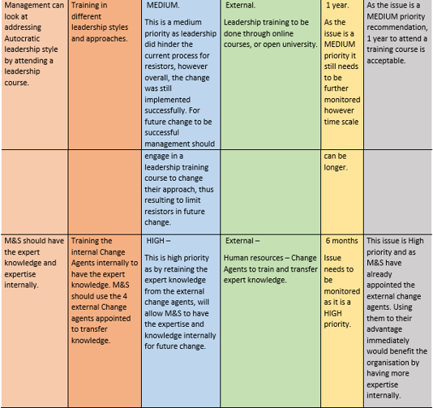

5.0 Appendices
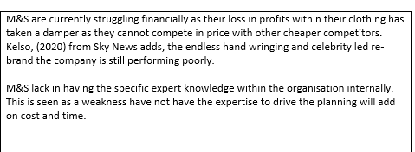
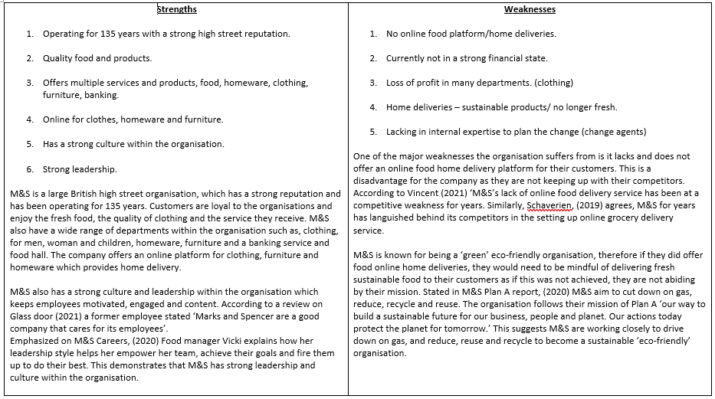

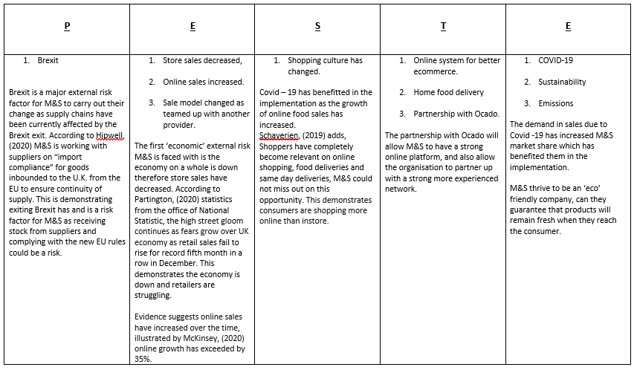
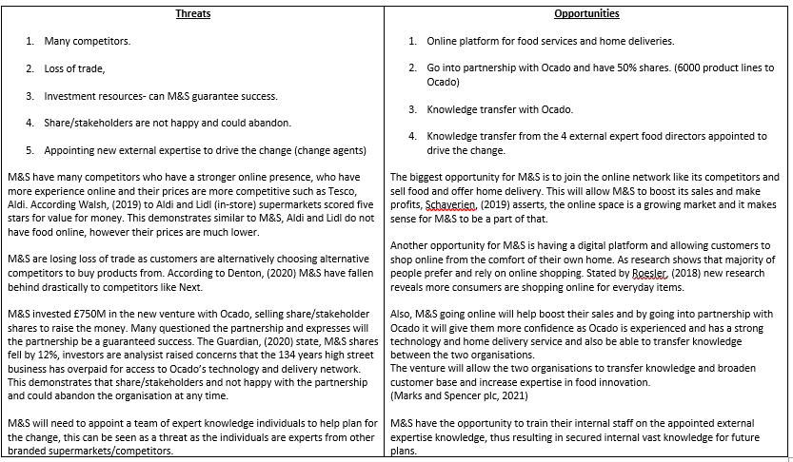

References

1/ American Society for Quality, (2021) FORCE Field ANALYSIS.
Available at: https://asq.org/quality-resources/force-field-analysis (accessed:11/03/2021)
2/ ASG, (2021) John Kotter’s 8-Step Change Model | 2021 Guide | Pros & Cons. Available at: https://www.airiodion.com/john-kotter-change-model/ (accessed: 08/03/2021)
3/ Bass, B M (2008) The Bass handbook of leadership: theory, research, and managerial applications. 4th Edn. New York: NY: Free Press.
4/ BBC, (2021b) Lockdown fashion: 'People are back in their pyjamas'. Available at: https://www.bbc.co.uk/news/business-55584843 (accessed: 30/01/2021)
5/ BBC, (2019) M&S and Ocado to start home delivery service next year. Available at: https://www.bbc.co.uk/news/business-47383159 (Accessed: 26/02/2021)
B/ BC, (2020c) M&S suffers first loss in 94 years as clothing slumps. Available at: https://www.bbc.co.uk/news/business-54807247 (accessed: 02/02/2021)
7/ BBC, (2020) M&S to cut 7,000 jobs over next three months. Available at: https://www.bbc.co.uk/news/business-53817598 (Accessed:30/01/2021)
8/ Belias, D and Koustelios, A (2014) THE IMPACT OF LEADERSHIP AND CHANGE MANAGEMENT STRATEGY ON ORGANIZATIONAL CULTURE. Available at: https://d1wqtxts1xzle7.cloudfront.net/51337137/2996-8812-1-PB_2.pdf?1484319964=&response-content-disposition=inline%3B+filename%3DTHE_IMPACT_OF_LEADERSHIP_AND_CHANGE_MANA.pdf&Expires=1615500633&Signature=AtdQnoS9RW-gsfystm2QWGg8JzV455ixdIBHgiinKM0B0qVtPhEHkLYgAl6rxFky4FmSXhcvUMFHYaiIYKzNHkpCSOfWdAHtzNElb~MgJ3Sa0OYvdjDjkwMcJYr330JFsa20ir65ejKyzBc2wYdHp5QD~Q~0I4y3StMMXhhcXPEmmlbYu4PCMX~nrsCBYrYCutRg1uv-bnNT9jWeb8BsyHAo22781NtHZR5HLcMObDufFWDPYQmEeEOuslQMOSkxEROYR2~AqQPQ0dIH6bnv~W-mul4C3UP7hkBAPxLntuhs9~JtlFT15ZdnaJSx3OmVS8FiGVx7uKPuC3EDHKlcXA__&Key-Pair-Id=APKAJLOHF5GGSLRBV4ZA (accessed: 11/03/2021)
9/ Butler, S (2020) Stand and deliver: Waitrose and M&S fight for Ocado customers.
Available at: https://www.theguardian.com/business/2020/aug/15/waitrose-marks-and-spencer-ocado-switch-food-supermarkets (Accessed: 09/03/2021)
10/ Calegari, M F, Sibley, R E, Turner, M E, (2015) A ROADMAP FOR USING KOTTER'S ORGANIZATIONAL CHANGE MODEL TO BUILD FACULTY ENGAGEMENT IN ACCREDITATION. Available at: https://search.proquest.com/docview/1768629258/abstract/363ECED512EB4060PQ/1?accountid=14680 (Accessed: 08/03/2021)
11/ Chartered Institute of Personnel and Development, (2021) Change management. Available at: https://www.cipd.co.uk/knowledge/strategy/change/management-factsheet#gref (accessed:11/03/2021)
12/ Connelly, M (2021) Eight Reasons To Use A Change Management Model. Available at: https://www.change-management-coach.com/change-management-model.html (Accessed: 07/03/2021)
13/ Corporate Marks and Spencer, (2018) Annual report – people and culture. Available at: https://corporate.marksandspencer.com/annual-report-2018/PEOPLE_AND_CULTUREv5RS.pdf (Accessed: 11/03/2021)
14/ Corporate.marksandspencer.com (2020) M&S Plan A Report 2020. Available at: https://corporate.marksandspencer.com/documents/reports-results-and-publications/plan-a-reports/2020/plan-a-report-2020.pdf (Accessed: 02/03/2021)
15/ Cottrell S, (2003) The study skill book. 2nd Ed. Hampshire. Palgrave Macmillan Ltd
16/ Denton, J (2020) Christmas shoppers hungry for festive treats help M&S to sell £700m more food than clothes but shares fall as 'one-off' problems dent recovery.
Available at: https://www.thisismoney.co.uk/money/markets/article-7868199/Marks-Spencer-shares-fall-sharply-amid-problems-food-waste-menswear-lines-gifts.html (Accessed: 02/03/2021)
17/ Dunphy, D, et al (2003) Organizational change for corporate sustainability. A Guide for Leaders and Change Agents of the Future. London: Routledge
18/ Emerald Works Limited (2021) Building Expert Power Earn Respect by Developing Expertise. Available at: https://www.mindtools.com/pages/article/newLDR_04.htm (accessed: 09/11/20)
19/ Fok-Yew, O, Ahmad, H and Baharin, S (2013), ‘Operational Excellence and Change Management in Malaysia Context,’ Journal of Organizational Management Studies, Vol. 2013, Article ID 957636, DOI: 10.5171/2013. 957636
20/ Glass Door. (2020) Marks and Spencer. Available at: https://www.glassdoor.co.uk/Reviews/Marks-and-Spencer-London-Reviews-EI_IE3278.0,17_IL.18,24_IM1035.htm (Accessed: 26/02/2020)
21/ Glassdoor, Inc. (2021) Marks & Spencer Reviews.
Available at: https://www.glassdoor.co.uk/Reviews/Marks-and-Spencer-Reviews-E3278.htm (Accessed: 02/03/2021)
22/ Greene, M (2020) Mark Cuban: 'The only constant of business is change'
Available at: https://www.theguardian.com/business/2020/aug/02/mark-cuban-small-business-gene-marks (Accessed: 07/03/2021)
23/ Hammer, M (2017) The change agent challenge
Available at: https://www.mckinsey.com/business-functions/operations/our-insights/the-change-agent-challenge (Accessed: 11/03/2021)
24/ Hiatt, J M (2006) ADKAR - A Model for Change in Business, Government, and Our Community. USA: Prosci Learning Center Publications
25/ Hipwell, D (2020) M&S Warns Brexit Could Weigh on Retailer’s Business in Ireland.
Available at: https://www.bloomberg.com/news/articles/2020-11-04/m-s-warns-brexit-could-weigh-on-retailer-s-business-in-ireland (Accessed: 03/03/21)
26/ Hussain, D and Washtell, F (2020) Marks and Spencer's is selling MORE food on Ocado than Waitrose did: £750million gamble to tie up with online retailer pays off. Available at: https://www.dailymail.co.uk/news/article-8738669/Marks-Spencers-750m-Ocado-deal-pays-off.html (Accessed: 26/02/2021)
27/ Insights Success (2020) 8 Most Effective Leadership Styles for Organizational Success. Available at: https://www.insightssuccess.com/8-most-effective-leadership-styles-for-organizational-success/ (accessed: 18/11/2020)
28/ Jahnshan, E (2019) M&S names 4 new food directors ahead of Ocado partnership.
Available at: https://www.retailgazette.co.uk/blog/2019/10/ms-names-4-new-food-directors-ahead-of-ocado-partnership/ (accessed: 09/03/21)
29/ Jahnshan, J (2019) M&S mulls 47 job cuts in clothing teams.
Available at: https://www.retailgazette.co.uk/blog/2019/05/ms-mulls-47-job-cuts-in-clothing-teams/ (Accessed:24/02/2021)
30/ Juneja, P (2015) Different Types of Change. Available at: https://www.managementstudyguide.com/types-of-change.htm (Accessed: 27/02/2021)
31/ Juneja, P (2015) Kotter’s 8 step Model of Change. Available at: https://www.managementstudyguide.com/kotters-8-step-model-of-change.htm (accessed: 07/03/21)
32/ Kelso, P (2020) Coronavirus: Latest round of job cuts at M&S will not be the last.
Available at: https://news.sky.com/story/coronavirus-latest-round-of-job-cuts-at-m-s-will-not-be-the-last-12051789 (Accessed:24/02/2021)
33/ Kotter, J P (2008) A Sense of Urgency. USA: Harvard Business Review Press
34/ Kotter, J P and Schlesinger L A (2008) Choosing Strategies for Change. Available at: https://hbr.org/2008/07/choosing-strategies-for-change (Accessed: 08/03/2021)
35/ Kotter, J P (2012) Leading Change. 3rd Edn. USA: Harvard Business Review Press
36/ Lunenburg, F C. (2010) ‘Managing Change: The Role of the Change Agent.’
INTERNATIONAL JOURNAL OF MANAGEMENT, BUSINESS, AND ADMINISTRATION VOL 13, No 1.
37/ M&S.com (2020) Apprenticeships Help Shape Leadership Talent at M&S.
Available at: https://jobs.marksandspencer.com/apprenticeships-help-shape-leadership-talent (Accessed: 02/03/2021)
38/ Marks and Spencer plc, (2021) History. Available at: https://corporate.marksandspencer.com/aboutus/history (Accessed: 30/01/2021)
39/ Marks and Spencer plc, (2021) IT’S DELIVERY DAY WITH OCADO
Available at: https://corporate.marksandspencer.com/stories/blog/it-s-delivery-day-with-ocado (Accessed:09/03/21)
40/ Marks and Spencer plc, (2020) M&S FOOD TO SUPERCHARGE DISRUPTIVE INNOVATION WITH THE LAUNCH OF DEDICATED NEW TEAM.
Available at: https://corporate.marksandspencer.com/media/press-releases/5e0f046f7880b21924350282/m-and-s-food-to-supercharge-disruptive-innovation-with-the-launch-of-dedicated-new-team (Accessed:24/02/2021)
45/ Marks and Spencer plc, (2021) OCADO RETAIL, Latest Ocado partnership news. Available at: https://corporate.marksandspencer.com/aboutus/ocado-retail (Accessed: 02/03/21)
50/ McKinsey & Company, (2020) The great consumer shift: Ten charts that show how US shopping behavior is changing. Available at: https://www.mckinsey.com/business-functions/marketing-and-sales/our-insights/the-great-consumer-shift-ten-charts-that-show-how-us-shopping-behavior-is-changing (Accessed: 03/03/2021)
51/ Mindtools.com (2021) The change curve, Available at: https://www.mindtools.com/pages/article/newPPM_96.htm (Accessed: 11/03/2021)
52/ Mindtools.com (2021) Available at: Kotter's 8-Step Change Model.
https://www.mindtools.com/pages/article/newPPM_82.htm (accessed: 08/03/2021)
53/ Mindtools.com (2021) Kotter's 8-Step Change Model, Implementing Change Powerfully and Successfully.
Available at: https://www.mindtools.com/pages/article/newPPM_82.htm (Accessed: 07/03/21)
54/ Moore, J (2019) M&S shares slump on Ocado deal but CEO Rowe has made the right move for the long term despite the fancy price
Available at: https://www.independent.co.uk/news/business/comment/m-s-ocado-joint-venture-food-deliveries-waitrose-grocery-shares-investors-a8799091.html (Accessed: 09/03/2021)
55/ Muenjohn et al, (2017) Leadership, Regional and Global Perspective. UK: Cambridge University Press
56/ Mullins. L J (2008) Essentials of Organisational Behaviour. 2nd Edn, Harlow: Pearson Education Limited.
57/ Mullins L J. (2016) Management and Organisational Behaviour. 11th ed. Harlow: Pearson.
58/ Nazir, S (2020) How will the Ocado deal pan out for M&S?
Available at: https://www.retailgazette.co.uk/blog/2020/08/how-will-ocado-deal-pan-out-ms-waitrose-online-grocery-partnership/#:~:text=Around%205000%20M%26S%20lines%20will,on%20Ocado%20from%20September%201.&text=The%20impending%20partnership%20was%20first,it%20would%20supply%20its%20groceries. (Accessed:24/02/2021)
59/ Neate, R (2019) M&S agrees £750m food delivery deal with Ocado.
Available at:https://www.theguardian.com/business/2019/feb/27/marks-and-spencer-agrees-750m-food-delivery-deal-with-ocado (Accessed: 26/02/2021)
60/ Partington, R J, (2020) High street gloom continues as fears grow over UK economy.
Available at: https://www.theguardian.com/business/2020/jan/17/high-street-gloom-continues-as-fears-grow-over-uk-economy (Accessed: 03/03/2021)
61/ PROSCI INC. (2021) What is the ADKAR Model? Available at:
https://www.prosci.com/adkar/adkar-model (Accessed: 08/03/2021)
62/ Quast, L (2012) Overcome The 5 Main Reasons People Resist Change.
Available at: https://www.forbes.com/sites/lisaquast/2012/11/26/overcome-the-5-main-reasons-people-resist-change/?sh=55f74f683efd (Accessed: 11/03/2021)
63/ Quirke, B (2008) Making the Connections -
Using Internal Communication to Turn Strategy In to Action. 3rd Edn. USA: Gower Publishing Limited
64/ Russon, M A, (2020) M&S: Five reasons the retailer is struggling. Available at: https://www.bbc.co.uk/news/business-53478403 (Accessed: 01/02/2021)
65/ Sirkin, H L, et al, (2005) The Hard Side of Change Management
https://hbr.org/2005/10/the-hard-side-of-change-management (Accessed: 01/03/2021)
66/ Tag, K N (2019) Leadership and Change Management. Singapore: Springer Singapore
67/ Terrell, K (2015) Managing Organizational Change in Operational Change Initiatives. Available at: https://www.imanet.org/-/media/ab93927820b54b7693e00fb48170ef84.ashx (Accessed: 27/02/2021)
68/ Tharp, (ND) Defining “Culture” and “Organizational Culture”: From Anthropology to the Office. Available at: https://www.thercfgroup.com/files/resources/Defining-Culture-and-Organizationa-Culture_5.pdf (Accessed: 11/03/2021)
69/ The Guardian. (2016) Asian workers making M&S clothes paid far less than living wage – report. Available at: https://www.theguardian.com/business/2016/feb/14/marks-and-spencer-workers-sri-lanka-india-bangladesh-earnings-living-wage-labour-behind-the-label (Accessed: 26/02/20)
70/ Tugby, L (2017) First look: Tesco and Next launch shop-in-shop tie-up. Available at: https://www.retail-week.com/grocery/first-look-tesco-and-next-launch-shop-in-shop-tie-up/7027746.article#:~:text=Tesco%20is%20piloting%20a%20shop,to%20utilise%20excess%20store%20space.&text=The%20shop%2Din%2Dshop%2C,retailer's%20womenswear%20and%20menswear%20proposition. (Accessed: 21/03/2021)
71/ Ward, P, Roth, E M, J. Schraagen, J M and Gore, J. (2020) The Oxford Handbook of Expertise. Oxford: Oxford University Press
72/ Walsh, H (2019) Best and worst supermarkets of 2019.
Available at: https://www.which.co.uk/news/2019/02/best-and-worst-supermarkets-for-2019/ (Accessed: 02/03/2021)
73/ Wassmer, S (2016) Why Operational Change Is About People, Not Process. Available at: https://www.linkedin.com/pulse/why-operational-change-people-process-scott-wassmer (Accessed: 27/02/2021)
74/ Wood, Z (2019) Marks & Spencer profits plunge as clothing sales continue to fall. Available at: https://www.theguardian.com/business/2019/nov/06/marks-and-spencer-profits-plunge-clothing-sales-fall (Accessed: 01/02/2021)

