

MODULE: MARKETING MANAGEMENT
MODULE CODE: LCMB7001

Assignment Title: Marketing Management Assignment 1
Student Name: Jemil Kishorbhai Gujarati
Student Id: 2212014
Lecturer Name: Tushara Balendran
Submission Date: 9th January 2023
Executive summary

A brief description of the organisation has been given in the initial section. Then the unique marketing policies that are undertaken have also been analysed. Effective marketing strategies can also lead to improved customer loyalty, greater success in business and access to new customer segments have been described in this report. Through targeted campaigns, companies can generate higher levels of engagement with customers, thus leading to greater loyalty and satisfaction. Apple has bene observed in facing increased competition from companies such as Samsung, Huawei, and Google. These companies are producing devices that are comparable to Apple's products at lower prices, making it harder for Apple to compete on price.
Apple has adopted a variety of tactics to address its problems, including joint venture collaborations, community involvement, market niche discovery, and more. Taking advantage of the competition customer journey planning and workplace diversity preparation. It has been suggested to Apple that they leverage influencer marketing and word-of-mouth advertising in their marketing strategy. In order to address the difficulties posed by the altered business environment, it has also been advised that Apple concentrates on their change management abilities and transformational leadership.

Table of Contents
Introduction 5
Background of organisation 5
Impact of innovative marketing strategies on customer satisfaction 6
Customer journey 9
Challenges experienced by the organisation 9
Strategies to overcome the challenges 10
Recommendations and conclusion 12
References 15

Introduction
Major organisations around the world are these days focussed upon using different strategic marketing techniques to access their clientele. Apple is one of the biggest brands in the sector of tech products like that of iPhone, tablets, and others. The organisation came up with different variants of the i-Phone to meet the demands of the consumers more agreeably. The latest model that has been launched by this organisation is called the iPhone 14 pro. The organisation is these days focussing mainly on accessing customer touch points instead of just focusing on the traditional marketing techniques. In the succeeding sections, the key marketing strategies that have been undertaken by this organisation to create a loyal consumer base have been analysed.

Background of organization
Apple is a multinational organisation that is headquartered in Cupertino, California. As of June 2022, the organisation has been able to acquire the largest amount of revenue in this sector (Apple, 2022). The iPhones sold by this organisation are generally considered to be part of the higher price range than almost all other brands in the market. As per the opinion of Bejaei et al. (2020), it can be said without a doubt that this organisation uses some of the highest technological frameworks to produce these products most of which are its innovation. But still, the organisation has been accused a number of times to have been taking advantage of its brand name and overpricing the products.
Key marketing activities of the company
Apple is known to be one of the greatest marketers of all time as this organisation knows ways to analyse the pulse of the consumers and frame marketing policies that helps to penetrate easily in the market. Apple believes in creating simple products that deliver high performance than most other brands that are available in the market. Acc ordering to the opinion of Liébana-Cabanillas et al. (2020), the marketing strategy that is used by this organisation is also rather simple than that of many other organisations on the market. The advertisements that are used are also quite simplistic and easy to understand for consumers. The organisation believes that the loyal consumers are always willing to pay the extra price that is necessary to acquire products that are delivered by this organisation. The web and sales copy processes that are used by this organisation are also quite simplified and only those things that are necessary to be endorsed are actually propagated.
The marketing strategy of this organisation is mainly focused on accessing the different customer touchpoints that help a consumer to have a great journey right from purchasing the product to finally disposing of it. As per the opinion of Vasylieva and Harvey (2020), the websites and the stores that are used to endorse and sell the products ate all aesthetically designed to create a convenient consumer experience. The organisation tends to give a high importance to the feedback that is generated by the customers. It helps to generate a better experience for the consumers each time.
A key strategy of this organisation has always been to create a hype in the market even before a product is launched in the market. As per the opinion of Lee et al. (2019), even before a product is launched in the market the marketing team clearly describes all the key specifications and better features that are going to be available in the new range. This tends to create a significant amount of excitement as the organisation teases out the product. This tactic of creating a mystery about the products to be sold helps to actuially sell a good number of products than the competitors.

Impact of innovative marketing strategies on customer satisfaction
The impact of marketing strategies on customer satisfaction is significant, as it can determine the success or failure of a business. Effective marketing strategies can help to build brand loyalty and trust, increase brand recognition, and create positive relationships with customers. Good marketing strategies can also lead to increased sales, better customer service, and improved customer experience. As per the opinion of Hole et al. (2018), by understanding customer needs and preferences, businesses can develop effective marketing strategies that can help to improve customer satisfaction and build positive customer relationships. Customer satisfaction is extremely important for a company, as it can greatly affect the success of the business. Apple is renowned for its exceptional customer service; so it ensures to develop a comprehensive customer service strategy to improve customer satisfaction levels (Apple, 2022). This should include providing quality customer care, clear and concise communication, prompt response times, easy-to-use contact methods, and personalized experiences.
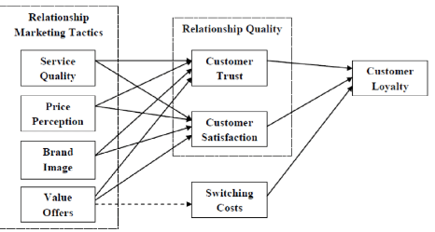
Figure 1: Impact of marketing on the satisfaction of customers
(Source: Influenced by Lee and Lee, 2020)
Customer satisfaction surveys and feedback allow companies to identify customer needs and preferences, develop new products or services, improve customer service, and increase brand loyalty (Lee, 2019). Companies that focus on customer satisfaction often have higher customer engagement rates, increased customer retention and loyalty, and greater sales and profits. Investing in customer satisfaction also helps create a more positive customer experience, which can lead to improved customer relationships and higher customer satisfaction levels (Lee and Lee, 2020). Therefore, customer satisfaction is essential for businesses of all sizes and industries. Customer satisfaction for Apple is quite high and the average score for Apple products was 83% which is the highest in the industry (Developer.apple.com, 2022). The survey revealed that customers are particularly happy with the company’s innovation, product quality, design, and customer service. Furthermore, as of 2020, 92% of Apple customers said they were satisfied with the overall experience of using their product iPhone.
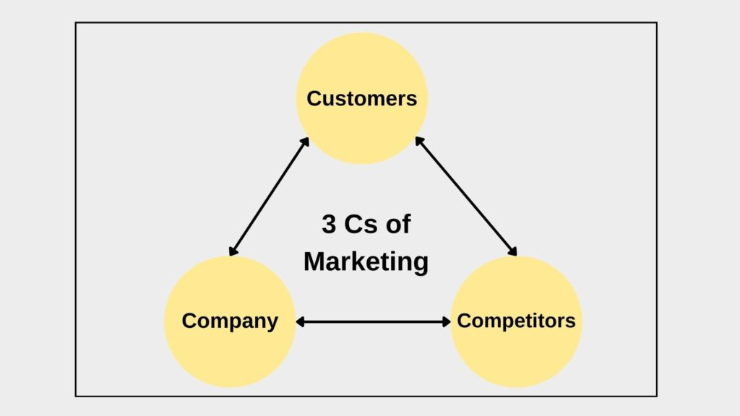
Figure 2: 3C’s of marketing
(Source: Influenced by Lee, 2019)
According to 3C’s of marketing concept, maintain consistency among customers and company can be helpful to sustain competitive environment of business. This is also associated with managing product quality and serving customers are the key to customer satisfaction (Lee, 2019). Apple uses advanced AI algorithms to create personalized product recommendations for customers based on their past purchases and browsing history. This helps to ensure a more tailored experience, improving the customer experience and satisfaction. This company has implemented an AI-driven automated customer support system that can answer customer questions quickly and accurately without human intervention (Hoe and Mansori, 2018). This helps reduce wait times and improves the overall customer experience. Apple utilizes AI and machine learning technology to target promotions and offers to customers who are most likely to be interested in them. This helps to improve customer engagement and satisfaction, as customers feel like they’re receiving tailored offers that are relevant to them.
Marketing strategies play an important role in customer satisfaction for Apple. Companies can create unique strategies to promote their products and services, engage with customers, and provide the best possible customer service (Hult et al., 2019). Through the use of targeted advertising, personalized content, and Omni channel marketing, Apple can increase customer engagement and loyalty, build customer trust, and ultimately improve customer satisfaction. Additionally, strategies such as content marketing and influencer marketing can help Apple reach more potential customers, while customer feedback initiatives can help Apple identify areas of improvement. Ultimately, by utilizing effective marketing strategies, Apple can ensure customer satisfaction and greater customer loyalty.

Customer journey
Apple is an organisation that tends to touch a significant number of consumer touchpoints to ensure that the consumers have a good experience from the start to the finish. A clean and easy-to-navigate website is the first stage through which this organisation tends to help the consumer have a good experience. As per the opinion of Weinstein (2020), the packaging of Apple products is also designed in an extremely special manner. The packages also come with special handles that help these products to serve as advertising billboards when the consumers leave the stores. The employees in this organisation are also given training so that they can be considered as hipper, cooler, smarter, and more patient in delivering the services to the customers.
One-to-One service is another key feature that is provided by this organization. For two consecutive years through 1-year training programs. These programs are specifically impactful to help consumers to understand the best techniques t using different types of products. It helps to raise the bar of loyalty and ensure that the customers are going to return to purchase these products again. According to the opinion of Vinokurova (2019), separate Personal Space is created in the stores where the customers get to know about all the different ways through which the products can be most conveniently used. Most organizations in this sector generally believe in delivering different added hardware components and making these components more attractive. This organization also focuses on different kits called like that Software Development Kits that have led to the development of some 1000 apps. A questionnaire for Satisfaction Survey is also generated by this organization from time to time. It has been helping Apple to consistently understand the way through which it can better access the touchpoints to provide better surveys.

Challenges experienced by the organisation
Strong competitiveness
Apple faces strong competition from other leading technology companies such as Google, Amazon, and Microsoft. To remain competitive in the fast-paced tech market, Apple must focus on differentiating its products through unique features and services, while continuing to innovate and develop new technologies (Li et al., 2021). Apple should also embrace collaboration and partnerships with other companies, to gain access to new markets and resources. Apple has faced increasingly intense competition in the market since its launch. Its competitors range from tech giants such as Samsung and Microsoft to smaller companies like Huawei and Xiaomi all competing for a share of the market (Bbc.com, 2022). Apple's competitive edge has come from its use of innovative design features, strong customer loyalty, and its record of releasing highly sought-after products. Apple has also maintained its competitive edge by consistently creating a product portfolio that is reflective of the latest trends in consumer electronics. Additionally, Apple has established itself as a leader in the industry through its vast array of apps and services as well as its fierce dedication to customer satisfaction. Additionally, they should look to expand into new markets, while focusing on providing high-quality customer service and support. Finally, they should continually strive to improve their existing products and services, to stay ahead of competitors.
Changing the business environment
The impact of changes in the business environment on a company can be both positive and negative. On the positive side, changes can provide new opportunities for growth, as well as open up new markets and customer bases. Additionally, changes can bring about an enhancement in operational efficiency and cost reduction. On the other hand, changes in the business environment can create challenges, such as increased competition, increased regulations, and financial instability. Companies need to be able to adapt quickly to the changing environment in order to survive and thrive. Apple faces intense competition in the Chinese market from local companies such as Huawei and Xiaomi, which offer similar products at lower prices.
China has some of the most restrictive digital laws and regulations in the world, which limit Apple’s ability to offer certain services and products in the country. Recent trade tensions between US and China have created tension between Apple and its Chinese customers, which has limited the company’s growth in the region. Apple products have traditionally been popular among affluent Chinese consumers, but the company must now cater to a wider demographic with different tastes and preferences (Bbc.com, 2022). This company faced issues in terms of using a different language to communicate effectively with customers in China. This could lead to misunderstandings or issues in customer service. Apple needed to navigate different cultural norms, such as preferences for local companies rather than foreign ones when attempting to do business in China.

Strategies to overcome the challenges
Apple has been one of the leading electronics gadget manufacturing companies in the USA and across the world. This study has chosen the iPhone to understand its marketing strategies. Apple has faced the issue of strong competitiveness and changing the business environment in China.
- Strategies for competition
Developing joint venture relationships is one of the strategies that can be used by Apple to combat its market competitiveness. Forming a network of synergistic relationships helps the company to combat the competition (Ge et al., 2018). Apple can adopt the strategy of joint ventures and can search for those companies that are synergies but are not direct competitors. Approaching these companies to come up with a joint venture agreement.
Getting involved in the local community can be another strategy for Apple to compact the challenges. Community groups, activities and initiatives can be the key elements for developing the company and can help the company to develop their competitive business strategy. As per the Branding theory of marketing, aligning core principles of the company with effective innovative marketing helps to make genuine business relationships (Joseph et al., 2021). It can help Apple to use word-of-mouth advertising which is the most effective means of branding for a business. In respect to this, Keller’s brand equity model is effective in understanding the situation as proper brand response and brand performance is helpful to get better brand identity through marketing.
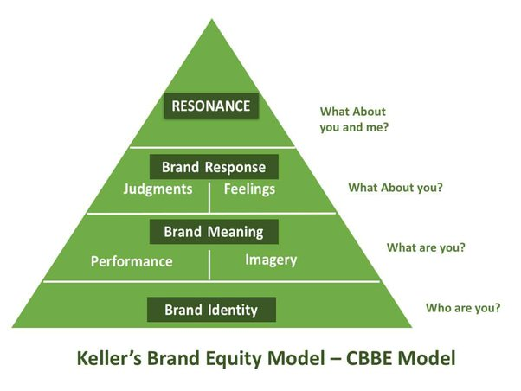
Figure 3: Brand equity model
(Source: Keller and Brexendorf, 2019)
Finding a niche in the market is one of the effective strategies of Apple which can help the company to combat the competition. Biting off more than the capacity is a common mistake that Apple has obtained (Salamzadeh, 2018). Apple is known for its brand reputation and iPhone products and this strategy helps Apple to build a reputation of excellence in one specific niche, focusing on the customer's needs and meeting those needs is helpful for the business. It helps Apple to build an ability to perform better in the competitive market.
Capitalizing on the competition is another effective strategy that Apple can obtain, it helps the company to turn its competitors into clients.
- Strategies for changing the environment
Preparing customer journey mapping is one of the most effective strategies that apple can obtain, customer journey mapping helps apple to understand their customer. It also helps the company to identify inefficiencies. in the operational activities which can be quick and easier with customer journey mapping. As stated by Arco et al. (2019), it can be a quick win for the customers' experienced leaders of the business. Apple can identify the needs and requirements of the customers and can amend their products according to the customers' needs and requirements.
Diversification of the workplace is another strategy for Apple to combat the changing business environment challenges (Tamunomiebi and John-Eke, 2020). Apple has faced cultural differences in the workplace in China. Apple is a US-based company that has expanded its business in the Chinese market. Therefore, it has created a gap between US employees and Chinese customers. Hence, Apple can diversify their workforce by employing Chinese talents to understand the perspective of the customers in the Chinese market.

Recommendations and conclusion
Recommendations
Suitable recommendations are provided to Apple in order to improve the communication strategies that they have used for their product iPhone.
- Apple has been recommended to use World of moth strategies through investing in user experiences. Apple can share their customer's experiences through social media posts which helps to combat the competition (Chen and Yuan, 2020). Similarly, it helps Apple to generate word of mouth without any cost.
- The use of influencer marketing is effective and also recommended to Apple to improve its marketing strategies in an innovative manner. It can be stated that Apple can start insurance marketing more effectively which helps them to attract more customers (Haenlein et al., 2020). Influencers will be able to share their personal point of view regarding products on social media channels through their content, video or normal posts. People prefer unicorn marketing over any other marketing method. Hence, Apple can influence their marketing approaches by improving influencer marketing and this is also able to enhance the brand awareness among major stakeholders of the firm such as the customers.
- The application of transformational leadership principles at the workplace helps the companies’ employees cope with the changing business environment. As stated by Asbari et al. (2020), it will help Apple employees to understand the business situation and needs of the customers which is very essential for the improving marketing approach Apple.
- Adaptation of change management practices is another recommendation to Apple which helps them to fit in the changing business environment and the changed processors, and diversified workforce. It strengthens company’s significant stakeholder like the employee's capacity to make effective communication strategies. This can aid to combat the competition and change the environment and help to build positive brand reputation.
Conclusion
From above discussion, it can be concluded that it has highlighted how using effective marketing techniques may increase client loyalty, repeat business, and access to new consumer groups. Companies may produce better levels of consumer involvement through focused initiatives, which will increase customer loyalty and happiness. Companies like Samsung, Huawei, and Google are among the ones challenging Apple more and more. It is more difficult for Apple to compete on pricing when these businesses are offering devices that are equivalent to Apple products at cheaper rates. Apple is one of the largest mobile phone manufacturing companies based in the USA. In recent years, Apple has faced social media marketing, TV advertisements, and print media as the means of communication. The methods for resolving the difficulties have been found in this study. Apple has long been recognised as one of the top producers of electronic devices both domestically and internationally.
The context of iPhone is used mainly to better understand its marketing techniques. Apple has struggled with fierce competition and a shifting economic climate in China. Multiple strategies have been chosen for Apple to combat their issues: Developing joint venture relationships, getting involved in the local community, finding a niche for the market, capitalizing on the competition, Preparing customer journey mapping and Diversification of workplace. Apple has been recommended to use word of mouth and influencer marketing for their marketing approach. Apple has also been recommended to focus on their change management skills and transformational leadership to combat the changed business environment issues.

References
Apple 2022. Home, available at: https://www.apple.com/iphone/ [accessed on 30.12.2022]
Arco, M.D., Presti, L.L., Marino, V. and Resciniti, R., 2019. Embracing AI and Big Data in customer journey mapping: from literature review to a theoretical framework.
Asbari, M., Santoso, P.B. and Prasetya, A.B., 2020. Elliptical and antidemocratic transformational leadership critics: is it still relevant? (A literature study). International journal of social, policy and law, 1(1), pp.12-16.
Bbc.com, 2022 news available at: https://www.bbc.com/news/business-63538042 [accessed on 30.12.2022]
Bejaei, M., Cliff, M.A. and Singh, A., 2020. Multiple correspondences and hierarchical cluster analyses for the profiling of fresh apple customers using data from two marketplaces. Foods, 9(7), p.873.
Chen, Z. and Yuan, M., 2020. Psychology of word of mouth marketing. Current opinion in psychology, 31, pp.7-10.
Developer.apple.com, 2022 challenges available at: https://developer.apple.com/wwdc22/challenges/ [accessed on 30.12.2022]
Ge, H., Chen, S. and Chen, Y., 2018. International alliance of green hotels to reach sustainable competitive advantages. Sustainability, 10(2), p.573.
Haenlein, M., Anadol, E., Farnsworth, T., Hugo, H., Hunichen, J. and Welte, D., 2020. Navigating the New Era of Influencer Marketing: How to be Successful on Instagram, TikTok, & Co. California management review, 63(1), pp.5-25.
Hoe, L.C. and Mansori, S., 2018. The effects of product quality on customer satisfaction and loyalty: Evidence from Malaysian engineering industry. International Journal of Industrial Marketing, 3(1), p.20.
Hole, Y., Pawar, S. and Bhaskar, M.P., 2018. Service marketing and quality strategies. Periodicals of Engineering and Natural Sciences (PEN), 6(1), pp.182-196.
Hult, G.T.M., Sharma, P.N., Morgeson III, F.V. and Zhang, Y., 2019. Antecedents and consequences of customer satisfaction: do they differ across online and offline purchases? Journal of Retailing, 95(1), pp.10-23.
Joseph, J., Katsos, J.E. and Daher, M., 2021. Local business, local peace? Intergroup and economic dynamics. Journal of Business Ethics, 173(4), pp.835-854.
Keller, K.L. and Brexendorf, T.O., 2019. Measuring brand equity. Handbuch Markenführung, pp.1409-1439.
Lee, C.Y., 2019. Does corporate social responsibility influence customer loyalty in the Taiwan insurance sector? The role of corporate image and customer satisfaction. Journal of Promotion Management, 25(1), pp.43-64.
Lee, S.M. and Lee, D., 2020. “Untact”: a new customer service strategy in the digital age. Service Business, 14(1), pp.1-22.
Lee, Z.W., Chan, T.K., Chong, A.Y.L. and Thadani, D.R., 2019. Customer engagement through omnichannel retailing: The effects of channel integration quality. Industrial Marketing Management, 77, pp.90-101.
Li, F., Larimo, J. and Leonidou, L.C., 2021. Social media marketing strategy: definition, conceptualization, taxonomy, validation, and future agenda. Journal of the Academy of Marketing Science, 49(1), pp.51-70.
Liébana-Cabanillas, F., García-Maroto, I., Muñoz-Leiva, F. and Ramos-de-Luna, I., 2020. Mobile payment adoption in the age of digital transformation: The case of Apple Pay. Sustainability, 12(13), p.5443.
Liu, X. and Li, S., 2022. The impact of criminal law regulation-based business environment optimization on entrepreneurial spirit and enterprise development. Frontiers in Psychology, 13.
Salamzadeh, A., 2018. Start-up boom in an emerging market: A niche market approach. In Competitiveness in emerging markets (pp. 233-243). Springer, Cham.
Tamunomiebi, M.D. and John-Eke, E.C., 2020. Workplace Diversity: Emerging Issues in Contemporary. International Journal of Academic Research in Business and Social Sciences, 10(2), pp.255-265.
Vasylieva, N. and Harvey, J., 2021. Production and trade patterns in the world apple market. Innovative Marketing, 17(1), p.16.
Vinokurova, N., 2019. Reshaping demand landscapes: How firms change customer preferences to better fit their products. Strategic Management Journal, 40(13), pp.2107-2137.
Weinstein, A., 2020. Creating superior customer value in the new economy. Journal of Creating Value, 6(1), pp.20-33.

