Task 1:

Table of Contents
- Introduction
- Current State: Tools, Features, and Capabilities
  - 2.1 Key Forensic Toolkits and Features
- Intersection of Digital Forensics and Cybersecurity
- Emerging Trends in Digital Forensics
  - 4.1 Cloud-Native and SaaS Forensics
  - 4.2 AI-Generated Evidence Verification
  - 4.3 Mobile Evidence Indispensability
- Key Challenges
- National and International Job Market
  - 6.1 Job Roles and Demand
  - 6.2 Geographical Trends
- Conclusion
- References

The State of Digital Forensics

1. Introduction
In 2026, Digital Forensics (DF) has undergone a fundamental transformation, transitioning from a reactive, law-enforcement-centric "post-mortem" investigative tool into a proactive, strategic pillar of modern cybersecurity governance. As global organizations navigate an increasingly volatile landscape dominated by cloud-native architectures, sophisticated end-to-end encryption (E2EE), and the rise of AI-generated threats, the capacity to identify and preserve digital evidence has evolved from a secondary legal requirement into a business continuity essential.
The modern investigative environment is increasingly characterized by "ephemeral data"—information that exists for only seconds in memory or virtualized containers—necessitating a shift in forensic methodology toward real-time acquisition and automated triage. This evolution is strictly governed by updated international standards, like ISO/IEC 27037:2026, which provide the foundational rules for identification, collection, and preservation of digital evidence across distributed and complex ecosystems [4]. Consequently, digital forensics now serves as the "source of truth" in an era of digital misinformation, providing the verifiable chain of custody required for both judicial proceedings and corporate regulatory compliance within the Digital Forensics and Incident Response (DFIR) framework. This report evaluates the current technological state, emerging trends, and the socio-economic challenges defining the field.

2. Current State: Tools, Features, and Capabilities
The field has undergone a paradigm shift from physical device seizure to Remote-First Acquisition and live memory analysis. Traditional "dead-box" forensics—analyzing static, powered-down drives—is increasingly insufficient for modern enterprise systems where data exists primarily in ephemeral, volatile states [1].

2.1 Key Forensic Toolkits and Features
Modern digital forensic suites—such as Magnet AXIOM/GrayKey, Cellebrite Pathfinder, Exterro (FTK), and Autopsy—now provide:
- AI-Augmented Triage: Utilizing machine learning to categorize massive datasets and identify deepfake artifacts with a significant 68% adoption rate among forensic service providers [3].
- Unified Timelining: The capability to correlate events across diverse sources—mobile, cloud (SaaS/IaaS), and IoT—into a single chronological map of an adversary’s movements.
- App-Centric Evidence Recovery: Modern tools prioritize recovering volatile app-level data, such as Signal/WhatsApp session keys or ephemeral chat logs, over full-device artifacts.
- Integrity Verification: Automated generation of cryptographic hashes (SHA-256) to ensure legal admissibility by proving data remains untampered since acquisition [2].

3. Intersection of Digital Forensics and Cybersecurity
At Level 7, forensics is viewed as a critical feedback loop within the Digital Forensics and Incident Response (DFIR) framework. The boundary between defense and investigation has largely dissolved into a unified "Continuous Assurance" model [5].
- Root Cause Analysis (RCA): Forensics provides the technical depth to uncover the underlying mechanisms of a breach, directly informing immediate remediation and long-term security patching.
- Proactive Threat Hunting: Evidence collected (e.g., specific PowerShell obfuscation patterns) is converted into Indicators of Compromise (IoCs) or YARA rules to scan for dormant threats globally [6].
- Zero-Trust Validation: Forensics is used to verify that Zero-Trust policies are actually enforced, auditing identity-centric attacks where adversaries "log in" rather than "break in" [2].

4. Emerging Trends in Digital Forensics

4.1 Cloud-Native and SaaS Forensics
Investigations have moved to the service layer. Forensic readiness now involves orchestrated data reconstruction across globally distributed SaaS platforms and Kubernetes audit logs rather than simple VM snapshots [1].

4.2 AI-Generated Evidence Verification
The rise of sophisticated deepfakes has made AI authenticity validation mandatory. Forensic labs now utilize specialized neural networks to detect GAN-generated media and audio authenticity [6].

4.3 Mobile Evidence Indispensability
Mobile devices remain the primary "source of truth." In 2026, over 60% of practitioners rely on mobile collections as their primary source, despite increased extraction difficulty due to hardened OS security and MDM controls [3].

5. Key Challenges
- Encryption and Privacy: The adoption of Quantum-Resistant Encryption and "Zero-Knowledge" architectures makes access to device content mathematically impossible without user cooperation [3].
- The "Dark Data" Problem: The average number of tools per case has increased significantly, leading to "multi-tool friction" where correlating disparate, high-volume data outputs becomes an investigative bottleneck.
- Anti-Forensics: Sophisticated actors employ fileless malware and memory-resident exploits that leave no trace on physical storage, challenging traditional collection methods [6].

6. National and International Job Market
The global digital forensics market is valued at approximately $14.2 Billion, characterized by a significant supply-demand gap in technical expertise.

6.1 Job Roles and Demand
- In-Demand Roles: DFIR Lead, Forensic Auditor, Malware Forensic Researcher, and eDiscovery Specialist.
- Skills Gap: In the UK, 28% of cyber businesses report a technical skills gap, with digital forensics and cryptography identified as the hardest areas to hire [5].

6.2 Geographical Trends
While the UK and USA remain the primary markets with a shift toward mid-career talent, the Asia-Pacific region is experiencing the fastest growth (18% CAGR) due to rapid digital transformation and new regional data residency laws [3].

7. Conclusion
Digital forensics in 2026 is a discipline of constant adaptation. The shift toward AI-driven automation and cloud-centric investigations is a necessary response to the complexity of modern cybercrime. To remain effective, practitioners must balance technical mastery with a deep understanding of evolving legal and ethical standards.

8. References
[1] M. Basharat, "Digital Forensics in 2026: Techniques for Cloud-Native Investigations," Medium, Dec. 2025.
[2] A Guide to Digital Forensics and Cybersecurity Tools (2026), Stevenson University Online, Jan. 2026
[3] Magnet Forensics, "2026 State of Enterprise DFIR Report: AI raising the bar," Magnet Forensics Industry Report, Mar. 2026.
[4] ISO/IEC 27037:2026, Information technology — Security techniques — Guidelines for identification, collection, acquisition and preservation of digital evidence, International Organization for Standardization, 2026.
[5] GOV.UK, "Cyber security skills in the UK labour market 2025," Department for Science, Innovation and Technology, Feb. 2025. [Online]. Available:
[6] J. Yin et al., "LLM-Assisted Digital Forensics: Frameworks and Vulnerabilities," in Proc. EAI ICDF2C, Dec. 2025.

Task 2:

2.1 Documentation of the acquisition process for my device

Well I divide this acquisition into two phase:
Phase 1: Device Identification and Setup

1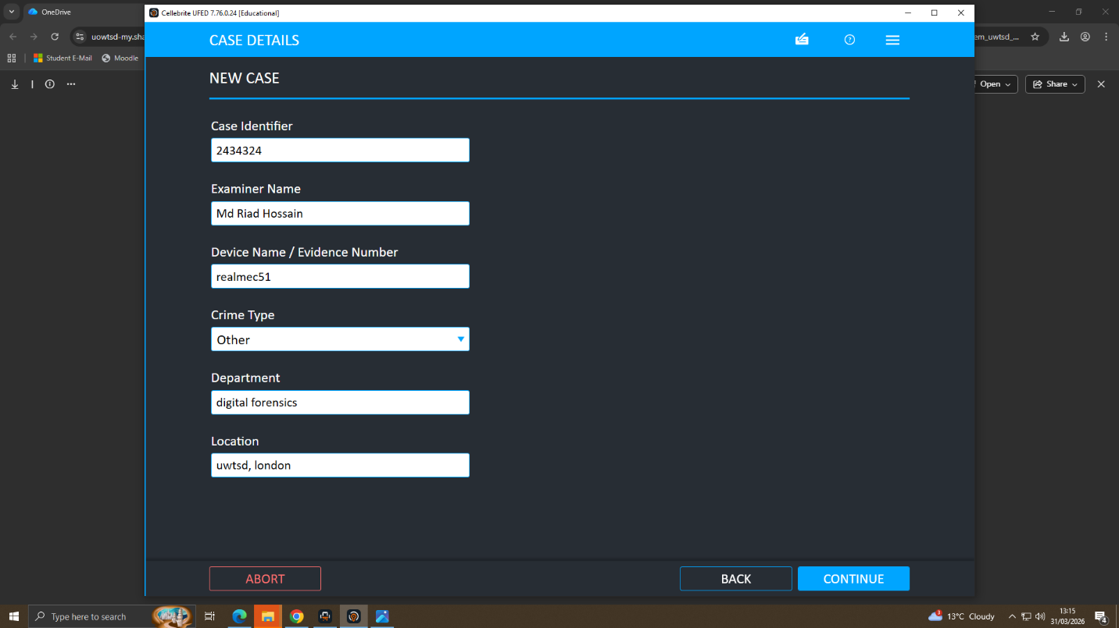
2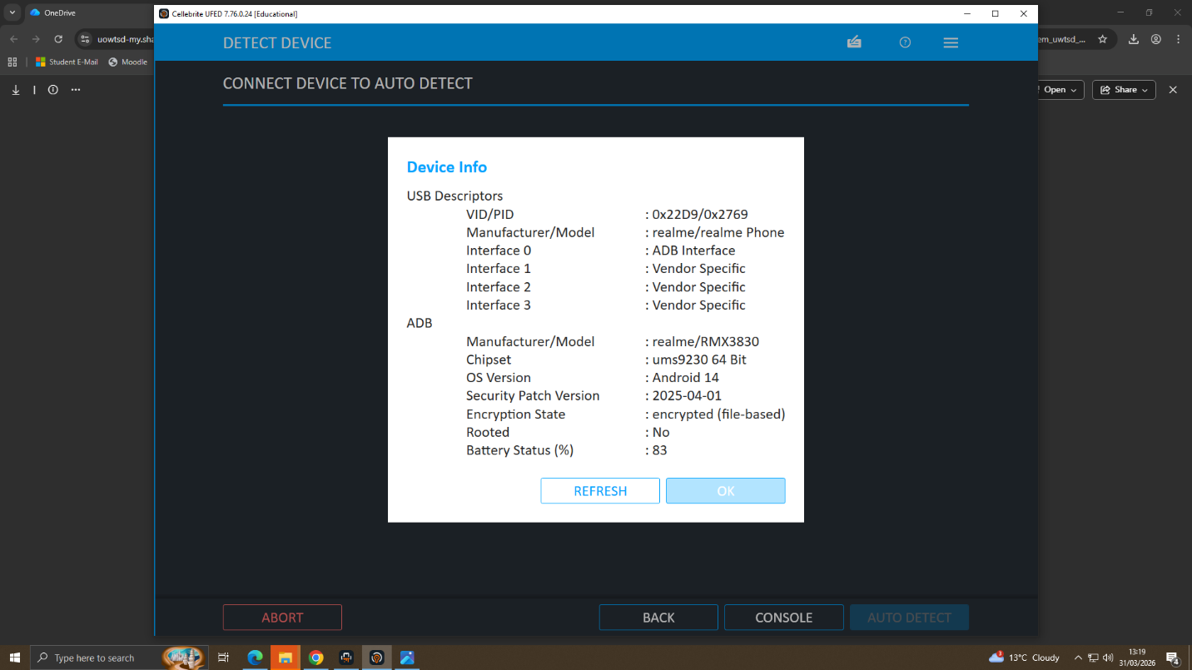

3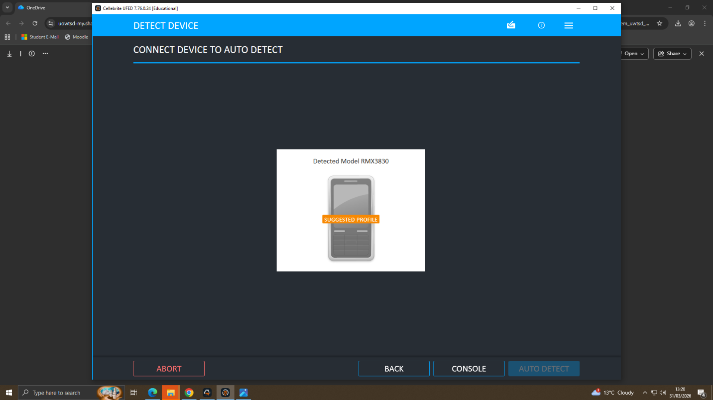

During the initial stage of the investigation, the target mobile device was connected to the Cellebrite UFED. As shown in (Figures 1-3), the system performed an automated hardware identification to determine the exact make, model, and firmware version. This is a critical forensic step to ensure that the software applies the correct communication protocol, preventing accidental data modification or device factory resets.

4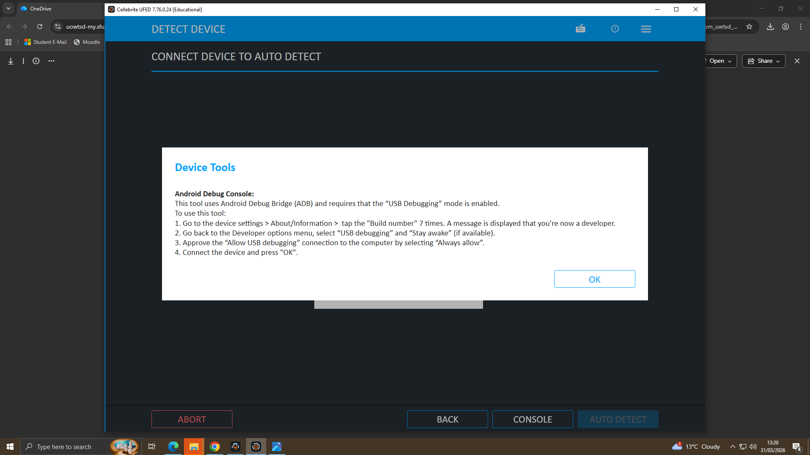
5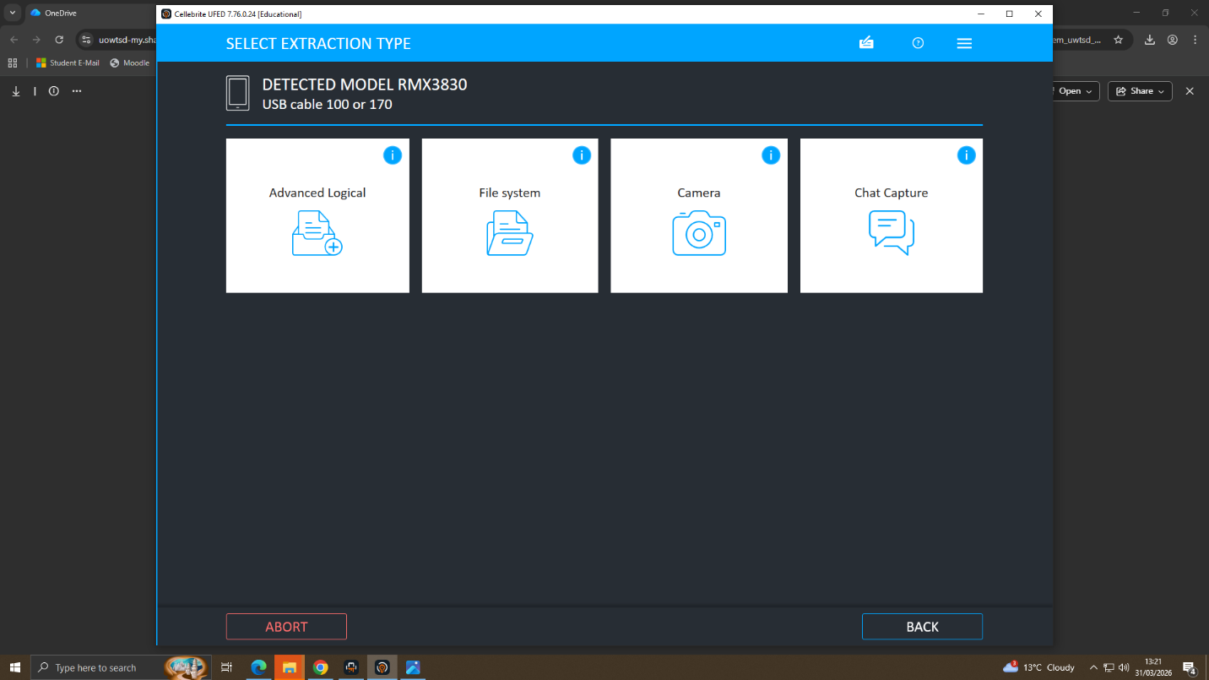

In these steps, the "Physical Extraction" method is selected, which allows the UFED to create a bit-for-bit copy of the entire flash memory.

6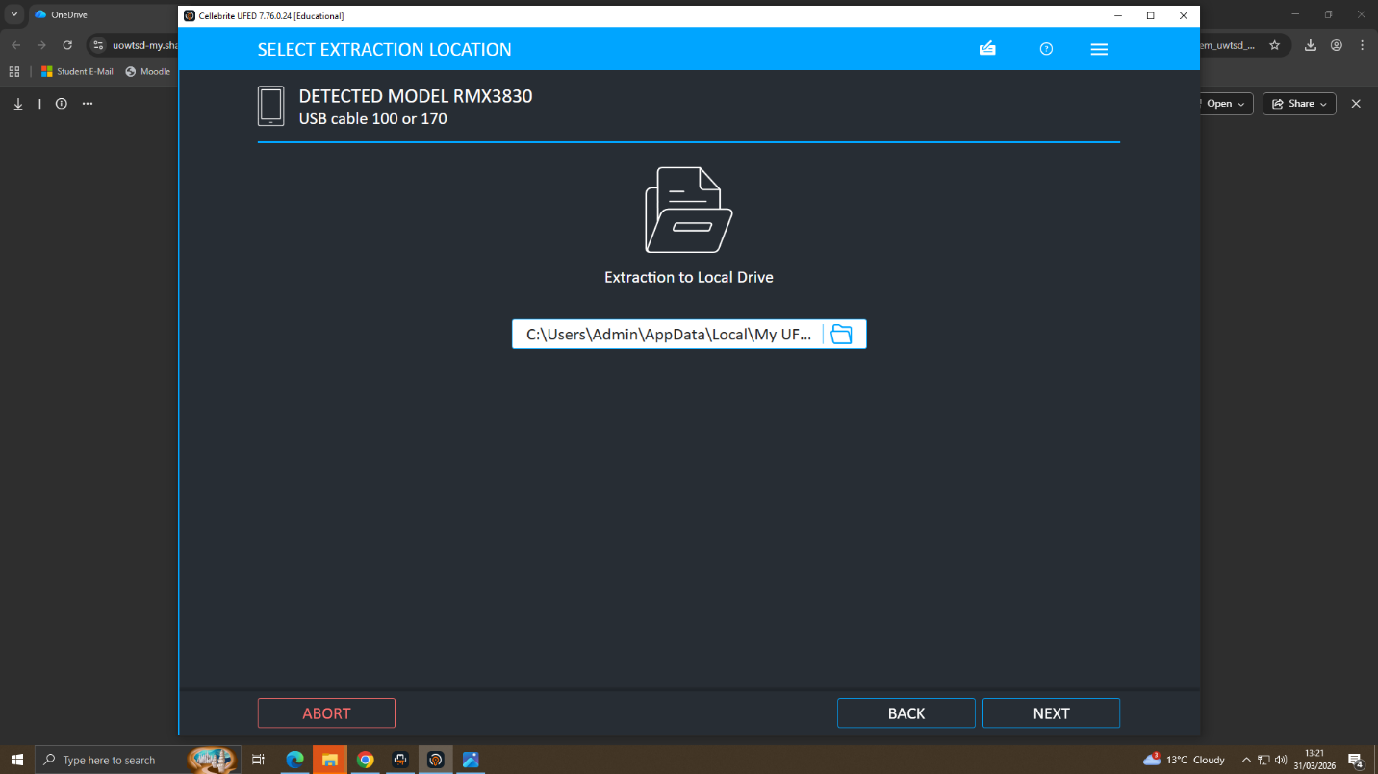
7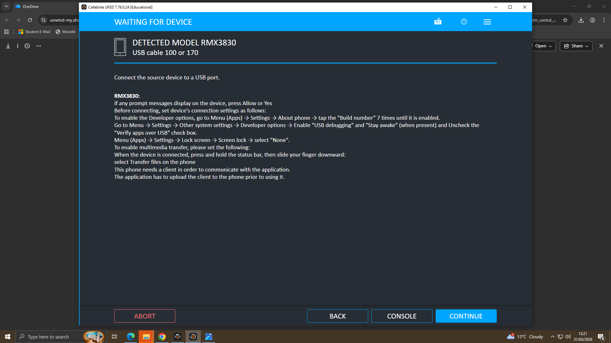

These screens demonstrate the procedural steps to put the device into the correct state, such as Download Mode or enabling USB debugging, to establish a stable forensic bridge.

Phase 2: Data Acquisition
8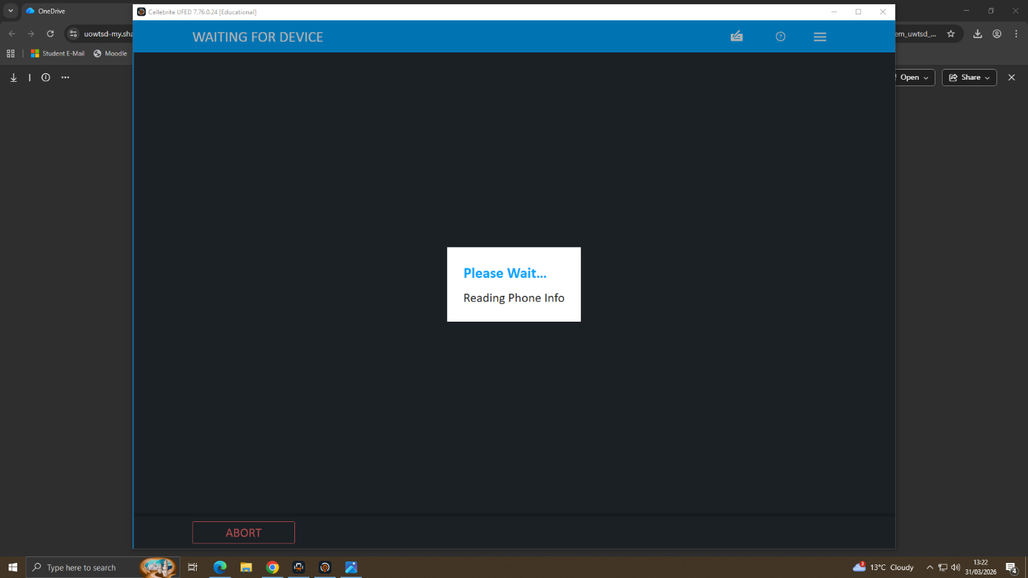9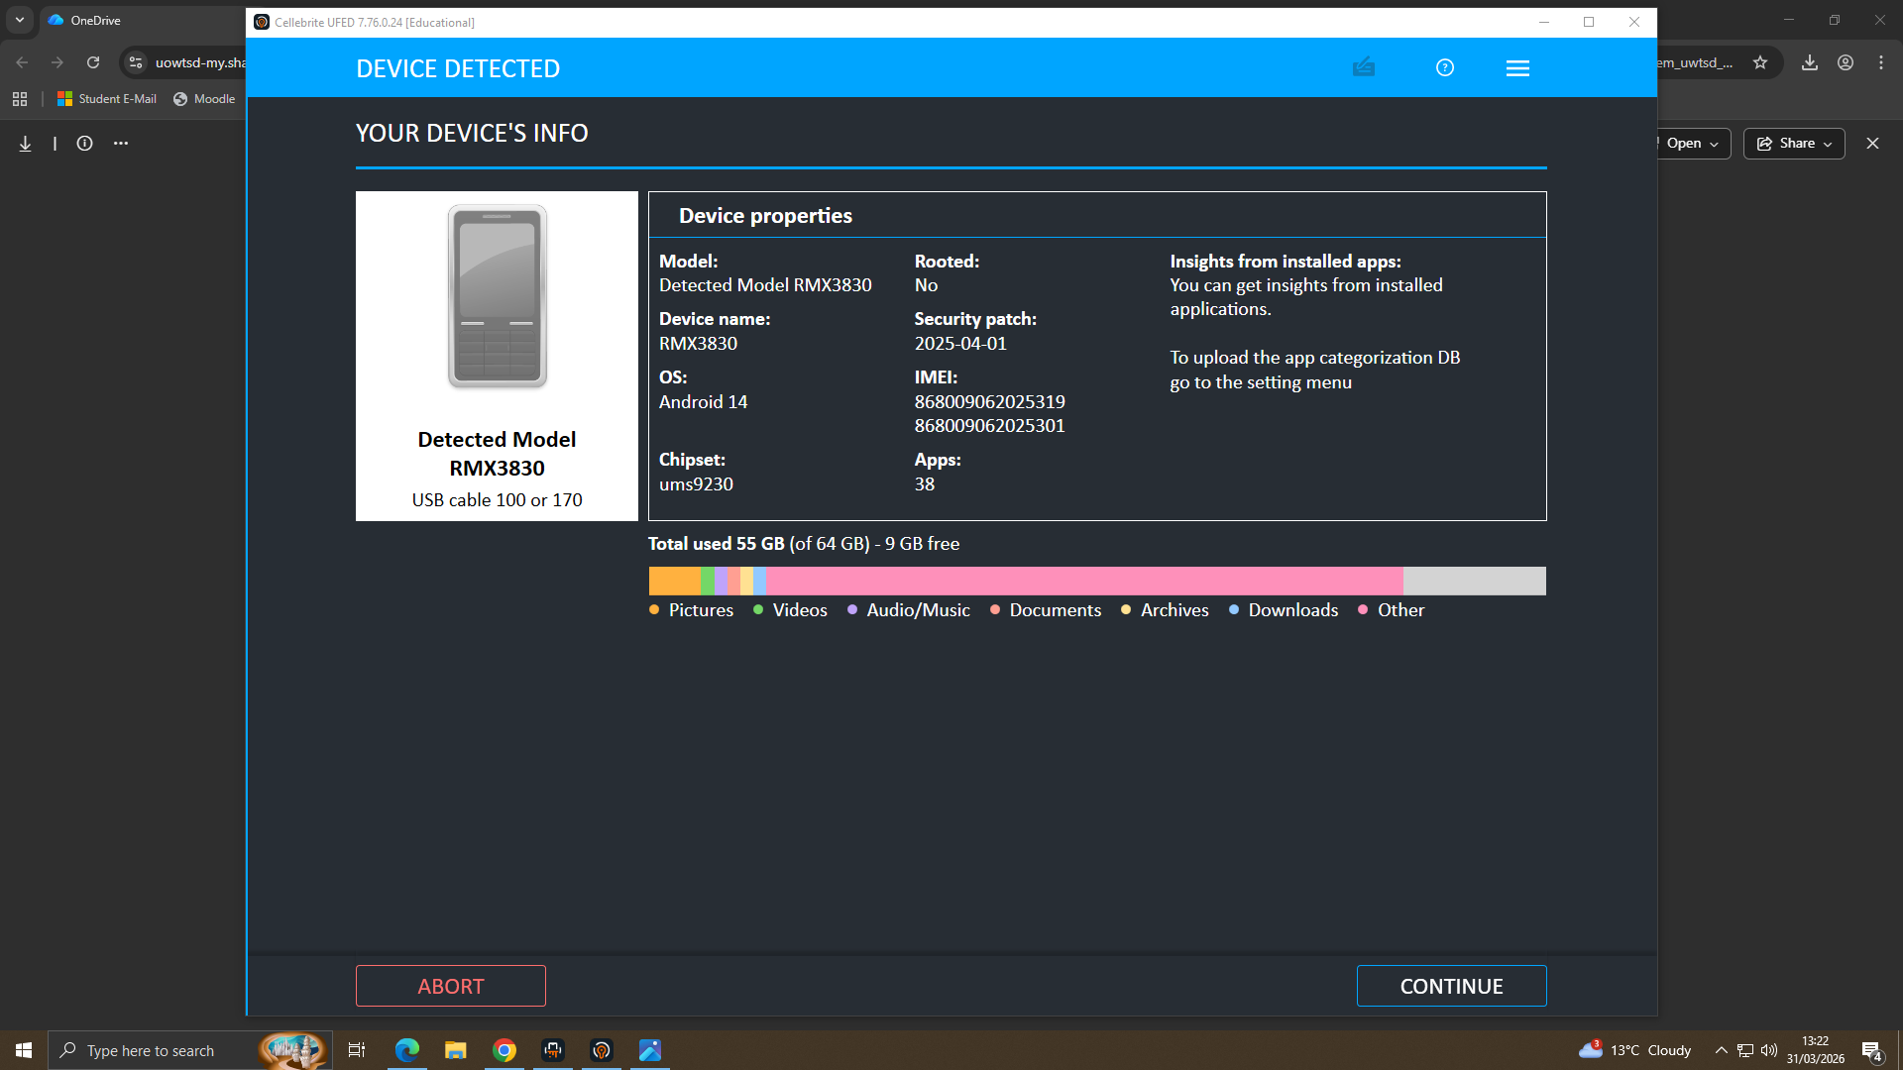
10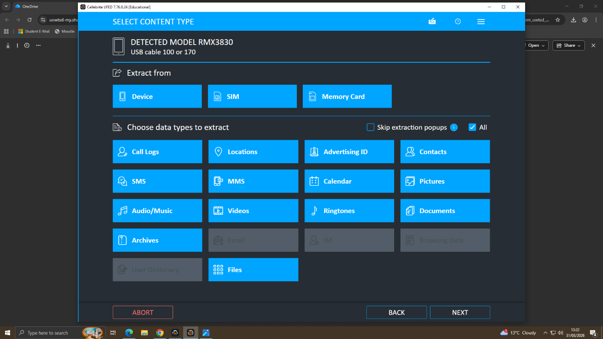
These screenshots document the real-time progress of the physical extraction as data is streamed from the mobile device to the forensic workstation. This provides a verifiable record that the data was captured directly from the source device during the investigation window.
11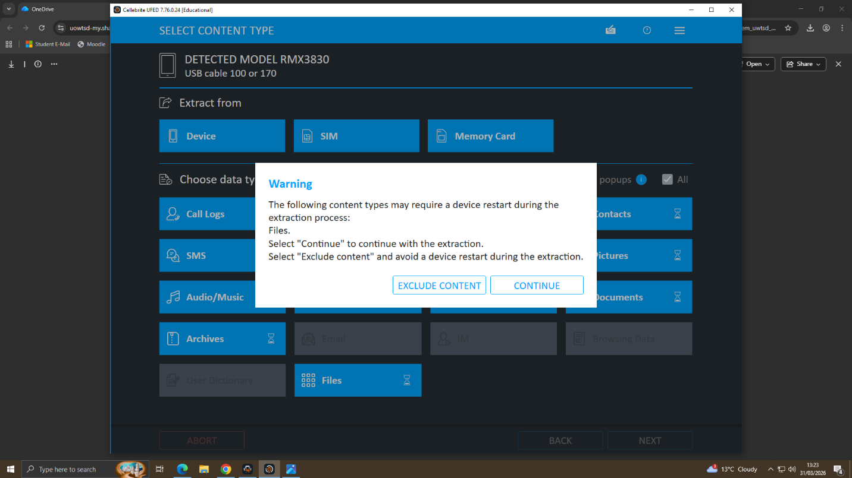
12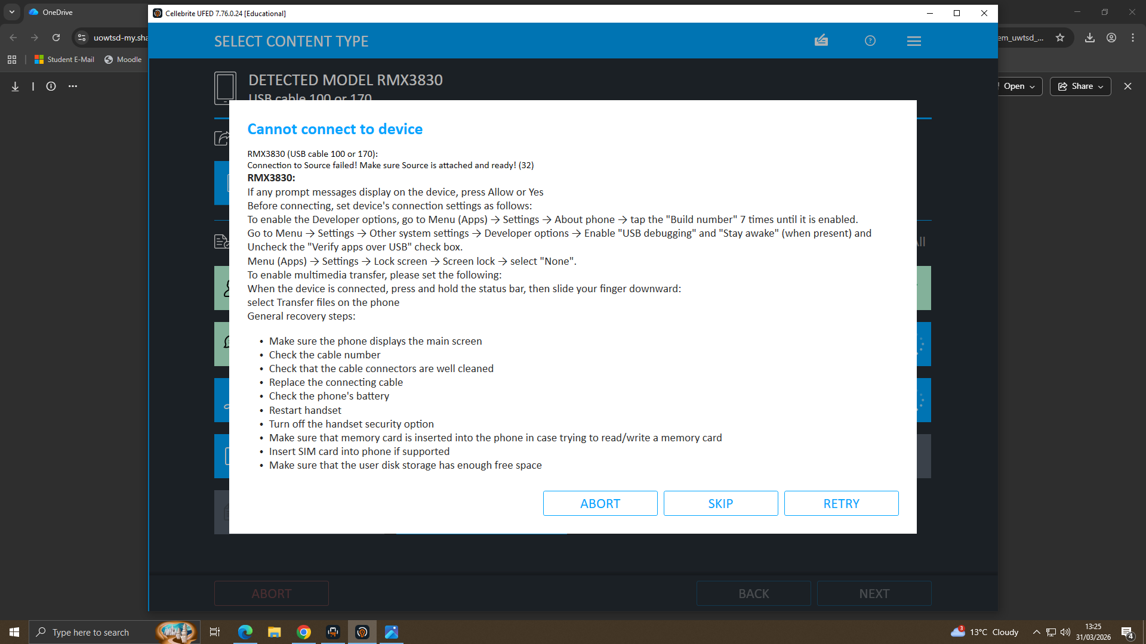
These images represent the successful completion of the "data dump" and the initial parsing of the file system into a forensic image file. This organizes the raw data into a structured format, allowing the investigator to begin searching for communication logs and unauthorized document transfers.
13
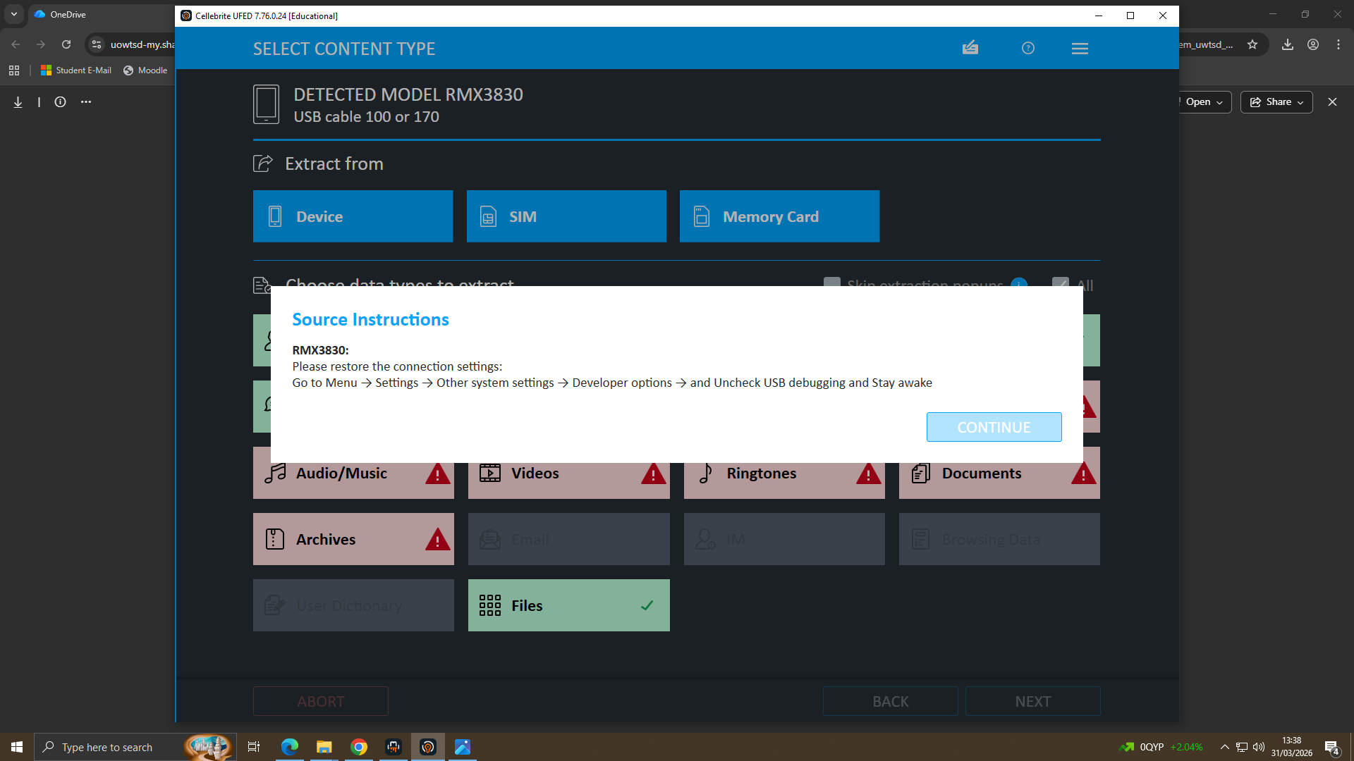
14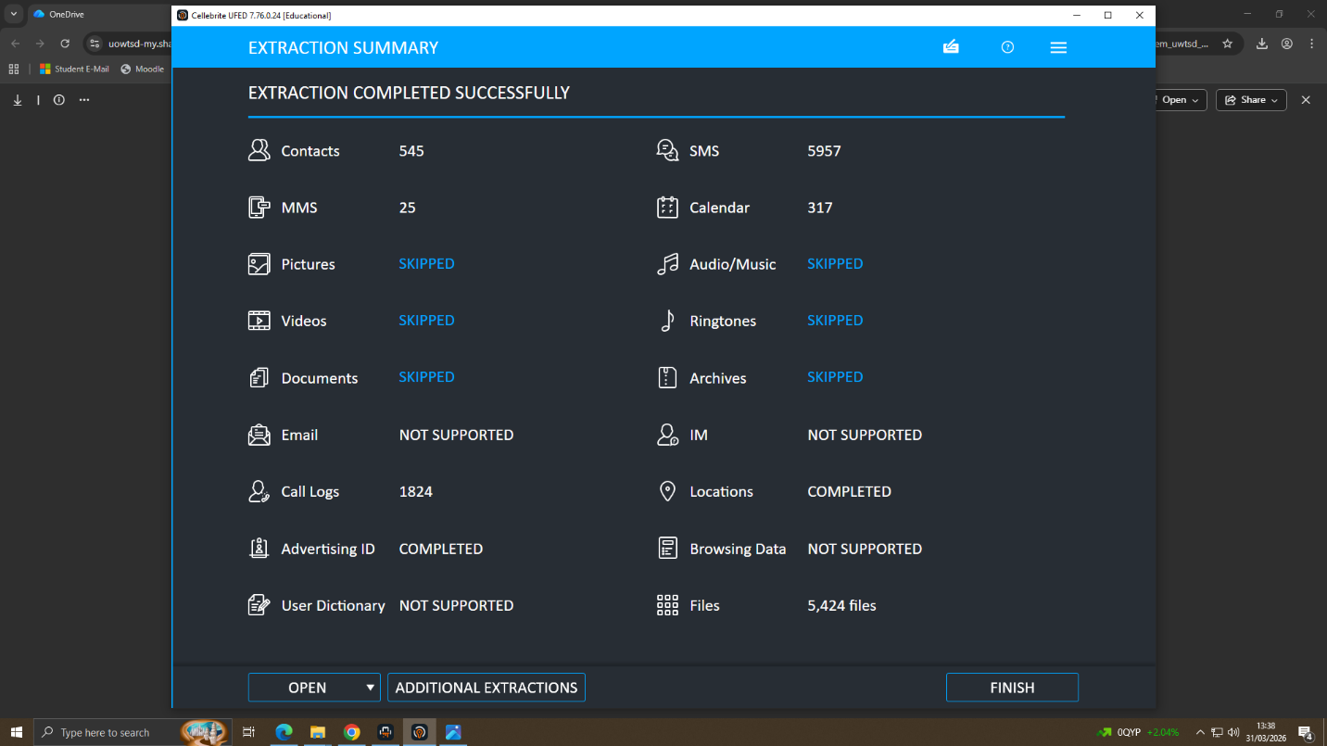
The final screens display the cryptographic hash generated for the acquired image. By recording these "digital fingerprints," the investigator proves that the forensic copy is an identical match to the original and has not been tampered with, satisfying strict legal integrity requirements.

2.2 Forensic Analysis of Communication & Social Media Artefacts

*Case Background
Quantum Tech identified unauthorized access to a proprietary AI chip design patent, labelled QT-AI-2025. Initial suspicion pointed toward an insider, specifically a recently joined employee named Emma. The organisation believed that Emma attempted to sell this confidential data to a competitor through an intermediary. The primary communication channel identified was WhatsApp, which became the focus of this forensic investigation.

*Objectives
The objectives of this investigation were fourfold.
First, to identify the roles of the individuals involved, including the perpetrator, intermediary, and potential buyer.
Second, to analyse communication and digital evidence extracted from the devices.
Third, to reconstruct a clear timeline of events based on the available data.
And finally, to determine the intent and motive behind the suspicious activities.
*Methodology
- The investigation followed standard digital forensic procedures.
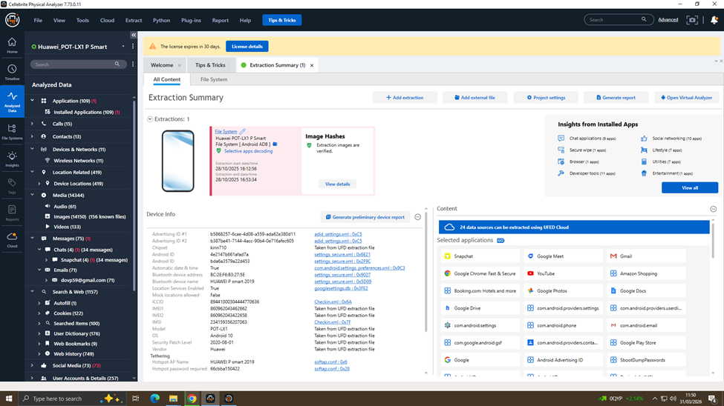
- Data was extracted using Cellebrite Physical Analyzer through a file system extraction method. To ensure evidence integrity, hash verification was performed, confirming that the data had not been altered.
- The analysis focused on WhatsApp communications, media files, and metadata.
- This approach ensures that the findings are reliable, reproducible, and legally admissible

*Communication Analysis
- The most critical evidence comes from WhatsApp conversations between Emma and Joe.
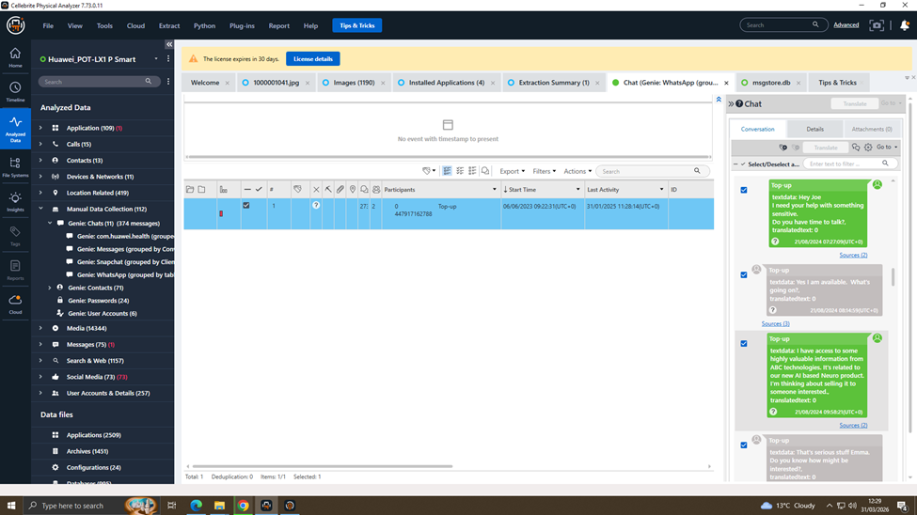
- Emma begins by stating she needs help with something ‘sensitive,’ indicating awareness of confidentiality.
- She then reveals access to highly valuable information related to an AI product. Importantly, she explicitly states she is thinking about selling this information.
Further messages show discussions about meeting clients in a hotel, confirming progression toward execution. This clearly demonstrates intent to sell confidential data.

*Behavioral Pattern
- The communication follows a clear behavioral pattern typical of insider threats. It begins with trust-building, followed by disclosure of sensitive information, and then moves into execution planning.
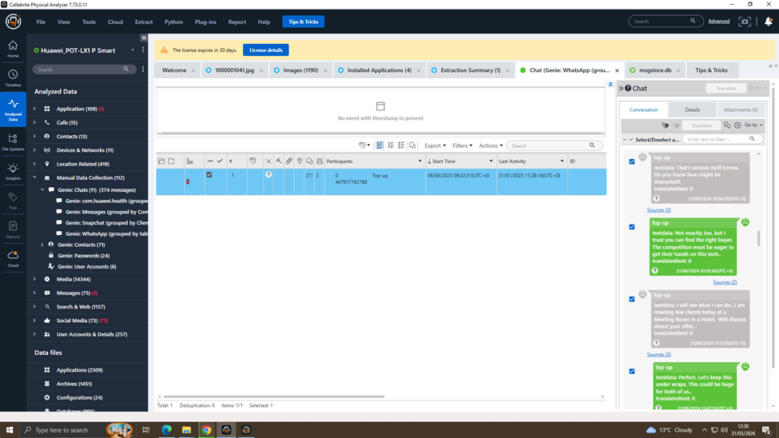
- Emma uses negotiation tactics, such as suggesting competition and alternative buyers, to create urgency. The activity persists over time, showing this was not a one-time action.
- Additionally, secrecy is emphasised with phrases like ‘keep this under wraps.’ This confirms a structured and deliberate approach.

*Timeline of Events
- The timeline reconstruction shows how the activity developed over time.
- On August 21st, Emma initiated contact and expressed intent to sell the data.
- By August 26th, she was actively searching for buyers and expanding her network.
- By November 20th, she continued follow-ups, indicating ongoing efforts to complete the transaction.
- This demonstrates a progression from initial intent to sustained execution attempts.
- The timeline is crucial in proving continuity and persistence.

*Supporting Evidence
- In addition to chat data, supporting evidence further strengthens the case.
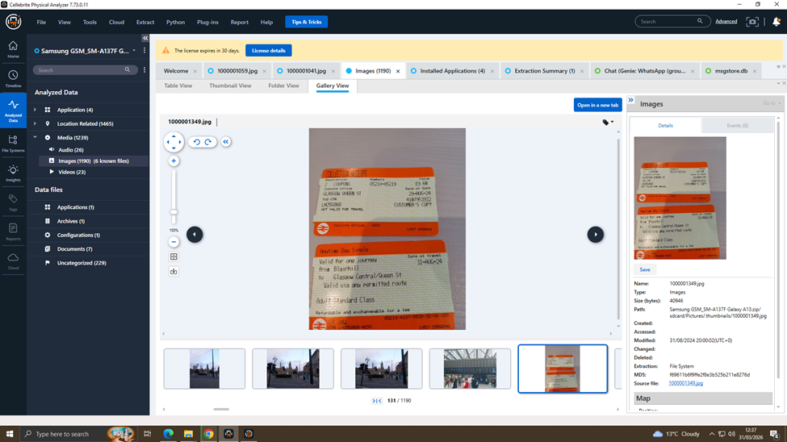
- A train ticket indicates physical movement, which aligns with the planned meetings discussed in chats.
- An image of a card suggests a possible method of financial transaction.
- Location sharing through maps indicates coordination of meeting points without leaving detailed text records. This combination of digital and physical evidence provides strong corroboration.
- It shows that the activity extended beyond communication into real-world actions.

*Conclusion & Suspect Roles
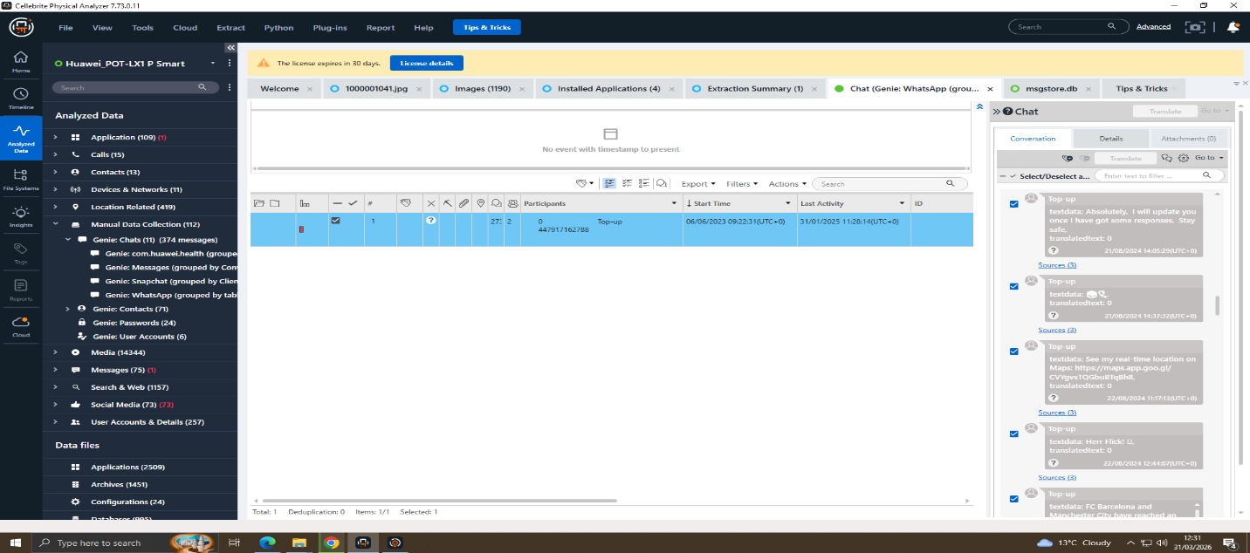

In conclusion, the investigation identifies Emma as the primary perpetrator, acting as an insider with access to sensitive data. Joe is identified as an intermediary who assisted in facilitating the transaction. There is also evidence of involvement from unknown external buyers. The findings clearly demonstrate intent, planning, and attempted execution of data exfiltration.
Overall, the evidence strongly supports a case of corporate espionage and insider threat activity. This highlights the importance of strong internal security controls and monitoring.

