Employability

Mohamed Trissia

Report required for the Academic and Employability skills module

University of Wales Trinity Saint David

By lecturer: MR Toyin Adisa

Contents:
Abstract ……………………………………………………………………………………………… 3
- Introduction……………………………………………………………………………………… 3
- Literature view/background………………………………………………………………. 4
- Methodology………………………………………………………………………………………5
- Results.……………………………………………………………………………………………….6
- Case study ……………………………………………………………………………………… 10
- Conclusion………………………………………………………………………………………… 10
- References………………………………………………………………………………………… 12

Abstract:
The study used in this essay examined different views about the most popular employability definitions (Divan and McBurney 2016). It further explores the main skills and capabilities that recruiters look for when hiring high education graduates.
To find out how the educational institutions contribute in getting students ready for work and, also how the UK government implemented new policies and rules to improve the role of these institutions, a typical background was conducted between in 1990’s when universities had great pressure to get graduates work ready and 2018 when ‘ office for student’ was established to support students’ employability challenges.
The methodology used in this report represents the way graduates were employed in European companies by observing 50 employees and emphasised three main features: most important skills in hiring graduates, organisations’ challenges in hiring graduates, and ways to increase graduates, employability. The results were statistically significant (European Commission 2010).

- Introduction:
There is no singular definition of employability (William et al.,2015). Hence, the most frequently used is Yorke (2006): employability is having a set of skills, capabilities and competencies that make a student able to move within the labour market to realise a full potential and have a career success. Another definition is Holmes’s concept (2011) who highlighted that graduates must have skills and show they are worth being employed. This concept is also supported by Tomlinson (2012) who reported that the engagement of individuals depends on their self-perceptions and developments within their job.
In recent years, a very strong connection between high education sector and employability has established. Many graduates are very likely to gain employment and be successful in their occupations once they develop outstanding personal attributes and skills that most employers require. These skills are known as “employability skills” or “soft skills” (Divan and McBurney 2016). In fact, every person starts to gradually grow these skills at early ages of their life, but still it is a necessity to advance them so that he can succeed and be effective in his job.
Employability skills can defer from one person to another regardless of their knowledge or background. Collected from source”1” These skills can be summarised as follow:
- Communication: exchanging information verbally by speaking, writing, or using non-verbally such as body language and expressions.
- Teamworking: being able to get along with people and working together for achieving goals.
- Problem solving: finding solutions when encountering difficulties.
- Self-management: planning and organising things that need to be done, timekeeping.
- Learning: willingness to understand new tasks and being able to adapt to new changes.
- Technology: using computer and IT skills.
Generally, employers are willing to teach someone the job specific skills required, though they want to see first that he has already the transferable skills because they assume those skills are hard to teach. Therefore, graduate employability has become a key strategic for universities in order to produce more work-ready students who contribute significantly to the needs of the organisations which leads to economic growth.

2.Literature review:
After conducting a typical literature search, a wide range of articles emphasised the important relationship between high education institutions and employment. Since 1990’s, the national and international evaluation of the of the role and purposes of the education suggest the need of high education to contribute to the economy demands (Harvey, 1999). As a result, experts and researchers were involved in government studies to see the impact of the education and training systems on the manufacturing and trading industries making them more competitive and productive. For instance, an Irish experts’ group has found: ‘Employees’ motivation and skills are the most important factors for a worldwide competitiveness’ (Harvey, 1999). Similarly, another research by the Department for Education and Employment (DFEE) and the Vice-Chancellors and Principals (CVCP) in the UK concluded that: ‘improving the training of UK highly skilled workers is the only way to achieve a strong competitiveness’ (CVCP/DFEE/HEQE, 1998, p2).
The main research that has changed the UK government policies is by introducing new strategies to extend the skills in educational establishments. This was called the “Dearing report”. In July 1997, the government appointed a committee lead by the lord Dearing to assess the connection between education and employment. As a result, the government endorsed its view that enhancing the graduate’s employability is a key task for higher education.
Despite all efforts to boost students’ self-perception of future employability prospects, various studies and research argued whether colleges and universities provide students the skills they need to have a positive impact in the economy after graduation. For example, Benbow & Hora (2018) investigated the conception of the required workplace skills in biotechnology and manufacturing. The two authors found that different factors play a role in developing important occupational skills such as work ethic, computer expertise, and even the geography and the culture of organisations. They concluded that educators, employers and policy makers need to adopt more concepts by considering all the circumstantial factors involved in student employment success. As a result, in 2018, a new regulator known as” Office For Student” was initiated by the Higher Education Act 2017 to tackle the challenges facing the graduates’ employability.

3. Methods
This survey is extracted from Eurobarometer “Employers’ perception and of graduate employability” (N304) to give a clear view and understanding of how graduates are recruited by observing at least 50 workers in different departments in various European organisations.
Among the main aspects that will be discussed in this methodology:
- How essential for graduates to have various aptitudes and capacities.
- Companies challenges in recruiting graduates.
- Opinion on finding new ways to increase graduates’ employability.
The study was conducted in all 27 European countries including Norway, Turkey, Iceland and Croatia in which companies hired higher education graduates in 10 years. Business, economic studies, and engineering were the major subjects (55% of companies) although the recruitment was from a wide range of educational domains. A total of 7036 organizations were evaluated between August 30th and September 7th, 2010 by fixed line telephone technique. Three quarters of them (76%) were medium sized (50-249 employees) and rest (24%) were large (250 or more). Furthermore, 36% of the surveyed companies were active in different sectors as follows: industry, 23% non-public, 17% public, 12% accommodation and food services, and 12% transport and construction.

4. Results:
Significant results were collected after asking the employers of the surveyed European countries if they had hired high education graduates last five years and if they plan to rehire such graduates next 5 years (European Commission 2010). For instance, 53% of Romanian and Czech, and 92% in Icelanders and Estonian bosses agreed. However, 33% Irish, 34% Italian, and 35% Lithuanian respondents said they hired graduates last 5 years but were not hiring such graduates the following 5 years (figure 1).
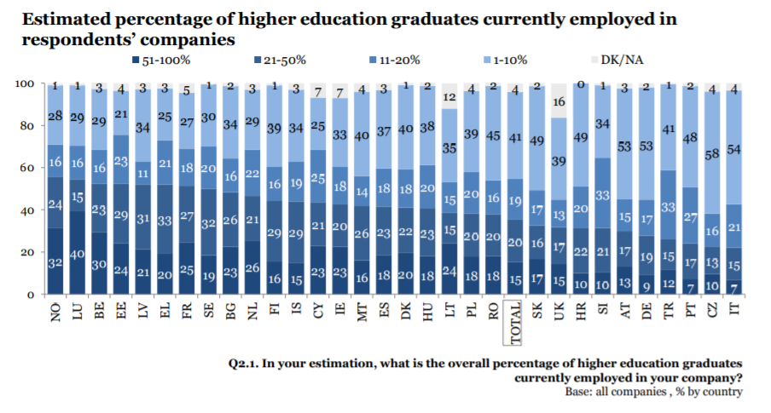
Figure 1: European Commission (2010)

4.2 Important skills for graduates hiring
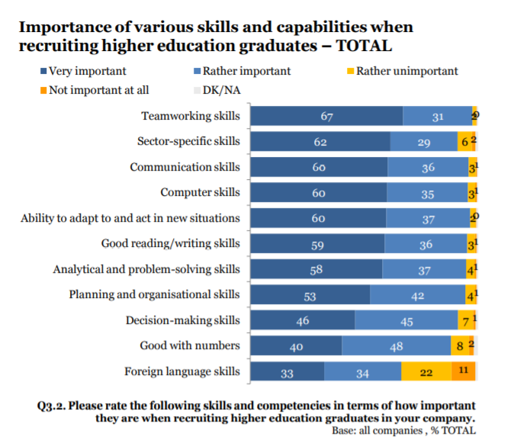
Figure 2: European Commission (2010) Roughly all the European employers (up to 98%) mentioned that employability skills were “very” or “rather” important for engaging graduate to the labour market. 67% of these employers emphasized that team working is essential skill and between 58% and 62% replied that abilities such as communication, technology, ready to learn, and problem solving were very important in graduates’ hiring process. However, 33% of them considered foreign language skill as important one. Figure 3 shows the averaging rating for every skill.
The data shown in figure 2 was affected by two major factors:
First factor, Organisation characteristics: 34% mid-sized companies’ managers preferred foreign language skills than any other abilities, whereas 63% of big companies’ recruiters were likely to hire graduates with communication and ready to learn skills. Also, foreign language skills were more important in industry sector recruitment (43%) than in public sector one (16%), and communication skills in non-public sectors were much higher than other capabilities (67%).
Second factor, Countries: across Europe, graduates’ employers had different views regarding which employability skills were prioritized in offering jobs. For instance, technology in Croatia was more important in hiring than in France (96% vs 34), excellent ability in writing/reading was highly considered in Malta than in Spain (86% vs 58%), and more job opportunities for graduates with ready to learn skills in Malta than in Netherlands (84% vs 45%). However, most of the employers surveyed agreed that team working skills were “very” important ranging between 94% and 100%.
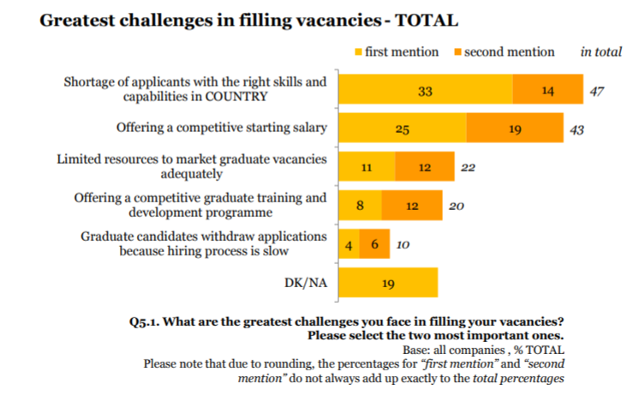
4.3 companies’ challenges for graduates’ recruitment:

Figure 3: European Commission (2010)
When European employers were required to choose two out of five big challenges which were facing in hiring graduates, 47% responded there was lack of candidates with skills and capabilities to do the job, whereas 43% mentioned that they were unable to secure attractive staring wages. Then the other challenges ranged as follows:
- 22% bosses replied graduates’ job offers marketing was tight.
- 20% found it hard to train and develop graduates.
- 10% moderate hiring process resulted in pulling the application back by the graduates.

4.4 how to increase graduates’ employability
Employers in the surveyed European countries argued which type of measures would be more effective in enhancing the graduates’ employability skills. For example 60% in Germany, and 57% in both Slovakia and Austria responded that work replacement in every sector was the best action required , 57% of those interviewed in Romania, Bulgaria and Turkey mentioned that prior to graduation students should practice the course studies would improve their abilities, and finally between 30% and 32% recruiters in Lithuania, the UK and Greece referred to making studies more applicable in organisations’ perspectives was the best measure needed (figure 4).
Figure 4: European Commission (2010)
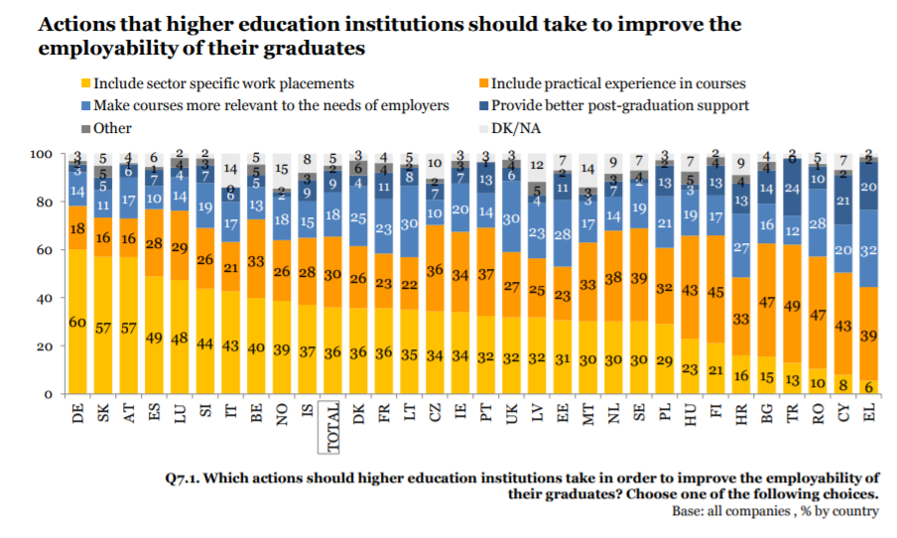

5. Case study:
Ruth had a remarkable CV that matched a postgraduate study vacancy ( Youth Central 2018). She was called for a phone interview as a first stage of getting the job. Ruth was sure that she was the perfect candidate for the offer but unfortunately, was astonished that she did not pass to the second stage of the hiring process. When she called the hiring company office to ask about the reasons of her failure, the HR department explained that her subject knowledge was superb, however she appeared that she was not a team worker and that she would not be able to collaborate withing the company.
Since then, Ruth understood that getting the job is not only about academic qualifications, but it is also about the applicant’s abilities and skills. As a result, she started answering questions carefully and searching about the companies’ cultures in every job offer she applied for.

6. Conclusion:
It has become clear that in order to find a job, to maintain it, to be able to move within the labour market and to improve the career prospects, high education graduates must have specific skills, clear understanding and strong personal qualities. These are key to succeed in any work environment and students must consider enhancing them prior to any initial work by engaging themselves in work replacements and taking part in extra activities or volunteering to get enough experience and be work ready.
Although policies, views, and new strategies have been implemented to get high education graduates succeed in their occupations, today’s global labour market is facing new issues such as generation and gender gaps which must be resolved quickly in order to empower the workforce. This can lead to a very strong consistent global economy.

7. References

Benbow, R. J. & Hora, M. T. (2018) Reconsidering College Student Employability: A Cultural Analysis of Educator and Employer Conceptions of Workplace Skills. Harvard Educational Review vol 88(4) p 483-515

Divan, A., McBurney, S. (2016) Understanding how students manage their employability. New directions in the Teaching of Physical Sciences. Vol 11(1)

European Commission (2010). Employer perception of graduate employability. [online]Available at:
https://ec.europa.eu/commfrontoffice/publicopinion/flash/fl_304_en.pdf
ontoffice/publicopinion/flash/fl_304_en.pdf. [Accessed 10th August 2020].

Harvey, L. (1999). Employability: developing the relationship between higher education and employment. Warwick university.
Holmes, L. (2011). Competing perspectives on graduate employability: possession, position or process? Studies in Higher Education, 38(4): 538-554.
Tomlinson, M. (2012). Graduate Employability: A Review of Conceptual and Empirical Themes. Higher Education Policy, 25 (4): 407– 21.
Yorke, M & Knight, P. (2006). Embedding employability into the curriculum. Higher Education Academy. York, UK.

Youth Central (2018). 8 jobs skills you should have. [online] Available at: https://www.youthcentral.vic.gov.au/jobs-and-careers/plan-your-career/8-job-skills-you-should-have. [Accessed 5th July 2020].

Williams, S., Dodd, L. J., Steele, C. & Randall, R. (2015). A systematic review of current understandings of employability. Journal of Education and Work, 0, 1-25.

Appendix



