A1. What is a variable and why are they important?
A variable is a way of storing data in a computer program. Values will change when the program is compiled having variables is a friendly way of storing this information [1]. For example, the area of a rectangle could contain variables for the area, length and width. The variables can store the information entered by the user in length and width make a calculation which is stored in area then return it to the user. This provides a way for the computer to store data that changes, this is important because it replaces the need to calculate separately every time the values for area and length change it also allows the programmer to access the information in a meaningful way, having meaningful names for variables is an important factor. A team could be working together on a development project having variables with meaningful names allows programmers to access each other’s code without confusion [1]. There are numerous naming conventions allocated to variables for the C language studied for this module these include not having spaces, special characters and keywords for C an example being scanf in any variable name. The four basic variable type in C are char, int, float and double which get allocated different amounts of memory, a single byte for char, four bytes for int and float with the double being allocated eight bytes [1]. These variable types char for a single character, int for a whole number, float for a number with a decimal up to six decimal places and double for a number with a decimal up to ten decimal places [1], this notifies the compiler of which type of data to expect. These variable types used inside the main function for example are local variables, there is also another type called global variables, which are declared outside the main function block [1]. In summary variables allow accessing, changing and storing of data.

A2. Explain why the for loop can also be referred to as a counting loop and give an example of when you would use it.

The for loop is a structure in programming to help make the code more efficient. The structure contains a start point an incrementor and an end point. It’s the incrementor that acts as the counting component of the loop hence the counting loop referral, a simple example is illustrated in figure 1.

for (startpoint=1 ; endpoint<10; incrementer++)
Figure 1: Basic for loop structure

In the above example the initialised value is set to one, the end point is less than ten and for each iteration the value of one will be added until nine is reached, this is the endpoint. A for loop is used when the number of iterations is known. An example of a for loop would be an entry of a PIN number to perform a financial action, the number of entries (endpoint) can be set to a certain number within the loop structure, when the number of times the user enters the number incorrectly exceeds this number the loop will end (endpoint) access to the service can be denied. The contrast with a while loop is when a for loop is used the number of iterations is known and set, in figure 1 for example its set to ten, a while will continue to loop until a statement is true.

A3. Explain what an array is, what their features are, and give an example of when you would use one.
Arrays provide a way of assigning multiple data items to a variable as a pose to holding single values. In the C language used for this module the value always starts at zero. There are two types of array one dimensional and multi dimensional, for example a one dimensional array assigned to a string could hold the value for a month whilst a multi dimensional array could hold the twelve months of the year. Figure 2 shows a one dimensional array and how the values are stored starting at zero.
char month [4] = June;
0 | 1 | 2 | 3 | 4
J | U | N | E
Figure 2: One dimensional array

Figure 3 highlights a multi dimensional array storing the twelve months of the year
char months [12] [9] = {“January”, “February”, “March”, “April”, “May”, “June”, “July”, “August”, “September”, “October”, “November”, “December”};
 | 0 | 1 | 2 | 3 | 4 | 5 | 6 | 7 | 8 | 9 | 10 | 11 | 12
0 | J | F | M | A | M | J | J | A | S | O | N | D
1 | A | E | A | P | A | U | U | U | E | C | O | E
2 | N | B | R | R | Y | N | L | G | P | T | V | C
3 | U | R | C | I |  | E | Y | U | T | O | E | E
4 | A | U | H | L |  |  |  | S | E | B | M | M
5 | R | A |  |  |  |  |  | T | M | E | B | B
6 | y | R |  |  |  |  |  |  | B | R | E | E
7 |  | y |  |  |  |  |  |  | E |  | R | R
8 |  |  |  |  |  |  |  |  | R

Figure 3: Multi dimensional array
Accessing a specified element is done via an index, for example using the C programming language to display the month “JUNE” on the screen the following syntax is applied printf(“%s” months[5]);

Exercise 1.
Show how variables can contain different types of values by declaring three variables that contain a name, a measure of height (e.g. 1.81cm) and a person's age (e.g. 32). Input these values and display them on the screen.

Logical steps Exercise 1

- Decide relevant variable types
- Char set for name correct variable for string
- Float set for height to enable user to enter to two decimal places
- Int set for age whole number
- Declare variables
- Initialise age ready for range test
- Get user to input data
- Store data
- Display data on screen
- Check age number is in range
- If number is out of range display message to user
- Output message on the screen

Code for exercise 1

#include<stdio.h>

void main()
{
int age = -100;//integer variable set for age
char name[50];//char variable set for name up to fifty characters
float height;//float variables set to allow for decimal

printf("Please enter your name ");//prompt user
scanf(" %s", name);//store name
printf("Your name is %s", name);//display name on screen

printf("\nPlease enter your height ");//prompt user
scanf("%f", &height);//store height
printf("Your height is %.2f", height);//display height to two decimal places

printf("\nPlease enter your age ");//prompt user
scanf("%d", &age);//store age

while (age < 0 || age>120)// test for age range
{
if (age < 0) //test for valid age range
{
printf("Age entered too low");//if value too low display message on screen
}

else if (age > 120)//test for valid age range
{
printf("Age entered too high");//if value too high display message on screen
}

printf("\nPlease enter your age again "); //prompt user to re-enter age if range is invalid
scanf("%d", &age);//store age
}

printf("Your age is %d", age);//display age on screen

Evidence of testing for Exercise 1
Figure 4 illustrating a normal in range test
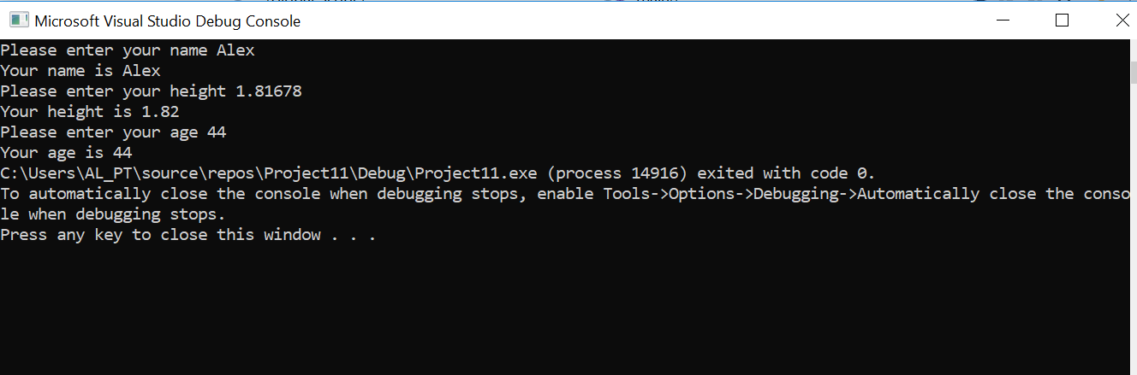

Figure 4: Normal test results
Figure 5 highlighting boundary test 1
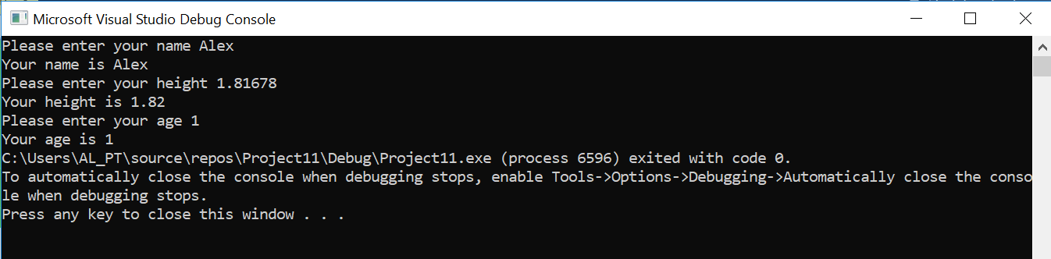

Figure 5: Boundary test for while loop

Figure 6 highlighting boundary test 2

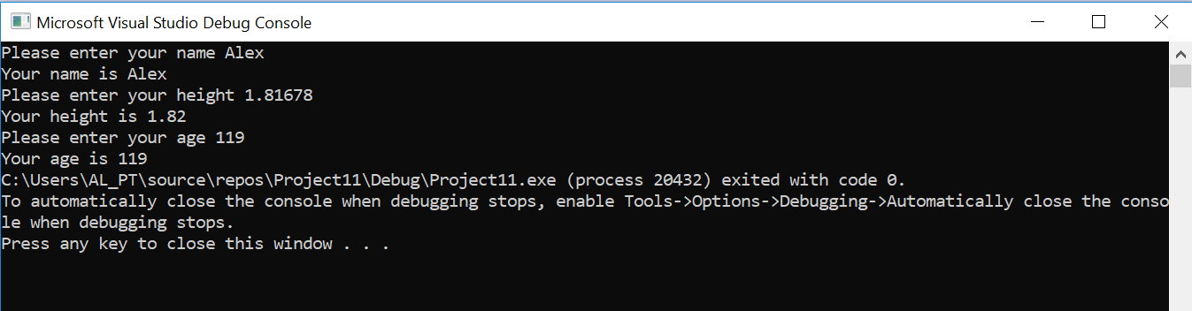

Figure 6: Boundary test for while loop

Figure 7 showing out of range test with while loop

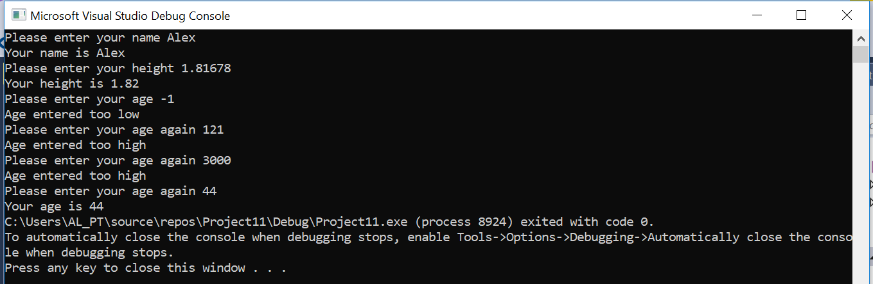

Figure 7: Out of range test

Exercise 2:
Allow the user to enter the dimensions of shapes shown below (Figure 1), then calculate the area of the blue shaded part. Note: The triangular area in the centre is empty.
Logical steps Exercise 2

- Decide relevant variable types
- Constant set for PI as value doesn’t change
- Floats set and initialised for area of circle and triangle, radius, base and height to enable user to enter and return values with a decimal
- First get the radius of the circle
- Prompt user to enter radius for circle
- Store radius from user
- Test for positive value
- If negative value entered prompt user
- Prompt user to enter height
- Store height from user
- Test if height is greater than radius
- If height is greater reset value to zero send user into loop
- If height entered is greater again prompt user and give correct range
- Prompt user to enter base
- Store base from user
- Test if base is greater than radius
- If base is greater reset value to zero send user into loop
- If base entered is greater again prompt user and give correct range
- Set formula for the area calculation
- Display the result on the screen
- Set formula for the triangle area calculation
- Display the result on the screen
- Deduct the area of the circle from the area of the triangle
- Display the result on the screen

Code for exercise 2

Version 1 – Basic functionality without error checking
#include <stdio.h>
#define PI 3.142
void main()

{
float radius=-1, areaCircle, areaTriangle, base=-1, height=-1, shadedArea;//declare variables for decimal type

printf("Please enter the circle radius ");//prompt user for radius
scanf("%f", &radius);//store data entered in variable

areaCircle = (radius*radius)*PI;//calculation for area of a circle

printf("\nThe area of the circle is %.2f", areaCircle);//display the circle area on the screen

printf("\n\nPlease enter the height of the triangle ");//prompt user for height of triangle
scanf("%f", &height);//store data entered in variable
printf("\nPlease enter the base of the triangle ");//prompt user for base of triangle
scanf("%f", &base);//store data entered in variable

areaTriangle = (base*height) / 2;//calculation for area of a triangle

printf("\nThe area of the triangle is %.2f ", areaTriangle);//display the triangle area on the screen

shadedArea = (areaCircle - areaTriangle);//calculation for shaded area

printf("\n\nThe shaded area of the circle is %.2f", shadedArea);//display the value for shaded area on the screen
}

Version 2 – Functionality with error checking

#include <stdio.h>

#define PI 3.142

void main()

{

float radius = -1, areaCircle, areaTriangle, base = -1, height = -1, shadedArea;//declare variables for decimal type

////////////////////////////////////////////////////////////////////////////////////////////////////////
printf("\nPlease enter your radius "); //prompt user to enter to radius
scanf("%f", &radius);//store radius

while (radius < 1)// test for minus values
{
printf("Radius entered must have a positive value");//if value too low display message on screen
printf("\nPlease enter your radius again "); //prompt user to re-enter radius if range is invalid
scanf("%f", &radius);//store radius
}

////////////////////////////////////////////////////////////////////////////////////////////////////////
printf("\nPlease enter your height "); //prompt user to height age if range is invalid
scanf("%f", &height);//store height

if (height > radius)//test for value of height of triangle cannot be larger than radius to calcultate value of blue shaded area
{
height = 0;//re set height to zero if user enters invalid range if invalid range entered send the user into the loop
}

while (height < 1)//test for minus values
{
printf("\nPlease enter correct range ");//if value too high display message on screen
printf("\nPlease enter your height again "); //prompt user to re-enter height if range is invalid
scanf("%f", &height);//store height

if (height > radius)//test for value of height of triangle cannot be larger than radius to calculate
value of blue shaded area
{
printf("Please enter correct range less than %.2f", radius);//display message on screen prompting user to enter the correct range
height = 0;//re set height to zero if user enters invalid range
}

}

////////////////////////////////////////////////////////////////////////////////////////////////////////
printf("\nPlease enter your base "); //prompt user to re-enter base if range is invalid
scanf("%f", &base);//store base
if (base > radius)//test for value of base of triangle cannot be larger than radius to calcultate value of blue shaded area
{
base = 0;//re set height to zero if user enters invalid range if invalid range entered send the user into the loop
}

while (base < 1)//test for valid age range
{
printf("\nPlease enter correct range ");//if value too high display message on screen
printf("\nPlease enter your base again "); //prompt user to re-enter base if range is invalid
scanf("%f", &base);//store base
if (base > radius)//test for value of base of triangle cannot be larger than radius to calcultate value of blue shaded area
{
printf("Please enter correct range less than %.2f", radius);//display message on screen propmting user too enter the correct range
base = 0;//re set height to zero if user enters invalid range
}
}

areaCircle = (radius*radius)*PI;//calculation for area of a circle

printf("\nThe area of the circle is %.2f", areaCircle);//display the circle area on the screen

areaTriangle = (base*height) / 2;//calculation for area of a triangle

printf("\nThe area of the triangle is %.2f ", areaTriangle);//display the triangle area on the screen

shadedArea = (areaCircle - areaTriangle);//calculation for shaded area

printf("\n\nThe shaded area of the circle is %.2f", shadedArea);//display the value for shaded area on the screen

}

Evidence of testing for Exercise 2
Figure 8 highlights testing within normal range with radius value greater than height and base
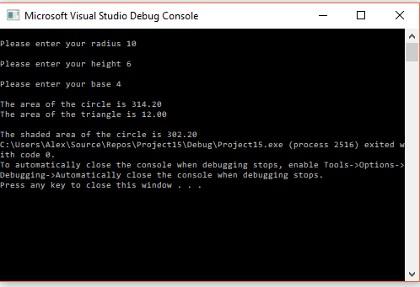

Figure 8: Normal range test
Figure 9 highlights boundary testing with radius value greater than height and base by 1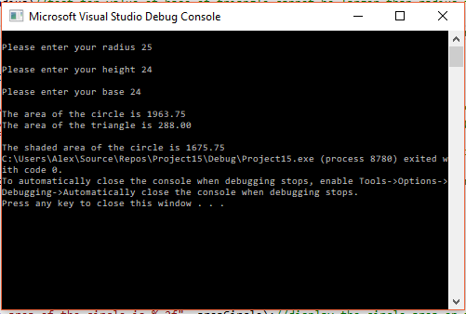
Figure 9: boundary testing

Figure 10 shows out of range tests when user enters negative values
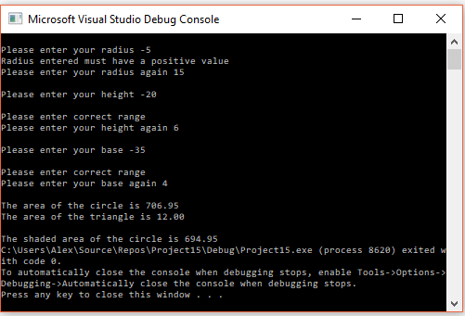
Figure 10: Out of range testing

Figure 11 shows out of range tests when user enters greater values for height and base
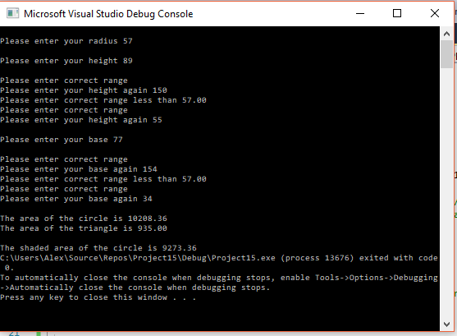
Figure 11: Out of range testing

Logical steps Exercise 3
- Decide relevant variable types
- Float variable type set for products, total price and VAT to allow decimal value
- Set for loop to allow 5 entries
- Increment by one after each entry
- Prompt user to enter values of products
- Store data from products entered
- If statement set to check for negative value
- If negative value entered prompt user
- If negative value re-entered prompt user
- Send user back into the loop by resetting variable
- Repeat steps from point 5
- Set for loop to add products
- Set calculation for adding products
- Store products in total
- Print the value on the screen
- Set calculation for VAT
- Add total and Vat
- Store in final total
- Print final total on the screen

Code for exercise 3
Version 1 – Basic functionality user enters 5 products into the array, values then displayed on the screen.

void main()
{
float myarray[5];//declare variables for decimal type assign the value for the array

int i = -1;//declare and initialise variable for loop

for (i = 0; i < 5; i++)//set for loop for user to make five entries
{
printf("\nPlease enter the value for my array");//prompt user to enter product

scanf("%f", &myarray[i]);//store data entered in variable

}

for (i = 0; i < 5; i++)//set for loop for user to make five entries
{
printf("%f\n", myarray[i]);//print entries on screen
}
}

Version 2 – Further functionality add total, store and output the 5 values entered by the user

void main()
{
float myarray[5];//declare variables for decimal type assign the value for the array

int i = -1;//declare and initialise variable for loop
float total=0;//declare and initialise variables for decimal type

for (i = 0; i < 5; i++)//set for loop for user to make five entries
{
printf("\nPlease enter the value for your product");//prompt user to enter product

scanf("%f", &myarray[i]);//store data entered in variable
}

for (i = 0; i < 5; i++)//set for loop for user to make five entries
{
printf("%f\n", myarray[i]);//print entries on screen
}

for (i = 0; i < 5; i++)//set for loop to calculate total

{
total = total + myarray[i];//calculation to add 5 entries together

}
printf("%.2f", total);//print total value on the screen

}

Version 3 – Set the calculation for adding 20% VAT then output final total.

void main()
{
float myarray[5];;//declare variables for decimal type assign the value for the array
int i = -1;//declare and initialise variable for loop
float total=0;//declare and initialise variables for decimal type
float vat = 0;//declare and initialise variables for decimal type
float finalTotal = 0;//declare and initialise variables for decimal type

for (i = 0; i < 5; i++)//set for loop for user to make five entries
{
printf("\nPlease enter the value for your product");//prompt user to enter product
scanf("%f", &myarray[i]);//store data entered in variable
}

for (i = 0; i < 5; i++)//set for loop to allow 5 entries
{
printf("%.2f\n", myarray[i]);//print entries on screen
}

for (i = 0; i < 5; i++)//set for loop to calculate total
{
total = total + myarray[i];//calculation to add 5 entries together

}
printf("%.2f", total);//print total value on the screen

vat = total * 0.20;//calculation for VAT at 20%

printf("\n%.2f", vat);//print VAT on the screen

finalTotal = total + vat;//calculation for the final total including VAT

printf("\nTotal including VAT is %.2f", finalTotal);//print final total on the screen
}

Version 4 – Error checking added for negative values start loop again
#include<stdio.h>
void main()
{
float myarray[5];;//declare variables for decimal type assign the value for the array
int i = -1;//declare and initialise variable for loop
float total = 0;//declare and initialise variables for decimal type
float vat = 0;//declare and initialise variables for decimal type
float finalTotal = 0;//declare and initialise variables for decimal type

for (i = 0; i < 5; i++)//set for loop for user to make five entries
{
printf("\nPlease enter the value for your product ");//prompt user to enter product
scanf("%f", &myarray[i]);//store data entered in variable

if (myarray[i] < 0)
{
printf("\nPlease enter a postive value for your product");//prompt user to correct range for product
printf("\nWe shall now start over! ");//tell user the process is going to start again
i = -1;//reset value of i to make user start the loop again
}
}
/////////////////////////////////////////////////////////////////////////////////////////////////////////////////////////

for (i = 0; i < 5; i++)//set for loop to calculate total
{
total = total + myarray[i];//calculation to add 5 entries together

}
printf("\nThe total value of your products is %.2f\n", total);//print total value on the screen

vat = total * 0.20;//calculation for VAT at 20%

//printf("\n%.2f", vat);//print VAT on the screen included in testing to check VAT calculation

finalTotal = total + vat;//calculation for the final total including VAT

printf("\nThe total value of your products including VAT is %.2f\n", finalTotal);//print final total on the screen

}

Figure 12 shows normal test range and output
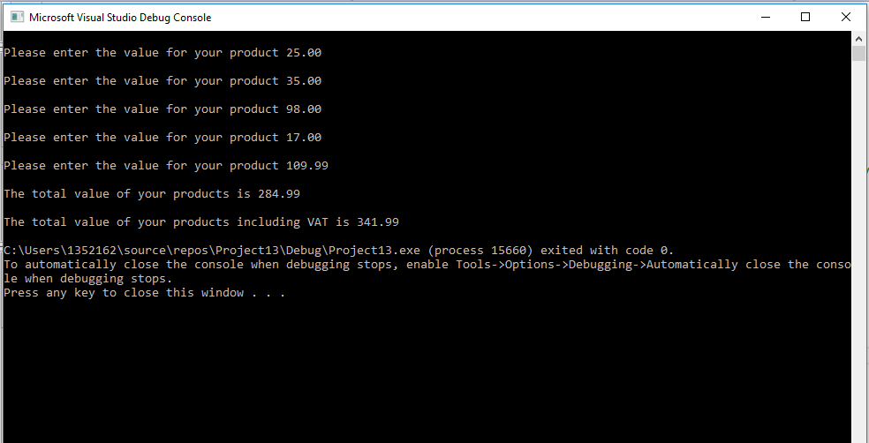
Figure 12: Normal test range
Figure 13 shows user entering negative value and the loop restarting
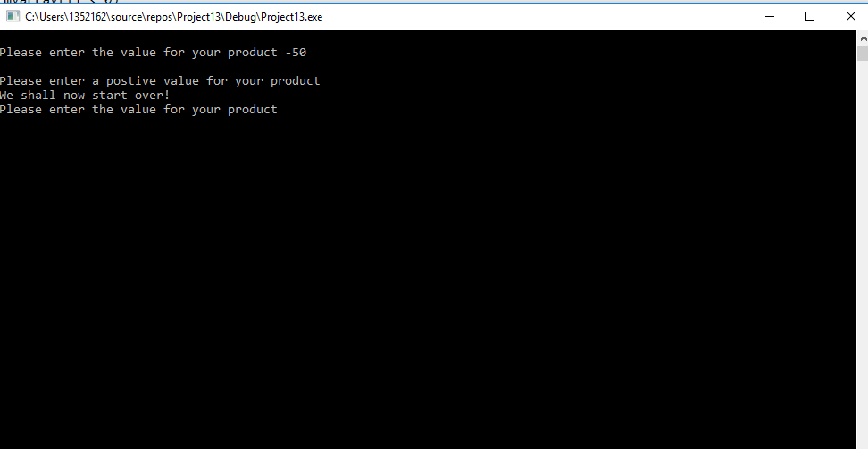
Figure 13: Out of range test

Figure 14 highlights user sent into the loop after continuing to enter negative values
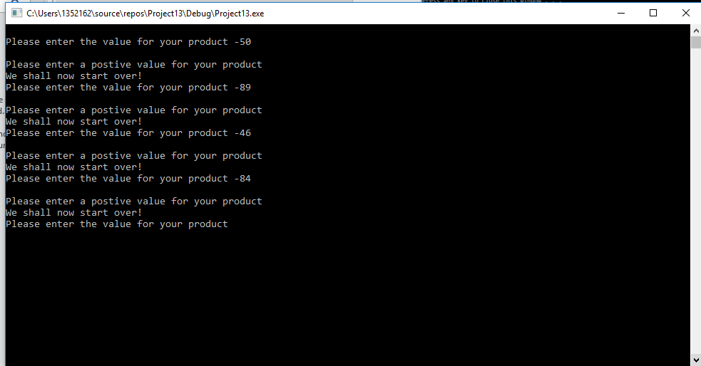
Figure 14: Out of range testing
Figure 15 shows program completion after negative values being entered
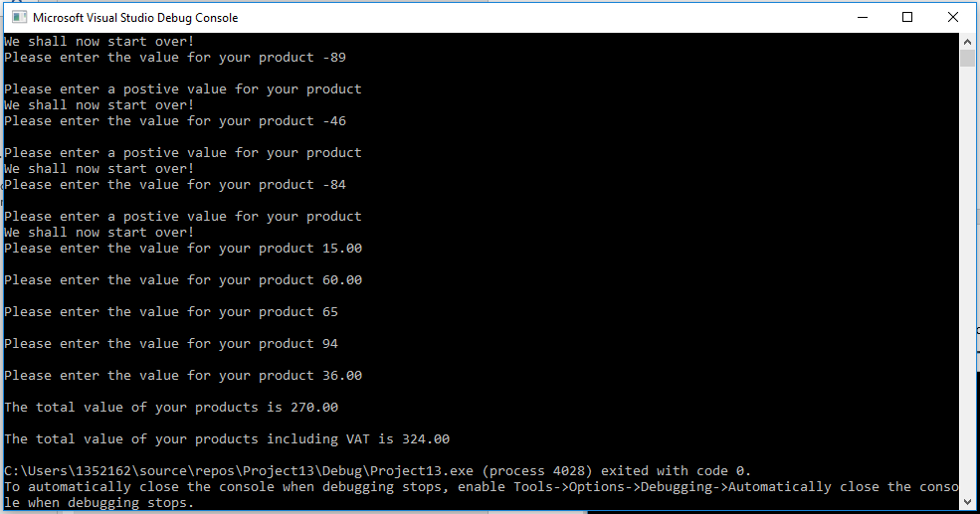
Figure 15: Out of range testing then normal test range completed

Exercise 4:
Build a fruit machine game which represents the 3 reels of symbols using numbers ranging from 1 to 5. Allow the user to have as many goes as they like (the numbers are chosen randomly each time).

- Decide relevant variable types
- Set the range of numbers for the three reels 1-5.
- Integer variable used as outputting whole number
- Char variable used for y/n choice
- Jackpot variable set to 5
- Prompt user to enter y/n
- Store choice
- Set while loop for user to keep playing if y is entered
- If n entered exit game
- Initialise variables using rand to produce random number
- Condition set to test for jackpot of 555
- If met print message on the screen
- Condition set for 2 fives been generated
- Print message on the screen
- Condition set for 2 numbers excluding fives
- Print message on the screen
- Final else if none of the previous conditions are met
- Print lose message on the screen
- Prompt user to play again
- If “y” entered send user back into the loop
- If “n” entered exit game

Version 1 – Without the 3 reels without setting jackpot and bonus
#include<stdio.h>
#include<stdlib.h>
#include<time.h>

void main()
{
srand(time(NULL));
int myrand;//initialse value for myrand variable//delete this not used
int low = 1;//set low range for random number
int high = 5;//set high range for random number

int reel1, reel2, reel3;//initialse integer variables to produce random umber
char choice;//set variable to store users entry
int jackpot = 5;

printf("Do you want to spin the reels? (y/n) ");//prompt user for input
scanf(" %c", &choice);//store data from user
while (choice == 'y')//set while loop to continue playing while user enters y
{
reel1 = rand() % (high - low + 1) + low;//inside loop to regenerate random numbers
reel2 = rand() % (high - low + 1) + low;
reel3 = rand() % (high - low + 1) + low;

printf("\n%d %d %d",reel1, reel2, reel3);

if (reel1 == reel2 || reel1 == reel3)// set condition to compare two values to see if they are the same
{
printf("\nYou win 200 bonus points ");
}
else if(reel1 == reel2 && reel1 == reel3)// set condition to compare three values to see if they are the same
{
printf("\nYou win the bonus 20 points");
}
else if(reel1 == jackpot && reel2 == jackpot && reel2 == jackpot)// set condition to compare three values to see if they are the same
{
printf("\nYou win the Jackpot!!"); //Print message on the screen

}
else
{
printf("\nYou lose 0 points");//Print message on the screen
}

printf("\nDo you want to spin the reels? (y/n) ");// Start loop again prompt user
scanf(" %c", &choice); //Store choice
}

printf("Ok, maybe another time");//Print message on screen
}

Version 2 – Final version conditions set to give correct output for 3 reels

#include<stdio.h>
#include<stdlib.h>
#include<time.h>
void main()
{
srand(time(NULL));
int low = 1;//set low range for random number
int high = 5;//set high range for random number

int reel1, reel2, reel3;//initialse integer variables to produce random umber
char choice;//set variable to store users entry
int jackpot = 5;//set variable value for jackpot

printf("Do you want to spin the reels? (y/n) ");//prompt user for input
scanf(" %c", &choice);//store data from user
while (choice == 'y')//set while loop to continue playing while user enters y, any other entry ends game
{
reel1 = rand() % (high - low + 1) + low;//initialise variable to generate random number
reel2 = rand() % (high - low + 1) + low;//initialise variable to generate random number
reel3 = rand() % (high - low + 1) + low;//initialise variable to generate random number

printf("\n%d %d %d", reel1, reel2, reel3);//print numbers on the screen

if (reel1 == jackpot && reel2 == jackpot && reel3 == jackpot)// set condition to compare three values to see if they are the jackpot
{
printf("\nYou win the Jackpot!! 2000 Points Well Done!!");//Print message on the screen
}

else if(reel1 == jackpot && reel2 == jackpot || reel1 == jackpot && reel3 == jackpot || reel2 == jackpot && reel3 == jackpot)//set condition to test for 2 fives
{

printf("\nYou win 100 bonus points");//Print message on the screen
}

else if (reel1 == reel2 && reel1 == reel3)//Set condition to compare two values to see if they are the same
{
printf("\nYou win the bonus 20 points");//Print message on the screen
}

else//Any of the conditions above are not met this condition is true
{
printf("\nYou lose 0 points");//print message on screen
}

printf("\nDo you want to spin the reels? (y/n) ");//Prompt user to enter choice
scanf(" %c", &choice);//Store choice
}

printf("Ok, maybe another time");//Print message if user opts not to play
}

Figure 15 shows output with three of the same number that isn’t the jackpot

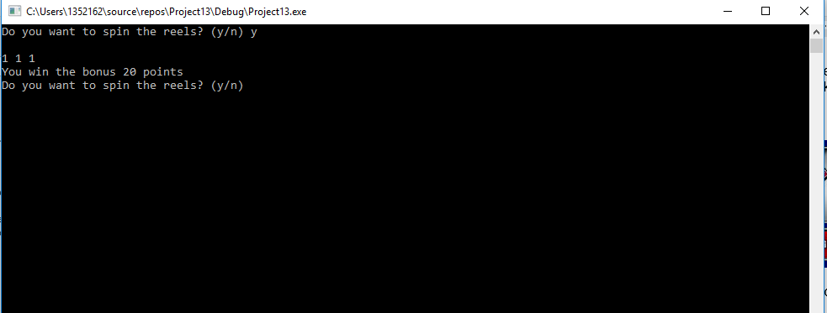

Figure 15: Three identical numbers not the jackpot
Figure 16 highlights two fives at reel one and three

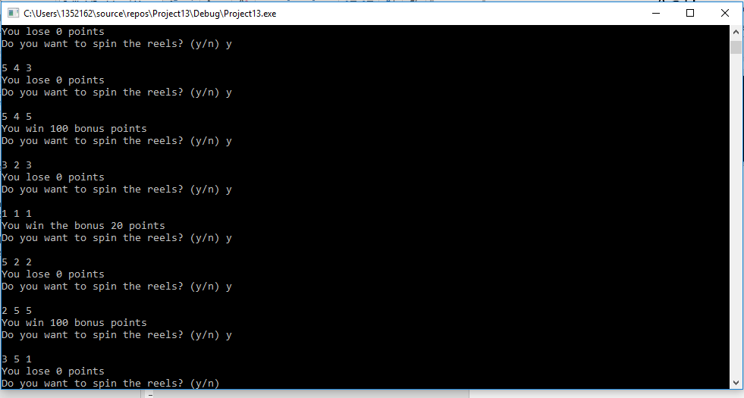

Figure 16: Reels one and three showing five and displaying message

Figure 17 highlights two fives at reel two and three

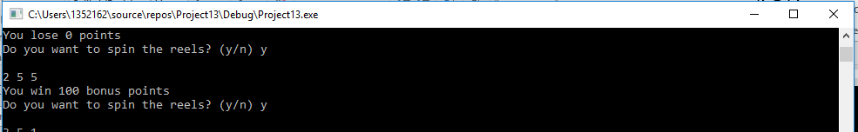

Figure 17: Reels two and three showing five and displaying message

Figure 18 highlights two fives at reel one and two

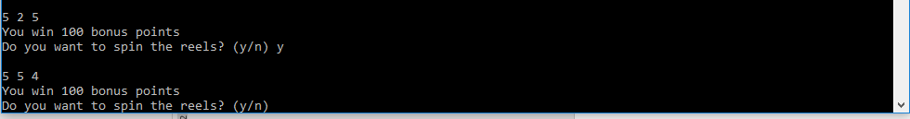

Figure 18: Reels one and two showing five and displaying message

Figure 19 highlights the jackpot and displaying message

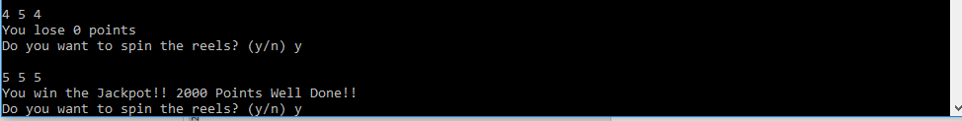

Figure 19: All three reels displaying five and showing message



