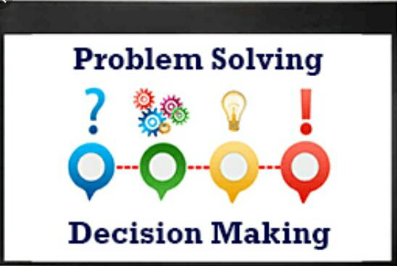
Student name : Mohammad Zakir Hossain
Student number :1713069.
Programme: Certificate in skill for workplace – term 3 : group 1.
Module : problem solving and decision making.
Module code :BMSK4004_LON
Lecture: Gazi Arif .

Contents
Introduction 2
Coca-Cola 2
Vision 2
Mission 3
Challenges 3
Recognize 3
Define 3
Investigate 3
Analyze 4
Objective Setting 4
Brainstorming 4
Assembling Group Members 5
Presenting Problem 5
Taking Input 5
Consolidating Proposals 5
Evaluation Proposals 5
Information Gathering 6
Protein-Based Beverages 6
Naturally Brewed Tea 6
Adult Soft Drinks 6
Flavored Water 6
Organizational Analysis 6
SWOT Analysis 6
Environmental Analysis 8
PESTLE Analysis 8
Competitor Analysis 9
Change Management 9
ADKAR Model 9
Stakeholders Analysis 10
Identify Stakeholder 10
Prioritize Stakeholder 10
Understand Key Stakeholder 10
Resistance to Change 11
Communication 11
Participation 11
Facilitation and Support 11
Communication Strategies 11
Email 11
Meetings 11
Website 11
Monitoring Change 12
Outcome Evaluation 12
Impact Evaluation 12
Conclusion 12
References 12

Problem Solving and Decision Making at the Coca-Cola Company

Introduction
The competitive environment has increased greatly in today’s time where businesses are competing for customers all around the world creating greater challenges. A number of problems can come up in the workplace where it is difficult to deal with such issues of proper approach is not taken up for dealing with such challenges. The dynamic environment of today can present a number of problems which should be tackled in a systemized manner where the current focus will be on such techniques through which problems can be solved and make decisions on organizational matters in a more effective manner. The analysis will be carried out of the Coca-Cola company which is a renowned brand carrying out business operations around the world. The description will be provided of the company stating its structure and working followed by challenges being faced by the company as a whole. The analysis will be carried out of internal and external environment followed by an analysis of the problem devising solution through various techniques.

Coca-Cola
Coca Cola is an international company with its origins in America where its main function involves manufacturing, retailing and marketing non-alcoholic products. The main product of the company is Coca Cola drink invented in 1886 in Atlanta where it is still in use today. Syrup concentrate is produced by the company which is further sold to bottlers around the world serving specific territories. Headquarters of the company is currently present in Atlanta, Georgia where James Quincey holds a position as Chairman. Total revenue generated by the company in 2018 amounted up to 31.85 billion where net income after deducting costs totaled up to 6.43 billion. Total employees working in the company are more the 62000 (Tripodi, 2011).
Product range of the company has considerably expanded beyond its original coca cola drink although the original product is still being sold a large number of additional brands have been launched such as Ciel mineral water, Dasani water, Vale orange juice, Fanta carbonated drink, fair life dairy products, Georgia coffee, Minute made juice, Odwalla flavoured milk and a variety of other products being sold under the Coca-Cola umbrella. It can be seen that the company has established a reputation since it has been carrying out its operations for several years diversified product portfolio along with global expanse provides security to the company.

Vision
Detailed vision has been presented by the company which gives a clear set of goals that are to be pursued relating to four main elements which include people, portfolio, partners, and the planet. The company shows care for its people by providing the best workplace for inspiration and co-working. Expand its portfolio so that the needs and desires of a large set of people can be met. Creating the value of partners in order to gain mutual benefit and build loyalty. Show greater responsibility towards the plant by taking part in sustainable practices. Create long term value for shareholders by maintaining profitability and finally mould business operations in such a way that it can be lean, effective and fast moving.

Mission
The mission of the company follows these end goals:
- To refresh the world in mind, body, and spirit
- To inspire moments of optimism and happiness through our brands and actions
- To create value and make a difference.

Challenges

Recognize
The business environment is changing rapidly where a number of new competitors are rising presenting problem for the company. Company is expanding in new territories around the world but still pressure being brought on the company is increasing. A number of factors can be present for this change where the long-term vision of Coca Cola will be affected such as ensuring long term profitability and keep satisfying needs and desires of customers. One needs to assess underlying factors which are carrying impact and how it can be improved.

Define
Market share of the company has been strong for the past years where the company keeps a close eye in changes in the microenvironment but despite vigilance, the competitive environment is increasing where the overall industry is being affected. Previously, the major trend was seen in weather variation where demand for products of the company declined but now other factors can be seen carrying an impact on the performance of the company (Moses and Vest, 2010). This shows that need is present to find underlying factors affecting the demand of the products of the company addressing the issue to ensure long term profitability.

Investigate
Awareness is spreading among customers regarding negative effect imparted by fizzy drinks on health due to which people have become more selective in their choice of food and drink. Use of such drinks is being banned in schools which puts a major customer group out of reach for the company since sweet drinks hold greater appeal for children. The competitive environment is increasing where several brands are already present in the market holding tightly onto their share such as Pepsi whereas new competitors are also rising in developing countries making it harder to take up such opportunities in new markets. World resource is depleting where the main component for making products of Pepsi is water. Declining quality of water around the world is presenting threat for the company where it will increase costs of operations affecting profitability. Consumer needs are changing where more emphasis is being put on the health factor for which the appeal of Coca-Cola products will decrease.

Analyse
A number of underlying factors have been discovered which are carrying an impact on the performance of the firm where each factor carries implications in different operational areas. Main challenge affecting the performance of the company from the factors discussed above is health-related concerns that products of the company are not healthy along with increasing competition, especially from firm’s originating from developing counties as they hold greater appeal for locals generally offering cost for the value proposition.

Objective Setting
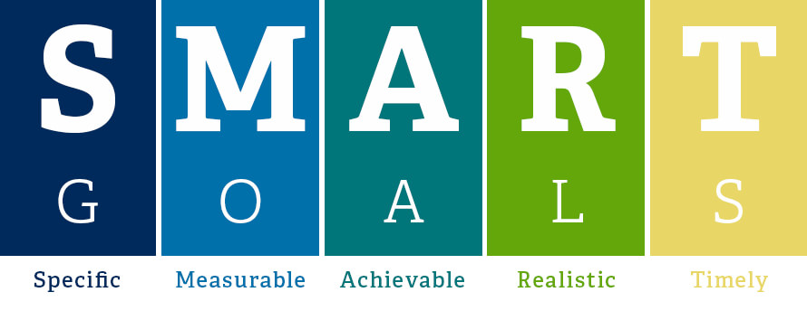
Smart goals will be set out for the current issue being faced where features to be implemented in the goals are specific, measurable, achievable, realistic and timely. SMART goals are important since they clearly state what is to be done and when it is to be done were keeping it in realistic range brings greater motivation for employees (Kim and Grunig, 2011).
- Improve market share of the company by taking it up to its previous place which was forty percent in the next five years through making amendments in operations
- Decrease cost of operations of the company by 20% by setting up plants in such countries where main raw materials are readily available such as freshwater bodies
- Bring about modification in products so that it can bring healthier appeal to customers particularly by decreasing sugar content and increasing nutritional value of products where a new product is to be designed through R&D in the coming five years

Brainstorming
Coca Cola company needs to address the issue which it is facing for which brainstorming technique can be applied.

Assembling Group Members
Key organizational members are to be gathered in one place so that problem can be looked into taking in a different point of views. Coca Cola company has several departments where the head of each department should be called out and taking in input from him such as the head of sales, marketing, HR, finance, etc. All these heads should be brought forward along with the presence of the CEO since he is to play the role of a strategic leader. Different departments play a key role in supporting business activities where each department can provide input relating to the problem at hand (Lunenberg, 2011).

Presenting Problem
Next step is bringing about an issue which is being faced by the company informing various members relating to facts and figures of the issue ensuring that they have a proper understanding before providing input. Following graph can be shown to explain how different regions make up a different part of revenue for the company where the need is present for increasing income from developing markets such as Africa. Estimate will be given relating to the future performance of the company where negative expectations will show the seriousness of the situation being faced currently.
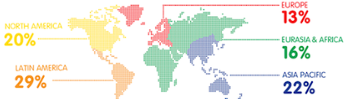

Taking Input
Each head of the department will be asked about his opinion on the problem discussed to take input of underlying causes which have led to the situation. General perspective can be taken on how problem discussed can be solved along with an individual report that his department will be playing in dealing with the discussed issue. Coca Cola is a large corporation having global operations but still, all organizational members may not have the same perspective on underlying causative factors where they may blame other departments.

Consolidating Proposals
Managers will be asked to take time till next meeting discussing with employees of their respective departments providing a more unified approach from the whole department. The current focus will not on a deriving solution for the given problem but rather let Coca Cola identify underlying factors of the company which have led to the current problem which could be the inefficiency of the sales team to report a change in customer demand or marketing department may not be carrying out working effectively.

Evaluation Proposals
Various proposals would be achieved after consensus from various departments for which pros and cons can be assessed for each alternative studied. This will help reach the most suitable option from various proposals made by various team members from Coca Cola company arriving at a mutually agreed upon solution.

Information Gathering
A large amount of data is present of the company given its years of functioning where such data can provide valuable insight into the cause of problems being faced and major trends. However, most of this information would be present in raw form such as sales made in various seasons which must be passed through some processing in order to gain valuable information from it. Various trends currently seen in the beverage industry will be brought under review in order to determine potential solutions which can be applied for dealing with problems being faced.

Protein-Based Beverages
The trend of protein-based beverages is increasing which are considered an alternative to protein derived from dairy products. A number of reasons are present for moving away from veganism such as the growing trend of Veganism in today's time along with more lactose intolerant people. Protein-based beverages lead to dry feeling in the mouth where an increasing amount of sugar will derive concern from health-conscious customers (Poppit, et al., 2011). Protein-based beverage trend can be taken up but various complications are present as discussed.

Naturally Brewed Tea
Tea is being used as a healthy alternative to other types of beverages where a large number of customers have already grown accustomed to its less sweet taste. Use of herbal products is also seen often in the beverage industry which further adds to healthy touch. Manufacturing of such products is both less costly and holds appeal to the growing customer group.

Adult Soft Drinks
Health drive can be seen carrying an impact on alcohol industry where negative side effects related to its use are being brought to light. These are lesser sweet beverages which are difficult to drink since people are to consume them during the whole evening being an alternative to alcohol. Developing such products will allow Coca Cola to take up market share being given up by the alcohol industry along with having less requirement of taste.

Flavoured Water
The trend of flavoured water is increasing in today’s time where water acts as the main ingredient but certain additions are made in the water such as natural flavours to generally involving carbonated water (Holler, 2011). This provides sweeter taste to consumers but without any unnecessary addition of Kcals.

Organizational Analysis

SWOT Analysis
Strengths
- Coca-cola has maintained a dominant market share in the non-alcoholic beverage industry for quite some time allowing it to generate a greater amount of profit selling more than sixty million beverages to various types of consumers around the world.
- Achieving economies of scale have allowed the company to decreases costs considerable adding towards the profitability of the company
- Years of working has provided the company with strong brand power where it can use its label to influence the choice of consumers where they recognize the brand name and logo for its quality and reliability
- A wide network of the company provides access to a large set of customers making it easier for the company to communicate new product range being launched
Weaknesses
- Increasing competitive pressure which is pushing down the profitability of the company where the main brand presenting challenge is Pepsi creating strong price competition between them
- Health conscious product launched by the company so far is coke zero which claims to have zero sugar where no other such product has been offered which will hold appeal for health-conscious people
- Company has been under heat for its weak water management methods leading to wastage where depleting sources of clean fresh water will further add to problems of the company increasing costs of operations
- Competitors of the company are slowly diversifying into other sectors such as snacks where coca cola is failing to keep up pace not entering into such sectors

Opportunities
- The company can diversify its product range entering into other segments which hold appeals such as protein-based products or flavoured water
- Some products are present of the company which do not catch as many sales as major selling items such as juice range where the marketing department should be directed to put more focus on such product ranges
- Strong opportunity is present to take up growing demand in developing markets such as ones present in Asia and Africa as demand is slowly declining in developed countries (Adeoye and Elegunde, 2012)
- Supply chain system of the company is carrying a major impact on the costs of the company were bringing about improvement in transportation and distribution system will help the company to control its costs in a more effective manner
Threats
- Along with direct competitors which providing trouble in international markets, there are a large number of indirect competitors or small-scale competitors chipping away at the market share of the company
- Government regulations are being changed in order to increase health drive such as banning the sale of carbonated drinks in schools which will in turn impact sales of the company
- Water is main raw material used in products of Coca-cola were the number of fresh and clean water bodies is decreasing with time posing a serious threat to operations of the company creating need to develop alternatives (Francdo, Mehta and Veldwisch, 2013)

Environmental Analysis

PESTLE Analysis
Political
Coca Cola is carrying out operations in a number of countries around the globe where it changing political conditions carry an impact on operations of the company such as political instability or trade sanctions. The adjustment has to be made in operations according to changes in the political environment.
Economic
Overall global economic conditions are showing a downward trend where greater impact can be seen in developing countries which can carry impacts such as a change in the interest rate or consumer spending. Decreasing the buying power of customers would mean that sales of the company would decline to carry an impact on profitability. Customers may shift to alternate local brands which are cheaper in order to save costs.
Social
Social trends are changing where greater emphasis is being put on taking up healthy living and stop using unhealthy products where unfortunately for the company, fizzy drinks are categorized as unhealthy. Developing countries are also showing support towards national companies rather than international brands for which these small competitors are chipping away at market share (Babor and Robaina, 2013).
Technological
The new development is being made which carries an impact on all parts of operations ranging from product to selling process. Technological changes need to be implemented in a timely manner by companies where it is a means of gaining competitive advantage. Not adopting such change may drive the company out of competition affecting sales (Nedovic, et al., 2011).
Legal
Various types of laws and regulations are present which apply to the food and beverage industry which should be compiled against. Changes can be present in legal regulations in different countries which need to be complied with. Dumping laws or rules relating to the use of materials can affect the operations of the company.
Environmental
Considerable importance is being directed towards environmental stability in today's time where corporations are expected to carry out activities which are sustainable. Coca Cola is facing a number of issues relating to excess use of water which can carry an impact on both reputation and operations of the company leader to higher costs.

Competitor Analysis
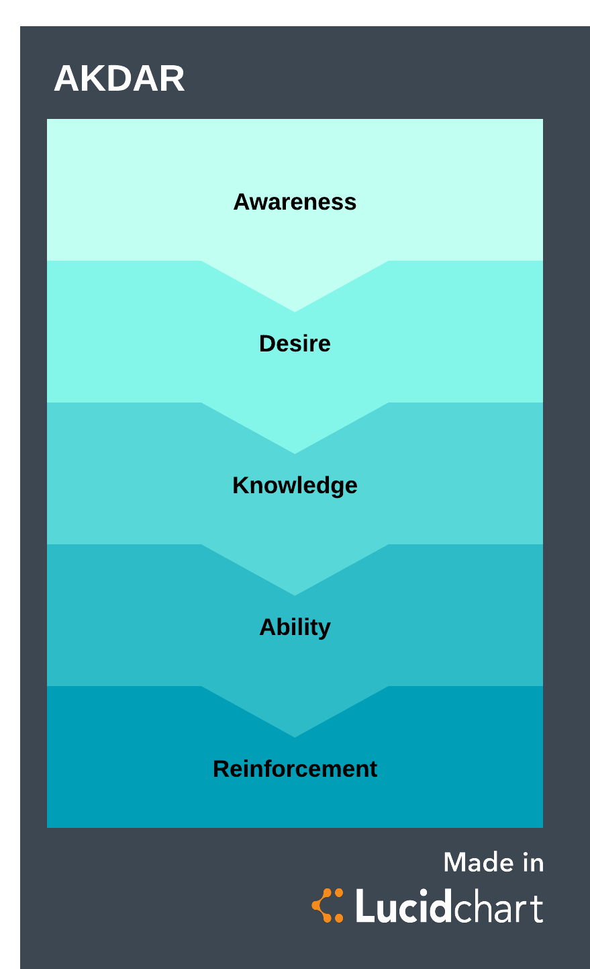
Coca Cola is considered the number one soft drink company of the world where it stands as the largest producer of soft drinks in the world. Greater effort is being made by the CEO for stabilizing working and processes. Heavy investment has been made by Coca Cola for increasing research and development adding towards product range. Holding competitive advantage in terms of production and sales leads to the image of too big to fall but in reality, there is a number of small competitors chipping away at the market share of the company posing threat to profitability. Greatest competitor for Coca Cola company is Pepsi Co. which not only holds a strong position in the beverage industry but also expanding into other sectors such as snacks increasing its financial standing presenting stronger competition for Coca Cola. The trend can be seen shifting away from the beverage industry where

Change Management

ADKAR Model
Awareness
Main step to bring about change in an organization is spread awareness regarding the need for change wherein current scenario meeting carried out with department heads at Coca Cola along with compiling viewpoint from different departments would help spread awareness (Boca, 2013).
Desire
Long term goals of the company are at stake in the current position where all organizational members wish to achieve these goals. Seeing new problems as a threat to achieving these goals would encourage employees to bring about movement.
Knowledge
Proper analysis has been carried out of both internal and internal conditions stating the main changes that are required in order to deal with issues present. This provides knowledge to various stakeholders about change aimed by the company.
Ability
Training will be given to related members directly involved in the change process so that they hold the ability to bring about change. Current objectives to be pursued will require greater funding to be directed towards research and development department along with bringing amendment in operations to reduce costs.
Reinforcement
Goals have to be reinforced from time to time reminding main objectives of change process being pursued along with ensuring that change is applied consistently. Not reinforcing values properly will cause changes to be reversed at Coca Cola leading to loss and time waste.

Stakeholders Analysis

Identify Stakeholder
A number of key stakeholders are present which will be affected by these changes where main stakeholders will be employees since they have to smoothly implement this change in the organization. Shareholders are investors who should be informed relating to plans being pursued in Coca Cola since it will impact their earnings. Key partners such as retailers should be informed about how a change in the product at Coca Cola will affect supply and demand.

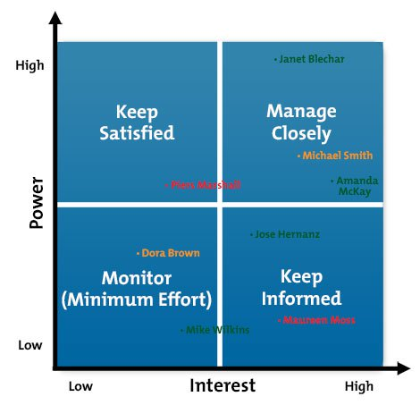
Prioritize Stakeholder
A most important stakeholder in the current scenario is employees since they are responsible for directly controlling functions of the company. They need to be managed closely inform since their power and interest is high. A second most important stakeholder in this change process are shareholders where they should be kept informed regarding change process being pursued and stage of completion at which the project stands (Missonier and Fedida, 2014).

Understand Key Stakeholder
Suppliers will be low power and less interested stakeholder for which they need to be monitored closely but no need for communication is present with them. Shareholders have a financial stake in the company where they have power over functions along with high interest. They need to be managed with greater care keeping them informed properly.

Resistance to Change
Employees at Coca Cola are used to carrying out functioning according to established standards where they may have doubts towards change.

Communication
Resistance often comes up due to confusion where employees do not have adequate information about what is going on. Heads of various departments will be involved in the change process where they are expected to communicate the main aim of the change with their respective departments. This will help increase understanding of the change being brought about and increase employee participation towards helping in this change. Emails will be sent out regularly from CEO of Coca Cola informing about a phase in which the company is and objectives to be achieved in each phase of implementation.

Participation
A bottom-up approach will be taken up in a change process where input will be taken from employees of different departments relating to change being implemented. Increasing participation of employees in this manner will help increase participation where they will try to facilitate the change rather than opposing it. Since Coca Cola is pursuing new design directed towards changing the need of the customer, transformational approach should be taken up for facilitating the change process.

Facilitation and Support
Leaders play an important role in motivating employees where current scenario calls for transformational leadership to be taken up at Coca Cola company which will motivate employees to put in greater effort. Leaders can also be separated out among employees who will play an important role in guiding colleagues through the change process.

Communication Strategies

Email
An email will be sent to all employees during the change process so that they can be informed relating to the change process that is being pursued. An email will also be sent out to external stakeholders such as suppliers and retailers in order to inform them about major changes taking place and how it may carry an impact on them.

Meetings
Meetings will be carried out from time to time with key individuals in the change process such as the head of department and change leader at Coca Cola. The discussion will be made on key aspects of the change process and discuss any hurdles that may come up.

Website
Website will share important news regarding change process so that all stakeholders in general, especially shareholders can be informed. This will help them understand how to change is brought about in Coca-cola will carry an impact on them as an individual.

Monitoring Change

Outcome Evaluation
The expected outcome of the project is that new product range is introduced in the company where it moves away focus from carbonated drinks to a healthier product range which would hold appeal for more customers increase market share. A significant change is required for this where the outcome of the change to be seen is more emphasis on research and development activities along with controlling costs of operation.

Impact Evaluation
The change would be observed in this part comparing the expected outcome from the actual outcome and highlighting the difference between them. Data will be collected of new market share and costs of operation checking the difference in before and after results showing impact factor.

Conclusion
The problem-solving technique has been applied at Coca Cola company where the problem being faced was that the company is expanding in new territories around the world but still pressure being brought on the company is increasing decreasing its profitability. Goals were set out to be achieved which includes improving product range, increasing market share and decreasing costs of operation. Coca Cola company has several departments where the head of each department should be called out and taking in input from him such as the head of sales, marketing, HR, finance, etc. Main step to bring about change in an organization is spread awareness regarding the need for change were in current scenario meeting carried out with department heads at Coca Cola. Resistance often comes up due to confusion where employees do not have adequate information about what is going on. Heads of various departments will be involved in the change process where they are expected to communicate the main aim of the change with their respective departments. The expected outcome of the project is that new product range is introduced in the company where it moves away focus from carbonated drinks to a healthier product range which would hold appeal for more customers increase market share. This change proposition may face considerable resistance but will provide benefit to the company in the long term.

References

Adeoye, A. O., and Elegunde, A. F. (2012). Impacts of external business environment on organisational performance in the food and beverage industry in Nigeria. British Journal of Arts and Social Sciences, 6(2), 194-201.

Babor, T. F., and Robaina, K. (2013). Public health, academic medicine, and the alcohol industry’s corporate social responsibility activities. American journal of public health, 103(2), 206-214.

Boca, G. D. (2013). ADKAR model vs. quality management change. In International Conference Risk in Contemporary Economy, Galati, Romania.

Franco, J., Mehta, L., and Veldwisch, G. J. (2013). The global politics of water grabbing. Third World Quarterly, 34(9), 1651-1675.

Kim, J. N., and Grunig, J. E. (2011). Problem solving and communicative action: A situational theory of problem solving. Journal of Communication, 61(1), 120-149.

Lunenburg, F. C. (2011). Decision making in organizations. International journal of management, business, and administration, 15(1), 1-9.

Missonier, S., and Loufrani-Fedida, S. (2014). Stakeholder analysis and engagement in projects: From stakeholder relational perspective to stakeholder relational ontology. International Journal of Project Management, 32(7), 1108-1122.

Moses, C. T., and Vest, D. (2010). Coca-cola and PepsiCo in South Africa: A landmark case in corporate social responsibility, ethical dilemmas, and the challenges of international business. Journal of African Business, 11(2), 235-251.

Nedovic, V., Kalusevic, A., Manojlovic, V., Levic, S., and Bugarski, B. (2011). An overview of encapsulation technologies for food applications. Procedia Food Science, 1, 1806-1815.

Poppitt, S. D., Proctor, J., McGill, A. T., Wiessing, K. R., Falk, S., Xin, L., ... and Hall, R. S. (2011). Low-dose whey protein-enriched water beverages alter satiety in a study of overweight women. Appetite, 56(2), 456-464.

Tripodi, J. (2011). Coca cola marketing shifts from impressions to expressions. Harvard Business Review, 27(04). Source:http://elaveresiu.com/s/CC_B2C.pdf

