Academic Report on Virtual Machine creation, management, resources, vNets and network security groups, images and practical work on an Azure task
Cloud Computing Architecture /ACCA5025/
Lecturer: Koushik Modak
Valentin Latinov Miladinov /2024732/
University of Wales Trinity Saint David
Submission Deadline: 03/05/2023

Table of content
Introduction: 3
Virtual Machine resources 3
CPU 3
Hard Drive 4
Memory 5
Network 6
VNet and network security groups /in Azure/ 6
Images in Azure 8
Conclusion: 8
References: 9

Introduction:
This report aims to present information and thoughts on Virtual Machines, their creation and managing, resources, virtual networks and network security groups. Also, presented will be the completion of a practical task, with video material and audio explanation in it.

Virtual Machine resources
A Virtual Machine resource is any program, date file, given set of files, device or whatever entity or set of entities that might be needed for use in application program processing. [1]
In order for a virtual machine to function properly, it needs four primary resources for its virtual hardware. The resources in question are CPU, hard disk, memory, and network, which appear as physical hardware to the guest operating system or application. A portion of these resources is granted to a virtual machine upon its creation, but it isn’t out of the question to reconfigure it any time after. Should a Virtual Machine ever experience a constraint, it would be one of the four resources going through a delay. [2] Creation and management of virtual machines are presented in the video material at the end of the report /after the references/, so it’d be easier to familiarize with.

CPU
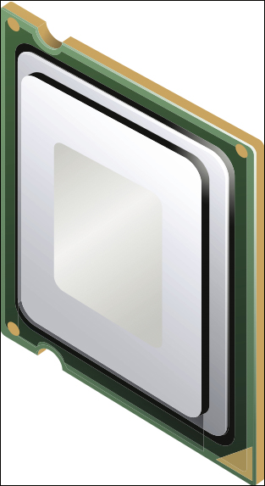
The virtualization layer runs CPU instructions, so the Virtual Machines run as they access the physical processor on the ESXi host. Performance is a priority for CPU personalization, which means ESXi host physical resources would be used anytime possible. An image of a Virtual Machine’s CPU is presented on the right: [2]
Virtual CPU, also known as vCPU, of vSphere 5.5 can go up to 64 as of count per Virtual Machine. What actually sets the limit of the number of vCPU allocated to a single Virtual Machine is the underlying logical cores that the physical hardware itself has. There is another factor for the same limitation and it is the tier of vSphere licensing, since only Enterprise Plus licensing would allow 64 vCPUs to be allocated to a single Virtual Machine. [2]
The VMkernel contains a CPU scheduler that dynamically organises vCPUs on the ESXi host’s physical processors. This scheduler uses socket-core-thread topology. A socket is a single, integrated circuit package, which could contain one or multiple physical processor cores, which cores have one or more logical processors, else known as threads. When the host has hyperthreading enabled on itself ESXi is in power to execute two threads or sets of instruction simultaneously. This hyperthreading grants more logical CPUs to ESXi, where vCPUs would be scheduled, granting more organizing throughput. Hyperthreading, however, does not double the power of the core. CPU contention is time when Virtual Machines are competing for resources. That’s when VMkernel ensures that the Virtual Machines run as if they have a specified number of vCPUs by time slicing the physical processor throughout all the Virtual Machines. [2]

Hard Drive
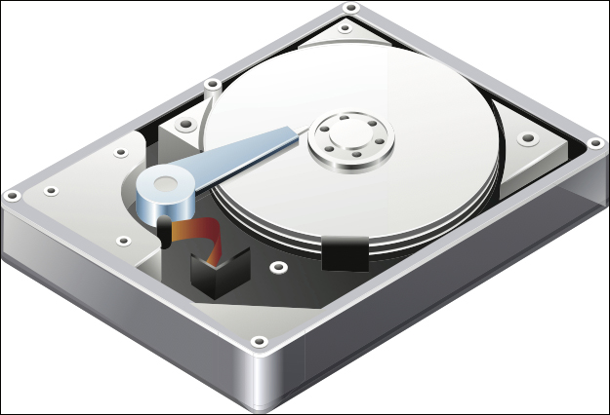
Physical servers connect to storage directly, regardless of it either being an external storage array or their actual internal hard disk that arrays to the server chassis, in a non-virtualized environment. The let-down about it is that any single server would demand a full ownership of the physical device, meaning no other server would make use of it for the time being. Sharing storage resources is tricky in non-virtualized environments. It could demand complex filesystems and migration to file-based Network Attached Storage or Storage Area Networks. [2] An image of a virtual hard disk is presented on the right:
Shared storage is a base technology which allows different important things to happen in a virtual environment. Such cases are high availability, distributed resource scheduler and more. There is an encapsulation of Virtual Machines in a set of secretive files and they are stored in a datastore. This specific encapsulation allows Virtual Machines to be portable and easy for cloning or backing up. When there is a Virtual Machine, there is a directory on the datastore for it, containing all of the given Virtual Machine’s files. A datastore is a generic term used for a container which holds files and .iso images and floppy images. It is formattable with VMwawre’s Virtual Machine File System (VMFS) or could use Network File Systems. Any datastore type could be accessed throughout multiple ESXi hosts. [2]
VMFS is a clustered filesystem of high-performance, which is devised for virtual machine. It enables architecture of multiple physical servers that are virtualization-based to read and write to a given storage simultaneously. VFMS is purposed for virtualization. Its newest version, the VMFS-5, uses 1 MB block size, being decent for bigger files, in the meantime it has an 8 KB subblock allocation for the small files, example being logs. It is able to have datastores reaching the size of 64 TB. In order to prevent one ESXi host to write to the Virtual Machine’s files, another ESXi host has a locking mechanism, which cuts access to the Virtual Machine whatsoever. This fights corruption. [2]
Multiple storage protocols are able to be in use to access and interact with VMFS datastores. Such protocols may be: Fibre Channel, Fibre Channel over Ethernet, iSCSI and direct attached storage. Network File Systems ought to be used to create a datastore as well. VMFS datastore is expandable even at dynamic pace. This ensures growth of shared storage pool, cutting any otherwise possible downtime. [2]

Memory

In non-virtualized environment, the operating system makes the correct assumption that it possesses all the physical memory in the given server. A guest operating system assumes the very same thing; however, it doesn’t really own all the physical memory whatsoever. ESXi creates configured memory for the guest operating system in a Virtual Machine by using a contiguous virtual address space. An image of Virtual Machine’s memory is presented on the right: [2]
Virtual memory is a popular technique. It creates contiguous virtual address space. This allows the hardware and the operating system to have the address translation between the physical and virtual addresses spaces under control. ESXi can run multiple Virtual Machines simultaneously due to the fact all Virtual Machines have their own contiguous virtual address space. Any Virtual Machine’s memory is off limit to other Virtual Machines. [2]
ESXi has three layers of virtual memory: physical memory, guest operating system physical memory and guest operating system virtual memory. The VMkernel is a slice of physical host memory to a Virtual Machine and plays the role of its guest operating system physical memory, whereas the guest operating system is the virtual memory to the applications. [2]
The guest operating system is informed of how much memory is at its disposal and this is exactly how much memory the Virtual Machine gets to have. This doesn’t mean that the Virtual Machine would just use all the memory it is given – it would only use what the guest operating system and the application need for the time being. That said, Virtual Machines cannot reach more memory than what is already configured as their memory size. In creation of the Virtual Machine, the memory needs of the guest operating systems and applications must be taken into consideration, so the memory allocation could be sized accordingly. [2]

Network

Virtual Networking has two key components: virtual switch and virtual Ethernet adapters. A single Virtual Machine is capable of configuration with no more than ten virtual Ethernet adapters. They are called vNICs. An image of a Virtual Machine’s vNIC is presented on the right: [2]

Virtual networks’ purpose is for virtual devices; due to the work of vNetwork standard switches or distributed switches, there is an established communication between the virtual machines and the external world (physical network). [2]
The virtual switch has many similarities with the physical Ethernet switch. Example given, standard VLAN implementation is supported by virtual switches. Also, they have a forwarding table. Both characteristics are typical for the physical switch too. The ESXi host isn’t limited to having only one virtual switch. To raise the availability for the Virtual Machines that use the virtual switch, these virtual switches can bind multiple vmnics together in a network interface card team. [2]
Virtual switches are known to have two connection types available: a port group and a VMkernel port. Port groups are where the Virtual Machines are connected on a virtual switch, so they could receive access to network resources. VMkernel ports grant network service to the ESXi host; this way management, vMotion, IP storage and more components are included. Any VKernel port is to be configured with unique IP address and network mask.[2]

VNet and network security groups /in Azure/
To put it shortly: VNet allows virtual networks to connect with one another. This connection enables private traffic between virtual networks through IPv4 addresses. Virtual Machines in peered VNets are accommodated to communication with each other the same way they would if they were in the same network. There are two kinds of VNet peering: Regional (connecting VNets with a given Azure region) and Global (connecting VNets beyond Azure regions). [3]
These are the positives of Azure’s VNet:
- Provides an isolated environment for applications;
- Access to the public internet;
- Eased direct traffic from resources;
- Network of high security;
- Network of high connectivity;
- Simple at work, builds sophisticated network topologies. [3][4]

There are three components to virtual networking:
- Subnets – they allow users to segment the virtual network into single or multiple sub-networks, which can be separated logically, each subnet consists of a server. Furthermore, subnets go by two types:
  - Private – internet access with NAT (Network Address Translation) gateway, if present in the public subnet;
  - Public – accessing internet directly.
- Routing – delivers data as it chooses a proper path from source to destination; for each subnet there is, routing table is created and traffic is routed by the virtual network in automation.
- Network security groups – acts as a firewall, protecting the Virtual Machine as it limits network traffic; inbound and outbound network traffic is restricted, all depending on the destination IP addresses, port and protocol. [4]
Network Security groups is separated on two groups:
- VNICs – one or more VNICs have the same security posture; all VNICs are to be in the given virtual cloud network the network security groups are;
- Security rules – the network security groups’ security rules dictate the kind of traffic that is acceptable in and out of the VNICs in the group, example being: ingress TCP port 22 SSH traffic from a given source.
If there are resources with different security postures in given VCN, an option is to make NSG security rules to restrict traffic between the resources with two different postures.

Images in Azure
Images find use in Azure as an operating system provider, for Virtual Machines. Images can have more than a single disk. Images are available from several sources, as it is going to be presented in the video with the additional task:
- In Azure’s Marketplace;
- Open-source community images in VM Depot;
- Own images by either capturing already existing Azure Virtual Machine that would be used as an image or uploading an image.
There are two types of images:
- Operating System images – includes generalized operating system, it has no additional disks;
- Virtual Machine images – it is an operating system and all disks attached to a Virtual Machine right after the image is created; it is a newer type of images.[6] Virtual Machine Images find a role in creating a virtual machine, which could be a part of a new or already existing deployment. Should the VM Image be generalized, provisioning information network configuration are to be provided too, just like with an OS Image nowadays. The virtual machine is now on the go and it behaves the very same as any other Virtual Machine that was created with OS Images or disks. The role is eligible for updates, additional disks could be attached or disks that already exist could be detached. However, should the VM image be specialized, no provisioning information would be necessary, again, like an OS disk nowadays. Virtual Machine gets deployed from VM Image, there would be a copy of the VHDs to be made for the new VM – meaning the existing VHDs are not attached directly. If a Virtual Machine is deployed this way, the Virtual Machine would rush into a running state, since there was no provisioning necessary. That said, there is a chance that the Virtual Machine would be still booting up, asking for additional minutes for remote desktop/SSH to be available, but when it is deployed and running, the Virtual Machine behaves as any other Virtual Machine created from OS disks or OS Images would. [7]

Conclusion:
To summarise it all, what a Virtual Machine mainly needs to come to existence is four components: CPU (so it can think), Hard Drive (so it can carry a lot of information), Memory (to provide information, needed in real time), Network (to connect a Virtual Machine to the physical network). VNet enables connection between virtual networks. It is a highly reliable, fast, simple way to have an isolated environment for applications, access the public internet and acquire eased direct traffic from resources. Network security groups are a component of virtual networking. They act as a firewall, which protects the Virtual Machines.

References:
[1] - “What is a VM Resource?,” What is a VM resource?, 17-Dec-2021. [Online]. Available: https://www.ibm.com/docs/en/zvm/7.2?topic=terminology-what-is-vm-resource. [Accessed: 27-Apr-2023].
[2] - R. Fitzhugh, “Virtual Machine Concepts,” in Vsphere Virtual Machine Management, Birmingham, United Kingdom: Packt Publishing, 2014, pp. 60–62.
[3]- A. Patel, “Azure - Virtual Network (vnet) peering overview,” Medium, 11-Sep-2020. [Online]. Available: https://medium.com/awesome-azure/azure-virtual-network-vnet-peering-overview-introduction-a795517bd83b. [Accessed: 27-Apr-2023].
[4] - K. Menon, “Introduction to azure virtual network(vnet) ,” Simplilearn.com, 23-Feb-2023. [Online]. Available: https://www.simplilearn.com/tutorials/azure-tutorial/azure-virtual-network-vnet. [Accessed: 27-Apr-2023].
[5] - “Network security groups,” Oracle.com, 31-Jan-2023. [Online]. Available: https://docs.oracle.com/en-us/iaas/Content/Network/Concepts/networksecuritygroups.htm. [Accessed: 27-Apr-2023].
[6] - K. Davies, C. Nottingham, P. Wright, and A. Pasic, “Azure-content/virtual-machines-images.md at master · Huachao/azure-content,” GitHub.com, 02-Dec-2015. [Online]. Available: https://github.com/Huachao/azure-content/blob/master/articles/virtual-machines/virtual-machines-images.md. [Accessed: 27-Apr-2023].
[7] - C. Avanessians, “VM image: Azure blog and updates: Microsoft Azure,” Microsoft.com, 14-Apr-2014. [Online]. Available: https://azure.microsoft.com/en-gb/blog/vm-image-blog-post/. [Accessed: 27-Apr-2023].

The link to the video material: https://www.youtube.com/watch?v=q447Kc8PlZU&feature=youtu.be
❤️

