
Manufacturing Processes and Defects

University of Wales Trinity Saint David
School of Engineering
Charlie Gallagher
2416608
BEng (Hons) Manufacturing Systems Engineering
17/12/25
Materials and Introduction to Processing
ACMA4000
1620

Abstract
This report explores how material choice and manufacturing processes influence the performance of everyday products. Three common objects are analysed: a stainless steel spoon, a PET plastic bottle and a ceramic mug, each representing a different group of materials. The materials are assessed based on their mechanical and thermal properties, manufacturing methods, lifespan, cost and environmental impact. Comparisons are made between the materials to explain why each is suitable for its intended application, while also highlighting their limitations. Alternative materials and processing methods are briefly considered to assess potential improvements in performance or sustainability. Overall, the report demonstrates that effective material selection involves balancing functional requirements, manufacturing efficiency, cost and end-of-life considerations in practical engineering applications.
Table of Contents
Abstract i
List of Tables ii
List of Figures ii
1 Introduction 1
2 Selection and Description 2
2.1 Stainless Steel Spoon 2
2.2 Plastic Water Bottle 3
2.3 Ceramic Mug 5
3 Manufacturing Methods Comparison 7
4 Mechanical and Thermal Properties Comparison 9
5 Lifespan and Cost Analysis 11
6 Material Selection and Alternative Choices 12
7 Conclusion 13
8 References 14

List of Tables
Table 1:Manufacturing method comparison 7
Table 2:Mechanical and thermal properties comparison 9
Table 3:Lifespan and cost analysis 11

List of Figures
Figure 1:A guide showing key factors to consider when choosing a product's material (Ashby, Shercliff, & Cebon, 2018). 1
Figure 2:Metal stamping process. 2
Figure 3:Face-centrered-cubic crystal structure of stainless steel (British Stainless Steel Association, 2026) 3
Figure 4: Image showing a stainless-steel spoon. 3
Figure 5:Blow moulding process. 4
Figure 6:Plastic bottle blow moulding process. 4
Figure 7: Plastic water bottles. 4
Figure 8:Ceramic mug slip casting process. 5
Figure 9: Ceramic mug 6
Figure 10: Stainless steel spoon process (Garbo, 2022) 7
Figure 11: Blow moulding process (Robinson, 2025) 8
Figure 12: Slip casting process (The Open University, 2017) 8
Figure 13:Strength against density Ashby Chart (Ashby, 1992) 10

Introduction
Material selection is crucial in a product's design and development. Figure 1 shows the number of factors that should be considered when choosing a material for a product (Ashby, Shercliff, & Cebon, 2018). These decisions affect its mechanical properties, weight, cost, manufacturing method, durability, and effect on the environment. This report investigates three household items from three different material groups and analyses why those materials were chosen. A stainless-steel spoon (spoon), a plastic water bottle (polymer) and a ceramic coffee mug (ceramic) were chosen due to their distinct properties and manufacturing methods. This report compares how these appropriate materials were chosen, how they were manufactured, their mechanical and thermal properties and how those factors affect their longevity, lifespan, and environmental effect.
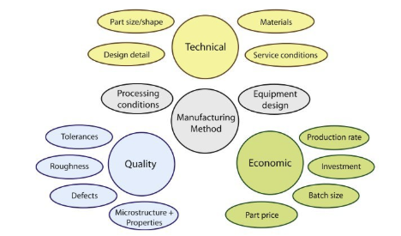
Figure 1:A guide showing key factors to consider when choosing a product's material (Ashby, Shercliff, & Cebon, 2018).

Selection and Description

Stainless Steel Spoon
A spoon is a staple item in every household and a simple invention often overlooked. In 2023, 250 million units of flavour-based utensils (e.g., spoons and measuring spoons) were manufactured (Industry Research.biz, 2025). Most stainless-steel spoons are made of 18/8 steel (1.4301 in BS EN 10088), which is composed of 18% chromium and 8% nickel. Some will be made with 18/0 (1.4016), resulting in a poorer-quality product due to the lack of nickel, which is responsible for the cutlery's shine. The presence of chromium in stainless steel is what makes it such an ideal anti-corrosive utensil due to the layer of chromium oxide that forms, which protects the metal from liquids (Gopel, 2024). According to JEC, this is how spoons are formed (Wu, 2024).
Figure 2:Metal stamping process.
Stainless steel spoons tend to be more expensive to produce than alternatives like aluminium or plastic. Stainless steel is also stronger than aluminium, with a UTS of between 310 and 540 MPa. Due to stainless steel having a higher density than other metals, it can cause cutlery to feel heavier than that made of mild steel or aluminium (thyssenkrupp, 2017). The crystal structure for 18/8 austenitic stainless steel is face-centred cubic. This is what gives stainless steel its toughness properties and allows it to absorb considerable amounts of energy before fracturing in its plastic region. The image below shows what this crystal structure looks like. (British Stainless Steel Association, 2026)
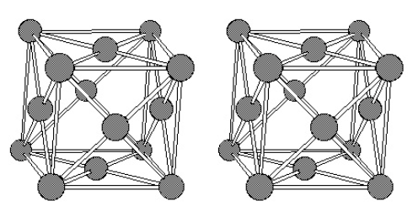
Figure 3:Face-centrered-cubic crystal structure of stainless steel (British Stainless Steel Association, 2026)
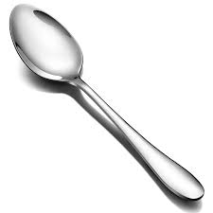
Figure 4: Image showing a stainless-steel spoon.

Plastic Water Bottle
The plastic water bottle is one of the most widely produced items in history, with 830 million tonnes of plastic created between 1950 and 2015, according to a study on plastic sustainability (De Marchi et al, 2020), with 70% of soft drinks being packaged in PET (Polyethene Terephthalate). PET is lightweight, safe, convenient, and recyclable, with more bottles being changed to be made from recycled PET every year (British Plastics Federation, 2025). A datasheet displays a UTS of 85MPa (Smith Metal, 2023), so it has a sufficient gas barrier for applications like short-to-medium shelf life carbonated drinks, although it remains permeable by certain gases over time. Plastic bottles are mostly manufactured using blow moulding, which follows the process below (Formabs, 2025).
Figure 5:Blow moulding process.
Disadvantages of PET plastic bottles include poor heat resistance, with a relatively low melting point, and their environmental impact. PET's chemical structure is a polymer chain, meaning it is made up of multiple monomers bonded together. This structure gives PET its combination of flexibility and toughness. And be so easily moulded by melting and cooling into a new shape, which makes it ideal for injection and blow moulding (SpecialChem, 2026).

Figure 6:Plastic bottle blow moulding process.
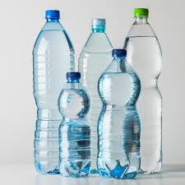
Figure 7: Plastic water bottles.

Ceramic Mug
Clay is the primary ingredient in ceramics, with additions of minerals such as quartz and feldspar being added for strength, texture, and bonding (Science Learning Hub Pokapu Akoranga Putaiao, 2010). Some clay types range from earthenware, stoneware, and porcelain, with porcelain being the most common type for crockery. Ceramics are an ideal material for products such as mugs, as they’re hard, well-insulated to keep heat in, and do not react to chemicals (American Ceramic Society, 2025). However, ceramics do break easily. Without much room to stretch in their plastic region, they are brittle and fracture near their yield point with a compression strength of between 105-400 MPa, where UTS is around 10x lower than compression (Pansini, 2020). Manufacturing methods are likely to be slip casting or press moulding. Slip casting process shown below (The Open University, 2017). Ceramics' properties are given by their molecular structure. Its hardness, high melting point, chemical resistance, and brittleness come from the ionic and covalent bonds that make up the material (The American Ceramic Society, 2026). Grain size and shape are the biggest contributors to a ceramic's molecular bond and have the greatest effect on its mechanical properties (Callister & Rethwisch, 2017)

Figure 8:Ceramic mug slip casting process.
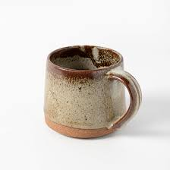
Figure 9: Ceramic mug

Manufacturing Methods Comparison
Table 1:Manufacturing method comparison
Object | Process | Cost | Production Rate
Spoon (Stainless Steel) | Stamping, Forming, Polishing | Moderate | High 100-500 Strokes Per Minute
Bottle (PET) | Blow Moulding | Low | Very High 20,000 Per Hour
Mug (Porcelain) | Slip Casting, Press Moulding | Moderate | Low 400 Articles Per Hour

Note: Information for Stainless Steel from (Birmingham Specialities LTD, 2023), information for PET from (RotoDyanmics, 2023) and (Grace Wu, 2025), and (Sacmi, n.d.) for Ceramics.
Stamping is a simple, highly repeatable, and stable process once a production line and tooling are established, meaning spoon manufacturing can achieve a high production rate and a low per-unit cost. With the ability to easily change materials, manufacturers can offer customers a wide range of products with the correct material characteristics to suit. It also allows manufacturers to create complex designs to generate unique products (Birmingham Specialities LTD, 2023). It is, however, expensive to procure the equipment and tooling costs for stamping are exponential, especially if parts require tooling/design changes.
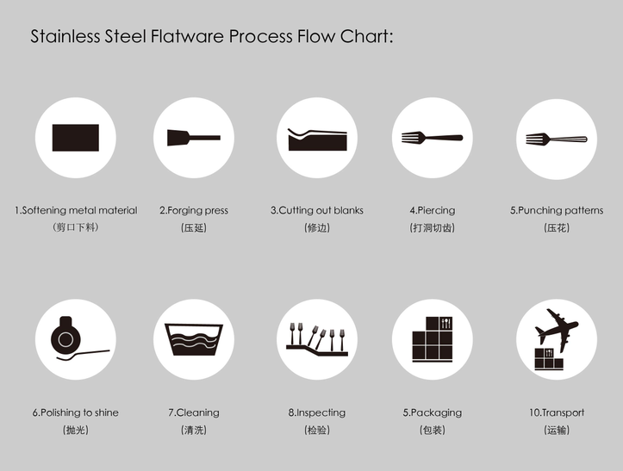
Figure 10: Stainless steel spoon process (Garbo, 2022)
Blow moulding for PET bottle manufacturing is a more complex process; yet it is extremely efficient with an incredibly high production rate of 10 seconds per bottle and up to 20,000 bottles an hour (Westone, 2025). This drives down the cost per unit, creating an efficient production line. It also allows complex designs to be made to allow customers to create whatever design they require. A disadvantage of blow moulding is strict wall thickness control, limiting design and putting restrictions on the production of certain products, whereas this limitation is not typically present in injection moulding, for example.
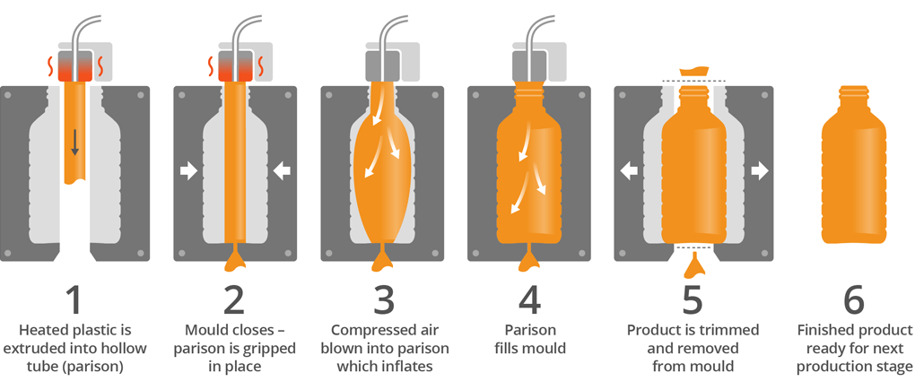
Figure 11: Blow moulding process (Robinson, 2025)
Slip Casting is a slower process in contrast to the other two, with the time taken to allow the slip to drain through the mould and then dry the product. Also, with the firing of the products being done in batches, this can slow down production when compared with a continuously moving line. With the low upfront cost for the moulds, it allows quick setting up and easy design changes due to the ease in mould changing, fitting any customer's needs (Sacmi, n.d.).
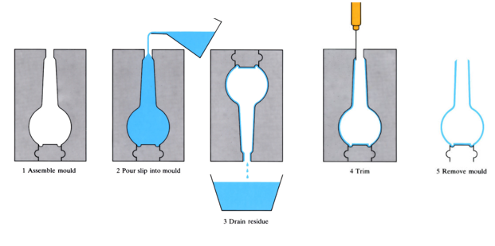
Figure 12: Slip casting process (The Open University, 2017)

Mechanical and Thermal Properties Comparison
Table 2:Mechanical and thermal properties comparison
Object | Density | Tensile Strength | Property | Melting | Thermal Conductivity
Stainless Steel | 8000 Kg/m³ | 500-700 MPa | Ductile | 1450 °C | 16.2 W/m.K
PET | 1380 Kg/m³ | 85 MPa | Tough | 255 °C | 0.28 W/m.K
Porcelain | 2400 Kg/m³ | *105-400 MPa | Brittle | N/A | 2 W/m.K

Note: Data on Stainless Steel from (thyssenkrupp, 2017), data on PET from (Smith Metal, 2023), and data on Porcelain from (Morgan Advanced Materials, 2024) and (Antovia, 2025).
*Compression strength shown for porcelain, as tensile strength isn’t a typical measurement for such a material since it's so brittle. UTS tends to be 10x less than the compression strength (Pansini, 2020).
Compared with PET or ceramics, metals combine high strength and ductility to become the ideal material for products such as cutlery, especially stainless steel, due to its corrosion-resistant properties and low thermal conductivity. This means it has thermal stability and will gradually increase in temperature over time. PETs have low density compared with metals and ceramics, but moderate strength, making them well-suited for containers and bottles, and also lightweight. Additionally, their toughness allows them to withstand pressure and prevents them from fracturing under force (Ashby, 1992). However, being single-use, they are among the most polluting products and have a damaging impact on our environment. Ceramics' hardness and superior heat resistance compared to stainless steel or PET make them excellent for everyday use and for containing hot drinks. Unlike a more forgiving polymer, the hardness means they are brittle and can be easily fractured or smashed with little force; however, they have high compression resistance (Callister & Rethwisch, 2017). The Ashby Chart below illustrates how these materials compare in terms of strength relative to density. As depicted, steel offers high strength without the highest density among metals, making it suitable for cutlery with a premium feel and durability. It also shows that certain ceramics possess the greatest strength, which accounts for their long-lasting, durable qualities. PET exhibits one of the highest strengths within the plastic group, making it resistant to carbonated drinks.

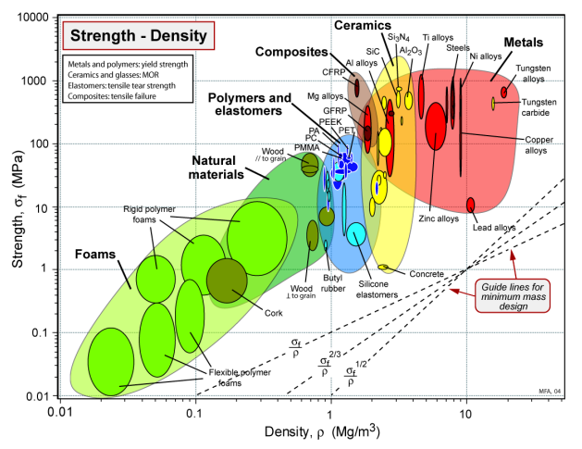
Figure 13:Strength against density Ashby Chart (Ashby, 1992)

Lifespan and Cost Analysis
Table 3:Lifespan and cost analysis
Object | Lifespan | Degradation | environmental effect
Spoon | 10+ Years | Corrosion | With recycled raw material effect can be lowered
bottle | Single Use | Sunlight and Heat | High due to the single-use and polluting effects
mug | 5-30 Years | Chips and Cracks | Low polluting effect but moderate manufacturing

Note: Spoon information from (Kingstone, 2025) and (Larson Tool, 2025), bottle information from (Chino PlasPack, 2025) and (Osterloff, 2017), and Mugs from (Curvd, 2026).
Aside from plastic bottles, due to their single-use properties, spoons and mugs will have varying lifespans depending on the level of care they receive. Corrosion is the greatest degradation property for stainless steel cutlery; it's imperative to ensure the surface of the metal is not damaged, breaking the outer protective layer. Like spoons, mugs will deteriorate once the surface begins to be damaged and moisture enters below the surface, weakening the structure of the ceramic. The environmental effect of spoons and mugs is moderate due to their long lifespan and natural origins. The greatest polluting factors are the carbon emissions to power the machinery during manufacturing, according to (Curvd, 2026) and (Larson Tool, 2025). Plastic bottles, on the other hand, are one of the most polluting products worldwide. Along with the emissions to manufacture in the first place, due to their plastic properties, many are non-recyclable, take years to decompose, and release millions of microplastics on their journey, seeping into our foods, water, oceans and wild animals (Osterloff, 2017).

Material Selection and Alternative Choices
All materials are suitably selected; however, there are some alternative choices, such as aluminium, which is cheaper and lighter, and still anti-corrosive (Ashby, 1992). Another suitable manufacturing method is waterjet cutting, using a high-speed stream of water to shape the sheet. Although aluminium offers a lower density, its inferior wear resistance makes it unsuitable for long-lasting cutlery (thyssenkrupp, 2025). For plastic bottles, PEF could be used, which is a biodegradable polymer with greater mechanical and thermal properties than PET (SpecialChem, 2021). Blow moulding is by far the best manufacturing method for plastic bottles due to its low cost and accurate properties when making hollow products; injection moulding is the most similar alternative process, however, it can be restrictive in design compared with blow moulding's versatility. For mugs, glass is a great alternative due to its natural origin, recyclability, chemical inertness, and light weight. Glass, however, is not as strong and tough as ceramics, meaning it may not have as long a lifespan as ceramic mugs would (Eco Roots, 2020). For glass, the most efficient manufacturing method is machine-blown, in which molten glass droplets are placed into a mould and blown into the desired shape, similar to blow moulding. This is a much more efficient process than slip casting and will yield a lower cost per unit (Bik Concepts, 2025).

Conclusion
This report provides a view into how crucial material selection is for a product's performance, cost, lifespan, and environmental impact of everyday objects. It highlights how such small decisions relate to a material's use, such as the type of stainless steel affecting how shiny a spoon will be due to the nickel content. It also proves how a stainless-steel spoon, plastic bottle, and ceramic mug are so perfectly selected due to their natural characteristics. Stainless steel provides longevity and strength, and anti-corrosive properties to the cutlery. PET provides affordability and ease of manufacturing, but also a highly suitable material for storing gas and liquids. And ceramics due to their thermal properties and durability over time. This report also highlights the environmental considerations associated with these products and alternative materials that could be considered, such as aluminium, Bio-PEF, or glass, where engineers need to consider the trade-offs to balance the performance, cost, environmental and lifespan effects of these choices.

References
American Ceramic Society. (2025). What are Ceramics and Glass? Retrieved from Ceramics.org: https://ceramics.org/about/what-are-ceramics/
Antovia. (2025). Technical Specification for Porcelain. Retrieved from Antovia: https://antoviasurfaces.com/technical-specification
Ashby, F. M., Shercliff, H., & Cebon, D. (2018). Materials: engineering, science, processing and design. Cambridge: Butterworth-Heinemann.
Ashby, M. F. (1992). Materials Selection in Mechanical Design. Cambridge: Cambridge University.
Bik Concepts. (2025, March 18). How is Glassware Made? A Complete Guide to Glass Manufacturing. Retrieved from Bik Concepts: https://bikconcepts.com/blogs/news/how-is-glassware-made-a-complete-guide?srsltid=AfmBOor1fN6cCyFVTAxR8nq_G-7Br7SfiYjpCUd5iNlc8EUjzGXCFmU3
Birmingham Specialities LTD. (2023, May 25). What is Metal Stamping? The Complete Guide. Retrieved from Birmingham Specialities LTD: https://bhamspec.co.uk/what-is-metal-stamping-the-complete-guide/#section-4
British Plastics Federation. (2025). PET Plastic Bottles - Facts Not Myths. Retrieved from BPF: https://www.bpf.co.uk/Sustainability/pet_plastic_bottles_facts_not_myths.aspx
British Stainless Steel Association. (2026). Austenitic Stainless Steels. Retrieved from British Stainless Steel Association: https://bssa.org.uk/bssa_articles/austenitic-stainless-steels/
Callister, W., & Rethwisch, D. G. (2017). Materials Science and Engineering: An Introduction. Utah: University of Utah.
Chino PlasPack. (2025, Febuary 6). Lifespan of Plastic Bottles and Gallons. Retrieved from Chino PlasPack: https://www.chinoplaspack.com/EN/news/news11.html
Curvd. (2026). How Long Do Ceramic Mugs Last? A Guide To Lifespan And Care. Retrieved from Curvd: https://www.curvd.com/blogs/news/how-long-do-ceramic-mugs-last?srsltid=AfmBOorn8yKcpZXbEgNWAkbdCwIdZj1GhDDt1lsJWXqrktMNn-ZH7g9H
Da Marchi, E., Pigliafreddo, S., Banterle, A., Parolini, M., & Cavaliere, A. (2020). Plastic packaging goes sustainable: An analysis of consumer preferences for plastic water bottles. Milan: Department of Environmental Science and Policy, University of Milan.
Eco Roots. (2020, May 6). 13 Reasons Why You Should Be Using Glass Coffee Mugs. Retrieved from Eco Roots: https://ecoroots.us/blogs/blog/13-reasons-you-should-be-using-glass-coffee-mugs?srsltid=AfmBOoogSaUGhuRNQm8gzD2VsyZIFfccsFh6UvyoIWkzwcflVobCLiiT
Formabs. (2025). Guide to Blow Moulding. Retrieved from Formlabs: https://formlabs.com/uk/blog/blow-molding/?srsltid=AfmBOoomtVIewb6gzC5YK8sLZ-U-odVazQxNgjEfDVpqE77tQJfqyfPN
Garbo. (2022, 06 24). Garbo Premium Quality. Retrieved from Garbo Flatware: https://www.garboflatware.com/news/manufacturing-process-of-garbo-stainless-steel-flatware.html
Gopel, R. (2024, 07 19). 18/8 Stainless Steel. Retrieved from CorrosionPedia: https://www.corrosionpedia.com/definition/6416/188-stainless-steel
Grace Wu. (2025, May 28). What are the typical speeds in high speed stamping? Retrieved from HT TOOL: https://www.httool-die.com/blog/what-are-the-typical-speeds-in-high-speed-stamping-131553.html
Industry Research.biz. (2025, 12 01). Stainless Steel Kitchen Utensils Market Share. Retrieved from Industry Research.biz: https://www.industryresearch.biz/market-reports/stainless-steel-kitchen-utensils-market-102082#:~:text=Flavor%20Type:%20Flavor%2Dbased%20utensils,cooking%20and%20seasoning%20tools%20grow.&text=India:%20Flavor%20~USD%2033.21M,5.0%25%20with%20regional%20coo
Kingstone. (2025, January 15). What Is The Service Life Of Stainless Steel Cutlery? Retrieved from Kingstone: https://www.ks-housewares.com/news/what-is-the-service-life-of-stainless-steel-cu-82446371.html
Larson Tool. (2025, July 18). The Environmental Impact of Metal Stamping: Sustainability and Eco-Friendly Practices. Retrieved from Laron Tool: https://larsontool.com/blog/the-environmental-impact-of-metal-stamping-sustainability-and-eco-friendly-practices/
Morgan Advanced Materials. (2024). Technical Ceramics. Retrieved from Morgan Advanced Materials: https://www.morgantechnicalceramics.com/en-gb/ceramics-101/thermal-properties-of-ceramics/thermal-conductivity/
Osterloff, E. (2017). Just how bad is the world's plastic problem? Natural History Museum.
Pansini, A. (2020). Electrical Distribution Engineering, Third Edition. River Publishers.
Robinson. (2025). Blow Moulding. Retrieved from Robinson Packaging: https://robinsonpackaging.com/technical-capabilities/blow-moulding/
RotoDyanmics. (2023, July 20). Blow Molding: Advantages, Disadvantages, and the Appeal of Rotational Molding. Retrieved from RotoDyanmics: https://rotodynamics.com/blow-molding-advantages-disadvantages-and-the-appeal-of-rotational-molding/#Advantages_of_Blow_Molding
Sacmi. (n.d.). High pressure slip casting system for cups. Retrieved from Sacmi: https://sacmi.com/en-US/lippert-solutions/high-pressure-casting-casting#:~:text=Compared%20to%20the%20standard%20model,of%20the%20pressure%20casting%20seam.
Science Learning Hub Pokapu Akoranga Putaiao. (2010, 04 27). Traditional Ceramics. What are Ceramics, p. 1.
Smith Metal. (2023). PET Technical Datasheet. Retrieved from Smith Metal: https://www.smithmetal.com/pdf/plastics/pet-p.pdf
SpecialChem. (2021, Febuary 19). Polyethylene Furanoate (PEF) as a Renewable Bioplastic. Retrieved from SpecialChem: https://www.specialchem.com/plastics/guide/polyethylene-furanoate-pef-bioplastic
SpecialChem. (2026, 01 15). Polyethylene Terephthalate (PET): How to select the right grade? Retrieved from Special Chem: https://www.specialchem.com/plastics/guide/polyethylene-terephthalate-pet-plastic
The American Ceramic Society. (2026). Structure and Properties of Ceramics. Retrieved from The American Ceramic Society: https://ceramics.org/about/what-are-ceramics/structure-and-properties-of-ceramics/
The Open University. (2017, 11 29). Slip-Casting. Retrieved from The Open University: https://www.open.edu/openlearn/science-maths-technology/engineering-technology/manupedia/slip-casting
thyssenkrupp. (2017). Stainless Steel 1.4307 - 304L. Solihull: thyssenkrupp.
thyssenkrupp. (2025). Properties of aluminium. Retrieved from thyssenkrupp: https://www.thyssenkrupp-materials.co.uk/properties-of-aluminium
Westone. (2025, 06 15). How Are Plastic Bottles Made? Retrieved from Westone: https://westone.com.my/how-are-plastic-bottles-made/#:~:text=How%20Long%20Does%20It%20Take,efficient%20choice%20for%20mass%20production.
Wu, M. (2024, 01 09). How It Is Made: The Stainless Steel Cutlery Manufacturing Process Unveiled. Retrieved from JEC: https://jeccutlery.com/how-it-is-made-the-stainless-steel-cutlery-manufacturing-process/

