The state of the UK labour market and changes in Human Resource Strategies

Programme: MBA – Master of Business Administration

Module: Human Resource Management
Module Code: LCMB7000

Assignment Title: Assessment 1

Student Name: Anastasiya Petrova
Student Number: 1816952

Lecturer: Dr Gladius Kulothungan

Table of content:
- Introduction ………………………………………………………………. p. 3
- The current state of the UK labour market …………………………… p. 3
- Emerging changes in Human Resource Strategies ……………….... p. 8
- Changes in the Post-Covid19 external environment ................... p. 8
- Changes in the Post-Brexit external environment ....................... p.13
- Conclusion ........................................................................................ p.17
- References ....................................................................................... p.18

- Introduction
Human resource management is the managerial task of recruiting, retaining and motivating workers and groups in an organisation (Armstrong M., Taylor S., 2020). The success of organisations is increasingly determined by the people involved, necessitating the rise of strategic human resource management (SHRM), which focuses on building systems for the effective and appropriate use of intellectual capital to achieve corporate goals.
In today's modern times, accompanied by challenges such as Brexit and the global Covid19 pandemic, the UK labour market faces the challenges presented in the report. Companies must undergo many changes to maintain their organisational operations, as argued by Raghavan A. et al. (2021). The report examines the emerging changes in HR strategy driven by changes in the post-Covid and post-Brexit external environment.
- The current state of the UK labour market
According to Statista (2022), the private industry lost 348,000 jobs between March 2020 and December 2021, while the public sector lost 276,000 jobs during the same period, as also argued by Hedges N. (2022). the private sector has been more significantly affected since the pandemic's beginning, and the employment decline is more significant than in the public sector. However, the number of people employed in the private sector increased in 2021 compared to the public sector. In March 2021, 17.5% of workers worked in the public sector, an increase from 16.7% in the previous month (Wood, 2022).
Number of private sector employees in the United Kingdom
from 1st quarter 1999 to 1st quarter 2022
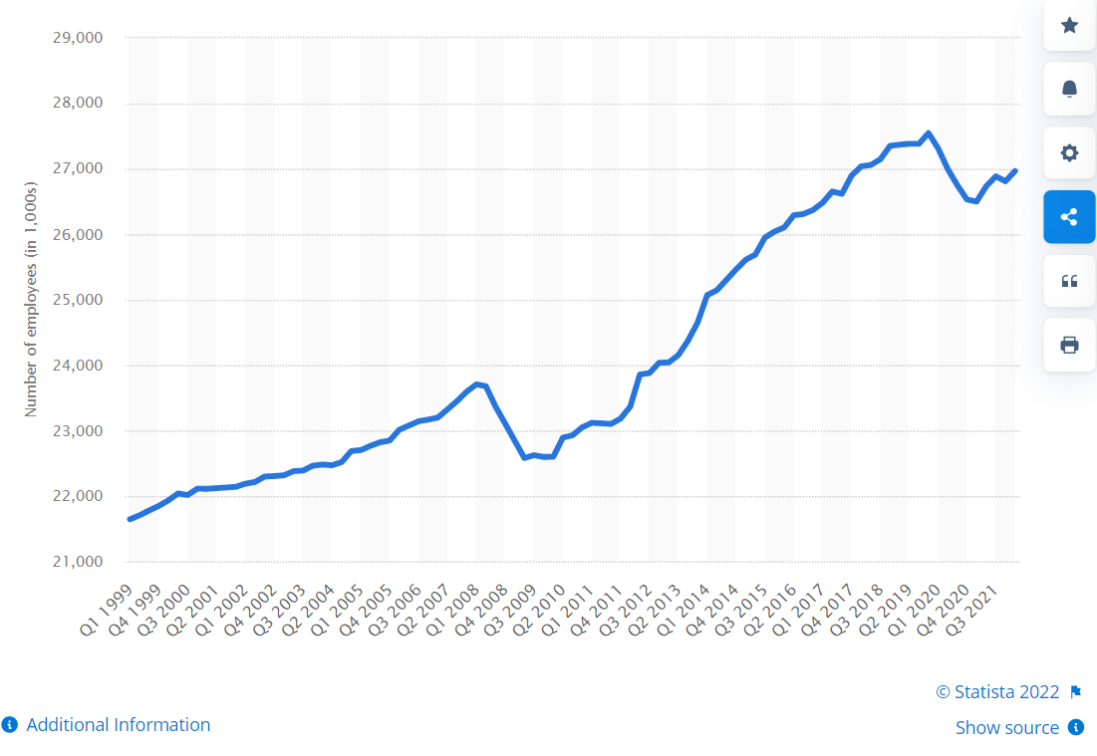
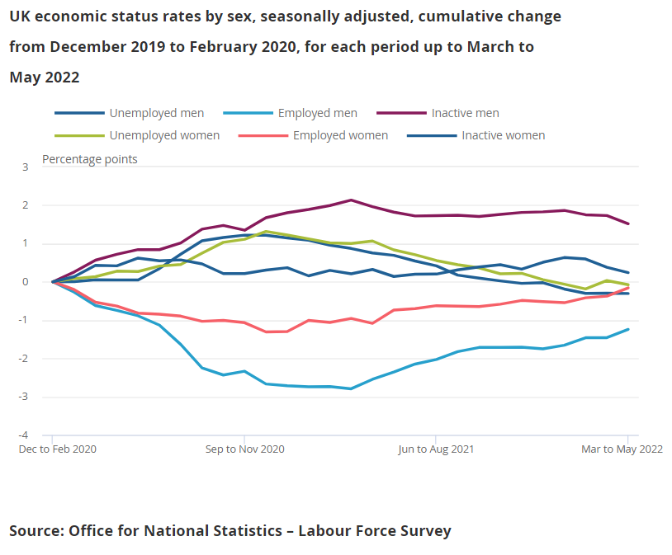
The figure above shows a decline in inactivity rates, with men being slower than women. However, compared to the high levels of the pandemic period, they still cannot reach the pre-pandemic levels. In addition, a decrease in both inactivity and unemployment rates results from increased employee engagement, as seen in the figure below.
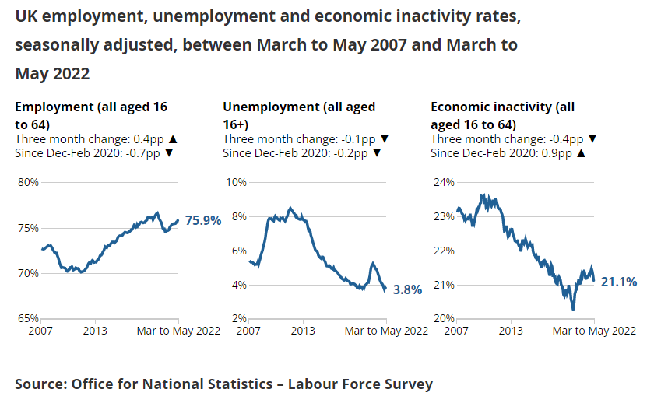
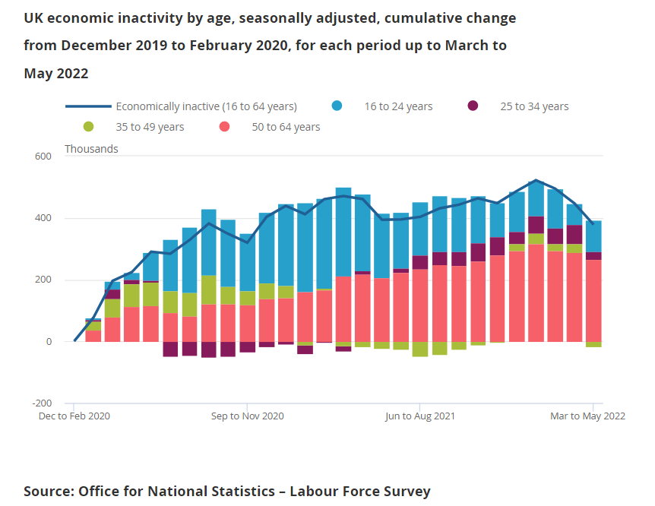
According to the study by Watson B. (2022), published in the Office for National Statistics, compared to the beginning of 2021 in the UK, there is a decrease in the unemployment rate, with London having the most significant increase in employed employees, and Northern Ireland the shortest stature. In the first five months of 2022, the percentage of employment in the South East is 73 per cent, while Northern Ireland lags at 70.1 per cent. In the North East, the unemployment rate remains the highest and the lowest in the East Midlands.
Average growth of weekly earnings in the United Kingdom compared with the CPI inflation rate from March 2001 to May 2022
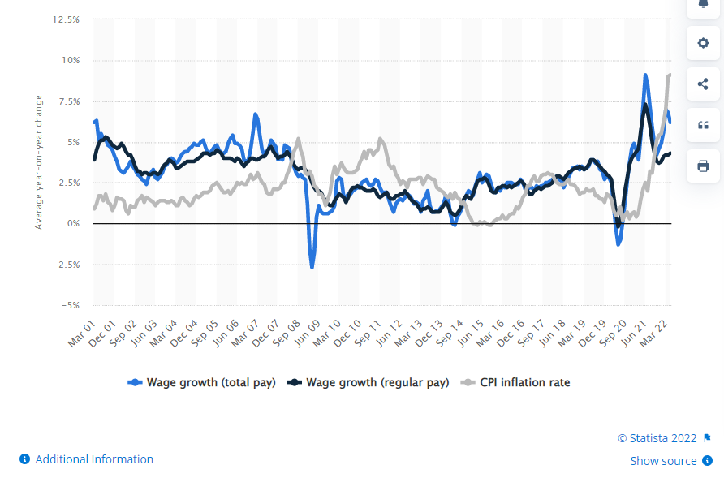
The latest data shows that wages are not increasing fast enough to keep up with rising inflation. The figure above confirms the claim of Clark D. (2022) that at the beginning of 2022, there was a 6.2 per cent increase in the average monthly gross salary and a 4.3 per cent increase in regular pay compared to the same period in 2021. On the other hand, for the same period, inflation for the consumer price index reached 9.1 per cent. These data show that despite the noted increase in wage growth, it can still not catch up or outpace inflation growth. In addition, the results show that economic stagnation has also increased due to increased employment from the previous quarter. The latest data, which covers the months of November 2021 and January 2022, shows that the post-pandemic labour market is still recovering. Leaker (2022) states that the employment rate rose marginally by 0.1 per cent in the quarter, while the unemployment rate fell by -0.2 per cent.
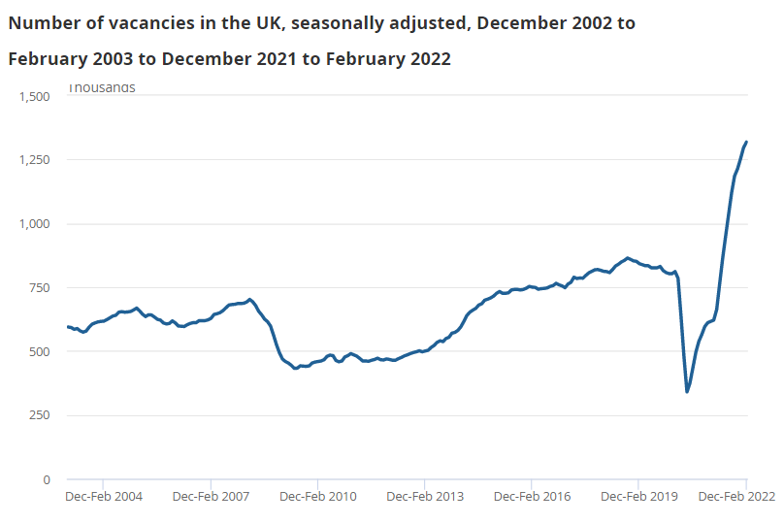
Source: Office of National Statistics (2022)
According to the Office of National Statistics (2022), with 1,318,000 job opportunities currently listed, vacancies are at a high point. On the other hand, the vacancy rate continues to slow, indicating that businesses may be changing their approach to hiring. The current inflation rate in the UK is 9 per cent, the highest level in 30 years, and it is unclear whether incomes will increase quickly enough to offset the cost of living. The most recent data shows that regular pay, defined as compensation without incentives and then tied to inflation, has declined by 1% in the past year, according to Boys (2022).
According to Powell et al. (2022), between November 2021 and January 2022, average total compensation increased by 3.8 per cent nominally and by 4.8 per cent factored in bonuses. The growth rate remained positive at 0.1 per cent for the whole year, thanks to this significant stimulus over the past six months. However, not all industries provide bonuses, and those tend to be in higher paying positions, with the banking and business sectors experiencing the fastest growth in total compensation. In the private sector, bonuses are much more common than in the public sector, leading to a significant gap in wage growth. Attention should be paid to the fact, also confirmed by Boys (2022), that due to the relatively low earnings base, the improvement in pay may be overstated by the year-on-year growth figures.
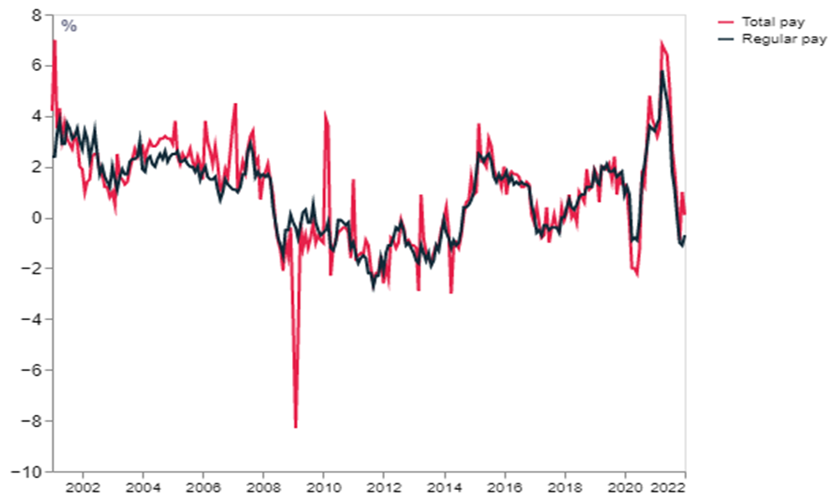
Source: Wood (2022)
Kennedy (2021) reports that there were 10.3 billion hours worked overall in the past three months, a growth of 4.7 million hours. Full-time employment increased, which contributed to the rising employment rate. The decline in self-employment, which has persisted throughout the epidemic, helped offset this to some extent. Since April 2021, there has been a steady rise in part-time employment, while it is still below pre-pandemic rates. Those who have jobs are starting to put in more hours. Although promising, this is still 23.1 million hours short of pre-pandemic rates.
According to Azar et al. (2022), 1.30 million Individuals were jobless in the UK from February to April 2022. Unemployment among people engaged in the economy now stands at 3.8%. The unemployment rate currently is 76,000 lower than before the epidemic after declining over the last quarter and year. The year and quarter inactivity rates have decreased, but they are still 371,000 more than before the pandemic. Between March and May 2022, there were 1.30 million open positions, a steady increase, which Ando et al. (2022) noted was an increase of 504,000 from pre-pandemic levels.
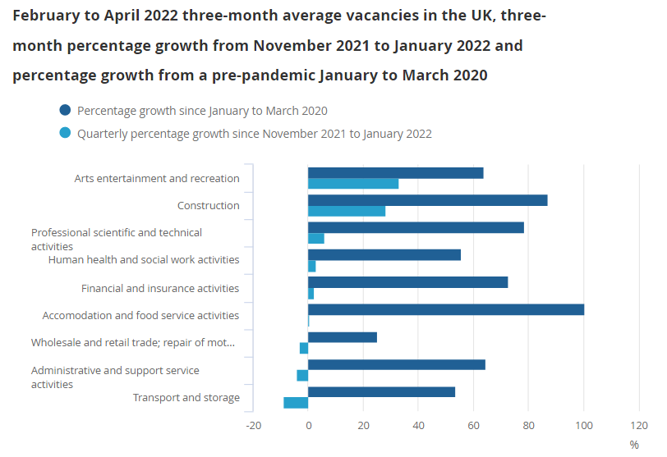
Source: Evans T, (2022), www.ons.gov.uk
According to the study by Evans T. (2022), although there is a slowdown in the growth of vacancies, and it continues to increase in fourteen of the eighteen industries. The fastest growth rates were seen in the arts, entertainment, recreation and construction industries, while transportation and warehousing, in contrast, saw negative growth. Compared to 2020, all sectors exceeded pre-pandemic levels, with the food and accommodation sector seeing a significant increase of almost 100 per cent. Another fact that deserves attention is that the level of vacancies significantly exceeds the number of unemployed even under conditions of falling unemployment.
- Emerging changes in Human Resourcing Strategies
Changes in the post-Covid19 external environment
The data presented in the previous section shows some of the devastating impacts of the Covid19 pandemic. The data shows the lasting negative effect on the economy and workforce, reflecting organisational sustainability. For these reasons, HRM had to rethink its strategies and adapt them to the new circumstances. Organisations must protect their employees from increased risk, financial difficulties, layoffs or closure, ensuring talent retention and attracting new ones.
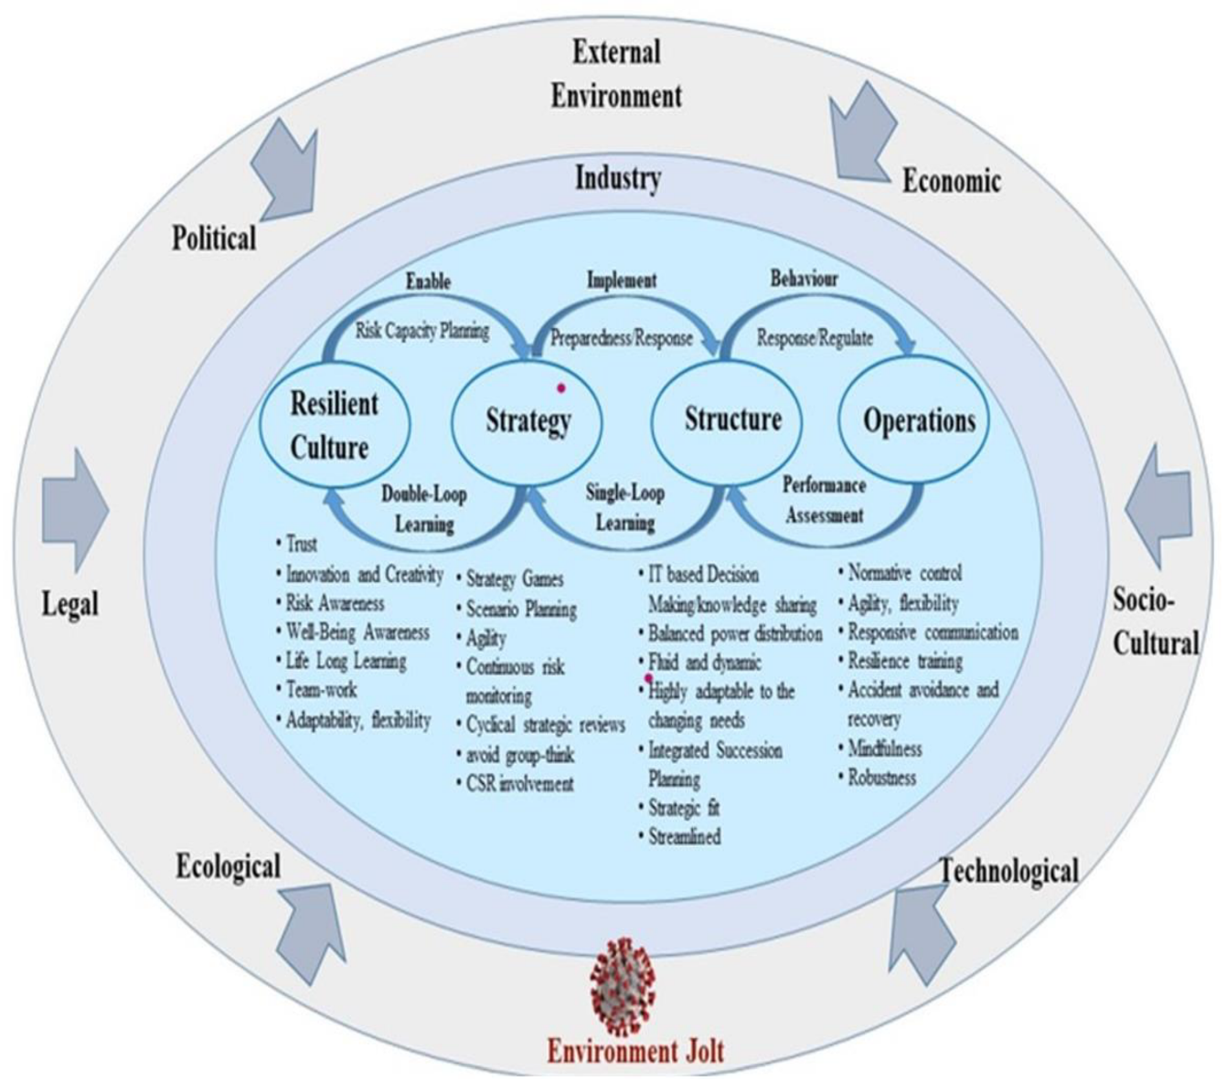
Source: Khanzad, Z. G. and Gooyabadi, A. A. (2021)
According to Piwowar-Sulej K. (2021), companies must adapt their structure and HR compliances by focusing on environmental and technological changes to guarantee long-term success. These changes in structure require changes in the approach to employees. It means that the development of employees must also have a long-term perspective to ensure the necessary competencies to achieve the long-term goals and sustainability of the company. In other words, the sustainable development of HR can ensure the sustainable development of businesses.

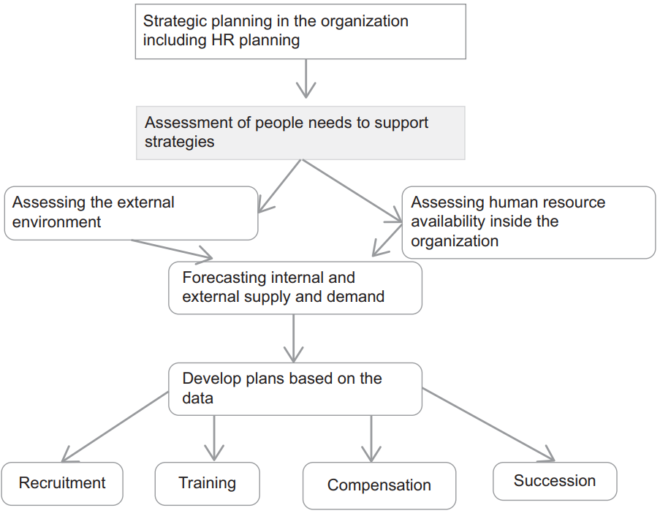
Source: Kispal-Vitai, Z., et al., (2018)
According to Raghavan, et al (2021), businesses are changing their processes and implementing new ones to deal with the pandemic. They also seek creative leadership to carry out new ideas to break down barriers and survive. In the current crisis, forward-looking governance is the most robust call for focusing on one another's shared well-being. Difficulty adapting to and maintaining work during the COVID-19 outbreak due to its detrimental effects on employees are reasons for increased stress. Companies must foster dialogue, trust, and openness about the epidemic to increase productivity and improve talent management. Maheshwari (2022) states that after COVID-19, organisations need to make numerous changes to their operational strategies. It is challenging to establish standard techniques of operation, policies, and interactions when social distance is being adopted and maintained, which presents a new issue for human resource practitioners. Thus, this part analyses the emerging changes in post-Covid HR strategies. The pandemic has forced organisations to rethink their business models and the need for flexible workforce planning.
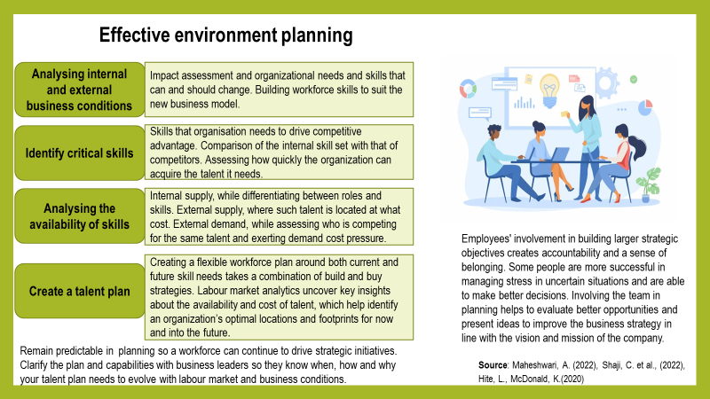
The organisation increases the talent pool, helps retain talent and reduces absenteeism by providing flexible work positions. According to the CIPD (2020), it is necessary to consider the role from the outset to allow flexibility in its implementation. Flexible hiring improves mobility within the organisation by harnessing the flexibility of talented employees and promoting the best of them to apply for promotion. Flexible hiring helps build the best team to optimise organisational performance and productivity.
Intelligent identification of challenges helps HR Managers use flexible strategies to achieve increased productivity, customer satisfaction, security and employee satisfaction for organisational stability and prosperity.
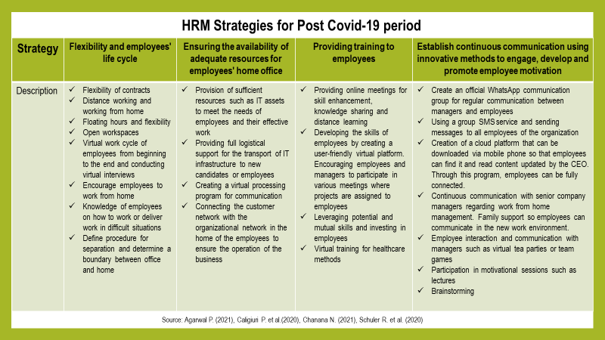
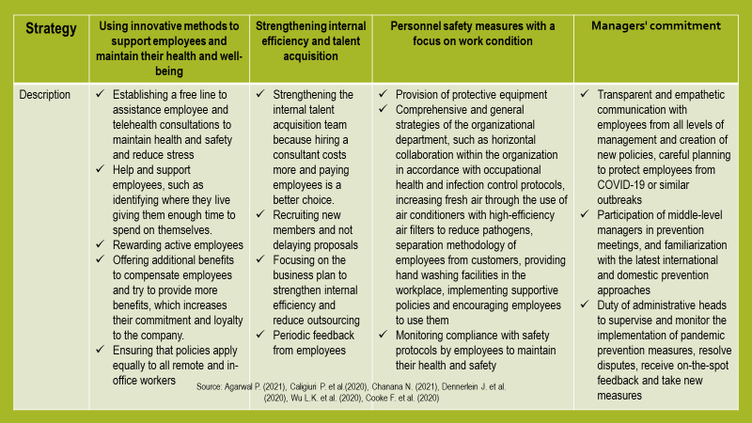
A flexible workplace is essential for staff because it keeps employees satisfied along their career path, which reduces turnover. According to the CIPD (2020), working flexibility at senior levels results in greater engagement, which reduces turnover by up to 87 per cent.
Changes in the Post-Brexit external environment
Brexit is a challenge for business. Companies must deal with the problematic movement of goods, capital and services, and in addition, with the restriction of the movement of labour. Reducing applicants from EU countries and finding talent seem more difficult (Azevedo, 2019). According to Trevena P. (2018), HR teams gather information about the state of the labour market and legislative changes. HR directors build planning and provide their teams with the most appropriate tools for attraction, retention, flexibility and integration of talents. Organisations need to design programs for targeted initiatives to fill the talent gap and change the skill mix.
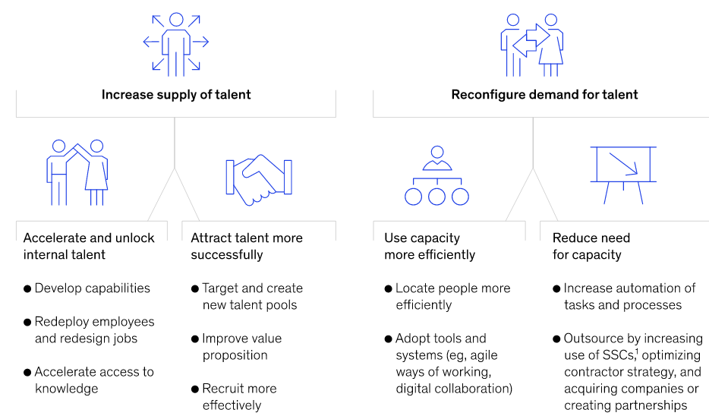
Source: Ferens, N. et al., (2019)
Planning
The data in the previous part of the report shows that the demand for staff exceeds the supply, leading to a significant limitation on the personnel reserve. The demand for workers from the EU has decreased by about 45%. Hight L.M. and McDonald K.S. (2020) note that recruiting strategies are reimagining the entire process from sourcing to finding talent by creating new hiring practices with lasting impact. It increases the company's competitiveness and allows for securing and retaining talent. HR planning should build on the strength of the labour market, the free movement of talent, employee rights and the necessary resources to ensure the changes in strategies. For example, the 'Point Based System' and visas bring additional restrictions, such as extended hiring periods and increased administrative costs and salary costs. HR professionals are turning to technology that helps with recruiting, ensuring they don't lose talent.
HR must assess the workforce based on external and internal statistics to assess whether to use talent from within or hire from outside.
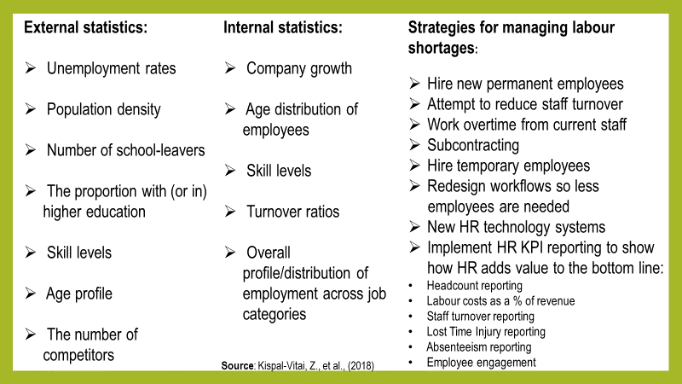
Using the Right Tools
When an organisation has the right hiring tools, it is more attractive to candidates. For example, an applicant tracking system (ATS) makes the application process smoother and more accessible for applicants to submit information. A candidate relationship management (CRM) system allows an organisation to engage with both passive and active candidates during the hiring process. Another advantage of using CMR is that organisations can understand talent interests from the information obtained from the candidate, making it possible to find other opportunities to engage him. The opportunity to connect with talent is at every stage, providing convenience and security for the candidate. For the organisation, an opportunity not to miss the right talent for its goals (Lussier R.N. and Hendon J.R., 2019).
A key benefit of using new technologies is that they provide the opportunity to transform the organisation and how people work within it. Automated systems offer an advantage to the organisation by allowing flexibility and competitiveness.
Retaining talent
Boon C. et al. (2019) argue that since Brexit, there has been a 95% drop in the proportion of EU citizens coming to the UK to live and work, which means that fewer and fewer EU workers will choose to take these positions in the future. Recruiters must fill these positions by recruiting from the UK but continue to face difficulties. Therefore, one of the critical strategies for developing a company with staff that includes international experience is the retention of European citizens. A recruitment strategy is a plan of action through which companies find the most suitable candidates for a specific position (Boxall P., Purcell J., 2022). The strategy should be realistic, easy to understand, and aligned with the company's goals.
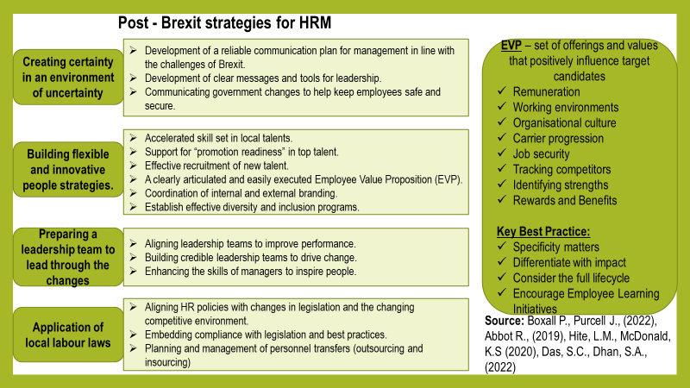
According to Nankervis A. et al. (2019), a different approach based on understanding what the workforce is looking for is appropriate for attracting workers from the EU. Employers provide current and future employees with clear guidance on settlement, their rights to live and work, and human rights legislation providing reassurance and security. In addition, the Government offers statutory annual leave and paid maternity leave. The best way to retain employees is through benefits packages. Flexible working hours, career development opportunities and work-life balance are among the most widely used strategies to boost staff morale. Companies foster an open and inclusive culture because top management regularly sends encouraging messages to international employees. For example, through proactive and regular communication, companies encourage European workers by informing them about sponsorship obligations, passports, work permission, and full-time work.
Employee engagement
Engagement and human behaviour encompass the motivational factors that interest employees. The level of commitment arises from the employee's ability to control their behaviour and goals. Psychological needs such as autonomy, competence, and psychological relatedness motivate employees to behave in ways that value their psychological health and well-being. Increasing employee satisfaction increases their performance, growth and engagement.
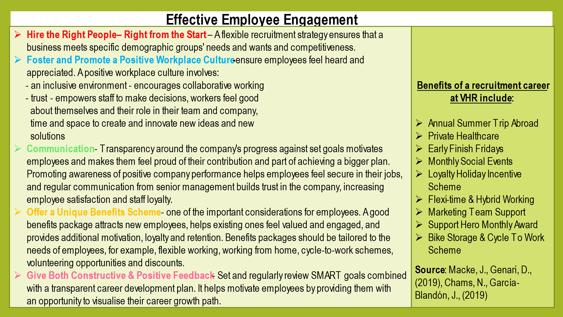
Improving brand image and distinguishing it from competitors increases the attractiveness of potential talent. It is necessary to consider the hiring process and present all the benefits the organisation can provide in the workplace. Advantages such as good management, flexibility, and workplace culture guarantee accessibility and inclusion of candidates. It adds to the company's long-term appeal and reduces short-term hiring difficulties.

- Conclusion
The challenges of Covid-19 and Brexit confirm the importance of human resources and show the fundamental need to invest in flexible human resource management systems. HR must meet the challenges by reimagining its and the organisation's future through long-term investments. Staff perceptions of the company are improved based on HR professionals' competence and ability to deal with crises and uncertainty. HR managers must increase productivity and efficiency and keep all teams motivated and well-prepared to meet current and future challenges.

- References:
- Agarwal P. (2021), Shattered but smiling: Human resource management and the well-being of hotel employees during COVID-19, International Journal of Hospitality Management, [online]
Available at: https://www.sciencedirect.com/science/article/pii/S0278431920303170
Accessed: 25.08.2022
- Ando, S., et al. (2022), European Labour Markets and the COVID-19 Pandemic: Fallout and the Path Ahead, Departmental Papers, International Monetary Fund [online]
Available at: https://www.elibrary.imf.org/view/journals/087/2022/004/article-A001-en.xml
Accessed:20.07.2022
- Armstrong, Taylor, (2020), Armstrong's handbook of human resource management practice, Kogan Page
- Azar, J., Marinescu, I. and Steinbaum, M. (2022), Labour market concentration, Journal of Human Resources, [online]
Available at: http://jhr.uwpress.org/content/57/S/S167.full.pdf
Accessed: 20.07.2022
- Azevedo, G. (2019), International HR Management in times of Brexit, [online]
Available at: https://www.thehrdirector.com/features/cultural-change/hr-management-in-times-of-brexit/
Accessed: 25.07.2022
- Boon, C., Den Hartog, D.N. and Lepak, D.P. (2019), A systematic review of human resource management systems and their measurement, Journal of Management, [online]
Available at: https://scholar.google.co.uk/scholar?output=instlink&q=info:JVU_ht2r6NoJ:scholar.google.com/&hl=en&as_sdt=0,5&scillfp=1424174194274579030&oi=lle
Accessed: 25.07.2022
- Boxall P., Purcell J., (2022), strategy and human resource management, books.google.com, [online]
Available at: https://www.academia.edu/download/9887394/Strategy%20and%20Human%20Resource%20Management.pdf
Accessed: 20.08.2022
- Boys, J. (2022), Labour Market Outlook Spring 2022, CIPD, [Online]
Available at: https://www.cipd.co.uk/Images/labour-market-outlook-spring-2022-web_tcm18-106241.pdf
Accessed: 19.07.2022
- Caligiuri P. et al.(2020), International HRM insights for navigating the COVID-19 pandemic: Implications for future research and practice, Journal of International Business Studies, [online]
Available at: https://scholar.google.co.uk/scholar?output=instlink&q=info:w1_qv4C5FwsJ:scholar.google.com/&hl=en&as_sdt=0,5&as_ylo=2020&as_yhi=2022&scioq=Revisiting+talent+management+practices+in+a+pandemic+driven+VUCA+environment&scillfp=1832087834086437994&oi=lle
Accessed: 25.08.2022
- Chams, N., García-Blandón, J., (2019), On the importance of sustainable human resource management for the adoption of sustainable development goals, Resources, Conservation and Recycling, [online]
Available at: https://scholar.google.co.uk/scholar?output=instlink&q=info:hz9qgZWcouAJ:scholar.google.com/&hl=en&as_sdt=0,5&as_ylo=2019&as_yhi=2022&scioq=Revisiting+talent+management+practices+in+a+pandemic+driven+VUCA+environment&scillfp=10983687543083056342&oi=lle
Accessed: 20.08.2022
- Chanana N. (2021), Employee engagement practices during COVID‐19 lockdown, Journal of public affairs, [online]
Available at: https://onlinelibrary.wiley.com/doi/pdf/10.1002/pa.2508?casa_token=fx_9f3jF7j0AAAAA:ZWWVfdlECdRY_EW08q6P6zhtaEIzgWFiItlYcKnxMjHkaPcTIm50xxRePUwR3vcWeMqt8W3zuxr5254
Accessed: 25.08.2022
- CIPD (2020), Flexible working toolkit for HR professionals, CIPD, [online]
Available at: https://www.cipd.co.uk/Images/flexible-hiring-guidance_tcm18-52767.pdf
Accessed: 25.08.2022
- CIPD (2020), Flexible working: the business case, CIPD, [online]
Available at: https://www.cipd.co.uk/Images/flexible-working-business-case_tcm18-52768.pdf
Accessed: 25.08.2022
- Clark D., (2022), Average weekly earning growth in the UK compared with inflation 2001-2022, Statista, [online]
Available at: https://www.statista.com/statistics/1272447/uk-wage-growth-vs-inflation/
Accessed: 19.07.2022
- Cooke F. et al. (2020), IJHRM after 30 years: taking stock in times of COVID-19 and looking towards the future of HR research, The International Journal of Human Resource Management [online]
Available at: https://www.tandfonline.com/doi/pdf/10.1080/09585192.2020.1833070
Accessed: 25.08.2022
- Dennerlein J. et al. (2020), An Integrative Total Worker Health Framework for Keeping Workers Safe and Healthy During the COVID-19 Pandemic, Human Factors: The Journal of the Human Factors and Ergonomics Society, [online]
Available at: https://journals.sagepub.com/doi/10.1177/0018720820932699
Accessed: 25.08.2022
- Evans T, (2022), Vacancies and jobs in the UK: May 2022. Estimates of the number of vacancies and jobs for the UK, Office of National Statistics, [online]
Available at: https://www.ons.gov.uk/employmentandlabourmarket/peopleinwork/employmentandemployeetypes/bulletins/jobsandvacanciesintheuk/may2022
Accessed: 20.07.2020
- Ferens, N. et al., (2019), Brexit: The bigger picture—Rethinking talent for the long term, McKinsey & Company, [online]
Available at: https://www.mckinsey.com/featured-insights/europe/brexit-the-bigger-picture-rethinking-talent-for-the-long-term
Accessed: 20.08.2022
Accessed: 25.08.2022
- Hedges N. (2022), Public sector employment, UK: December 2021, Estimates of people employed in public and private sectors in the UK, www.ons.gov.uk, [online]
Available at: https://www.ons.gov.uk/employmentandlabourmarket/peopleinwork/publicsectorpersonnel/bulletins/publicsectoremployment/december2021
Accessed: 18.07.2022
- Hite, L., McDonald, K.(2020), Careers after COVID-19: challenges and changes, Human Resource Development International, [online]
Available at: https://scholar.google.co.uk/scholar?output=instlink&q=info:YooJ3s-O4kQJ:scholar.google.com/&hl=en&as_sdt=0,5&scillfp=3239087049237831880&oi=lle
Accessed: 24.08.2022
- Kennedy, J. (2021), UK Labour Market 2021 Review and 2022 Outlook: How Long Can the Job Market Keep Roaring Back?, Hiring Lab, [Online]
Available at: https://www.hiringlab.org/uk/blog/2021/12/15/labour-market-2021-review-2022-outlook/
Accessed: 20.07.2022
- Khanzad, Z. G. and Gooyabadi, A. A. (2021), Development of Strategic Resilience Framework for Small Businesses Post-COVID-19, Businesses, [online]
Available at: https://scholar.google.co.uk/scholar?output=instlink&q=info:pjRXME9OmSwJ:scholar.google.com/&hl=en&as_sdt=0,5&scillfp=16687668285426762023&oi=lle
Accessed: 21.07.2022
- Kispal-Vitai, Z., et al., (2018), HR planning: Institutions, strategy, tools and techniques, Human Resource Management [online]
Available at: https://librarysearch.uwtsd.ac.uk/discovery/openurl?institution=44WHELF_UWTSD&vid=44WHELF_UWTSD:44WHELF_UWTSD_VU1&aulast=Kispal-Vitai&id=doi:10.4324%2F9781315299556-12&auinit=Z&atitle=HR%20planning:%20Institutions,%20strategy,%20tools%20and%20techniques&sid=google
Accessed: 20.08.2022
- Leaker, D. (2022), Labour market overview, UK: April 2022, [Online]
Available at: https://www.ons.gov.uk/employmentandlabourmarket/peopleinwork/employmentandemployeetypes/bulletins/uklabourmarket/april2022#:~:text=The%20UK%20employment%20rate%20was,decrease%20in%20part%2Dtime%20employees
Accessed:19.07.2022
- Lussier, R.N. and Hendon, J.R. (2019), Fundamentals of human resource management: Functions, applications, and skill development, Sage Publication, [online]
Available at: https://www.unlv.edu/sites/default/files/degrees/syllabi/HMD%20205-Hospitality%20Human%20Resources%20Management.pdf
Accessed: 19.07.2022
- Macke J., Genari D. (2019), Systematic literature review on sustainable human resource management, Journal of cleaner production, [online]
Available at: https://www.sciencedirect.com/science/article/pii/S0959652618331056?casa_token=ovBYcyIaZCYAAAAA:U-o-uSQ9bT3pekRcTvsEZqb4sxfT3f-eNi-ZXqFajQkSlXHOMyKLPGswT2Oc6MwxigwCEjG6Lg
Accessed: 20.07.2022
- Maheshwari, A. (2022), Understanding organisational remote engagement and employee social transformation in post-covid times with special reference to start-ups in India, European Journal of Human Resource Management Studies, [online]
Available at: https://www.oapub.org/soc/index.php/EJHRMS/article/download/1275/1858
Accessed: 24.07.2022
- Nankervis, A., Baird, M., Coffey, J. and Shields, J. (2019), Human resource management, Cengage
- Office for National Statistics, (2022) – Labour Force Survey, [online]
Available at: https://www.ons.gov.uk/employmentandlabourmarket/peopleinwork/employmentandemployeetypes/bulletins/employmentintheuk/latest
Accessed: 18.07.2022
- Office of National Statistics (2022), Vacancies and jobs in the UK: March 2022, [online]
Available at: https://www.ons.gov.uk/employmentandlabourmarket/peopleinwork/employmentandemployeetypes/bulletins/jobsandvacanciesintheuk/march2022
Accessed: 19.07.2022
- Piwowar-Sulej K. (2021), Human resources development as an element of sustainable HRM–with the focus on production engineers, Journal of Cleaner Production, [online]
Available at: https://www.sciencedirect.com/science/article/pii/S0959652620340531
Accessed: 20.07.2022
- Powell, A., Francis-Devine, B. and Clark, H. (2022), UK labour market statistics, House of Commons Library, [online]
Available at: https://researchbriefings.files.parliament.uk/documents/CBP-9366/CBP-9366.pdf
Accessed: 19.07.2022
- Raghavan, Demircioglu, and Orazgaliyev (2021), COVID-19 and the new normal of organisations and employees: an overview, sustainability. , 2021, Vol.13(21), p.11942
Available at: https://librarysearch.uwtsd.ac.uk/discovery/openurl?institution=44WHELF_UWTSD&vid=44WHELF_UWTSD:44WHELF_UWTSD_VU1&volume=13&date=2021&aulast=Raghavan&issue=21&issn=2071-1050&spage=11942&id=doi:10.3390%2Fsu132111942&auinit=A&title=Sustainability%20:&atitle=COVID-19%20and%20the%20new%20normal%20of%20organizations%20and%20employees:%20an%20overview&sid=google
Accessed: 18.07.2022
- Shaji, C. et al., (2022), Re-thinking HR Strategies for the Post-Covid Workplace, Researchgate, [online]
Available at: https://www.researchgate.net/publication/346654577_Re-thinking_HR_Strategies_for_the_Post-Covid_Workplace
Accessed: 24.08.2022
- Schuler R. et al. (2020), Human resource management research and practice in Asia: Past, present and future, Human Resource Management Review, [online]
Available at: https://scholar.google.co.uk/scholar?output=instlink&q=info:ubzIulArxNUJ:scholar.google.com/&hl=en&as_sdt=0,5&as_ylo=2020&as_yhi=2022&scioq=Revisiting+talent+management+practices+in+a+pandemic+driven+VUCA+environment&scillfp=6829481471357406049&oi=lle
Accessed: 25.08.2022
- Statista (2022), Number of private sector employees in the United Kingdom from 1st quarter 1999 to 1st quarter 2022, [online]
Available at: https://www.statista.com/statistics/676734/private-sector-workforce-uk/
Accessed: 18.07.2022
- Torrington, D., Hall, L., Atkinson, C. and Taylor, S. (2020), Human resource management, Pearson
- Trevena P. (2018), Attracting and retaining migrants in post-Brexit Scotland: is a social
integration strategy the answer, SPICe Briefing, [online]
Available at: https://sp-bpr-en-prod-cdnep.azureedge.net/published/2018/6/28/Attracting-and-retaining-migrants-in-post-Brexit-Scotland--is-a-social-integration-strategy-the-answer--1/SB%2018-44.pdf
Accessed: 20.08.2022
- Watson B. (2022), Labour market in the regions of the UK: July 2022, Office of National Statistics, [online]
Available at: https://www.ons.gov.uk/employmentandlabourmarket/peopleinwork/employmentandemployeetypes/bulletins/regionallabourmarket/latest
Accessed: 19.07.2022
- Wu L.K. et al. (2020), Preparedness for the next emerging infectious disease outbreak by implementing strategic human resource management,
- Wood, M. (2022), What do the latest UK labour market data reveal?,[online]
Available at: https://www.economicsobservatory.com/what-do-the-latest-uk-labour-market-data-reveal
Accessed: 18.07.2022

