An Event Planning Report

Module: Live Events Project
Module Code: BMTP5021
Lecturer: Debbie Jenkins
Student Name: Elijah Thomas
Word Count: 3136

Event Description

As part of the live event project module, being tasked with putting together a live event. The final decision for the live event would be a party held for UWTSD and Swansea students. The name of our event is “Cowboy’s and Cocktails,” and the concept of this event is a western themed cocktail party, we are expecting around 50 Attendee’s to buy tickets and attend. We will be providing a range of hand-crafted cocktails. As well as burgers crafted by gastronomy students. It is a student themed party that focuses on the provision of food and beverage, Aswell as the provision of western live music provided by our DJ and games such as cactus ring toss, quick draw, and a western quiz. The event is also focused on providing live entertainment. The importance of a good theme when it comes to an event is crucial, for every theme and element follow’s creative innovation, this allows the opportunity to build on idea’s which can lead to unique products and services being provided. Which in the fast-paced world of events will create differentiation giving reason to attend your event over others. After experiencing an event attendees remember unique designs, creative theming, and surprise elements outside the normal (Murray)

Event Programme

The Cowboy’s and Cocktail’s event will be held on the 12th of March, At the Dylan Thomas Centre Somerset Place Swansea SA1 1RR United Kingdom. The event is set to run from 7pm up until 11pm straight with zero intervals.

An event programme Is a carefully crafted outline of the event schedule, this includes but is not limited to key activities, timings and essential details that inform attendee’s and ensure they know where everything is, what time key games and events take place ensuring optimum use of products and services from guests. The importance of an event programme is substantial as it leads to a timely arrival from guests, clear communication between event to guests, navigation assistance and enhanced engagement from guests with a clear schedule of games, music, and live entertainment (Field Drive)

The Cowboy’s and Cocktails Event Programme

The Event is set to start from 7pm to 11pm, The event programme is not following a particular schedule the programme is set to offer recommendations and advice to guests about products and services.

Cowboy’s and Cocktails Stage One 7pm to 8pm

From 7pm check in will become available for those on the guest list to enter the event, from there they will be welcomed and directed upstairs. They will have access to the following.
- Cocktail tasters of all the five spirit cocktails, poured out of a chilled jug by the cowboy’s and cocktails staff in small taster glasses to sample and create interest for the bar.
- Access to the cocktail bar, where guests can buy bottled beers, cider, spirits, and hand-crafted cocktails made fresh by the Cowboy’s and Cocktails staff.
- Entry into Vivian Hall where guests can be seated, put together burgers made by gastronomy students, listen to live music and have access to wide array of games which runs all night.

Cowboy’s and Cocktails Stage Two 8pm to 9pm

As the event continues the event programme suggests they partake in
- Running from 8pm Cactus ring toss running all night offering a competitive scene scored by cowboy’s and cocktails staff
- Running from 8pm Quick draw tournament running from 8pm scored and ran by cowboy’s and cocktails staff offering prizes at the end.

Cowboy’s and Cocktails Stage Three 9pm to 10pm
As the event enters its third hour the event programme suggests they take part in
- Western quiz in groups of tables starting from 9pm and running for around 30 minutes. Prizes given out.
- Best dressed announced at 9:30pm from Cowboy’s and Cocktails host prize given out.

Cowboy’s and Cocktails Stage Four 10pm to 11pm
As the event enters its final hour the event programme suggests they take part in
- From 10pm enjoy the last set of songs played by the DJ
- Get your last cocktail orders from the bar and visit the burger stand one last time for last minute food.
- At 10:45 Listen to the closing thank you speech from Cowboy’s and Cocktail staff as the event reach’s its close at 11pm

Aims And Objectives

The aims and objectives of our event are to collaborate with local businesses and other students to put on a successful student event. Being a creative and diverse event, the aim is to not only create a memorable event but also inspire students to put on their own events. It is shown benefits of students attending out of campus events is building a sense of community, enhancing student engagement, and promoting networking opportunities which may encourage and provide other students with the resources and inspiration to host their own events (Trimble). The aim of creating a memorable event is important for the attendee’s, creating memorable experiences have been shown to last long after the event has ended. Conjuring an emotional connection between an event and attendee’s, it is also just as essential for the event organisers, Leading to increased brand recognition, loyalty for future events and positive word of mouth (eventplanners.io). The final aim is to work in partnership with local businesses and create partnership through the success of the event. For example, gaining sponsorship from Hensol Gin and Morladron Rum in providing the cocktails. With them offering us products for promoting their brand. Brand partnership and sponsorship has positive impacts for student events such as legitimising the event being backed up by reputable sponsors, which boosts registration with people more likely to spread word of mouth (Chartier)

Project Planning Techniques

For the planning of this event a variety of planning techniques were used for optimum work efficiency between the cowboy’s and cocktails group. A major project technique we used was the work breakdown schedule. A work breakdown schedule is the foundation of budget and organizing the event schedule. Good WBS is the decomposition of work and organization by the project team to organize the event (Norman et al.). In the planning of Cowboy’s and cocktails the work breakdown schedule is going to follow seven different stages. Pre event concept planning and preparation, Venue and staff acquisition, Arrangements of food and beverage, Arrangements of music and decorations, Marketing and promotion, Event operations and Post event operations

The work schedule breakdown is split between five members of the cowboy’s and cocktails team. Each member takes care of the following responsibilities, Elijah Thomas (Student Number 2313487) Food and Beverage + Marketing Assist , Riley Tippett (Student Number 2305603) Music and Activities + Food and Beverage Assist, Jayden Bond (Student Number 2305531) Venue, Staff and Finance, Tao Jones (Student Number 2302087) Marketing + Decorations Assist and Charlie Macdonald (Student Number 2304849) Ticket and Third-Party Sponsor Management

A Gantt chart was also used in the schedule planning of this event, Gantt charts are derived from WBS and enables viewing of start and stop times of tasks and subtasks for projects. Depicting these tasks in chronological order and allows event planning tasks to be organised and coherent (Davidson). See below our Gantt Chart with the running order of tasks, which depicts the running order of the event planning.

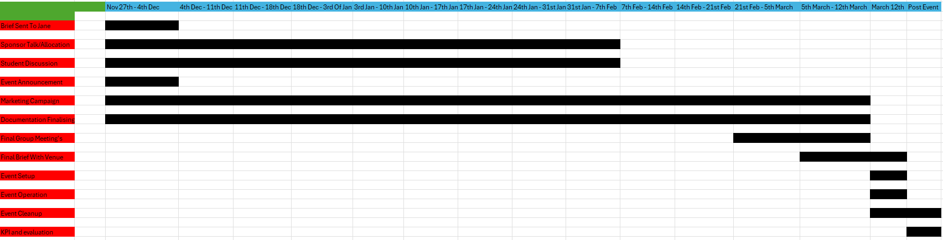
The running order is a project technique also used in the planning of this event, an event running order is a detailed timeline that outlines the schedule of activities during (French). Planning and allocating people in the running event order was a major part of the project, this involved allocating people who will be working the games in the event programme, behind the bar and hosting the games.

Market Research

Identifying the market for Cowboy’s and Cocktails is essential for the success of the event. The first market segment identifiable from this student event is university students, Swansea has shown to have a large student population reaching 29,965. With two different universities this is a large market to hit with the marketing campaign (“Statistics on Students in Swansea - Swansea”). Student motives for attending events can be varied, Students studying in university tend to spend a lot of their time outside studies socializing and looking for relaxation. They develop through both the social and academic side of campus life (Harb et al.). This emphasises the importance of marketing the social side of Cowboy’s and Cocktails.

A second market Cowboy’s and Cocktails appeals to is young professionals/graduates. It is quite common in young graduates to experience burnout and need to experience a further social life. Study shows 53% of all young professionals feel burnout at some point (THE MENTAL HEALTH and WELLBEING of YOUNG PROFESSIONALS). This emphasises the importance of marketing to young graduates, The social side of the event will appeal to them for relaxation and social purposes. Like university students young professionals look for memorable social experiences, (“Why the Youth Market Is Important to Your Brand”).

The final market Cowboy’s and Cocktail’s aims to appeal to is local businesses and sponsorship possibilities within Swansea. This market segment falls in line with the aim and objective of building partnerships between the university and local businesses. This will allow the event to gain publicity and attendee’s from well recognised brands, creating partnerships and gaining sponsorship benefits both marketing to local businesses and potential customer markets. Adding both aided and unaided recognition to the event (J et al.). Marketing to and gaining successful partnership can result in cost effectivity, strong relationships and built trust leading to a successful event (Verbeck).

Event Marketing Plan

Identifying an effective marketing plan is essential for gaining attendee’s, publicity and making turnover. The key to an effective marketing plan is running it as a function of random area’s that intertwine during and sometimes after the set period is over (Reic). To further this, this involves running a variety of marketing methods. Whether it is physically or online and simultaneously running them and linking them together to create a successful campaign.

Cowboy’s and Cocktails will be using physical forms will be a successful way to get the brand out. This involves physical copies of marketing material, Street marketing and spreading word of mouth. Street level marketing refers to promotional activities in public areas, this method tends to provide unconventional however provide interactive and engaging experiences. For example, giving out samples of mocktail’s for the public. This form of marketing is designed to create memorable experiences lasting impressions lead to brand loyalty and word of mouth promotion (Chinweizu Oham and Onyinye Gift Ejike).

Cowboy’s and cocktails will also be using digital marketing to get the brand name out. This involves social media marketing and direct messaging to the target market. Social media marketing utilises social media channels and technology. The main aims of social media marketing are to create, communicate and deliver. For example, creating a post, scheduling it for the right time, delivering it and communicating through stories and group chats Aswell as exchange offerings that have value to stakeholders and sponsors such as marketing their products and services and them doing the same in return (“Google Books”).

The final aspect going into Cowboy’s and Cocktail’s marketing plan is the importance of a marketing schedule. This refers to keeping track of campaign engagement, Marketing goals and deadlines and what team members are responsible for (CoSchedule). Cowboy’s and cocktails will use a schedule for social media postings. For the marketing plan posting from 10am Monday, Wednesday, and Friday weekly. Studies show that the optimum time to post for university students is Friday 10am (“Blog - the Optimum Time for Universities to Publish Content on Social Media Platforms”). Along with this street market weekly with mocktails and posters

Expected Expenditure and Income

Cowboy’s and cocktails having a planned financial plan is critical, the financial budget plan is a forecast that will regulate the operations of the event. It provides records of expenditure acting a control document that provides how much insight into how much profit we are going to make and how much money we need to source (Smit).

The budget for Cowboy’s and Cocktails has been estimated as follows:
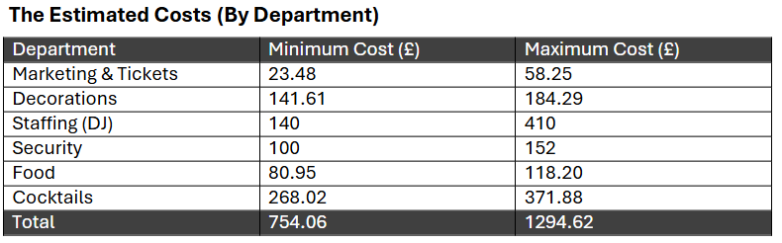
Going off the minimum costs for the event for the event, between all 5 Cowboy’s and Cocktails members will have to put forward £150.81 minimum to cover costs for the event. The Cocktails and food being the highest prices.
Price Breakdown –
Down below are estimated prices between all departments mentioned within the Work Breakdown schedule.

Cocktails:
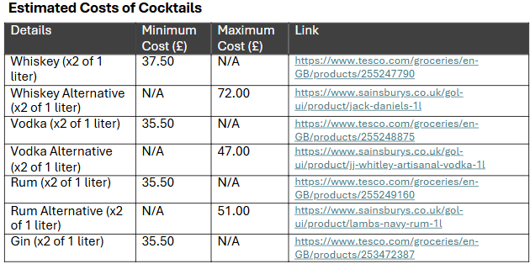
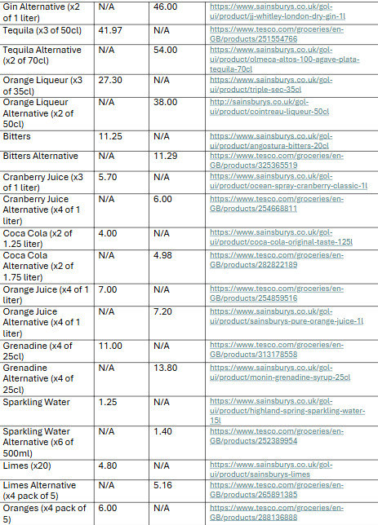

These cocktail prices are estimated based on making twenty versions of all five cocktails plus extra for the mocktails. With the sponsoring of Morladron rum and Hensol gin these costs may go down by a percentage

Food:
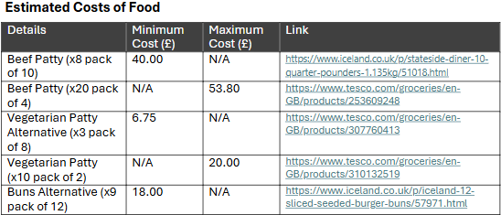
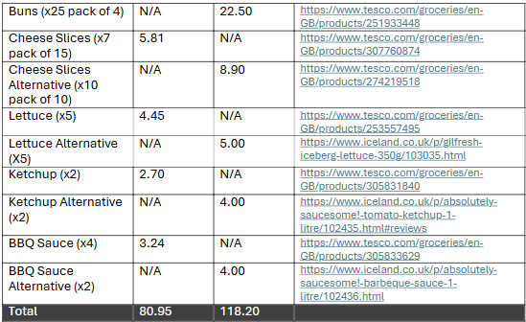
These estimates are based off one hundred burgers, split to the ratio of 80:20 of beef and vegetarian. Dylan Thomas Centre has agreed to buy the food for us, and we are estimating this number of burgers for around fifty guests.

Decorations:
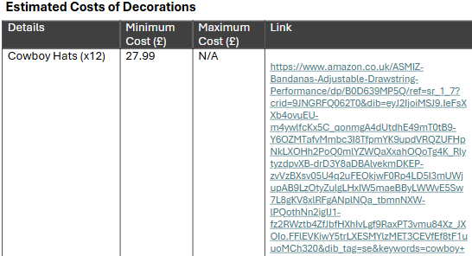
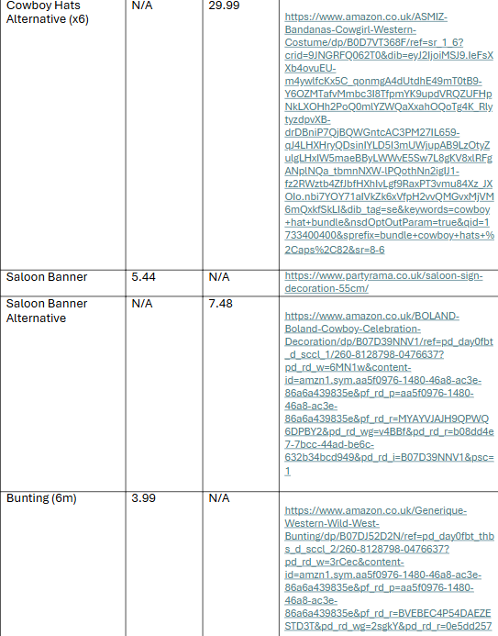
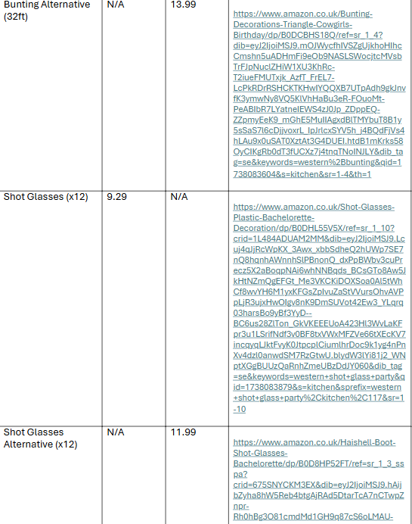
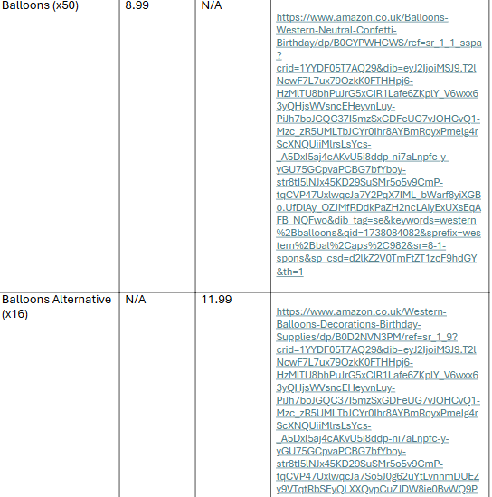
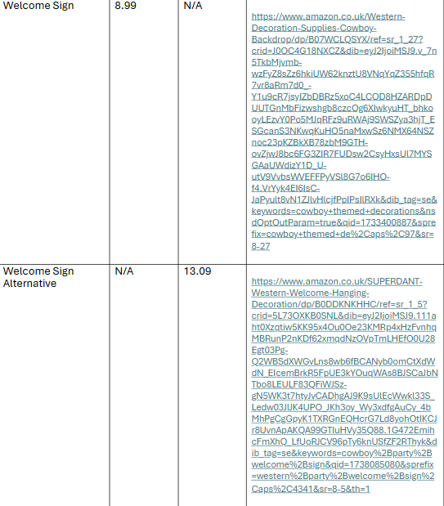
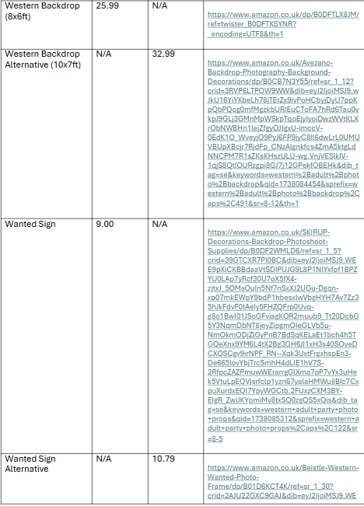
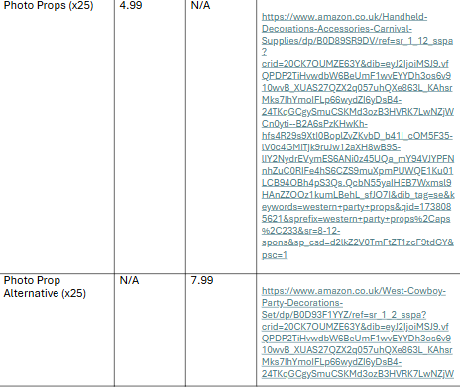
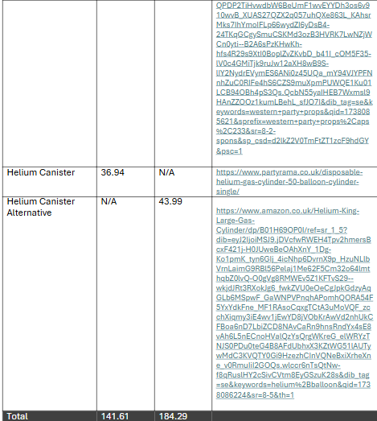

DJ:
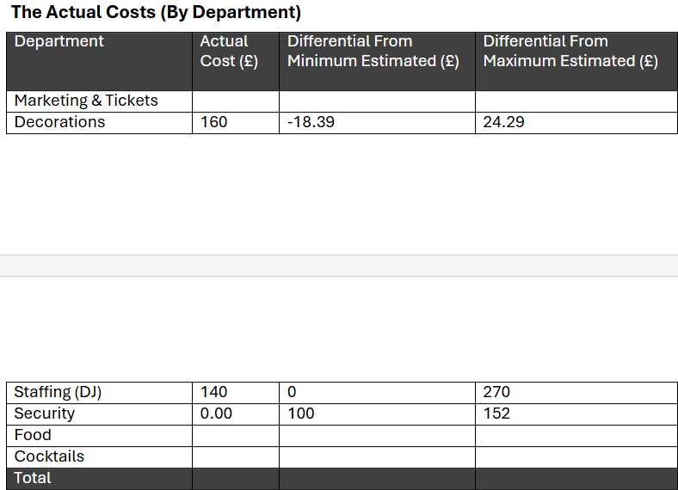
The DJ is quoted at £140 for four hours work, therefor each member of Cowboy’s and Cocktails is putting forward £28 each to cover it.

Marketing + Extra’s :
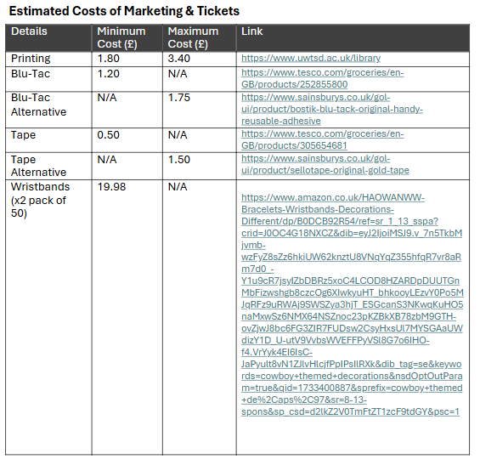
State of operations + income:
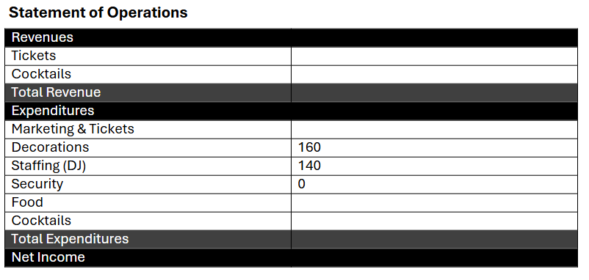
Our profits for this event are going to come from the ticket sales and cocktails, according to our analysis sheet we are going to need to sell sixty-two cocktails for £6 each and fifty tickets at £10 each to break even.

Financial budget sheet made by Jayden Bond safety co-ordinator (“Sign in to Your Account”)

Risk Management and Legal Arrangements

When planning this event having knowledge of risk assessments and legal procedures is essential. Risk management is often perceived as a process that is carried out once the event is organised, however it should be integrated into event design and run before and during the event (Rutherford Silvers).

Following legal procedures is also essential. It is important to follow fire safety procedures, Fire procedures at events involves conducting fire risk assessments to identify hazards, adopting preventive actions establishing response plans, As well as this it involve giving a fire briefing to all staff before the event and then to attendee’s to inform them of no planned fire evacuations (Tracy). Another legal procedure needing to be followed is alcohol licensing and age verification. This is following the challenge twenty-five policy whereby anyone who looks below age 25 will be asked to provide an acceptable form of identification. Practicing this raises awareness of the illegality of underage. With all bar staff practicing this at Cowboy’s and Cocktails this will reduce underage drinking (Laing). The final important legislation to follow is food allergen and safety awareness. Businesses are required to provide allergen information on food packages and when providing food. In case of this event Dylan thomas will put allergen information by the burgers and answer any questions. (Food Standards Agency).

Risk Assessment:
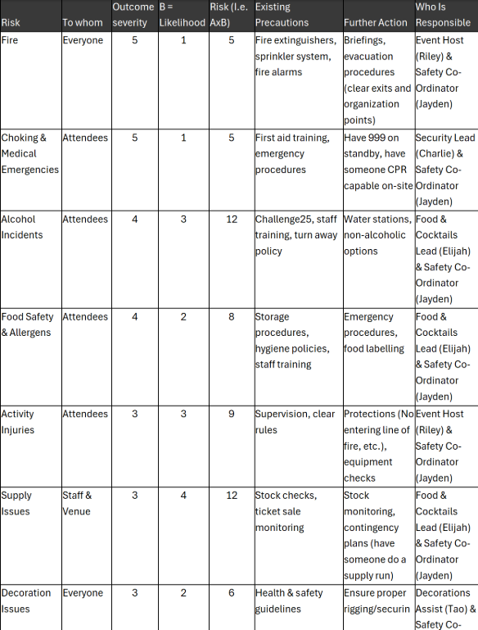
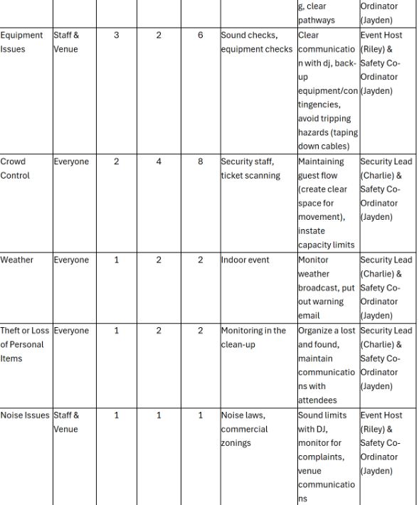

Any food and beverage related risks on this assessment fall under responsibility of Elijah Thomas (2313487) the food and beverage director of Cowboy’s and Cocktails
Risk assessment created by safety manager Jayden Bond (“Sign in to Your Account”)

Contingency Planning

Producing a contingency plan for Cowboy’s and Cocktails is essential. For events contingency planning is a vital part of risk management and smooth operations, without a plan these risks could lead to financial loss, reputational damage, and event failure (Lanoue).

Supply shortages can be a big risk in the running of Cowboy’s and Cocktails. This could be caused for a variety of reasons; it could be more sales than expected creating more bar attention or a cocktail may be more popular than most. Contingency for this is researching local shop’s nearby and have money on hand ready to order what is needed, as well as ensuring there are free staff members who can run and grab ingredients when required.

Alcohol related problems can be a big risk in the running of Cowboy’s and Cocktails. This can be caused by an individual who excessively drinks at the event, Contingency for this is setting clear guidelines for drinking responsibly for example drink limits, as well as assigning the team to monitor any guests who have concerning or aggressive behaviour. Finally reduce it by offering soft drinks and water in less severe cases, in more severe cases they get looked after by security and escorted out the event.

Evaluation Strategy

Having an evaluation strategy to monitor and manage the success of the event is crucial. Event evaluation is an activity that seeks to measure the extent to which an event is meeting its aims and purpose (Francis). There are a variety of methods which can evaluate event success, one way is continuous interaction with the guests at the event. This ensures guests are happy and if there are any issue’s they are dealt with quickly to ensure guest satisfaction, as well as this having constant Interaction with team members during the event can measure satisfaction. This allows you to find out if there have been any problems with guests, on top of how well products and services are selling at the event to get an idea of what does and does not work well.

A lot of event evaluation comes after the end of the event. Methods used to evaluate post event success consist of event reviews and survey’s, Gaining and analysing these results can allow you to find strengths and weaknesses in the event and when planning future endeavours learn from past event operations (Ambalathinkal)

Evidence Of Work Division Planning

My name is Elijah Thomas (2313487) and my role in the planning of Cowboy’s and Cocktail’s was Food and Beverage Co-ordinator and Marketing Assist. My key responsibilities were.
- Attending Meetings with Dylan Thomas Centre
- Producing the methods and recipes for the cocktails
- Producing the Cocktail and food idea’s
- Talking to potential sponsors over email about supplying materials
- Assisting in creating market materials and promoting on social media
- Being the main point of contact between the venue and event

Email Evidence:
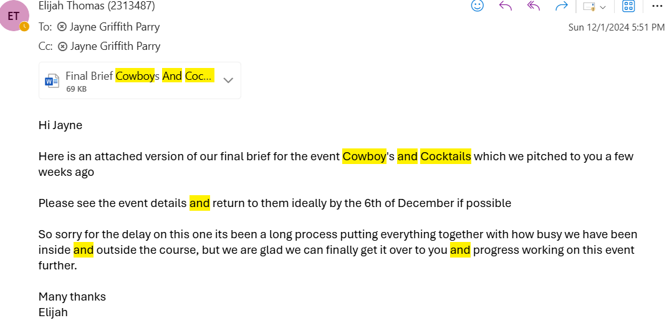
This email is sending over the first brief of cowboy’s and cocktails over to Jayne Griffith a manager at Dylan Thomas centre operations where it was later approved.

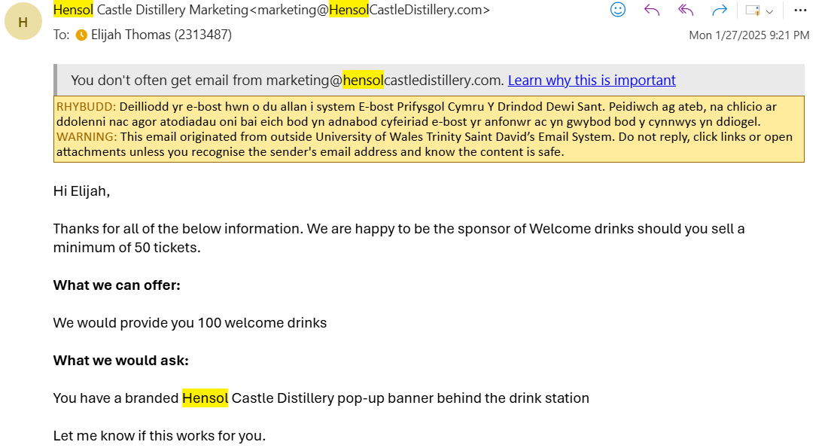
After enquiring on their website about a potential sponsor request, Hensol castle gin responded, and I secured our first sponsor. Despite it being conditional needing fifty ticket sales and a pop-up banner across the bar
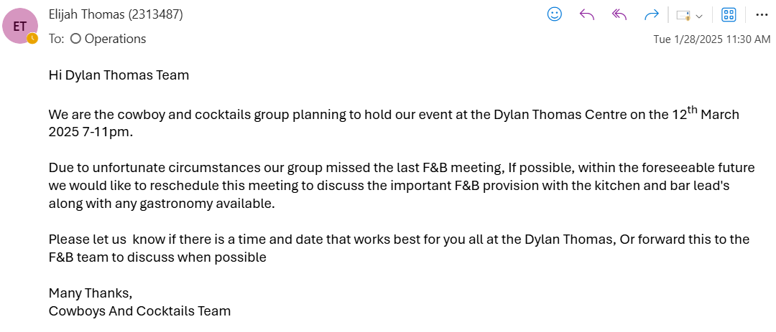

Missing the first F&B meeting due to unforeseen circumstances I rearranged the meeting and attended myself to discuss the provision of F&B

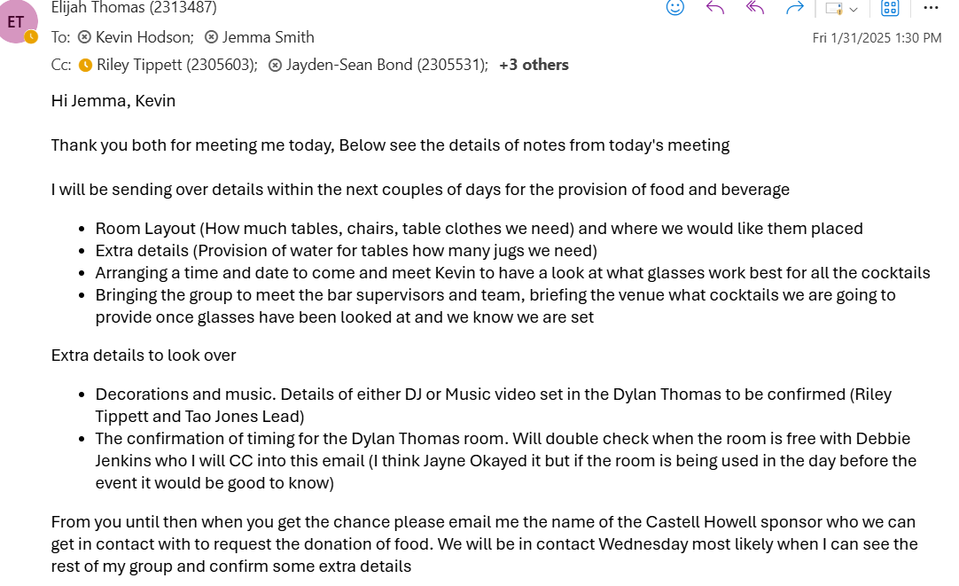

Following up from the meeting I discussed details with Kevin over email and after discussing with the group sent over final details over the highlighted bullet points.
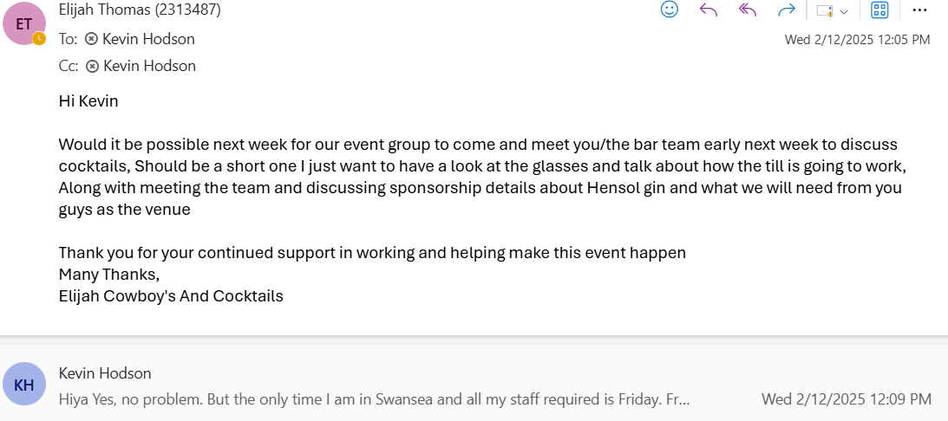

Not long after that I emailed Kevin again and went to a second meeting with Riley Tippett (2305603) the F&B assist to have a look at cocktail glasses and discuss which one’s work best.

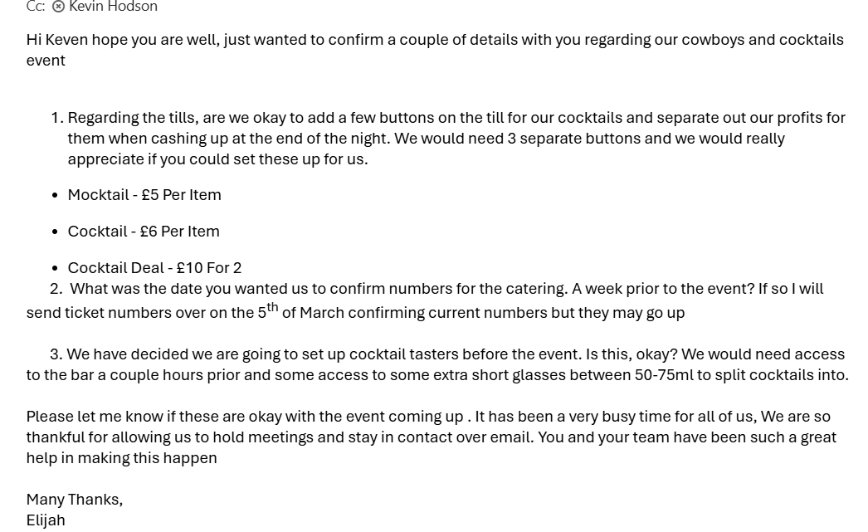
2 weeks before the event I have emailed Kevin to discuss these key points and send over cocktail prices and sort out the till system.

Marketing evidence:
@Cowboy_Cocktails.2025
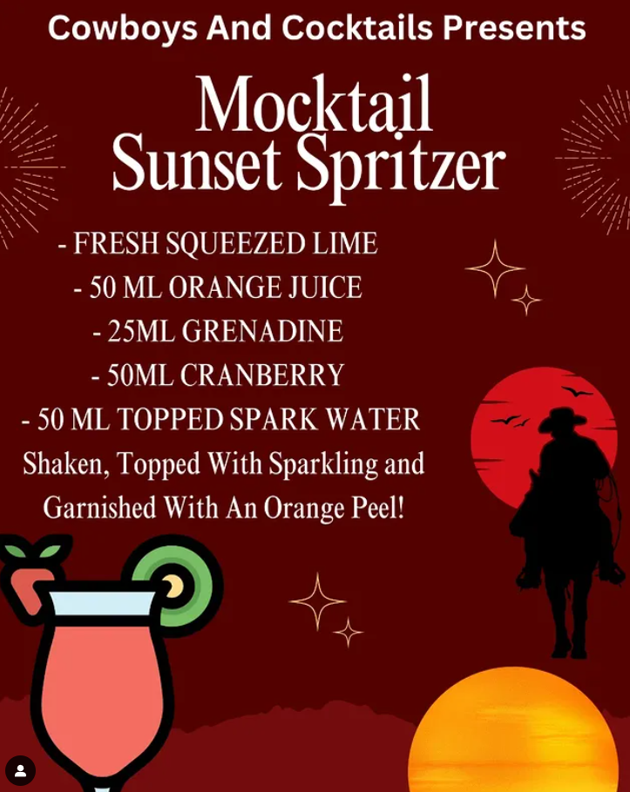
Designed a Mocktail poster and the recipe behind it to help promote the drink.
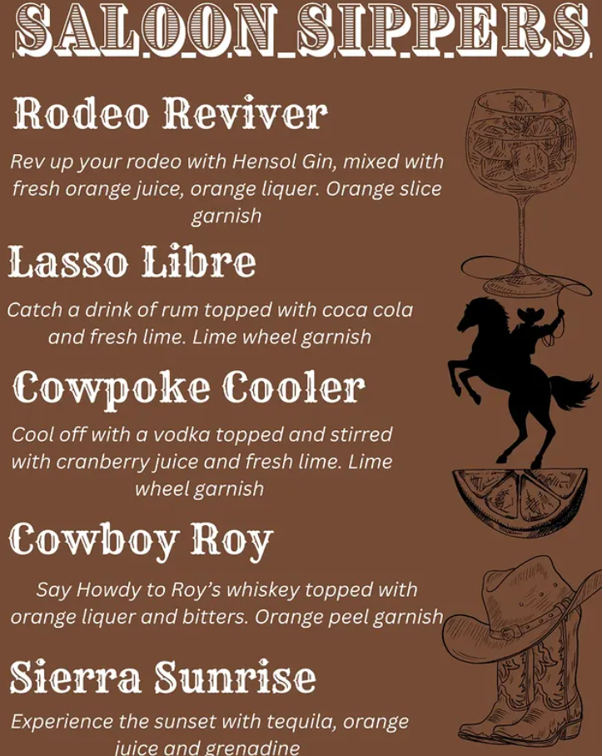

Produced the cocktail idea’s and designed the menu with the help of Jayden Bond (2305531) safety and finance lead.
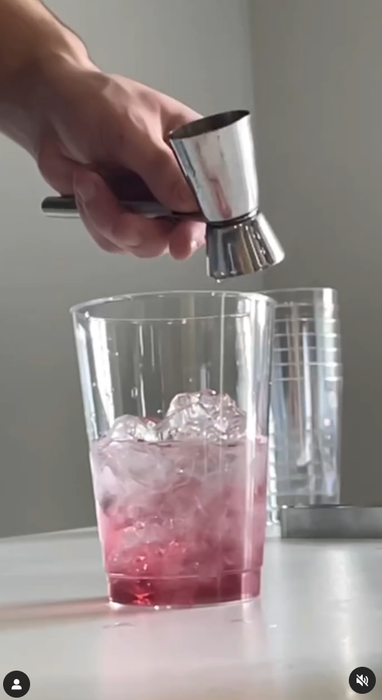
Created a promotional video making the cocktail “Cowpoke cooler” to help promote it before the event.

References
Works Cited
Ambalathinkal, Natasha. “Essential Elements to Consider for Your Post Event Analysis Report.” Eventible.com, 2024, www.eventible.com/learning/post-event-analysis-report/.
“Blog - the Optimum Time for Universities to Publish Content on Social Media Platforms.” Terminalfour Higher Education Digital Marketing Blog, www.terminalfour.com/blog/posts/the-optimum-time-for-universities-to-publish-content-on-social-media-platforms.html.
Chartier, Matthieu. “Ultimate Guide to Event Sponsorships (for Academic Events).” Fourwaves, 17 Oct. 2023, fourwaves.com/blog/event-sponsorships/.
Chinweizu Oham, and Onyinye Gift Ejike. “The Dynamics of Street-Level Marketing: Engaging Urban Audiences with Interactive Strategies.” World Journal of Advanced Research and Reviews, vol. 19, no. 1, 30 July 2023, pp. 1560–1568, https://doi.org/10.30574/wjarr.2023.19.1.1326. Accessed 2 Nov. 2024.
CoSchedule. “How to Build an Effective Marketing Schedule (Template).” CoSchedule Blog, 25 Apr. 2019, coschedule.com/blog/marketing-schedule-template.
Davidson, Jeffry P. “Google Books.” Google.co.uk, 2019, www.google.co.uk/books/edition/Project_Management/7x3LIw7TB5cC?hl=en&gbpv=1&dq=gantt+chart&pg=PA80&printsec=frontcover. Accessed 9 Jan. 2025.
eventplanners.io. “Creating Memorable Experiences in Event Planning - Event Planners.” Eventplanners.io, 27 Nov. 2023, eventplanners.io/insight/creating-memorable-experiences-in-event-planning/.
Field Drive. “Creating an Event Program: Guide + Templates.” Fielddrive.com, Field Drive, 20 Mar. 2024, www.fielddrive.com/blog/program-of-events-template-guide.
Food Standards Agency. “Allergen Guidance for Food Businesses.” Food Standards Agency, 14 June 2022, www.food.gov.uk/business-guidance/allergen-guidance-for-food-businesses.
Francis, Abey. “Event Evaluation - Evaluating the Success of Events.” MBA Knowledge Base, MBA Knowledge Base, 6 Oct. 2010, www.mbaknol.com/marketing-management/event-evaluation/.
French, Kim. “How to Create the Perfect Event Running Order.” Julia Charles Event Management, 24 Oct. 2023, www.juliacharleseventmanagement.co.uk/how-to-create-the-perfect-event-running-order/.
“Google Books.” Google.co.uk, 2022, www.google.co.uk/books/edition/The_SAGE_Handbook_of_Social_Media_Market/tOF0EAAAQBAJ?hl=en&gbpv=1. Accessed 6 Mar. 2025.
Harb, Ayman, et al. “Cultural Exploration as an Antecedent of Students’ Intention to Attend University Events: An Extension of the Theory of Reasoned Action.” Journal of Marketing for Higher Education, vol. 34, no. 1, 1 Aug. 2021, pp. 1–23, https://doi.org/10.1080/08841241.2021.1958125.
J, Glenn A, et al. “Google Books.” Google.co.uk, 2023, www.google.co.uk/books/edition/Events_Management/1mPDEAAAQBAJ?hl=en&gbpv=1. Accessed 5 Mar. 2025.
Laing, Gill. “What Is the Challenge 25 Policy?” Lawble, 14 Mar. 2023, www.lawble.co.uk/challenge-25/.
Lanoue, Spencer . “The Importance of Having a Contingency Plan | Bricks.” Thebricks.com, 2024, www.thebricks.com/resources/the-importance-of-having-a-contingency-plan.
Murray, Ryan. “The Importance of Creativity in Events | Innovative Events.” Julia Charles Event Management, 3 Feb. 2023, www.juliacharleseventmanagement.co.uk/the-importance-of-creativity-in-events/.
Norman, Eric S , et al. “Google Books.” Google.co.uk, 2019, www.google.co.uk/books/edition/Work_Breakdown_Structures/FbDqjIeiqdsC?hl=en&gbpv=1&dq=Work+breakdown+schedule&printsec=frontcover. Accessed 4 Mar. 2025.
Reic, Ivna. “Google Books.” Google.co.uk, 2016, www.google.co.uk/books/edition/Events_Marketing_Management/lT4lDwAAQBAJ?hl=en&gbpv=1&dq=Importance+of+an+event+marketing+plan&pg=PA278&printsec=frontcover. Accessed 6 Mar. 2025.
Rutherford Silvers, Julia. “Google Books.” Google.co.uk, 2020, www.google.co.uk/books/edition/Risk_Management_for_Events/zuAIEAAAQBAJ?hl=en&gbpv=1&dq=Importance+of+a+risk+management+at+events&printsec=frontcover. Accessed 7 Mar. 2025.
“Sign in to Your Account.” Sharepoint.com, 2025, uowtsd-my.sharepoint.com/:w:/r/personal/2305531_student_uwtsd_ac_uk/_layouts/15/doc2.aspx?sourcedoc=%7BC9C5D4A3-4B9B-4486-A6CC-65A5D8B446C0%7D&file=Live%20Event%20-%20Financials.docx&action=default&mobileredirect=true&DefaultItemOpen=1.
“Sign in to Your Account.” Sharepoint.com, 2025, uowtsd-my.sharepoint.com/:w:/r/personal/2305531_student_uwtsd_ac_uk/_layouts/15/Doc.aspx?sourcedoc=%7BF173DD8C-D625-4AD4-B5F8-267AC65A1A39%7D&file=Risk%20Analysis%20Sheet.docx&fromShare=true&action=default&mobileredirect=true. Accessed 7 Mar. 2025.
Smit, Laricia . “Google Books.” Google.co.uk, 2019, www.google.co.uk/books/edition/Event_Management_Putting_thery_into_prac/GCXPaA_4yV4C?hl=en&gbpv=1&dq=Importance+of+a+financial+plan+in+events&pg=PA362&printsec=frontcover. Accessed 6 Mar. 2025.
“Statistics on Students in Swansea - Swansea.” Swansea, 2022, www.swansea.gov.uk/studentstatistics?lang=en. Accessed 4 Mar. 2025.
THE MENTAL HEALTH and WELLBEING of YOUNG PROFESSIONALS. files.eric.ed.gov/fulltext/ED629141.pdf. Accessed 4 Mar. 2025.
Tracy. “Fire Safety at Events.” Fire Training Company, 15 Feb. 2024, www.firetrainingcompany.co.uk/fire-safety-at-events/.
Trimble, James. “The Impact of Campus Events on Student Success.” Gomomentus.com, Momentus Technologies, 6 Aug. 2024, gomomentus.com/blog/the-impact-of-campus-events-on-student-success.
Verbeck, Tiffany. “The Power of Local Partnerships.” Nav, 11 Aug. 2023, www.nav.com/blog/local-partnerships-2416223/.
“Why the Youth Market Is Important to Your Brand.” BAM Agency, 29 May 2019, www.bamuk.com/why-the-youth-market-is-important-to-your-brand/.

