
BA (Hons) Leadership and Management Skills for the Workplace
ORGANISATIONAL CULTURE (LCLM5005)
Student Name: Andrei Silviu Popina
Student number: 2332738
Lecturer Name: Dr. Amir Homayounfard
Submission Deadline: 21.04.2025

ORGANISATIONAL CULTURE AT TESCO PLC
A Critical Evaluation of Structure, Decision-Making, and Performance

Word count: 2921

Contents
1. Introduction 3
2. Culture, Structure, and Decision-Making at Tesco 3
2.1 Cultural Foundations and Structural Design 3
2.2 Culture and Decision-Making Processes 4
3. Application of Cultural Frameworks to Tesco 5
3.1 Schein's Three Levels of Culture 5
3.2 Handy's Cultural Types 6
3.3 Hofstede's Cultural Dimensions 7
4. Cultural Adaptation to External Environmental Influences 8
5. Organisational Culture as Barrier or Enabler at Tesco 9
6. Impact on Performance and Evidence-Based Recommendations 10
6.1 Performance Impact 10
6.2 Recommendations 11
7. Conclusion 11
References 12

1. Introduction
Tesco PLC is the biggest grocery retailer in the United Kingdom with 20 million customers every week and a workforce of 345,000 colleagues in five countries and 4,000 stores. According to Mullins and Christy (2016) culture is defined as how things are done around here and it defines structure, decision making and how work is organised. This report is a critical analysis of the Tesco culture and how the culture impacted the structure, decision making, external adaption, and performance. This analysis will use the three-level model using the Schein and the cultural typology with Handy as well as the Hofstede dimensions to help identify the current culture and to identify whether culture is a barrier or enabler. Pathiraneg, Jayatilake and Abeysekera (2022) associate cultural fit to corporate achievement whereas Heskett (2022) describes culture as a competitive advantage. The report is closed by the targeted recommendations.

2. Culture, Structure, and Decision-Making at Tesco

2.1 Cultural Foundations and Structural Design
Tesco organisational structure is a blend of hierarchical-divisional structure influenced by organisational culture of emphasis on customer service, operational discipline, cost leadership and involvement of colleagues. The operations of the company are divided into UK and Republic of Ireland retail, Booker wholesale, Tesco Bank and Central Europe divisions which report through a well defined management line to the Group Chief Executive. According to Pathiranage, Jayatilake and Abeysekera (2022), culture sets the conditions of the structural design, as the mutual assumptions of authority, communication flows, and accountability shape the arrangement of formal roles within the enterprise. In this case, the Tesco scenario has had a history of cultural focus on discipline in the operations and a centralised standard which has led to a stratified command structure whereby regional managers, store managers, team leaders and colleagues report to well established responsibility lines of command. Heskett (2022) substantiates the idea that cultural continuity frequently institutionalises structural form such that strategic change seldom generates relative changes in reporting relationships unless the leadership takes an active role in redesigning the cultural underpinnings alongside the formal hierarchy. A complementary result is presented by Azeem, Ahmed, Haider and Sajjad (2022), who show that organisational culture mediates between knowledge-sharing routines and competitive advantage, which are evident at Tesco in terms of the disciplines of category management embedded in the company and the protocols of supplier collaboration between the grocery, general merchandise, and clothing divisions.

2.2 Culture and Decision-Making Processes
The pace, form and integrity of decision making at Tesco is guided by cultural values. The mission of the company, which is to serve the Shoppers of Britain a little better every day, challenges the managers to make data-driven decisions in accordance with the customer confidence, price competitive and reliability in its operations. Chatterjee, Chaudhuri and Vrontis (2023) discover that coherent cultures that are strong minimize ambiguity in decision-making since the staff members have common assumptions regarding acceptable trade-offs, resulting in reduced coordination costs and faster implementation with huge workforces. At Tesco, range decisions, promotional decisions and service recovery decisions are decentralised at store level using standardised operating procedures whereas strategic decisions on property acquisition, investments in technology and pricing architecture are made at Group level using formal governance forums such as the Executive Committee and the plc Board. Warrick (2023) argues that layered decision rights can lead to efficiency in situations where they match cultural norms, but slowness in situations where frontline teams feel that a culture of control is exercised at the expense of empowerment, a conflict that is evident in Tesco between central merchandising departments and local store autonomy in perishables ordering.
Tesco reaction to the 2014 accounting scandal is an example of how culture can influence the integrity of decision-making in the company. The new norms of reporting, the focus on ethical behaviour, and the investment in the engagement of colleagues were established by leadership under Dave Lewis, which Tran (2023) correlates to the shift towards a command-based learning organisation and a more participative and innovation-oriented one. Aboramadan (2022) finds psychologically safe cultures help to hasten honest upward communications, which enable top leaders to respond to operational issues before they become a source of reputational harm or regulatory penalty. These cultural leverages helped Tesco in its later margin recovery and the stakeholder trust repair that was evident post 2017, and shows the quality of finding decisions is dictated by cultural health in lieu of formal controls. According to Tesco PLC (2024), the company has continued to invest in ethics training, supplier code implementation and whistleblowing initiatives, which are in line with the cultural discipline necessitated by a business of the scale and publicity of the company. New governance practices, such as the re-empowered audit committee mandate and the new code of business conduct, are a manifestation of a long-standing attempt to incorporate integrity into everyday decision-making in commercial, supply chain and finance operations.

3. Application of Cultural Frameworks to Tesco

3.1 Schein's Three Levels of Culture
The model of Edgar Schein identifies artefacts, espoused values and underlying basic assumptions as three levels of organisational culture and they are more difficult to observe and more difficult to modify. The artefacts that are visible at Tesco are the blue and red livery, the uniform store design, the Clubcard loyalty program, the yearly colleague recognition awards, the published purpose and values displayed in the workplaces, which convey to both internal and external audiences a customer-first orientation. The published Tesco values include serving a little better every day and treating people how they want to be treated, acting in the spirit of inclusion, and diversity, mental health, and ethical trade, espoused values. Warrick (2023) states that the actual test is behind the scenes, where the underlying assumptions regarding the performance, hierarchy and ethics influence every day behaviour and determine how the leader may use time, attention and resources. The most profound assumption at Tesco is the operational excellence and disciplined execution as a way of safeguarding the customer trust, which is supported by the performance management routines, store visit procedures and succession decisions based on commercial track record. Meng and Berger (2023) demonstrate that alignment on the three Schein levels predicts a reputation outcome, thus where artefacts and assumptions are not aligned, the confidence of stakeholders is likely to decline, which Tesco can mitigate by communicating regularly internally and reporting the progress made against the stated values.
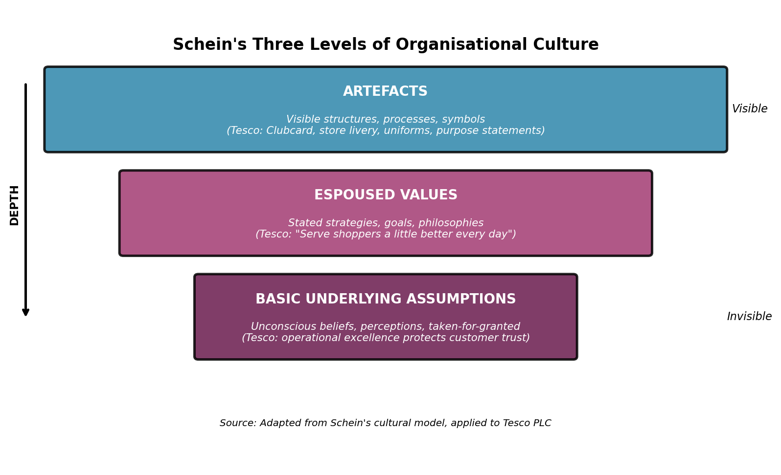
Figure 1: Schein's Three Levels of Organisational Culture Applied to Tesco PLC

3.2 Handy's Cultural Types
Charles Handy classifies cultures as power, role, task and person culture, which are appropriate in various organisational contexts. Tesco has a dominant role culture since the firm has a job definition, standardised procedures, and hierarchical reporting lines to promote consistency in thousands of stores. Jogulu and Wood (2023) affirm that large retailers tend to be role-based due to the need of scale to be predictable and replicable, and role structures provide the superior solution to the issue of predictability and replicability compared to task-based structures. The aspects of task culture are manifested in Tesco innovation functions, such as the digital team that creates Tesco app and the sustainability team that creates the packaging reduction programmes where cross-functional projects are more prioritized than official job titles. Minor aspects of power culture still remain at the board level where the Chief Executive and key directors direct key strategic decisions with a direct personal impact on tone and priorities. Kumari, Abbas, Hwang and Cioca (2022) discover that hybrid cultural forms help to enhance retail resilience, as the role structures generate stability and the task enclaves generate innovation in the face of competition.

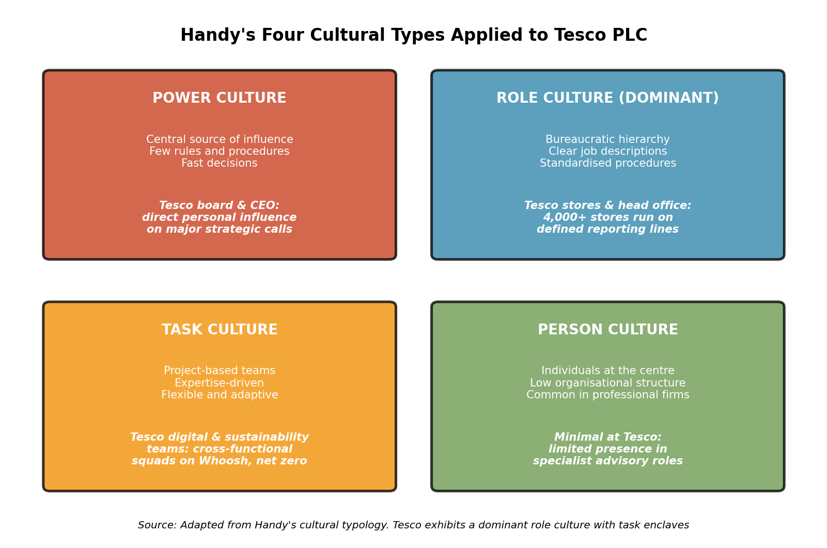
Figure 2: Handy's Four Cultural Types Applied to Tesco PLC

3.3 Hofstede's Cultural Dimensions
The dimensions created by Hofstede give an opportunity to compare the Tesco cultural profile with the national ones. According to Hofstede Insights, the United Kingdom has low power distance, high individualism, moderate masculinity and low uncertainty avoidance at thirty-five, sixty-six, and thirty-five respectively. Nguyen, Huynh and Lam (2023) demonstrate that the dimensions of Hofstede still help to explain the variance of workplace behaviour in the context of retail organisations, especially where organisations work in the multi-country format. Low power distance at Tesco can be seen in open leadership style with Ken Murphy who visits store employees and consults them directly, whereas high individualism is seen in the reward systems that are based on individual performance measures. The moderately high masculinity score is consistent with the Tesco competitive pricing culture, and market share leadership drive, which rewards aggressive commercial behaviour. The low uncertainty avoidance is in favour of the firm to pilot new formats, which included Tesco Finest, Tesco Express, and Tesco automated Whoosh rapid delivery service. Bharwani and Talib (2023) note that balance of Hofstede is a better fit with international operations in a firm and this observation proves in line with Tesco mixed performance in Central European markets where the local culture is different than the British defaults.
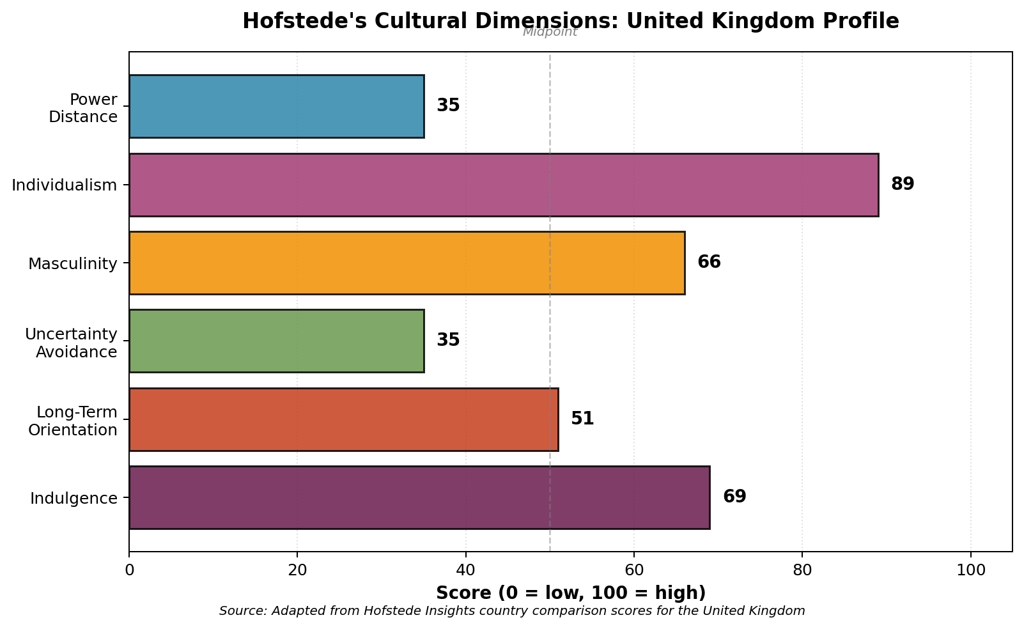
Figure 3: Hofstede's Cultural Dimensions Profile for the United Kingdom

4. Cultural Adaptation to External Environmental Influences
Outside forces determine the ways Tesco can use cultural assets to sustain a competitive stance in a competitive grocery market. The Aldi Aldi and Lidl discounter threat, cost-of-living crisis, the move to digital shopping, and the increasing demands on sustainability are all challenges to the culture of a flexible firm. Al-Swidi, Gelaidan and Saleh (2022) show that organisations that have sustainability-oriented cultures perform better than their colleagues on environmental indicators and stakeholder confidence as values-based alignment can speed up the process of green practices implementation in supply chains. Tesco and its reaction to the discounter threat exemplifies a cultural change on scale where Aldi Policy Match scheme and Clubcard Prices systems redefined the price war by making specific communications to address price competition instead of wholesale deflation. Culturally adaptive firms, Islam, Khatoon, Cheema and Ashraf (2023) consider the use of customer-facing innovation to be even faster when internal values focus on experimentation, a trend that aligns with the Tesco intention to test value brands and simplified ranges in response to the inflationary pressure on household budgets.
Another instance of cultural adjustment by the company is digital transformation. In the recent years, Tesco started Whoosh rapid grocery delivery in 2021 and extended Scan As You Shop technology to the UK estate and restructured the online service after leaving the Ocado-powered system in previous years. Kim and Chang (2023) demonstrate cultures that value customer centricity and data literacy embrace digital rollouts since employees embrace the data capture, training investment, and process change to be a successful rollout. The sustainability aspect also displays cultural reach with Tesco declaring commitments to net zero in both its UK operations and through the entire value chain by 2035 and 2050 respectively. According to Paais, Tuuk and Pattiruhu (2023), sustainability promises can be turned into a reality in operations only when the culture is rewarding long-term stewardship and short-term commercial results, and Tesco tries to achieve that balance by employing performance scorecards with sustainability indicators. Outside cultural influences have also compelled Tesco to report on gender, ethnicity, and disability pay gaps, which Isensee, Griese, Teuteberg and Topi (2023) reported as a characteristic of cultures that are capable of transforming transparency into trust with employees, shareholders, and authorities.

5. Organisational Culture as Barrier or Enabler at Tesco
The culture of Tesco is both an inhibitor and facilitator and the balance between them is distributed uneasily among business functions and strategic initiatives in both directions, necessitating a fine interpretation. The powerful customer-service culture, as an enabler, facilitates daily service recovery, discretionary effort by colleagues, and brand loyalty over the long term, among socio-economic groups, such as low-end shoppers in the cost-of-living crisis. Heskett (2022) claims that culture facilitates performance in cases where values, norms, and incentive systems promote the same behaviours among populations of employees, and Tesco estimates that this is the case by the Every Little Helps pillars, the Colleague Clubcard, the Shares in Success scheme, and long-service recognition systems. Pathiraneg, Jayatilake and Abeysekera (2022) validate the enabler impact on the basis of a meta-analysis between the strength of culture and financial performance, especially in service-based industries where employee behaviour shapes customer perception. Chatterjee, Chaudhuri and Vrontis (2023) also demonstrate how cultures with operational discipline generate reliability benefits relative to competitors with cultures that do not have consistent performance norms, which are reflected in Tesco on-shelf availability and queue-time performance compared to competitors.
The dimension of barrier manifests itself in the less agile rate of change compared to more agile competitors. The stratified role culture generates predictability but the structures stifle experimentation along the boundaries of the business. Tran (2023) notes that role cultures experience ongoing tension at the time of technology-driven change, as the existing decisions rights clash with the requirement of speedy experimentation and capability to fail fast. The failure of Tesco to succeed in the international market, which is evident in its experience with Fresh and Easy in the United States, which failed in the market and shut down in 2013 at a loss of £1.2 billion, exemplifies the barrier effect wherein the British cultural defaults could not measure up to American expectations of shops. Bharwani and Talib (2023) demonstrate cross-cultural discrepancies arise when cultural assumptions of the home market are imported with little localization of routines, assortment logic, and practices of engaging colleagues. According to Jogulu and Wood (2023), culture is seen as an impediment in the presence of dominant norms that drown out dissent and stifle the diversity of ideas that reach top-level decision-makers, which is inherent in any large role culture based on formal reporting lines instead of open challenge. Overall, the evidence places the Tesco culture as a net enabler in the UK core, and as a partial barrier when the business needs to pivot rapidly or on cultural new grounds, overseas.

6. Impact on Performance and Evidence-Based Recommendations

6.1 Performance Impact
In the 2023/24 financial year, Tesco recorded group sales of approximately £68.2 billion and an adjusted operating profit of 2.83 billion, and an improvement in market share against the discounters and further penetration of Clubcard membership throughout the customer base. These results are supported by the cultural dimension as the company ensures consistency in customer service, disciplined implementation, and an ethical tone is revived following the 2014 reset with new leadership. Pathiranage, Jayatilake and Abeysekera (2022) identify cultural coherence as a predictor of financial performance in a sample of retailers, and this trend is evident in the margin trend of Tesco since 2018 when the scandal period ended and Tesco was back to growing profits at a sustainable rate. Aboramadan (2022) demonstrates that cultures that endorse psychological safety transfer to retention of colleagues and advocacy, which can be quantified in the engagement scores of Tesco that are currently reported about eighty-four percent favourable in recent internal surveys. Saha, Cerchione, Singh and Dahiya (2023) contribute a conclusion that corporate social responsibility values turn into financial benefits when cultural norms coincide with those stated in publications, which is reflected in the regaining of investor trust in Tesco throughout the scandal period and the resumption of the dividend in 2017 after a two-year break. According to Tesco PLC (2024), the total shareholder return has been above the FTSE 100 average in the past five years, which is aligned with the cultural discipline in delivering the consistent implementation of its competitive strategy.
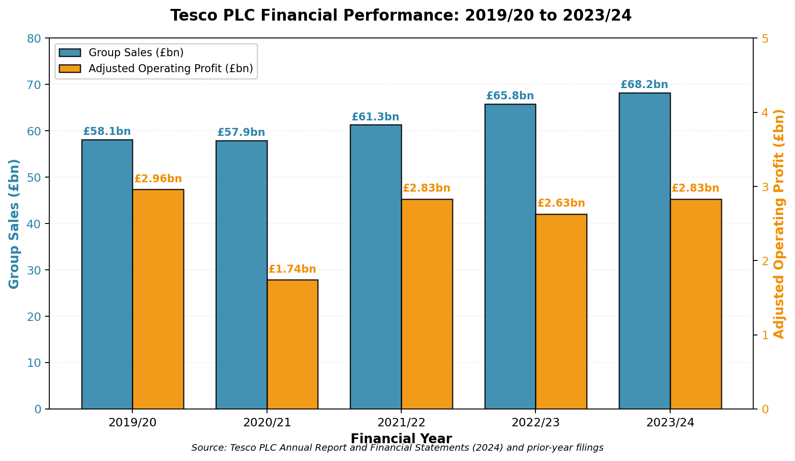
Figure 4: Tesco PLC Group Sales and Adjusted Operating Profit, 2019/20 to 2023/24

6.2 Recommendations
There are five evidence-based actions which would enhance the cultural contribution to performance at Tesco. To begin with, the company can strengthen distributed decision rights at store and regional scale to minimize the barrier effect mentioned by Tran (2023), extending frontline control over local product assortments and product promotional plans within accepted risk margins. Second, Tesco needs to work institutionalise cross-functional digital and sustainability work teams by borrowing the task-culture principles in the typology offered by Handy and the hybrid structures of Kumari, Abbas, Hwang and Cioca (2022). Third, the management must preserve the psychological safety improvements made after 2015 by formalizing upward feedback systems into the management practices, which can be backed by the evidence about the connection between internal climate and reputation outcomes by Meng and Berger (2023). Fourth, a cross-cultural learning to international leadership should be invested in by the group to minimize the Bharwani and Talib (2023) risks of cultural export to the home market. Fifth, Tesco needs to keep espoused sustainability values and operational motivators closer to each other, and in this regard, the Isensee, Griese, Teuteberg and Topi (2023) caution of espoused-enacted gaps that undermine trust among stakeholders in the face of lack of transparency.

7. Conclusion
The culture of Tesco is a key mechanism of structuring, decision making, external adaptation and performance in a highly competitive grocery market. The comparison based on the scheme model by Schein demonstrates that there are stratified artefacts, values and assumptions of operational discipline and a customer centrality that has been developed over decades of stable leadership behaviour and strengthened by performance systems. The typology by Handy indicates that the role culture is dominant and supported by task enclaves to work on the innovation in the digital, sustainability and supply chain functions, and the Hofstede dimensions place the firm in a British cultural profile of low power distance, high individualism and moderate masculinity, reflecting the commercial stance taken by the firm. The cultural resources of the company allow the trustworthy service, rigorous performance, and ethical behaviour after the accounting scandal in 2014, but cultural peculiarities impede the quick change in the company and make it difficult to enter foreign markets where the local standards do not coincide with the British standards of default. Specific suggestions would revitalize distributed decision authority, expand task-culture enclaves, and maintain psychological safety.

References
Aboramadan, M. (2022) ‘The effect of green HRM on employee green behaviors in higher education: the mediating mechanism of green work engagement’, International Journal of Organizational Analysis, 30(1), pp. 7–23. Available at: https://www.emerald.com/insight/publication/issn/1934-8835 (Accessed: 12 April 2026).
Al-Swidi, A.K., Gelaidan, H.M. and Saleh, R.M. (2022) ‘The joint impact of green human resource management, leadership and organizational culture on employees’ green behaviour and organisational environmental performance’, Journal of Cleaner Production, 343, 130950. Available at: https://www.sciencedirect.com/journal/journal-of-cleaner-production (Accessed: 12 April 2026).
Azeem, M., Ahmed, M., Haider, S. and Sajjad, M. (2022) ‘Expanding competitive advantage through organizational culture, knowledge sharing and organizational innovation’, Technology in Society, 66, 101635. Available at: https://www.sciencedirect.com/journal/technology-in-society (Accessed: 14 April 2026).
Bharwani, S. and Talib, P. (2023) ‘Managing diverse workforces in multinational organisations: cultural competence and organisational outcomes’, Journal of Organizational Change Management, 36(4), pp. 745–762. Available at: https://www.emerald.com/insight/publication/issn/0953-4814 (Accessed: 11 April 2026).
Chatterjee, S., Chaudhuri, R. and Vrontis, D. (2023) ‘Antecedents of effective workplace culture and firm performance: evidence from service-intensive sectors’, Journal of Business Research, 165, 114044. Available at: https://www.sciencedirect.com/journal/journal-of-business-research (Accessed: 15 April 2026).
Heskett, J.L. (2022) Win from Within: Build Organizational Culture for Competitive Advantage. New York: Columbia Business School Publishing. Available at: https://cup.columbia.edu/book/win-from-within/9780231203470 (Accessed: 14 April 2026).
Isensee, C., Griese, K.M., Teuteberg, F. and Topi, C. (2023) ‘Sustainable digitalisation and organisational culture in small and medium-sized enterprises’, Business Strategy and the Environment, 32(4), pp. 1856–1872. Available at: https://onlinelibrary.wiley.com/journal/10990836 (Accessed: 17 April 2026).
Islam, T., Khatoon, A., Cheema, A.U. and Ashraf, Y. (2023) ‘How does ethical leadership enhance employee innovative behaviour? The mediating role of psychological capital’, Leadership & Organization Development Journal, 44(4), pp. 567–585. Available at: https://www.emerald.com/insight/publication/issn/0143-7739 (Accessed: 13 April 2026).
Jogulu, U. and Wood, G.J. (2023) ‘Organisational culture and leadership in retail: hierarchy, scale and adaptive capability’, The International Journal of Human Resource Management, 34(8), pp. 1565–1589. Available at: https://www.tandfonline.com/toc/rijh20/current (Accessed: 15 April 2026).
Kim, T. and Chang, J. (2023) ‘Organisational culture and digital transformation in retail firms’, Journal of Retailing and Consumer Services, 71, 103227. Available at: https://www.sciencedirect.com/journal/journal-of-retailing-and-consumer-services (Accessed: 11 April 2026).
Kumari, K., Abbas, J., Hwang, J. and Cioca, L.-I. (2022) ‘Does servant leadership promote emotional intelligence and organisational citizenship behaviour among employees? A structural analysis’, Sustainability, 14(9), 5231. Available at: https://www.mdpi.com/journal/sustainability (Accessed: 16 April 2026).
Meng, J. and Berger, B.K. (2023) ‘Organisational culture and leadership in strategic communication: alignment effects on reputation’, Corporate Communications: An International Journal, 28(2), pp. 245–263. Available at: https://www.emerald.com/insight/publication/issn/1356-3289 (Accessed: 14 April 2026).
Mullins, L.J. and Christy, G. (2016) Management and Organisational Behaviour. 11th edn. Harlow: Pearson Education Limited.
Nguyen, P.V., Huynh, H.T.N. and Lam, L.N.H. (2023) ‘The impact of entrepreneurial leadership and organisational culture on SMEs’ performance’, Heliyon, 9(3), e14377. Available at: https://www.cell.com/heliyon/home (Accessed: 17 April 2026).
Paais, M., Tuuk, D.L. and Pattiruhu, J.R. (2023) ‘Organisational culture, leadership, and sustainable performance in service firms’, Journal of Asian Finance, Economics and Business, 10(2), pp. 357–368. Available at: https://www.koreascience.or.kr/journal/OTGHEU.page (Accessed: 16 April 2026).
Pathiranage, Y.L., Jayatilake, L.V.K. and Abeysekera, R. (2022) ‘A literature review on organisational culture towards corporate performance’, International Journal of Management, Accounting and Economics, 7(9), pp. 522–544. Available at: https://www.ijmae.com/article_162668.html (Accessed: 12 April 2026).
Saha, R., Cerchione, R., Singh, R. and Dahiya, R. (2023) ‘Corporate social responsibility and firm performance in the retail sector: evidence from a systematic review’, Corporate Social Responsibility and Environmental Management, 30(4), pp. 1876–1892. Available at: https://onlinelibrary.wiley.com/journal/15353966 (Accessed: 15 April 2026).
Tesco PLC (2024) Annual Report and Financial Statements 2024. Welwyn Garden City: Tesco PLC. Available at: https://www.tescoplc.com/investors/reports-results-and-presentations/annual-report-2024/ (Accessed: 15 April 2026).
Tran, Q.H.N. (2023) ‘Transition from learning organisation to innovation organisation: the role of culture and leadership’, Bulletin of the Karaganda University. Economy Series, 109(1), pp. 149–159. Available at: https://bulletineconom.buketov.edu.kz/ (Accessed: 16 April 2026).
Warrick, D.D. (2023) ‘Revisiting the impact of organisational culture on organisational performance and competitive advantage’, Organization Development Journal, 41(2), pp. 15–28. Available at: https://www.organizationdevelopmentjournal.org/ (Accessed: 13 April 2026).

