International Meetings Management for the Hotel Industry
BMIH6007

Planning and Delivering an International Meeting/Event.

Student Name: Alina Gaspar
Student id: 2120009

Lecturer’s Name: PHILIPPA FITZGERALD

Deadline for the report: 01/03/2024

Table of Contents
1. Introduction 3
2. Event Cycle 3
3. Event Concept 4
4. Aim and Objectives of the Meeting / Event 4
5. Event Operations 5
6. Event Budget 7
7.Industry Trends/Impacts 8
8. Cultural and Situational Considerations 10
9. Conclusion 11

1. Introduction
The "Charity Walk for Clean Water" is a significant event designed to tackle the worldwide issue of water scarcity. The event is planned to occur in a metropolitan park with picturesque trails on March 29, taking advantage of the beginning of spring to increase participation and community engagement. The walkathon aims to raise awareness and cash for water sustainability projects and unite the community around an important environmental cause.
The event location was selected for its accessibility, aesthetic attractiveness, and abundant amenities to accommodate a large number of attendees and cater to their requirements. The location symbolises the cause by highlighting the beauty of nature and the importance of conserving such treasures through sustainable methods. It is in line with the event's philosophy of promoting environmental awareness and proactive behaviour among the people.
This event serves as a call to action in a world where millions still face challenges in obtaining clean drinking water. The event presents a chance for the local community and others to come together in support of an important and pressing issue (Mao, 2022). The "Charity Walk for Clean Water" is supported by local businesses and NGOs, and is expected to demonstrate civic effort, social responsibility, and the effectiveness of collective action.
2. Event Cycle
The Event Cycle is a structured framework that delineates the various phases of an event's progression, starting with the initial idea to the ultimate post-event activities. The process often consists of stages including research, design, planning, coordination, evaluation, and post-event activities (Younts, 2021). The study phase for the "Charity Walk for Clean Water" involves evaluating community interest and the practicality of organising a charity walk focused on water sustainability. During the design phase, the event's goals, branding, and thematic aspects were created. Planning involves logistical arrangements and operational tactics, while coordination entails coordinating the event's different components to enable smooth execution. After the event, the attention will turn to assessing the success in meeting objectives and analysing the event's influence on water sustainability initiatives (Social Tables, 2019).
3. Event Concept
The "Charity Walk for Clean Water" is more than just an event; it is a whole experience created to educate and motivate action for water sustainability. Participants will explore the lush landscapes of the city park and visit checkpoints that highlight the global concerns of water scarcity. Every checkpoint will offer interactive teaching material, featuring water purification technologies and conservation tactics.
The schedule commences with registration and an introductory address, then proceeds with the walk featuring breaks for refreshments, interactive exhibits, and live demonstrations of water saving techniques. The walk ends with a celebratory event that includes guest speakers, live music, and a display of clean water projects supported by the event.
4. Aim and Objectives of the Meeting / Event
Aim:
To bring the community together for a joint effort that promotes awareness and generates cash for global water sustainability, assuring a successful and impactful "Charity Walk for Clean Water."
SMART Goals:
Target a varied population of participants with the goal of enrolling a minimum of 500 walkers for the event.
Measurable goal: Generate a minimum of $13,000 through donations, sponsorships, ticket sales, and item sales, with continuous monitoring of contributions during the event.
Goal: Obtain at least three significant sponsorships from businesses dedicated to corporate social responsibility in the field of environmental sustainability.
Distribute instructional materials to all participants and secure local media coverage to raise awareness about water scarcity issues in the community.
Ensure that all objectives are achieved by the event date, March 29. Conduct post-event follow-ups within two weeks to evaluate impact and allocate cash to water sustainability initiatives.
5. Event Operations
The successful execution of the "Charity Walk for Clean Water" event will necessitate a diverse range of skills among the event crew, such as proficiency in project management, logistics coordination, disaster preparedness, and customer service. In addition, the event will be enhanced by the expertise of marketing and community engagement professionals to optimise its reach and effectiveness.
Key resources consist of:
A well-equipped facility capable of managing the logistical requirements of the event.
An extensive marketing plan utilising digital media for advertising and interaction.
An efficient volunteer management system to guarantee sufficient staffing for all event components.
Required Skills:
Event Management: Skilled in strategic planning and adept at overseeing many event components concurrently to ensure a smooth experience.
Marketing & Promotion: Proficiency in digital marketing and community interaction to efficiently utilise social media and other internet platforms for optimal event exposure.
Volunteer Coordination involves recruiting, training, and managing volunteers to ensure they are adequately prepared for their tasks at the event.
Emergency Preparedness involves possessing the necessary skills in health and safety to offer prompt medical assistance, evaluate risks, and develop plans for emergency responses.
Financial Management: Proficiency in budgeting and financial monitoring to guarantee transparency and responsibility for all finances.
Expertise in sustainability: Understanding of environmental management to establish and oversee eco-friendly procedures during the event.
Customer Service: Proficient communication and interpersonal abilities to engage with clients and offer support as required.
Resource Requirements:
Central Park venue is a large and easily reachable place that meets the logistical needs of the walk and related events.
Digital Platforms such as social media and websites are tools used to help promote, register, and engage with the target audience of an event.
Volunteers: A committed group of volunteers responsible for a wide range of tasks, from setup to guiding participants.
Medical Services (First Aid, Ambulances): Necessary medical supplies and skilled medical personnel to guarantee safety.
Financial management tools for events, such as software or systems, used to handle income and expenses.
Implementing recycling and trash management systems to handle waste in an environmentally sustainable manner, in line with the event's environmental objectives.
Information Booths: Established to provide event information, address inquiries, and aid participants during the event.
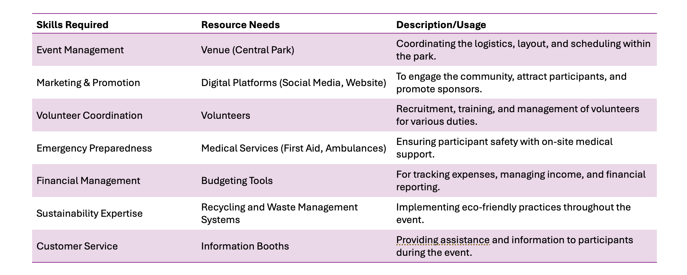
6. Event Budget
The financial framework of the "Charity Walk for Clean Water" is carefully crafted to maintain a balance between raising significant donations for the cause and supporting operating expenses. Here is a concise analysis of the expected revenue and expenses, emphasising funding sources and income creation tactics.
Income:
Donations are expected to reach 2,000 and serve as a main source of cash, generated through internet campaigns and on-site collecting at the event.
Sponsorships are anticipated to generate 5,000 units of cash, focusing on local businesses and organisations with CSR programmes that support environmental sustainability.
The aim is to sell 500 tickets at $10 each, generating $5,000 in ticket sales to make the event financially viable and accessible.
Merchandise sales are estimated at 1,000 units. Sales of eco-friendly items will provide financial support for the cause and raise awareness.
Total income: 13,000
Expenditures:
Venue Rental: Priced at 2,000, this fee guarantees a top-tier location that is convenient and well-suited for the event.
Permits and insurance are crucial for legal compliance and risk management, with a cost of 1,000.
Marketing & Promotion are crucial for attracting participants and sponsors using various media with a budget of 2,000.
Operational Costs: Totaling 5,000, this includes expenses for venue setup, security, medical services, and food.
Merchandise Production: With a quantity of 500, this process enables the development of branded objects intended for sale to generate cash.
Total Expenditures: 10,500
Net income: 2,500
The budget is designed to make sure the event is financially sustainable and to maximise donations to the cause. Expenses like venue rental and marketing are meticulously discussed to guarantee cost-effectiveness without sacrificing quality. The strategic pricing of tickets and items is intended to boost participation and generate extra money, respectively. Sponsorships and gifts are crucial because they offer substantial financial assistance without adding further expenses to the event. The financial strategy is cautious to account for unexpected expenses and to ensure the event can successfully fund water sustainability activities.
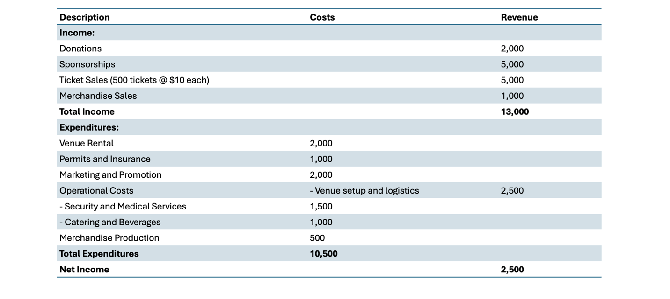
7.Industry Trends/Impacts
Recent trends, influenced by technological advancements, sustainability concerns, and the global shift towards personalised interaction, have greatly changed the meetings and events business. An analysis of the current factors impacting the "Charity Walk for Clean Water."
Virtual and Hybrid Events:
The rise in virtual events, prompted by the COVID-19 epidemic, has had a lasting impact on the business despite the resumption of in-person gatherings (Gordon-Bennett, 2022). Hybrid events are now common, merging the wide audience and convenience of virtual events with the interaction of in-person experiences (InEvent, 2023). Introducing a virtual participation option for the "Charity Walk for Clean Water" could broaden its scope by enabling individuals worldwide to participate remotely and support the cause.
Sustainability Focus:
The business is placing a greater focus on sustainability, with events now being required to implement eco-friendly methods and demonstrate environmental responsibility (Events, 2022). The "Charity Walk for Clean Water" naturally supports sustainability, which could enhance its attractiveness to environmentally aware participants and sponsors.

Personalization and Customer Experience:
Personalisation is crucial for improving the consumer experience. This approach entails customising the event experience based on individual preferences, frequently utilising data analytics (Deloitte, 2022). Utilising data to personalise messages and engagement methods for the "Charity Walk" could enhance participant satisfaction and retention.
Local and Community Engagement:
There is a trend towards engaging local communities and companies in events to enhance the cultural richness and significance of the experiences (CPI, 2022). This is seen in the "Charity Walk for Clean Water," where it collaborates with local NGOs and companies, aligning with participants' wish to support their community's well-being.
Increased Focus on Health and Wellbeing:
Events are now more frequently including health and wellness components, such as wellness activities or prioritising the health and safety of participants (CIPD, 2023). The "Charity Walk" can take advantage of current public health concerns by highlighting health advantages and safety protocols to make it more appealing.
8. Cultural and Situational Considerations
The "Charity Walk for Clean Water" event's resonance and effectiveness depend significantly on broader cultural and situational factors. The elements encompass cultural variety, inclusion, environmental ethics, and the present socio-economic climate.
Cultural Diversity and Inclusivity:
Considering the essential need for water worldwide, the event should cater to and honour the cultural variety of the potential attendees. This involves recognising different cultural customs related to charitable giving, communal events, and environmental conservation. Integrating multicultural aspects like varied food options and linguistic assistance can increase inclusivity and improve the participant experience at the event. It is important to acknowledge ethnic holidays and observances that may align with the event schedule to prevent unintended exclusion and increase attendance.
Environmental Ethics:
The event dedicated to sustainability must exemplify the ideas it promotes. This requires reducing the carbon impact and ensuring that all event components, such as merchandise and catering, meet strict environmental criteria. Showing dedication to sustainability can enhance credibility and resonate with the ideals of environmentally aware individuals.
Socio-Economic Context:
Economic situations can impact both individuals' desire to donate and the availability of corporate sponsorships. Comprehending the economic environment is essential for establishing practical fundraising objectives and customising the event's communication. During difficult economic periods, highlighting the concrete effects of donations can promote generosity.
Public Health Situation:
Given worldwide health issues like the COVID-19 epidemic, it is crucial to think about the consequences of large public gatherings. Implementing health rules for participants and providing virtual participation choices can address health and safety concerns while expanding the event's audience.
Political Climate:
The design and execution of an event can be greatly affected by local restrictions and political stances on public events and environmental concerns. It is crucial to navigate this terrain with care and compliance to prevent obstacles and gain cooperation from local authorities.
9. Conclusion
The "Charity Walk for Clean Water" symbolises the merging of communal togetherness, environmental care, and worldwide accountability. This event is intended to go beyond just raising funds and instead intends to cultivate a heightened awareness of water sustainability and rally a unified reaction to a crucial global problem. The planned activities, strategic venue choice, and the walk itself are all part of a thoughtfully designed experience that supports the crucial goal of providing clean water access globally.
The event is painstakingly planned and executed, from conceptualization to operational details and budgetary planning, as outlined in this report. Utilising the Event Cycle guarantees a methodical and meticulous approach, covering each phase thoroughly. The SMART objectives establish a clear and attainable plan for success, supported by tactics that adapt to industry changes, technological progress, and the present socio-economic environment.
The event's operations are based on inclusivity, acknowledging the diversity of the community it serves. This approach applies to all aspects, including marketing and face-to-face encounters, to ensure that every participant feels appreciated and included. The "Charity Walk for Clean Water" leads the way in modern event management by including current industry trends including hybrid event formats, a strong emphasis on sustainability, and personalised experiences.
The careful budget planning guarantees that financial resources are used efficiently, maximising the effectiveness of each dollar generated for the cause. The event serves as a chance to raise cash, educate, and inspire, leading to a lasting impact that goes beyond the walk itself.
Cultural and situational factors are included into the planning and implementation process, recognising the diverse community values, public health issues, and environmental principles. The event is prepared to adeptly manoeuvre through the political and economic environment, assuring adherence to regulations, and promoting positive relationships.
The "Charity Walk for Clean Water" demonstrates the effectiveness of community-led efforts in tackling worldwide issues. The event demonstrates that strategic planning, including the community, and prioritising sustainability may result in an event that has a positive impact on social, environmental, and economic aspects. It serves as an example of how events may spark change by harnessing the combined energy of people towards a worthy goal, and signalling progress towards a future where clean water is not scarce but a sustainable norm for everyone.

10. REFERENCE LIST

CIPD (2023). Wellbeing at Work. [online] CIPD. Available at: https://www.cipd.org/uk/knowledge/factsheets/well-being-factsheet/ [Accessed 26 Feb. 2024].
CPI, C. (2022). Maximizing Event Budgets in 2022 and Beyond | MPI. [online] MPIWeb. Available at: https://www.mpi.org/essential-guide/blog/article/maximizing-event-budgets-in-2022-and-beyond [Accessed 26 Feb. 2024].
Deloitte (2022). Connecting meaningfully in the new reality. [online] Available at: https://www2.deloitte.com/content/dam/Deloitte/ca/Documents/deloitte-analytics/ca-en-omnia-ai-marketing-pov-fin-jun24-aoda.pdf [Accessed 26 Feb. 2024].
Events, G. (2022). Green Events Code. [online] Vision 2025. Available at: https://www.vision2025.org.uk/green-events-code/ [Accessed 26 Feb. 2024].
Gordon-Bennett, C. (2022). Hybrid: The Guide to In-person Events With a Virtual Audience. [online] Bizzabo. Available at: https://www.bizzabo.com/blog/in-person-events-with-virtual-audience [Accessed 26 Feb. 2024].
InEvent (2023). ‘What are Hybrid Events?’: Your Ultimate Guide. [online] InEvent Blog. Available at: https://inevent.com/blog/tech-and-trends/maximize-engagement-hybrid-events-virtual-inperson-experiences-ultimate-guide.html#:~:text=Conclusion. [Accessed 26 Feb. 2024].
Mao, B. (2022). Work together to improve access to clean water worldwide. [online] World Economic Forum. Available at: https://www.weforum.org/agenda/2022/08/access-clean-water-inequality-financing/.
Social Tables (2019). Event Logistics: 17 Simple Secrets to Better Events. [online] Social Tables. Available at: https://www.socialtables.com/blog/event-planning/how-to-get-logistics-right/ [Accessed 26 Feb. 2024].
Younts, D. (2021). The Perfect Plan: What Are the Five Stages of Event Planning? [online] Midlothian Conference Center. Available at: https://www.midlothiancenter.com/the-perfect-plan-what-are-the-five-stages-of-event-planning/ [Accessed 26 Feb. 2024].

