

Master of Business Administration
Module Name: Marketing Management
Module Code: LCMB7024

Student Name: Shravan Nalumasu
Student ID:2432622
Lecturer’s Name: Tushara Balendran

Term 1
Assessment component 1: Marketing Environment Analysis
Table of Contents
1. Introduction 3
2. Task 1: Critical Analysis of the Macro Marketing Environment 4
2.1 Overview of the Macro Marketing Environment 4
2.2 Selection of Two External Macro Marketing Actors 4
2.2.1 Economic Conditions 5
2.2.2 Technological Change 6
2.3 Critical Analysis of Each Actor 8
3. Task 2: Strategic Responses of Pioneering and Follower Organisations 10
3.1 Pioneering Organisations’ Strategic Responses 10
3.1.1 Ansoff’s Growth Matrix – M&S 11
3.1.2 Porter’s Generic Strategies – M&S 12
3.2 Follower Organisations’ Strategic Responses 13
3.2.1 Ansoff’s Growth Matrix – ASOS 14
3.2.2 Porter’s Generic Strategies – ASOS 15
4. Conclusion 15
Reference List 17

1. Introduction
The report will focus on investigating the strategic marketing management to two UK-based fashion or retail organisations such as the pioneering retailer Marks & Spencer (M&S) and the following online fashion retailer ASOS. The purpose of the report is to understand how the organisations share a broader industry respond differently in a better manner to shift in their macro marketing environment, along with any differences in strategic response from a well-established pioneer compared to a relatively younger follower company. The process of understanding the macro environment is important for decision-making in strategic marketing as the changes in some external factors have the ability to serve for impacting a number of aspects of the marketing procedures, including subsequent behaviour of consumer, structures based on cost, competitive positions and opportunities to increase and expansion (Yaneva, 2020).

Figure 1: Logo of Pioneer Company (Marks and Spencer)
(Source: M&S, 2025)

Figure 2: Logo of Follower Company (ASOS)
(Source: ASOS Plc, 2025)
The first task is focused on a critical assessment of the macro marketing environment, using the models, like PESTEL framework considering the two factors such as change in technology and economic conditions for the purpose of examining how it affect both pioneer and follower firms. In the second task, it will discuss the strategic choices and decisions established by M&S (pioneer) and ASOS (follower) using strategic models including the models such as Ansoff's Growth Matrix and Porter's Generic Strategies. These helps in demonstrating how the firm responds to the external drivers that are previously identified. Finally, the report conclude with a summary of findings, and the importance of environmental landscape and its strategic role in marketing.

2. Task 1: Critical Analysis of the Macro Marketing Environment

2.1 Overview of the Macro Marketing Environment
The macro marketing environment focuses on providing the sizable external context in which all firms helps in operating by the PESTEL framework. These forces outlines the methods of establishing the opportunities of market and threats in market with influential consequences for the decisions based on strategic marketing with respect to promotion, market entry, development of product, pricing, and distribution (Asawawibul et al., 2025). The two external actors are: (1) economic conditions, and (2) technological change. Economic factors impact the spending of customer, pricing, and profitability, at the same time advancement in technology focuses on reshaping the e-commerce operations, and engagement with customer (Sharma, Srivastva and Fatima, 2023).

2.2 Selection of Two External Macro Marketing Actors
The conditions of economic aspects are important such as M&S reported evidence of strong revenue growth of food and other accessories of 12.3% in the face of pressures associated with cost-of-living in the grocery market of UK (The Guardian, 2025). Inflation, growth in wage, and consumer flexible spending are all considered as the conditions that impact the performance of retailers in a direct manner. Change in technology is another major actor including the company M&S, which has committed towards digital transformation, and have focused on reducing the carbon emission which is linked to their technology of supply-chain (M&S, 2025).

2.2.1 Economic Conditions
First, the conditions based on economic aspects exist as a consideration. For example, in 2024, the output of retail sector in UK was £111.6 billion, which accounted for the rate of 4.5 % of the total output with the landscape of UK (Ward, 2025). Furthermore, the inflation of consumer remained high in the period of August 2025, CPI was considered as 3.8% (Tmhcc.com, 2025).
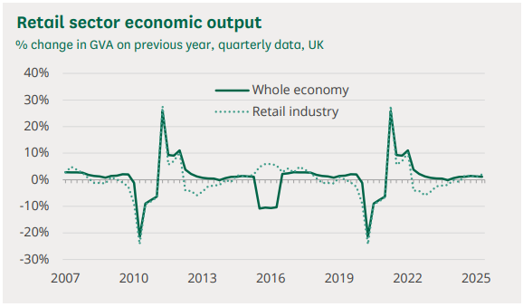
Figure 3: Economic Output of Retail Sector
(Source: Ward, 2025)
Retailers also noted weak demand involves the monthly measure from the CBI decreased to 29 in September 2025, which was indicated in decreased sales for twelve consecutive months (Reuters Staff, 2025). These factors are considered as for pioneer organisations that is legacy retailers who have provided a broad range of products, along with the follower organisations who are specialists in operations of e-commerce. These involves the pressure to factors of consumer spending down flexible spending, increases in sensitivity of price, and establishes additional pressure on margins, which combines the economic conditions are a considerably potent external factor.
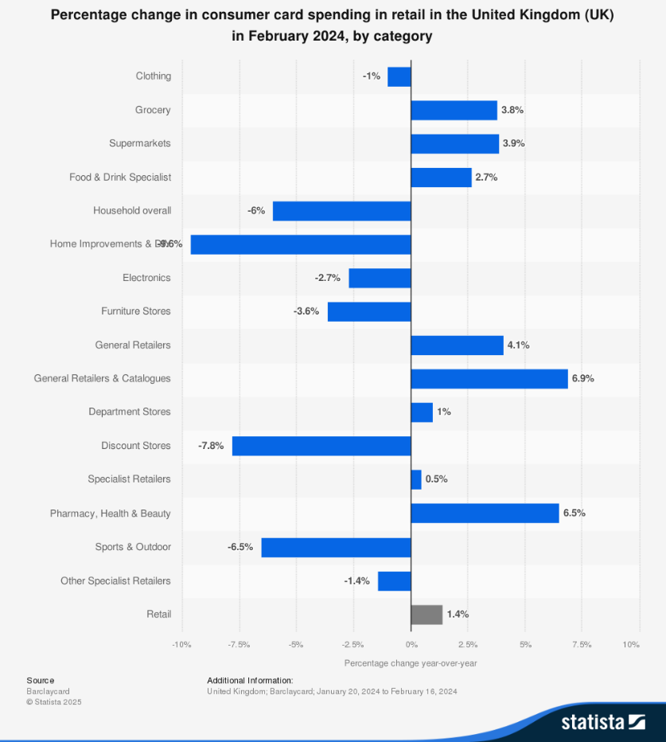
Figure 4: Change in Consumer Spending in UK Retail Market
(Source: Statista and Barclaycard, 2025)

2.2.2 Technological Change
The second external actor is technological change, which involves an interest due to the fast pace of digital transformation within retail. These have stated that advances in AI, robotics, platforms of e-commerce and capabilities related to omnichannel are changing practices in operations, supply chains and engagement with customer (Deloitte, 2025). The relevance of this factor is the difference as it establishes between pioneer executives with legacy networks of store and established systems, and follower digital natives with quick online models. For example, rapid adoption of online sales at the rate of 27.6% of all UK retail sales in August 2025, which focuses on demonstrating the increasing importance of digital channels (Tmhcc.com, 2025).
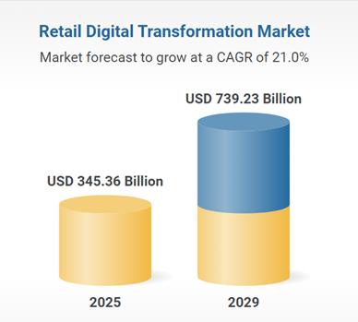
Figure 5: Market Forecast of Retail Digital Transformation
(Source: Researchandmarkets, 2025)
Change in technological aspects is important as an external actor shaping strategy of channel, cost base, experience of customer and competitive disruption. The report of industry explore that the global market in retail digital transformation is valued at USD 345bn in the year 2025 and growing at 21% CAGR (Researchandmarkets, 2025). Furthermore, rate of 99% of UK retail decision-makers has efforted on reporting some level of expertise in AI applied in their business (Retail Technology Innovation Hub, 2025).
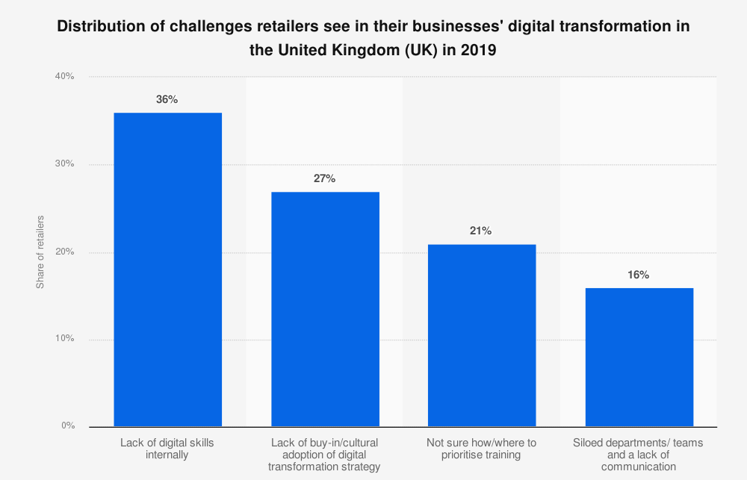
Figure 6: Challnges in the UK Retail Businesses’ Digital Transformation
(Source: Statista and Retail Week, 2025)

2.3 Critical Analysis of Each Actor
The combination of heritage of physical stores and their online channels of M&S focuses on necessitating significant investments for carrying out the necessary upgrades with their systems from a technical perspective. In contrast, ASOS with its model based on digital business, which has potentially segmented the agility, and might result in experiencing faster advantage based on “speed to market” through the development of new product (ASOS Plc, 2025). Recent data focuses on demonstrating that the own-brand sales of ASOS in UK have resulted in growing the 9% Year on Year for H1 FY25 (ASOS Plc, 2025).
External Actor | Organisation | Impact: Opportunities & Threats | Key Strategic Implications
Economic Conditions | Pioneer: Marks & Spencer (M&S) | Opportunities: M&S reported food sales growth of 9.1 % and like-for-like volume up 6.7 % in FY 25, improving resilience amid cost-of-living pressures (M&S, 2025).  Threats: Inflation remains at 4.1 % (CPIH) in UK to Sept 2025; sustained consumer budget constraints could reduce discretionary spend (Ons.gov.uk, 2025) | With stronger food results, M&S must reinforce its value proposition and cost control across its clothing and home business; monitoring consumer confidence must inform channel and product mix decisions.
Economic Conditions | Follower: ASOS plc (ASOS) | Opportunities: Lower cost structure (online-only) allows agile pricing and global expansion in tighter economy.  Threats: ASOS guided FY25 revenue decline of -9 % to -2 %, indicating heightened sensitivity to economic squeeze in discretionary fashion (Dunn, 2025). | ASOS must prioritise cost-leadership, optimise supply-chain efficiency, and target growth in non-UK markets to offset weak domestic demand; must also reassess brand positioning to avoid value erosion.
Technological Change | Pioneer: M&S | Opportunities: Digital transformation enables omni-channel integration and improved customer experience; e-commerce growth in UK expected to reach 30.7 % of total retail by 2025 (Perkins, 2025).  Threats: Legacy store estate and dated systems increase capital burden and slow agility relative to digital natives. | M&S must invest in scalable online and mobile platforms, accelerate logistics and supply-chain automation, and reallocate resources from under-performing physical formats to digital-first models.
Technological Change | Follower: ASOS | Opportunities: UK e-commerce market value projected at USD 265 billion in 2025 with strong mobile component (55 %) involves ideal for ASOS’s online-native model (Mordor Intelligence, 2023).  Threats: Market growth rate slowing to 3.6 % in 2025 signals maturity; intense digital competition and higher customer acquisition costs (Perkins, 2025). | ASOS should exploit its agile digital capabilities, emphasise global and mobile growth segments, differentiate through speed and innovation, but also control digital marketing costs and invest in customer retention.

3. Task 2: Strategic Responses of Pioneering and Follower Organisations

3.1 Pioneering Organisations’ Strategic Responses
Being a pioneer for a long time, the brand of M&S particularly interacts with challenges as well as opportunities in the external landscape by improving its main value proposition, such as quality and trust. This thus helps in giving a new life to its physical and virtual stores and making sustainability such as "Plan A" a key attribute of its brand (Retail Gazette, 2024). It does this by adopting changes in aspects of technology along with economic conditions through upgrading its operations and also boosting omnichannel capabilities.
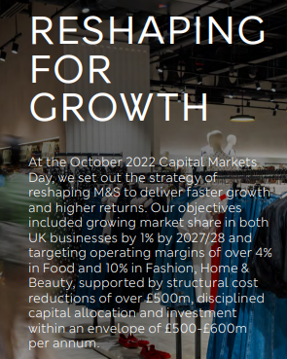
Figure 7: Reshaping for Growth Program
(Source: M&S, 2025)
Strategic responses involve the implementation of framework such as Ansoff’s Growth Matrix through the sustainability initiative based on “Plan A” and Porter’s Generic Strategies involves differentiation for the first mover organisation M&S. As an example, M&S has revealed that mid-year pre-tax profits which grew by 17% with the sales of food increasing by the rate of 8.1% (The Guardian, 2024).

3.1.1 Ansoff’s Growth Matrix – M&S
Growth strategy | Description at M&S | Example activity
Market Penetration | Strengthening presence in existing UK food and clothing markets | M&S: “Reshaping for Growth” programme delivering increased share in food and clothing (M&S, 2025).
Product Development | Introducing new products or improving existing ones for the current market | Launching functional-food ranges (gut health, brain health) in its food division (FoodNavigator.com, 2025).
Market Development | Entering new geographic markets or new customer segments for existing products | Expansion of food store count from 316 to 420, targeting a broader UK footprint (M&S, 2025).
Diversification | New products for new markets which is more risky but potentially high reward | Bringing third-party brands into its apparel and home business to attract younger demographics (Retail Gazette, 2024).
Although the application of the four Ansoff strategies at M&S is not always apparent, the company does use all of them. It keeps core aspects such as market penetration strong, creates new products through product development, expands to new geographical markets focusing on market development and tries out nearby businesses by understanding and highlighting diversification, thus aiming to find a balance between risk as well as its innovative heritage as well as brand strength.
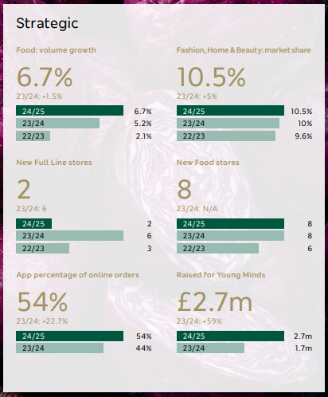
Figure 8: M&S Strategic Figures
(Source: M&S, 2025)

3.1.2 Porter’s Generic Strategies – M&S
Strategy | M&S Strategic Approach | Illustrative Evidence
Cost Leadership | Streamlining operations and reducing reliance on heavy promotions to offer better value | M&S reduced % of food sales on promotion in 2017 which increased to 3.9% in recent years (M&S, 2025).
Differentiation | Emphasising product quality, premium ranges, branded collaborations and sustainability credentials | M&S focuses on “quality worth paying for”, investing in style and third-party brands (M&S, 2025).
Focus | Targeted segments such as food premium convenience, younger apparel, within the overall market | M&S’s food business is targeting convenience and functional health products (Retail Gazette, 2024).
It can thus be stated that M&S adopts a mixed or hybrid strategy of cost leadership and differentiation to its advantage, where it raises value by slashing the cost of marketing and at the same time stressing the quality of the product and the uniqueness of the product, placing itself even more firmly in this context, as a pioneer retailer.
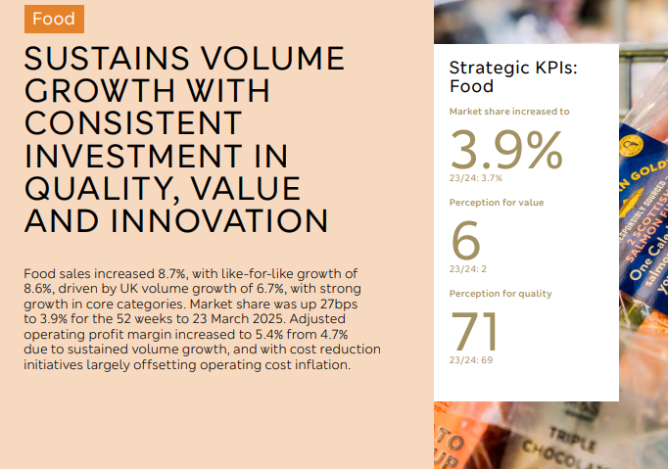
Figure 9: M&S Food Sales
(Source: M&S, 2025)

3.2 Follower Organisations’ Strategic Responses
ASOS, as a following firm, responds to the dynamics of the market with aspects such as agility, as well as a digital-first operating model and a niche market strategy, instead of with legacy infrastructure. It therefore quickly surges online growth in response to external changes, tailors its products toward younger consumers, and pushes aggressively to adapt its cost and inventory structure. This approach allows ASOS to effectively compete even in the midst of being a late entrant in the market.
A strategic response includes the use of online growth, development of product and leadership or focus of cost for ASOS as a second mover. Despite strategic models of ASOS suggesting a hybrid of focus and cost or differentiation through a bespoke approach targeting a customer trend based on younger aspects and agiler fulfilment. There is some negative news involved a revenue declined in the year of 2023 to £3.54 billion, down at the rate of 9.9% (Curry, 2022).

3.2.1 Ansoff’s Growth Matrix – ASOS
Growth strategy | Description at ASOS | Example activity
Market Penetration | Increasing share in existing online fashion markets among young consumers | ASOS is ramping up its own-label and marketplace offerings targeted at UK/EU youth (Fashion Network, 2025).
Product Development | Developing new product lines or features within its existing online market | Launching new “responsibly made” own-brands and expanding beauty/active assortments.
Market Development | Entering new geographic markets or customer segments with existing products | ASOS is moving into additional international regions (over 200 markets) and male fashion segments (ASOS Plc, 2025).
Diversification | Introducing new product-market combinations (higher risk) | Expanding into third-party marketplace and brand partnerships beyond its core online retail model.
ASOS applies the entire range of the Ansoff matrix, where it builds on its foundations, such as penetration, and also develops new products in its categories, thus entering new markets, and takes on initiatives which pose more risks. This allows a follower firm to stay nimble and close to evolving customer behaviour.
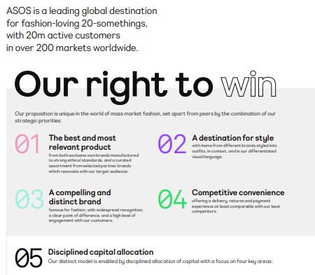
Figure 10: ASOS Strategic Goals
(Source: ASOS Plc, 2025)

3.2.2 Porter’s Generic Strategies – ASOS
Strategy | ASOS Strategic Approach | Illustrative Evidence
Cost Leadership | Operating an agile, purely online model with lean inventory and rapid turnaround to offer competitive pricing | ASOS combines cost leadership with differentiation.
Differentiation | Curating fast-fashion high-trend items, providing a strong own-brand identity and digital experience | Parker and Alexander (2022) emphasise ASOS’s focus on unique service and brand image for youth.
Focus | Targeting younger, fashion-conscious consumers online rather than the mass market | The company directed its offering at 20-something global shoppers in multiple markets (ASOS Plc, 2025).
ASOS possesses, as can be checked, a hybrid strategy in which it targets a niche market consisting of young consumers while simultaneously combining the elements of cost-leadership, which is done through an online model and scale, as well as differentiation through fast trends and digital experience. By utilising this method, the follower remains competitive in a market that has already become overcrowded.

4. Conclusion
In conclusion, the wider context is impacted by effective drivers such as economic conditions and change in technology where both the company has responded. The incumbent M&S has strong brand allegiance and some diversification, whereas required to absorb and engage investment towards change. The newcomer ASOS has digital agility and trend-sourcing is exposed towards the conditions of economic aspects and has an identified gap for investment in branded stock. The assessments of strategic options indicate that continuous observation of the business environment, the use of strategic models like PESTEL, Ansoff and Porter, which is mainly the process of executing adaptive responses of marketing in a proactive manner, and has the ability to support the continued competitiveness.
The quality of observation allows firms for the purpose of evaluating the opportunities such as increased online base of customer or sustainability and early threats like inflation, and disruption, along with the adaptive marketing responses, which results in allowing them for taking advantage or deflect. In the end, whether as a been a leader or someone following on from being a leader, on strategic marketing management is being able to align their sites internal resources with external conditions while behaving in a proactive manner, as opposed to a reactive one. Ultimately, success in strategic management of marketing focuses on aligning internal capabilities with external realities along with acting in proactive is not considered as reactive. This helps in improving that the sustainable and effective success demands innovation in a continuous manner, agility centred by customer, digital integration, and strong considered planning in an ever-changing competitive landscape.

Reference List
Asawawibul, S., Na-Nan, K., Pinkajay, K., Jaturat, N., Kittichotsatsawat, Y. and Hu, B., (2025). The influence of cost on customer satisfaction in e-commerce logistics: Mediating roles of service quality, technology usage, transportation time, and production condition. Journal of Open Innovation: Technology, Market, and Complexity, 11(1), p.100482. https://www.sciencedirect.com/science/article/pii/S2199853125000174
ASOS Plc (2025). New commercial model driving profitability transformation. Available at: https://asos-12954-s3.s3.eu-west-2.amazonaws.com/files/7517/4654/1590/HY_FY25_Interim_Results.pdf
Curry, D. (2022). ASOS Revenue and Usage Statistics (2022). Business of Apps. Available at: https://www.businessofapps.com/data/asos-statistics/
Deloitte (2025). Retail Trends | Deloitte UK. www.deloitte.com. Available at: https://www.deloitte.com/uk/en/Industries/consumer/perspectives/retail-trends.html
Dunn, N. (2025). Top 33 ecommerce statistics, facts and figures you need to know in 2023. www.charle.co.uk. Available at: https://www.charle.co.uk/articles/ecommerce-statistics/
Fashion Network (2025). Asos hits youth sweet spot again with soaring profits, sees huge global potential. Available at: https://uk.fashionnetwork.com/news/Asos-hits-youth-sweet-spot-again-with-soaring-profits-sees-huge-global-potential
FoodNavigator.com (2025). M&S’s Global Food Business Strategy – Is There opportunity? Available at: https://www.foodnavigator.com/Article/2025/02/27/how-to-get-food-listed-with-ms-using-its-business-strategy.
M&S (2025). HIGHLIGHTS OF THE YEAR Financial Strategic Marks and Spencer Group plc Annual Report and Financial Statements 2025 2 STRATEGIC REPORT GOVERNANCE FINANCIAL STATEMENTS. Available at: https://corporate.marksandspencer.com/sites/marksandspencer/files/2025-05/M-and-S-Strategic-Report-2025.pdf
M&S, (2025). MARKS AND SPENCER PLC- FINANCIAL STATEMENTS 2025. Available at: https://corporate.marksandspencer.com/sites/marksandspencer/files/09-2025/SIGNED%20Financial%20Statements%20-%20Marks%20and%20Spencer%20plc%20FY25.pdf
Mordor Intelligence (2023). UK E-commerce Market Size, Share (2022 - 27) | Industry Report. www.mordorintelligence.com. Available at: https://www.mordorintelligence.com/industry-reports/united-kingdom-ecommerce-market
Ons.gov.uk (2025). Consumer price inflation, UK. [online] Ons.gov.uk. Available at: https://www.ons.gov.uk/economy/inflationandpriceindices/bulletins/consumerpriceinflation/september2025
Parker, G.L. and Alexander, B., (2022). Digital only retail: assessing the necessity of an asos physical store within omnichannel retailing to drive brand equity. Bloomsbury Fashion Business Cases. https://ualresearchonline.arts.ac.uk/id/eprint/17978/1/ASOS%20case%20study%20accepted%20version,%20BFBC.pdf
Perkins, C. (2025). UK Retail and Ecommerce Sales Benchmarks 2025. EMARKETER. Available at: https://www.emarketer.com/content/uk-retail-ecommerce-sales-benchmarks-2025
Researchandmarkets (2025). Retail Digital Transformation Market Report 2025. Researchandmarkets.com. Available at: https://www.researchandmarkets.com/reports/5983838/retail-digital-transformation-market-report?srsltid=AfmBOopuuA1NUKQNbFjysRpTUAPFaBY96R-oxPYftlTvfst49tTXlt2r
Retail Gazette (2024). 5 Ways M&S Has Driven Bumper Profits - Retail Gazette. Available at: https://www.retailgazette.co.uk/blog/2024/05/5-ways-ms-profits/.
Retail Technology Innovation Hub (2025). Retail Technology Innovation Hub. Retail Technology Innovation Hub. Available at: https://retailtechinnovationhub.com/home/2025/8/18/ai-technology-adoption-surges-as-majority-of-uk-retailers-now-have-chief-ai-officers-to-drive-strategy
Reuters Staff (2025). UK retail sales fall for 12th month in a row, CBI says. Reuters. Available at: https://www.reuters.com/business/retail-consumer/uk-retail-sales-fall-12th-month-row-cbi-says-2025-09-25/
Sharma, R., Srivastva, S. and Fatima, S., (2023). E-commerce and digital transformation: Trends, challenges, and implications. Int. J. Multidiscip. Res.(IJFMR), 5, pp.1-9. https://pdfs.semanticscholar.org/9090/1ca619de45cfc8df70b1804923d497e8058e.pdf
Statista and Barclaycard. (2025). Percentage change in consumer card spending in retail in the United Kingdom (UK) in February 2024, by category. Statista. Statista Inc. Available at: https://www.statista.com/statistics/1085656/growth-in-spending-in-the-uk-by-category/?srsltid=AfmBOopdLh2veyB7K3u8Hb-12sffdbn9RZ8CTX1USPIzIvDvMcYMbcLi
Statista and Retail Week. (2025). Distribution of challenges retailers see in their businesses' digital transformation in the United Kingdom (UK) in 2019. Statista. Statista Inc. Available at: https://www.statista.com/statistics/1015823/challenges-retailers-see-in-digital-transformation-united-kingdom-uk/?srsltid=AfmBOopEHmsx9MQW3Qb33dJkK2C9l8mE8CtQklrX6qIet7aFw0NcOIAY
The Guardian (2024). M&S profits rise but retailer warns of £60m hit from Reeves’s budget. the Guardian. Available at: https://www.theguardian.com/business/2024/nov/06/m-and-s-profits-jump-but-reeves-budget-could-cost-it-120m-in-2025
The Guardian (2025). UK grocery inflation jumps to highest level in 15 months. the Guardian. Available at: https://www.theguardian.com/business/2025/may/28/uk-grocery-inflation-jumps-to-highest-level-in-15-months
Tmhcc.com (2025). UK Retail Sector Report: October 2025. Tmhcc.com. Available at: https://www.tmhcc.com/en/news-and-articles/thought-leadership/uk-retail-sector-report-oct-2025
Ward, M. (2025). Retail Sector in the UK. Parliament.UK. Available at: https://researchbriefings.files.parliament.uk/documents/SN06186/SN06186.pdf
Yaneva, D., (2020). Importance of the marketing environment analysis in the process of Strategic Marketing Decision making. Economics and Law, 2(2), pp.24-32. https://el.swu.bg/wp-content/uploads/2020/12/IMPORTANCE-OF-THE-MARKETING-ENVIRONMENT-ANALYSIS-IN-THE-PROCESS-OF-STRATEGIC-MARKETING-DECISION-MAKING.pdf

