

University of Wales
Trinity Saint David

LCBB6002
International Financial Management
Lindt & Sprüngli
ASSIGNMENT 1

Teodora Georgieva
Student ID: 2111818
Date of submission: 29/12/2023

Table of Contents

1. Introduction ………………………………………………….…………………………..2
2. Foreign exchange risks and types…………………………………………..……..……...2
2.1.Transactions exposure…...…………………………………………………………...3
2.2.Translation exposure………………………………………………….………..…….3
2.3. Economic exposure………………………………………………………………….4
3. Lindt & Sprüngli – exposure to Foreign exchange risks….……....……………………...5
4. Management strategies adopted by the Lindt & Sprüngli…...…………………………...5
4.1. Hedging Techniques…………………………………………………………………5
4.2. Natural hedging ………………………………………………………………….….6
4.3. Diversification……………………………………………………………………….6
5. Evaluation company management in foreign exchange risk……………….…….….…...7
6. Recommendations ……………………………………………………………………….8
7. Conclusion ………………………………………………………………………….......11
8. References …………..……………..…………………………………………………...12

1. Introduction
The management of companies operating in international markets includes activities not only of the type of import and export of goods but also international financing and investment. The purpose of this management is to increase the capabilities and value of the company (Madura et al., 2018). Larger firms set up subsidiaries in other countries to take advantage of new destinations. However, there are also attendant risks such as inflation, tariffs and interest rates that need to be considered. This essay will show the types of currency risks as well as the approach and challenges for the international company Lindt & Sprüngli to deal with them. I also added recommendations for better and more successful work.
2. Foreign exchange risks and types
The management of currency risks requires effective techniques and strategies because of the danger of unwanted consequences on the profitability of the company, incorrect assessment of investors and analysts, as well as because of correct forecasting of international market trends. Fluctuations in currency exchange rates place multinational companies at constant potential risk. Transfers, transactions and economic exposure are the critical operations that cause difficulties and the decisions that need to be made are according to their nature (Madura, 2018).
2.1. Transactions exposure
Transaction exposure is when the company pays or receives funds that are denominated in foreign currencies. In this case, there is a risk of possible losses or gains in the settlement (Shapiro and Hanouna, 2019). Exchange rates and their fluctuations are the determining factors here, with transaction exposure affecting each transaction differently.
2.2. Translation exposure
Translation exposure exists when a multinational corporation combines all the reporting currencies of its subsidiaries into one common functional currency of management. Fluctuations in exchange rates have a positive or negative impact on a company's overall statements and financial performance (Hull, 2018).
2.3. Economic exposure
On the other hand, compared to the rest of the exposures, the economic or operational exposure has an impact on the assets of a multinational corporation affected by certain transactions but also provides guidelines for dealing with competition, market demand and cost structuring and how to manage risks for the company (Bodnar & Wong, 2003).
3. Lindt & Sprüngli – exposure to Foreign exchange risks
Lindt & Sprüngli, a global company for the development, production and sale of luxury chocolate products and 178 years of experience, headquartered in Kilchberg, Switzerland and listed on the SIX Swiss Exchange, is distributed by 32 subsidiaries, including Japan, Brazil, China and South Africa and regional offices in Sweden, United Arab Emirates, Ireland, North America, Czech Republic, Mexico, Hungary, Netherlands and Portugal (Lind and Spruengli, 2023). There are 12 production bases spread across Europe and America. Converting US Dollars or Euros to Swiss Francs, for example, may affect earnings when converted to Swiss Francs (CHF). The company also has 500 stores with their brand, as well as more than 100 independent distributors (Lindt and Spruengli, 2023). Undoubtedly, the holding's large-scale activity is exposed to currency risks at every stage of management – from production facilities to international sales.
In allocating costs, the company aims to monitor the exchange rates of the currencies of the countries playing a major role in the production processes and of its main suppliers of raw materials, which are mainly producers of cocoa beans from farms in Ecuador, Ghana, Madagascar, the Dominican Republic and Papua New Guinea (Lindt and Spruengli, 2023). If Lindt and Sprüngli source cocoa or other ingredients from countries with different currencies, changes in exchange rates may affect the cost of goods sold. For example, if the company sources cocoa from West Africa and sells the product in the United States, provided the US dollar strengthens against the currencies of the producing countries, this may increase the price of the commodity. Lindt & Sprüngli generates a significant portion of its sales in the euro area and if the euro weakens against the Swiss franc, this could result in translation gains when converting euro-denominated earnings into Swiss francs.
4. Management strategies adopted by the Lindt & Sprüngli
To have the stability of funds and minimal costs caused by fluctuations in international currency exchange and various market changes, the company applies strategic approaches using the capacity of its international capabilities.
4.1. Hedging Techniques
Companies use various hedging techniques, including forward contracts, options and futures, to manage currency risks (Hull, 2018). In the forward contract, the company fixes a specific exchange rate for a future transaction, providing security for cash flows. The Company may exchange currencies at this predetermined rate but is not required to do so. Futures contracts offer similar benefits but are standardized and traded on organized exchanges.
Hedging can protect Lindt & Sprüngli from adverse currency movements, ensuring stable costs and revenues. With the expected receipt of payments in US dollars in the future, they can use a forward contract to hedge against a potential depreciation of the US dollar. Alternatively, if Lindt & Sprüngli expected a future payment of US$10 million for cocoa imports, they could enter into a forward contract to fix the current exchange rate, which would ensure that they would pay a predetermined amount in their reporting currency (e.g. . CHF ) regardless of future exchange rate fluctuations. The dynamic approach of leading and lagging to manipulating currency payments is where payments are made in advance or late depending on the currency movement (Eun et al., 2021). Upon information about an expected devaluation of their currency, Lind accelerates payment so as not to lose funds.
Hedging also has disadvantages related to high fees for using financial instruments. In addition, if the company makes incorrect predictions about currency movements, hedging may result in missed profit opportunities.
4.2. Natural hedging
Lindt & Sprüngli use natural hedging by matching foreign exchange income with expenses. The company has manufacturing facilities in the United States and generates significant revenues in US dollars. With these funds, the company can naturally hedge by absorbing production costs in US dollars (Wells, 2016).
This way, the need for financial instruments and related costs is reduced, and the company's income and expenses are equalised while providing a natural buffer against currency fluctuations.
4.3. Diversification
Lindt & Sprüngli can diversify their geographic and currency exposure by operating in different countries and denominating transactions in multiple currencies. The company has manufacturing facilities in Europe and America and can benefit from revenue streams in Euros, US dollars and other local currencies. Diversification can mitigate the impact of adverse currency movements in one region by offsetting it with favourable movements in another (Levi, 2011). In cases where the euro weakens, revenues generated in US dollars may increase in value when converted to euros. When expanding its manufacturing facilities in a new country, through the new revenue stream in the local currency and diversification, the company reduces its dependence on any single currency and has control over adverse currency movements.
5. Evaluation of company management in foreign exchange risk
Due to the global nature of the company's operations, there are financial, operational and strategic risks. Decentralization in the company structure gives individual companies the advantage of taking timely control over commodity risks and exchange rate fluctuations, and commodity trade liabilities are usually hedged through hedged forward currency contracts (Lind and Spruengli, 2014).
The functional statements of the company, which are in Swiss francs, shown in the statements for the year 2022 and the first half of the year 2023 in Figures 1 and 2, show trading in currency options and forwards. The variety of currency transactions and accounting techniques require skilful management and constant control of the events and financial attitudes of each of the parties with which the company interacts.

Lindt & Sprüngli Annual Report 2022
Accounts receivable – Currencies
CHF million | 2022 | 2021
CHF | 61.2 | 48.1
EUR | 307.6 | 291.9
USD | 330.4 | 294.9
GBP | 81.7 | 85.8
AUD | 72.4 | 72.0
CAD | 42.4 | 45.2
Other currencies | 57.4 | 57.4
Accounts receivable net | 953.1 | 895.3

Fig.1 (Lindt and Spruengli, 2022)

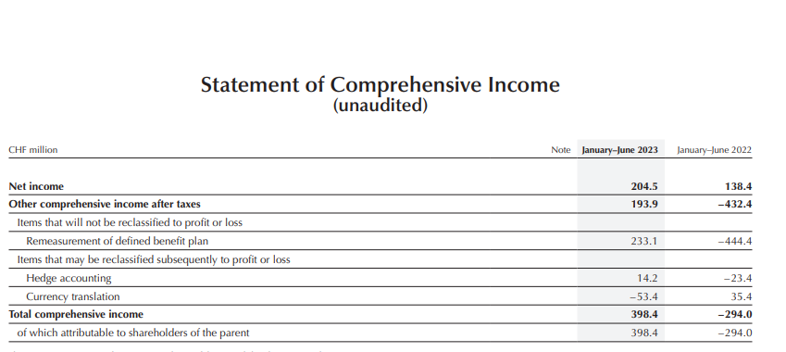
Fig.2 (Lindt and Spruengli, 2023)

The company's financial performance for the first half of 2023 shows sales growth of +10.1% to 2.09 billion Swiss francs, an increase in operating profit to 255.0 million, and an increased margin of 12.2% (Lindt and Spruengli, 2023). This positive statistic is due to the right approaches to success in its geographical segments - fig.3
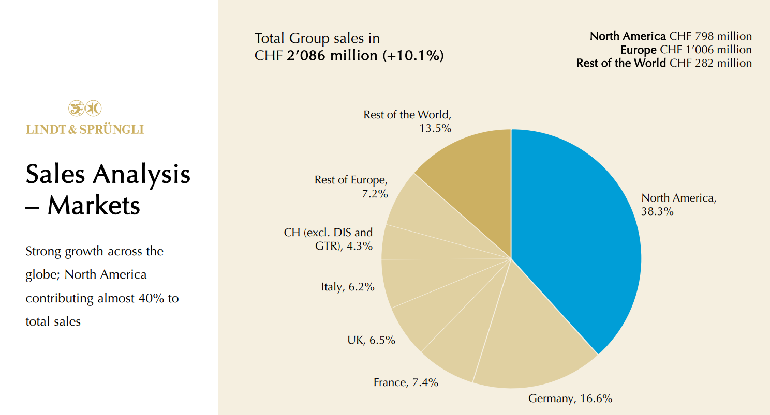
Fig.3 (Lind and Spruengli, 2023)

It should be noted that the company was able to achieve these results despite the global political, economic and social upheavals, as a result of which a large part of production costs and basic raw materials had a noticeable increase in prices. Under certain conditions, preliminary contracts are concluded or commodity futures are used for the purchase of cocoa, the price of which rises, as a result of seasonal demand, speculation or climatic conditions – Fig.4.
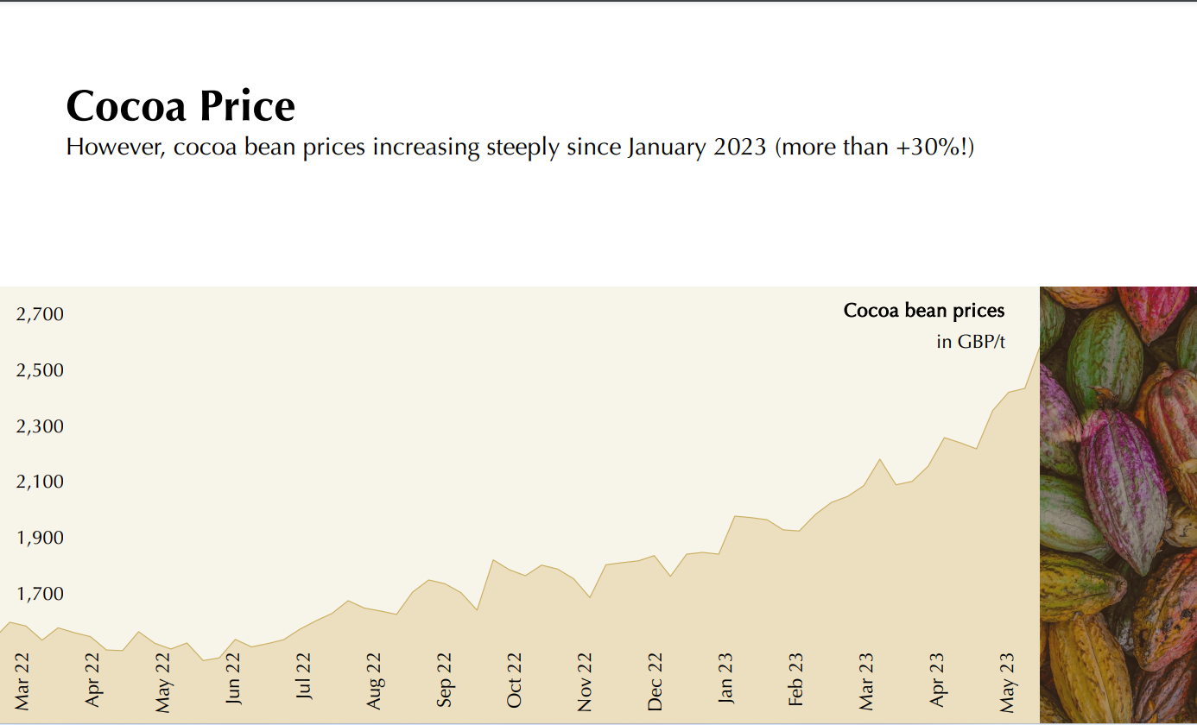
Fig.4 (Lind and Spruengli, 2023)

6. Recommendations
Strategic cash flow management skills to cover costs associated with running a business in different parts of the world are vital to a company's expected performance. Awareness of international financial regulations, compliance requirements in each country of operation and assumed currency rates is a step ahead of the competition and an opportunity to implement strategies to manage currency risk such as forward contracts or options and hedge against exchange rate fluctuations. Mitigating the impact on financial results of currency volatility can also be achieved through ERP system implementation and innovative technologies that support multi-currency functionality and ensure accurate financial reporting, profitability and efficiency. In addition, a good centralized treasury management system will allow stable control over the financial operations of the company's widely diversified investments, by monitoring and managing cash flows, liquidity and financial risks throughout the organization.
7. Conclusion
In conclusion, it can be said that international companies, in particular, Lindt & Sprüngli in their relations with subsidiaries, partners and institutions, must be well informed, flexible and innovative in taking their financial operations to have stability of income and loss protection.

8. References

Bodnar, G.M. and Wong, M.F. (2003) ‘Estimating exchange rate exposures: issues in model structure’, Financial Management, 32(3), pp.71-91.
Eun, C.S., Resnick, B.G. and Chuluun, T. (2021) International financial management. 8th edn. McGraw-Hill
Hull, J.C. (2018). Options, futures and other derivatives. 9th Edn. London: Pearson.
Levy, M. D., and Levy, M. (2011) International Finance: Markets and the Financial Management of Multinational Business. 2nd edn. London: Routledge.
Lind and Spruengli (2014) Financial report.
Available at: https://www.report.lindt-spruengli.com/14/ar/en/financial_report/notes_to_the_consolidated_financial_statements/3._risk_management.htm
(Accessed 27 12 2023).
Lind and Spruengli (2023) Half-Year Results Presentation.
Available at: https://www.lindt-spruengli.com/amfile/file/download/id/8014/file/L_S_HY_2023_Investor_Conference_PDF.pdf
(Accessed 25 12 2023).
Lind and Spruengli (2023) Lind and Spruengli Today.
Available at: https://www.lindt-spruengli.com/about-us/history
(Accessed 24 12 2023).
Lindt and Spruengli (2022) Lindt & Sprungli Annual Report.
Available at: https://reports.lindt-spruengli.com/annual-report-2022/_assets/downloads/entire-lindt-ar22.pdf
(Accessed 25 12 2023).
Lindt and Spruengli (2023) About Us.
Available at: https://www.lindt-spruengli.com/about-us
(Accessed 24 12 2023).
Lindt and Spruengli (2023) Commitment to Sustainability.
Available at: https://www.lindt-spruengli.com/about-us/history
(Accessed 24 12 2023).
Lindt and Spruengli (2023) Half Year Results Press Release.
Available at: https://www.lindt-spruengli.com/amfile/file/download/id/7984/file/Press-Release-Half-Year-Report-2023.pdf
(Accessed 25 12 2023).
Madura, J., Hoque, A. and Krishnamrti, C. (2018) International financial management. 2nd edn. South Melbourne: Cengage Learning.
Shapiro, A.C. and Hanouna, P. (2019) Multinational financial management. John Wiley & Sons.
Tun-Smith, C. (2018) Cocoa Beans for Lindt & Sprungli. PhD. University of Connecticut.
Wells, L. T. (2016) Natural Hedging: Managing Exposure to Volatility in Natural Resource Prices. New York: Springer.

