Part 2
Rohan Dubrey (1905715)
Module leader: dale clarke
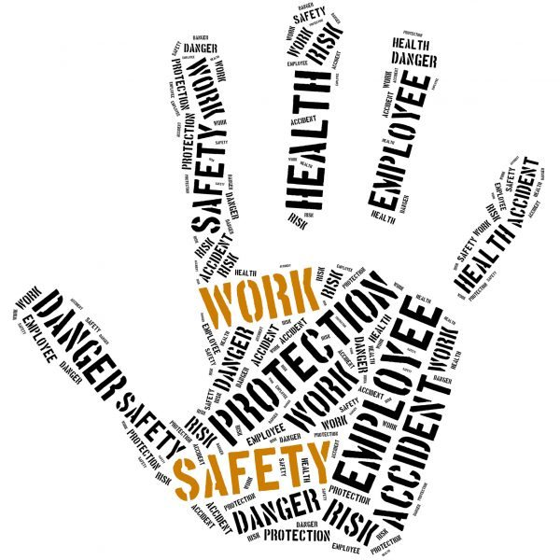

Business Skills For International Hotel Industry
MODULE CODE: M4X 01917
Contents

Introduction--------------------------------------------------------------------------------2

Healthy and Safety----------------------------------------------------------------------2

COSHH-------------------------------------------------------------------------------------3

PPE------------------------------------------------------------------------------------------4

Manual Handling--------------------------------------------------------------------------4

Fire Prevention----------------------------------------------------------------------------5

Data Protection----------------------------------------------------------------------------5

Food Hygiene------------------------------------------------------------------------------6

Risk Management-------------------------------------------------------------------------7

Liability Risk--------------------------------------------------------------------------------7

Licensing------------------------------------------------------------------------------------8

Conclusion----------------------------------------------------------------------------------9

Refrence------------------------------------------------------------------------------------10

Introduction

Throughout the hospitality industry, they are legislations in place protecting both employees and customers. However, these legislations cover stringent guidelines enabling the safety at work for staff, customers and contractors. Customers have choices on where to eat, gaining confidence and building trust through viewing businesses food hygiene ratings. This rating system is implemented within health and safety legislation (Lee, 2012).

This report will analyse the legal legislations that both managers and employees have a duty of care in maintaining, ensuring potential hazards are identified and risk assessments conducted within AC Marriott. Penalties and fines imposed on other organisations will be discussed outlining the implications if these legislations are not followed.

Health and Safety

Notably, AC Marriott has a legal obligation to ensure the health and safety of employees are protected. Employment of more than five staff makes the health and safety at work etc act 1974 (HASAWA) legally binding for businesses (Hse.gov.uk, 2019). On the contrary, how is the health and safety of staff in micro-businesses regulated with less than five staff? This brings into question the full capacity of the act covering all aspects of health and safety.

Significantly the health and safety act of 1974 covers health and safety in Great Britain, as the main piece of legislation, governing safety issues implemented and upheld (Hughes and Ferrett, 2016). Health and safety executives are appointed by city councils and other enforcement bodies to enforce the act. Additionally, AC Marriott appoints a health and safety manager to ensure smooth handling within the hotel.

Furthermore, the act covers a series of criteria evaluated by risk assessment enabling safety in the workplace, including the control of substances hazardous to health (COSHH) (Murphy, 2019). Consequently, companies including Heineken UK and Kerry Ingredients UK, have seen six (6) figure sum fines for environmental violation breaking green laws. On account 2017 saw Heineken fined one hundred and sixty thousand £160,000 and Kerry Ingredients UK one hundred and twenty-seven thousand nine hundred and seventy-five (£127,975) (the Guardian, 2019).

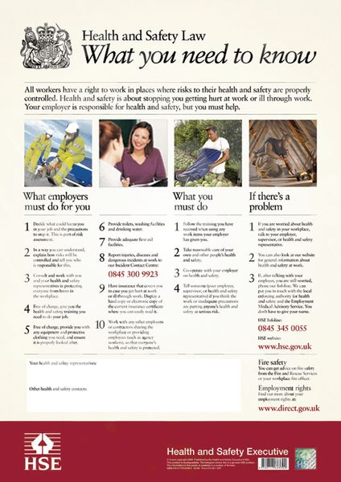
(Hse.gov.uk, 2019)

COSHH

Murphy, (2019) states COSHH risk assessment is conducted to identify hazardous substance ensuring controllable measures are in place with adequate precautions. Employers have the overall responsibility to ensure assessments are conducted with controls in place, providing training, instructions and information from material safety data sheet (MSDS) to employees. Staff should be protected at all times from substance hazardous to health.

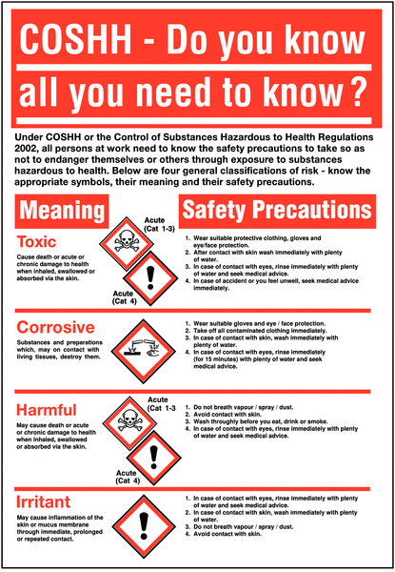
(Hse.gov.uk, 2019)

PPE

Personal protective equipment (PPE), is equipment to protect employees against health and safety risks, provided by employers for employees to wear or use (Hse.gov.uk, 2019). This is defined in the PPE at work regulations 1992 as all equipment to include clothing, protecting against risk to health and safety (Hughes and Ferrett, 2016). Equipment includes steel cap toe shoes, safety harness, gloves, hard hats, and eye protection. In particular, the onus is upon Hotel managers to train employees, making full awareness of the need and requirement involving PPE, along with the correct use (Hughes and Ferrett, 2016. Properly trained staff results in greater productivity. Inadequate supervision of storage and maintenance can be seen as a major role at times overlooked in PPE, regarding the defects. On the other hand, this is seen as contrary for effective use, if employees are provided with equipment that is not adequately maintained. Hotels risk facing prosecution if negligence is found and employees are open to risk.

Manual Handling

Manual handling operations (MHOR) 1992 amended in 2002, covers the manual handling of goods, supporting or moving and includes lifting, pulling, pushing, putting down, or carrying (Aziz, 1992). Subsequently MHOR was introduced to protect the health and safety of staff avoiding potential injuries.

Clear guidelines with measures to assess risks from manual handling are.
- Avoid manual handling deemed hazardous.
- Hazardous manual handling that cannot be avoided should be properly assessed.
- Aim to avoid the risk of injuries as much as possible.

This health and safety legislation covers both employees and employers.

Fire Prevention

Adequate fire prevention measures are in place at the AC Hotel after an initial assessment by the health and safety manager. Fire sprinklers are installed with fire hoses and alarm bells located at designated points on each floor in accordance with regulations (Christian, 1984). Christian (1984) reveals the health and safety manager is responsible for carrying out a fire safety risk assessment at AC Marriott, ensuring measures are up to date, and in guideline with the fire precautions act 1971. Designated assembly points and evacuation procedures to include disabled access, should and are clearly signposted and located throughout the hotel. The assessment can be conducted to coincide with overall risk assessment; however, it is conducted separately as a fire risk assessment.

Negligence regarding fire safety has seen business close due to loss. Data gathered concluded that 80% of business end up closing after confronting major incidents including fire, within eighteen (18) months. Ninety per cent (90%) of those businesses incurring the loss of data are forced to cease trading within two (2) years (Kingsleynapley.co.uk, 2019).

Data Protection

AC Marriott has a legal obligation to ensure data collected from guests and staff are held securely. General data protection regulation (GDPR) 2018 rules were modernised protecting individual’s personal information, harmonising privacy laws across Europe (Burgess, 2019). This replaced the previous 1998 data protection act (DPA) directive based on UK laws. Who will enforce this European wide data protection law in the UK, has caused concern.

The data protection act 1998 clearly outline data collected should be done for a legitimate reason. DPA 1988 specifies data must be collected fairly and in a manner that is transparent and not irrelevant. Presently GDPR has been finalised and although it replaced DPA 1988, the uncertainty of Brexit can be unpredictable (Bainbridge and Pearce, 1998).

Food Hygiene

Food safety act 1990 is the legislation that covers food standards across all hospitality sector in the United Kingdom (Petrovic Oggiano, 2015). The primary focus is ensuring food standards are upheld and maintained in a safe and responsible manner. AC Marriott has a legal obligation to ensure food is kept, prepared and served at safe standards. This ensures preventing cross-contamination, the spread of harmful bacterias or food poisoning (Wheelock, 1994).

Under the food safety act 1990, food cooked for future use should be cooled down quickly and stored at a temperatures six degrees (6º) or below. Reheating should only be done once before serving and to a temperature of sixty-three degree (63º) or above, to kill harmful bacterias that can cause food poisoning (Taylor and Taylor, 2006).
The same temperature guidelines are enforced by management and adhered to for food displayed on buffet lines at AC Marriott. Food is checked periodically using a food probe with temperatures recorded (Hse.gov.uk, 2019).

Adequate training is giving to staff, requiring the passing of examinations to acquire food hygiene certificates, as required by the regulated food standards agency (Seaman, 2010). Modules covered are as follows:
Refuse
Food safety risk assessment
Control of Substance Hazardous to Health (COSHH)
Safe food handling
Food poisoning
Cleaning
Hazard Analysis and Critical Control Points (HACCP)
Reporting of Injuries Diseases and Dangerous Occurrences Regulation (RIDDOR)
Cross Contamination

Risk Management

Risk assessments are carried out within AC Marriott, making appropriate decisions enabling suitable control measures are in place. Management is responsible for the carrying out of risk assessment, identifying methods systematically that are of potential risk and implementing suitable controls (Lamba, 2013). Consideration is given as to who might be harmed and how. Suitable precautions are in place at AC Marriott for employers to assess the risk and take actions, recording and reporting findings while constantly reviewing the risk management protocol (Lamba, 2013).

Liability Risk

AC Hotel is vulnerable to liability risks as other hospitality organisations. The hotel can be held responsible for negligence regarding losses which could prove quite substantial to the hotel. A liability insurance cover is therefore in place in the eventually of any such occurrence taking place, preventing a direct financial impact on the hotel. Public liability insurance should always be taken out for a hospitality organisation. Companies risk closing down resulting from financial loss due to liability claims and compensation pay-outs to customers (Lamba, 2013). The hotel is under the liability as per the hotel proprietors act 1956, to resolve the loss or damage for guests booking accommodation at the property in certain circumstances. The hotel is not liable for vehicles left on the property.

Licensing

The licensing act of 2003 was fully effective in November 2005, regulating the retail sale of alcohol, the use of entertainment and the supply of alcohol in venues (Hse.gov.uk, 2019). The objective of the licensing act 2003 embeds in the prevention of public safety in relation to law and order, protecting children from harm and avoidance to public nuisance (Kermally, 1983).

Offences are carried out under the licensing act, if the hotel sells alcohol to guests under the age of 18, or allowing disorderly conduct on their licensed premises. In addition, alcohol can be served to a guest 16 or 17 if accompanied by an adult. The licensing authority primarily regulates activities that are conducted at the premises and the impact caused to members of the public and surrounding neighbourhood (Hse.gov.uk, 2019).

AC Hotel does not require a specific license to trade as a hotel, although governed by the hotel proprietors act of 1956. Establishments providing sleeping accommodation, drink and food, including inns and guest houses are also covered by the act (Kermally, 1983).
Under the act the hotel does not have to enter into a contract with guests to accommodate them, guests need to be in a fit state, not drunk or disorderly and willing to pay a reasonable fee for facilities and services provided (Kermally, 1983).

Conclusion

As revealed in the report, significant findings conclude that it is not merely a matter of choice, instead, companies are legally obliged to follow stringent health and safety laws, or risk facing fines or closures for negligence. Employers have a duty of care providing and training employees for a safe work environment, ensuring public safety is upheld.

Recommendation would be for the same legislations to cover micro-businesses, with less than five (5) employees.

In relation to GDPR and DPA regarding the UK, what happens after Brexit is unsure. However, with data protection an important legislation, expectations are that adequate measures will be maintained.

In general, the stringent legislations allow guests and staff a feeling of safety within the organisation.

References: Books and Journals
Aziz, B. (1992). Manual handling: proposed regulations. Nursing Standard, 7(12), pp.25-29.

Bainbridge, D. and Pearce, G. (1998). The UK data protection act 1998 — Data subjects' rights. Computer Law & Security Review, 14(6), pp.401-406.

Christian, S. (1984). Home Office Legislation, Regulations and Controls in the UK in respect of premises within the scope of the Fire Precautions Act 1971. Fire and Materials, 8(1), pp.49-53.

Hughes, P. and Ferrett, E. (2016). Introduction to health and safety at work. 6th ed. Abingdon, Oxon: Routledge, Taylor & Francis Group.

Kermally, S. (1983). The Hotel Proprietors Act, 1956 — a Scottish survey. International Journal of Hospitality Management, 2(4), pp.207-208.

Lamba, K. (2013). Hospitality insurance and risk management. New Delhi: Centrum Press.

Lee, N. (2012). Food Allergy, a Newly Emerging Food Epidemic: Is the Current Regulation Adequate?. Journal of Food Hygiene and Safety, 27(4), pp.325-331.

Petrovic Oggiano, G. (2015). Food Safety and Hygiene. Journal of Nutritional Health & Food Science, 3(3).

Seaman, P. (2010). Food hygiene training: Introducing the Food Hygiene Training Model. Food Control, 21(4), pp.381-387.

Stern, G. (2000). Manual Handling. Physiotherapy, 86(11), p.612.

Taylor, E. and Taylor, J. (2006). HACCP for hospitality. [Manchester, UK]: [Practical HACCP Publishing].

Wheelock, V. (1994). UK Industry Guides to Good Hygiene Practice. British Food Journal, 96(8), pp.47-48.
References: Websites

Burgess, M. (2019). What is GDPR? The summary guide to GDPR compliance in the UK. [online] Wired.co.uk. Available at: https://www.wired.co.uk/article/what-is-gdpr-uk-eu-legislation-compliance-summary-fines-2018 [Accessed 4 Dec. 2019].

Hse.gov.uk. (2019). Health and Safety at Work etc Act 1974 – legislation explained. [online] Available at: http://www.hse.gov.uk/legislation/hswa.htm# [Accessed 11 Dec. 2019].

Kingsleynapley.co.uk. (2019). Fire Safety: How does a Director avoid becoming an irresponsible ‘Responsible Person’? | Directors & Officers | Kingsley Napley. [online] Available at: https://www.kingsleynapley.co.uk/insights/blogs/directors-and-officers/fire-safety-how-does-a-director-avoid-becoming-an-irresponsible-responsible-person [Accessed 11 Dec. 2019].

Murphy, J. (2019). What is a COSHH Assessment and how do I write one? Free information from HS Direct. [online] Hsdirect.co.uk. Available at: https://www.hsdirect.co.uk/free-info/coshh-assessment.html [Accessed 11 Dec. 2019].

The Guardian. (2019). Companies pay out more than £1.5m for breaking environment laws. [online] Available at: https://www.theguardian.com/environment/2017/jan/30/companies-pay-out-more-than-15m-for-breaking-environment-laws [Accessed 11 Dec. 2019].

