
Case study for building sustainability upgrade
Lampeter university student accommodation building

March 9, 2018
Jack bray
P148002

Contents
Introduction 1
Property overview 2
Sustainable Design 2
The Social Impacts 2
The Economic Impacts 3
The Environmental Impacts 3
Lampeter sustainable upgrade 3
Upgrade options 3
Materials 4
Strategies 6
Conclusion 7
References 7
Bibliography 7

Introduction

The aim of this report is to propose a document of potential upgrades that could improve the sustainability of the student accommodation buildings for Lampeter university, whilst also identifying and focusing on one specific key issue, which for this document is Materials. The development however is limited as the existing building cannot be extended due to the design brief as well as the grade 2* listing, declaring this building as one of particular interest.

Property overview

The property being assessed is the Student accommodation for Lampeter university. The building is found in the small town of Lampeter, Ceredigion which is in South West Wales. The original buildings were designed by John Foster in 1822-7 who based his designs off earlier projects completed by C R Cockrell, a famous English Architect who had lived in the late 18th century to the early 19th. The exterior design is in the Tudor gothic style with Tudor arches over several of the doors and cast-iron windows; oriel windows which protrude from the rendered external wall faces; pitched slate roofs; and a large Tudor arch giving access to courtyard (quadrangle). This original building is laid out around this quadrangle with accommodation located in the East, South and West blocks with the student hall, chapel, headmasters quarter and other student spaces. The building was initially called St Davids College and was designed for the education of future Anglican Clergymen however, has since changed its name to St Davids University College in 1971 and again to University of Wales Lampeter in 1996. The university also received a royal charter to become the first higher education establishment in Wales and now provides students studying here with the ability to live and work in this close-knit rural community. It is because of this great wealth of history to this establishment that it gained a grade 2 star listing in 1964 which was also amended in 2012 in order help preserve this historic wealth.
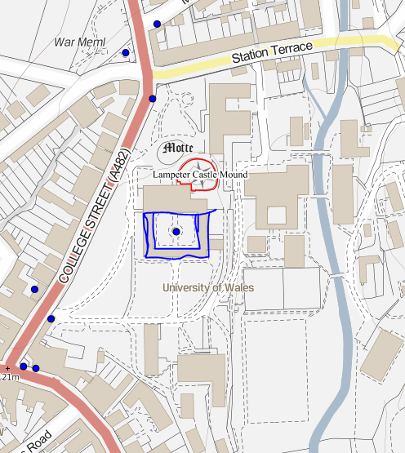
Figure 1 – site layout highlighting the student accomodation and quadrangle/courtyard

Sustainable Design
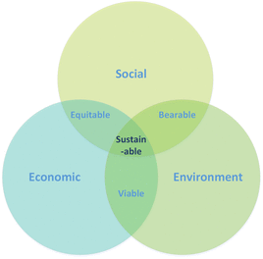 Sustainability Venn diagram

Sustainability by todays standards is more than just looking at reducing the environmental impacts our buildings are having on the environment and can also now include social and economic impacts that are also extremely important. In order to ensure our buildings are sustainable we look to finding a balance between these three key issues as shown in figure 1 on the right.

The Social Impacts
The social impacts a building has can alter the way the buildings are designed in order to create a comfortable environment to live, work and relax in, depending on the buildings purpose. Having this in mind can allow designers to create an efficient space that is fit for purpose and therefore further measures such as heating, and lighting can be designed so that there is less wasted. For example, in the case of Lampeter student accommodation, lighting may be put on sleep timers as during lecture hours, only minimal lighting will be required if at all and therefore can reduce the energy being used.

The Economic Impacts
The economic impacts also need to be considered during the design, as the sustainable measures will have to be affordable for the client to both install and run as if costs begin to exceed the clients’ financial ability it may lead the client to explore other, less sustainable options. It must therefore also be fit for purpose as there is no point in putting expensive sustainable upgrades into a space that will rarely be used or accessed such as storage or maintenance spaces.

The Environmental Impacts
Buildings can also have both massive direct and indirect impacts on the environment such as global warming and the emissions of harmful chemicals and gases. Being able to protect the environment is an important part of sustainability as this means that we are striving to leave behind a healthier planet for future generations as well as helping to protect the plants and animals. It isn’t just the emissions of the building that can affect the environment, as where a building is constructed can also damage and kill wildlife and therefore it is important to have an ecology report carried out to ensure that measures can be taken to mitigate the damaging effects the construction has on the planets and/or animals. As well as damaging the environment, during construction we also need to consider our material choices as the planets raw materials are quickly being used up, we need to begin looking at renewable materials that we continue to reuse and replace for the foreseeable future.

Lampeter sustainable upgrade

All of these impacts can occur across the lifecycle of the building from construction to demolition, and therefore it is extremely important to put a strategy into action which can help to mitigate these negative effects and help to create a more sustainable building as early as possible when designing new buildings. However, in the case of the Lampeter student accommodation, this building was constructed in the early 19th century, where the idea of sustainable design wasn’t the major feature that it is by todays standards, and the design and construction of the building wouldn’t have had any of the technologies available to it that we have now. However, it is still possible to incorporate sustainability into this building by replacing and upgrading features of the building whilst also letting it keep its character and history to help it become more sustainable. The Idea of designing a more sustainable upgrade plan for the Lampeter student accommodation will need to be carefully considered, weighing up several potential options in detail in order to discover the options that will best suit this specific case in terms of practicality and cost effectiveness.

Upgrade options

There are several potential upgrade options for the student accommodation that can increase the sustainability of this building that can be explored that won’t require any extension to the building that can vary in practicality, cost and effectiveness and it will come down to what lengths the client want to go to, what their overall goal is and their preference over which upgrades are implemented if any. Some of the upgrade options that can be explored could include; a more sustainable heating system that can help to improve the carbon footprint as well converting to renewable methods of energy production, these systems could include photovoltaics that could potentially be placed on the roofs which would use solar energy, another heating option could be the introduction of a biomass boiler that uses wooden pellets that are a sustainable material. Both of these methods are sustainable ways of producing energy, although they can both potentially take up large areas of space to store the equipment that comes with them as well as having large initial costs to purchase the photovoltaic panels and biomass boiler. The photovoltaics can provide cost free energy unlike the biomass boiler which needs the user to purchase pellets although the photovoltaic system may need to be used alongside another system as solar gains cannot always be guaranteed to occur.

Materials

In order to tackle the massive topic that is materials, this report has focused on materials of the building envelope, which is an import area to get correct as it can have a massive impact on sustainability from energy loss through thermal bridging, it can also affect comfort levels for users through the indoor air quality and the internal light levels. These are some reasons why it is therefore important to ensure that the building envelope is completed correctly and efficiently as it can begin to have these effects on users.
Firstly, we need to look at what the materials are or could be that form the existing building envelope in order to gain a better understanding into what issues may occur in this type of construction and how we can improve, upgrade or repair it. From the CAD drawings provided we can see that the external walls all vary around 600mm in thickness around the building and we can also see from Figure 2 that the external face is a roughcast rendered possibly using lime cement and gravel. Although the exact external wall makeup cannot accurately be discovered without further intrusive examination we can presume that brick and stud were used as at least one layer in the makeup of the wall, as due to the age of the building and from the visible makeup of the internal wall in figure 3 on the left I would believe this is a safe assumption, however the materials used for the rest of the layers are unclear. The thickness of these external walls may suggest that they are designed this way in order to retain heat although they wouldn’t have had the level of efficiency in insulation that has been reached by today’s standards. From the thermal imaging of the courtyard wall in figure 4 and 5 below, it would appear that very little to no heat is escaping through this external wall of the courtyard although further images of all the courtyard walls would need to be taken to confirm that there is no thermal bridging. Further to this, to ensure the thermal imaging is accurate these tests would need to be carried out during the night time rather than during a sunny day as the solar gains on the walls may have affected the results and provided inaccurate readings. In the event that further insulation was needed, although figure 5 contradicts this, the further insulation would need to be applied internally as to not change the external appearance of the listed building as per the brief. Applying insulation levels internally should also help to pass the listing consent that may still need to be achieved depending on the conditions of the listing as the client or designer can argue that they are keeping the external appearance the same. Another option could be to alter the layout of the building creating a corridor following the external walls of the courtyard and from this alteration, insulation could be applied to the internal walls helping to insulate the student’s rooms although this would still leave the external walls uninsulated it would help to provide additional insulation to the student rooms and communal spaces. This change may be a challenging alteration as the changes would probably have to be submitted to get approval for change from the listing and then the design would be tricky to get it to conform with current existing regulations whilst also keeping the original character of the building. This could also provide additional space as only two sets of stairs would theoretically be needed which could then mean the other steps could be removed, as well as communal spaces could be combined giving students more ability to spend down time with other students. If the client does want to provide internal insulation, they should ensure that they source sustainable materials sustainably looking at local providers who use local materials if and where possible as they are then sustainably sourcing their materials.
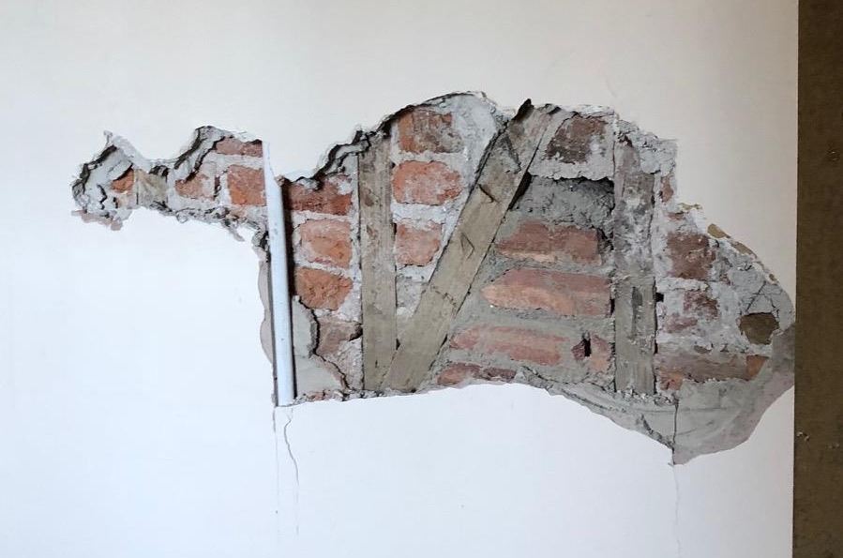
Figure 3 – Exposed Internal Ground Floor wall
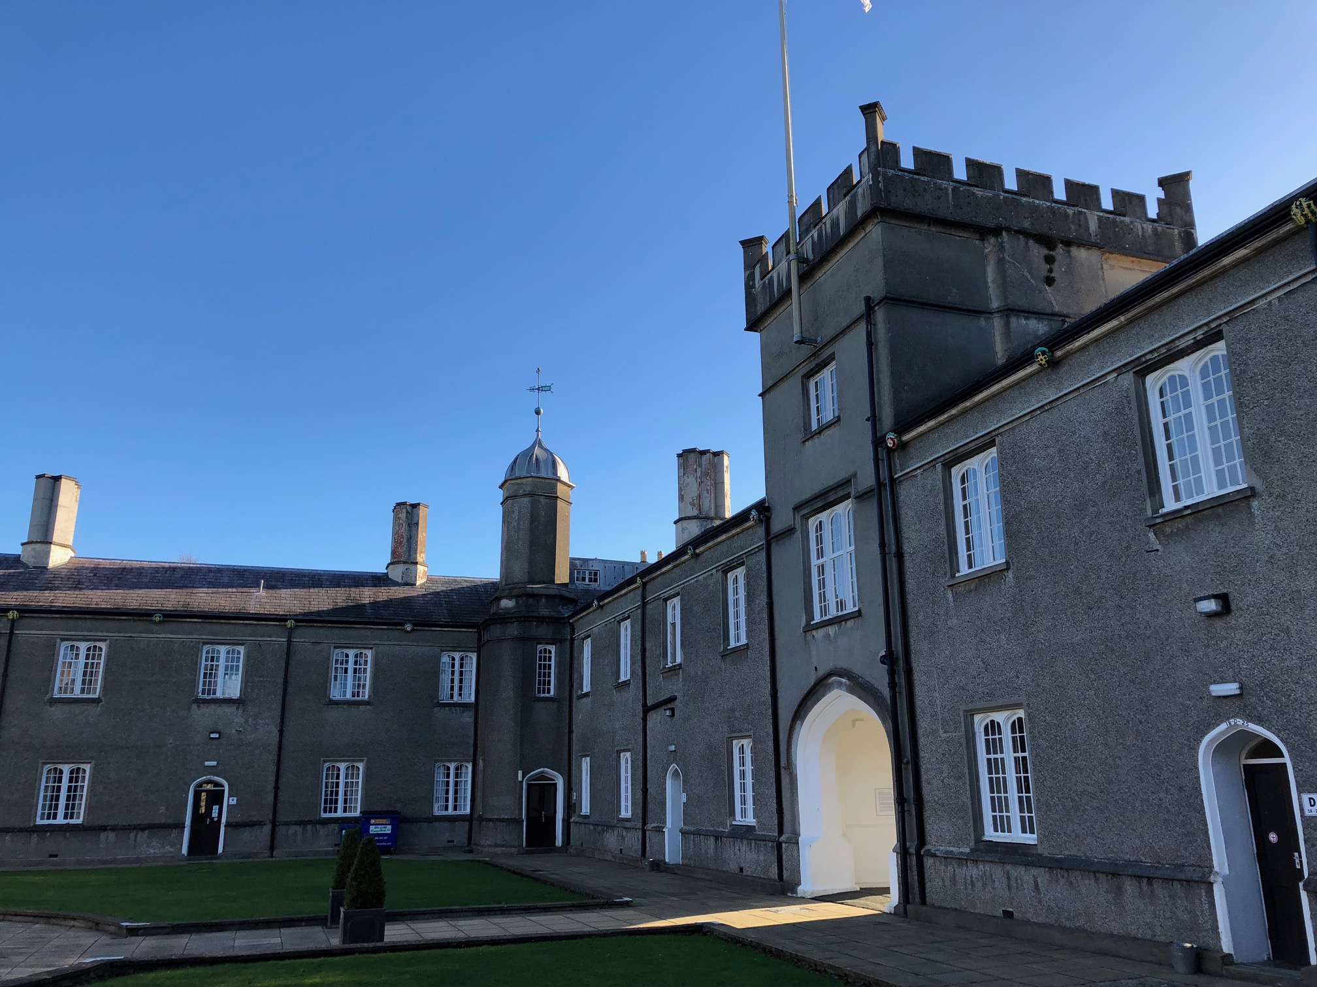Figure 2 – Internal quadrangle face
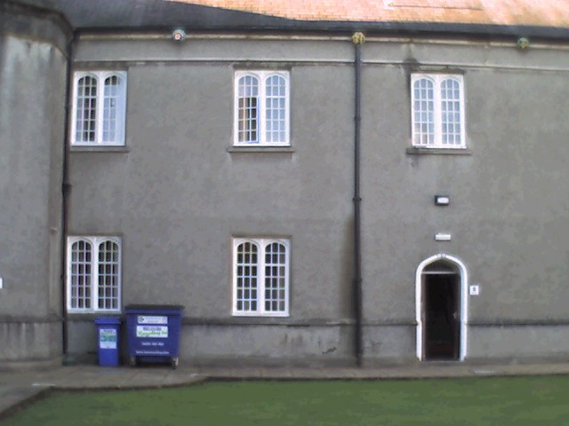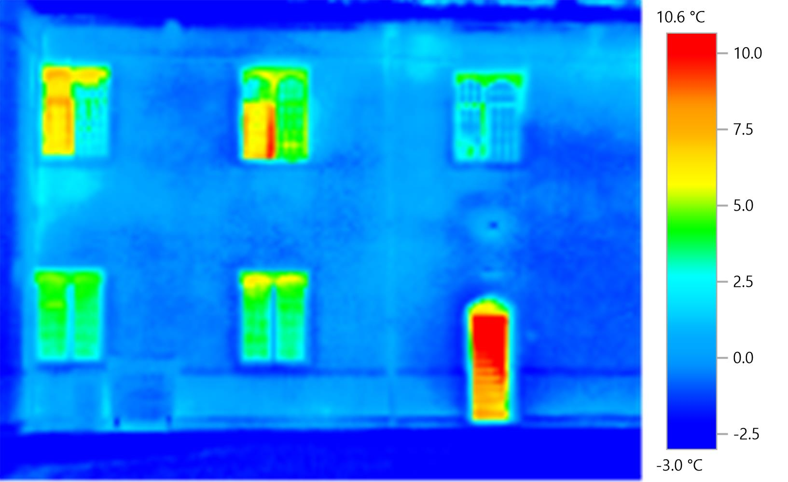
Figure 4 & 5 – Courtyard wall and the thermal imaging picture of the wall showing where heat is being lost
Figure 6 shows one frequent problem that can occur which is the problem of damp which may not directly affect the sustainability of the building however may indirectly affect it. In the case of damp, if the problem is left un-remedied it can continue to cause further problems, along with the negative health effects it can have on the building occupants can lead to the need for heating to be left on for longer hours in order to counter the damp. Also, damp can cause damage to several building materials along with the building occupants belongings which when damaged or broken will inevitably end up as waste and in need of replacing. In order to ensure that damp is treated and that it doesn’t return it could be a promising idea for the client to get in a damp specialist who can fully assess the extent of the damp and advise on what steps can be taken to remove the damp and stop it from returning again.
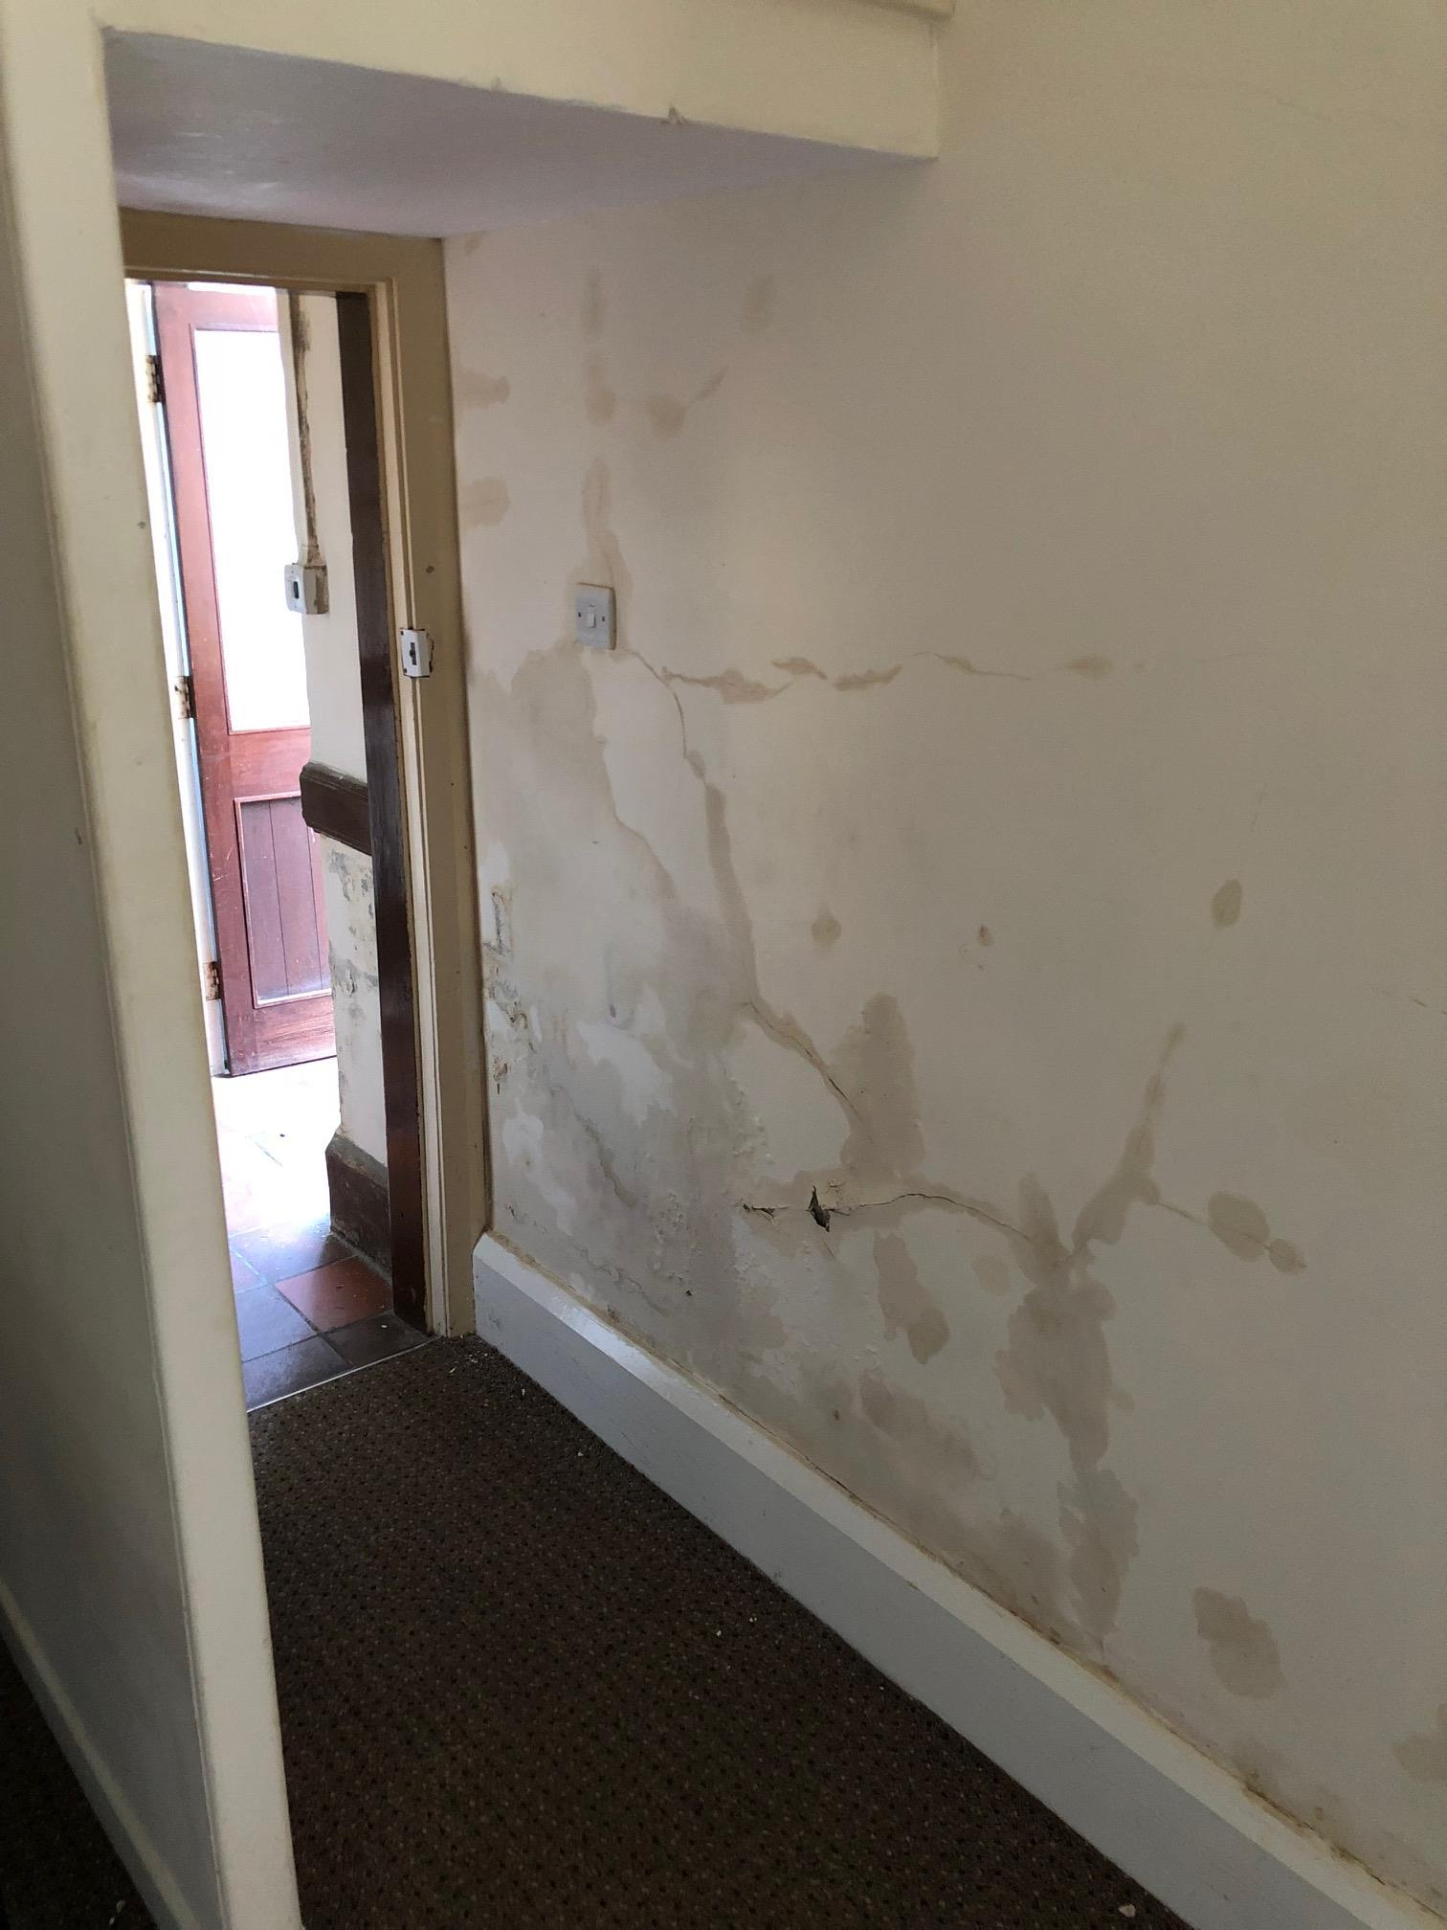
Figure 6 – damp on the internal face of the external wall
The final option I will briefly evaluate is to upgrade the windows which could be greatly beneficial to insulating the building which as shown in figure 5, as the windows appear to be letting out a great deal of heat and will therefore be increasing heating costs and decreasing the buildings operational sustainability. In order to keep the buildings original character, I would advise the client to look at local window specialists and look at getting either double or triple glazing units that could be made up in a similar or the same style as the current existing windows.

Strategies

In order to design an adequate strategy to tackle the building upgrade the client will first need to decide which sustainable upgrades they want to and can financially implement. Following this, a suitable plan can be created on how the chosen upgrades will be implemented. As part of the upgrade strategy, it will need to be organised, possibly through the use of BIM modelling, on how these systems will work around the existing physical structure as well as how they will work with other sustainable upgrades also when they can be carried out. As this is a university accommodation building, a logical way of tackling these sustainable upgrades would be to organise them so that they can be installed during the educational holidays which would be easiest over the summer holiday which would help to reduce any disruption to students and lecturers and in the case of heating and the thermal envelope, could help to ensure that these are in place ready for the colder winter months as long as no delays occur.

Conclusion

In conclusion there are a lot of ways to sustainably upgrade this building many of which may not have been mentioned in this report. If the client wants to include sustainable upgrades to improve their property, they need to fully explore their options and what areas they want to improve. The logical place to start for this would be what financial input they want to put towards this sustainable development from this they can narrow down their options and help them to see clearly what steps they want to take. If the client choses not to explore sustainable upgrades then there are always small sustainable measures that can be implemented as well such as lights on timers with signs asking the building occupants to turn them off when not in use, waterless urinals and several other areas that I would suggest aren’t building upgrades but small measures being taken to help the planet.

References

http://cadw.gov.wales/historicenvironment/recordsv1/cof-cymru/?lang=en
http://www.circularecology.com/sustainability-and-sustainable-development.html

Bibliography

http://www.uwtsd.ac.uk/media/uwtsd-website/content-assets/documents/prospectuses/undergraduate-prospectus-2018.pdf
http://cadwpublic-api.azurewebsites.net/reports/listedbuilding/FullReport?lang=en&id=10431
http://www.circularecology.com/sustainability-and-sustainable-development.html#.WqI3ZejFK00
http://www.ihsti.com.ezproxy.uwtsd.ac.uk/tempimg/33B3404-CIS888614800304918.pdf
https://www.thenbs.com/knowledge/sustainable-building-materials?scl=01MzUzQzIwMDUtNzEyNi00RDZBLTg2NEItNTQzNTAxOTg4Nzk0XzYzNjU2MTQyODU4MzgzMzA4Ng%3d%3d

Lyons, A. (2015). Materials for architects and builders. (5th edn). Abingdon: Routledge.
Weston, R (2003). Materials, Form and architecture. (1st edn). London:Laurence King Publishing
Word Count: 2570

