

InterContinental Hotels Group PLC (IHG) Strategic Marketing Case Study

ZiXun Zhao (2103115)

18 March 2022

A report submitted in fulfilment of the requirements for Course BMBM6016, Strategic Marketing, University of Wales Trinity Saint David.

Executive Summary
The emergence of the COVID-19 pandemic has had a huge impact on the world. In this report, it critically analyses the IHG company through SWOT, PESTEL and McKinsey’s 7S Framework and Porter’s 5 Forces. At first, it shows the cash liquidity of IHG is high, which is helpful for the company to repay debts in the short term. Then, it reflects that the pandemic has prompted hotels to use new technologies, such as using robots to reduce contact and enhance disinfection. The impact of the economic environment on IHG is huge, but they can use this opportunity to expand the market. Furthermore, during the pandemic IHG positioned itself in a more niche market, with its main business being rent their room as offices. Finally, IHG also faces fierce competition from established hotel groups, such as Marriott and Hilton, as well as Airbnb, which will bring higher costs for IHG's future market expansion. Through the epidemic, customers pay more attention to health and environmental protection. Therefore, IHG needs to change its service focus, such as customizing appropriate fitness programs for customers, carrying out ecological tourism and strengthening sanitation services.

Content
Executive Summary 2
1.0 Introduction 5
1.1 Background 5
1.2 InterContinental Hotels Group PLC (IHG) 7
2.0 Main Findings 8
2.1 Analysis of SWOT 8
2.2 Analysis of PESTEL 10
2.3 Analysis of McKinsey’s 7S Framework 14
2.4 Analysis of Porter’s 5 Forces 16
3.0 Recommendations 18
4.0 Conclusions 19
References 21
Appendix 27

1.0 Introduction
Industries across the globe are being hit hard by the pandemic of COVID-19. In particular, hotel industry has seen its business activities severely disrupted by the pandemic (Sharma & Nicolau, 2020). In order to adopt timely and effective plans to respond to the COVID-19 pandemic, this report needs to critically analyze the company's current and future internal and external environment. It will choose the InterContinental Hotels Group PLC (IHG) as the case to analyze through PESTEL, SWOT, McKinsey’s 7S Framework and Porter’s 5 Forces. Besides, it will give some recommendations about IHG should make which strategy to overcome the pandemic. The last section of this report will draw a conclusion for hotel.

1.1 Background
The sudden emergence and rapid spread of the COVID-19 pandemic has been devastating to many businesses around the world. The hotel industry is particularly vulnerable to a drop in tourism and a slowdown in economic activity (Hoisington，2020). The pandemic has led to a sharp drop in travel demand, and hotels have seen their performance decline as family and business travel has declined. In the face of the highly contagious COVID-19, it is clear that hotels need to re-formulate more appropriate and effective strategies to ensure the safety of customers and staff (Sharma et al., 2021). In fact, many hotels already have a number of safeguards in place to protect against infectious diseases (Shin and Kang, 2020). Successful service innovation is essential for the hotel and tourism industry to maintain its competitiveness during the pandemic (Gössling et al., 2020).

Different quarantine policies in different countries have caused inconvenience, and measures such as home quarantine have prevented people from going outside. With the decline of hotel business, many fixed expenses still exist. Such as labor costs, rent, water and electricity maintenance, all kinds of taxes and fees are difficult to be deferred. All hotel industries suffer from serious imbalance of income and expenditure, which resulting in a shortage of capital chain. Additionally, with the spread of the epidemic, the demands of customer also have changed and the hotel business must accept stricter hygiene requirements and new consumption habits of customers. The emergence of the epidemic will also disrupt the original market pattern, according to the different response measures of each hotel, the market share will change to some extent (Wang, 2020).

1.2 InterContinental Hotels Group PLC (IHG)
InterContinental Hotels Group PLC established in 2003, it is one of the world's leading hotel groups. IHG's mission is to provide true service to all guests. As of 2020, the company has more than 6,000 hotels in about 100 countries. IHG focuses on three distinct market segments, which involves mainstream, premium and luxury. Its brands include Hotel Indigo, EVEN Hotels, HUALUXE Hotels and Resorts. The company has more than 36,000 employees located in different regions (Fernandes, 2021).
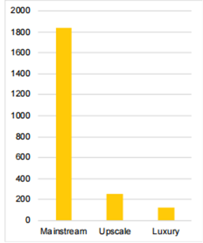
Figure 1. IHG pipeline, segmentation (2019). Source: IHG HOTELS AND RESORTS (2022)

2.0 Main Findings

2.1 Analysis of SWOT
A SWOT analysis is a simplified business model that provides direction for a company and serves as a basis for marketing plan development (Firat and Shultz, 1997). SWOT can help enterprises identify their own strengths and weaknesses which is internal factors that the company can control, while opportunities and threats are factors related to the external environment. A company can strengthen its market competitiveness by managing these factors (Tsangas, Jeguirim, Limousy and Zorpas, 2019).

Strength is generally regarded as the internal enhancement factor of a capable and valuable resource or attribute within an enterprise or organization (Leigh, 2010). A strong brand portfolio and a wide range of customers are one of IHG's strengths. IHG has several different hotel brands, covering all segments from affordable to luxury. The Holiday Inn Express is a medium-sized service hotel, and its target customers are the middle class. Candlewood Suites is a luxury hotel that focuses on luxury guests and has more upscale services and amenities than other hotels. As for Hotel Indigo, it is a hotel designed for customers who pay attention to fashion. The diversified hotel brand portfolio can provide more diversified choices for customers. And it also has the potential to improve returns and a wide range of income sources. At the same time, IHG's strong customer base also enables the enterprise to maintain strong competitiveness during the epidemic. Today, IHG has more than 80 million members worldwide (InterContinental Hotels Group PLC (IHG), 2014).

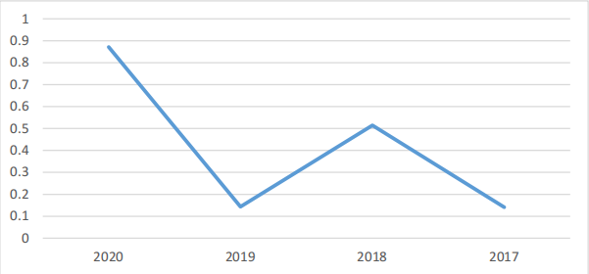
Figure 2. Cash ratio of Intercontinental Hotels Group (2021) Source: Financial Analysis of InterContinental Hotels Group (2021).

The cash ratio measures a company's liabilities using cash for its current financial services. Cash is the most liquid asset a company has, which determines its ability to meet short-term financial obligations (Irons，2020). According to figure 2, The company's liquidity position is improving. IHG has a cash ratio of more than 1, which is crucial to improve its reputation to suppliers, and it has sufficient working capital to ensure the normal operation of the enterprise in the short term. A high liquidity rating indicates a company's ability to meet short-term financial requirements and maintain its day-to-day financial and operational needs. In the future, IHG has enough liquidity to ensure that they have enough anti-risk ability during the epidemic to reduce the investment risk of shareholders (Ameri et al., 2021).

2.2 Analysis of PESTEL
PESTEL analysis is a framework for analyzing macroeconomic factors of organizational performance (Woodman, Sawyer and Griffin, 1993). It can help managers to be more sensitive to the changes in the macro environment. Analyzing the external environment can help organizations utilize existing information to minimize threats to the organization in their daily operations (Witcher and Chau, 2010).

Technology has a huge impact on enterprises. From the company's point of view, technology not only has a potential impact on the business, but also has the potential to revolutionize the long-term development of the organization (Shatskaya, Samarina, and Nekhorosheva, 2016). COVID-19 is highly contagious through human-to-human transmission and people should reduce personal contact and increase physical distance (WHO, 2020a). Many large international hotel chains, such as Marriott International, Hilton and Hyatt are using new technologies or upgrading existing ones, so it can strengthen disinfection to avoid human contact (Garcia, 2020). IHG hotels are beginning to pay more attention to the potential benefits of artificial intelligence (AI) and its applications, such as robotics in hotel management practices (Zabin，2019). The changing hospitality landscape presents an opportunity for IHG hoteliers to better serve and delight their guests in innovative ways through artificial intelligence and robotics (Huang and Rust, 2018).

In the context of COVID-19 health crises, IHG hotels employ mechanical artificial intelligence to perform cleaning and disinfection tasks or assist hotel staff in their duties. For example, robots can monitor the cleanliness of areas with massive human traffic. The technology is still immature, future areas to be addressed include how to develop robot-friendly hotel facilities for AI-powered robots to perform tasks (Jiang and Wen, 2020). Although the application of artificial intelligence and robotics in hotels represents a new service concept. Service innovation using robots can improve the sustainable competitiveness of hotels. However, IHG are going to have a long way to go to make good use of this technology, they may spend a lot of money and time on development and research in this area (Kuo et al.，2017).

The impact of economic factors is that they have a significant impact on how businesses and profitability are run within an organization (Shatskaya, Samarina, and Nekhorosheva, 2016). International Monetary Fund (IMF) noted that the COVID-19 pandemic has had a huge impact on global markets, far surpassing the impact of the economic recession in 2008 (UN, 2020b). With airlines and cruise ships grounded, travel and hotel supply chains have been hit like never before (UN, 2020a). According to statistics (UNWTO 2020), the number of tourists decreased by 20-30% in 2020. Economic losses exceed $300 billion to $400 billion in international tourism revenue. In the hotel industry, 80% of hotel rooms are empty, more than $10 billion is lost, more than $500 million is lost in room revenue per day, nearly 3.9 million jobs have been eliminated in the short term, 70% of hotel employees have been laid off or taken extended leave, and 33,000 small and medium businesses are at risk of immediate closure (American Hotel and Lodging Association, 2020).

During the pandemic, IHG saw a 60% drop in business activity, 90% of which was in China, while at most more than 178 stores were closed. In 2020, IHG eliminated a dividend of $150 million to the board and employees, reduced expenses by $100 million, and eliminated fees associated with existing and new bookings at all hotels worldwide. It also modified or reduced the frequency of restaurant and bar events and sold a certain amount of room furniture and amenities (InterContinental Hotels Group (IHG), 2020; Brandler, 2020). With high cancellation rate and low reservation volume, IHG hotels are losing their much-needed cash flow. This situation will make hotels lose their ability to continue operating in the short term, and they gradually find themselves in a forced liquidity crisis (Nhamo, Dube and Chikodzi, 2020). As a result, IHG slowed down their expansion, closed unprofitable hotels and sold some properties for cash flow to cope with the current crisis (Fernandes, 2021). According to the figure 3, it indicates that Marriott and IHG lost less market share. During the pandemic, it secured most of the market.
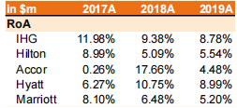
Figure 3. the ROA of IHG vs Peers. Source: Fernandes (2021).

2.3 Analysis of McKinsey’s 7S Framework
McKinsey's 7S Framework provides a strategic approach for organizations to manage resources. It can help to compare the current state of the enterprise with the ideal state, connecting the various elements. Leaders can better understand the current situation of the enterprise and bring effective changes to the organization based on their own experience (Ashu, 2013).

A Strategy is defined as a plan or an organization's approach to achieving business goals. According to different resources within the organization, develop appropriate strategies to ensure the sustainable competitive advantage of the enterprise and meet the needs of stakeholders (Talwar, 2006). The global panic associated with COVID-19 could have a lasting impact on tourism. In the wake of this public health crisis, effective strategies must be put in place to boost traveler’s confidence (Jiang and Wen, 2020).

As the epidemic has forced many people to work from home, IHG has invested a lot to transform some standard rooms into offices. Moreover, the booking time is very flexible, which can be days, weeks or even longer. IHG expects that working from anywhere will be a new trend and will continue in the future. What is more, IHG's home office program effectively reduces rental costs and provides a good work-life balance. And the IHG office is about half the price of a standard room. As a consequence, the occupancy rate has reached 85%. As a pioneer in the office market, IHG estimates that the ROI of this segment is likely to grow to 168.61% in the future. However, as time goes by, profit growth will gradually slow down, because more and more hotels will enter this segment of the market (Fernandes, 2021).

2.4 Analysis of Porter’s 5 Forces
Porter's 5 Forces is a framework commonly used for industry analysis and corporate strategy development. It is mainly on the premise that enterprises use strategies to deal with opportunities and threats in the external environment. It advises companies to assess the forces in the industry that present threats and opportunities. The organization can manage its resources according to the factors in the model so as to improve its competitive position in the market (Asad, 2012).

Intensity of existing competitive rivalry means that a firm is likely to lose strength in the face of increased competition, and that the firm is likely to take appropriate measures to increase its profits in the face of weak competition (Porter, 2008). Many hotel chains are implementing cost-cutting measures, including layoffs, wage cuts, staff furloughs and shorter working hours to maintain liquidity. For example, Hyatt announced that it would extend a number of offers to its members (Chaturvedi, 2020). Moreover, focusing on the corporate social responsibility of hotels can help reduce the potential impact of the epidemic. During this period, organizational CSR activities become more important (Farmaki and Stergiou, 2020). Marriott (2020a) offers $10 million worth of accommodations to health care workers, while Hilton(2020a) has pledged 1 million free rooms to health care workers. They changed the hotel's parking lights to blue to support health workers and hosted an online digital party for medical staff. Many customers have been forced to cancel or change their reservations due to the pandemic. IHG has implemented a flexible pricing policy in response to this situation. For example, if a customer cancels a reservation, they will not be charged any related fees. However, this is a huge financial pressure for the hotel (Gürlek and Kılıç, 2021).

Nevertheless, Airbnb's listing has intensified competition in the hotel industry. Airbnb's main model is for hosts to sublet their homes to others through Airbnb's platform. In the midst of the pandemic, Airbnb went public with a market capitalization of more than $85 billion on its first day. Due to its listing, Airbnb's inventory has mushroomed and the number of rooms has surpassed the largest hotel chains. Moreover, as an intermediary platform, Airbnb has lower operating costs than traditional hotels. And its emergence has occupied a large part of the low-end market. In the face of such competition, IHG has begun to offer simpler check-in procedures than Airbnb or more personalized services, such as allowing customers to choose how soft or hard their pillows should be (Fernandes, 2021).

3.0 Recommendations
During the COVID-19 pandemic, many people are reconsidering their lifestyles (Wang et al.，2020). Considering the newly prominent consumer demand, helping guests live a healthy lifestyle may become a trend for hotels in the post-pandemic era. For instance, meditation programs, digital detox programs and sleep hygiene programs are likely to become increasingly popular in a hotel's marketing mix. In this context, it seems necessary to further study how hotels can design personalized products to enhance guests’ happiness and improve the guests’ experience. Specifically, it could consider how to leverage guests’ behavioral data and their consumption history and predictive analytics to develop customized, health-conscious amenities (Mariani, 2019; Mariani et al., 2018; Mariani and Perez，2020).

Given the growing consumer demand for hotel hygiene in the wake of the COVID-19, enhanced cleaning and disinfection to prevent or limit the spread of disease can be a selling point during and after the outbreak. Zemke (2015) founded those young travelers and woman of all ages are willing to pay a premium for enhanced room disinfection. In addition, as higher levels of cleanliness may require investment in technology, equipment and resources, consideration should also be given to the extent to which different types of IHG hotels should improve their disinfection practices.

4.0 Conclusions
The emergence of COVID-19 is a huge challenge for the world. Through this report, the internal and external environment of IHG hotel is briefly analyzed. SWOT analysis shows that although IHG's current liquidity is sufficient, it is not the basis for IHG to maintain its own development in the long run. In addition to the analysis of PESTEL, the outbreak of the epidemic has made every hotel put the use of robots on the agenda, but the technology is not mature enough and more time is needed to verify the feasibility of this programme. The recession of the economic environment brought a huge impact on IHG, but IHG slowed down its expansion pace. Meanwhile, the strategy of IHG focuses on the office market segment, which is a leading advantage in the hotel industry. However, with the continuous entry of competitors, IHG will face fierce competition in this market segment in the future. Airbnb has increased competition in the hotel industry, and IHG is keeping customers loyal by offering a more nuanced service. Finally, due to the gradual change in people's consumption concept after the epidemic, IHG should also be adjusted accordingly. For example, improve cleanliness and safety standard of the hotel room, provide appropriate fitness programs.

Word count: 2698

References
- Alan, C.B., So, S. and Sin, L. (2006). Crisis management and recovery: how restaurants in Hong Kong responded to SARS, International Journal of Hospitality Management. Vol. 25 No. 1, pp. 3-11.
- Ameri, M., Katheeri, W., Ali, A., Alameemi, M., Alderei, B., and Alzaabi, F. (2021). Financial Analysis of InterContinental Hotels Group. [Online]. Available at: https://www.researchgate.net/publication/355169612_Financial_Analysis_of_InterContinental_Hotels_Group [Accessed 10/3/2022].
- American Hotel and Lodging Association (2020). Covid-19’S impact on the hotel industry, American Hotel and Lodging Association. [Online]. Available at: https://www.ahla.com/covid-19s-impact-hotel-industry [Accessed 10/3/2022].
- Asad, M. (2012). Porter Five Forces vs Resource Based View - A Comparison, SSRN Electronic Journal. Vol. 2.
- Ashu, S. (2013). A Study of Role of McKinsey’s 7S Framework in Achieving Organizational Excellence, Organization development journal. Vol. 31 (3), p. 39.
- Brandler, H. (2020). IHG chief: "Demand for hotels is currently at the lowest levels we’ve ever seen", BuisnessTraveller. [Online]. Available at: https://www.businesstraveller.com/business-travel/2020/03/20/ihg-chief-demand-for-hotels-is-currently-at-the-lowest-levels-weve-ever-seen/ [Accessed 11/3/2022].
- Chaturvedi, A. (2020). COVID-19: Hotels across the board undertake pay cuts, give unpaid leave options to staff, The Economic Times. [Online]. Available at: https://economictimes.indiatimes.com/industry/services/hotels-/-restaurants/covid-19-hotels-across-the-board-undertakepay-cuts-give-unpaid-leave-options-to-staff/articleshow/75069700.cms?from=mdr. [Accessed 11/3/2022].
- Farmaki, A., and Stergiou, D. P. (2020). Corporate social responsibility and employee morale identity: A practice-based approach, Current Issues in Tourism. [Online]. Available at: https://doi.org/10.1080/13683500.2020.1850654 [Accessed 12/3/2022].
- Fernandes, F. S. M. S. (2021). Intercontinental hotels group-time to check-in? analysis of one of the biggest hotel players in times of a global pandemic. [Online]. Available at: https://run.unl.pt/bitstream/10362/122740/1/2020-21_fall_30458_francisca-fernandes_part-2.pdf [Accessed 9/3/2022].
- Firat, A. F., and Shultz, C. J. (1997). From segmentation to fragmentation: markets and marketing strategy in the postmodern era. European Journal of marketing.
- Garcia, I. (2020). Hilton, Hyatt, and Marriott Will introduce new cleaning protocols. [Online]. Available at: https://www.housebeautiful.com/lifestyle/a32367701/hilton-hya tt-and-marriott-new-cleaning-protocols-coronavirus/ [Accessed 8/3/2022].
- Gössling, S., Scott, D., and Hall, C. M. (2020). Pandemics, tourism and global change: A rapid assessment of COVID-19, Journal of Sustainable Tourism. Vol.1, pp. 1–20.
- Gürlek, M., and Kılıç, İ. (2021). A true friend becomes apparent on a rainy day: corporate social responsibility practices of top hotels during the COVID-19 pandemic, Current Issues in Tourism. Vol. 24 (7), pp. 905-918.
- Hilton (2020a). Statement From Hilton: Coronavirus. [Online]. Available at: https://www.hilton.com/en/corporate/coronavirus/ [Accessed 8/3/2022].
- Huang, M. and Rust, R.T. (2018). Artificial intelligence in service, Journal of Service Research. Vol. 21 No. 2, pp. 155-172.
- InterContinental Hotels Group (IHG) (2020). Our travel advisory policy. InterContinental Hotels Group (IHG). [Online]. Available at: https://www.ihg.com/content/gb/en/%20customer-care/travel-advisory [Accessed 7/3/2022].
- InterContinental Hotels Group PLC (IHG) : Company Profile and SWOT Analysis (2014). World Market Intelligence. London: GlobalData plc.
- International Monetary Fund-IMF (2020). Opening Remarks at a Press Briefing by Kristalina Georgieva following a Conference Call of the International Monetary and Financial Committee (IMFC), International Monetary Fund. [Online]. Available at: https://www.imf.org/en/News/Articles/2020/03/27/%20sp032720-opening-remarks-at-press-briefing-following-imfc-conference-call [Accessed 8/3/2022].
- Jiang, Y. and Wen, J. (2020). Effects of COVID-19 on hotel marketing and management: a perspective article, International journal of contemporary hospitality management. Vol. 32 (8), pp. 2563–2573.
- Kuo, C.M., Chen, L.C. and Tseng, C.Y. (2017). Investigating an innovative service with hospitality robots, International Journal of Contemporary Hospitality Management. Vol. 29 No. 5.
- Leigh, D. (2010). SWOT Analysis. Handbook of Improving Performance in the Workplace. Vol. 1-3, pp. 115–140.
- Mariani, M. (2019). Big data and analytics in tourism and hospitality: a perspective article, Tourism Review. Vol. 75 No. 1, pp. 299-303.
- Mariani, M.M. and Perez Vega, R. (2020). Beyond the hype: psychological mechanisms enabling the acceptance, adoption, and engagement with artificial intelligence technology in marketing, Psychology and Marketing.
- Mariani, M.M., Baggio, R., Fuchs, M. and Höpken, W. (2018). Business intelligence and big data in hospitality and tourism: a systematic literature review, International Journal of Contemporary Hospitality Management. Vol. 30 No. 12, pp. 3514-3554.
- Marriott (2020). Community caregiver programs. [Online]. Available at: https://marriottcares.marriott.com/ [Accessed 8/3/2022].
- Porter, M. E. (2008). The five competitive forces that shape strategy, Harvard business review. Vol. 86 (1), pp. 25-40.
- Sharma, A., and Nicolau, J. L. (2020). An open market valuation of the effects of COVID-19 on the travel and tourism industry, Annals of Tourism Research. Vol. 83, pp. 102.
- Sharma, A., Shin, H., Santa-María, M. J., and Nicolau, J. L. (2021). Hotels' COVID-19 innovation and performance, Annals of Tourism Research. Vol. 88, pp. 103-180.
- Shatskaya, E., Samarina, M., and Nekhorosheva, K. (2016). PESTEL analysis as a tool of strategic analysis in international markets, SCOPE ACADEMIC HOUSE B&M PUBLISHING. Vol. 47.
- Shin, H., and Kang, J. (2020). Reducing perceived health risk to attract hotel customers in the COVID-19 pandemic era: Focused on technology innovation for social distancing and cleanliness, International Journal of Hospitality Management. Vol. 91, pp. 102.
- Talwar, P. (2006). Human Resource Management. Mehra Offset Press.
- Tsangas, M., Jeguirim, M., Limousy, L., and Zorpas, A. (2019). The application of analytical hierarchy process in combination with PESTEL-SWOT analysis to assess the hydrocarbons sector in Cyprus, Energies. Vol. 12 (5), pp. 791.
- United Nations (2020a). Shared Responsibility, Global Solidarity: Responding to the socioeconomic impacts of COVID-19, United Nations. [Online]. Available at: https://www.un.org/sites/un2.un.org/files/sg_report_socio economic_impact_of_covid19.pdf [Accessed 10/3/2022].
- United Nations (2020b). Policy brief: The impact of COVID-19 on women, United Nations. [Online]. Available at: https://www.un.org/sites/un2.un.org/files/policy_brief_on_ covid_impact_on_women_9_apr_2020_updated.pdf. [Accessed 10/3/2020].
- Wang, G., Zhang, Y., Zhao, J., Zhang, J. and Jiang, F. (2020). Mitigate the effects of home confinement on children during the COVID-19 outbreak, The Lancet. Vol. 395 No. 102, pp. 28.
- Wang, J. X. (2020). The dilemma of the hotel industry under the COVID-19 outbreak and the coping strategies in the "post-epidemic" period, JOURNAL OF ANHUI VOCATIONAL AND TECHNICAL COLLEGE. Vol. 19, No. 2, pp. 42-45.
- Wen, J., Kozak, M., Yang, S. and Liu, F. (2020). COVID-19: potential effects on Chinese citizens’ lifestyle and travel, Tourism Review.
- WHO (2020). Q&a on coronaviruses (COVID-19). [Online]. Available at: www.who.int/news-room/q-a-detail/qa-coronaviruses [Accessed 10/3/2022].
- Witcher, B. J. and Chau, V. S. (2010). Strategic Management Principles and Practice, Cengage Learning EMEA, United Kingdom.
- Woodman, R. W., Sawyer, J. E., and Griffin, R. W. (1993). Toward a theory of organizational creativity, Academy of management review. Vol. 18 (2), pp. 293-321.
- Zabin, J. (2019). Artificial intelligence: working hand in hand with hotel staff. [Online]. Available at: https://hoteltechnologynews.com/2019/07/artificial-intelligence-working-hand-in-hand-with-hotel-staff/ [Accessed 10/3/2022].
- Zemke, D. M. V., Neal, J., Shoemaker, S. and Kirsch, K. (2015). Hotel cleanliness: will guests pay for enhanced disinfection?, International Journal of Contemporary Hospitality Management. Vol. 27 No. 4, pp. 690-710.

Appendix
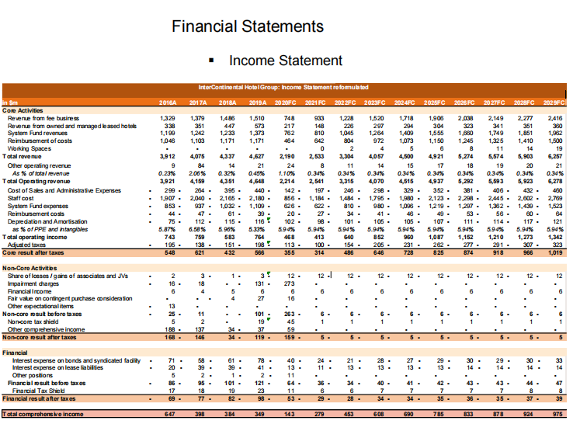
Figure 4. Income Statement of IHG (2021). Source: Fernandes (2021).

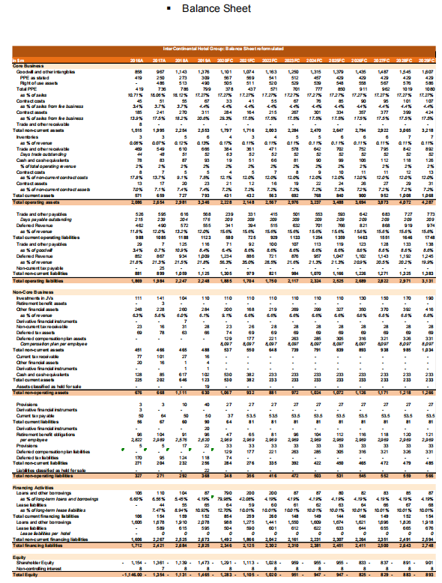
Figure 5. Balance Sheet of IHG (2021). Source: Fernandes (2021).

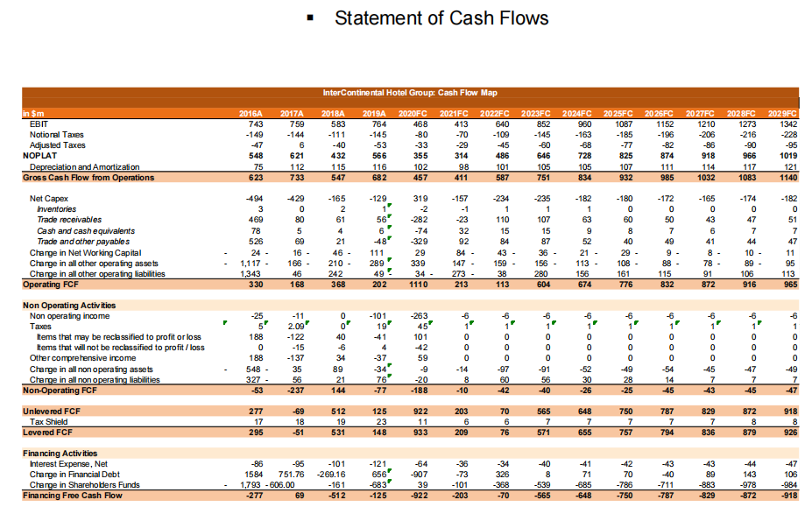
Figure 6. Statement of Cash Flows (2021). Source: Fernandes (2021).

