

Marketing Fundamentals (LCBB4004)

Assignment 2

An individual essay: The role of marketing in creating value for customers.
Stakeholder engagement and their impact on the marketing activities of Chanel

Module Lecturer’s Name: Ze Zook

Student Name: Manuela Hristova Manoloova
Student ID: 2018271

The role of marketing in creating value for customers

- Definition of marketing concept and how Chanel practices this concept?

The marketing concept is entirely focused on the needs and desires of customers. Instead of cheap and mass production, this concept emphasizes customer satisfaction. The focus here is not about the product, but about the satisfaction. Marketing research is used to define the needs of the segments.

The marketing concept holds that a company should research the needs and wants of a well - defined target market and deliver the desired satisfaction. The societal marketing concept holds that the company should generate customer satisfaction and long-run consumer and societal well-being as the key to achieving both its goals and responsibilities". (Kotler,1994) p. 18)
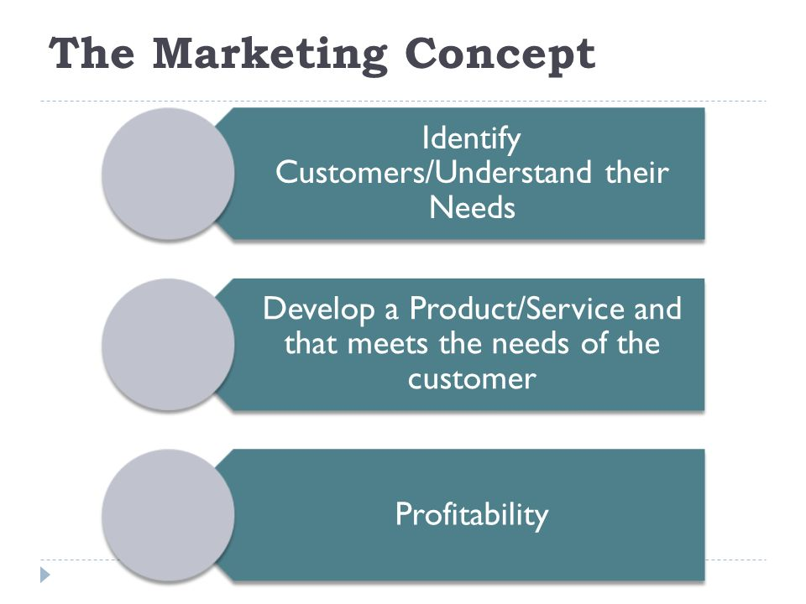

- In 1920, Chanel completely transformed the notions of style in the fashion market. Chanel's production focuses on the urgent need for women to replace uncomfortable corsets with comfortable blazers, pants and suits. It completely breaks the fashion by creating something different and unique and thus completely grabs the attention of consumers.

- The prices of Chanel products increase slightly over time as this is done in order for customers to accept shopping as an investment of money. Chanel keeps constant and high prices to feel the luxury, value and uniqueness of the products.

- When the desired sales of Chanel No.5 in the United States are not achieved, the number of stores selling a perfume is reduced and the money are invested in increased advertising with the help of celebrities such as Audrey Tauto and Marilyn Monroe.

- Chanel also satisfied the customer needs of show and theater using unique sets in their Runway shows and great mini movies to advertise their products. Knowing how to grab the public attention Chanel create a fabulous spectacle, that everyone is talking about.



- In 2013, Chanel published Inside Chanel, where they introduced their clients to the life of the designer founder of the company and the entire history of the brand from the very beginning, focusing on their products. This is a marketing ploy that impresses their customers and is used to advertise their products. Most famous products are included and the history of their creation get attention.

- Advantages of marketing to consumers
Marketing helps customers to be more informed about all the news, changes and trends. What is coming and what characteristics it has. Then the customers can easy make a decision what to buy. With the new technologies, digital marketing has received a great development, which provides fast, convenient and effective acquaintance with the products. The value for customers is the easiest way to find and buy online what they want immediately. Marketing build trust and connection between business and consumers. They are more likely to buy from a company that shows similar thinking like their. Sometimes customers are ready to buy products even if they don’t really need it just because they liked the way it is performed.

Chanel tries to outperform its competitors and beat them by striving to offer the best quality at the lowest possible prices, while maintaining the uniqueness of its products. In terms of cost, it can achieve good results by ensuring good distribution, modern and advanced technological production.
Chanel's goal is to win loyal customers by offering products of high quality, durability and efficiency along with enhanced advertising, using many celebrities. This imposes a certain image of the company synonymous with innovation and style. That is why Chanel is recognized as a class and power.

- Definition of branding, and advantages of branding to the customers
“A brand is a name, term, design, symbol, or any other feature that identifies one seller’s good or service as distinct from those of other sellers” (American Marketing Association)
“Branding is endowing products and services with the power of a brand” (Kotler & Keller, 2015)
- Branding leads to higher product quality. Whenever consumers buy a product, they get constant quality.
- Branding makes it easier for customers to find information about the nature and characteristics of the product they want to buy.
- A strong brand helps the customer to easily recognize it as well as to distinguish it from the competitors. Consumers would buy a well-known brand from a stranger even if they had not heard details about the company.
- Loyal customers of the brand would try every new product, even if they did not have a specific need for it, they would buy the product just because of the brand. It is very interested for the customers and this leads to a lot of inovations.
- Branding makes the customer feel that the product he buys is safe and reliable. This evokes gratitude and trust from customers for the brand's products. Customers like to buy from well-known companies that they like.
4.The Ansoff matrix strategies could also create value such as product development, or diversification
In order for a company to be successful, it is necessary to constantly search for new ways to increase its sales and profits. Ansoff Matrix shows risks and benefits of four strategies that can help the firm to develop.

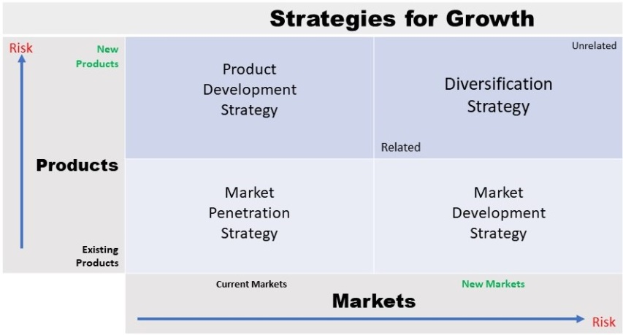

- Product Development Strategy - This strategy is to sell various products on the existing market. It is related to innovation and expansion of the company's products in order to meet customer needs. This can happen by develop or repackage the products.
- Diversification Strategy- This is about using a new product in a new market. This strategy could be very profitable because it relies on new customers, but it is also quite risky. There are two types of diversification strategy- related, when there is relation between the existing product and the new one and unrelated when there are no synergies.
- Market Penetration Strategy- An existing products on the existing market. The company tries to increase its market share by lower prices and using promotions and distributions.
- Market Development Strategy- Here the target is new market. Company wants to sell an existing product on the new market. PESTEL analysis and Marketing mix are very helpful in this strategy to find out the opportunities and threats and to reach different types of people.

Chanel's strategy is to capture as much market share as possible by focusing on innovation. Therefore, in 1999 it entered a completely new market niche, focusing on the production of products suitable for people under 25 years of age. Chanel has a huge range of products. They inspire young to old, men and women. Watches, perfumes, clothes, bags and shoes for anyone who can afford to wear this luxury brand.
Although the prices are largely constant, for their advertising activity Chanel adds promotions that apply to their very new products, not the old ones. All promotions can be found on the company's website, which is constantly updated and provides fully information.
Chanel use product development strategy for its perfumes. Every ten or twelve years the company performs new fragrance on the market and something that can be proud with is three of the top five in the world perfumes are by the brand of Chanel.
Chanel retail strategy is focused on the exclusivity. Its product can be bought only in Chanel`s boutique or website and it create feeling of something valuable and unique.

- Relationship Marketing
Chanel's success is also due to the company's good relationships with a community of customers in the show business and fashion industry. Marilyn has become an emblem of the brand. Brad Pitt is also advertising Chanel products. Nicole Kidman in “La Film” and a lot of more movies are focused on the brand.
In 2010 Chanel created a mobile application that gives customers opportunities to watch its fashion shows, to buy products and to find information about the news around the brand online.

Stakeholder engagement and their impact on the marketing activities of an organization

- Definition of stakeholder
Stakeholder is a person, group of people or organizations that show interest in the company what it does and the decisions it makes. These can be, for example, customers, shareholders or staff. “Any group or individual who can affect or is affected by the achievement of the organization's objectives” (,1984: pp46)
Each company needs to identify its stakeholders by first putting the organization at the center and then assessing their impact.

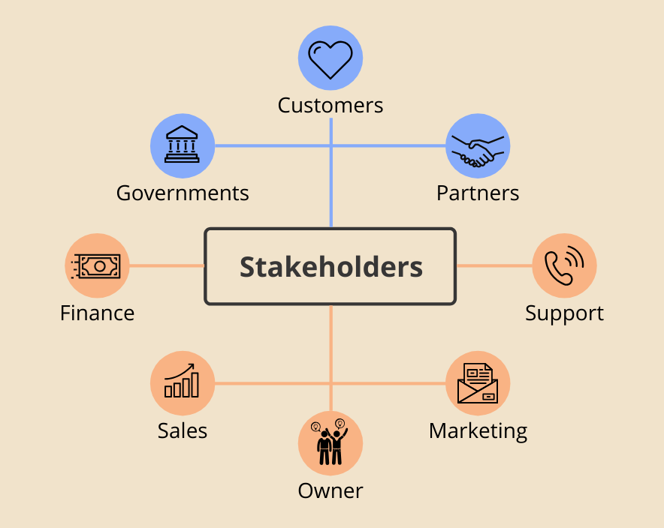

- Definition of internal and external stakeholders and provide some examples of your company
Stakeholders are internal and external.
Internal stakeholders are directly related to the organization. It can be investors, owners or workers. For them the company performance, success or failure are very important. In Chanel Internal stakeholders are:
-Top Management
-Leaders and Financial Community
-Employees
External stakeholders are not working directly in the company but they are still connected to the organization results, like creditors and suppliers. The company actions can affect the external stakeholders and the opposite also. In Chanel external stakeholders are:
-Community
-Suppliers
-Media and influencers
-Trade Unions
-Competitors
In Chanel internal stakeholder are the employees who are directly concerned about the development and success of the company. Because their pay is very good, they have the opportunity for professional development and feel valued. They even have a lot of benefit as getting one suit per year. That is why employees would like to keep their jobs as long as possible. The impact of the employees on the company is that they gives their best to achieve a company goals and this will lead company on the top. Here is the power of the motivation.
Suppliers are an important part of Chanel as it has a long-term plan related to the prospects of the business. The providers they use are highly qualified and contribute to the community as a whole. The reason for suppliers interest is about timely payment of debt and the adequate liquidity - there are 310 boutique connected very comfortable and tightly.
Customers are also stakeholder in Chanel. Even the price of the product is high consumers are ready to buy. They feel very happy and satisfied because of the quality and Chanel provides care even after the product is sold. There is a period of one year after buying that the repair is for free. This is how Chanel turns a consumer into a loyal customer that expect appreciate and buy every new product of the company.
Chanel supports gender equality and believes that this is important for global progress, as research shows that these communities are more stable and prosperous. That is why Chanel helps by giving grants to organizations that work to improve the economic and social conditions of women.

Chanel is a symbol of class, perfection and beauty. The marketing approaches the company uses are gaining millions of followers around the world. The ideology inspires women to be bold, diverse and themselves. To look stylish and elegant and at the same time feel comfortable attracted the attention of ladies. The high prices of the products do not prove to be an obstacle for the sales, on the contrary they strengthen them and the purchase is accepted as an investment in something valuable. Using glamorous shows and Hollywood celebrities, Chanel has become easily recognizable by consumers. Chanel is constantly strengthening his authority and good reputation. It supports many training and access to health services programs, striving to be a role model in society.
Marketing is extremely important for any business. It is science that triggers a purchase and thus improve the company's sales. Helps to find and communicate with customers and create a sense of loyalty in them. Marketing meets the needs of customers and builds a positive reputation of the company. Branding creates a clear business idea and sets it apart from the competition, making it easy for consumers to remember. It helps the penetration of new market niches and the development of the company. Marketing creates also value for the customers. It helps them to find what they need and to invest their money in the right product. Marketing studies the desires of customers, stimulates competition and reduces product prices. Encourages innovative ideas, promotions and adds value to the customer. It helps them rediscover, express themselves and to connect with the brands.

Reference:

- Hooley, G. J., Saunders, J. A. and Piercy, N. (2004) Marketing Strategy and Competitive Positioning, 3rd Ed, Pearson Education: London, 622pp

- Freeman, R. E. (1984) Strategic Management: A Stakeholder Approach, Latest ed.Boston. MA: Pitman. pp46

- Bryson, J. (2004) What to do when stakeholders matter. Public Management Review, 6 (1), p.21 - 23.

- Lynch, R. L. (2009) Strategic management, 5th ed, Pearson Education Limited: UK, pp 826

- Ackermann, F. and Eden, C. (2011) Strategic Management of Stakeholders: Theory and Practice. Long Range Planning 44(3): 179–196.

- Agnew, H. (2017). Why Gabrielle is still Chanel`s biggest asset.
Avaliable at: http://www.ft.com/content/28612c64-f779-11e6-9516-2d969e0d3b65

Accessed: (20th April 2021)

- Sood, T. (2017) Strategic marketing management and tactics in the service industry, Pennsylvania

- Chanel
Available at: https://www.chanel.com/gb/fashion/handbags/c/1x1x1/
Accessed: (20th April 2021)

- Kotler, P. (1994) Marketing Management: Analysis, Planning, Implementation, and Control, pp18

