
Network Security
Jordan Luxton B.S. Hons MRes Computer Networks
Jluxton.139822@student.uwtsd.ac.uk

Table of Contents

Contents
Table of Contents 2
List of Figures and Tables 3
List of Acronyms 4
Introduction 6
Contingency Policy 7
Penetration Testing Framework 8
Penetration Testing Tools 9
Cyber Security Attacks 14
Solutions for Threats Identified 19
Cost of Solutions 21
Time table of execution 25
Conclusion 28
References 29
Appendices 32
System Development Life Cycle 42

List of Figures and Tables

Figure 1: SDLC approach towards the system 8
Figure 2: Nessus reported vulnerabilities 10
Figure 3:CVE database highlighting Linux Kernel weaknesses 10
Figure 4: OWASP ZAP report of the findings 11
Figure 5: Online scanning tools using hackertarget.com 12
Figure 6: Insecurely configured website 12
Figure 7: Attempting to gain access to the SSH server running on the server 13
Figure 8: Identifying accounts, images and networks to that email address 14
Figure 9:CUPSTV login page link 15
Figure 10: Changed HTML link 15
Figure 11: SSLstrip being implemented and deployed to target CUPSTV[50] 15
Figure 12: Utilised the WHOIS information to the applied WordPress login 16
Figure 13: Nessus report highlighting the vulnerabilities’ 17
Figure 14: Server string of connected network devices to the primary host server 18
Figure 15:OVH Cost of research, installation and the product 22
Figure 16:VPS Hosting, installation and research costing 22
Figure 17: Dedicated hosting pricing and installation 23
Figure 18: Service provider services and costings 23
Figure 19: Service Provider services 24
Figure 20: Showing the preferred dedicated hosting service and execution 25
Figure 21: VPS hosting service completion and installation times 25
Figure 22:OVH pro-web hosting solution creation time and research 25
Figure 23: Gantt chart showing the progress of the project 26
Figure 24: Gant chart showing the completion of the project elements 27
Figure 25: Cupstv.com WHOIS lookup data 32
Figure 26:Shodan search showing available ports and connections 33
Figure 27:Chrome audit of the CUPSTV website 33
Figure 28:Insecure page having no encryption 34
Figure 29: Phishing web portal CC 35
Figure 30: The Phishing Attack Workflow [59] 35
Figure 31: Injection 36
Figure 32: Broken Authentication 36
Figure 33: sensitive data exposure 36
Figure 34: XML External Entities (XXE) 37
Figure 35: Broken Access Control 37
Figure 36: Security Misconfiguration: 37
Figure 37: Cross-Site Scripting (XSS) 38
Figure 38: Insecure Deserialization 38
Figure 39: Using Components with Known Vulnerabilities 38
Figure 40: Insufficient Logging & Monitoring 39

List of Acronyms

- CUPS………………………. Citizens United for Peace and Stability
- CDN………………………...Content Distribution Network
- SDLC………………………. System Development Life Cycle
- CPU…………………………Central Processing Unite
- DDoS………………………..Distributed Denial of Service
- WAF………………………..Web application Firewall
- SQL………………………… Structured Query Language
- XSS…………………………Cross-Site Scripting
- IP……………………………Internet Protocol
- UML………………………...Unified Modelling Language
- HTML……………………… Hypertext Markup Language
- SDL…………………………Security Development Lifecycle
- HIPPA……………….............Health Insurance Portability and accountability Act of 1996
- IMSI…………………………Information Security Management System
- BCM……………………...….Business Continuity Management
- CSRF…………………………Cross-Site Request Forgery
- WHM…………………….......Web Host Manager
- IOC………………………..... International Organization for Standardization
- IEC………………………...... International Electrotechnical Commission
- Zero-Day attack……………..(active vulnerability undiscovered)
- RAM…………………………Random-Access Memory
- SSL…………………………...Secure Socket Layer
- SAS………………………..…Serial-attached SCSI
- SEO…………………………..Search Engine Optimisation
- TB……………………………Terabyte
- WHOIS………………………Querying a domain database
- SHA-2……………………….Secure Hash Algorithm 2
- DNSSEC……………………..Domain Name System Security Extension
- SLA…………………………..Service Level Agreement
- ASA Firewall………………...Adaptive Security Appliance
- SSL…………………………...Secure Socket Layer
- CSRF…………………………Cross-Site Request Forgery
- XXE………………………….XML External Entities
- PHP…………………………..Hypertext Pre-processor
- DRP………………………….Disaster Recovery Protocol
- BCP…………………………..Business Continuity Planning
- IRP……………………………Incident Response Planning
- AUP…………………………..Acceptable Use Policy
- NSM………………………….Network Secure Monitoring
- MITM………………………....Man In The Middle
- AAA…………………………..Authentication, Authorisation, Access Control
- 2FA……………………………2 Factor Authentication
- AES……………………………Advanced Encryption Systems
- RSA…………………………....Rivest-Shamir-Adleman
- ECDHE……………………….. Elliptic Curve Diffie-Hellman Key Exchange
- WI-FI…………………………..Wireless Fidelity
- SYN……………………………Synchronise
- NULL………………………….Null route
- ACK…………………………...Acknowledgment
- FIN…………………………….Finish
- UDP……………………………User Datagram Protocol
- HSTS…………………………..HTTP Strict Transport Security
- CSP……………………………Content Security Policy
- TOFU……………………….....Trust On First Use

Introduction

Network Security is the practice of utilising both the physical and logical elements pre-emptively preventing attacks and reconnaissance. Therefore, it defends against morphing, entree access, obliteration, mismanagement and unwarranted leaks. The process to actively and dynamically implement security features creates secure, trusted environments which are stable to operate and conduct business. As a result, a security report and analysis, demonstrating a variety of vectors and opportunities in cybersecurity attacking Citizens United for Peace and Stability (CUPS)[1] has been created. This security analysis is achieved using black box penetration testing[2]-[3] this method is used from a position of external reconnaissance and attacks on system architecture and software, understanding the internal developments of construction and deployment of the target systems. In addition to real world developing attacks, the use of simulation software will be utilised to construct systems that would better defend and protect the target company in question. Supporting secure communication of the Television (TV) and radio broadcasts making use of Content Distribution Networks (CDN)[4][5]–[7] and cloud defences CUPSTV provide a variety of media sources. Therefore this research aims to gather as much detail as possible on the website (CUPSTV), the hosting provider, its themes and software to provide as much clarity into what are the possible vectors of attack. From this the explanation of exploitation will be provided showing real world inspections of systems and possible ways to attack a website.

Contingency Policy
To conduct a thorough and proper evaluation of the systems, the creation of a contingency policy has been assembled to enact a redundancy procedure in the case of wrong doing or mismanagement of the systems. Therefore, many different areas have been looked at to prevent any possible harm to the business or other businesses.
As a result, the research concluded that the best way to protect the website was to create very clear lines of communication between the different elements of the operation between the site owner and the other facets through which the business could be hindered. The principal contingency policies are broken into pro-active active and reactive meaning that many procedures should be considered before the attacks begin and if the attacks are successful that the site should follow the reactive procedures. Disaster recovery planning (DRP), Business continuity planning (BCP), Incident response planning (IRP) and Acceptable Use Policy(AUP) are compiled in to Quantitative risk analysis and Qualitative risk analysis found in Appendix 19.

Penetration Testing Framework

The framework developed in this report adheres to a strain of activities that are followed so to complete an assembly of effective methods. This is highlighted in the policies where the link to specific stage influences have been aligned for best management and synergy. As a result the system development life cycle (SDLC) has been developed to demonstrate the stages of the penetration testing framework in Appendix 20.

Figure 1: SDLC approach towards the system

Penetration Testing Tools

The testing tools utilised in this report were specifically deployed in a reconnaissance sense so to research into the many elements of the business. The tools therefore were tasked to identify and vulnerabilities within the current configuration of the CUPSTV website and the systems that support it. The result of which inspected policy violations, misconfiguration, malware on the websites or active attackers. The tools deployed gained as a result the crucial detail required during the reconnaissance which checked the different elements of the OSI layer[34] in regards to the inspected elements such as the application, presentation, session, transport, network and data link.
- Nessus
- WHOIS search
- Shodan
- CVE database
- OWASP ZAP
- WordPress online security search
- Chrome
- Putty

The first tool used was Nessus N Professional[35]–[37], which is used by millions of people as a responsible reliable and trustworthy tool to depend on and develop the necessary information required to analyse and defend networks from known weaknesses.
During the scan of the CUPSTV.com website Nessus professional managed to find 47 vulnerabilities from which is determined by the release of information and then the actual classification of exploitable areas. This can be seen below with SSH exceptions and email clear text login easily taken advantage of using man in the middle (MITM) and other deceptive technology’s which trick the user in believing they are on the correct site.
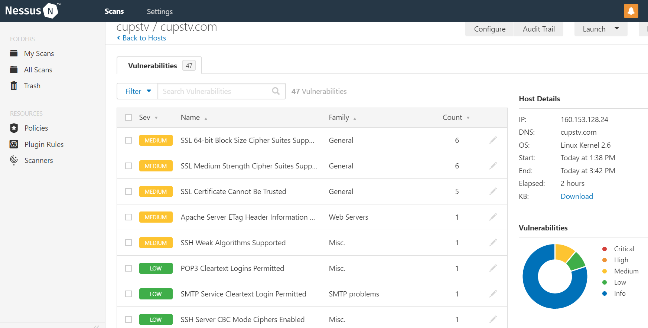
Figure 2: Nessus reported vulnerabilities
However other non-intrusive and regularly available data was gained through common channels and protocols such as a WHOIS lookup through the search engine Google. The image in Appendix 1 highlights exactly what could be found from this search such as the registrar, the expiration date of the domain which if not renewed is an exploit, name servers, and the status of the domain. However a primary element of the information gained from doing a WHOIS lookup search was the owner and administrator contacts which by law have to be real and kept up to date. The result of which means a huge social engineering exploit which is demonstrated in the Cyber security attacks section. This information divulged to the public domain email addresses, phone numbers, organisation addresses.
Another simple however effective tool is the use of Shodan[38] which was used as a simple method to determine the connection stream of hosting servers, management servers and port availability showing a range of features which if targeted such as the exploitation of cPanel for the website or the WHM cPanel for the server could be detrimental Fig26 (Appendix 2).
From this information gained from Shodan and Nessus a determination can be made how to attack the systems as a structure of network communication is starting to appear with the IPs and name servers identified. However the data also provides application layer problems in administrative sections such as the version of the Linux kernel and the vulnerabilities to it if the appropriate patches are not applied. This was proven with the CVE database as seen below using the tool to determine a potential 149 vulnerabilities.
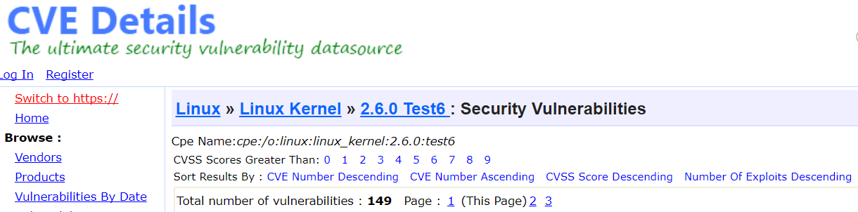
Figure 3:CVE database highlighting Linux Kernel weaknesses
This database of vulnerabilities as a tool proved instrumental in issuing levels of severity that the attacks provided can afflict on the targeted systems and how to conduct those tests. The site having such an eclectic range of data meant that the divulgence of theme information was shown to be present and exploitable which was verified in the OWASP Zap.
OWASP Zap was an excellent open source tool developed by the open source community having a highly configurable application allowing for advanced searches into the top 10 most common vulnerabilities identifies by OWASP in the testing guide 4.0[39] and OWASP top 10-2017 critical web applications exploits[40]. This amounted to the searches into:
- Injection
- Brocken authentication
- Sensitive data exposure
- XML Extension Entities (XXE)
- Brocken Access Control
- Security Misconfiguration
- Cross-Site Scripting (XSS)
- Insecure Deserialization
- Applying components to known vulnerabilities to reassemble an attack
- Insufficient logging and monitoring
Additional elements Queried were:
- Security misconfiguration
- Missing function level access
- Cross-site Request Forgery (CSRF)
- Un-validated redirects and forwards
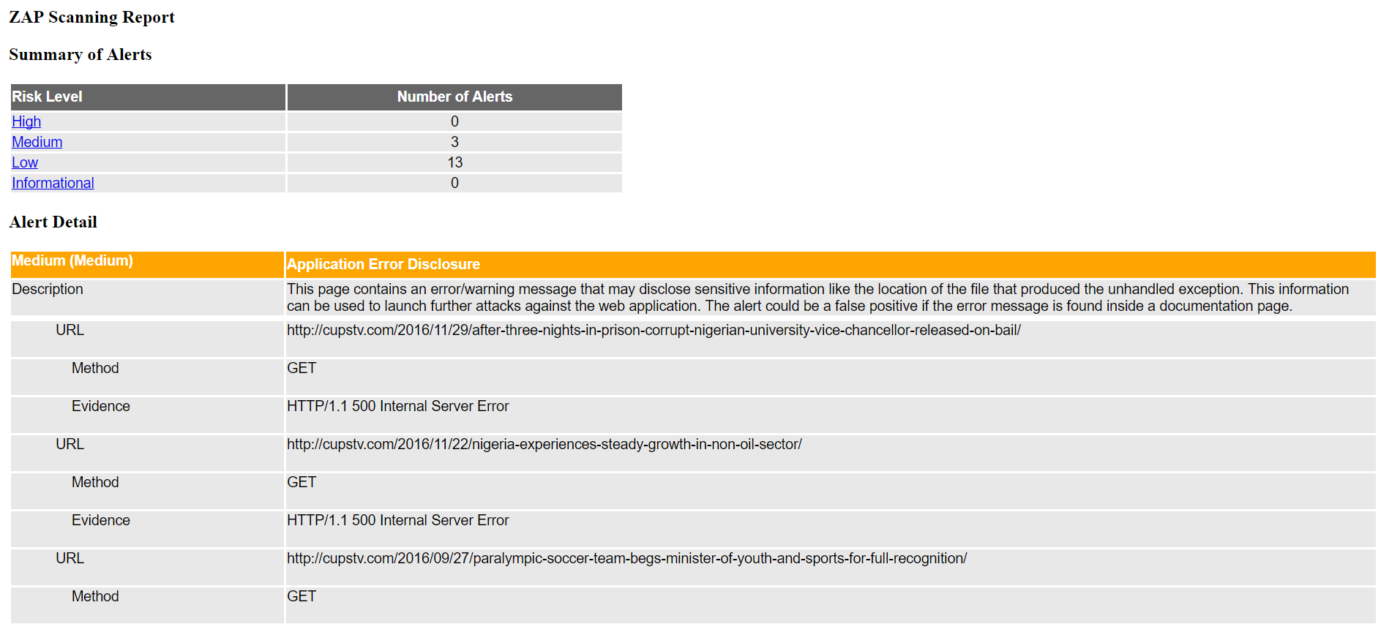
Figure 4: OWASP ZAP report of the findings
This is a report compiled from OWASP Zap which shows the summary of alerts through which a highly detailed analysis is compiled showing the breakdown of the investigation and the description of the alert.
In addition to those active scanning solutions passive scanning was also developed using an online WordPress security scan which check through common elements found in websites. This scan produced a simple and effect means of checking the WordPress site highlighting weaknesses in its composition.
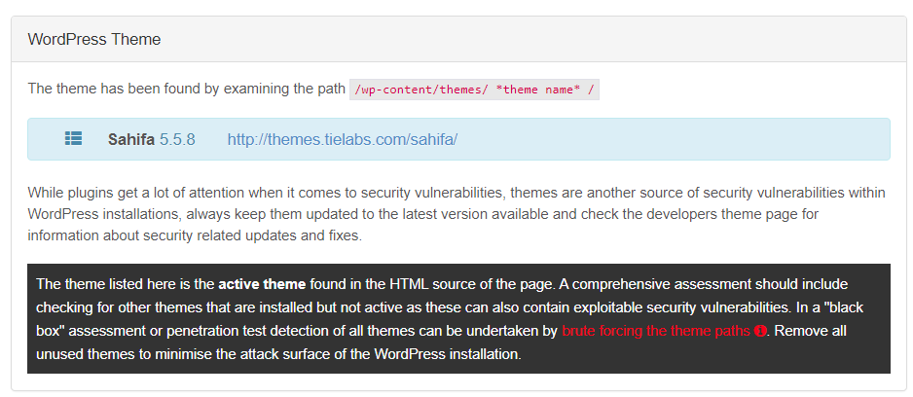
Figure 5: Online scanning tools using hackertarget.com
The report compiled showed a brief analysis of the potential breakdown of themes, specifically in this case to the website it was using Sahifa 5.5.8 which again produced multiple results.

Additionally to the tools used was the standard search engine Google, simply seeing what exactly the website has to offer and if there are any blatantly clear problems which were actually discovered. The image below demonstrates a basic however important feature in website security which is the encryption of the webpage.
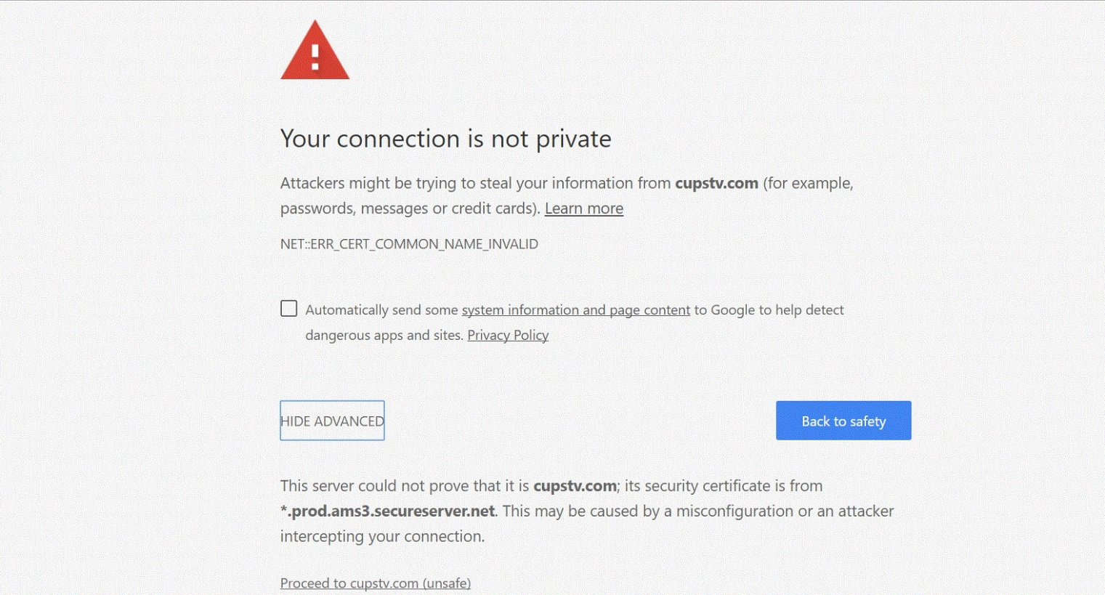
Figure 6: Insecurely configured website
This element of exploitation will be discussed later however in addition to a standard search there is the option to dive into the developer configurations which also provide details on accessibility, performance, best practises and progressive web features. The result of this chrome audit can be found in(Appendix 3, Fig27).
Putty was used to see the exploitability of the SSH server running on the WHM cPanel. This is an area that if a sustained brute-force attack were to happen then there is the potential for entry into the systems server.
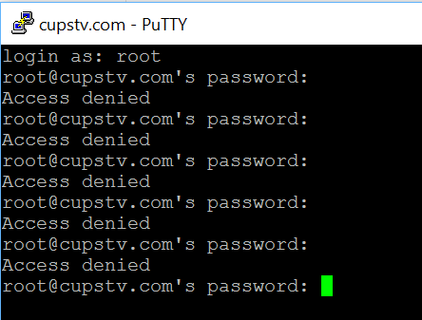
Figure 7: Attempting to gain access to the SSH server running on the server

Cyber Security Attacks
Social Engineering
Reconnaissance attack, through testing for vulnerabilities a number of interesting ports where discoverable on the central server. These ports ended up belonging to cPanel, one is a standard cPanel application which corresponds to the websites on the server independent of each other. The other was a WHM[41] cPanel application[42] which if it was to be cracked controls the server which houses all of the webistes including the target website cupstv.com. Mitigations on cPanel do range from however 2FA, cPHulk. In addition there is another area of the attack on the WordPress website which using the admin email of the WHOIS search has a corresponding account on the for mentioned site. Thirdly another parameter of attack is the email address its self which is susceptible to attack however there is an automatic google security procedure that when the potential entrance doesn’t meet the geo location, language etc, as a result an effective 2FA comes into effect either through Gmail association of the account or a phone number, interestingly the phone number on the WHOIS information corresponds with the requested phone number, upon more research the that phone worked out to be a mobile phone number belonging to EE. With that in mind a potential method of attack would be to infiltrate the google attack install the app Cerebus anti theft app[41], this will enable an effective remote control method that can be undertaken designed not to be seen by the user so they are unaware of what is happening in the background. This will be the most effective method in obtaining 2FA message information, emails, texts etc. However in order to get into passed the 2FA and access to the site a process needs to be completed so that phone calls can be forwarded to another phone number, this is achievable as under google you can select a phone call or text messages which wouldn’t be forwarded. Using community EE forums[43], I found that any EE phone through the technical department or by ringing 01707315000 will enable them to manually change the call diverts to another number there by temporarily gaining the 2FA features required to access the main Gmail account and through that the phone by using the mobile app which will monitor all activity. If that was possible then many of the keys to taking the website down could be achieved by extrapolating data from the phone and email accounts or by simply sending a deliberate suspicious message that would subsequently make a person think about the security of the website and so by logging into it and checking the setting all the while a screen recorder and all the tools to get a password reset are available.
The image below illustrates a common social engineering tool used to find social networks.

Figure 8: Identifying accounts, images and networks to that email address
Website exploitation
During the inspection of the website to determine its strengths and weaknesses it was observed that there was no encryption on the site and no authority to determine if the connection to the site was genially from CUPSTV or from a third party (Appedix 4 Fig 28). This results in a number of problems which when exploited can have massive effects to the end user or even the administrator of the site. The fact that the link to the login in page is insecure and the login page is insecure creates a systematic flow of problems in regards to authenticity due to the fact that the link cannot be trusted because it could have been changed or replaced with a link to potentially harming or advantages server in regards to mining or malware exploitation. The capability therefore to change clear text websites are entirely open, and open to change due to the lack of secure encryption that should be expected such as, TLS 1.2[44] (strong protocol) ECDHE_RSA with X25519[45] (strong key exchange) and AES_128_GCM[45](strong cipher). The affect therefore means that if a person was using WI-FI could result in a MITM attack[46]–[48] or if a client was in a country where ISP potentially change or adapt webpages [49] then the link could be changed for login to cups1v.com which could fool people and send them to a different site.
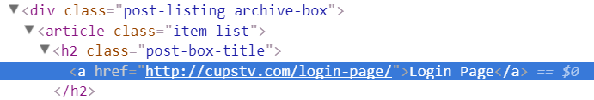
Figure 9:CUPSTV login page link
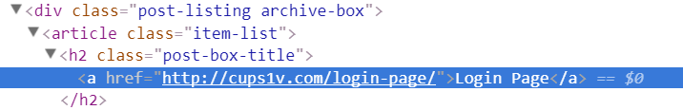
Figure 10: Changed HTML link
The result of changed link is shown above in Fig9 where a link was changed by an intermediate in the transport chain. The addition here is that this is a single link to attack however utilising the tool called sslstrip[50] which grabs all HTTPS traffic and actively redirects them to look alike links or homograph-similar links. Even supporting a lock icon further making the user believe they are protected.
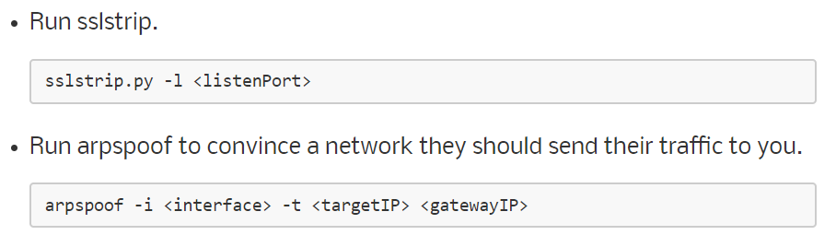
Figure 11: SSLstrip being implemented and deployed to target CUPSTV[50]
The figure below shows how simple website exploitation can be through simple reconnaissance and dictionary attacks.
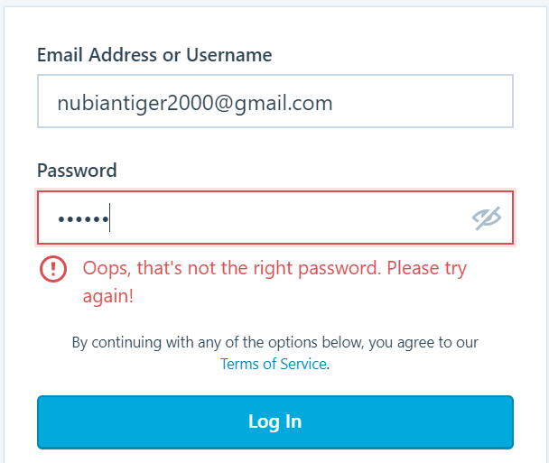
Figure 12: Utilised the WHOIS information to the applied WordPress login

OWASP ZAP
OWASP ZAP was utilised in this report to test in different strengths of attack what the website and the servers that host and house the systems can stand to take. The features developed into the software amount to intercepting proxy which help analyse the traffic and sockets used which was inspected during the testing. Automatic scanners which detected security holes simulating an attack, passive scanning as a result identifies the server systems showing elements that are available freely when in operation. Brute forcing scan is also an element, which is automatically completed which when in attack mode operation attempts to access files and directories on the server and webpage. Spidering in ZAP determines the hierarchical structure of the website identifying every link on the website. With spidering in effect fuzzing is also an element which is activated to supply unexpected and invalid data to attempt to crash the systems and create unexpected events. Port scanning was utilised as an inherent element of the application which is the first process of approach checking all open ports from which the attacks and approach in regards known database vulnerabilities. Dynamic SSL certificates are an operation within the process application intercepting the server responses and requests through which data can be examined to determine links objective destination which proved to be effective in the result of the ZAP reports highlighting broken or hackable links. The BeanShell console is an effective java script which performs java syntax. The interaction of the BeanShell console enables scripts using ZAP functionalities and data sets which ultimately led to the discovery of medium and low threats to the server systems.
Nessus
Nessus was utilised as being a developed network security scanner using the plug-ins established into the local server architecture that encapsulates the wide range of attacks. The plugins were then utilised in the application which completed primary attacks that align with known common vulnerabilities. The primary use of Nessus is the fact that it has a large community behind it so when vulnerabilities’ are found then plug-ins are established which directly integrate into the systems applications.
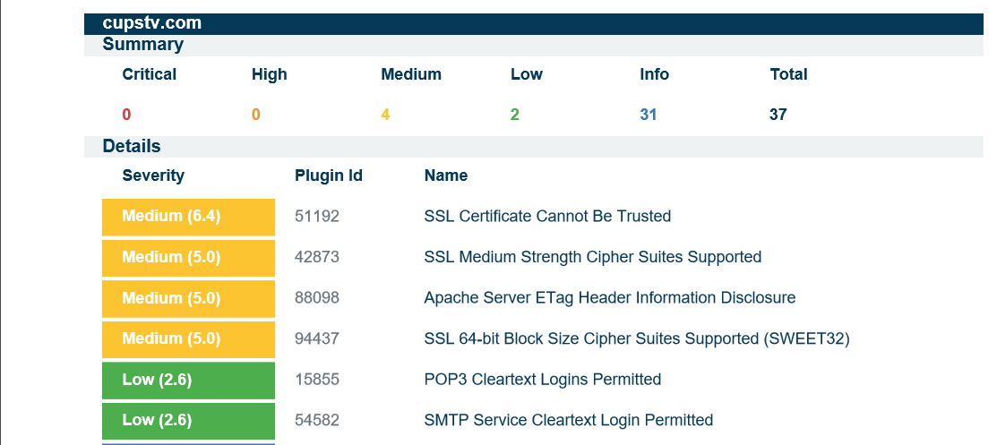
Figure 13: Nessus report highlighting the vulnerabilities’
During the testing eight reports were compiled as a result of the various testing done of the plugins available such as advanced testing issuing a complex and long assault on the website. Analysing specially into the front facing interfaces surface which is the most obvious to target and assault and then the elements behind it such as host operating system weaknesses or webserver exploitations. Tests such as Intel AMT security[51], [52], shadow brokers tools, Wanacry[53], [54], advanced application, presentation and session attacks had attempted to execute and effect the CUPSTV website.

Shodan
The use of the passive and active scanning tool, Shodan (Fig 26 Appendix 2) proved to be instrumental in breaking down the relevant information which provided the key information into gaining knowledge on the systems and its utilities.

Figure 14: Server string of connected network devices to the primary host server
Shodan however is not an attack tool but a means to collect data which when used with other prime tools can result in the target being effected. The primary result however gained from Shodan was the controlling servers which if enough time was dedicated to specifically taking over them will result in the website being taken down. This would be achieved using a dictionary attack[47] as an example on the login page to the WHM cPanel or a brute force on the servers SSH[55], [56]. Utilising certain parameters such as SYN, connect, NULL, Xmas, ACK, Fin and UDP scanning approaches on the target systems gaining the different elements of the target information. Shodan however is a developing tool which if a premium is paid then the ability to gain in-depth reports, a greater insight into detailed analysis and the ability to commence an effective network monitoring tool. Checking all IP addresses owned by the company from which an attack footprint is created the tool shows real-time stream which when used maliciously can show how the company is defending and developing systems to cope with hackers.

Solutions for Threats Identified
Primary solutions which can prevent the majority of threats is to follow the list below covering common weaknesses established in the cyber security industry:
- User training, education and responsiveness
- Network security
- Malware deterrence
- Detachable device controls
- Secure conformations and configurations
- Homebased and dynamic work systems
- Observation technologies
- Instance administration
- Organisation user rights
Social engineering
In order to combat the techniques used to enter networks such as phishing, Clone[57], Spear[58] and Phone phishing[59] (Fig 29 Appendix 5) then Counter-measure need to be established depending on the type of attack. However one consistent element within all the social engineering configurations of attack is that human error leads to the success of the phishing campaign. Therefore the primary solution to eradicating social engineering is to ensure that all works are thoroughly trained to recognise inconsistences within webpages, documentation and professionalism when divulging information to people over different media streams. The addition of blacklisting known phishing sites is an important step in addition to WAF in recognise patterns and vulnerabilities that use effect systems to trick users into giving private data (Fig 30 Appendix 6).
Website exploitation
Whether it is upgrading the web hosting, getting VPS hosting or a dedicated server, the actual additional features that are primary to the solution enable a comprehensive solution to every concern. This is relevant to both the systems, networks and web applications which as stated come with a vast array of solutions which can defend against the active and passive as well as dynamic and static attacks including zero-day. Using anti-DDos technology, WAF, CDN architecture, malware removal, SSL certification, DNSSEC and redundant IPs just to state a few of the common protections available (Fig19). Depending on the single point of management however additional services can also be added such as Cloudflare, which offer an additional easy layer of security such as easy website configuration for 301 permanent redirects, HSTS and CSP (Appendix 7).

OWASP ZAP / NESSUS
In order to defend against these automatic operations which utilise the hundreds and thousands of vulnerabilities covering millions of devices requiring specific solutions. However general categories below are suggested solutions which have the ability to cover a large range of attacks conducted by OWASP ZAP and NESSUS plug-ins.
Using control functions through avoidance, mitigation or safeguards means architecturally the strategy of layering defences through information security principles, encrypted sites and network secure monitoring (NSM). In addition, AAA of passwords authentication, authorisation and access control act as countermeasures thus preventing ZAP and Nessus highlighting standard redirects and forwards when spidering. The use of strong encryption which was reported in Nessus and ZAP as missing is another simple improvement and protection which is also free through Lets Encrypt. Another area of inspection identified in the reports were the escalation rights on the website from improper rights assignments so the assessment and refinement of rights is required to meet the proper standards required to protect data. Specifically for the parameters searched in the applications, the solutions for the threats identified in Appendix 18.

Cost of Solutions
The cost incurred through the compiling of this report are broken-down into categorise depending on the solution provided. This can amount to costs that replace hardware or software in regards to virtual or physical devices in addition to in house or third party solutions costing. Also the listed costs will include the implementation fixes, and the hourly rate of the reports consultant. The costs therefore associated with consultancy will be applied to each section and account for research time and as stated solutions to the organisations infrastructure.
The report has concluded that there are 3 solution approaches, this has been determined by the way in which multiple system or architectural advantages and efficiency improvements can be made.

Upgrade Business Web Hosting
The cheapest and most seamless way to ensure that the site is the least effected by improving the current organisation structure and infrastructure systems would be too simply upgrade the current product packages. This ensures that firstly the products will work straight away as the systems are already built into the hosting providers and application structures. Also there will be no confusion in regards to time and process required to upgrade the systems as the current sites associated with the CUPSTV operation are well documented such as GoDaddy and WordPress. However, as an aspect of the upgrade for which accounted for an approximate repair time of 1hour as the automatic renewal process and ensuring anti-theft technology would be enabled, secondly the installation of a SSL certificate for CUPSTV in cPanel. The configurations would then checked to ensure that HTTPS socket layer is working correctly. In Fig18/19 the most suitable solutions have been compiled into the chart showing the cost of upgrading from the current configuration of the webserver. The GoDaddy servers can be seen to provide a clear advantage in identifiable specifications with the ability for expansion if required however it is one of the more costly solutions compared to OVH or Gandi which are able themselves to provide expandable services providing the same level of support in addition to excellent reputation. As an element is progress of the project in regards to upgrading the web hosting services time incurred should be a large element, this can be either the additional expense of having seamless integration. The other approach is to take on OVH or Gandi where they provide the same service for a similar price, the primary disadvantage is time for configuration and installation however conducting this in a systematic approach will ensure that minimal down time will be incurred. As a result, the report suggests that OVH provides the best services at the cheapest prices and so should be developed for future expansions in the organisations digital approach. This means that in total for upgrading to a pro-business website solution on OVH it will be £6 per month and will take 2 days to prepare for installation of the website in addition to 2 hours to develop the current website into the OVH structure costing £712 not including VAT as seen in Fig15.

Figure 15:OVH Cost of research, installation and the product
VPS Hosting
The report researched into primary VPS hosting providers looking at the current offering in which the web hosting is conducted on such as GoDaddy and WordPress, however other providers such as OVH and Gandi were inspected. The findings summarised in Fig5 show what VPS Hosting configurations had to provide such as RAM, storage, bandwidth, SSL and IPs. All have excellent services however the refinement to the CUPSTV website means that not going over the top or under-developing the service have to be considered. Therefore the VPS service provider of choice is GoDaddy as it enables acceptable resources to the site, a free SSL certificate and appropriate configurations in addition to being developed into the GoDaddy systems so transitioning from a business website to a VPS will be less complicating with an expected installation of 1hr, 2 days research and the cost of the VPS which is £20/month. The overall cost therefore is £848 to have a full developed system into the VPS GoDaddys Systems as seen in Fig16.

Figure 16:VPS Hosting, installation and research costing

Dedicated
Dedicated hosting was the third solution researched in this report which would provide the best solution for the CUPSTV website ensuring greater senses of control and support when creating and developing the systems to support and protect the website. As shown in the Fig18 chart, dedicated service solutions were researched and investigated however only two of the four providers offered such as service. This meant that the variety and availability are not as diverse as the other services however the packages selected for this chart were more than adequate but also their lowest specification configurations and the cheapest dedicated solutions. As a result using Fig17 the conclusion drawn through the report on dedicated hosting solutions can be derived from the additional benefits included with the package. For instance, the GoDaddy is £56/month or £672 a year and an unmetered bandwidth which is a massive benefit if the site wishes to develop a broadcast of radio and TV which would use precious data allowances however that is not unique to GoDaddy as it’s also included in OVH. The other element is complete control over the device server and its management interfaces using cPanel. The primary benefit seen when using OVH is the pronounced inclusion of L7 DDoS protection. This is not included in GoDaddy requiring extra packages which will be expressed in a later element of the report. Ultimately therefore the paper suggests that the dedicated hosting package to choose from would be OVH as it includes a primary security feature of DDoS. The total amounted can be seen in Fig17 with two days of research required 4 hours of installation plus the yearly hosting cost amounting to £1,592.
Figure 17: Dedicated hosting pricing and installation

Figure 18: Service provider services and costings
Fig18 is an eclectic assembled table of available service and hosting providers to support a business class level of requirement and services so the business has a sense of security when using these services.
Figure 19: Service Provider services
The figure 19 above is an additional element of services and reasoning towards the different services provided by the previously states service/hosting providers with the addition of Cloudflare services. Cloudlfare should be noted as being an addition to any of the supporting systems if required preventing certain attacks using its WAF, DNSSEC and DDoS services. The other elements were selected on being the most appropriate for the website in regards to affordability, productivity and serviceability to change and adapt the services if additional products and elements wish to be added.

Time table of execution
The following Figures 20, 21 and 22 are the multiple options available from which the report constructed to be the best solution depending on the system or architectural as well as money considerations. This element of time was expanded in the cost of solutions element of the report where by the costs where shown in alignment with the time spent into researching and installation.
Figure 20: Showing the preferred dedicated hosting service and execution
Fig20 presents the OVH dedicated solution time parameters if the cyber security specialist contracted to complete the project would require to ensure a fully operational system. This means thanks to the extra usability and control over the dedicated systems having root access and cPannel support enable two days for the system to be in operation.
Figure 21: VPS hosting service completion and installation times
Fig21 VPS hosting presented to be the best solution in the virtual architecture available that would be assured to have a reliable and expandable system so the organisation can develop in the future whilst giving an effective experience operation for the owners, admins and users to navigate. Therefore the total time required to implement the system is three days.
Figure 22:OVH pro-web hosting solution creation time and research
Fig22 displays the time period to simply upgrade the systems of an effective web experience aimed at businesses. The reason for the additional time is purely to migrate the systems and its website requirements to OVH of GoDaddy. As a result the total time projected to complete a Pro-web installation is three days.

The Gantt charts table below provides the time taken during the project to assemble and compile this report The first table is directly about the projects phases such as research time, systems design, functionality reports and the written report time its self.
Figure 23: Gantt chart showing the progress of the project
Fig23 above shows the stages required to complete the report and the tasks within that such as systems tests and health checks in addition to code reviews when testing the website.
Figure 24: Gant chart showing the completion of the project elements
Fig24 above shows the completeness of tasks and the report identifying sections such as Testing framework creation which highlights its aspects in the reports compilation and the time dedicated to research it.

Conclusion

In conclusion the report produced a variety of in-depth reports into how to conduct, defend and prevent cyber-attacks in addition to a costing and management breakdown of the report. The report found that the site had numerous problems however only two elements that were potentially harming such as the lack on encryption with SSL and the themes introduced onto the WordPress site. The report found that through reconnaissance testing that the site needed to improve which resulted into in-depth solutions and protocols to use if the site was to be expanded upon and elevate. Over all the report provided the knowledge required to complete the task and scoping out the CUPSTV website. The project determined multiple methods for solutions and visual aids highlighting the tools used in order to complete the reconnaissance.

References
[1] “CUPSTV.COM.” [Online]. Available: http://cupstv.com/. [Accessed: 02-Nov-2017].
[2] “Black box secuirty testing tools,” 2004.
[3] D. M. Hafele, “Three Different Shades of Ethical Hacking: Black, White and Gray GSEC Practical Assignment Version 1.4b Option 1 The Rationale for the Ethical Hacker,” 2004.
[4] “Content Delivery Network (CDN) &amp; Cloud Computing Services | Akamai.” [Online]. Available: https://www.akamai.com/. [Accessed: 24-Mar-2017].
[5] Akamai, “Akamai Media Content Delivery Services,” p. 2, 2017.
[6] G. Nam and K. Park, “Analyzing the Effectiveness of Content Delivery Network Interconnection of 3G Cellular Traffic,” p. 6, 2014.
[7] V. Stocker, G. Smaragdakis, W. Lehr, and S. Bauer, “The Growing Complexity of Content Delivery Networks: Challenges and Implications for the Internet Ecosystem,” p. 32, 2016.
[8] C. J. Stefanou, “System Development Life Cycle,” pp. 329–344, 2016.
[9] Cloudflare, “Web Application Firewall,” p. 2, 2017.
[10] Cloudflare, “Cloudflare CDN,” p. 9, 2017.
[11] “Advanced DDoS Protection and Mitigation | CloudFlare | The web performance & security company.” [Online]. Available: https://www.cloudflare.com/ddos/. [Accessed: 10-May-2016].
[12] Cloudflare, “Enterprise Overview,” p. 8, 2017.
[13] Google, “Project Shield,” 2017.
[14] Akamai, “Q1 2017 State of the Internet Security Report | Akamai,” p. 26, 2017.
[15] Akamai, “Q1 2017 State of the Internet - Connectivity Report | Akamai.”
[16] Akamai, “Q2 2017 State of the Internet Security Report | Akamai,” vol. 4, no. 2, p. 27, 2017.
[17] Akamai, “Q3 2017 State of the Internet Security Report | Akamai,” vol. 4, no. 3, p. 24, 2017.
[18] OWASP, “OWASP CODE REVIEW GUIDE,” no. V1, p. 25, 2008.
[19] OWASP, “Code Review Guide Book v. 2.0 ALPHA,” no. V2, p. 25, 2017.
[20] HIPPA, “SUMMARY OF THE HIPAA PRIVACY RULE HIPAA Compliance Assistance O C R P R I V A C Y B R I E F SUMMARY OF THE HIPAA PRIVACY RULE,” 2017.
[21] PECB, “ISO/IEC 27002:201,” p. 12, 2017.
[22] Bsi, “I nformati on technol ogy Securi ty techni ques Code of practi ce for i nformati on securi ty control s,” p. 94, 2017.
[23] D. Kosutic, “ISO 27001 The Manager’s Information Security Strategy Manual.”
[24] I. Calder, “Information Security & Iso 27001,” IT Gov., vol. 1, no. 2, pp. 1–9, 2013.
[25] H. Ibrahim, “Implementation Guidance of Information Security Management System based on ISO/IEC 27003:2010.”
[26] Rostyslav Barabanov, “ISO/IEC 27004,” 2011.
[27] Pilar-tools, “ISO/IEC 27005:2011,” 2015.
[28] Iec, “ISO 27006 Information technology — Security techniques — Requirements for bodies providing audit and certification of information security management systems COPYRIGHT PROTECTED DOCUMENT,” 2015.
[29] “iso 27007 Information technology — Security techniques — Guidelines for information security management systems auditing,” ISO/IEC, 2011.
[30] W. Fumy, “ISO/IEC 27014:2011 Security Standardization News ITU Workshop on &quot; ICT Security Standardization for Developing Countries &quot;,” pp. 15–16, 2014.
[31] BSI, “ISO 22301 Business Continuity Management.”
[32] P. D. P. René St-GERMAIN, Faton ALIU, Eric LACHAPELLE, “ISO 22301.”
[33] “BUSINESS CONTINUITY MANAGEMENT &amp; ISO22301 Frequently asked questions,” 2015.
[34] H. Zimmermann, “OSI Reference Model,” IEEE Trans. Commun., vol. 28, no. 4, pp. 425–432, 1980.
[35] “Nessus Professional Vulnerability Scanner.”
[36] “Nessus Compliance Checks Auditing System Configurations and Content,” 2017.
[37] “Nessus Agents,” 2017.
[38] J. Matherly, “Shodan.”
[39] M. Meucci and A. Muller, “4.0 Testing Guide.”
[40] OWASP, “The Ten Most Critical Web Application Security Risks Important Notice Request for Comments GM Golden Master.”
[41] Cerberus, “Anti-theft solution for Android,” 2017. .
[42] “cPanel.”
[43] “Solved: Set up call forwarding / divert via the website - The EE Community.” [Online]. Available: https://community.ee.co.uk/t5/4G-and-mobile-data/Set-up-call-forwarding-divert-via-the-website/td-p/273874. [Accessed: 22-Nov-2017].
[44] T. D. <tim@dierks.org>, “The Transport Layer Security (TLS) Protocol Version 1.2.”
[45] S. Website Security, “Elliptic Curve Cryptography (ECC). Certificates Performance Analysis,” 2013.
[46] S. Gangan, “A Review of Man-in-the-Middle Attacks.”
[47] Mauro Conti, “IEEE: A Survey of Man In The Middle Attacks.”
[48] M. Eriksson, “An Example of a Man-in-the-middle Attack Against Server Authenticated SSL-sessions.”
[49] “Solved: Are you aware? Comcast is injecting 400+ lines of ... - Xfinity Help and Support Forums.” [Online]. Available: https://forums.xfinity.com/t5/Customer-Service/Are-you-aware-Comcast-is-injecting-400-lines-of-JavaScript-into/td-p/3009551. [Accessed: 14-Dec-2017].
[50] Scott Helme, “Moxie Marlinspike &gt;&gt; Software &gt;&gt; sslstrip.” .
[51] S. Baker, “Increase Business Security with Windows ® 10 and 6th and 7th Gen Intel ® Core TM vPro TM Processors.”
[52] “Intel AMT vulnerability. Life after CVE-2017-5689.”
[53] N. Scaife, P. Traynor, and K. Butler, “Making Sense of the Ransomware Mess (and Planning a Sensible Path Forward),” IEEE Potentials, vol. 36, no. 6, pp. 28–31, Nov. 2017.
[54] A. Akkas, C. N. Chachamis, and L. Fetahu, “Malware Analysis of WanaCry Ransomware,” 2017.
[55] M. Jonker, “Flow-based SSH Dictionary Attack Detection: the Effects of Aggregation,” 2014.
[56] A. Satoh, Y. Nakamura, and T. Ikenaga, “SSH Dictionary Attack Detection Based on Flow Analysis,” in 2012 IEEE/IPSJ 12th International Symposium on Applications and the Internet, 2012, pp. 51–59.
[57] J. A. Chaudhry, S. A. Chaudhry, and R. G. Rittenhouse, “Phishing Attacks and Defenses,” Int. J. Secur., vol. 10, no. 1, pp. 247–256, 2016.
[58] J. Shi and S. Saleem, “Phishing.”
[59] “HACKER INTELLIGENCE INITIATIVE.”
[60] “Encryption,” May 2016.

Appendices
(Appendix 1)
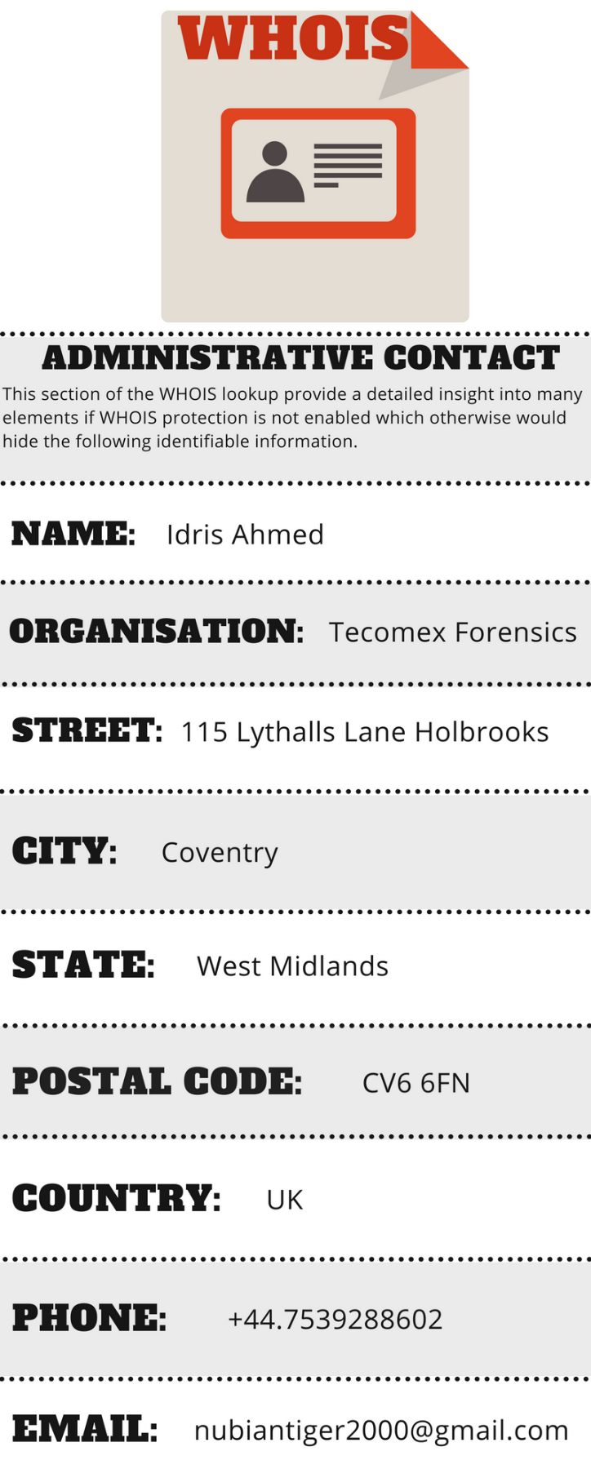
Figure 25: Cupstv.com WHOIS lookup data
(Appendix 2)
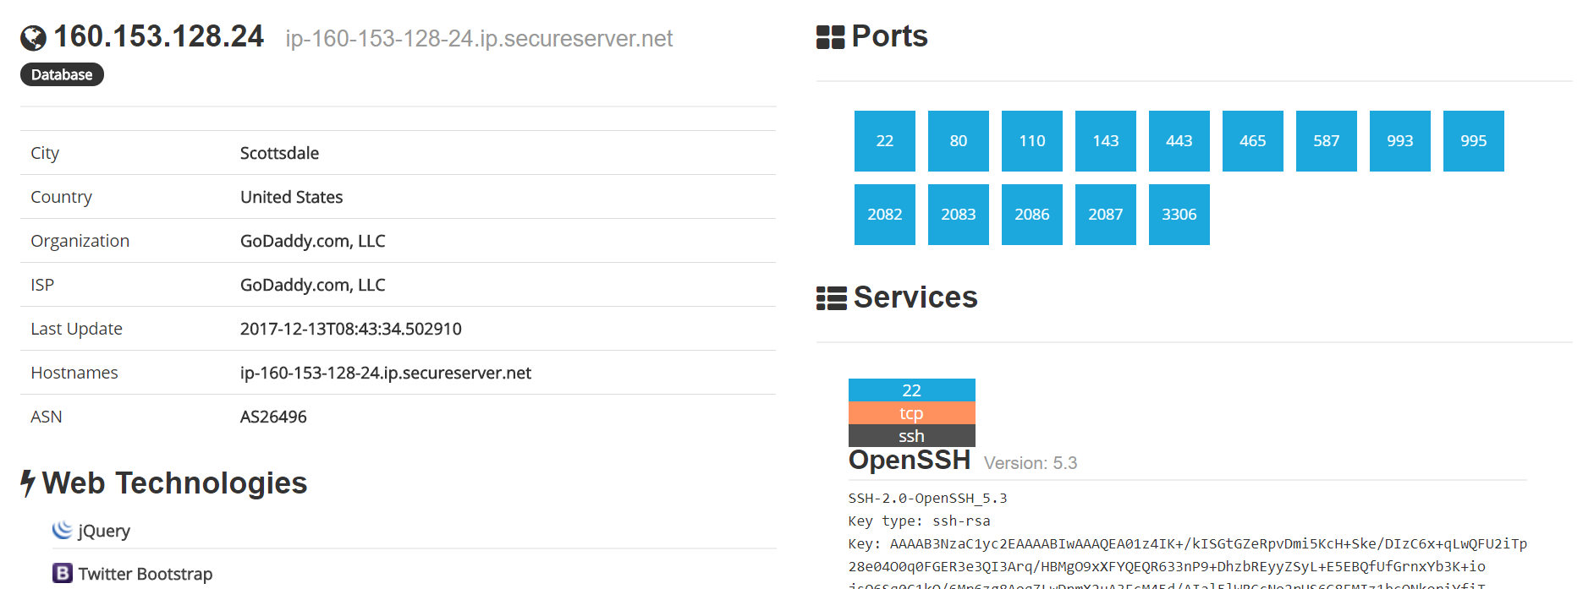
Figure 26:Shodan search showing available ports and connections

(Appendix 3)
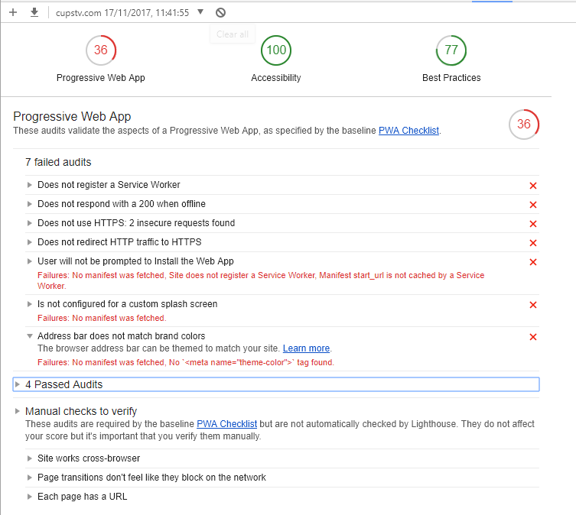
Figure 27:Chrome audit of the CUPSTV website

(Appendix 4)
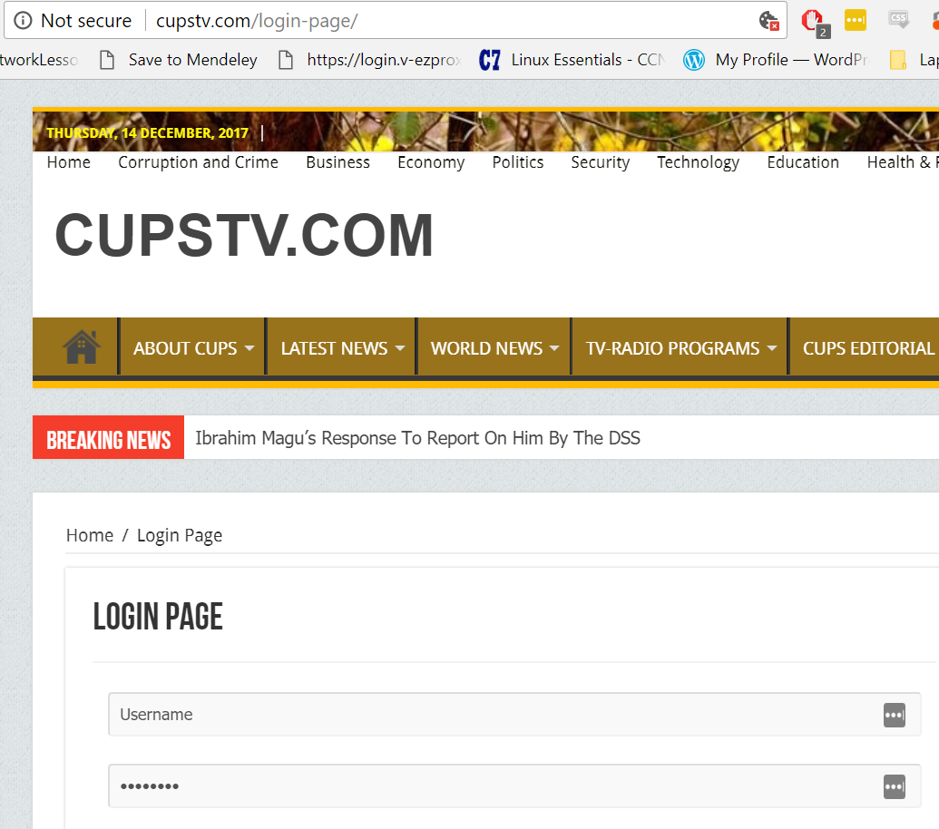
Figure 28:Insecure page having no encryption
(Appendix 5)
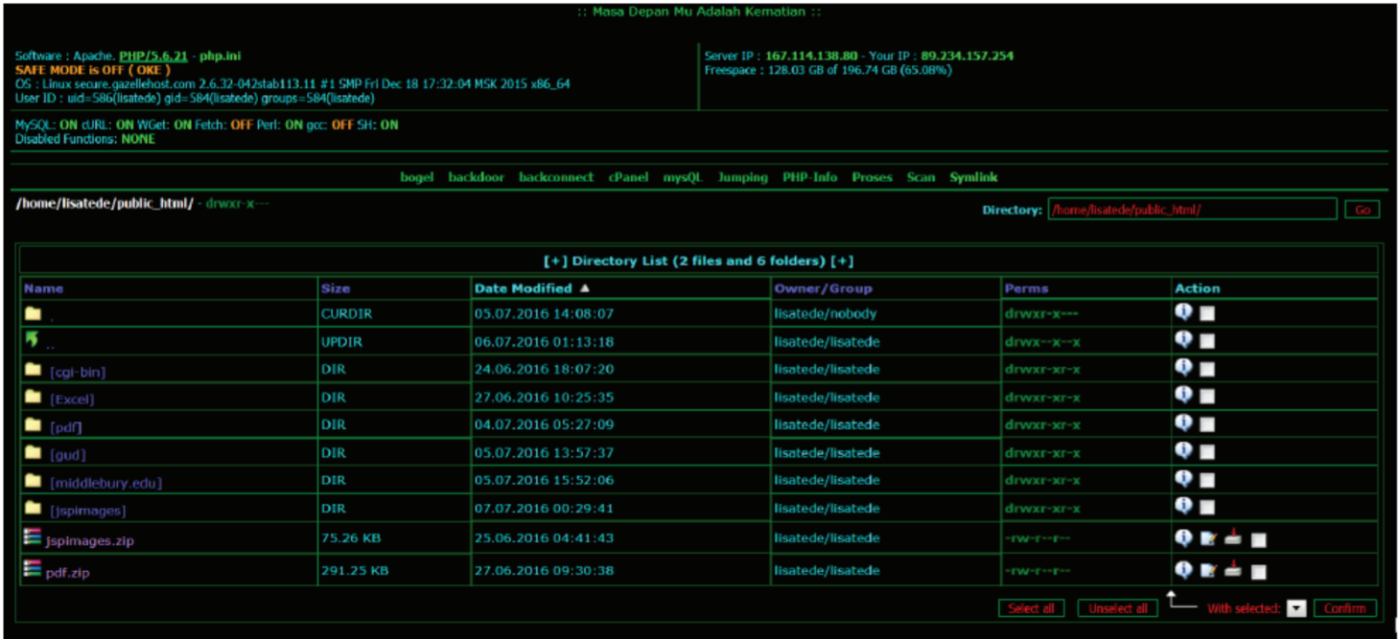
Figure 29: Phishing web portal CC

(Appendix 6)
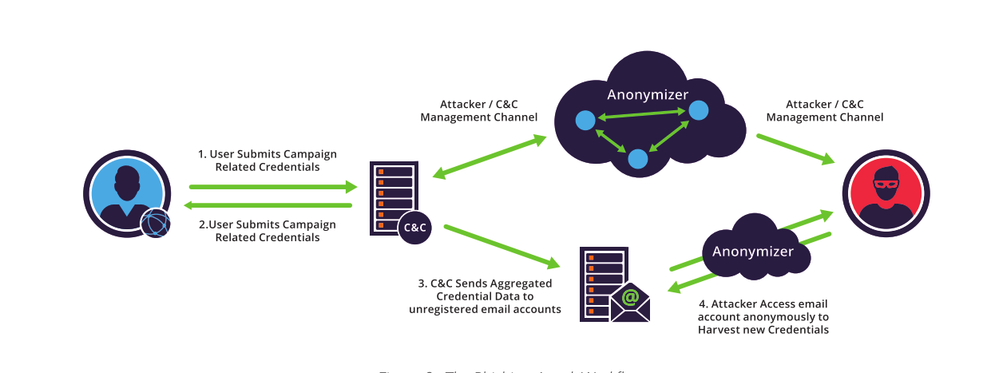
Figure 30: The Phishing Attack Workflow [59]
(Appendix 7)
Add 301 “Permanent Redirect” so to push people from a request of HTTP to HTTPS.
Use HSTS (HTTP strict Transport Security) to fix “Trust on First Use” TOFU, this leaves 301 as an issue as sensitive data with the cookies. HSTS changes the 301 with a simple response header which prevents an insecure request from that browser for a year and if another request is issued then a 307 internal redirect is issued preventing insecure responses. Cloudflare is an easy way to implement HSTS and fix HTTP problems.
In addition insecure scheme reference should be changed, again automatic HTTPS rewrites. Additionally upgrade the Contest security Policy (CSP) which also is an element that cloudflare can adapt the headers which then can report automatically back to report uri to monitor the CSP reports. One element that is a benefit to the site that the webpage doesn’t use <button> as a link as so the link to the next site is shown.
(Appendix 8)
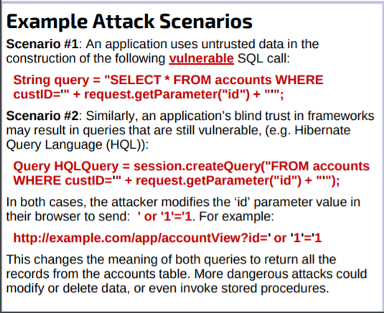
Figure 31: Injection
(Appendix 9)
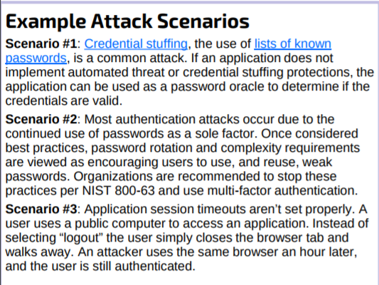
Figure 32: Broken Authentication
(Appendix 10)
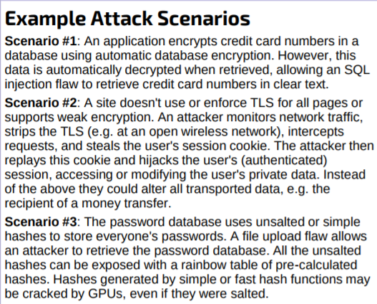
Figure 33: sensitive data exposure
(Appendix 11)
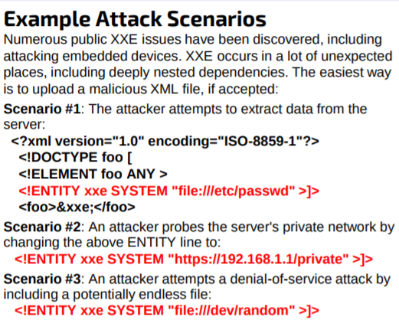
Figure 34: XML External Entities (XXE)
(Appendix 12)
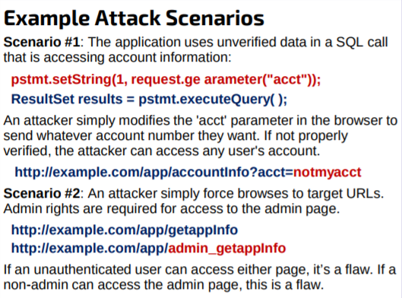
Figure 35: Broken Access Control
(Appendix 13)
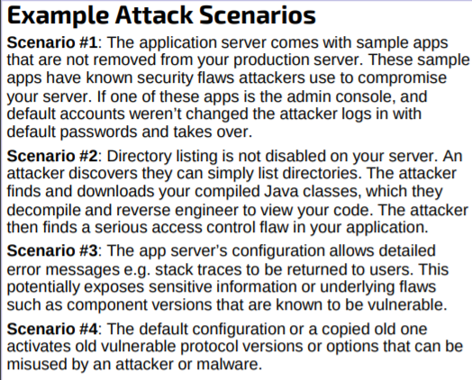
Figure 36: Security Misconfiguration:
(Appendix 14)
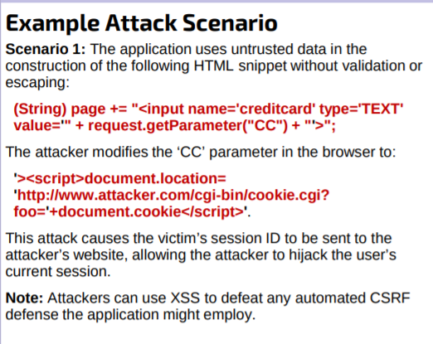
Figure 37: Cross-Site Scripting (XSS)

(Appendix 15)
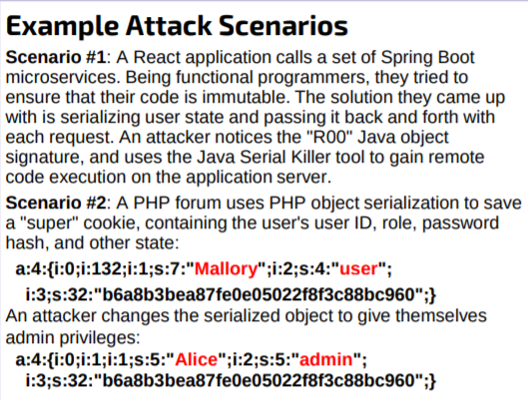
Figure 38: Insecure Deserialization
(Appendix 16)
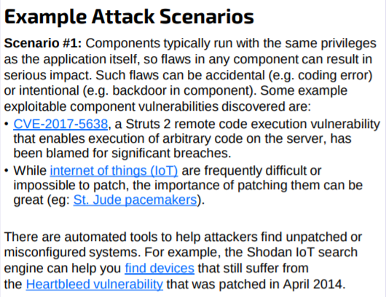
Figure 39: Using Components with Known Vulnerabilities
(Appendix 17)
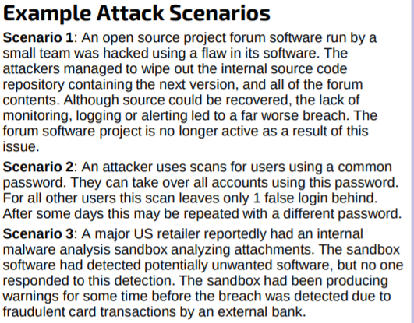
Figure 40: Insufficient Logging & Monitoring
(Appendix 18)
• Injection (App8)
Preventing injection means keeping data separate from commands and queries. By using safe APIs parameterized interface are enabled.
• Brocken authentication (App9)
Using multi-factor authentication to prevents credential brute forces and stolen credential re-use attacks.
• Sensitive data exposure (App10)
Store passwords using strong adaptive and salted hashing functions.
• XML Extension Entities (XXE)(App11)
virtual patching and API security gateways are used to block XXE attacks
• Brocken Access Control(App12)
Access control if enforced in trusted server-side code prevents the attacker.
• Security Misconfiguration (App13)
Send security detaials to client agents.
• Cross-Site Scripting (XSS)(App14)
Preventing XSS requires untrusted data not to be activated from active browser content.
• Insecure Deserialization(App15)
Don’t except objects from untrusted sources
• Applying components to known vulnerabilities to reassemble an attack (App16)
Ensure a plan for monitoring, triangulating ing, and applying updates are available

• Insufficient logging and monitoring (App17)
The use of commercial and open source software frameworks such as OWASP AppSensor, web application firewalls

Appendix 19
Pro-active contingency policy procedure
The development of security based requirements risk assessments security based architecture, unlike white box security tests and code reviews the reason for the black box testing of this site is for the crucial not evident weaknesses that can be found from third party applications and security specific system procedures providing great insight regarding design and implementation.
The second principal to determine in the policy of systems is the system development life cycle (SDLC)[8] so to understand exactly the operations which are in effect to serve the end user providing and supporting the media which the business wish to serve. The black box reconnaissance testing completed in this report compliments the SDLC in finding any unfound elements but also supporting the evidence in the SDLC compiling a thoroughly compounded report. The review of SDLC verify that the systems therefore are in order and functioning correctly so to secure the site, its users and the managers. The review in the SDLC enable third party components which could be considered for future integrations which allow for intelligent logical decisions to be made in how to progress as a digital business and the requirements it needs. Of course, the uncovering of incorrect product builds showing weaknesses in the dependences that could be crucial in finding a single point of failure or not properly configured files and modules which should be there are also discovered by this method as mistakes happen and should be actively sought for. Underlying problems in the system environment such as unhardened devices or software service points which have improper configurations are also sticking points which will be determined. Discovering the potential weaknesses found in boundary environments of the chain which are not always apparent during the design due to third party service, software, hardware changes and implementation phases which have not been kept up to date due to improper disclosure or the inability to update the systems to the new standard.
After the mapping and progression has been developed for active policy management it is understood and stated above that any problems that do arise then immediately contact the security practitioners or site administrators which will then enact an instantaneous effect to the request. An example can be Central Processing Unit (CPU) overload or a Distributed Denial of Service (DDoS) preventing legitimate business inhibiting the ability to propagate the service. Once the request has been put through to stop the attacks or reduce the amount of certain types of traffic so not to impede the actual site owners. The intended effects result in clear lines of engagement, understood so that areas that are known to be weak and are getting fixed are not interrupted or ruined so refinement and defining key attributes are essential.

Reactive contingency policy procedure
Definition: Reactive responses are the direct effect of an event that has occurred or in the process of taking effect to the systems.
First actions to take is to contact the local system administrator and the security specialists to desist from attacking the site and resolve the problem.
In order for effects to be minimised or mitigated completely, forward thinking is required to combat the effects, as a result the use of technology’s which are pre-emptively installed and configured are the key in defeating any problems that may arise. The policy therefore is to react depending on the attack, for instance if the server was encrypted and sites defaced then the use of redundancy technologies should be deployed which can re-flash the systems with the old systems and configurations thereby temporarily overcoming those problems however the immediate task of repairing and patching the systems must be completed.
To that effect a policy of repairing and fixing the problems should be immediately fixed in addition the use of common testing tools should be deployed to the appropriate sections that were identified as being week to check for integrity and stability issues.
In addition there should be a failover for a failover event so if a DDOS was to much for one provider to handle as seen with Bryan Krebs in 2016 when the amount of traffic was the biggest ever recorded due to new huge bot networks then redundancy systems should be thought of. In the case of CupsTV the use of Cloudflare[9]–[12] was suggested as a DDOS site as there is a monetarily obligation to the client (site owner) to defend the attack as much as possible unlike Googles Project Shield[13] which is a good faith agreement. However a redundant failover could be Akamai[14]–[17] which is a industry leader in DDOS defence and cyber security recognition.

Appendix 20

System Development Life Cycle

STAGE 1
A pre-development strategy that underlines the different segments have been noted such as a predevelopment strategy, the result accounts for an SDLC development where a predefined spectrum has been refined and the inherit security focus is evident in all decisions. This is the result of a strong policy procedure, pronounced and clear measures provided to ensure that minimal effects or downtime occurs as a result of human error and exception to vulnerabilities. Therefore standards deployed in this framework ensure that if the hosting provider has a problem there is a failover, if there are incompatibilities there are redundant standards to follow. In addition, the program defined in segment 1 ensure direct development measurement conditions are accounted for allowing for specific focuses on areas to develop and inspection, this ensures consistency when checking areas so further development have tractability and replicability to conduct future tests.
STAGE 2
The classification and design is the identification of key security requirements that are incorporated into the companies structure whether it be directly or indirectly controllable features such as third party applications and themes or server systems. The testing of the elements are developed from existing knowledge and improving that to find any specificities that are with the site. This proves the assumptions and that are made in so it meets the necessary requirements and testing parameters. For instance one feature in the testing phase would be to develop it into the Cloudflare systems not only for DDOS protection but also for its web application firewall (WAF) preventing SQL injection, cross-site scripting (XSS) in addition to zero day attacks. This then identifies a weakness that the servers IP address is susceptible to query and brute force attacks. The result of which demonstrated a gap in the security however if it was effectively proxied behind Cloudflare the origin of the hosting server would be obfuscated. Therefore some principal areas that the site and its hosting/supporting systems covered are:

- User administration management permissions and authorisation
- Authentication, verification, reliability and integrity
- Disclosure, data confidentiality, responsibility and accountability
- Transport security and session management
- Tiered system segregation
- Standards and Legislative adherence (Industry and government)
The additional insight into expected methods of operation and protocol highlighting the documented steps and process taken by the services and companies who operate the facilitating services. The result shown demonstrating to that effect the foundations on which the digital business is operating on. The reports identified the methods used and the security to repel and prevent digital attacks from occurring as pronounced in the requirements segment. The benefit of inspection for future decisions to be invested in the future are that flaws analysed in this stage of review have a better chance of being rectifiable and cost effective as the foresight and knowledge enable the admins not to have an issue arise that wasn’t expected which can cause major damage.
For instance one element picked up in the research conducted was the different sites required for the business to have contact with which potentially require 2FA. This as a business could be improved so that there is a centralised service by where all the requests are sent instead of different machines and different approaches creating efficiency improvements in addition to better oversight.
The next stage to identify after the completion of the design elements is the creation of a Unified Modelling Language (UML). The UML identifies and describes the applications in the process from which a model is produced aligning so applications are fully understood. From the UML crucially a record is kept from central application functions and behaviours.
Lastly in this stage the review of the models compiled and the knowledge gained are summarised into threat model showing how the effects of the attacks and reconnaissance techniques completed in this report effect the system. From the use of UML models and system/architectural designs with the attacks conducted, the mitigation techniques are highlighted to show potential improvements and that the business can take. The compilation of the project components are here as a suggestion to the system architect of the companies data structure and design for modification that can be made in the future.

STAGE 3
This stage is providing a breakdown of inspected code highlighting areas within the HTML programming where by links were shown to be dead and yet still active or the release of sensitive information is possible as a result of improper formatting and even systematic weaknesses due to encryption and SSL protections. The report however is limited in a deep inspection in the code review however using multiple tools created by advanced developers and effective debugging vulnerability scanners. The breakdown provided demonstrates the layers of software that have been developed and the operations they rely on to work in synergy with each other at a high level of inspection deriving the purpose of said software’s in the companies structure and system design. The review of the code[18], [19] ultimately was structured showing where there was the potential for vulnerabilities which could be exploited, then showing the proper trusted method of approach to code in the Security Development Lifecycle (SDL) using sources for the specific field. An example for instance would be a health information regulatory privacy in which you follow HIPPA (Health Insurance Portability and accountability Act of 1996)[20] if the organisation developed into something bigger actively engaging with the people they are trying to serve. However specific to this report a composition of sources should be included in future upgrades and current assessments when in use such as ISO/IEC 27002[21], [22], that highlights information technology standards, techniques and practices to follow for a fully invested information security strategy the business should comply with. Another area that must be followed as a regulatory statute of law is OFCOMs broadcasting rules [22] specific to the organisations endeavours to broadcast TV and Radio. In Addition standard organisational requirements should be inspected with greater alignment with standards such as ISO 27001[23][24] ISO 27003[25], ISO 27004[26], ISO 27005[27], ISO 27006[28], ISO 27007[29] and ISO 270014[30], developing a strong information Security Management System (ISMS). In addition as a managerial element for organisation governance and development the report suggests the issuance of ISO 22301 [31]–[33] business continuity management (BCM). BCM is the preparation development and actionable moves used to classify and recognise features within the business activities and properties that are important or crucial making it vital for the management to have a clear developing knowledge of what is happening.
STAGE 4
During the reports development of conducting tests on the website CUPSTV in regards to design and protocol review, code analysis and inspection the data amounted concluded the weaknesses and strengths and the remedy’s to those specifics in detail. However, penetration testing the actual end product which is the client facing website is a revealing test to be conducted to highlight that all elements of the design present no weaknesses. This could be a default package no installed or updated. During testing on CUPSTV this very point was developed as the theme on the site is out of date requiring an upgrade which when automatically applied as it is to the website reveals a loophole. This loophole meant that the exploitability was a high risk allowing XSS possible, privilege escalation, unrestricted file upload and download as well as privileged information disclosure. This management of application testing ensured that clearly it was necessary to conduct final testing in the framework as access login methods were checked and did not disclose any critical data that wasn’t in the public domain relying on secure systems of third party vendors. The primary fault in regards to client administrative management was solely within the website construction adapting WordPress template pages and implementing additional features for appearance and usability. The critical features out of the control of the organisation was its dependency on third party hosting and facility’s which are weaknesses to the hosting server and the website its self, such as leaving the WHM cPanel searchable open to query.
STAGE 5
The analysis undertaken on the CUPSTV in stage 5 reviews how the organisation should develop a system to conduct a functioning management system review. Discussed in stage 3 the appointment of standards that should be incorporated into the companies corporate structure the notation of ISO 22301 was suggested. This standard lays down management determination of important critical knowledge that manages the way in which the unity of products assimilate so current and future affairs do not face incompatibilities. Specifically to management the report suggest ISO/IEC 38500:2015 which:
— assures stakeholders and interested parties that principles and practices suggested are followed in confidence of the organisation's governance when dealing with IT.
— Notifying and regulatory governing bodies in the use of IT in their organisation position.
— Instituting a vocabulary for the organisations governance with the IT systems.
The management therefore including the system architects and administrators have a framework that is adaptable and concise. This ensures that suggested activities are completed now that the perspective of an operational system is in effect such as intermittent health checks all around the year allowing for immediate inspection of zero-day attacks and for patches that need to be implemented and upgraded to the systems. No strict time line is suggested however for CUPSTV the health checks should occur monthly covering both infrastructure and the applications. This maintains the level of security first developed through testing and assembly of the organisations architecture ensuring no risks have an effect or a limiting effect thanks to the frequent yet intermittent testing. Lastly the integrity of changes and verifications accepted into the systems should have an holistic approach, from which the application is integrated into production and the management process. The below figure shows the SDLC testing framework process during the CUPSTV report.

marking criteria and Student FEEDBACK

This section details the assessment criteria. The extent to which these are demonstrated by you determines your mark. The marks available for each criterion are shown. Lecturers will use the space provided to comment on the achievement of the task(s), including those areas in which you have performed well and areas that would benefit from development/improvement.

Common Assessment Criteria Applied (Assignment 1) | Marks available | Marks  awarded
1. Research-informed Literature
Extent of research and/or own reading, selection of credible sources, application of appropriate referencing conventions.
Outstanding knowledge of research informed literature. High level of referencing skills consistently applied. (Grade mark: 90.00%) | 10 | 9
2. Knowledge and Understanding of Subject
Extent of knowledge and understanding of concepts and underlying principles associated with the discipline.
High detailed knowledge & understanding of the main theories and concept. Structure and quality of report of high standard. (Grade mark: 90.00%) | 10 | 9
3. Analysis
Analysis, evaluation and synthesis; logic, argument and judgement; analytical reflection; organisation of ideas and evidence
Some aspects of your analysis could be more focused to the given scenario rather than giving general information and cross reference your findings with the lit review. Excellent documentation of cost solution such as your consultancy time, timetable etc. Overall very good report. Some other areas could do with some improvement: The introduction could end with the most specific information: a guide to the scope and structure of your report (What coming next in each section). Conclusion could be improved. You could be improved by summarised more key areas of the report and state what improvement could be done in the future to improve your finding. (Grade mark: 85.71%) | 35 | 30
4. Practical Application and Deployment
Deployment of methods, materials, tools and techniques; application of concepts; formulation of innovative and creative solutions to solve problems.
A range of advanced tools used to gather information and launched attack to tests for vulnerabilities on cupstv.com site. Results of the actual test was provided with discussions with additional output/information in appendix. Nature of how it was done, application used and protocol involved was discussed. (Grade mark: 85.71%) | 35 | 30
5. Skills for Professional Practice
Attributes in professional practice: individual and collaborative working; deployment of appropriate media; presentation and organisation.
Can communicate with an exceptionally high level; Flow, professionally done, well presented and just a minor error. (Grade mark: 95.00%) | 10 | 9.5

Assignment Mark (Assessment marks are subject to ratification at the Exam Board. These comments and marks are to give feedback on module work and are for guidance only until they are confirmed. ) | Late Submission Penalties (tick if appropriate) |  | 88%
 | Up to four weeks late |  | 88%
 | First Attempt? |  | 88%

