

Assignment Title: Knowledge and Information Management Skills for the Workplace

Programme: BA Leadership and Management Skill for the Workplace

Student Name: Mahmuder Rahaman
ID: 1605850
MODULE Title BMSK 5006
Lecturer Name: DR. Anupam Mazumdar

Submission Date 13/05/2019

Table of Contents
Introduction 4

LO1 5
A) Explain the relationship between data, information and knowledge. 5
B) Explain the relationship between individual knowledge and organisational knowledge 9
C) Apply analysis and modelling techniques to identify knowledge assets…………………..12
D) Evaluate actual and potential knowledge assets. 14
LO2 15
A) Explain what is required to create, store, apply and integrate knowledge. 15
B) Consider the importance of Intellectual Property rights. 21
LO3 22
A) Explain the contribution knowledge assets have on an organisation……………………...23
B) Evaluate the knowledge requirements for the organization. 24
C) Evaluate the organization’s framework for enabling knowledge sharing. 25
D) Recommend improvements to the current framework. 28
Conclusion……………………………………………………………………………………….29
Bibliography 30

List of Figures:
Figure1 Transformation process 0f data Source :(Bradley , 2018) ………………………………5
Figure 2 Relationship among knowledge, information and data (Adapted from: Hall, 2018) 7
Figure 3 Hierarchy of data, information and knowledge (Kleiner, 2018). 9
Figure 4 Transmission of knowledge (Pola, 2018). 10
Figure 5 Relationship between individual and organizational knowledge (Armistead, 2018) 11
Figure 6 Knowledge management life cycle (Bradley, 2018) 12
Figure 7 Knowledge management process (Hall, 2018) 16
Figure 8 Business Intelligence (Clarke, 2018) 18
Figure 9 Knowledge sharing framework in Wal-Mart (Clarke, 2018) 26

List of Tables:
Table 1 Differences between Data, Information and Knowledge (Adapted from: Hislop, 2018; Amine, 2018 and Armistead,2018) …………………………………………………8
Table 2 Strategies of Knowledge Management (Katschberg, 2018) ………………….21

Introduction
Data, information and knowledge are the basic terms included in the knowledge management system of any business organisation. The transformation of data and information into knowledge requires systematic processing system and strategies. The report describes the theories related to data, information and knowledge. The author has also described the ways an organisation can utilise data to generate information, utilise information to develop knowledge over time and utilise the knowledge to gain wisdom over a specific area of business. The report also distinguishes between data, knowledge, information and wisdom to clearly describe the theories. Information and knowledge management in a business organisation determines the level of success and competitive advantage the organisation can gain in its market. Innovation in the business organisations comes from the level of data analysis and knowledge utilisation within the business structure. Innovation within a business organisation also comes from the proper communication of information and knowledge among the organisational members. Growth and sustainability of an organisation also depends on the knowledge management system and knowledge sharing framework developed within an organisation. Knowledge and wisdom are also necessary for developing effective management strategies in order to achieve business objectives. Moreover, business decision making for the managers requires wisdom and knowledge of the current situation. Wal-Mart, one of the largest super shops in the UK utilises market data to generate information and knowledge. The managers and marketers in Wal-Mart collects customer and market environment related information and analyse the information to gain understanding of the customer behaviour and market situation. Managers in every organisation like Wal-Mart gain knowledge in an organisation level through utilising the information and data related to the environment surrounding the organisation. Knowledge assets of Wal-Mart are also the products of the information and data Wal-Mart have in its database (Katschberg, 2018). The report provides detailed understanding of the organisational process and knowledge generation process in Wal-Mart with necessary theories.

LO1

A) Explain the relationship between data, information and knowledge.

Data
The facts or figures of the world or about our surroundings can be defined as data (Amine, 2018). For example, price for a car in December was $120,000 which is a data.

Information
According to Armistead (2018), Information refers to the set of data that provides understanding of the facts for which data is collected. For example, the price trend in different periods of a year for the car is information for the customers.

Transforming data into information
Data includes no meaning, understanding or intention for the facts of data. It only presents a specificfacts in a situation or moment of time. Therefore, data may offer different significance for different individuals or organisations. However, information requires processing of the data to create meaning for the situation, context or trend. Therefore, data needs to be processed to become information for an individual or organisation (Bradley, 2018). In the below, I am going to use a figure, which shows the transformation process of data.
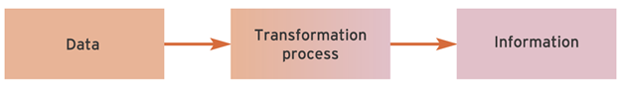
Figure 1 Transformation process of data
Source: (Bradley, 2018)

Knowledge
The set of experiences and information a person possess which provides guidance of performance to the person can be termed as knowledge (Clarke, 2018). For example, the sales volumes in different periods of the year are information to the sales manager. Demand trend in the market processed from the data is a knowledge which can be used in determining sales strategy.

Wisdom
Wisdom refers to the ability to judge values related to the customs, relationship between facts and environment with a view to making appropriate decisions regarding the activities of a person or an organisation (Katschberg, 2018). for example, the sales manager can analyse years of information of sales and can decide on promotional offers in different period of time.
Use of information to generate knowledge
Knowledge is actually the processed and summarised information to a person who can use the information to set the course of the person’s activities. For example, the operation managers collect, process and save information related to the production requirements, employee productivity and outcomes of different operation management strategies in their mind to enhance their knowledge regarding operation management. They utilise the information for adopting managerial strategies that are mostly effective for the performance of the operation managers (Clarke, 2018).

Knowledge, information and data come with a systematic process that maintains hierarchy of understanding and meaning. Knowledge remains at the top position among the three sources of understanding and meaning. The following diagram describes the relationship with data, information and knowledge (Hall, 2018).
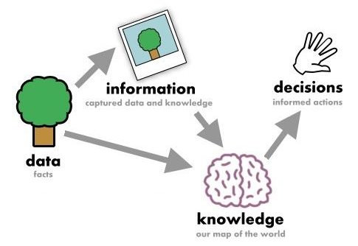
Figure 2 Relationship among knowledge, information and data (Adapted from: Hall, 2018)

In addition to the above explanation, in the below, I am going to show some basic differences of data, information and knowledge based on the different factors.

Factors | Data | Information | Knowledge
Reason | Processing | Storing and analysing | Innovation and decision making
Characteristics | Raw facts with no specific meaning | Processed facts that bear simple meaning | Summarised understanding that provides direction and supports action
Understanding level | Provides no meaning | Provides specific understanding of a fact | Provides elaborated understanding of a fact
Quantity | Usually, large in amount | Comparatively lower in amount | Knowledge is a summarised idea where knowledge includes a lot of data and information.
Modification | Data is difficult to modify as data remains in large amount | Information modification requires further analysis of data. | Knowledge can come from other sources of information or changes in the current source of information.
Example | Sales volume of a particular day is a data. | When data from sales volume of a week comes together and indicates growth or decline of sales that is information. | Information of changes in sales volume and impact of the marketing strategies are knowledge when analysed in a combined way.

Table 1 Differences between Data, Information and Knowledge (Adapted from: Hislop, 2018; Amine, 2018 and Armistead, 2018)

Examples:
- In the health care industry, the nurses collect data related to patient’s health condition such as vital signs, weight and blood pressure of the patients. From the data, the doctors understand some information like trend of vital signs and weight loss of the patients. The information provides the doctors with necessary understanding of the medications necessary for the patients. The prescription for the medication comes from the knowledge of the doctors generated from the previous analysis on vital signs and remedies (Katschberg, 2018).
- The sales representatives collect orders from the local stores where the sales volume is presented as data for the sales manager. The sales manager stores everyday sales information like sales increase, change in sales after specific promotion and revenue from the sales in different period of the year. The information is further utilised at the end of the year when producing yearly report of sales. The summary of the sales report provides understanding related to the sales trend and changes in sales growth in different times and effectiveness of different marketing promotions. The understanding performs as knowledge for the sales managers who utilise the knowledge in determining sales strategies for the upcoming years (Koh, 2018).

Hierarchy of data, information and knowledge
The following diagram presents the hierarchy of data, information and knowledge based on understanding, meaning and effectiveness in decision making.
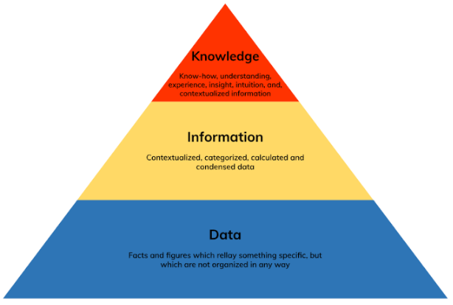
Figure 3 Hierarchy of data, information and knowledge (Kleiner, 2018).

B) Explain the relationship between individual knowledge and organisational knowledge

Individual knowledge
According to Kwon and Shin (2018), experience, learning and perception of a person that shape the behaviour of the person can be termed as individual knowledge. For example, employees learn from the culture of their organisation and they behave as per the cultural values of their organisation.

Organisational knowledge
Learning and experience of the organisational members that create the culture, rules and norms of an organisation can be termed as organisational knowledge (Li and Nakamori, 2018). For example, the Apple.inc has developed creative culture as it has learnt that Innovation is the key to competitive advantage in the market.

Relationship between individual knowledge and organisational knowledge
Individual learning and experience support the development of organisational knowledge in every organisation. Business organisations hire skilled employees to enhance the knowledge base of the organisation (Marshall, 2018). The following diagram can demonstrate the process through which individual learning becomes organisational knowledge.
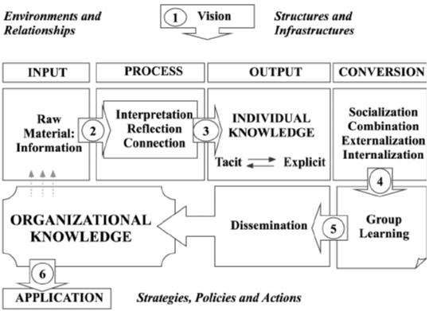

Figure 4 Transmission of knowledge (Pola, 2018).

As shown in the process, individuals gather knowledge from the raw information processing within their organisations. In the information analysis process the employees interpret, reflect and connect information with relevant meanings to enhance their knowledge. Individuals gain tacit and explicit knowledge during the information analysis process from written materials and experiences (Storey and Barnett, 2018). The employees convert their knowledge into new ones according to the organisational culture, values and experiences; thus develop their knowledge based on the requirement of their organisation. Knowledge conversion can happen in four ways like socialisation, capture, dissemination and internalisation. In socialisation process the employees gather knowledge from the practice and culture of their organisation. The capture process makes the employees convert their experiences into written reports for the organisation. Then the employees copy and disseminate the explicit knowledge from their organisation in the dissemination process. The employees also convert explicit knowledge into experiences through the internalisation process. Individuals in an organisation learn from the group they belong and disseminate their knowledge in their groups. The sharing process of knowledge creates same knowledge base to every member of an organisation and they act as a whole in their organisation. The combined performance and other experiences create organisational knowledge (Amine, 2018). The following table demonstrates the relationship between individual and organisational knowledge.
 | Individual knowledge | Organisational knowledge
Tacit Knowledge | Intuitiveness - Combining the knowledge and experience an individual has to solve individual problems. | Social Practice – Collective experience of solving problems.
Explicit Knowledge | Expertise – Individuals share knowledge they have in an organisation. However, to share knowledge, one of the individuals needs to have more expertise than others so that he or she can share knowledge to others. | Rules – To shape performance and knowledge base of the employees, organisations develop written rules. The rules shape knowledge gathering process and performance of the employees.

Figure 5 Relationship between individual and organizational knowledge (Armistead, 2018)

C) Apply analysis and modelling techniques to identify knowledge assets.

Knowledge Asset
Database, experience and the available knowledge of the employees within an organisation can be termed as the knowledge asset of the organisation. Knowledge assets are required for development of skills and expertise of the employees within an organisation (Beda, 2018). In the below, I am going to apply various techniques for identifying knowledge asset.

- Knowledge management life cycle
The process of generating new knowledge and retaining the knowledge within the culture of an organisation with a view to transferring the knowledge to the new employees in future can be termed as knowledge management life cycle (Bradley, 2018). The figure below will show the Knowledge management life cycle.
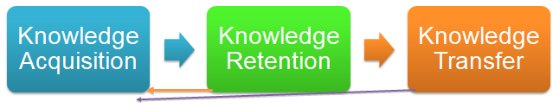

Figure 6 Knowledge management life cycle (Bradley, 2018)

Knowledge Acquisition:
Achieving new knowledge through exploring new areas of operation within a business organisation is termed as knowledge acquisition. It emphasises on innovation and creativity (Clarke, 2018). For example, a production manager can learn a new technology or managerial process to increase productivity. When the manager is successful in learning the technology, it is defined as knowledge acquisition.

Knowledge retention:
Acquired knowledge within an individual or organisation needs to be controlled so that the knowledge remains within the individual and the organisation. Knowledge retention is possible through the following tools (Hall, 2018).
- Database management - Storing, saving and controlling the organisational information in the database (Hislop, 2018).
- Business intelligence – Stores information and presents to the decision makers whenever necessary (Koh, 2018).
- Data warehouse – Large database that includes all the data from previous periods and current periods with a view to supporting the decision-making process (Katschberg, 2018).

Knowledge Transfer:
Sharing, exchanging, disseminating and distributing knowledge among the members of an organisation or group can be termed as knowledge transfer. Knowledge transfer is possible within a business organisation or from outside of the organisation (Kleiner, 2018). In the following ways knowledge transfer is possible between organisations and individuals.
- Printing materials
- ICT
- Other technologies

- Knowledge modelling for identifying knowledge assets:
Conceptualise the knowledge base of an organisation can be termed as knowledge modelling. There are some well-established techniques of knowledge modelling as described below.
- Common CADS: The modelling technique supports knowledge engineering process and knowledge management through analysis of knowledge requirements of an organisation. Organisation model, agent model and task model are the widely used common CAD models for identifying organisational knowledge assets (Kwon and Shin, 2018).
- Protégé 2000: It is a frame-based ontology tool for knowledge acquisition. The technique is widely used for domain modelling (Li and Nakamori, 2018).
- Multi-perspective Modelling: It includes several techniques for knowledge acquisition where every technique considers a particular aspect of knowledge (Marshall, 2018).

- Knowledge Asset analysis
Analysis of the knowledge assets supports the managers to identify current and potential knowledge assets of an organisation (Pola, 2018). The following analyses are available for business organisation to assess knowledge assets.
- Bottleneck analysis: The technique considers specific events that enhance knowledge assets and occur frequently in an organisation (Storey and Barnett, 2018).
- SWOT analysis: Current position of an organisation in terms of knowledge asset and the potential position of knowledge assets are attainable through SWOT analysis (Amine, 2018).

D) Evaluate actual and potential knowledge assets.

Actual Knowledge Asset:
Actual knowledge assets are available knowledge assets like experience, knowledge inventory and rules of an organisation. On the other hand, potential knowledge assets are the knowledge assets achievable by the course of improvement of the knowledge acquisition process (Armistead, 2018). Knowledge assets of an organisation support the organisation in the following ways.

Evaluation of actual knowledge asset:
Business organisations manage the actual knowledge assets in order to gain competitive advantage. Actual knowledge assets like experience and rules provide guideline for the existing employees so that the employees can ensure maximum performance and quality of products and services. Actual knowledge assets like experience of organisation and the employees create competitive advantage through ensuring better quality of the products and minimising the cost of the organisation. Therefore, the organisation can provide quality service and products to the customers and develop innovative values for the customers. Actual assets also create platform for the new employees to develop their skills and knowledge base for performing their roles and responsibilities in the organisation. Knowledge assets are also useful in creating innovative culture within an organisation. In this case, the employees and other members share knowledge assets to other members and support socialisation of the employees in a flexible and creative culture (Beda, 2018).

Potential knowledge Asset:
Capabilities of an organisation provides opportunity to create new knowledge elements like experience, better knowledge and better principles which are usually termed as potential knowledge assets.

Evaluation of potential knowledge asset:
The knowledge assets that are potentially expected within a business organisation can create opportunities for the organisation. Potential knowledge assets also provide guideline towards the vision and mission of an organisation. In many cases, potential knowledge assets reveal new market opportunity feasible through improvement of the actual knowledge assets. Potential knowledge assets also provide understanding of the way the knowledge assets should be managed to reach a certain point of performance in near future (Bradley, 2018).

LO2

A) Explain what is required to create, store, apply and integrate knowledge.

Knowledge management process includes several elements and tools that are required for creating, storing, applying and integrating knowledge within the organisational structure of an organisation. Business organisations usually apply the Knowledge Management Life Cycle to manage the knowledge asset creation and utilisation within the organisational framework (Clarke, 2018).

Knowledge Management Life Cycle:
To create and apply knowledge in a workplace, Knowledge Management Life Cycle provides necessary tools and guidelines required for the creation, storing, applying and integration of the knowledge. The process of knowledge management life cycle includes the following stages (Hall, 2018).
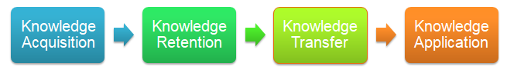

Figure 7 Knowledge management process (Hall, 2018)

Knowledge acquisition:
Creativity and innovation is highly required to create new knowledge assets within an organisation. Business organisations acquire new knowledge through innovative ideas from the employees or the managers (Hislop, 2018). Besides innovation, the following elements can be required for creation of knowledge assets of an organisation.
- New Employees – New employees usually come with new ideas and skills. They also perform in different way and are highly effective in creating knowledge assets (Katschberg, 2018).
- Training - For the existing employees, training programs with several strategies like 360 degree and off the job training can be effective in creating new ideas (Hislop, 2018).
- Consultancy – Consulting the employees and decision makers with external experts can generate new knowledge assets for an organisation (Katschberg, 2018).
- Mergers – Merger with another organisation can provide an organisation with opportunity to gain new knowledge from the other organisation (Koh, 2018).
- Acquisitions – Taking control over another organisation provides an organisation opportunity of understanding new managerial strategies and rules established in the acquired organisation (Kleiner, 2018).
- Research and development activities – New ideas in most of the cases come from the research and development initiatives (Kwon and Shin, 2018).
- Learning of the employees - From the changes in external environment, the existing employees can learn strategies and enhance knowledge assets of the organisation (Li and Nakamori, 2018).

Knowledge retention:
Business organisation creates new knowledge asset through acquisition. The organisation needs to store the knowledge assets and prevent the widespread distribution of the knowledge of the knowledge assets to gain full advantage from the knowledge assets (Marshall, 2018). The required elements for storing the knowledge assets are described here.

- Database:
An organisation can store related information in a database to retrieve the information whenever necessary (Pola, 2018). There a range of database options for every business organisation. When developing the following databases, a business organisation needs to analyse its requirements and organisational structure.

- Flat file database: It stores one type of data or records related to the organizational elements such as employee. The database provides no scope for retrieving information from other databases (Storey and Barnett, 2018).
- Free-form database: An organization can store different types of information in unstructured format in a free form database. The database allows the users retrieve information using keywords and categories (Amine, 2018).
- Hypertext database: Information with different objects like text, graphic and links are allowed in a hypertext database. The users can also link different types of data in this database (Armistead, 2018).
- Relational database management system (RDBMS): It allows the users to link information and data from variety of sources (Beda, 2018).

- Business intelligence:
The system is highly required in modern business organisations as the organisations include large amount of data in the information management system. Besides, it allows the users and decision maker to collect data from the information management system in form of patterns and diagrams so that the decision makers can understand the state of the organisation (Bradley, 2018).

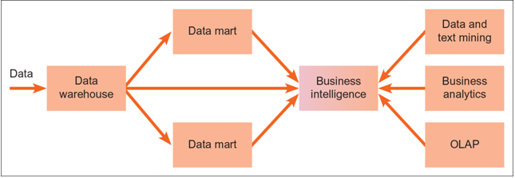

Figure 8 Business Intelligence (Clarke, 2018)

Data warehouses:
The warehouses include all the data from past and present incidents in an organisation to support the decision makers with necessary data. Business organisations also develop data marts which are smaller data warehouses. Data marts provide specific information of a specific department (Hall, 2018).

- Knowledge Transfer:
Sharing the knowledge is directly related to the integration of information and other knowledge assets of an organisation (Hislop, 2018). To apply the knowledge in the workplace of an organisation, the following strategies and tools can be considered as necessary.

Knowledge transfer processes:
Diffusion, socialisation, learning, education and personal transfer of knowledge are common process of knowledge transfer required for integrating knowledge in an organisation (Katschberg, 2018).

Sticky knowledge:
It is required for transferring knowledge from one individual or department to other individuals and departments (Koh, 2018).

Knowledge giver and receiver:
The fact is obvious that the knowledge giver is necessary for sharing knowledge within the organisation so that the knowledge can be integrated by all the elements of the organisation (Kleiner, 2018).

Personality traits:
Altruism among the organisational members is required for sharing information spontaneously. Besides, free riding tendency which is learning from others by own effort is also required personality trait (Kwon and Shin, 2018).

Agency:
Organisational agencies like management can create cooperation among the organisational members to apply the knowledge assets organisation wide (Li and Nakamori, 2018).
Value of knowledge:
Management needs to evaluate knowledge assets before integrating the knowledge (Marshall, 2018).

Media of transfer:
Print and digital media are used to transfer knowledge in business organisations. Nowadays, ICT services have become essential elements for transferring and integrating knowledge within an organisation (Pola, 2018).

Trust:
When integrating knowledge assets, trust between the provider and the receiver needs to be strong as the managers seek for useful information when integrating the information in the organisational purposes (Storey and Barnett, 2018).

Knowledge application:
Application of the knowledge assets of an organisation requires several strategies and tolls within the organisation (Amine, 2018). The required elements for knowledge application are described below.

Knowledge management:
Knowledge management is necessary for applying the collected and analysed information in the operation of an organisation. Knowledge management capture information, analyse and improve organisation’s knowledge assets and make it available to the organisational members (Armistead, 2018).

Strategy:
Predetermined strategy for knowledge application is necessary for applying the knowledge assets in appropriate place in right time. Aim of an organisation directs the strategies of the organisation (Beda, 2018).
Knowledge-based view (RBV) of the firm:
Knowledge needs to be considered as resources of an organisation when the knowledge creates competitive value. Competitive resources are valuable, inimitable, rare and not substitutable (Clarke, 2018).

Information Systems Strategy:
The strategy focuses on the data processing system adopted in an organisation. Application of the information and knowledge available in an organisation requires a suitable information system strategy (Hislop, 2018).

Knowledge Management Strategy:
Knowledge assets require management strategies to be applied in the organisational development process. There are a range of knowledge management strategies available for business organisations (Katschberg, 2018). The most effective strategies are presented in the following table.

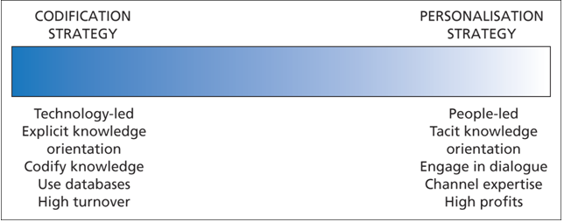
Table 2 Strategies of Knowledge Management (Katschberg, 2018)

Knowledge Strategy:
Business organisations need to adopt specific knowledge strategy like portfolio model of strategic thinking for the knowledge contents is highly necessary for effective application of the knowledge assets of the organisations (Koh, 2018).

B) Consider the importance of Intellectual Property rights.

Intellectual property rights:
According to Li and Nakamori (2018), legal protection for the designs and knowledge assets of an individual or an organisation in terms of use of the intangible assets without any competition for a certain period of time refers to intellectual property rights.

Evaluation of intellectual property rights:
The mostly used intellectual property rights are described below.
Copyright:
It protects authority of works and knowledge assets of an organisation like written reports and rules (Marshall, 2018).

Trademark:
Function of trademark covers the protection of brand from being utilised by the competitors (Pola, 2018).
Trade secret:
It protects innovative ideas from the third parties by keeping the trade innovations secret (Storey and Barnett, 2018).
Patent:
Patent provides protection for the features of innovative products and services of an organisation (Amine, 2018).
According to Armistead (2018), importance of intellectual property rights can be mentioned as below.
- Provide necessary protection from the unexpected users.
- Provide recognition to the creator and owner of the intellectual property or knowledge assets
- Ensure reward for the knowledge assets to the legal owner of the knowledge assets.
- Ensure competitive advantage to the organisation holding the knowledge assets
- Ensure growth of business with the proper utilisation of the knowledge assets and creation of new knowledge assets from the actual knowledge assets.

LO3
Wal-Mart Stores Inc. Is well known as worldwide supermarket chain with large number of stores in many countries around the world. The supermarket chain was established in 1970 as a supermarket chain in USA (Hall, 2018). The products of Wal-Mart include electronics, home appliances, clothing, footwear, movies and grocery. In 2018, Wal-Mart has generated $514 billion revenue with the support of 2.3 million employees worldwide (Bradley, 2018).

A) Explain the contribution knowledge assets have on an organisation

Knowledge assets of Wal-Mart include culture, rules, experiences, management strategies and employee expertise. Knowledge assets usually contribute to the growth of an organisation in the market. The contributions of the knowledge assets of Wal-Mart are described below.

Competitive advantage
Wal-Mart creates its competitive advantage with its management strategies and marketing expertise. The knowledge assets are effective in improving employee expertise within work environment of Wal-Mart. Therefore, the employees including the new employees can product superior quality in the service and products of Wal-Mart (Hislop, 2018).

Innovation
Wal-Mart practice innovation through improving the current knowledge assets into new effective ones. For example, Wal-Mart has developed mobile application that shows store location, price and purchasing options to the customers. Another remarkable innovation of Wal-Mart is the automated inventory system. All the innovations of Wal-Mart come from its creative culture, market knowledge and experience (Kwon and Shin, 2018).

Sustainable growth
Innovations and continuous changes in the organisational strategies in Wal-Mart are actually the outcome of effective knowledge management system and knowledge assets of Wal-Mart. In most of the changes, Wal-Mart utilises its experience and intuition towards the market opportunities (Li and Nakamori, 2018).
Effective operation
Knowledge assets of Wal-Mart allows the managers develop the operation and management processes precisely. It reduces waste and enhance the productivity of the employees. Employees also gain ability to perform better as they learn the knowledge assets frequently through the process developed by the managers. Therefore, Wal-Mart can make the operation management effective through proper utilisation of the knowledge assets (Bradley, 2018).

Motivation for employees
Knowledge assets allows the managers and leaders to establish knowledge culture in Wal-Mart. The culture is characterised by sharing knowledge and cooperation among the organisational members. When there is sufficient knowledge flow in an organisation, the employees automatically get motivated to work for the organisation. In Wal-Mart, the employees are enthusiast to learn new things and they are highly motivated to perform better every day (Armistead, 2018).

B) Evaluate the knowledge requirements for the organization.

Knowledge requirements are the necessary setting or processes within an organisation for supporting the process of knowledge generation and utilisation of the knowledge (Amine, 2018).

Knowledge generation process in Wal-Mart includes creation, storing, applying and integrating the information available in Wal-Mart. In Wal-Mart, knowledge requirements include knowledge management strategies, market knowledge and supporting knowledge culture (Marshall, 2018).

Evaluation of the knowledge requirements:
Knowledge management strategies:
Wal-Mart needs to improve the knowledge management strategies such as database management and content management in the online store. KM strategies can provide Wal-Mart opportunity for gaining information related to competitive advantages of the competitors, market trend, effectiveness of management strategies and improvement opportunities (Pola, 2018).
Market knowledge:
Research and development is highly necessary for gaining market knowledge. Market knowledge includes information like demand trend, competitor’s actions and capabilities, innovations in the industry and changes in the market environment. Market knowledge is required by the Wal-Mart as the innovation and growth of Wal-Mart depends on the experience and information related to the changes in the market (Storey and Barnett, 2018).

Knowledge culture:
Creativity and information analysis practice within the organisational environment and among the employees is required for growth and sustainability of Wal-Mart. Wal-Mart needs to develop supportive knowledge culture within the business environment (Amine, 2018).
Factual and theoretical knowledge:
Wal-Mart needs to develop strategies to make the employees learn factual knowledge and theoretical knowledge from the rules, reports and other documents of Wal-Mart (Armistead, 2018).
Ability to apply the information:
Wal-Mart has developed its knowledge management strategies effectively as observed from the previous performance. However, it needs to ensure the capability of applying information in the employees so that the employees can generate and apply effective knowledge assets for Wal-Mart (Beda, 2018).

C) Evaluate the organization’s framework for enabling knowledge sharing.

The knowledge sharing framework in Wal-Mart is developed based on socialisation, education and learning processes. Socialisation process in Wal-Mart is often supported by the existing employees and applied to the fresh employees. The education process is largely related to explicit knowledge stored in digital and printed sources of knowledge in Wal-Mart. Learning process occurs most often from the outcomes of other’s activities and self-performance of the employees in Wal-Mart (Bradley, 2018). Employees are supposed to gather and utilise knowledge following the framework presented below.

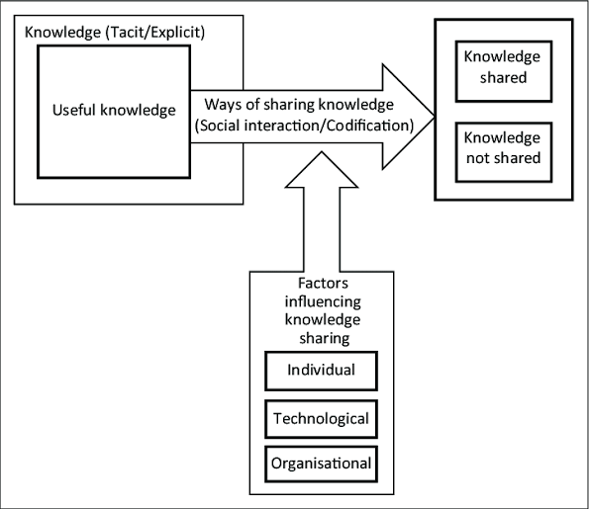

Figure 9 Knowledge sharing framework in Wal-Mart (Clarke, 2018)

Knowledge sharing framework
The framework includes organisational knowledge, knowledge sharing strategies, influencing factors and the outcome of the knowledge sharing process.
Organisational knowledge:
Knowledge within Wal-Mart can be classified into explicit and tacit knowledge. Explicit knowledge is comparatively easy for the employees to codify and share to the whole organisation. Tacit knowledge requires personal interaction and concentration to be shared (Hall, 2018).
Knowledge sharing strategies:
Socialisation is the mostly used knowledge sharing strategy where the organisational members of Wal-Mart share their values and knowledge to others in daily activities. Besides, the employees codify the outcomes of other’s practices as knowledge in Wal-Mart (Hislop, 2018).
Factors that influence knowledge sharing:
Individual perception and attitude of the employees influences the rate of knowledge sharing among the employees in Wal-Mart. Some employees are curious to learn when others are defensive. Available technologies like intranet within Wal-Mart boost up the rate of knowledge transfer. Organisational culture and leadership in Wal-Mart supports knowledge sharing among the employees. Wal-Mart practices creative culture and participative leadership to large extent to support knowledge transfer (Katschberg, 2018).

Advantages of the knowledge sharing framework
- Enhances learning effectiveness:
Knowledge is hard to push towards the organisational members as the individuals learn more from experiences than socialisation and explicit learning. The framework lets the employees learn from all the ways possible in Wal-Mart (Bradley, 2018).
- Fill knowledge gaps:
The knowledge sharing framework in Wal-Mart creates a knowledge sharing culture to enable every employees share their knowledge to others. The process fills all the knowledge gaps among the employees automatically as the employees learn from others whenever they need (Beda, 2018).

- Increase efficiency:
The knowledge sharing framework saves searching time for the knowledge of the employees. Employees can avail their required knowledge through intranet in Wal-Mart and the framework increases efficiency of operation (Armistead, 2018).
- Promote innovation:
Innovation mostly comes from the creative culture and sharing of knowledge among the employees. The knowledge sharing framework allows the employees of Wal-Mart sharing information to others and support innovation in the management of Wal-Mart (Amine, 2018).

D) Recommend improvements to the current framework.

From the previous discussion the following improvement areas can be suggested in terms of the knowledge sharing framework of Wal-Mart.
- Improvement of the search tool: Wal-Mart needs to improve the search tool so that the employees can easily find any information and learning material they need within the shortest possible time.
- Development of profile led KMS: At the first phase of the knowledge sharing framework, Wal-Mart can develop experience based profile of the employees so that the employees can identify right person to learn form.
- Making the framework easy to understand: Effectiveness of the framework depends on the ease of access of the framework. Wal-Mart needs to consider the improvement in the easiness of the framework.
- Making information available to everyone: From all the levels of organisation including employees to top level management, information should be available.
- Including content creation framework: Wal-Mart can include a content generation framework in the existing knowledge sharing framework so that the employees and managers can share their tacit knowledge and transform the knowledge into explicit knowledge.

Conclusion
Knowledge management system within an organisation determines the success and growth rate of the organisation. Business organisations develop systems for knowledge management that include data and information processing and utilisation of knowledge. Knowledge of an organisation needs to be created, stored, shared and applied effectively with an effective knowledge management process. Knowledge management strategies in organisations may vary depending on the leadership, culture and rules of the organisation. Regardless of organisation’s culture and strategies, every business organisation requires development and maintenance of knowledge management system.

Bibliography
Amine, M. (2018). Knowledge management: a personal knowledge network perspective. Journal of Knowledge Management, 16(5), pp.829-844.
Armistead, C. (2018). Knowledge management and process performance. Journal of Knowledge Management, 3(2), pp.143-157.
Beda, A. (2018). Distributed data bases—An international symposium. Information & Management, 4(3), pp.157-160.
Bradley, P. (2018). Data, Data Everywhere. Legal Information Management, 14(04), pp.249-252.
Clarke, S. (2018). Knowledge, management, and knowledge management in business operations. Journal of Knowledge Management, 12(2), pp.3-17.
Hall, M. (2018). Knowledge management and the limits of knowledge codification. Journal of Knowledge Management, 10(3), pp.117-126.
Hislop, D. (2018). Knowledge management as an ephemeral management fashion? Journal of Knowledge Management, 14(6), pp.779-790.
Katschberg, L. (2018). Role of data dictionaries in information resource management. Information & Management, 10(1), pp.21-46.
Koh, C. (2018). Data management in executive information systems. Information & Management, 33(6), pp.301-312.
Kleiner, K. (2018). Tacit knowledge management: the role of artefacts. Journal of Knowledge Management, 6(2), pp.112-123.
Kwon, O. And Shin, B. (2018). Data quality management, data usage experience and acquisition intention of big data analytics. International Journal of Information Management, 34(3), pp.387-394.
Li, M. And Nakamori, Y. (2018). Systems thinking on knowledge and its management: systems methodology for knowledge management. Journal of Knowledge Management, 6(1), pp.7-17.
Marshall, J. (2018). Data bases for special libraries: A strategic guide to information management. Information Processing & Management, 29(5), p.672.
Pola, S. (2018). Business data systems: A practical guide to systems analysis and data processing. Information Processing & Management, 20(5-6), p.659.
Storey, J. And Barnett, E. (2018). Knowledge management initiatives: learning from failure. Journal of Knowledge Management, 4(2), pp.145-156.

