
BA (Hons) Leadership and Management Skills for the Workplace

Module: Workplace Culture and its Impact on Organisational Efficiency
Module code: BMSW 5101

Student: Rupia Hussain-ID: 2010133
Lecturer: Olusoyi Ashaye

Assignment Title: Task 1-
“How do broader external environmental factors along with COVID-19 and ethical dilemmas affect organisational culture and its performance?”

Table of contents

- Executive Summary………………………………………………………………………………………Page 3
- Introducing the case study organisation – Sainsbury……………..……………………..Page 3
- Introduction to Company context………………………………………………………..…….Page 3-4
- Business Environmental analytical tools………………..………………….……............Page 4-5
- Sainsbury’s Internal organization environment …………………………………………….Page 5
- Swot Analysis………………………………………………………………………………………..……Page 5-8
- The Macro-environment is the external force that affects Sainsbury’s
Organisation……………………………………………………………………………………………..Page 8-9
7.1. Porter's Five Forces Analysis
- Evaluating an organisation within its Broader Environment.….…………….…..Page 9-11
  - Pestle Analysis
- Context of the analytical report with the COVID-19 situation ………………………Page 11
- Impact of COVID-19 on the Business Environment….…………………………..……….Page 11
  - Positive and Negative
- Critical Assessment of Sainsbury’s Culture of Wed………………………………..…Page12-13
- Ethical Dilemma: Critical evaluation of the relationship between Sainsbury’s culture and its efficiency in achieving financial and non-financial performances……..page 13
- Sainsbury had to face countless ethical dilemmas during the Covid-19 pandemic………………………………………………………………………………………. Page 13
- Recommendations …………………………………………………………………………………...….Page 14
- Conclusion…………………………………………………….…………….…………………..………….Pages 15
- Reference. Task 1………………………………………………….……….................................Page 16
- Task 2. Individual Reflective Essay……………………………………………………………Page 17-22
- Reference. Task 2….………………………………………………………………………………………Page 23

- Executive Summary
These findings contribute in several ways to our understanding of the supermarket giant Sainsburys and provide a basis for how the business can advance its strategies and develop more efficiency to dominate the market. The reports disclose critically analysed outcomes of analytical tools like Swot, Porter's Five Force, Pestle used to determine the position of Sainsbury's in the competitor’s market. This thesis has provided a deeper insight into external environmental factors along with COVID-19 and ethical dilemmas that affect organisational culture and its performance.

- Introducing the case study organisation – Sainsbury
When running a business, many components are considered to create and maintain sales. organisational structure and culture Management are strategies, processes, people and ‘technology used to manage interactions with customers and potential customers according to Salesforce [8] (Salesforce, 2019). It is detrimental to all successful businesses and organisations - without a substantial employee loyalty base, any other actions would be futile for growth and sustainability - it is the loyalty of people who work that keeps a business relevant and alive.
There are however many threats that can shake the foundations of an organization: they are in permanent change. However, we will evaluate how a multibillion-pound company managed to endure all these threats at once due to an unexpected predicament that impacted all lives and organisations still thrived and flourished with modern open-minded strategies.

- Introduction to Company context
Sainsbury’s first originated in 1869 by John James Sainsbury and his wife Mary Ann Sainsbury in Drury Lane, Holborn, London, with Simon Roberts as the current CEO since 1st Jun 2020. It is now the second-largest chain of supermarkets in the United Kingdom with a 16.5% market share in the retail market [13] (Wikipedia Contributors, 2019). Annual revenues of £29.048 Billion (2021). Net profit of £280 Million (2021) [4] (Grimsley, 2021). The company now has approximately 189,000 employee's majority in customer-facing stores and eCommerce sites.

Presently there are over 600 supermarkets and 800 convenience stores. According to Forbes, as of May 13, 2021. Sainsbury’s operates through the following segments, the retail segment distributes food, general merchandise, and clothing [2] (Forbes, n.d.). When Sainsbury’s included their clothing line Tu clothing launched in 2004, now boasting to be the sixth-largest retailer, also acquired Argos and Habitat in September 2016, the supermarket now supplies a variety from different segments and increases their brand awareness. According to Bizibl ‘With Argo's technology, Sainsbury’s could leapfrog its competitors and gain a significant share of the Millennials, Generation Z and new generation Alpha of digital consumers. Sainsbury’s 1,300 stores could then become click-and-collect spots [1] (bizibl.com, 2016). Reaching the most common touchpoints such as Facebook, social media, call and contact centres, direct mail, email, advertising, and retail stores increases brand exposure on a larger platform to a wider audience.
Nectar Card Scheme started in 2002 and has been a huge hit being the UK’s biggest loyalty programme offering incentives, coupons, and a points system to take off from their next shopping at Sainsbury's.

- Business Environmental analytical tools
The business environment helps in identifying business opportunities and useful resources assist in planning and improving the overall performance, growth, and profitability of the business. The forces of external factors which constitute the business environment are government laws, regulations, tariffs and other trade barriers, war, suppliers, competitors, media, customers, economic conditions, investors, and multiple other institutions working externally. However, there are two main types of Business environments: Microenvironment and Macro Environment [11] (Toppr-guides, 2018).
Macroeconomic factors influence the entire economy, things as interest rates, unemployment rates, currency exchange rates, consumer confidence, consumer discretionary income, and recessions.
Micro-economic factors that can affect organisations, such as market size, demand, supply, relationships with suppliers, distribution chain, retail stores that sell your products, and the number and strength of your competition [4] (Grimsley, 2021).
Sainsbury’s business strategy consists of cost-saving programmes to invest in Environment and work culture, supplying quality food, increasing choice and innovation and consistently delivering value to customers. Third-party Brands – Argos, Habitat, Tu, Nectar and Sainsbury’s Bank. Sainsbury’s customers and employees benefitting from third parties boost positive impact [7] (Sainsbury's, 2019).

- Sainsbury’s Internal organization environment
“An inclusive place to work and shop” [12] (www.about.sainsburys.co.uk, n.d.). Sainsbury's inhabit diversity at all levels. The inclusive retailer where everyone is treated fairly and with respect. Increasing and engaging in hiring, developing, progressing, and retaining diverse talent across the business to ensure it represents the external community and the customers. Celebrating the difference and achievements of diverse colleagues. Continuous improvement focused on initiatives, culture, and accountability through aspirational targets like to reach by 2024 which covers Black representation. Importantly, these targets will form part of Sainsbury’s long-term incentives for management.

- Sainsbury’s SWOT Analysis
SWOT Analysis helps examine what it does best right now and develop a successful future strategy. Swot will disclose the areas where people are holding back also, how competitors may profit. The operations strategies can give it an upper hand over its competitors.

6.1. The following are the Strengths of Sainsbury’s:
- A Listed Company: Sainsbury’s is listed under the constituents of the London Stock Exchange. Being a public company people can easily buy their shares and trade them as and when they want.
- Great Customer Feedback: successful attracted customers and managed to hold them, because of its high-quality products and customer relationship management. Customers taking the time to give feedback results in high customer satisfaction.
- Unique Strategies for Promotion: The strategies adopted by the company are innovative and effective against the competitors, strategies such as Brand Match, proving that their products are cheaper and better. Compare to other competitors Aldi and Tesco. Provides Every Segment Products- Sainsbury’s provides value products for the economy segment and branded and expensive products as well as special products for the upper-class segment [9] (Shastri, 2022).
- Social Media & Online Presence: Sainsbury’s maintains constant contact with their customers on social media sites as well they ask for frequent feedback from them. Engaging in marketing using social media & online reputation management is one of the biggest reasons for Sainsbury’s secrets to success. Crucial to maintaining relations with customers, a business can never become a brand [9] (Shastri, 2022).

Weaknesses refer to areas where the business needs development Some of the keys are 6.2. Weaknesses of Sainsbury’s are:
- Fewer Margins: Lot of competition but also the risk of online retailers which led to most retailers losing their volumes. Sainsbury’s is reducing the margin by keeping the prices low to attract customers.
Increase in Prices: The pandemic has caused economic uncertainty and also resulted in a shortage of supplies. The company had to increase the prices due to cost increments. As a result, the sale prices dropped to a great extent [9] (Shastri, 2022).
- Switching Brands: Retail brands face a lot of risks from brand switching, loyalty programs and promotions are held but still, Sainsbury’s finds it difficult to retain customers.
- Expensive for Some Customers: Inexpensive as discounters which include Aldi. This is now no longer convincing for lots of customers.
Financial Instability: Sainsbury’s is facing huge financial losses for the past 2 years which results in decreasing annual revenue and net profit as compared to the year 2020 [9] (Shastri, 2022).

Sainsbury’s is one of the largest supermarkets. Therefore, many opportunities impending them that could allow them to capitalize to increase their returns.

6.3 Opportunities for Sainsbury’s are:
- 24*7 Service: Self-checkouts automated technology, Sainsbury’s has to serve the customers 24*7. This process would increase sales by making the process quick and efficient.
- Latest Trends: Sainsbury’s has successfully established a large network in the UK. Opportunity for the company to develop an extra profit and new income streams by adding new product variants. Room for expanding its business in other countries. Being the world’s largest consumer market with full potential and opportunities [9] (Shastri, 2022).
- Growth in Villages: Before, rural areas did not use branded products. Today, even village areas have categorized branded products. This opens paths for retailers to expand.
- Global Expansion: Going beyond the UK. Although Sainsbury’s attempt to merge with Asda was blocked by the CMA (The Competition and Markets Authority), it is ready for other experiences too.
- Economical Shift: There’s an economic uplift, more audiences have shifted their preferences to Sainsbury's servicing. Sainsbury’s also converted their 5 to 6 focus DIY stores into convenient supermarkets [9] (Shastri, 2022).
Sainsbury’s also has some threats on their business from the outside. It is critical to anticipate them before one becomes a victim of them.
6.4. Threats to Sainsbury’s are:

- Covid19 Pandemic: In the year 2020, the Covid19 pandemic and the worldwide lockdown took place, which forced the closing of many of Sainsbury’s stores across the UK. This resulted in revenue and net income dropping by 3.2% and 32.78% after the pandemic, purchasing power of common people declined.
- Globalization: The world is moving forward due to technological development. Many companies are expanding their market to become global multinational brands. The laws and regulations of countries are different from one another, creating difficulties in legal and expansion terms for the company.
- Competitors: Contributing constant competition to Sainsbury’s and competitors developing new technologies are genuine threats to the company. Sainsbury’s offers a variety of products in various categories. However, competitors in the different categories give tough competition which they are pocketing a major share of the market demand.
- Controversies: Sainsbury’s has been in the limelight with several controversies such as dairy price-fixing, VAT avoiding scheme, environmental and ethical issues etc.
- Rules & Regulations: The legal standards and a new set of rules have created a major setback for Sainsbury’s. Liability laws in different states created a threat to the product services of Sainsbury’s as per some policies of the countries [9] (Shastri, 2022).

Sainsbury’s might strengthen its strategic posture and planning. They may undoubtedly utilize social media to create a more focused and active consumer channel to attract new customers. The unprecedented pandemic caused many obstacles and complicated challenges with operations and supply chain management. Which affected the Micro-environment of suppliers, distributors, and retail stores [9] (Shastri, 2022).

The Macro-environment is the external force that affects Sainsbury’s organisation.
Using Porter's Five Forces analytical tool Sainsbury's can determine the developments and areas that need to be dealt with priority and effectively. Also, be clear on its position and competitor position in the markets.
7.1 The threat of New Entrants:
At present new entrants are low in the UK. Due to this fact, the four big retailers like Sainsbury, Morrison, Asda and Tesco dominate 70% of the total UK market. This reflects competition from smaller retailers like Waitrose, Aldi, Lidl and Iceland will not allow new entrants to thrive in the market. Unless they have high-quality products selling at very low prices [6] (Peachy Essay, 2019).

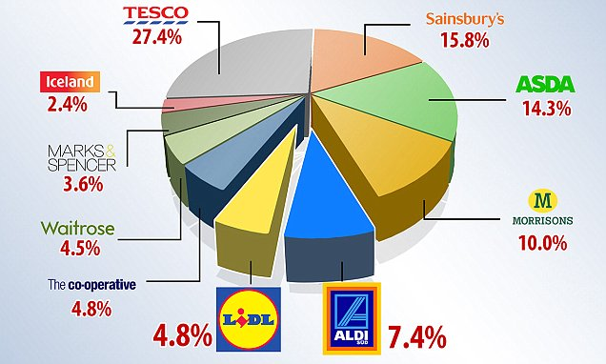 (Image:[6] Peachy Essay, 2019).

7.2 Threat of Substitutes

The method of substitutes has monopolized both groceries and retail business always and will continue to do so. Sainsbury's has stiff competition. However, Sainsbury still has a small chance of fending off substitute brands with online digital systems.

7.3 Power of Buyers

Sainsbury’s customer has a very strong power of bargaining due to accessibility to many competing large retailers: Asda, Morrison, Tesco, Waitrose, Marks & Spencer

Customers switching power is easily met. Special deal events at other competitors like Lidl and Aldi attract customers' attention and retention.

7.4 Power of Supplier
Surprisingly there is low supplier bargaining power at present, as there are many existing supplying companies available. This Indicates Sainsbury can change and buy from alternative suppliers for low costs and provide varieties to consumers for reduced prices. But this may change due to Brexit in near future.

7.5 Competitive Rivalry

The UK has a very competitive market for supermarkets like Sainsbury. Too many other large rivals’ competitors offer similar products at the same or slightly low prices. This is affecting Sainsbury negatively within the market and influences share prices.

The downside of Sainsbury is that company does not manufacture many of their goods. They have to obtain from suppliers and outside the UK. This indicates relationships with suppliers have to be reliable and favourable at all times to stay in operation. They need to ensure quality products are received in the correct quantity to keep up with the demand of consumers at a given time. Coming to Brexit would put enormous pressure on the company to keep up with demand and market competition [6] (Peachy Essay, 2019).

- Evaluating an organisation within its Broader Environment
  - By the use of the analysis tool PESTLE -The political, economic, sociocultural, technological, legal, and environmental factors that affect Sainsbury’s in the current market. Political factor: at present for Sainsbury’s is the imminent Brexit. England no longer remains a part of the European Union, leading to increased import rates, cause for increased product pricing of the brand and thus a large number of customers may be lost to competitors that provide cheaper alternatives. Another factor relationship between Qatar and England. The Sovereign Wealth Fund of Qatar is one of the largest shareholders of the company and any political feud between the two nations may lead to a drop in the market shares of Sainsbury’s. Inevitably this issue may be affected by Brexit and its political fallouts [2] (Farooq, 2019).
  - Economic factors: many major Economic issues affect the organization: Sainsbury’s mostly uses road-based transport means to ship its products all across the UK. The rising cost of both petrol and diesel courses to increase its product pricing. A side effect would be the loss of lower-income customers. Unless they explore alternative means of transport. The higher wage movement is gaining momentum across the UK and Sainsbury’s is expected to meet the demands of its workers to retain its shareholders.
The rise of new Supermarket chains around the UK has always been a strong threat that Sainsbury’s has to deal with. Asda and Tesco have been old rivals, but the newer ones such as Lidl and Aldi are proving tough competition in the current market [2] (Farooq, 2019).
  - Technological Factors: Sainsbury’s eCommerce stores attracted the current tech-friendly generation.
However, there is room for improvements, to provide their customers with a better user experience. Using modern data-based analytical systems, such as big data and AI would give a better understanding of the demographical needs of their consumers. These analytical methods also penetrate increase sales and run better marketing campaigns.
  - Legal Factors: Being a big brand Sainsbury’s does have layers of decision-making structure to it, systemic changes are delayed due to business structure. Quickly changing customers’ needs urgently need to be addressed to meet the specific demands. Delay in regulatory approval can occur a loss in market shares and customers.
This may Create a chance for competitors to provide a better experience to the customers. The legal ramifications of post-Brexit a major issue might require changing many of its policies while running its outlets.
  - Environmental Factors: Highly adversarial to the current environmental conditions is supermarkets chain producing a high level of carbon footprint. With the current climate change movement gaining momentum throughout the UK, leading supermarkets like Sainsbury’s ought to take urgent steps to curb their environmental impact. Other major causes are the plastic waste it produces and fossil fuel-based transportation methods. Added pressure to make quick changes to suit current climate-oriented needs since it is an industry leader [2] (Farooq, 2019).
The PESTLE analysis of Sainsbury’s provides a deep insight into the brand’s current position in the market. The supermarket giant has been able to exist in the market for more than a century through calculated upgrades [2] (Farooq, 2019).

- Context of the analytical report with the COVID-19 situation
Sainsbury's has slumped to a £261m loss despite bumper food and Argos sales during the coronavirus pandemic. According to a BBC report by Simson, 2021. The supermarket giant said that in the year to 6 March Covid costs "to help keep our colleagues and customers safe had been high". However still optimistic for profit to bounce back soon. Sainsbury’s reported £485 Million on Covid- related costs.

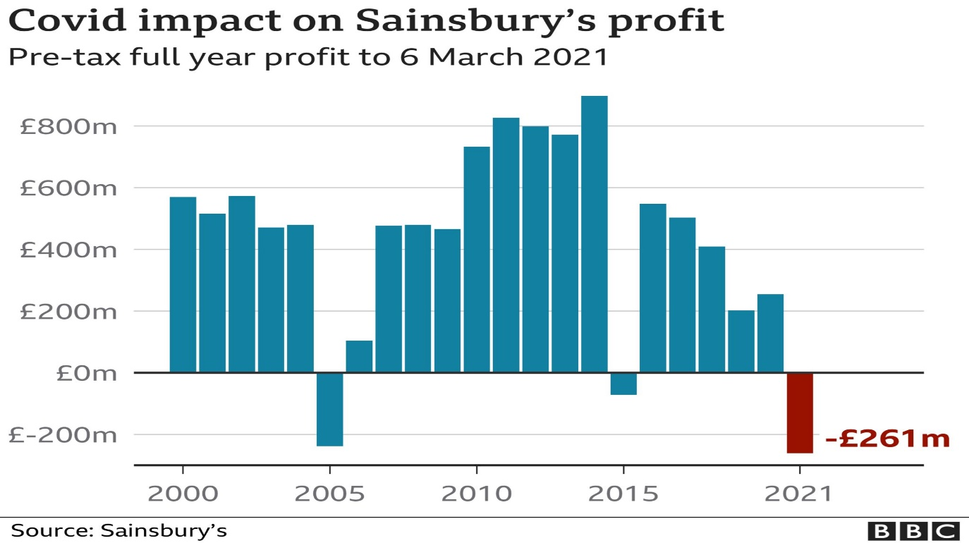 (Graph:[10] Simpson, 2021)

- Impact of COVID-19 on the Business Environment.
Positive:
- Move towards digitalisation
- Remote working /hybrid working
- Reduction in overhead costs
- Change in the working pattern
- Increased demand for delivery drivers
- plans to open 25 to 30 convenience stores
- existing 800 convenience stores sales rose by 13%
- Internet shopping boosted from 8% to 17%
- Argos digital sales boomed by11% [10] (Simpson, 2021)
Negative:
- Staff reduction
- Change in the working pattern
- Announced 1,150 jobs were at risk.
- Paid 10% extra to 157,000 colleagues and frontline Managers
- Extra costs for technology and remote working
- Paying employees who were shielding and self-isolating
- paid business rates relief on its stores in line with other rivals
- restructuring costs, including closing 170 standalone Argos stores.
- pre-tax loss for the year was £261 Million
Despite the huge dent of loss during the Covid-19 pandemic Sainsbury still moving forward with new norms with a positive approach. Planning to open at least 25/30 convenience stores per year for the next three years. Locating the stores in essential areas where people are working more locally [10] (Simon,2021).

11. Critical Assessment of Sainsbury’s Cultural Web.
Sainsbury’s vision is to be the most trusted, harbouring talent, creativity and diverse employees. Staff participation is the greatest strength for the performance of every company. Flexible scheduled workplace strategies help to minimise expenses, improve efficiency, motivate workers and release more resources Regularly invest in multiple initiative programmes for employee training and development. Somewhere over 185,000 colleagues can become the best versions of themselves.
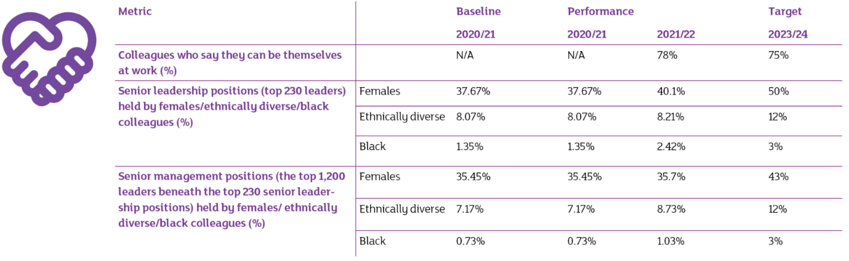
(Image: [12] www.about.sainsburys.co.uk, n.d.)
Sainsbury recognises the importance of listening and creating conversations across the business. The CEO Simon Roberts holds regular one-hour Q&A sessions online platform Yammer. The feedback and inputs help shape the strategy led by diverse groups. Sainsbury's also, serves the community majority of the workforce is employed from the UK. Mentoring and leadership programme for BAME colleagues. Sainsbury received the highest Disability Confident Leader status in 2017 for an active role in the Government campaign [6] (Peachy Essay, 2019).

12. Ethical Dilemma: Critical evaluation of the relationship between Sainsbury’s culture and its efficiency in achieving financial and non-financial performances.
An ethical dilemma concept is that a problem relay on two possible options neither of which acceptable from an ethical perspective. All companies have faced a situation where they must make a decision that questions their ethical values and the company’s survival – sometimes these do not coincide and that is where ethical dilemmas are faced. COVID-19 forced all companies around the whole world to choose whether they companies should risk the organisations' culture and values or take the necessary cuts and losses required to stay afloat.
12.1 What is Ethics meaning in retail:
Code of conduct – a general guide on integrity, honesty, accountability, and legal compliance. Avoid Exploitation of consumers and workers. Avoid profiteering unscrupulous business activity: black-marketing, selling banned goods. The business ethics concept is in practice in developed countries, while poor and developing countries are backward in applying the principle of business ethics.

12.2 Sainsbury had to face countless ethical dilemmas during the Covid-19 pandemic.
- Trust vs Loyalty- As many venerable employees were unable to work at all. There was no certainty of they are coming back to work again. Sainsbury continued paying their wages for 14 weeks. Even though the costs of trading during Covid were rising.
- Short-term v Long-term- Committed to the Net Zero by 2040. Despite the significant loss and difficult changes during the Covid pandemic Sainsbury still investing £1 Billion. The company has no plan to pause the plan to gain financial recovery. Moving steadfastly towards becoming a Net Zero business. Focusing on plastic packing, water usage, food waste and reducing Carbon emissions.

13. Recommendations
Sainsbury should use its current geographical position to enhance its sustainability in the market. Organisations to embrace technology innovation and creativity. Sainsbury should identify and target a variety of products to improve not just quality but value ways too. The company position is at present in the mid-tier market. It will be an advantage to produce products that can participate in the lower end of market price ways. Many other issues can improve:
- Concentrate and give priority to food waste sooner rather than later
- Sainsbury should give thought to Halal food supplying for ethnic Minority groups- Over 3.3 million Muslims are living in the UK [5] (Muslim census, 2021)
- Hire more Ethnic minority groups- Asian background workers.
- Review of working pattern
- Adaptability – be ready to adjust to changes in the environment: COVID-19 or should a similar situation arise again.
A further analytical investigation could assess the long-term effects and trends. Considering the above directives and strategies will allow the company to develop more diverse and pragmatic arrangements. Opportunity to reposition on the current market demand. The Marketing mix will allow it to have an improved marketing strategy, hence increasing the level of sustainability of Sainsbury. The marketing mix to keep in mind is the product, price, place, and promotion. [6] (Peachy Essay, 2019)

14. Conclusion

The purpose of the current study was to determine that with the use of the application of evaluation and analytical tools, such businesses can improve work culture and effectively improve organisational performance. For instance, with the internal and microenvironment, use of SWOT analysis or McKenzie’s 7s, and for the external environment – PESTEL, Porter’s 5 Forces, and Hofstede’s Cultural Dimension, etc, organisational can evaluate the most its broader environment. Sainsbury’s is a leading chain in the UK. Unfortunately, the pandemic caused a lot of repercussions and complicated challenges with their operations and supply chain management during the epidemic. In the constantly changing market by utilizing all the available analytical tools they can develop and adapt to new strategies to operate on time to dominate and secure their position in the market. Sainsbury’s dream of to be becoming an exclusive retailer.

Reference Task 1.
[1] bizibl.com. (2016). Why Retailers Should Watch The Proposed Sainsbury’s Argos Takeover With Interest. [online] Available at: https://bizibl.com/commerce/blog/why-retailers-should-watch-proposed-sainsbury%E2%80%99s-argos-takeover-interest [Accessed 18 Jul. 2022].
[2] Farooq, U. (2019). Pestle Analysis of Sainsbury’s - Supermarkets Chain in the UK. [online] Marketing Tutor. Available at: https://www.marketingtutor.net/pestle-analysis-of-sainsburys/ [Accessed 16 Aug. 2022].
[3] Forbes. (n.d.). J Sainsbury. [online] Available at: https://www.forbes.com/companies/j-sainsbury/ [Accessed 18 Jul. 2022].
[4] Grimsley, S. (2021). What Is Business Environment? - Definition & Factors - Video & Lesson Transcript | Study.com. [online] Study.com. Available at: https://study.com/academy/lesson/what-is-business-environment-definition-factors-quiz.html [Accessed 16 Aug. 2022].
[5] Muslim census (2021). A Year of Lockdown: The Impact on Muslims Report. [online] Available at: https://muslimcensus.co.uk/wp-content/uploads/year-of-lockdown-revised-v1.pdf [Accessed 17 Aug. 2022].
[6] Peachy Essay. (2019). British Retailer Sainsbury’s Porter, SWOT and PESTEL Analysis. [online] Available at: https://peachyessay.com/sample-essay/british-retailer-sainsburys-porter-swot-pestel-analysis/ [Accessed 17 Aug. 2022].
[7] Sainsbury's (2019). Our business strategy. [online] Sainsburys.co.uk. Available at: https://www.about.sainsburys.co.uk/about-us/our-business-strategy [Accessed 16 Aug. 2022].
[8] Salesforce (2019). What is CRM? Customer Relationship Management - Salesforce UK. [online] Salesforce.com. Available at: https://www.salesforce.com/uk/learning-centre/crm/what-is-crm/ [Accessed 18 Jul. 2022].
[9] Shastri, A. (2022). Dynamic SWOT Analysis of Sainsbury’s - 2021 Update | IIDE. [online] Available at: https://iide.co/case-studies/swot-analysis-of-sainsburys/ [Accessed 16 Aug. 2022].
[10] Simpson, E. (2021). Sainsbury’s: Cost of Covid has been high. BBC News. [online] 28 Apr. Available at: https://www.bbc.co.uk/news/business-56912064 [Accessed 16 Aug. 2022].
[11] Toppr-guides. (2018). Business Environment: Definition, Features, Importance, Types. [online] Available at: https://www.toppr.com/guides/business-environment/#:~:text=Definition%20of%20Business%20Environment%20is [Accessed 16 Aug. 2022].
[12] www.about.sainsburys.co.uk. (n.d.). Diversity and inclusion. [online] Available at: https://www.about.sainsburys.co.uk/sustainability/better-for-everyone/diversity-and-inclusion [Accessed 18 Jul. 2022].
[13] Wikipedia Contributors (2019). Sainsbury’s. [online] Wikipedia. Available at: https://en.wikipedia.org/wiki/Sainsbury%27s [Accessed 7 Jun. 2022].
PLEASE NOTE I HAVE USED RELEVANT INFORMATION FROM MY PREVIOUS ASSIGNMENTS

BA (Hons) Leadership and Management Skills for the Workplace

Module: Workplace Culture and its Impact on Organisational Efficiency
Module code: BMSW 5101

Student: Rupia Hussain-ID: 2010133
Lecturer: Olusoyi Ashaye

Assignment Title: Task 2- Individual Reflective Essay

Introduction

This Module provided an important opportunity to advance my knowledge all around, especially from a professional perspective. I will give details of my learning experience. What was most interesting and amazed me. What differences I am making in my profession with my learnings? Therefore, I will mansion examples and scenarios of my workplace where I practised many of the theories I have learned.
Enlightenment was week-8 slides Hofstede’s Dimension of culture. Remarkably interesting to learn about different countries' work culture beliefs and ethics and also, their management approaches.
Kolb’s learning cycle is a great tool to use to learn and reflect. The cycles have four stages of learning-:
    - Experience- doing it.
    - Observation and reflections- reviewing and reflecting on the experience.
    - Development of Ideas- learning from experience
    - Testing ideas in practice – trying out practically what you learnt
After the active experience, the learner applies new ideas to see if any modifications appear in the next experience. The second experience begins the next cycle [5] (Wikipedia Contributors, 2018)
Kolb’s learning cycle
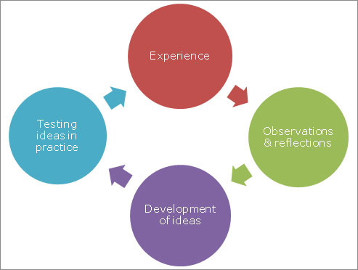 [2] (learn.solent.ac.uk, n.d.)

Reflecting on using Kolb’s cycle for my assignments. I attended the lectures; I took notes and went over them at home but made no sense. The following week, I went back to my lecturer and questioned him about it and asked him to explain again. Came home and started the assignment while I still remember it well. Sent it to the lecturer to check if my starting Ideas were in the right direction.

The Porter’s Five Forces: week two. I can relate to the five forces with my job at an Indian takeaway and catering services. Already suffering company, the covid-19 pandemic made it worse, businesses had to close. Food businesses were one of the booming businesses during the Covid-19 lockdown. The owners did not act fast enough on the evolving changes.
The Porter’s Five Forces:
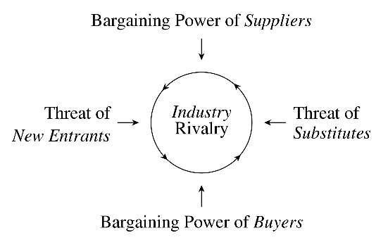[4] (Wikipedia Contributors, 2019)
All five elements affected the business. There were too many Rivalry new businesses opening in the same area. Suppliers were falling short and increasing prices. There were almost the same or similar products found all around. The consumers had the power and options to find the same or similar items elsewhere with the same or even lower prices. The team sat to discuss what has happened and what we can learn and do differently. After critically evaluating, a decision was made to reopen with a new name and new variety menu. Fast food: Burgers, Per Peri along with Indian traditional dishes. We started the new venture in June 2022.

Organisations Structures
It was staggering to find out so many types of structure methods used in different organisations. Many large organizations have very hierarchical and bureaucratic structures. I strongly agree it is vital to have a good working structure to be in place to have the organisation running smoothly and efficiently allows to monitor all activities of the organisation.
At my present work organisation, we have a simple company structure placed
Director 1 ˃ | ˂ Director 2
Manager Ʌ | Ʌ
Shop front workers & drivers Ʌ | Shop back, workers Ʌ

This works well as it is a new limited company where a small group of people work very closely.
Work Cultures
This segment’s study enforces the importance of the work culture environment. Before this Module, I did not give much thought to what was meant by work culture. I think it is paramount to have a good work culture environment at any minor or major organisation. In other words personality of the workplace. Individuals coming from various backgrounds, with different education, and experience, and with diverse personalities all, work together in harmony to achieve common goals and missions. “It’s a sum of your workplace environment, mission statement, values and beliefs, ethics, vision, language, practices, and employees and management” [1] (Kaplan, 2020).
At my present workplace, used to be a very masculine work culture. I was the first female and youngest team member with opposite personalities, ethics and beliefs. At first, I had to adjust to their traditional work environment. I had to go through Tuckman's team building process Forming, Storming, Norming and Performing to make my place within the team. Bruce Tuckman in 1965, said that these phases are all necessary and inevitable for a team to grow, face up to challenges, tackle problems, find solutions, plan work, and deliver results [7] (Wikipedia Contributors, 2018).
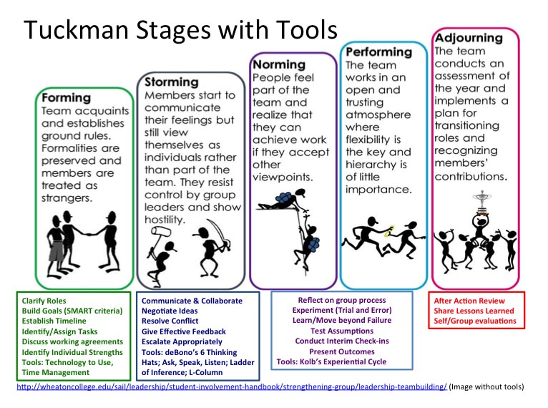 [3] (slideplayer.com, n.d.).
McKinsey’s 7s
I used the interesting method of change by, McKinsey’s 7s ( Structure, Systems, Style, Staff, Skills, Strategy, Shared Values) the model can be used to help identify what needs to be realigned to improve performance, or to maintain alignment (and performance) during other types of change [6] (Wikipedia Contributors, 2019). I had to bring them to the realisation that we the employees are the business, we have the abilities and responsibilities to make the business successful. We are the main stakeholders and the face of the business. We have to work together to achieve the same goals to profit the business and achieve job satisfaction. It was hard but slowly we got there. Presently all members are treated equally, getting involved in talking about changes, discussing a problem as a team and putting everyone's opinions and voice across. The members who thought I was not fit to work in the company, now answer to me as I am the manager who manages them.

Conclusion
Ending with conclusions of my whole learning experience and process for this term. Reflective Cycle was invented by Graham Gibbs, in 1988 as a demonstration of learning processes. Explains the 6 stages of learning experiences. It offers a framework for examining experiences, and given its cyclic nature lends itself particularly well to repeated experiences, allowing you to learn and plan from things that either went well or didn’t go well [8] (The University of Edinburgh, 2020).
Gibb’s Reflective Cycle
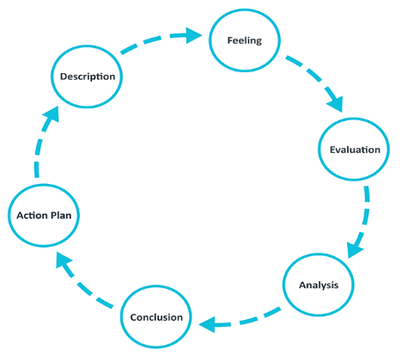 [8] (The University of Edinburgh, 2020).

This module made a significant positive change to my understanding of organisational settings and the internal work environment. After learning about Gibbs's reflecting method I try to apply the method to review the situation experienced and do things better if I was to participate in the same or similar situation for better outcomes. Taking feedback, brainstorming and critically analysing the information is crucial to have a positive impact and decision making. I believe knowledge is the power that can only be increased by sharing and practising. At the end of this module, I realised that an organisation's work structure and culture have an enormous impact on an organization's outcome of productivity, profitability and sustainability, which can influence employees' motivations and job satisfaction.

Reference Task 2.

- [1] Kaplan, J. (2020). What Is Company Culture and How to Make Yours Great. [online] www.wix.com. Available at: https://www.wix.com/blog/amp/2019/12/what-is-company-culture?utm_source=google&utm_medium=cpc&utm_campaign=13774768257 [Accessed 11 Aug. 2022].
- [2] learn.solent.ac.uk. (n.d.). Archived Material (Reflection). [online] Available at: https://learn.solent.ac.uk/mod/book/tool/print/index.php?id=2732&chapterid=1112 [Accessed 1 Sep. 2022].

- [3] slideplayer.com. (n.d.). Tuckman’s 5 Stages of Group Development - ppt video online download. [online] Available at: https://slideplayer.com/slide/9710389/ [Accessed 31 Aug. 2022].

- [4] Wikipedia Contributors (2019). Porter’s five forces analysis. [online] Wikipedia. Available at: https://en.wikipedia.org/wiki/Porter%27s_five_forces_analysis [Accessed 10 Aug. 2022].

- [5] Wikipedia Contributors (2018). Kolb’s experiential learning. [online] Wikipedia. Available at: https://en.wikipedia.org/wiki/Kolb%27s_experiential_learning [Accessed 31 Aug. 2022].

- [6] Wikipedia Contributors (2019). McKinsey 7S Framework. [online] Wikipedia. Available at: https://en.wikipedia.org/wiki/McKinsey_7S_Framework [Accessed 1 Sep. 2022].

- [7] Wikipedia Contributors (2018). Tuckman’s stages of group development. [online] Wikipedia. Available at: https://en.wikipedia.org/wiki/Tuckman%27s_stages_of_group_development.

- [8] The University of Edinburgh (2020). Gibbs’ Reflective Cycle. [online] The University of Edinburgh. Available at: https://www.ed.ac.uk/reflection/reflectors-toolkit/reflecting-on-experience/gibbs-reflective-cycle [Accessed 31 Aug. 2022].

