
Master of Business Administration
Marketing Management
Module Code:LCMB7024
Brand Extension Strategy for Next plc – Launching “Next Active Wear”
Student Name: Trupti Mehul Mehta
Student ID: 2421879
Lecturer Name: Dr Haoran Liu
Date of Submission: 28th April
Word Count: 2476

Table of Contents
Introduction 3
Brand Extension: Next Activewear 3
Segmentation, Targeting and Positioning (STP) 5
Customer Personal Profile 8
Marketing Mix Strategy (7Ps) 10
Conclusion 12
References 14

Introduction
Next plc is one of the world's greatest multinational retailers, and it is based in Britain. Its specialisations are in clothing, footwear, and home products. With a store network of over 500 in the UK and a vast omnichannel presence, Next plc has successfully made fashionable but affordable and good-quality clothing. It has positioned itself as a mid-market brand, and consequently, targets a very wide range of audience, which includes working professionals and families. Its collections are usually lauded for blending versatility with style and practicality (Soe and Datta, 2024).
This report intends to present a strategic brand extension for Next plc: Next Activewear performance-oriented range of high-performance, sustainable athletic wear. The product line, being on target with the global increasing market potential of health, fitness, and wellbeing, will take form. This extension is meant to accommodate the evolving lifestyles of customers, particularly those of the post-pandemic period, wherein one would notice the increasing manifestation of investment in health-conscious and comfortable, sustainable clothing.
The report will articulate how the new line dovetails with the Next Plc brand values, part of its strategic fit in the current market, and an inquiry into the market void that this extension will fill. An analysis of segmentation, targeting, and positioning strategy will also be followed by an in-depth persona creation of the customer. The strategy for the brand's successful entry into the market would then be enhanced using the marketing mix (7Ps).

Brand Extension: Next Activewear
Next PLC is going to show off NEXTFit, a new range of activewear found as part of the brand's portfolio, which aims to reach health-conscious consumers, as well as the patrons of fashion, who usually would like to see the affordable yet stylish catwalk-worthy look from Next PLC (NEXT plc MarketLine Company Profile, 2023). This line extension includes such athleisure and performance products as leggings, sports bras, tops for moisture management, and dozens of accessories, such as a water bottle or a yoga mat, that are amenable to any workout, lounging at home, or just casual outings.
Alignment with brand values and market position
First, NEXTFit conforms to all of Next Plc's values about the brand's quality, affordability, and contemporary design. For years, the company has been reputed to be the "high street" most trusted clothing retail brand that provides clothes with a balanced trend and value. As part of a renewed line of activewear, it buttresses its tweaking to ever-changing lifestyle trends of the consuming public because of increased awareness of health, wellness, and body positivity messages in fashion. The line supplements Next Plc's image as a family-oriented brand with products for men and women available, underlining the brand's inclination towards including all in practicality. Besides these casual and formal offerings, the next major is Homeware and Children's Wear (Ell, 2020). However, a strong view holds on this category, the activewear segment, which, at present, is experiencing continuous growth worldwide. The NEXTFit brand extension will undoubtedly put Next Plc on the map for competing against the likes of high-street competitors such as H&M's Move range or M&S's Goodmove collection, who have already taken profits from consumer wear trends (O'Sullivan et al. 2017).
Valuable Addition and Market Opportunity
Profit margins flow through NEXTFit by allowing Next Plc to evolve into a lifestyle brand rather than a fashion-restricted retailer. The fashion extension caters to the increasing need for all-purpose clothes that sustain a hybrid sort of living, balancing fitness with comfort and style. Post-pandemic consumer needs have shifted toward clothing that is low-maintenance, serving use in different settings: home, gym, and social. Besides, airflow in the public towards mental and physical well-being deserves to be highlighted in that activewear has recently gone. Consumers are now driven to procure what helps them on their wellness journey, and thus, NEXTFit will provide these sorts of clothing. The range will also offer sustainable alternatives in the form of garments made with recycled polyester, remaining consistent with Next Plc's environmental ethos. This brand extension provides Next Plc with the opportunity to fill a market gap in its current array while observing further cultural trends and consumer shifts.

Segmentation, Targeting and Positioning (STP)
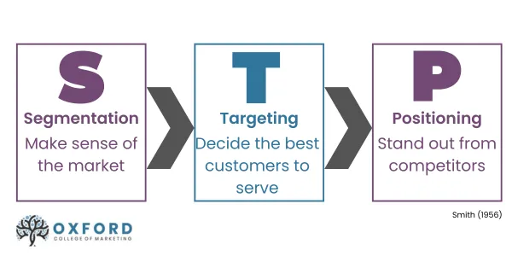
Figure 1: Segmentation, Targeting and Positioning (STP)
(Source: Geof, 2023)

The next four segmentation bases are key:
Demographic Segmentation: It is a segmentation that involves testing or targeting parents aged between 25 to 40, generally millennials or Gen Z, when they are entering parenthood, who tend to be tech-savvy, socially conscious, and generally dual-income-earners. This group looks for functionality in their children's products along with sustainability (Granger et al., 2019).
Geographic Segmentation: Urban and suburban regions across the UK and Ireland are where the awareness of sustainable fashion and access to smart parenting products are higher. These areas will also have a strong retail and online presence for Next Plc.
Psychographic Segmentation: Focused on values and lifestyle, this segmentation consists of modern and environmentally conscious parents who pursue ethical, convenient and innovative consumption of products. Such customers trust brands that resonate with their beliefs and pay a premium for such enhanced safety and sustainability (Ladhariet al., 2019).
Behavioural Segmentation: Frequent online shopping behaviour, brand loyalty, and disinterest in either expensive or niche baby products characterise the group. The preference is durability, organic materials, and smart features like temperature-controlled or activity-tracking clothing.
Targeting
The main target segment would be urban and suburban middle to upper-middle-class parents, aged between 25-40 years, who are digitally engaged and remain socially aware. This demographic comprises newcomers to parenthood and young families who maintain an innovative, convenient, and sustainable lifestyle (Corboşet al., 2023). Next Plc will carve up a differentiated targeting strategy for this selected demographic and then extend its scope to eco-friendly customer types, such as grandparents or friends gifting, such that messaging will be able to address the relevant audience directly. Activewear benefits, such as breathable smart fabrics, growth-flexible designs, and recyclable packaging, can then be communicated accordingly to audiences’ most relevant audiences. The secondary target segments may include working parents looking for comfortable, stylish and safe everyday wear for their children (Singhal, 2023). Next Plc. will implement a differentiated targeting strategy, developing different lines and marketing messages for men and women, alongside various collections for gym wear, running gear, yoga apparel, and athleisure. Such a strategy, in line with Next Plc's approach, will allow them to create tailored experiences for distinct segmentations with particular styles and preferences in the large fitness fashion area.
Positioning
Next Plc's Activewear will be positioned as a stylish, functional, and accessible activewear collection, merging performance features with everyday wearability. The company is setting out to deliver the quality and aesthetics of premium activewear brands such as Nike or Lululemon but at a friendlier price, with a lens on inclusivity in sizing, sustainable materials, and a modern design (Gul et al., 2021).
Positioning Statement:
"For the stylish and performance-driven active individual, offering versatility and quality in athletic apparel—designed to take you through your most rigorous workout and transition effortlessly into everyday looks—all at an accessible price."
Different from high-priced competition that caters to niche markets, Next Plc’s Activewear builds on its brand's mainstream appeal and wide distribution network to offer performance-based fashion for the modern consumer. Sustainability, comfort, and inclusion will be key tenets of the line, which will resonate with this generation, one that recognises functionality as paramount without rubbing off anything in terms of fashion and values.

Customer Personal Profile
Name: Emma Johnson  Gender: Female  Age: 31 | 
Marital Status: Married  Children: Two (ages 2 and 6)  Occupation: Project Manager at a tech firm | Emma Johnson, aged 31, is a university graduate residing in Manchester, UK. She is a project manager at a tech company earning around £42,000 annually. Married with an older child of 6 and a younger child of 2.
Income: £42,000 per annum  Location: Manchester, UK  Education: University graduate | Emma represents a burgeoning group of health-conscious and career-driven women living the balancing act of being professional and keeping the family. Because of her packed schedule, she needs practical, comfortable clothes to wear before and after work, at home, and for leisure activities.
Table 1: Customer Personal Profile
(Source: Self-created)
From a psychological view, Emma is an efficiency geek enjoying health and sustainability. She is environmentally conscious and tends to buy from brands that promote ethically conscious sourcing and production. An active life full of movement is a priority for her; in the early morning, she does her yoga and runs in the park with her child over the weekend. To her, fitness is a meditative form of self-care. Any purchase decision she makes is likely weighed by both utilitarian needs and aesthetics. She looks for functional items that are stylish enough for dressy outside wear, yet comfy enough to wear lounging around at home.
Emma shops online frequently, follows fashion and wellness influencers on Instagram, reads customer reviews, and seeks a product before purchasing. Emma is not brand loyal; she considers the quality, flagship social values, and price points. For Emma, the aspiration is to achieve harmony in her life, work, family, and personal well-being. Such brands appeal to her since they enable her to achieve her goals. In Next Plc’s Activewear lineup, Emma is a perfect customer whose segment stresses performance, affordability, and ethical fashion. Targeting customers like Emma positions Next Plc's activewear as not only an intelligent purchase for fitness but also an intelligent purchase for a woman's lifestyle, giving her confidence, capability, and comfort throughout her day.

Marketing Mix Strategy (7Ps)
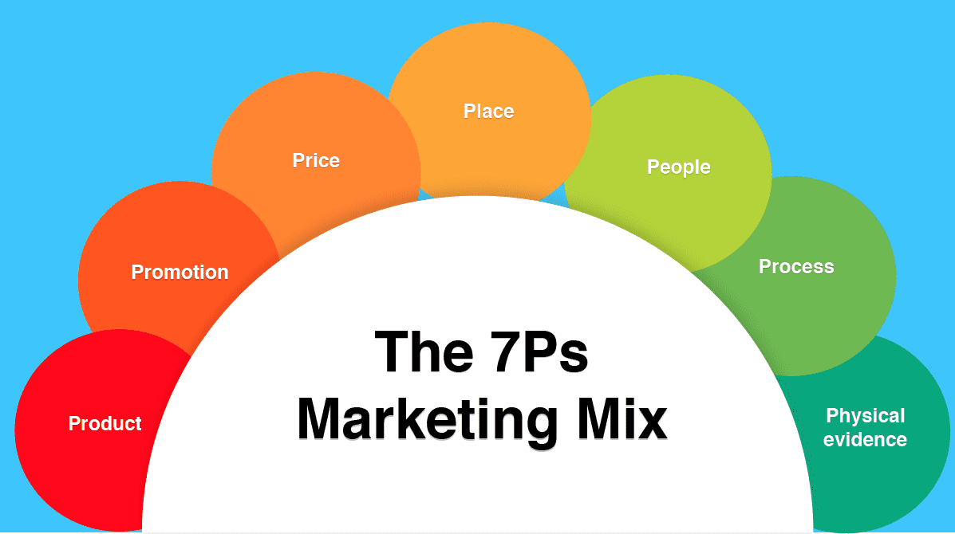
Figure 2: Marketing Mix Strategy (7Ps)
(Source: Martin, 2020)

Product
Next Plc’s Activewear will be a complete range of athletic apparel with something for everyone and every type of wear: from active performance to everyday living. The collection includes leggings, sports bras, t-shirts, hoodies, and outerwear for men and women. Products will have sweat-wicking fabric, ergonomic seams, and recycled materials. It will offer broader sizing, trend-sensitive designs, and ruggedness. This line will merge fashion with function to meet the modern-day active, health-conscious consumer, who seeks activewear to live outside the gym (Ho et al., 2022).
Price
Next Plc would also sell products at competitive prices, such as leggings from £25 and hoodies between £35 and £50, using a combination of value-based pricing, lower-than-average pricing, and placed between fast-fashion and premium brands in selling athletic apparel through discounts and multiple purchases for larger basket sizes. In using pre-existing supply chains, Next Plc can incorporate the features normally considered premium while offering great pricing. It caters the customers with limited budgets, who are conscious and want both quality and value while shopping (Socialpolitik, 2022).
Promotion
A multi-channel promotion combining aspects of social media marketing, influencer partnerships, email campaigns, and in-store displays would be used to convey the message (Bai et al., 2022). The features of products and styling with fitness-related content will be posted using popular social media platforms such as Instagram and TikTok. The expression of authenticity and reach will be borne by influencers and fitness professionals. Online ads are targeted toward consumers, ultimately based on fitness interests and purchase behaviour. New collection drops, limited-time discounts, and sustainable communication messages would be the focus of the promotions (Yang et al., 2025).
Place
Next Plc will be selling its range both online and at selected physical retail locations in the UK. An online shopping experience complete with size guides, user reviews, and AI-generated recommendations will lead to an enriched shopping experience. Flagship stores and larger Next Plc outlets will have dedicated shopper zones for an interactive experience with Activewear. Enhanced accessibility will be availed through click-and-collect, next-day delivery and hassle-free returns. Strategic partnerships with fitness studios and gyms will also take pop-up sales in warehouses to increase visibility and local engagement (Kingsnorth, 2022).
Process
The online ordering, fastest delivery, and easy return processes will cause much traffic to move through the customer experience community. Product development pipelines will collect consumer feedback and trend analysis for the relevance of the processes involved. Sustainable sourcing, ethical manufacturing, and quality control checks are some of the features expected in the supply chain (Peter Davis Sumo et al., 2023). In-store staff will assist customers with product fit and functionality, while online support will provide chatbots and FAQS as part of the seamless performance with informed purchasing (Fares et al., 2024).
People
Retail staff and customer service teams are critical players in delivering Next Plc's Activewear brand promise. The employees will be trained on fitness styling advice applications, product knowledge sharing, and consistency in customer satisfaction (Ray and Nayak, 2023). The influencers and brand ambassadors will reflect the brand values—confidence, balance, and empowerment. The internal team, from design to marketing, will follow and align with Next Plc's sustainability and innovation goals, ensuring the people behind the brand reflect its mission.
Physical Evidence
All the physical properties making Next Plc’s Activewear include its lovely fabrics, branded tags, sustainable packaging, and displays at the stores. Online, the brand is characterised very well through the website by product photography and customer reviews. Green packaging, such as recyclable and reusable bags, builds a sustainable image very well (Sabatini et al., 2023). Such branded fitness accessories as yoga mats or water coolers included in such promotions build tangible extensions of the brand. Altogether, these elements increase trust and build on an experience that is premium but not limited.

Conclusion
The launch of Next Activewear is indeed not only timely but highly strategic within the parameters as discussed in market trends, as well as core values espoused by Next plc, in brief, the lifestyles of consumers today are leaning more towards health, wellness, and sustainability; hence, the demand for activewear that is functional and versatile is peaking. The new line capitalises very cleverly on a very fast-growing segment in the fashion world, activewear, by providing both stylish and proper functional clothing to a broad, enthusiastic audience.
Next Plc’s Activewear then has every opportunity to create a powerful competitive player within the mid-market athleisure segment with Next Plc's proven brand identity, efficient worldwide supply chain partners, and powerful digital presence.
It is found that segmentation and targeting strategies have been defined and well-spelt out in this STP Analysis, and target the young, health-worshipping individuals like Emma Johnson, who juggles a busy personal and professional life. This positioning makes the brand affordable yet high quality in activewear because it meets the price-value sweet spot that is not found in the offerings of premium brands. Last, an all-around strategy for the marketing mix, product, price, and multichannel promotion, as well as excellent customer service, is part of the strategy to ensure a seamless brand experience across all touchpoints.
Recommendations to Next Plc are that they should monitor customer feedback closely and consider such dynamic fitness trends, if possible or evolve the product line continually. Partnering with fitness influencers and getting into smart apparel technology could offer new opportunities for future growth. Ultimately, Next Plc’s Activewear strengthens the brand's relevance in changing markets, makes it stand the test of time with its consumers, and creates a further pocket of income by catering to emerging consumer needs with functional, fashion-given styles designed for real life.

References
Bai, H., McColl, J. and Moore, C. (2022) ‘Luxury fashion retailers’ localised marketing strategies in practice – evidence from China’, International marketing review, 39(2), pp. 352–370. Available at: https://doi.org/10.1108/IMR-02-2021-0079.
Corboş, R.-A., Bunea, O.-I. and Triculescu, M. (2023) ‘Towards Sustainable Consumption: Consumer Behavior and Market Segmentation in the Second-Hand Clothing Industry’, Amfiteatru economic, 25(SI 17), pp. 1064–1080. Available at: https://doi.org/10.24818/EA/2023/S17/1064.
Ell, K. (2020) ‘H&M Group’s Cos Introduces Activewear’, WWD, pp. 8–8.
Fares, N. et al. (2024) ‘Optimisation of multi‐tier supply chain distribution networks with corporate social responsibility concerns in fast‐fashion retail’, Corporate social-responsibility and environmental management, 31(1), pp. 311–330. Available at: https://doi.org/10.1002/csr.2571.
Geof (2023). [online] Oxfordcollegeofmarketing.com. Available at: https://blog.oxfordcollegeofmarketing.com/wp-content/uploads/2020/06/Updated-STP.png.
Granger, M. (Michele M.), Sterling, T. and Cantrell, A. (2019) Fashion entrepreneurship : retail business planning. Third edition. New York, NY, USA: Fairchild Books, Bloomsbury Publishing Inc.
Gul, R.F. et al. (2021) 'Linkages between market orientation and brand performance with positioning strategies of significant fashion apparel in Pakistan', Fashion and textiles, 8(1), pp. 1–19. Available at: https://doi.org/10.1186/s40691-021-00254-9.
Ho, C.-I., Liu, Y. and Chen, M.-C. (2022) ‘Factors Influencing Watching and Purchase Intentions on Live Streaming Platforms: From a 7Ps Marketing Mix Perspective’, Information (Basel), 13(5), pp. 239-. Available at: https://doi.org/10.3390/info13050239.
Kingsnorth, S. (2022) The digital marketing handbook : deliver powerful digital campaigns. London: KoganPage.
Ladhari, R., Gonthier, J. and Lajante, M. (2019) ‘Generation Y and online fashion shopping: Orientations and profiles’, Journal of Retailing and Consumer Services, 48, pp. 113–121. Available at: https://doi.org/10.1016/j.jretconser.2019.02.003.
Martin (2020). [online] Smartinsights.com. Available at: https://www.smartinsights.com/wp-content/uploads/2014/03/The-7Ps-Marketing-Mix.png.
NEXT plc MarketLine Company Profile (2023). MarketLine is a Progressive Digital Media business.
O’Sullivan, G.A. et al. (2017) ‘Women’s activewear trends and drivers: a systematic review’, Journal of Fashion Marketing and Management, 21(1), pp. 2–15. Available at: https://doi.org/10.1108/JFMM-07-2015-0059.
Peter Davis Sumo, Ji, X. and Cai, L. (2023) ‘Efficiency evaluation and loan assessment of fashion upcyclers in Liberia using fuzzy, DEA and FIS models’, Research journal of textile and apparel, 27(3), pp. 366–388. Available at: https://doi.org/10.1108/RJTA-07-2022-0082.
Singhal, V. (2023) ‘Segmenting and Targeting Fashion Consumers Using Social Media: A Study of Consumer Behaviour’, Journal of Creative Communications [Preprint]. Available at: https://doi.org/10.1177/09732586231203848.
Socialpolitik, V. für (2022) UntersuchungenüberPreisbildung. : Abteilung B: Preisbildung für gewerblicheErzeugnisse. Erster Teil. (Schriften des Vereins für Sozialpolitik 142-I). 1st ed. Berlin: Duncker &Humblot.
Soe, T.K.K. and Datta, P. (2024) 'Corporate Social Responsibility (CSR) and consumer purchase intention in the UK fashion industry', Journal of Business & Retail Management Research, 19(1). Available at: https://doi.org/10.24052/JBRMR/V19IS01/ART-02.
Yang, J., Guo, H. and Wei, S. (2025) ‘How Pricing and Promotion Strategies Influence Customer Satisfaction in Sustainable Fashion’, International Journal of Electronic Commerce, 29(2), pp. 210–234. Available at: https://doi.org/10.1080/10864415.2025.2471675.

