- Determine the integrals for:

1a) 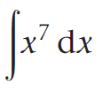 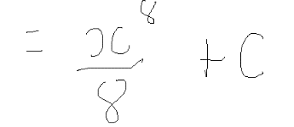
[2 Marks]
1b) 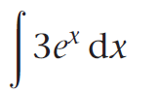 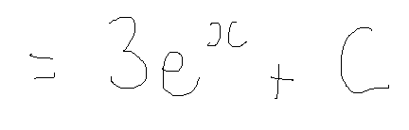
[2 Marks]
1c) 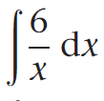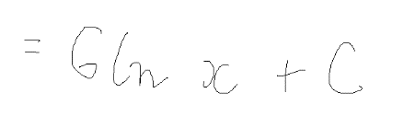
[2 Marks]
1d) 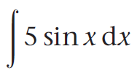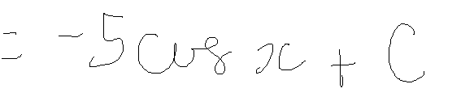
[2 Marks]

1e) 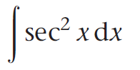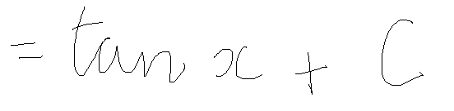
[2 Marks]
1f) 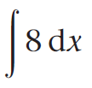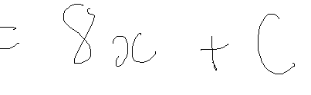
[2 Marks]
1g) 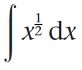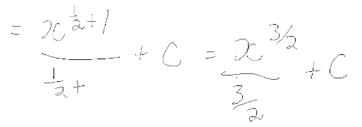
[2 Marks]
1h) 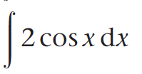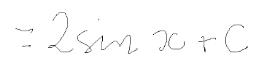
[2 Marks]
1i) 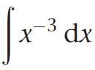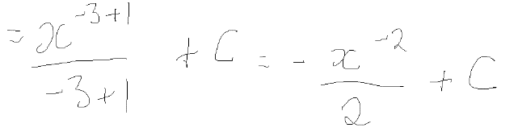
[2 Marks]
1j) 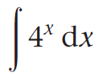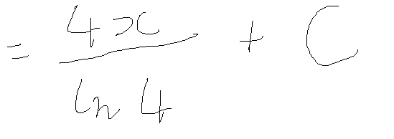
[2 Marks]

2a) Simplify by collecting like terms :

4xy + 3xz - 6zy - 5zx + yx

[4 Marks]
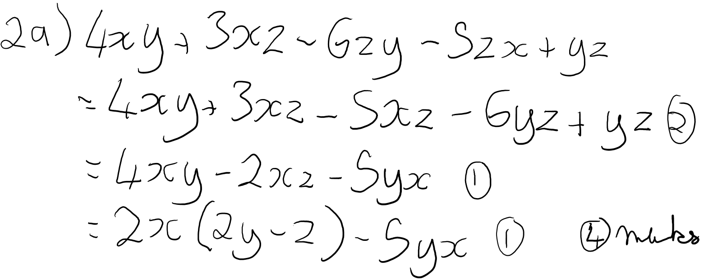
2b) Solve for x:

12 + 4x -3(x+2) = 5x + 4
[4 Marks]

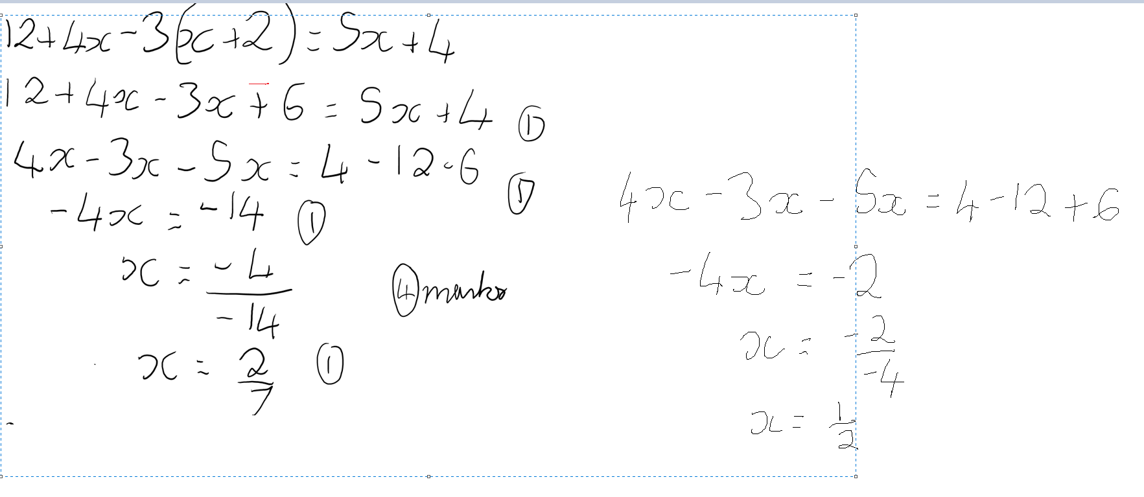
2c) Solve for x:

$\frac{x+4}{3}=\frac{14-5x}{2}$

[4 Marks]

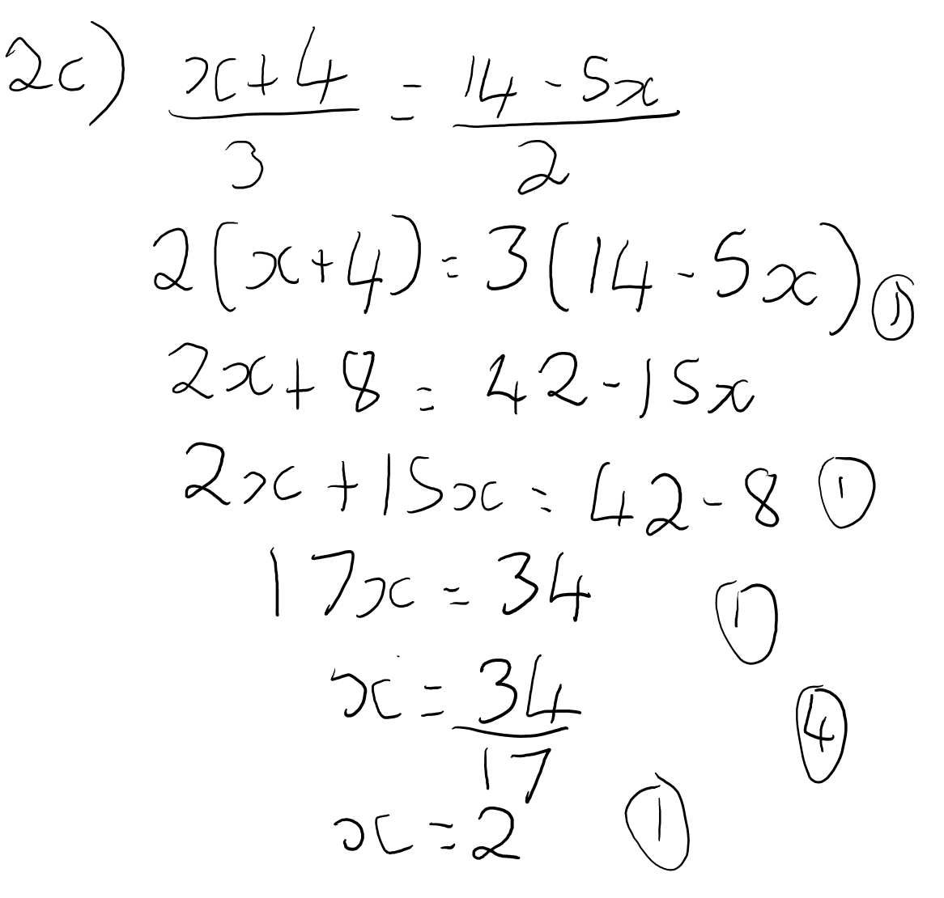
2d) Divide the polynomial $x^{2}+ 2x-7$ by $(x-2)$.
[8 Marks]

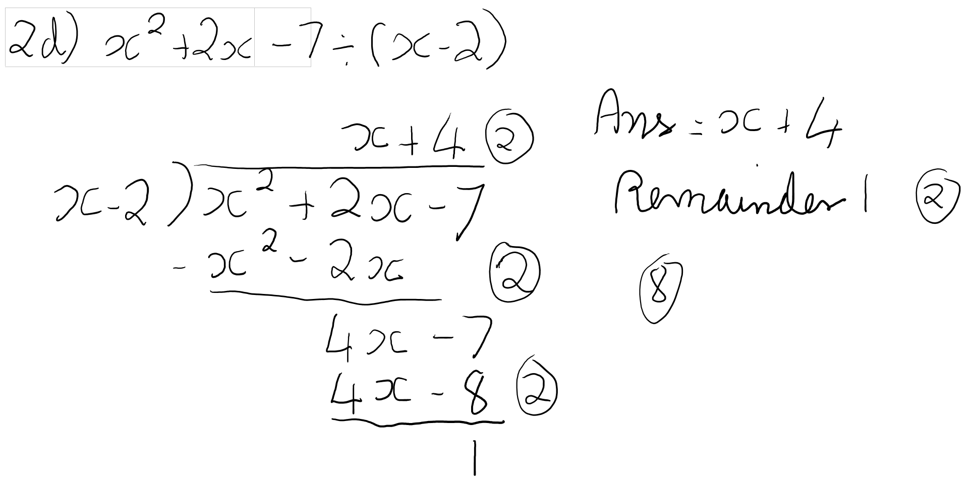
2e) Divide the polynomial 2$x^{3}$ − 3$x^{2}$ + 4$x$ + 5 by x +2

[10 marks]
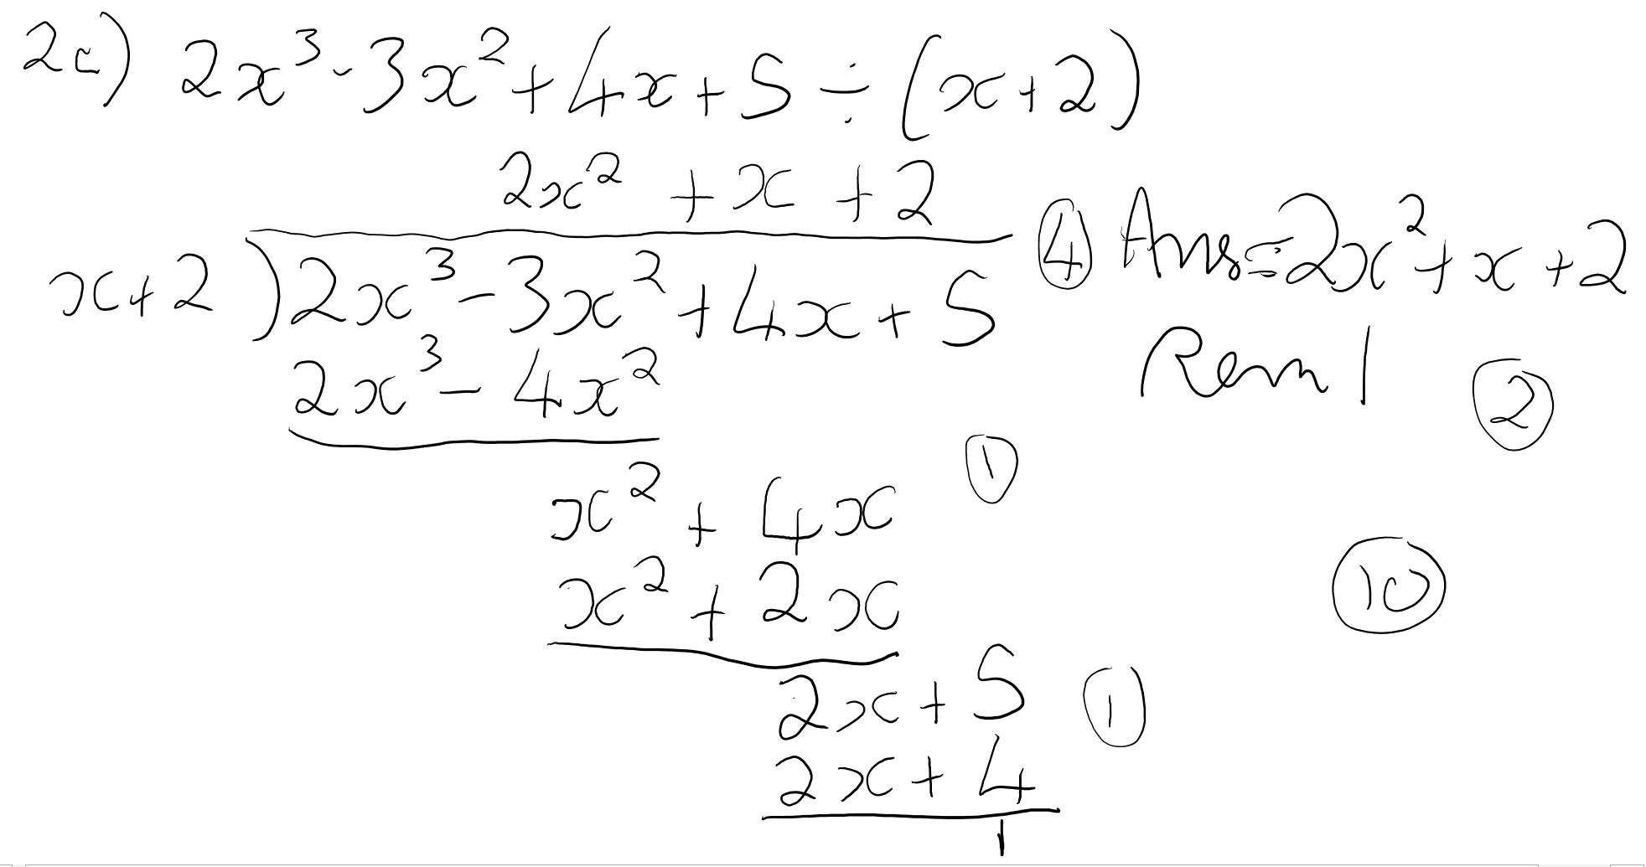
3a) Solve the following simultaneous equations by substitution:

-x + y = 2
2x + y = 11
[5 Marks]

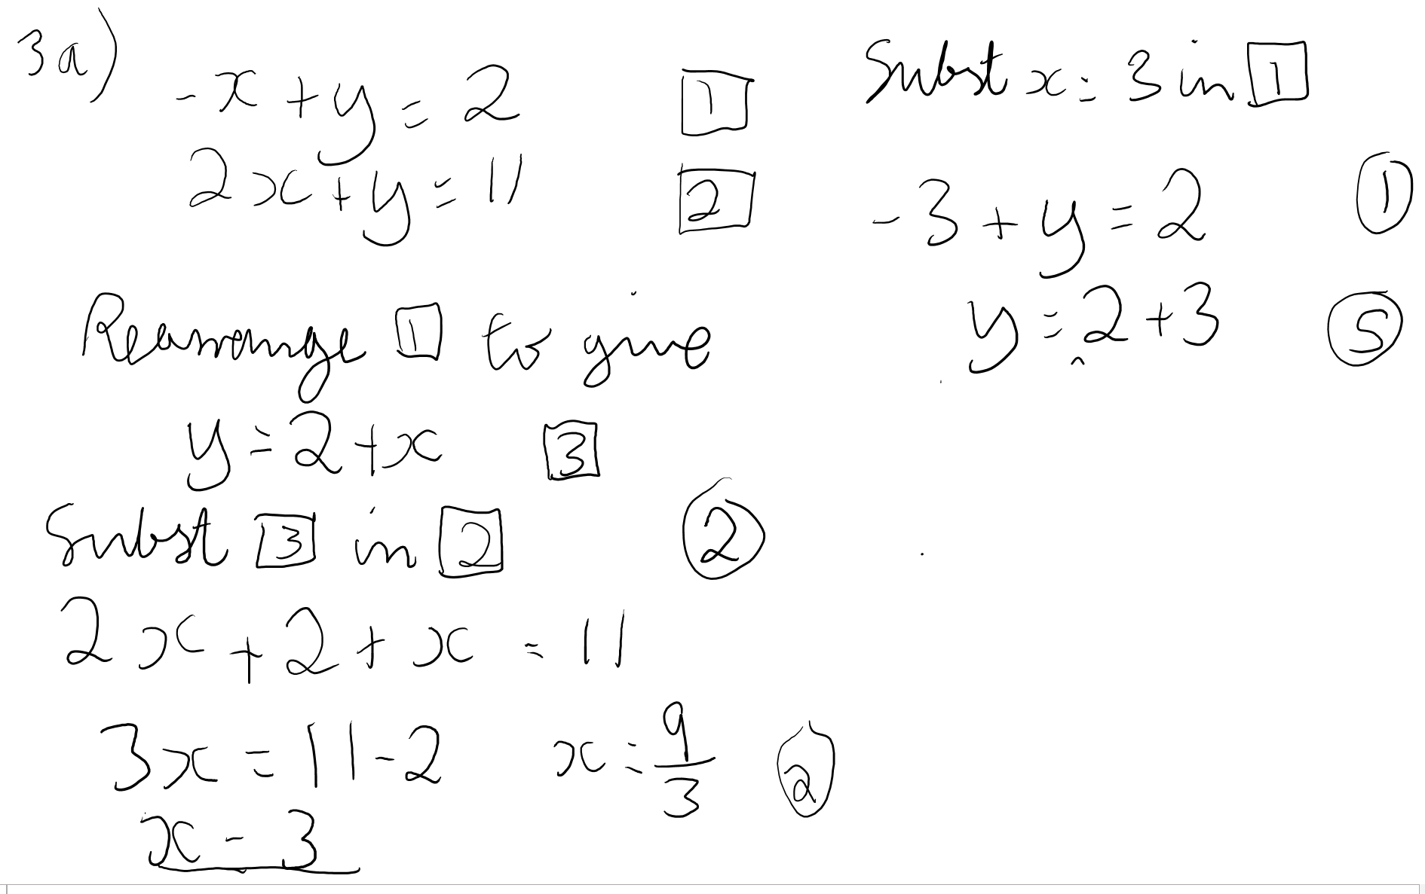
3b) Solve the following simultaneous equations by elimination:

3x + 2y –z = 6
−2x + 2y +z = 3
x + y +z = 4
[10 Marks]

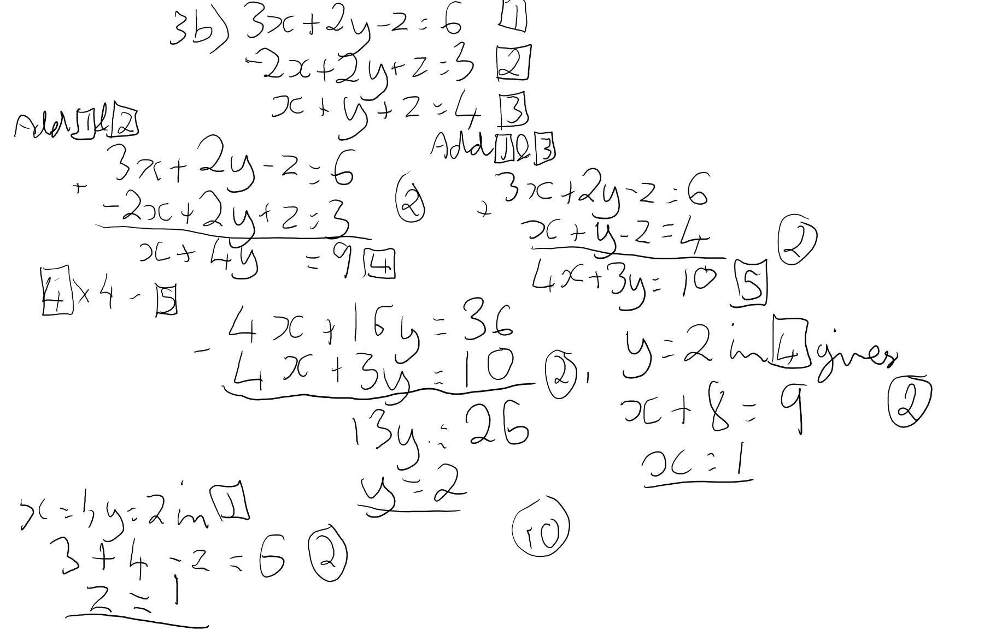

3c) Solve the following simultaneous equations using any method:

3 x + y = 5
2 x – y = 0

[10 Marks]
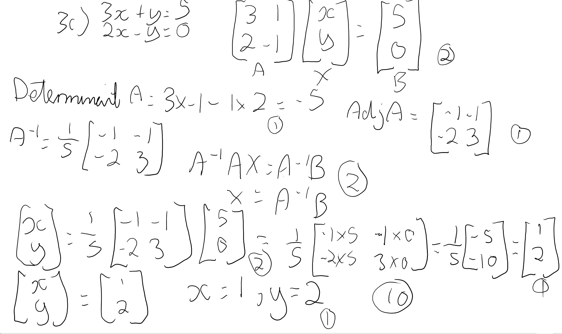

4. Differentiate the following equations:

4a) $y=7x^{5}$ [3 Marks]
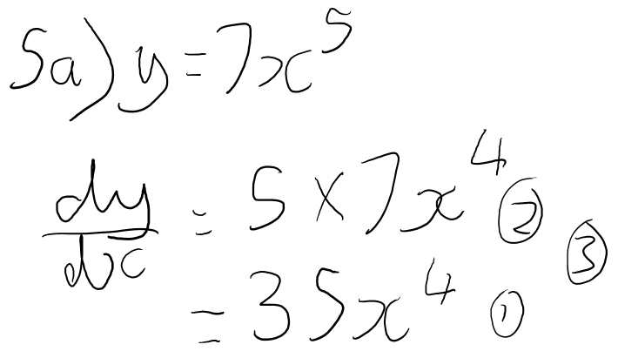

4b) $y=x^{-5}$ [3 Marks]
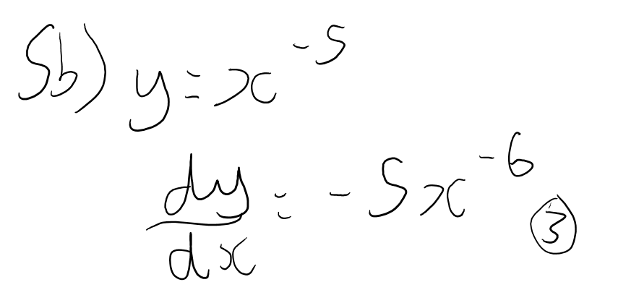

4c) $y=4x^{2}+ 12x-15$ [4 Marks]
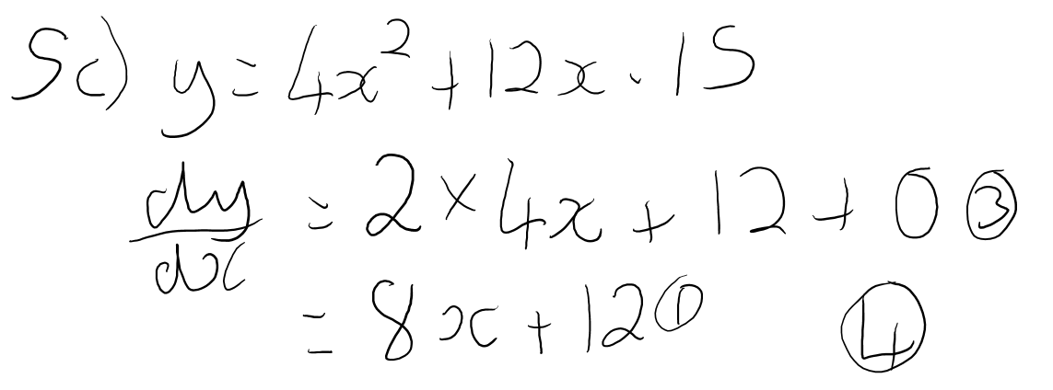

4d) $y=(4{x+3)}^{4}$ [5 Marks]

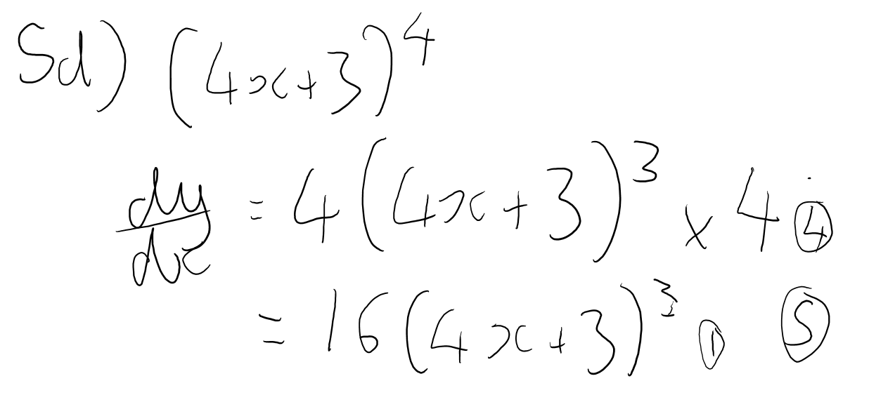

4e)$y=\frac{3+4x^{2}}{2x^{3}}$ [5 Marks]
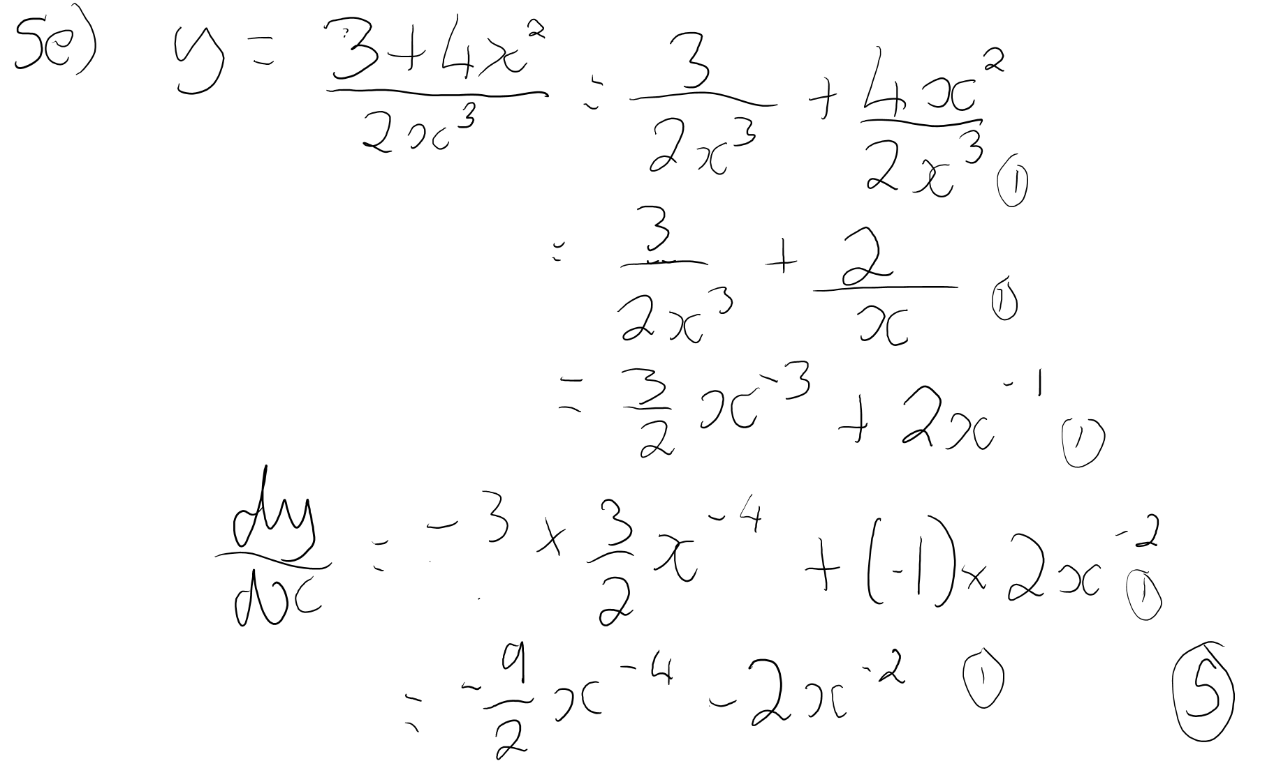
4.f) y = cos x. sin x
[5 Marks]
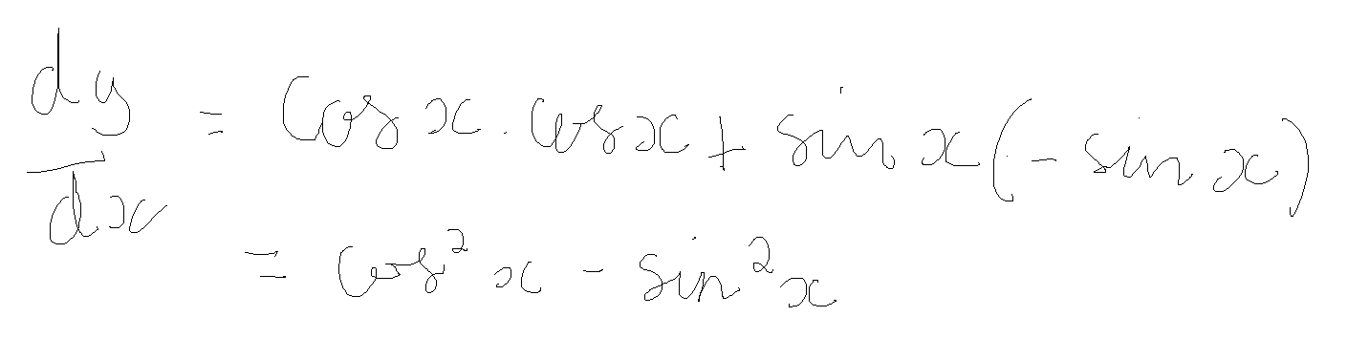
4.g) y = $e^{x}$. cos x
[5 Marks]


