Leo Smith (2217998)
ACDA6020 – Advanced Chemistry of OME
2nd January 2026
AP HTPB vs cl-20 GAP Rocket Propellants: A Technical summary

Table of Contents
Table of Figures 1
Table of Tables 1
Table of Equations 2
1.0 Introduction 3
2.0 Technical Contribution 3
2.1 Solid Rocket Motor Performance 3
2.2 Formulation Data 4
2.3 Oxygen Balance Comparison 5
2.4 Estimating Combustion Products 6
2.5 Calculating Heat of Combustion 7
2.6 Estimating Combustion Temperatures 8
2.7 Specific Impulse Comparison 9
2.8 Burn Rate Characteristics 9
2.9 Performance Conclusions 10
3.0 Technical Reflections for Future Work 11
4.0 Conclusion 11
5.0 References 12
Appendix A – Presentation Slides 15

Table of Figures
Figure 1 - Rocket motor thrust equation. [3], [4], [5] 3
Figure 2 - Plot of Thrust against Time and the Total Impulse equation. [6], [7] 4
Figure 3 - Modified Kistiakowsky-Wilson Rules. [18] 6
Figure 4 - Use of Hess's Cycle to determine the heat of combustion. 7
Figure 5 - Combustion Temperate extrapolation for each propellant formulation. 8
Figure 6 - Burning Rate and Flame Temperature with respect to Pressure [21]. 10
Figure 7 - Qualitative comparison of thrust time curves. 10

Table of Tables
Table 1 - Thermochemical data for propellant formulation components. 5
Table 2 - Chemical and Thermochemical data for representative propellant formulations. 5
Table 3 - Estimated combustion products. 6
Table 4 - Average Molecular Mass of Combustion Products. 7

Table of Equations
Equation 1 - Specific Impulse Equation. [3], [4], [6] 4
Equation 2 - The proportionality of Specific Impulse and chemical factors. [3], [4], [6] 4
Equation 3 - Oxygen Balance equation for Cl containing energetics. [19] 6
Equation 4 - Oxygen Balance calculation for AP / HTPB propellant. 6
Equation 5 - Oxygen Balance calculation for CL-20 / GAP propellant. 6
Equation 6 - Heat of Combustion calculation for AP / HTPB 7
Equation 7 - Heat of Combustion calculation for CL-20 / GAP 8
Equation 8 - Combustion Temperature equation. [18] 8
Equation 9 - Proportional Specific Impulse calculations. 9
Equation 10 - Vieille's Burning Rate Law [3]. 9

1.0 Introduction
This technical summary report has been produced to highlight the authors contribution to, and reflections on, the group presentation shown in Appendix A.
This presentation looked to compare the performance, manufacturability, safety and stability of both of Ammonium Perchlorate (AP), Hydroxyl Terminated Polybutadiene (HTPB) and Hexanitrohexaazaisowurtzitane (CL-20), Glycidyl Azide Polymer (GAP) propellants within Solid Rocket Motor (SRM) systems.
AP / HTPB represents a typical composite rocket propellant consisting of an oxidiser (AP) and a fuel (HTPB). This formulation is used in many tactical weapons systems, e.g. ASRAAM, CAAM etc [1].
In contrast CL-20 / GAP propellants, where both elements contribute as a fuel and oxidiser, represent a high energy density propellant, similar to those currently being explored by SRM engineers.
This area of research is of critical importance to SRM engineers in the context of increasing geo-political uncertainty, where nation states are investing in increased sovereign hard power. CL-20 / GAP propellants promise to support this by enabling tactical weapons with increased payload, range and speed. One such example from the UK is Project Nightfall [2], which aims to develop a sovereign short range ballistic missile. Such systems, as will be demonstrated, could see significant benefits from the use of high energy propellants highlighting the potential impact of this research.

2.0 Technical Contribution
This section of the report will focus on the authors technical contribution to the presentation and explores the comparison of propellant performance.

2.1 Solid Rocket Motor Performance
The primary measure of SRM performance is thrust which can be calculated using the equation shown in Figure 1.
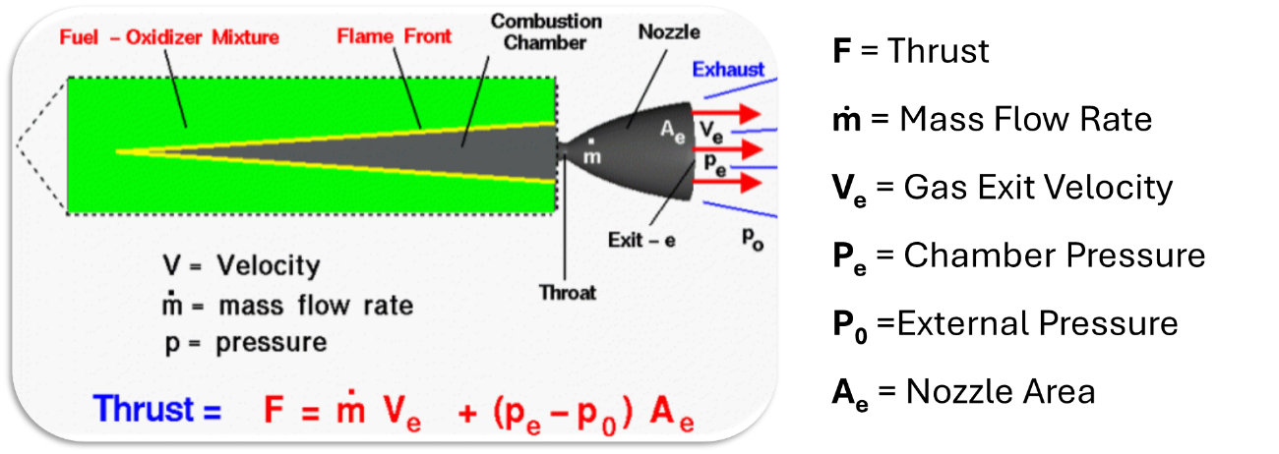
Figure 1 - Rocket motor thrust equation. [3], [4], [5]
Thrust however, is an instantaneous measurement and must be integrated with respect to time, Figure 2, to provide the work done by the motor, also known as total impulse [6], [7].
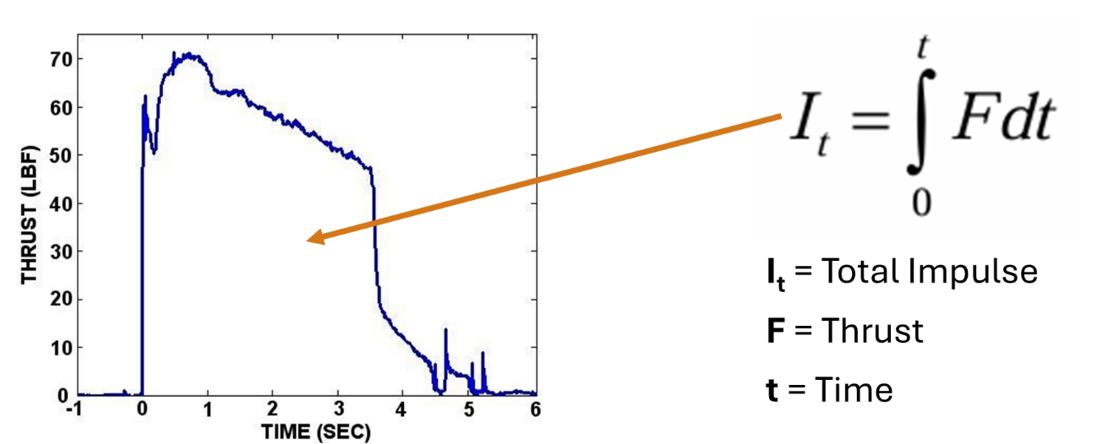
Figure 2 - Plot of Thrust against Time and the Total Impulse equation. [6], [7]
To enable comparison between propellants total impulse must be made agnostic of the motor size. This is achieved via Specific Impulse (I_{sp}), Equation 1, which normalises for propellant mass [3], [4], [6].
Equation 1 - Specific Impulse Equation. [3], [4], [6]
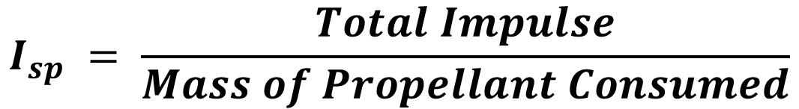
I_{sp} can be calculated through a number of formula. For propellant comparison however, the factors related to motor design may be isolated as constants allowing purely the chemical factors to be considered as shown in Equation 2.
Equation 2 - The proportionality of Specific Impulse and chemical factors. [3], [4], [6]
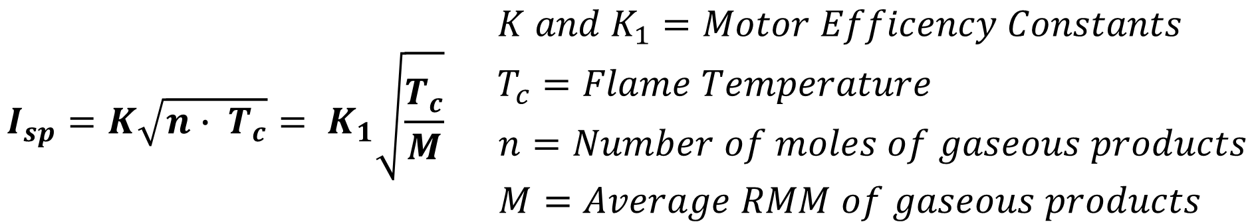
This shows that I_{sp} is proportional to propellant flame temperature and inversely proportional to the average molecular mass of combustion products. Both these may be estimated using basic thermochemical calculations enabling an empirical comparison of propellant performance.

2.2 Formulation Data
To perform these thermochemical calculations fundamental properties of each material must be know. These are easily collected for the molecular oxidisers but must be calculated for a single unit cell of the polymeric binders using thermochemical codes due to variations in cross linking and polymer chain lengths [8]. The required data is shown in Table 1.

Table 1 - Thermochemical data for propellant formulation components.
Component: | Image: | Chemical Formula: | Molecular Weight (g/mol): | Heat of Formation (kJ/mol): | References:
AP | 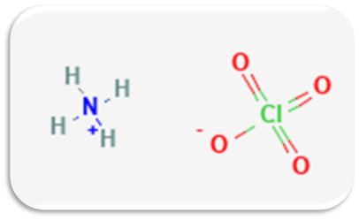 | NH₄ClO₄ | 117.489 | -295.77 | [9], [10]
CL-20 | 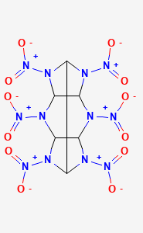 | C₆H₆N₁₂O₁₂ | 438.185 | +454 | [11], [12], [13]
HTPB (R-45M) + IPDI | 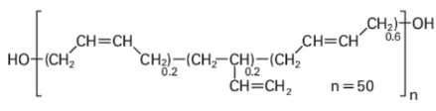 | C₂₁₄H₃₂₃O₅N₂ | 2999 | +342 | [14], [15],
GAP + IDPI | 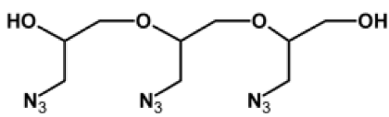 | C₈₁H₁₃₈O₂₇N₆₅ | 2452 | +2311.06 | [4], [16], [17]

In order to enable direct comparison this data was then combined to produce data on a 1kg propellant formulation with an 80% solid loading as show in Table 2. This formulation data will be used in all further calculations.
Table 2 - Chemical and Thermochemical data for representative propellant formulations.
Formulation: | 80% AP + 20% HTPB | 80% CL-20 + 20% GAP
Mol. Oxidizer: | 6.809 | 1.826
Mol. Binder: | 0.067 | 0.082
Stochiometric Formula: | C₁₄H₄₉N₇O₂₈Cl₇ | C₁₈H₂₂N₂₇O₂₄
Molecular Weight: | ≈ 1000 g/mol | ≈ 1000 g/mol
Heat of Formation: | -1991.14 kJ / kg | +1017.37 kJ / kg

2.3 Oxygen Balance Comparison
Oxygen Balance indicates if complete combustion may occur without the addition of environmental oxygen and is an indicator of the propellant’s combustion efficiency [18]. It can be calculated via Equation 3.
Equation 3 - Oxygen Balance equation for Cl containing energetics. [19]
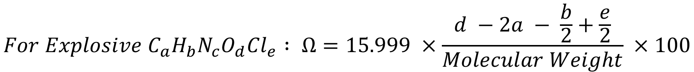
Results for both formulations are shown in Equations 4 and 5 respectively.
Equation 4 - Oxygen Balance calculation for AP / HTPB propellant.
Equation 5 - Oxygen Balance calculation for CL-20 / GAP propellant.
$${AP}/{HTPB} : Ω=15.999 ×\frac{28 -2(14) - \frac{49}{2}+\frac{7}{2}}{1000} ×100= -33.23\%$$
$${CL-20}/{GAP} : Ω=15.999 ×\frac{24 -2(18) - \frac{22}{2}+\frac{0}{2}}{1000} ×100= -36.80\%$$
The oxidising nature of chlorine contributes to an improved oxygen balance for AP / HTPB suggesting a more efficient combustion. This however does not predict SRM performance.

2.4 Estimating Combustion Products
To calculate the Heat of Combustion (HoC) the combustion products must be identified. In practice this system is in equilibrium requiring iterative calculation but empirical rules such as the Kistiakowsky–Wilson (KW), Modified Kistiakowsky–Wilson (MKW) and Springall Roberts (SR) Rules may be used for low accuracy estimations [3], [18], [20].
In this work the MKW rules were used as they effectively handle low oxygen balance formulations. These rules are shown in Figure 3 bellow and have been modified such that all Cl becomes HCl in line with empirical results. The combustion products for each formulation are subsequently presented in Table 3.
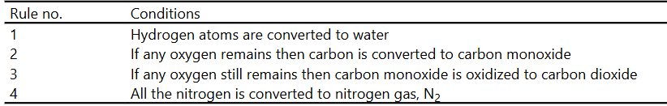
Figure 3 - Modified Kistiakowsky-Wilson Rules. [18]
Table 3 - Estimated combustion products.
Formulation: | AP / HTPB | Cl-20 / GAP
Stochiometric Formula: | C₁₄H₄₉N₇O₂₈Cl₇ | C₁₈H₂₂N₂₇O₂₄
Mol HCl : | 7 | 0
Mol H₂O : | 21 | 11
Mol CO₂ : | 0 | 0
Mol CO : | 7 | 13
Mol C : | 7 | 5
Mol N₂ : | 3.5 | 13.5

Beyond use in calculating HoC, these estimation also allow the average molecular mass of combustion products to be identified as required for I_{sp} calculations. This is presented in Table 4.
Table 4 - Average Molecular Mass of Combustion Products.
Formulation: | AP / HTPB | Cl-20 / GAP
Avg MM of Comb. Products: | 22.23 | 23.53

These results suggest AP / HTPB should perform better due to the inverse relationship between I_{sp} and product mass. This, however, does not consider flame temperature.

2.5 Calculating Heat of Combustion
The HoC for each formulation may be calculated using a Hess’s Cycle as shown in Figure 4, [3], [18], [20]. The calculations for each formulation are subsequently shown in Equations 6 and 7 respectively.

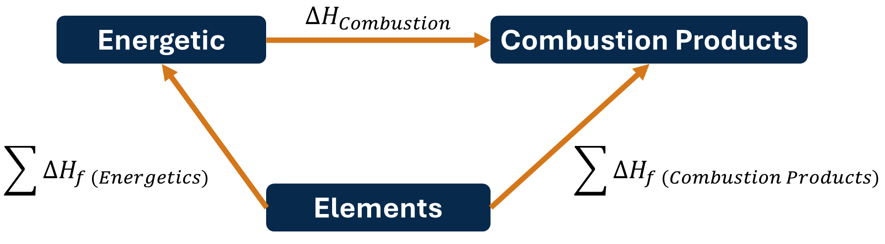
Figure 4 - Use of Hess's Cycle to determine the heat of combustion.

Equation 6 - Heat of Combustion calculation for AP / HTPB
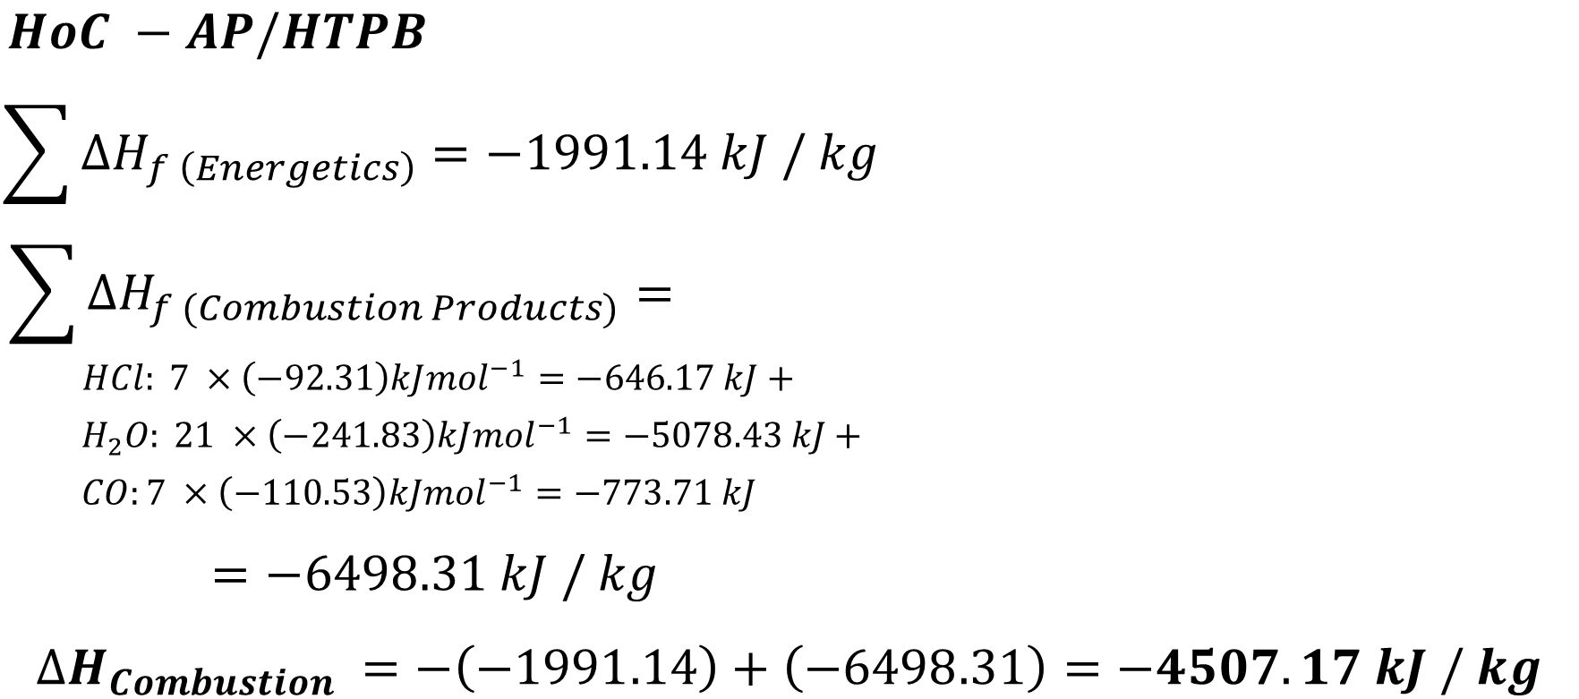
Equation 7 - Heat of Combustion calculation for CL-20 / GAP
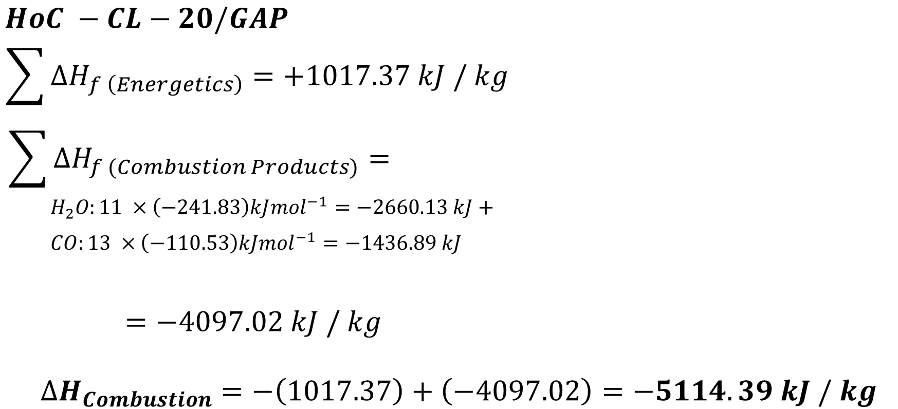

2.6 Estimating Combustion Temperatures
Combustion Temperature can be estimated from the Heat of Combustion and Combustion Products using Equation 8, [3], [18], [20].
Equation 8 - Combustion Temperature equation. [18]
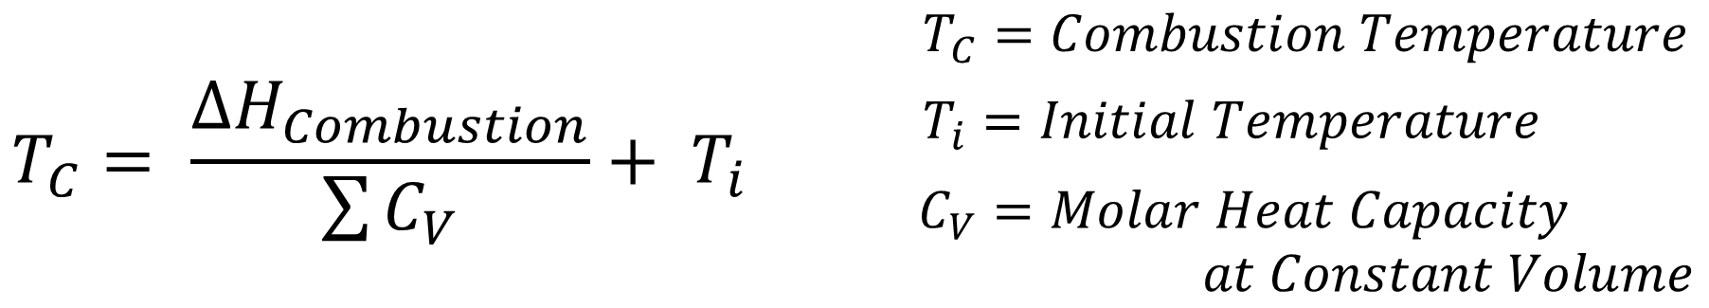
This equation assumes volume in constant and all liberated energy is used to heat the gas. As molar heat capacities vary nonlinearly with temperature T_{c} cannot be directly calculated. Instead, an iterative or extrapolative method is used.
This work used an extrapolative method with the results shown in Figure 5.
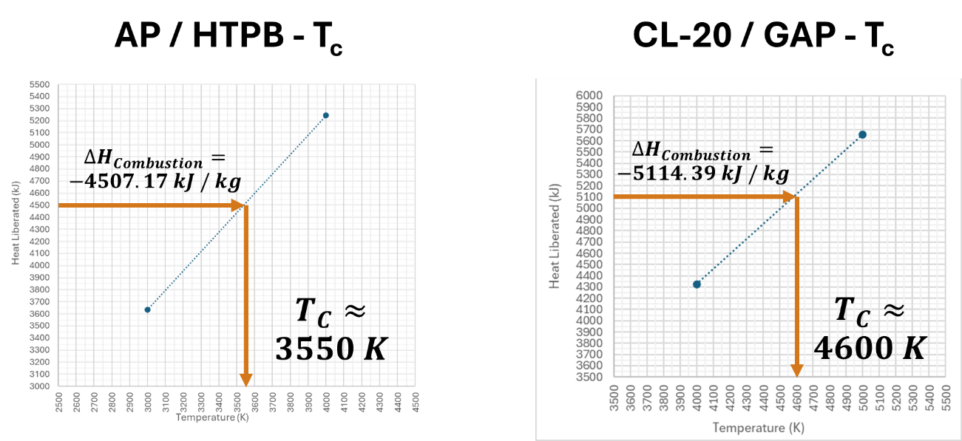
Figure 5 - Combustion Temperate extrapolation for each propellant formulation.

2.7 Specific Impulse Comparison
With the T_{c} and combustion product mass calculated the proportional specific impulse of each formulation can be calculated as shown in Equation 9.
Equation 9 - Proportional Specific Impulse calculations.
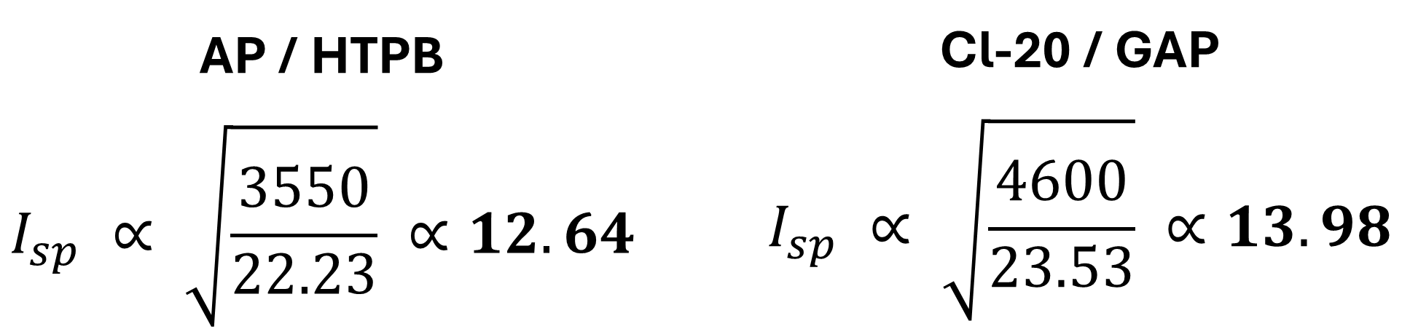
This shows that CL-20 / GAP SRM’s provides a 10% increase in specific impulse assuming equivalent motor efficiency. This demonstrates a significant increase in energy density, and hence payload, range and velocity improvements as required for generation after next weapon systems.

2.8 Burn Rate Characteristics
When comparing SRM performance it is also important to consider how the impulse is delivered and the shape of the thrust time curve. This is heavily influenced by both mechanical factors such as grain geometry and chemical factors such as burn rate.
Propellent combustion is a surface effect where the burning surface gradually regresses. The speed of this regression is known as the Linear Burn Rate and is dictated by Vieille’s Law, Equation 10, [3], [4], [18].
Equation 10 - Vieille's Burning Rate Law [3].
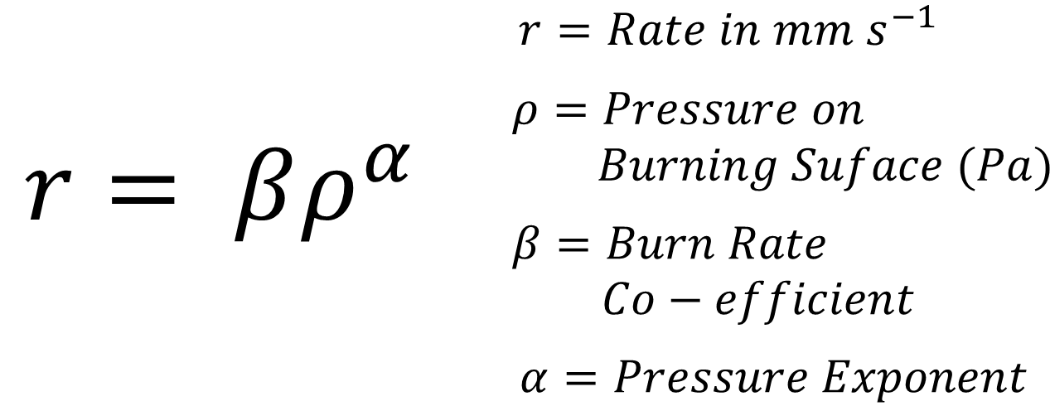
The burn rate coefficients 𝛽 𝑎𝑛𝑑 𝛼 are unique to each propellant formulation and must be determined experimentally by varying the pressure on the burning surface and measuring regression. Experimental data for the studied formulations are shown in Figure 6.
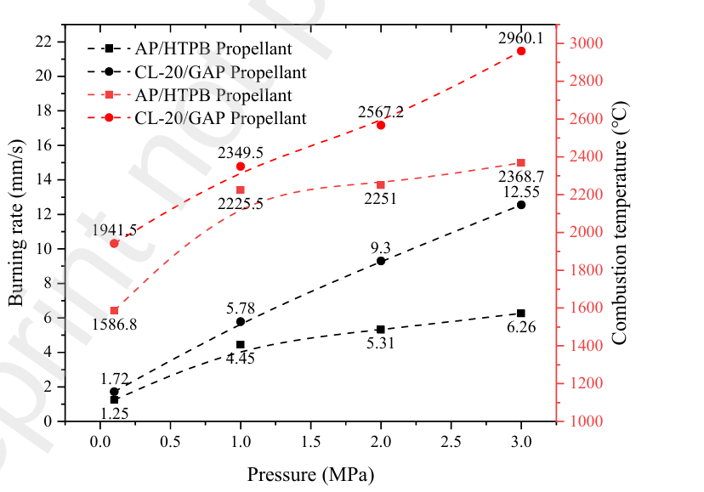
Figure 6 - Burning Rate and Flame Temperature with respect to Pressure [21].
This data clearly shows CL-20 / GAP formulations have higher burning rates and pressure exponents which increases the mass flow rate and hence thrust. It also means the propellant is used up at a faster rate creating steeper shorter thrust time curves as shown in Figure 7.
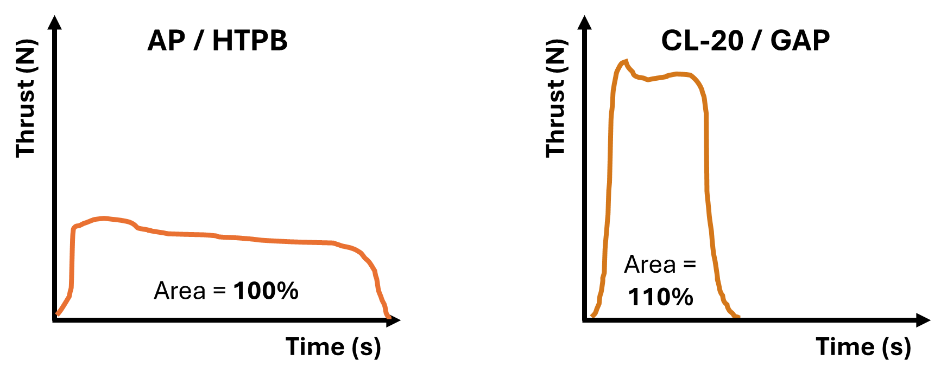
Figure 7 - Qualitative comparison of thrust time curves.

2.9 Performance Conclusions
The thermochemical calculations conducted in this report show CL-20 / GAP provides a greater specific impulse but that this is delivered over a short period of time. This makes the formulation preferable for high acceleration systems such as ballistic and hypersonic missiles.
In contrast AP / HTPB motors typically have greater endurance and are less sensitive to pressure improving thrust stability and making them preferential in low-cost conventional munitions.

3.0 Technical Reflections for Future Work
Despite the depth and breadth of the work presented this only explores a fraction of the potential comparisons between the propellant formulations. This presentation briefly discusses the use of thermochemical codes for calculating performance [20], [22], [23], [24], but this is a whole topic in itself which could be better explored. Furthermore, this work utilises simplistic, unrealistic formulations, excluding metallic fuels, plasticisers and processing aids. Future work should look to explore these to draw more comprehensive and accurate conclusions. Finally, the conclusions drawn regarding the thrust profile and applications of each propellant are rudimentary and generalised. If more work was to be conducted it should explore the use of burn rate modifiers, propellant grain geometry and motor hardware design to alter the thrust profiles of each propellent type and enable more flexibility in final application [25]. With the time constraints provided however, this work still provides essential insight and understanding on the future of solid rocket propellants.

4.0 Conclusion
This technical summary clearly highlights the importance of the authors contribution to the group presentation shown in Appendix A. The importance of both propellants within SRM design is highlighted before a comprehensive thermochemical analysis is conducted for each propellant. This shows a clear increase of 10% in specific impulse for CL-20 / GAP which highlighting the differences in the thrust time profile. This analysis allows for conclusions to be drawn on the application of each propellant; Ballistic and hypersonic missiles for Cl-20 / GAP, conventional and low cost for AP / HTPB. Finally, technical limitations are discussed alongside areas for exploration in future work which, if conducted would provide a more rounded analysis and further advance the audiences understanding.

5.0 References

[1] | Roxel Propulsion Systems, “Market segments,” [Online]. Available: https://www.roxelgroup.com/en/products-and-services/#marketsegments. [Accessed 2 January 2026].
[2] | G. Allison, “Britain launches Project ‘NIGHTFALL’ for ballistic missile,” UK Defence Journal, 25 August 2025. [Online]. Available: https://ukdefencejournal.org.uk/britain-launches-project-nightfall-for-ballistic-missile/. [Accessed 2 January 2026].
[3] | J. Stierstorfer and T. M. Klapotke, High Energy Materials. Propellants, Explosives and Pyrotechnics. By Jai Prakash Agrawal., Weinheim: Wiley-VCH, 2010.
[4] | T. M. Klapotke, Chemistry of High-Energy Materials, De Gruyter, 2015.
[5] | NASA Glenn Research Center, “Solid Rocket Engine,” [Online]. Available: https://www1.grc.nasa.gov/beginners-guide-to-aeronautics/solid-rocket-engine/. [Accessed 25 November 2025].
[6] | NASA LPTC, “Liquid Propulsion Systems – Evolution & Advancements,” [Online]. Available: https://ntrs.nasa.gov/api/citations/20140002716/downloads/20140002716.pdf. [Accessed 25 November 2025].
[7] | A. Karabeyoglu, G. Zilliac, P. Castellucci, . P. Urbanczyk, J. Stevens, G. Inalhan and . B. Cantwell, “DEVELOPMENT OF HIGH-BURNING-RATE HYBRID-ROCKET-FUEL FLIGHT DEMONSTRATORS,” in 39th AIAA/ASME/ASEE Joint Propulsion Conference, Huntsville, Al, 2003.
[8] | G. Dong, H. Liu, L. Deng, H. Yu, X. Zhou, X. Tang and W. li, “Study on the interfacial interaction between ammonium perchlorate and hydroxyl-terminated polybutadiene in solid propellants by molecular dynamics simulation,” De Gruyter E-Polymers, vol. 22, pp. 264-275, 2022.
[9] | National Institute of Standards and Technology, “Ammonium perchlorate,” [Online]. Available: https://webbook.nist.gov/cgi/cbook.cgi?ID=C7790989&Mask=2. [Accessed 25 November 2025].
[10] | O. Kositsyna, K. Varlan, M. Dron and O. Kulyk, “Determining Energetic Characteristics and Selecting Environmentally Friendly Components for Solid Rocket Propellants at the Early Stages of Design,” Eastern-European Journal of Enterprise Technologies, vol. 6, no. 6, 2021.
[11] | National Library of medicine, “Hexanitrohexaazaisowurtzitane,” [Online]. Available: https://pubchem.ncbi.nlm.nih.gov/compound/9889323. [Accessed 25 Novmeber 2025].
[12] | National Library of Medicine, “Ammonium perchlorate,” [Online]. Available: https://pubchem.ncbi.nlm.nih.gov/compound/Ammonium-perchlorate. [Accessed 25 November 2025].
[13] | M. Geetha, U. Nair, D. Sarwade, G. Gore, S. Asthana and H. Singh, “Studies on CL-20: The most powerful high energy material energy material,” Journal of Thermal Analysis and Calorimetry , vol. 73, pp. 913 - 922, 2003.
[14] | J. Thomas and E. Peterson, “HTPB Heat of Formation: Literature Survey, Group Additive Estimations, and Theoretical Effects,” AIAAJ, 2021.
[15] | S. Haska, E. Bayramli, F. Pekel and S. Ozkar, “Mechanical properties of HTPB-IPDI-based elastomers,” Journal of Applied Polymer Science, vol. 64, no. 12, 1997.
[16] | S. Ma, Y. Li, Y. Li, G. Li and Y. Lou, “Research on the Mechanical Properties and Curing Networks of Energetic GAP/TDI Binders,” Central European Journal of Energetic Materials, vol. 14, no. 3, 2017.
[17] | S. Sahu, A. Panda, D. Sadafule, C. Kumbhar, S. Kulkarni and J. Thakur, “Thermal and photodegradation of glycidyl azide polymers,” Polymer Degradation and Stability, vol. 62, no. 3, pp. 495 - 500, 1998.
[18] | J. Akhavan, The Chemistry of Explosives 4th Edition, RSC, 2022.
[19] | G. Collett, J. Akhavan, R. Hazael and R. Critchley, “Calculating the heat of explosion for non-ideal,” in Next Generation Energetics: 2nd International Explosives Conference, Edinburgh, 2025.
[20] | M. H. Keshavarz and T. Klopotke, Energetic Compounds: Methods for Prediction of their Performance, Walter de Gruyter GmbH & Co, 2017.
[21] | Z. Li, J. Liu, X. Liao, H. Gae and P. Xie, “Comparative Study of the Ignition and Combustion of GAP/CL-20 and AP/HTPB Propellants,” KeAi First Look, 2024.
[22] | Lawrence Livermore National Laboratory, “Cheetah, v10,” [Online]. Available: https://softwarelicensing.llnl.gov/product/cheetah-v10. [Accessed 25 November 2025].
[23] | OZM, “EXPLO5 THERMOCHEMICAL COMPUTER CODE,” [Online]. Available: https://www.ozm.cz/files/explosives-and--propellants-testing-instruments/explosives-performance-tests/thermochemical-computer-code-explo5/thermochemical-computer-code-explo5.pdf. [Accessed 25 November 2025].
[24] | NASA, “CEARUN,” [Online]. Available: https://cearun.grc.nasa.gov/. [Accessed 25 November 2025].
[25] | T. J. Kumar, K. Rao, C. Kanth and T. Krishna, “SOLID PROPELLANT BURN RATE ENHANCEMENTS WITH VARIOUS GRAIN CONFIGURATIONS,” Journal of Emerging Technologies and Innovative Research, vol. 9, no. 6, 2014.
[26] | Space.com, “Success! SpaceX Launches Falcon Heavy Rocket on Historic Maiden Voyage,” [Online]. Available: https://www.space.com/39607-spacex-falcon-heavy-first-test-flight-launch.html. [Accessed 25 November 2025].
[27] | B. T. Tuan, “Research on the Working Characteristics of Solid-Fuel Rocket Engines,” International Journal of Science and Engineering Applications, vol. 13, no. 9, 2024.
[28] | The Planetary Society, “Apollo 11 liftoff from pad 39A,” [Online]. Available: https://www.planetary.org/space-images/apollo-11-liftoff-from-pad. [Accessed 11 November 2025].
[29] | TWZ, “New Patriot Missile Interceptor Axed By Army,” [Online]. Available: https://www.twz.com/news-features/plans-for-new-interceptor-for-patriot-air-defense-system-axed-by-army. [Accessed 11 November 2025].
[30] | M. Vernacchia, “Rocket-propelled small fast aircraft (Firefly),” [Online]. Available: https://mvernacc.github.io/portfolio/project_pages/firefly/. [Accessed 25 November 2025].
[31] | National Library of Medicine, “Glycidyl azide,” [Online]. Available: https://pubchem.ncbi.nlm.nih.gov/compound/14397832. [Accessed 25 November 2025].
[32] | National Institute of Standards and Technologies, “Hydrogen chloride,” [Online]. Available: https://webbook.nist.gov/cgi/cbook.cgi?ID=C7647010&Mask=1&Type=JANAFG&Table=on. [Accessed 25 November 2025].
[33] | OZM Research, “Rocket Propellants Ballistics Tests,” [Online]. Available: https://www.ozm.cz/rocket-propellants-ballistics-tests/. [Accessed 25 November 2025].
[34] | L. Prus, “Northrop Grumman targets leading role in Golden Dome for America missile defence initiative,” Defence Industry Europe, 28 July 2025. [Online]. Available: https://defence-industry.eu/northrop-grumman-targets-leading-role-in-golden-dome-for-america-missile-defence-initiative/. [Accessed 25 November 2025].
[35] | Defence Science and Technology Laboratory, “Hypersonic missiles: travelling at the speed of sound...times 5,” 24 July 2023. [Online]. Available: https://www.gov.uk/government/news/hypersonic-missiles-travelling-at-the-speed-of-soundtimes-5. [Accessed 25 November 2025].
[36] | MBDA, “ASRAAM,” [Online]. Available: https://www.mbda-systems.com/products/air-dominance/asraam. [Accessed 25 November 2025].
[37] | MBDA, “ASTER 15,” [Online]. Available: https://www.mbda-systems.com/products/area-protection/aster-family/aster-15. [Accessed 25 November 2025].

Appendix A – Presentation Slides


