application of ARTIFICAL INTELLIGENCE in the retail environment

  - Subtitle


Executive Summary

This report was commissioned to examine the benefits and risks of implementing AI technology within the context of HR and people management at Lidl.
The British Retail Consortium (BRS) estimates that over a 20 year period, 60% of retail sector jobs could be lost to automation (Szajna-Hopgood, 2018). The report draws to attention the benefits and concerns of implementing AI technology within a retail sector business in order to gain competitive advantage, cost savings and increase efficiency. The report explores a number of ways competitors are applying AI to their businesses and focuses on retaining and growing the 5.6% market share Lidl currently holds (Independent, 2018).
Concluding the report, it is found that Lidl should act immediately to implement the technology examined, in order to improve efficiency, aid recruitment and development and retain/gain competitive advantage.
It is recommended within the report:
- AI technology is applied within the business for the purposes of recruitment, learning and development, employee engagement and performance management.
- That HR support is required to apply the technology within the business.
- Ethical issues such as security, unemployment and taxation are considered before application.

Contents
1. Introduction 4
2. Lidl and AI 5
2.1 Currently implemented AI technology 5
3. How AI is used by competitors 5
4. How AI is benefitting people management 6
4.1 Recruitment 6
4.2 Learning & Development 6
4.3 Employee Engagement 7
4.4 Performance management 7
5. Ethical Issues 9
5.1 Mitigating Ethical Issues 10
6. Recommendations for adopting AI solutions 10
6.1 HR Support Requirements 11
7. References 12

1. Introduction
This report follows a request from the board to understand the benefits and risks of implementing AI technology within the context of HR and people management.
Lidl is a German discount supermarket chain that operates internationally and currently has over 10,000 stores (Busvine, 2018). In the EU, Lidl’s chief competitor is Aldi (Owler, 2018). Lidl uses it’s own supply chain to create products and use minimal packaging (such as bulk displays on pallets etc) and low staffing in stores to save money (Sedex, 2018).
The 4th industrial revolution relates to the implementation of cyber-physical systems into our everyday lives, and also into businesses. Professor Klaus Schwab warns that “the changes are so profound that, from the perspective of human history, there has never been a time of greater promise or potential peril” (Schwab, 2017).
To understand the changes that this revolution will bring, it is important to look at VUCA (See Fig. 1) as a way of adapting to the change cyber-physical systems will bring. It is imperative that a company adapts to these changes in order not to lose competitive advantage (Marr, 2018). Changes such as globalisation of economic and labour markets and geo-political instabilities and conflicts lead to both high levels of complexity and uncertainty. Society is going through rapid change, leading to volatility. Technological acceleration results in all aspects of VUCA needing to be addressed.
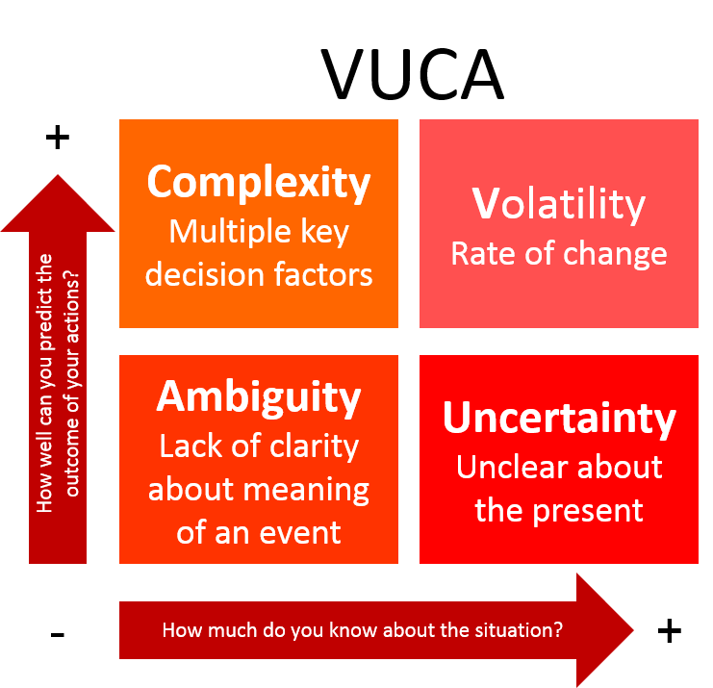
Figure 1: VUCA Diagram
(Source: VComply)

These macroenvironmental changes combined with AI technological developments must lead to change in the internal structure, organisations, processes and behaviours in order to maintain competitive advantage, to increase efficiency, and to successfully adapt to a new technological environment (Healey-Benson, 2018).

2. Lidl and AI

2.1 Currently implemented AI technology
In 2018, Margot, an artificially intelligent sommelier was introduced via the medium of Facebook to Lidl customers (Christie, 2018). This was initially coined as a way to make the experience of choosing wine more suited to an individual’s taste and budget (Lidl, 2018). This has had the knock-on effect of freeing up many hours of social media team time, where the majority of questions about the company’s wine selection can now be answered using AI.
Removing the need for multiple checkout staff, self service checkouts were implemented within Lidl stores throughout the UK. This can save money on staffing costs, as well as speed up the process of checkout for customers. However, the limitation of AI technology can lead to security issues including theft and inventory issues where items are incorrectly weighed or scanned (Guardian, 2016). In Lisbon, Lidl has launched a trial of its Shop & Go app which allows customers to scan purchases as they shop with their smartphone. This allows customers to avoid queues and have flexibility to switch and change products as they browse the store (Pinhammer, 2017).
Lidl has expanded its use of AI with an automated case picking system in its logistics centre in Kircheim, Germany. By using the Schaefer Case Packing System (SCP) the company can guarantee perfectly picked and well packed pallets. This form of warehouse is scalable and therefore can be increased indefinitely (Logistics Manager, 2013).
The British Retail Consortium (BRS) estimates that over a 20 year period, 60% of retail sector jobs could be lost to automation (Szajna-Hopgood, 2018). The above technology not only increases the efficiency of day-to-day operations for Lidl, but significantly changes their use of people within the business. As in the example of self service checkouts, staff deployment is changed. This means staff would have to be trained in other areas of business, or the company would have to consider cutting roles. This means changing skillsets, and adaptive learning in order to stay ahead of technological changes.

3. How AI is used by competitors
Within the retail supermarket sector, AI technology is rapidly becoming more prevalent.
In 2018, Tesco announced a more flexible style of working which would be powered by AI. This kind of workforce management would allow for staff to book overtime, holiday or edit rotas through a smartphone app. This reduces the time spent by store managers on workforce time management (Moss, 2018).

Morrisons have implemented AI based technology to aid replenishment. The self-adjusting technology uses a cloud based system in order to make 430 million calculations and 13 million AI decisions every day (Lemmon, 2017).
Marks & Spencer Food is developing AI systems to their in-store bakeries in order to reduce waste. The BakePlan software will be used as part of a company-wide plan to reduce food waste by 50% by 2025 (Weinbren, 2017).
Lidl’s market share is currently 5.6% (Morrison, 2018). This could be severely affected by the increasing use of AI by competitors, as Lidl will lose competitive advantage. Although as mentioned previously Lidl has already implemented customer-focused AI, it must also aim to apply this technology to back-end systems in order to stay in competition with the market it operates within.

4. How AI is benefitting people management

4.1 Recruitment
52% of recruitment leaders polled agreed the toughest aspect of recruitment is screening candidates from a large applicant pool (Ideal, 2017). AI can be implemented to autoscreen candidates and to sift the best applicants for the role based on a number of variables including language and experience (Forbes, 2018). As 75% to 88% of resumes received are unqualified and screening resumes takes up to 23 hours of a recruiter’s time for one position (Ideal, 2017), AI can be particularly helpful in making recruitment more efficient, and also offers competitive advantage as talent is not lost to faster acting competitors.
AI can also be implemented to provide standardised job matching. This compares the experience, knowledge, skills and requirements of the job to the candidate and delivers a better talent match. Better talent matching decreases staff turnover; companies who have already adopted this process have seen this decrease by up to 35% (Ideal, 2017).
Alongside resume screening, recruiter chatbots and digitized interviews can also be used to save time on the recruitment process (Forbes, 2018). This gives the opportunity to offer instant feedback as well as providing data to the company to be used either for the role itself or for future roles. AI can analyse speech patterns, body language and facial movements to provide even more accurate job matching and even culture matching to the organization.
Although AI recruitment has many benefits, it lacks the nuances of human judgement (Jobstreet, 2018). Algorithms may become inappropriately biased and reject those with genuine prospects for a role, which may in turn damage a company’s reputation with candidates (Deiters, 2018). An example of this was an Amazon recruitment AI tool which was subsequently withdrawn as it showed bias against hiring females (Dastin, 2018).

4.2 Learning & Development
AI is providing adaptive learning in the workplace by providing training which is personalized to the individual (Lamson, 2018). Preventing a “one size fits all” learning environment can ensure that all employees are trained to the level which is required and can even identify key areas of improvement or even high performance and achievement. As learning and development used in conjunction with AI is personalised, it is easier for employees to engage with it.
The AI software can also create learning on demand wherein employees can undertake learning in their own time. This means that trainers and L&D specialists will have time freed up to create better content, and employees will be able to learn at their own pace (Redwitz, Lamson, 2018).
Disadvantages to AI learning and development includes susceptibility to errors. Finding and correcting errors in material can take time and can be complex to fix. Algorithms used by AI to train can also take time to collate meaningful data (Dataflair, 2018). This can be overcome by ensuring an up-to-date news portal as part of an AI learning environment to ensure employees are on top of day-to-day updates and changes in policy etc.

4.3 Employee Engagement
Responsive feedback platforms are an excellent way to engage employees using AI. These platforms change a yearly feedback survey to constantly updated information which allows management to understand the current experience of the company. Companies can therefore make adjustments as necessary and employees remain engaged (HR Daily, 2018).
AI data analysis of employees can be used to ensure that employees are in teams with other like-minded people, avoid personality clashes and match working styles. This can be used to create teams which are engaged and happy and can collaborate well, often increasing efficiency and productivity in the workplace (Forbes, 2018). AI can also analyse data to identify leadership for groups and create management teams effectively.
Although AI can be used to efficiently collect employee engagement data, it risks losing human interaction between management and staff (NI Business Info, 2018). Though this kind of data can keep managers up to date on general feeling of employees, without context and humanisation it may not answer why employees are not engaged, should that be the case (Chamorro-Premuzic, 2018).

4.4 Performance management
AI can be an effective tool in managing Key Performance Indicators (KPI) and people management within a business. Software allows a company to track and monitor KPIs and improve performance where necessary (Pimenta, 2018).
In research conducted by MIT Sloan Management Review, 84% of respondents believe that using AI will help them gain competitive advantage, however only 23% have actually implemented it into their current business setup (See: Fig 2) (Columbus, 2017). This reflects how early adoption of AI systems in the workplace can potentially give competitive advantage over 77% of businesses (See: Fig 3).
Using AI in performance management will almost certainly increase the amount of data available on individual performance. It is therefore a risk that contrast bias, or human application of this data, could lead to harmful generalisations or misjudgement of data – leading to overworking or overly critical management bias (Shaw, 2018).

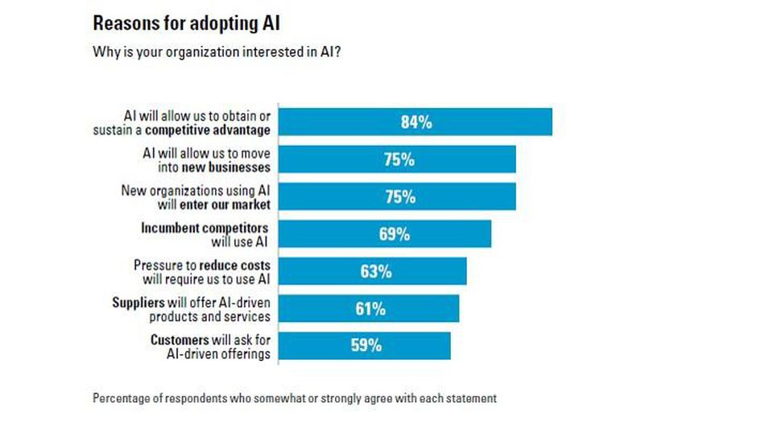
Figure 2: Reasons for Adopting AI
(Source: Boston Consulting Group & MIT Sloan Management Review)

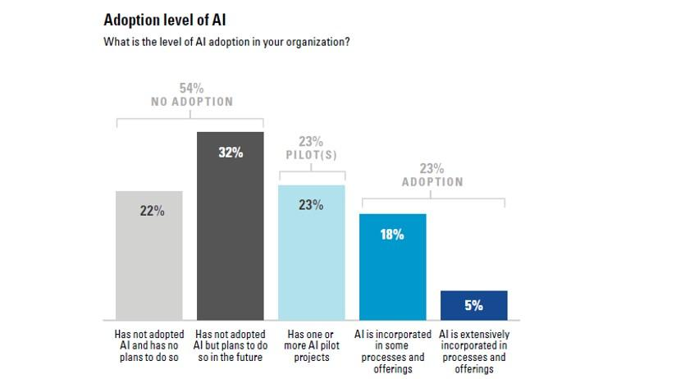
Figure 3: Adoption Level of AI
(Source: Boston Consulting Group & MIT Sloan Management Review)
Based on research by Pegasystems, 55% of those consumers who are familiar with and understand AI are now comfortable with its use by business. 35% of customers felt that AI would be able to improve their customer service experience (Pegasystems, 2017). This reflects that the consumer is becoming comfortable with the use of AI and therefore any use of AI within the business which the public are aware of will not be off-putting.

5. Ethical Issues
There are many ethical issues which arise from the use of AI technology. Unemployment could rise significantly due to the implementation of AI, with unskilled workers most at risk. This would severely affect areas of low income with high levels of low skill workers (Bossman, 2016).
A robotic workforce would be one which, in the current climate, would not be taxable. While there are cost savings to be made to business in terms of manpower, the ethical implications of a workforce which does not pay tax are complex, particularly where an AI workforce has caused unemployment (Abbott, Bogenschneider, 2018). South Korea has already applied “Robot Tax” by limiting tax incentive schemes for those businesses heavily invested in automation (McGoogan, 2017)
Like any software, AI is only as good as the data is already has. AI screening processes require large amounts of data to be accurate. It also requires that the data it receives is genuine and not exaggerated (Ideal, 2017). AI also cannot understand its own mistakes. Any mistakes in code or software would have to be identified by humans (Bossman, 2016).
Governments need to be prepared for a segregated workforce split into low skill low pay, and high skill high pay workforces. This could create social tensions and could bring about a negative change by removing specific human capabilities from the workplace such as empathy, compassion and co-operation (Schwab, 2016).
Security is a prevalent ethical concern with AI. Considerations as to cyber security would have to be practically managed in order to prevent misuse of data or malicious access to technology, and GDPR procedures applied appropriately and reviewed as necessary (Bossman, 2016).

5.1 Mitigating Ethical Issues

Issue | Mitigating Effect
Unemployment | - Appropriate reskilling, upskilling, training and development of staff to new roles.  - Preparedness for roles to be automated.
Privacy and security | - Explicit permission gained, and awareness communicated to staff around the use of AI in the workplace.  - Use of secure systems with appropriate GDPR procedures applied.
Data Inaccuracy | - Constant review and update of data used.  - User based reporting of inaccuracy of data in place.
Taxation | - Government taxation systems for robotic and cyber-physical workforces to be in place.
Bias | - Systems to be continuously reviewed by management teams for unfair or biased practice.
Segregated Workforce | - Ensuring roles are reviewed regularly to identify opportunity for retraining and implementing new roles where appropriate.

Figure 4: Mitigating Effect Table

6. Recommendations for adopting AI solutions
To conclude this report proposes the following adaptations within Lidl are recommended:
Recruitment
- Screening candidate resumes
- Standardised job matching
- Recruiter chatbots
- Digitalised applicant interviews
Learning and development
- Customised staff training
- Learning on demand

Employee Engagement
- Responsive feedback platforms, updated in real time
- Collaborative team matching
- Identification of team leaders
Performance Management
- KPI tracking

6.1 HR Support Requirements
HR teams within Lidl need to assist in applying the recommendations within this report, with consideration taken to mitigating any potential ethical issues which can arise (See Fig 4). Priority should be given to the following:
- Communication of any implemented AI technology should be given ahead of time to staff. This communication should be clear and implicit.
- Identifying retraining, redevelopment of roles and redeployment of staff should roles be changed or lost to cyber-physical systems.
- Any potential redundancies should be identified as quickly as possible, and consultation should take place to identify any training opportunities or redeployment as above to prevent churn.
- Appropriate human management should be applied to any AI instilled within the company, in order to protect security, safety and wellbeing of all staff.

7. References
Abbott, R., Bogenschnieder, B. (2018). Why we should start taxing the robots that are taking human jobs. Available: http://theconversation.com/why-we-should-start-taxing-the-robots-that-are-taking-human-jobs-91295. Last accessed 11th December 2018.
Bernard Marr. (2018). The 4th Industrial Revolution Is Here - Are You Ready?. Available: https://www.weforum.org/pages/the-fourth-industrial-revolution-by-klaus-schwab. Last accessed 11th December 2018.
Busvine, D. (2018). German discounter Lidl slows U.S. expansion: paper. Available: https://www.reuters.com/article/us-lidl-usa/german-discounter-lidl-slows-u-s-expansion-paper-idUSKBN1F62GJ. Last accessed 12th December 2018.
Chamorro-Premuzic, T. (2018). The Dark Side of Employee Engagement. Available: https://www.forbes.com/sites/tomaspremuzic/2014/05/20/the-dark-side-of-employee-engagement/#7d811262166e. Last accessed 12th December 2018.
Chowdhury, R. (2018). How Human-Centric AI Can Help Your Employees Love Mondays Again. Available: https://www.forbes.com/sites/rummanchowdhury/2018/03/16/how-human-centric-ai-can-help-your-employees-love-mondays-again/#146cb3d3f458. Last accessed 6th December 2018.
Chris Lemmon. (2017). Morrisons boosts productivity with AI innovation. Available: http://www.retail-systems.com/rs/Morrisons_Blue_Yonder_AI_Technology.php. Last accessed 11th December 2018.
Christie, S. (2018). Lidl launches online chatbot that recommends wine based on your budget and food choices. Available: https://www.telegraph.co.uk/business/2018/01/31/lidl-launches-online-chatbot-recommends-wine-based-budget-food/. Last accessed 20th November 2018.
Colombus, L. (2017). How Artificial Intelligence Is Revolutionizing Business In 2017. Available: https://www.forbes.com/sites/louiscolumbus/2017/09/10/how-artificial-intelligence-is-revolutionizing-business-in-2017/#3f2d2f0a5463. Last accessed 7th December 2018.
Dastin, J. (2018). Amazon scraps secret AI recruiting tool that showed bias against women. Available: https://www.reuters.com/article/us-amazon-com-jobs-automation-insight/amazon-scraps-secret-ai-recruiting-tool-that-showed-bias-against-women-idUSKCN1MK08G. Last accessed 11th December 2018.
Dataflair. (2018). Advantages and Disadvantages of Machine Learning Language. Available: https://data-flair.training/blogs/advantages-and-disadvantages-of-machine-learning/. Last accessed 12th December 2018.
Deiters, C. (2018). Disadvantages of artificial intelligence (AI) in recruitment. Available: https://www.milchundzucker.com/disadvantages-of-artificial-intelligence-ai-in-recruitment/. Last accessed 13th December 2018.
Forbes. (2018). 10 Ways Artificial Intelligence Will Change Recruitment Practices. Available: https://www.forbes.com/sites/forbescoachescouncil/2018/08/10/10-ways-artificial-intelligence-will-change-recruitment-practices/#6182444e3a2c. Last accessed 6th December 2018.
Healey-Benson, F (2018). Lecture 1 Delivered 3rd October 2018. Swansea Business School, University of Wales Trinity Saint David.
HR Daily Advisor. (2018). Can AI Help Drive More Employee Engagement?. Available: https://hrdailyadvisor.blr.com/2018/07/27/can-ai-help-drive-employee-engagement/. Last accessed 6th December 2018.
Ideal. (2017). AI For Recruiting: A Definitive Guide For HR Professionals. Available: https://ideal.com/ai-recruiting/. Last accessed 6th December 2018.
JobStreet. (2018). Weighing in on the pros and cons of AI in HR recruitment. Available: https://www.jobstreet.com.my/en/cms/employer/weighing-pros-cons-ai-hr-recruitment/. Last accessed 13th December 2018.
Julia Bossman. (2016). Top 9 ethical issues in artificial intelligence. Available: https://www.weforum.org/agenda/2016/10/top-10-ethical-issues-in-artificial-intelligence/. Last accessed 11th December 2018.
Klaus Schwab. (2016). The Fourth Industrial Revolution: what it means, how to respond. Available: https://www.weforum.org/agenda/2016/01/the-fourth-industrial-revolution-what-it-means-and-how-to-respond/. Last accessed 11th December 2018.
Klaus Schwab. (2018). The Fourth Industrial Revolution, by Klaus Schwab. Available: https://www.weforum.org/pages/the-fourth-industrial-revolution-by-klaus-schwab. Last accessed 11th December 2018.
Lamson, M . (2018). The Role of AI in Learning and Development. Available: https://www.inc.com/melissa-lamson/the-role-of-ai-in-learning-development.html. Last accessed 6th December 2018.
Lamson, M. & Redwitz, A. (2018). The Impact of AI on Learning and Development. Available: https://trainingindustry.com/articles/learning-technologies/the-impact-of-ai-on-learning-and-development/. Last accessed 6th December 2018.
Lidl. (2018). Margot the Winebot. Available: https://www.lidl.co.uk/en/How-to-use-Margot-the-Winebot-11782.htm?gclid=EAIaIQobChMIrfiL6Lfq3QIVxrTtCh3pkQwJEAAYASAAEgJflfD_BwE&gclsrc=aw.ds&dclid=CLCA3Om36t0CFUq0UQodBy8MXw. Last accessed 20th November 2018.
Logistics Manager. (2013). Lidl picks with Schaefer. Available: https://www.logisticsmanager.com/20554-lidl-picks-with-schaefer/. Last accessed 20th November 2018.
McGoogan, C. (2017). South Korea introduces world's first 'robot tax' . Available: https://www.telegraph.co.uk/technology/2017/08/09/south-korea-introduces-worlds-first-robot-tax/. Last accessed 11th December 2018.
Morrison, C. (2018). Aldi and Lidl gain market share again as UK shoppers begin buying festive treats. Available: https://www.independent.co.uk/news/business/news/aldi-lidl-supermarket-tesco-sainsburys-waitrose-market-share-kantar-a8585911.html. Last accessed 13th December 2018.
NI Business Info. (2018). Risks and limitations of artificial intelligence in business. Available: https://www.nibusinessinfo.co.uk/content/risks-and-limitations-artificial-intelligence-business. Last accessed 11th December 2018.
Owler. (2018). LIDL's Competitors, Revenue, Number of Employees, Funding and Acquisitions. Available: https://www.owler.com/company/lidl. Last accessed 11th December 2018.
Pegasystems. (2017). What Consumers Really Think About AI: A Global Study. Available: https://www.ciosummits.com/what-consumers-really-think-about-ai.pdf. Last accessed 20th November 2018.
Pimenta, A. (2018). Artificial Intelligence in Performance Management. Available: https://performetric.net/blog/artificial-intelligence-in-performance-management/#. Last accessed 6th December 2018.
Pinhammer, J. (2017). LIDL expands tech initiatives with self-scan app trial in Portugal. Available: https://www.planetretail.net/NewsAndInsight/Article/159278. Last accessed 20th November 2018.
Ransbotham, S., Kiron, D., Gerbert, P., Reeves, M. (2017). Reshaping Business With Artificial Intelligence. Available: https://sloanreview.mit.edu/projects/reshaping-business-with-artificial-intelligence/. Last accessed 7th December 2018.
Rob Moss. (2018). Technology to drive gig-style working for Tesco staff. Available: https://www.personneltoday.com/hr/technology-to-drive-gig-style-working-for-tesco-staff/. Last accessed 11th December 2018.
Sedex. (2018). Lidl UK uses Sedex to implement and embed human rights within their business practices. Available: https://www.sedexglobal.com/lidl/. Last accessed 12th December 2018.
Shaw, S. (2018). Is AI Above the Curve in Evaluating Employee Performance? . Available: https://www.lexology.com/library/detail.aspx?g=935e7736-dc4e-422c-b91d-7396b1a34004. Last accessed 12th December 2018.
Szajna-Hopgood, A. (2018). The rise of automation: Should retailers be worried?. Available: https://www.retailgazette.co.uk/blog/2018/10/the-rise-of-automation-in-retail-should-retailers-be-worried/. Last accessed 20th November 2018.
The Guardian. (2016). Self-service checkouts: unexpected stealing in the bagging area. Available: https://www.theguardian.com/business/shortcuts/2016/aug/03/self-service-checkouts-unexpected-stealing-in-the-bagging-area. Last accessed 20th November 2018.
VComply. (2017). What is VUCA and its relevance in business?. Available: https://blog.v-comply.com/vuca/. Last accessed 11th December 2018.
Weinbren, E. (2018). M&S set to use artificial intelligence to reduce bakery waste . Available: https://www.thegrocer.co.uk/home/topics/waste-not-want-not/ms-to-use-artificial-intelligence-to-reduce-bakery-waste/560456.article. Last accessed 13th December 2018.

