The Efficacy of the Arms and Armour of a Roman Soldier
Introduction
This paper will consider how efficient the arms and armour of the Roman’s was between the Third Century BCE and the Second Century CE, and how the designs developed. Research will be focussed upon the writings of Polybius (6.19-25) for the years before 107 BCE, with the research conducted by Goldworthy (2007) and Grant (2009) providing a basis for the First and Second centuries CE. Use of archaeological evidence to support their explanations will be provided in the appendices.
The Romans produced one of the most effective fighting forces of the ancient world through their use of arms, amour, and tactics. By the second century BCE their legionaries were equipped in a relatively uniformed garb, with variations for the other forces held within the legions but not classified as Legionaries (Goldsworthy, 2007). This standardization not only allowed for easy replication but also acted as a morale boost to the troops as it brought them together as a cohesive body while also acting as a demoralizing force to be reckoned with for any unorganized and undisciplined opponents.
The skill and level of success of the Romans continuously required them to evolve in order to address the different forces and battle styles that they encountered. The arms and armour that the Romans ultimately used was decided upon according to their time in war with exposure to different yet effective weaponry and armour that their enemies possessed which they could incorporate (Goldsworthy, 2007). There is significant evidence that arms and armour were often adopted from their opponents and had some improvements made by the Romans to better suit their tactics. Adopting and adapting select elements of both the equipment and techniques to create them, ultimately made the Romans a stronger and more protected fighting force. As such, an examination of the armour and arms used by the Romans, along with a judgment on the effectiveness of these, provides useful insight into how, with just equipment, the Romans were so proficient.
Throughout its existence, the Roman army would change its arms and armour. While there is much visual overlap between soldiers of the Republic and Empire Eras, there are differences in the types of equipment and units used. The Roman Republic of the second century BCE, along with the introduction of the Marian Reforms in 107 BCE, will be the starting point for the examination of equipment and units used by the army, before moving into the changes which were brought about during the Imperial Era after 27 BCE. While the Roman Empire lasted until the fifth century CE with the fall of the Western empire, where possible no evaluation will take place beyond the second century CE. Nor will a second evaluation of a weaponry or armour be evaluated unless a necessary point can be raised as some equipment was shared across time and units.
The Roman Republic Forces
Before the Marian Reforms took place, a unit called a Velites was used which was made up of the youngest soldiers in the legions. They were equipped with a sword, spears, a target shield, a headpiece similar to a helmet, and the pelt of a wolf or other similar animal. No mention of protective body armour is seen other than the helmet and wolf skin (Plb, 6.22).
While the sword is not spoken of in greater detail by Polybius for the velites (Plb, 6.22), it can be assumed that a variant of the gladius was the blade of choice as this was used by other units, it will be assessed in conjunction with those units. The spear was a wooden haft, some 91cm (approximately 3 foot) long and 1.5cm wide with a metal head a span long, roughly 7 to 9 inches. The head was hammered and sharpened in such a manner that it would bend when first striking resistance. Due to the spear’s design and length, it is perhaps more correct to refer to it as a javelin, especially as it appears multiple would be carried.
The target shield, also known as a parma, was around 3 foot in diameter, more than enough to cover the entire body of the wielder. While not an exact replication, re-enactment and construction of similar shields can provide insight into how this may have best been implemented, furthermore, it possesses similarities with the Greek hoplite shield due to both having a similar diameter. With pottery depictions of the hoplites (Wees, 2015), it is also possible to gain an understanding of how this shield may have been used.
The headpiece is a helmet type called galea (Plb, 6.22). Made of leather, though also used in reference to metal variants (Bezuidenhout, 2018), it would offer some protection from glancing blows, the weather, and potentially the noise of battle. On top of this would be worn the wolf skin which could provide additional protection as well identification in battle (Plb, 6.22).
Possessing multiple throwing spears that break on contact is both useful and detrimental as this feature would allow for the Velites to strike an opponent at range while simultaneously denying them the use of a new throwing weapon themselves. However, due its flimsy nature, this would be much less useful in combat, though still effective, and would be why the sword is an additional weapon, and multiple spears are carried.
The shield, providing protection for the upper body and legs would provide good overall protection for the individual though would require more extensive movement to defend the lower legs and head when in melee range. The galea provide better protection than no helmet though are much less useful than a metal helm from missiles and head height strikes. Depending on the thickness and treatment, cuts and knocks to the head would be lessened in severity. The addition of the pelt would further help to protect against blows as it would provide additional padding with other bonuses of hiding some of the body profile of a Veles as it would move in battle and potentially allow for the arms to be covered before making an attack which is useful if your opponent needs to be able to see where your attack is coming from in order to block or dodge it.
The Hastati, Principes and Triarii
The Hastati, Principes and Triarii are in a joint analysis due to them possessing the same equipment with limited variation for the ranks. Polybius (6.23) puts the equipment of the Hastati as: a scutum shield, a gladius, pila spears, and pectoral plate armour. The pectoral armour has been translated as being a “span square”, though further research suggests this was a piece of square or rectangular bronze, roughly a hand’s span that was placed over the pectoral muscle and breast region in an attempt to protect the heart further (image 1, Appendix 1). As the pectoral muscle has some control over the arms and breathing, additional protection would be useful for this region, as well as to protect the heart from thrusting attacks. However, due to the lack of material for this believed armour, its overall effectiveness would be lessened if a blade was to glance off or be aimed into the torso which is seemingly unprotected, though the addition of the shield would negate this possibility drastically.
The scutum was a large shield of 30 inches (two and a half foot) wide and 48 inches in length (four foot) with variants adding an additional palm’s breadth of roughly 3 inches (image 2, Appendix 1). It was made of two layers of wood which is strengthen by glue, leather hide, and iron or bronze on the rim to add further structural protection and greater blocking ability. In the middle of the shield, was an iron boss called an Umbo to protect the hand while allowing for the shield to be held as well as add further protection against stones, pikes, and heavier missiles.
The gladius was the main blade used by these forces due to its versatility (image 3, Appendix 1). Different variations exist though the main variant used appears to be the Spanish Sword, most likely the Hispaniensis design though it may instead refer to where the metal originated as the other variants appear more prominent in later centuries (Plb, 6.23; Bezuidenhout, 2018). It was described as having an excellent point and capable of providing a formidable blow with either edge as each side of the blade was sharpened, while, due its sharpened point, it would be highly effective at thrusting attacks (Plb, 6.23). Further, these soldiers would carry two pila, a helmet, and potentially leg greaves known as ocreae (Plb, 6.23). The design of the pilum (image 4, Appendix 1) seems to have a thicker and thinner variant though appears to be used in the same fashion, with only the grip and thus weight being the main difference. Possessing a 3 cubit or 135cm long haft with an equally long metal head, it was attached with clasps via rivets in a way that the iron would break sooner and the metal point would become useless to use (Plb, 6.22). Other than the name of the greaves and not of the helmet, Polybius does not write further on them.
The Roman Empire Forces
The Marian reforms of 107 BCE saw the Roman Army transform into a professional and permanent fighting force. While it would take time to equip every solider with new equipment, by the Pax Romana (Roman Peace) of 27 BCE to 180 CE, most every soldier possessed the new style of equipment (Goldsworthy, 2007). With only soldiers, officers, and auxiliary forces, much of the equipment was shared across units though some differences did exist though these were mostly decorative except for the auxiliary.
The main troop of the Roman army was the Legionnaire (image 5, Appendix 1). By the beginning of the second century this soldier was equipped with; two pila, a gladius, a pugio, a scutum, helmet, and lorica segmentata (Grant, 2009; Holmes, 2006). The pila or pilum was a continuation of the earlier versions available throughout the army. It was roughly a two-metre-long throwing spear or javelin with a finely sharpened and hammered metal point which was designed to break or bend upon impact. The wooden haft it was attached to was only a third of the length allowing for this break in the metal to occur. A second spear may have been carried by other troops known as the lancea. It was much like a short spear, though an account by Arrian mentions it being thrown in front of the first ranks of legionnaires when assaulted by cavalry meaning it was light and accurate enough to strike opponents outside of thrusting range (Bishop, 2017).
The legionnaire would carry two blades into battle, the gladius and pugio. The gladius was the main sword implemented by the Roman forces and came in multiple variants. By the first century CE, the Mainz pattern was most prevalent though the Pompeii was used by Centurions before replacing the Mainz in the latter half of the century (Goldsworth, 2007; Bezuidenhout, 2018). While the design was different, the overall length was roughly equivalent with the Mainz being 16 to 22 inches long and the Pompeii 16.5 to 20 inches long. The Mainz pattern was excellent for thrusting attacks due to a very long point that extended out from the middle of the blade which bulged out in a leaf like fashion. In comparison, the Pompeii was a straighter blade that was useful for both cutting and thrusting. Each blade was sharpened on both edges so as to improve the lethality of the weapons and allow for a multitude of attack variations (Grant, 2009; Bezuidenhout, 2018). For the cavalry, the spatha was similar in design to the Pompeii but larger at approximately 30 inches and being greater at cutting actions due its weight, especially when combined with the speed from a horse.
The pugio was the side arm of the legionnaire being a dagger of between 9 and 14 inches. It possessed a very long point with both edges being sharpened. While the techniques of forging both the gladius and pugio are not consistent empire wide, it does appear that the mass manufacturing of Rome meant the quality was mostly consistent and better than that wielded by the enemies of Rome (Goldsworthy, 2007).
The scutum seemingly did not develop further other than becoming rectangular with a cylindrical curve when compared with earlier oval variants (Plb, 6.23; Grant, 2009). It was still the shield of choice due to its mobile and defensive features which allowed for group and individual protection. Throughout the first century CE the Gallic style of helmet was most used though was replaced in the early second century by the Imperial Italic style (Holmes, 2006; Goldsworthy, 2007). There is limited difference between the two variants with the main aspect being less decoration on the italic version (image 6, Appendix 1). Both helmets were made of iron with extended neck and brow guards that were designed to help deflect strikes away from the head by providing an extra curved guard where there was limited armour and overlap.
In the first century CE, the lorica segmentata become the prevalent form of armour and overtook the other similar designs of the Lorica Squamata scales of bronze and previously used lorica hamata (chainmail) (Grant, 2009). Being made of 7 to 8 banded segments covering each side of the soldier, they overlapped the one under and were tied together via leather, hinges and links (Bezuidenhout, 2018). With the one above covering the lower, attacks striking downwards would not be able to penetrate though those able to get a blade in-between the plates could strike upwards into the body and cause injury. Seemingly not hardened, it is a possibility that the softer metal would allow for the force of a blow to dissipate over a wider surface and protect the wearer to a greater extent by diminishing the effects of each blow. The Centurion possessed the same arms and armour as that of a legionnaire though had a plume of feathers atop his helmet to act as a signifier of command structure (Goldsworthy, 2007)
Auxiliary units known as Auxilia replaced and combined the lost unit variants that existed prior to the Marian reforms (Goldsworthy, 2007). Designed as light skirmishing infantry, the sub-units would often be made up of individual ethnicities though this may have also included those trained in the same manner, as population would be a major factor in recruitment. The Cavalry, while no longer part of a higher equestrian class of soldiers, continued to be organized in Turmae squadrons, but were now a state-trained unit which was equipped and recruited from by local tribes under Roman control (Goldsworthy, 2007). Those in the cavalry were equipped differently to the legionnaire, instead of lorica they continued to use chainmail as it was still highly effective, though less effective against heavier blows to the person (Bishop, 2022).

Conclusion
The Roman army was a force that continued to improve upon itself and was not afraid to use equipment that it came across and found to be an improvement on their own. As such, throughout the centuries, the typical Roman Soldier would change in appearance though not as drastically as one may originally expect over such a long time period. Even in the second century BCE, the stereotypical design elements of the first century CE legionnaire can be seen as logical steps forward are made to improve upon the necessary equipment that required modification or changing. Due to the earlier units having incorporated the more effective elements of war gear, the Roman Empire was able to keep to a high standard of protection for its troops without need to reinvent the entire armies equipment.
Bibliography
Bezuidenhout. W. M. (2018). Arms, Armour and Siege-Craft of the Graeco-Roman World Between 2000 BC and 200 AD: The Use and Translation of Terminology. Masters Dissertation. University of the Free State Bloemfontein. [online] Available at: https://scholar.ufs.ac.za/handle/11660/9771 (accessed: 17/03/2023)
Bishop. M. C. (2017). The Pilum: The Roman Heavy Javelin. New York: Osprey Publishing
Bishop. M. C. (2022). Roman Plate Armour. New York: Osprey Publishing
D’Amato, R; Sumner, G. (2009). Arms and Armour of the Imperial Roman Soldier: From Marius to Commodus. Yorkshire: Frontline Books
Goldsworthy, A. (2007). The Complete Roman Army. London: Thomas and Hudson LTD
Grant, R., 2009. Soldier. London: Dorling Kindersley Ltd.
Holmes, R. ed., 2006. Weapon. London: Dorling Kindersley Ltd.
Mathew, P. (2020). Marian Reforms. World History Encyclopedia. [online] Available at: https://www.worldhistory.org/article/1598/marian-reforms/#:~:text=The%20Marian%20Reforms%20were%20a%20set%20of%20the,a%20semi-professional%20militia%20to%20a%20professional%20fighting%20force. (accessed: 20/03/2023)
Polybius. Histories 6.19-25. [online] Available at: http://data.perseus.org/citations/urn:cts:greekLit:tlg0543.tlg001.perseus-eng1:6.22 (accessed: 17/03/2023)
Wasson, D. L. (2021). Roman Armour and Weapons. [online] Available at: https://www.worldhistory.org/article/1692/roman-armor--weapons/ (accessed: 18/03/2023)
Wees, H. V. (2015). Greek Warfare: Myths and Realities. London: Bloomsbury Academic

Appendices
Appendix 1: Images of weaponry and armour
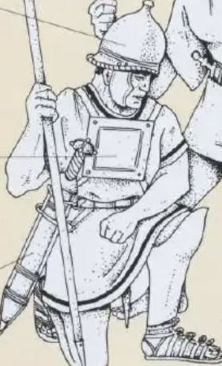
Image 1: Depiction of a pectoral plate used in the second century BCE. Goldsworthy, 2007

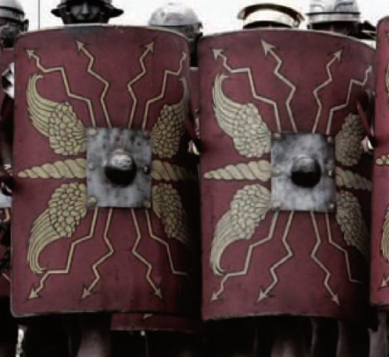
Image 2: The scutum during the Roman Empire. Grant, 2009.

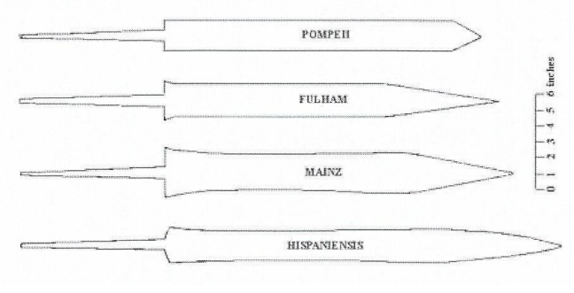
Image 3: The variations of the gladius design. Bezuidenhout, 2018.
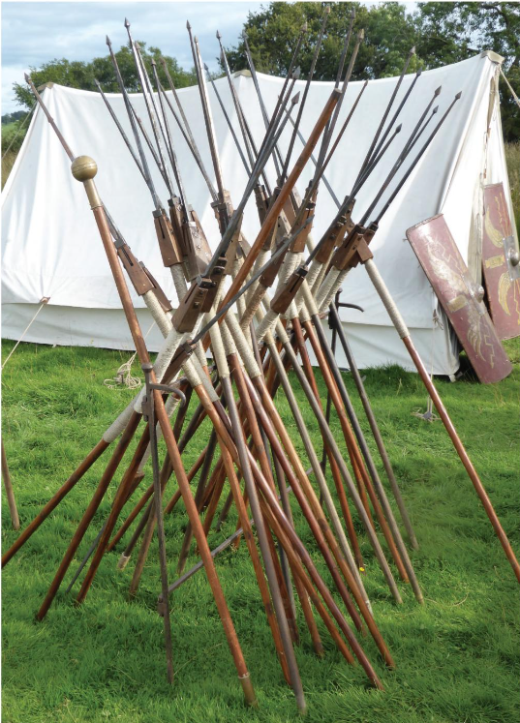
Image 4: Pilum set up in a camp. Bishop, 2017
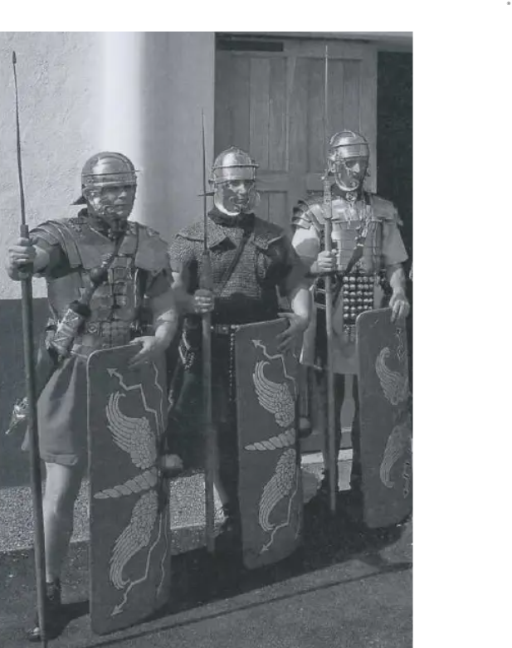
Image 5: Three Legionnaire wearing different lorica variants. Goldsworthy, 2007
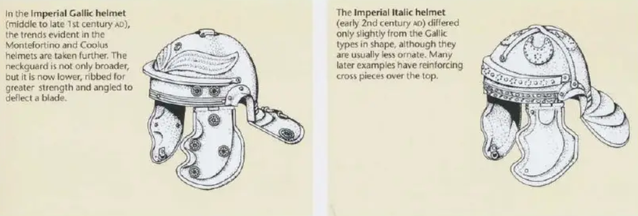
Image 6: The gallic and italic helmet variants. Goldsworthy, 2007.

