Gethin Cardy
2105599
Principles and Contexts of work with young people

In this essay we will be discussing what non-formal and informal youth work is all about and will also be looking at where youth work takes place in the different areas within the contexts. We will then be discussing the principles, values and characteristics that underpin youth work as it is today.
So, Youth worth is a non-formal or informal way of learning as stated by the principles and purposes document (2023) non-formal, informal and structed educational opportunities and experiences which challenge both the institutions and young people themselves to enhance their personal, social and political development. Youth work is based around education that educates young people in all areas of life such as social skills, team development, cognitive skills and basic life skills. It is all voluntary between the youth worker and young person if they do choose to engage so there is a difference if that is voluntary engagement or voluntary participant. Youth work is also about meeting the needs of a young person or the young people that you are working with wither that’s on a one-to-one basis or in group sessions that may be but not always classed as NEET and that stands for not in education, employment or training. Jeffs and Smith (2010) mention that for over 150 years, five elements have fused to delineate what we now know as youth work and to distinguish it from other welfare activities. It is distinctive only when all are present. Remove one and what is observed may possess a resemblance to, but is unquestionably not, youth work. The five are a focus on Voluntary participation. Education and welfare. Young people. Association, relationships and community. Being friendly, accessible and responsive while acting with integrity. Youth work is person centred focused and intends to meet the needs of that young person at that point in their lifetime. As stated by Young (2006), Youth work focuses on young people at that particular moment in their lives when they are developing their awareness, seeking answers and, crucially, beginning to explore their beliefs, values and choices. By delivering good youth work you will be able to meet the needs of the young person or young people that you are working with, and one approach often used within youth work to deliver good youth work is the NAOMIE module. Naomie stands for Needs, Aim, Objectives, Method, Implement and Evaluate.
“Purposeful relationships with young people are at the heart of good youth work. It is important to know how to initiate such relationships and also the ways in which they can be maintained in order for young people to learn and develop.”
(NOS, 2019)

Youth Work can be found in many places and originations. You have cantered based youth work so for example this could be in a youth club setting working either one to one or group work and they work with young people to deliver informative workshops for example safe sex, mental health etc and also deliver activities such as football, baking, musical productions to engage team building. Youth also have detached or outreached youth work that focuses more on the individual’s needs, and this is more targeted work for example the county council have teams appointed to this type of youth work. Youth work can also be seen in schools, and they help with the school curriculum but also tending to the principles and purposes of youth work, they will encourage and help students with their work but also getting the young people to participate in team building exercises and other form of informative exercises. This too can be one on one or group work. There are other places where you might find youth work such as religion-based youth work in churches etc, activities based such as the duke of Edinburgh awards, Scouting, Young Farmers etc and also residential organization. There is also mobile work or street based, virtual engagement targeted provisions or even residential work.
Noted by Ingram and Harris (2001) The second difficulty about offering an explanation is that youth work takes place in a very wide range of settings using diverse set of activities. These include:
- Detached or outreach work and work in mobile centres.
- Clubs that may operate every night of the week in large urban centres, or once a week in rural areas.
- Specific project work, for example, the Duke of Edinburgh’s Award, youth theatres, adventure clubs.
- Work in units based on the identity of the young people (young women’s groups, groups of black young people, PHAB groups, groups for young people who lesbian, gay or bisexual).
- In specialist projects based around such issues of health, prostitution.
- There are information services, one stop information shops and centres that offer counselling.

In youth work there are principles, values and characteristics some of which we will look at in the next part of the assignment. These all contribute to how youth work is carried out within the different sectors wither that’s first, second or third and within different organisation and without these three major components youth work would not run smoothly and would irreversibly be ineffective. So, what are the principles in youth work. Some of the principles in youth work stated by the Youth Work in Wales: Principles and Purposes are:
- Youth work starts at whatever point young people are in their lives, regardless of circumstances, and recognises their potential.
- Youth work recognises that young people have rights and seeks to work in a rights-based way.
- Youth work recognises that young people have responsibilities and requirements place upon them. Youth work seeks to help them address those responsibilities and requirements.
- Youth work is essentially focused on activity which is both informal and non-formal. Informal activity seizes opportunities that are not necessarily planned. Non-formal activity provides planned opportunities which lie outside formal systems such as school-based education. Both kind of activity might lead to accreditation or recognition.
What are the values in youth work. According to The Youth work in Wales: Principles and Purposes document Youth work has a value base which is grounded in respect of young people and in the principles of inclusion and equal opportunity. Through its voluntary relationships with young people it offers opportunities for learning that are: Educative, Expressive, Participative, Inclusive, Empowering. These are also known as the five pillars of youth work and underpin some of the values. In relation to the national occupational standards for youth work some of the values are work with young people and others, plan and implement strategy and youth work activities for young people, and also facilitate learning and development of young people through planning and implementing learning activities in youth work. Here is the functional map from the NOS document.
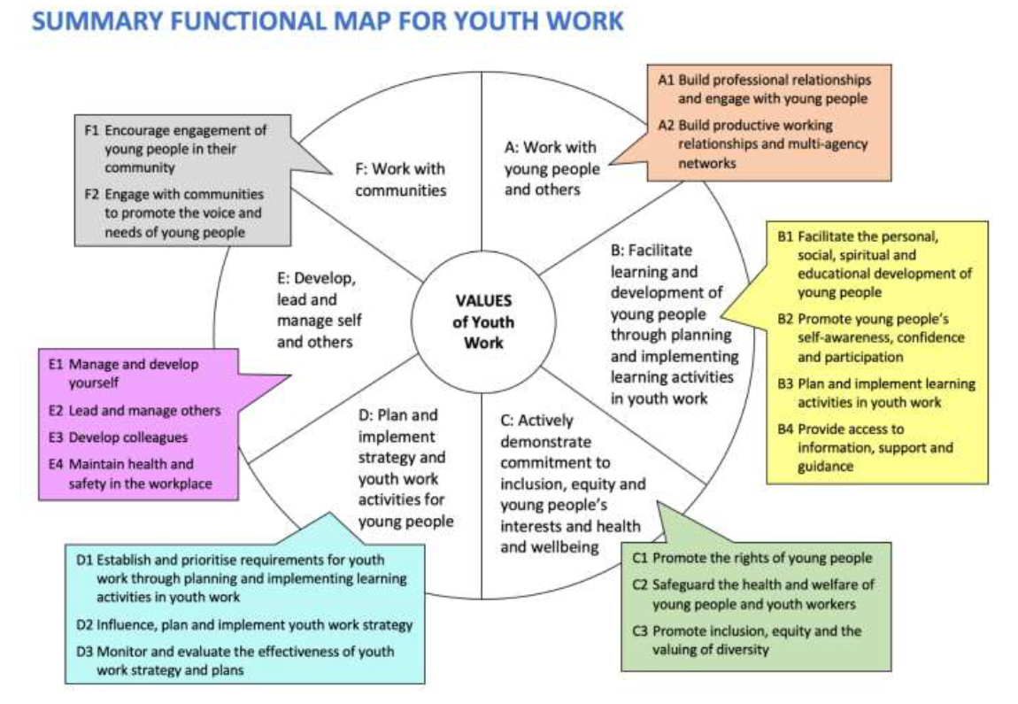
As stated by Young (2006) Its about attitude. Accepting where young people are coming from. Not putting them down but gaining their trust and being able to explore with them. There’s a difference between a young person saying something and you just telling them they shouldn’t have said it; and letting them say it and working out what’s the belief underneath it.
What are the characteristics of youth work. The characteristics are what represent youth work on a national scales and there are three major characteristics that stand out when it comes to youth work and it is being that it is non-formal and informal education that helps with developing of young people, voluntary engagement of young people that is it should be the young person’s choice if they want to engage of not and the young person’s participation within the different settings of the youth work provision that will encourage them. As stated by the National Youth Strategy for Wales, the Youth service in the context of this strategy is the term used to describe the structure within which a form of work with young people is undertaken. Youth work within this framework is underpinned by the following characteristics:
- the voluntary involvement by young people who have chosen to engage in the process.
- being age specific, focused on 11-25 year olds.
- a non-formal education approach.
- being driven by a young-people-first approach.
- a universal approach.

In my conclusion we have spoken about what youth work is and where it can take place. We have also spoken about the values, characteristics and principles that under line youth work linking with the national occupational standards.

Bibliography

Young, K. (2006) The Art of Youth Work. 2nd edn. Dorset: Russell House Publishing.
Jeffs, T. Smith, M. (2010) Youth work practice. Hampshire: Palgrave Macmillan
Standard Setting Organizations. (2019) National Occupational Standards.[website] Available at: https://www.ukstandards.org.uk/EN (Accessed: 1st July 2023)
Ingram, G. Harris, J. (2001) Delivering Good Youth Work. Dorset: Russell House Publishing.
Youth Work in Wales Review Group. (2022) Youth Work in Wales: Principles and Purposes. Wales: CWVYS
Welsh Assembly Government. (2007) Young People, Youth Work, Youth Service: National Youth Service Strategy for Wales. Cardiff: Welsh Assembly Government.

